Figures

Fig.1 Representative Cultures showing effect of carbendazim on shoot multiplication and conservation on Curcuma longa cv. NDH- 98 cultures

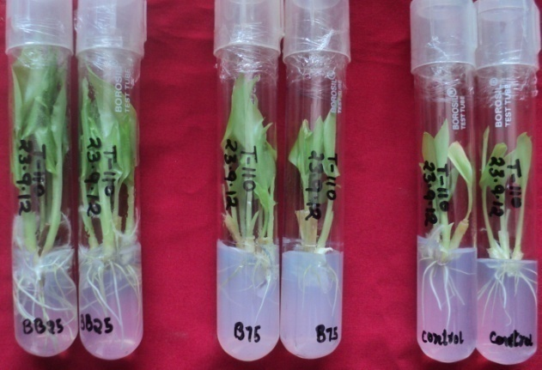 | 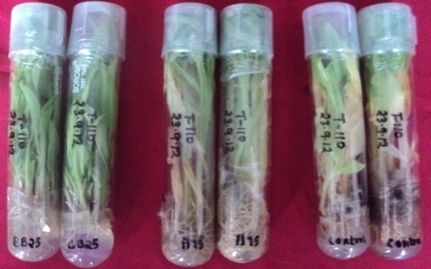
A. After 8 weeks of subculturing | B. After 8 months of conservation

Fig. 2 Representative Cultures showing effect of carbendazim on shoot multiplication and conservation on Z. officinale cv. HP Pullapally cultures

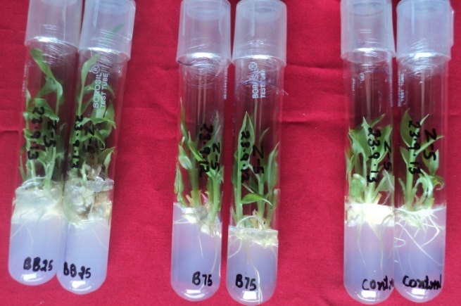 | 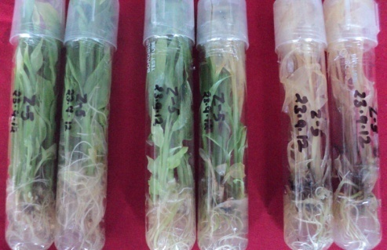
A. After 8 weeks of subculturing | B. After 8 months of conservation

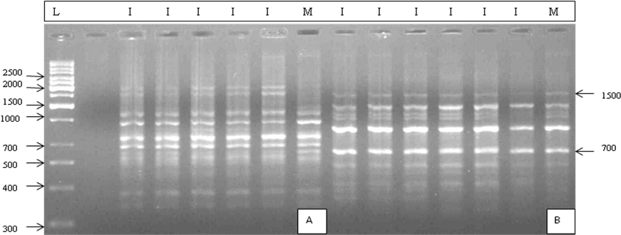

Fig. 3 RAPD profile of in vitro-conserved Z. officinale cv. HP Pullapally (IC248817) with primers OPD 5 (A) and OPD 7 (B). L denotes DNA ladder (1 Kb); M, mother plants and I, in vitro-conserved clone

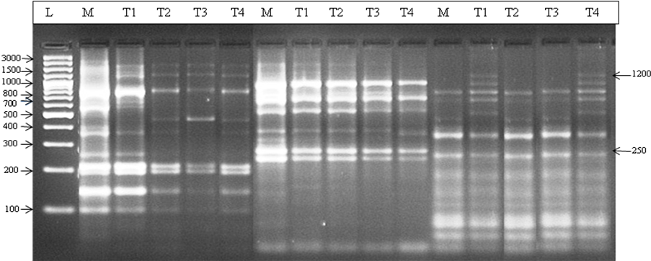
Fig. 4a SRAP profile of C. longa cv. NDH-98 (IC564498) with primers viz., ME2/EM8; ME3/EM2; ME3/EM3; ME4/EM4 (L-Ladder); Size of ladder 100bp (L), M – Mother plant; T1-T4- in vitro plantlets

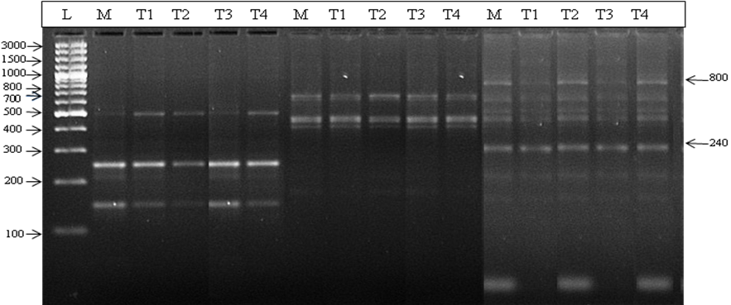

Fig. 4b SRAP profile of C. longa cv. NDH-98 (IC564498) with primers viz., ME4/EM4; ME5/EM4 and ME5/EM11 (L-Ladder); Size of ladder 100bp (L), M – Mother plant; T1-T4- in vitro plantlets

