**Disease incidence and severity of leaf, panicle and fruit blight during 2017 season**



Fig. 1. Disease incidence (DI), percent infected leaves (IL) and percent disease severity index (PDI) of leaf blight disease on nursery plants of litchi during 2017 at NRCL Experimental Farm, Muzaffarpur. Height of columns indicates the mean value of parameters in six nurseries, whereas the value above bars indicates the range in samples; the vertical bar indicates standard error (SE) of the mean. The least significant difference (LSD) at *P=*0.05 for DI, LI and PDI were 3.75, 5.64, and 5.90, respectively.

Table 1: Disease incidence and severity of panicle blight during 2017 season*

|  |  |  |  |  |  |  |
| --- | --- | --- | --- | --- | --- | --- |
| Block/ Orchard | Disease incidence (%) | % Distribution of trees in various severity categories | | | | |
| <20 | 21-40 | 41-60 | 61-80 | >80 |
| cv. ‘Shahi’, April 2017 | | | | | | |
| I | 20.8 | 40.0 | 60.0 | 0.0 | 0.0 | 0.0 |
| II | 28.0 | 71.4 | 28.6 | 0.0 | 0.0 | 0.0 |
| III | 25.4 | 20.0 | 53.3 | 26.7 | 0.0 | 0.0 |
| IV | 12.0 | 100.0 | 0.0 | 0.0 | 0.0 | 0.0 |
| V | 27.0 | 83.3 | 8.3 | 8.3 | 0.0 | 0.0 |
| VI | 18.5 | 60.0 | 20.0 | 20.0 | 0.0 | 0.0 |
| cv. ‘China’, May 2017 | | | | | | |
| I | 37.5 | 83.3 | 16.7 | 0.0 | 0.0 | 0.0 |
| II | 23.8 | 70.0 | 30.0 | 0.0 | 0.0 | 0.0 |
| III | 31.6 | 75.0 | 16.7 | 8.3 | 0.0 | 0.0 |
| IV | 47.6 | 90.0 | 5.0 | 5.0 | 0.0 | 0.0 |
| V | 31.4 | 75.0 | 12.5 | 12.5 | 0.0 | 0.0 |

*Values in the table are based on observations taken on all the trees (n = 60-78) of the orchard.

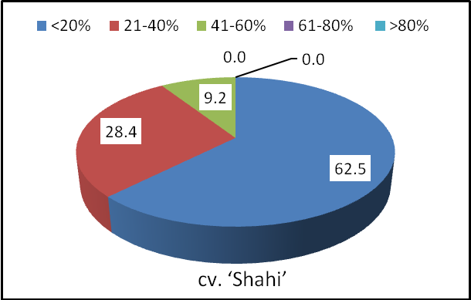

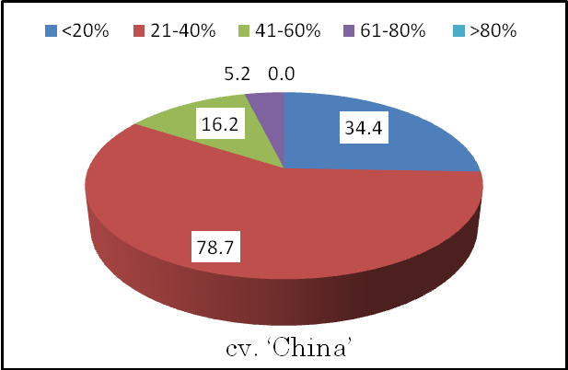

Fig. 2. Percentage distribution of trees in various severity categories of panicle blight during 2017 season; data presented is the average value of 6 and 5 orchard of cv. ‘Shahi’ and ‘China’, respectively



Fig. 3.Incidence of fruit blight disease during 2017 seasons recorded in June month on litchi cv. ‘China’ on trees in farmers’ orchard in Muzaffarpur, Bihar. Height of columns indicates the mean disease incidence, whereas the value above bars indicates the range in samples; the vertical bar indicates standard error (SE) of the mean. The least significant difference (LSD) at *P=*0.05 for disease incidence is 1.06.