ANNEXURE - V
INDIAN COUNCIL OF AGRICULTURAL RESEARCH
RESEARCH PROJECT PROFORMA FOR MONITORING ANNUAL PROGRESS (RPP- II)
(Refer for Guidelines ANNEXURE-XI (E))

- Institute Project Code : IIOR-105-16
- Project Title: Exploiting the bio-efficacy of Entomopathogenic nematodes (EPNs) against Tobacco caterpillar (Spodoptera litura) and Serpentine leaf miner (Liriomyza trifolii) in oilseed crops
- Reporting Period : 2017-18
- Project Duration: Date of Start – Oct 2017 Likely Date of Completion – Sep 2020
- Project Team (Name(s) and designation of PI, CC-PI and all project Co-PIs, (with time spent for the project) if any additions/deletions

S. No. | Name, designation and institute | Status in the project | Time to be spent (%) | Work components to be assigned to individual scientist
1 | B Gayatri | PI | 70 | Collection and identification of EPN strains, Mass multiplication of EPN strains in vitro and evaluation of virulent EPN strains In vitro and In vivo.
2 | P Duraimurugan | Co-PI | 15 | In vitro and In vivo testing of the selected EPN strains on targeted pests
3 | Sunanda B S | Cc-PI | 15 | Mass multiplication of EPN strains in vivo

- (a) Activities and outputs earmarked for the year (as per activities schedule given in RPP-I)

Objective | Activity | Scientist involved | % of activity envisaged to be completed as per RPP-I | % achieved as targeted
- Collection of EPN strains and testing the virulence on different life stages of Spodoptera litura and Liriomyza trifolii | Multiplication of bait insects(Galleria melonella) and EPN strains | B. Gayatri | 100 | 100
 | Collection, Isolation and identification of native EPN strains from oilseed crop ecosystems | B. Gayatri and Sunanda B S | 100 | 100
 | Testing the virulence of collected EPN strains on different life stages of S. litura and L. trifolii under lab conditions | B.Gayatri and  P Duraimurugan | 100 | 100

(b) If shortfall/addition, reasons for the same and how to catch up with the intended activities: Nil

- Annual Progress Report (research results and achievements in bullets):

- Bait insect cultures (Galleria melonella) were multiplied and maintained on artificial diet as well as on honey combs. Two EPN species Steinernema carpocapsae and Heterorhabditis indica were multiplied on Galleria larvae and were used in experimentation.
- About 60 soil samples were collected from IIOR Rajendranagar and Narkhoda fields and one sample out of 60 samples found positive to EPNs.
- Three EPN species (Steinernema carpocapsae Heterorhabditis indica and IIOR-epn) were tested against 2nd 3rd 4th instar larvae and pupae of S.litura and pupae of L.trifolii. 100% mortality was observed in all larval instars at 96 hrs after infection. Pupae of both pests were not infected at the given EPN dose (100 infective juveniles(ijs)/larva or pupa)

- Output During Period Under Report:
  - List of Publications (one copy each to be submitted with RPP-II)
    - Research papers
    - Reports/Manuals
    - Working and Concept Papers
    - Popular articles
    - Extension Bulletins
  - Intellectual Property Generation
  - Presentation in Workshop/Seminars/Symposia/Conferences
(relevant to the project in which scientists have participated)
  - Details of technology developed
(Crop-based; Animal-based, including vaccines; Biological – biofertilizer, biopesticide, etc; IT based – database, software; Any other – please specify)
  - Trainings/demonstrations organized :Nil
  - Training received
- Attended to Training Course on Analysis of Experimental Data from 19-24, February, 2018 at ICAR-NAARM, Hyderabad.
  - Any other relevant information

- Constraints experienced, if any :Nil

- Lessons Learnt: Work should be published simultaneously.

- Evaluation
10
      - Self-evaluation of the project for the period under report by the PI with rating
in the scale of 1 to 10
      - Evaluation by PI on the contribution of the team in the project including self
S. No. | Name | Status in the project  (PI/CC-PI/Co-PI) | Rating in the scale of  1 to 10
1. | B Gayatri, Scientist (Nematology) | PI | 10
2. | Dr P Duraimurugan, Senior Scientist (Entomology) | Co-PI | 10
3. | Dr Sunanda B S, Asst. Scientific officer (Nematology) | Cc-PI | 8

- Signature of PI, CC-PI(s), all Co-PIs
1. | B Gayatri, Scientist (Nematology) | PI
2. | Dr P Duraimurugan, Senior Scientist (Entomology) | Co-PI
3. | Dr Sunanda B S, Asst. Scientific officer (Nematology) | CC-PI | NIPHM, Hyderabad

- Signature (with specific comments on progress/achievements, shortfall and

constraints along with rating of the project in the scale of 1 to 10) of
Head of Division/Regional Center / Section

- Comments of IRC

- Signature (with specific comments on progress/achievements, shortfall

and constraints along with rating of the project in the scale of 1 to 10)
of JD (R)/ Director

RPP II- Enclosures
Obj 1: Collection of EPN strains and testing the virulence on different life stages of Spodoptera litura and Liriomyza trifolii

- Multiplication of bait insects(Galleria melonella) and EPN strains
- Greater wax moth larvae were used for multiplication of entomopathogenic nematodes and also in soil baiting for EPNs.
- Base insect cultures were collected from naturally infested honey combs and were multiplied on honey combs as well as on artificial diet.
- Adult insects emerged were collected in a box for egg laying. The eggs laid were inoculated into diet for multiplication. Pupae in artificial diet were collected in a separate box for adults.
- Growth of the Insects was same in natural and artificial diet.
- Two EPN species, Steinernema carpocapse and Heterorhabditis indica were obtained from NIPHM, Hyderabad and they were multiplied on 4th stage Galleria larvae
- Larvae were infected with EPNs and dead larvae were kept on white’s trap for nematode emergence.
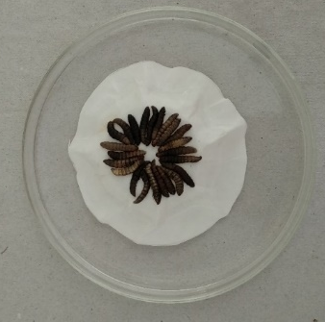
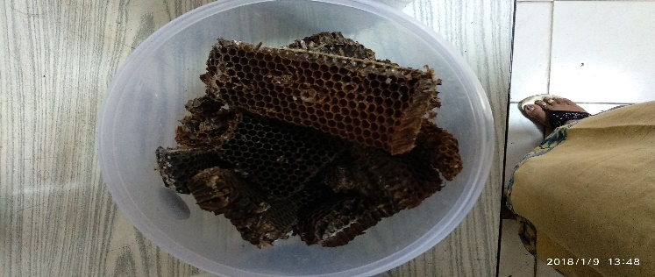
- Infective juveniles emerged into water were collected and stored at 25±2ºc

- Collection, Isolation and identification of native EPN strains from oilseed crop ecosystems
- Soil samples were collected from fields of IIOR. Sample was taken from top 10-20 cm soil.
- Soil samples collected were baited with 4th stage Galleria larvae and were checked every 24 hours for insect mortality. Dead and intact insect cadavers were collected and kept on white’s trap for nematode emergence.
- Total 60 samples were collected and one sample was found positive to EPNs.

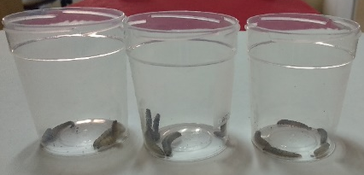
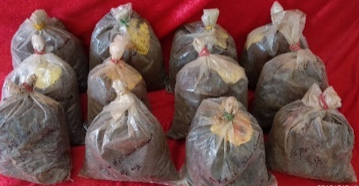

- Testing the virulence of different EPNs on different life stages of S. litura and L. trifolii under lab conditions:
- Three EPN isolates S.carpocapsae, H.indica and IIOR isolate were tested against 2nd 3rd 4th pupal stage of S.litura and pupal stage of L.trifolii.
- Infective juveniles were inoculated @100 ijs per larva/pupa. Mortality was observed from 24 hours post infection.
- Fourth instar larvae of S.litura were found more susceptible when compared to other instars.
- Pupa of S.litura and L.trifolii were not infected by EPNs@100 ijs/pupa.
