K.H. PATIL KRISHI VIGYAN KENDRA, HULKOTI, GADAG DISTRICT, KARNATAKA STATE

FRONTLINE DEMONSTRATION FOR THE YEAR 2015-16

Crop : Safflower Season : Rabi, 2015-16 Farming situation : Rainfed
Variety : PBNS-12 No. of Demonstrations : 20 Village : Hirekoppa
Block : Naragund, District : Gadag Area : 20 Ac

FLD IN SAFFLOWER (2015-16)
Number of farmers : 20 Villages Selected : Hirekoppa Block : Naragund Dist. : Gadag
Sl. No | Farmers’ Name | Yield (Q/ha) |  | Increase in yield %
 |  | Local check | Demo
1 | Vasugouda Venkanagouda Kulkarni | 7.0 | 8.5 | 21.42
2 | Mrs. Shekavva Ramesh Kulkarni | 5.75 | 7.5 | 30.43
3 | Chidanand Gurupadappa Angadi | 6.5 | 8.0 | 23.07
4 | Somalingappa Gurupadappa Angadi | 6.0 | 7.0 | 16.66
5 | Lingaraddi Venkaraddi Jagapur | 5.75 | 6.5 | 13.04
6 | Sangappa Gadigeppa Malladad | 6.5 | 7.75 | 19.23
7 | Hemaraddi Timmaraddi Lingadal | 7.0 | 8.25 | 17.85
8 | Mrs. Neelavva Shiddanagouda Patil | 6.25 | 7.50 | 20.0
9 | Ravindragouda Laxmanagouda Kulkarni | 6.75 | 8.0 | 18.51
10 | Maheshagouda Basavanagouda Yallappagoudar | 5.75 | 7.0 | 21.73
11 | Mrs. Bhuvaneshwari Laxmappa Pujar | 5.50 | 6.75 | 22.72
12 | Yamanappa Hanumappa Talwar | 6.0 | 7.0 | 16.67
13 | Ningappa Shankrappa Meti | 6.75 | 8.0 | 18.51
14 | Sankanagouda Lingabasappa Asuti | 5.75 | 7.0 | 21.73
15 | Shankargoudar Totanagouda Patil | 7.0 | 8.5 | 21.42
16 | Jagadish Venkaradde Lingadal | 7.5 | 9.0 | 20.0
17 | Shivabasappa Mallappa Ramadurga | 6.5 | 7.5 | 15.38
18 | Venkanagouda Ishwargouda Bharamagoudar | 6.75 | 8.0 | 18.51
19 | Venkaraddi Govindaraddi Lingadal | 8.0 | 9.5 | 18.75
20 | Venkappa Govindappa Barker | 6.25 | 7.50 | 20.0
 | Average | 6.46 | 7.73 | 19.66

Yield, Cost of cultivation, gross returns, net returns and BC ratio of safflower FLD conducted by ICAR-K.H. Patil Krishi Vigyan Kendra, Hulkoti, Gadag district, Karnataka State (2015-16)
Sl. No. | Farmers’ Name | Yield q/ha |  | COC (Rs/ha) |  | GROSS RETURNS (Rs/ha) |  | NET RETURNS (Rs/ha) |  | BC RATIO
 |  | DEMO (IT) | Local check (FP) | DEMO (IT) | Local check (FP) | DEMO (IT) | Local check (FP) | DEMO (IT) | Local check (FP) | DEMO (IT) | Local check (FP)
1 | Vasugouda Venkanagouda Kulkarni | 8.5 | 7.0 | 17535 | 16275 | 24650 | 20300 | 7115 | 4025 | 1.41 | 1.24
2 | Mrs. Shekavva Ramesh Kulkarni | 7.5 | 5.75 | 15965 | 14235 | 21750 | 16675 | 5785 | 2440 | 1.36 | 1.17
3 | Chidanand Gurupadappa Angadi | 8.0 | 6.5 | 16430 | 15200 | 23200 | 18850 | 6770 | 3650 | 1.41 | 1.24
4 | Somalingappa Gurupadappa Angadi | 7.0 | 6.0 | 17438 | 16000 | 20300 | 17400 | 2862 | 1400 | 1.16 | 1.08
5 | Lingaraddi Venkaraddi Jagapur | 6.5 | 5.75 | 16850 | 15175 | 18850 | 16675 | 2000 | 1500 | 1.12 | 1.09
6 | Sangappa Gadigeppa Malladad | 7.75 | 6.5 | 16965 | 15845 | 22475 | 18850 | 5510 | 3005 | 1.32 | 1.18
7 | Hemaraddi Timmaraddi Lingadal | 8.25 | 7.0 | 18110 | 17640 | 23925 | 20300 | 5815 | 2660 | 1.32 | 1.15
8 | Mrs. Neelavva Shiddanagouda Patil | 7.50 | 6.25 | 18330 | 17280 | 21750 | 18125 | 3420 | 845 | 1.18 | 1.05
9 | Ravindragouda Laxmanagouda Kulkarni | 8.0 | 6.75 | 17615 | 16315 | 23200 | 19575 | 5585 | 3260 | 1.32 | 1.19
10 | Maheshagouda Basavanagouda Yallappagoudar | 7.0 | 5.75 | 16125 | 15085 | 20300 | 16675 | 4175 | 1590 | 1.25 | 1.10
11 | Mrs. Bhuvaneshwari Laxmappa Pujar | 6.75 | 5.50 | 16200 | 15185 | 19575 | 15950 | 3375 | 765 | 1.20 | 1.05
12 | Yamanappa Hanumappa Talwar | 7.0 | 6.0 | 16625 | 15715 | 20300 | 17400 | 3675 | 1685 | 1.22 | 1.10
13 | Ningappa Shankrappa Meti | 8.0 | 6.75 | 17850 | 16275 | 23200 | 19575 | 5350 | 3300 | 1.29 | 1.20
14 | Sankanagouda Lingabasappa Asuti | 7.0 | 5.75 | 17675 | 16430 | 20300 | 16675 | 2625 | 245 | 1.14 | 1.01
15 | Shankargoudar Totanagouda Patil | 8.5 | 7.0 | 19355 | 18285 | 24650 | 20300 | 5295 | 2015 | 1.27 | 1.11
16 | Jagadish Venkaradde Lingadal | 9.0 | 7.5 | 19715 | 18460 | 26100 | 21750 | 6385 | 3290 | 1.32 | 1.17
17 | Shivabasappa Mallappa Ramadurga | 7.5 | 6.5 | 17920 | 16445 | 21750 | 18850 | 3830 | 2405 | 1.21 | 1.14
18 | Venkanagouda Ishwargouda Bharamagoudar | 8.0 | 6.75 | 17965 | 16395 | 23200 | 19575 | 5235 | 3180 | 1.29 | 1.19
19 | Venkaraddi Govindaraddi Lingadal | 9.5 | 8.0 | 20685 | 19560 | 27550 | 23200 | 6865 | 3640 | 1.33 | 1.18
20 | Venkappa Govindappa Barker | 7.50 | 6.25 | 18125 | 17330 | 21750 | 18125 | 3625 | 795 | 1.20 | 1.04
 | Average | 7.73 | 6.46 | 17674 | 16456 | 22417 | 18734 | 4743 | 2278 | 1.26 | 1.13

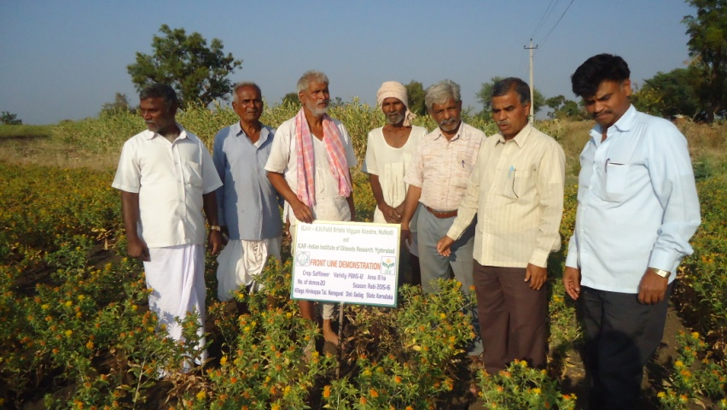
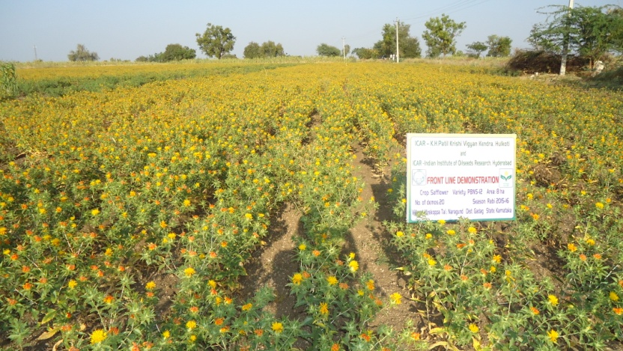
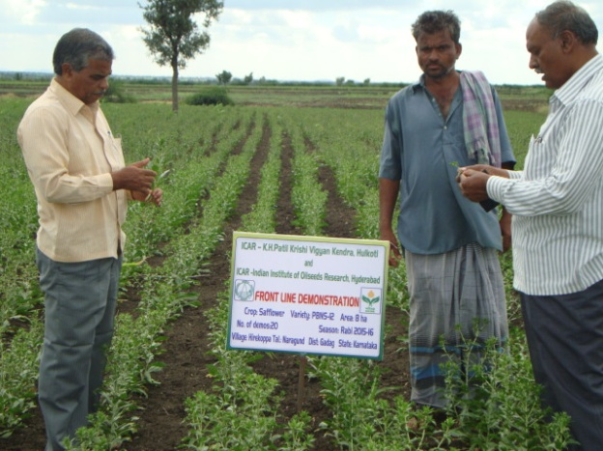
Note: Yields are low due to moisture stress observed during different critical stages of the plant growth.

