Case studies /Success stories
Zone-I

Attractive income from protected cultivation of cut-carnation flower (KVK, Solan)

Shri Vikrant Thakur belonging to Kothi village in Solan Block of Himachal Pradesh is one of the progressive farmers, who cultivated flowers like Rose, Chrysanthemum, Hydrangea, exotic vegetables in his polyhouse in the year 2009 with 300 square meters of area. He faced many difficulties in the initial years with meagre net income but he did not stop. He converted his entire protected area under the cultivation of Carnation (Dianthus caryophyllus L.) with the support of financial institutions under the technical guidance of KVK, Solan in 2013. Now the farmer has 10,000 sq. meter of area under carnation and has become an inspiration for the young farmers that carnation cultivation could also be profitable, if modern technologies like application of GA₃100 ppm after first pinch and when axillary shoots are 8-10 cm in length, drip irrigation, mulches, soilless media, growing bags etc., are adopted. He is producing on an average of 37 lakh cut stems/ ha and earning approximately on an average of 30 lakhs from the cultivation of carnation per year. According to farmer, it is not possible to earn such a handsome return in any other vocation. He has built rain water harvesting structures by making small poly-lining ponds. Now the farmer is self-sufficient and storing 85 lakhs litres of water for the cultivation of flowers in polyhouse. He has permanently employed 15-16 local workers to carry out all the cultural operations in the cultivation of flowers. He has been playing an instrumental role as well as enlightened the path of many youths of the district by setting an example in the protected cultivation of cut flowers – carnation which is one of the most important commercial cut flowers of Solan district of Himachal Pradesh and gained popularity due to its excellent keeping quality, wide array of colours & forms and ability to rehydrate after continuous transportation.

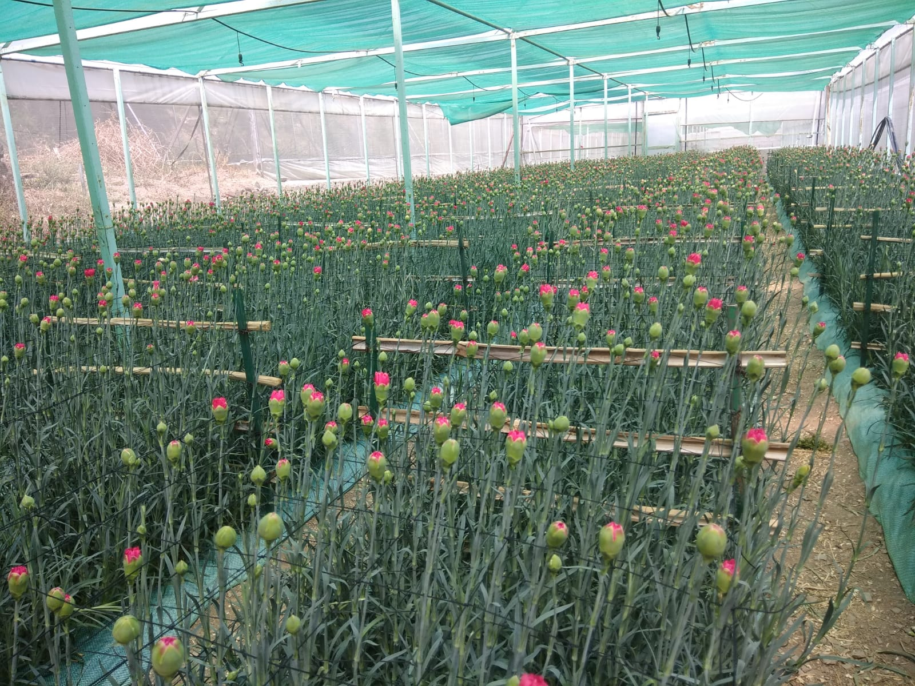
A view of carnation under polyhouse of Shri Vikrant Thakur

Zone-II

Intercropping of ber in date palm: a way forward for doubling of farmers income (KVK, Barmer-II)

Shri Sona Ram, Innovative farmer belonging to Bhedana Village in Gudamalani Tehsil of Barmer District cultivated Date palm variety Barhee in 2016. He planted 208 date palms at spacing row to row 08.00 meter and plant to plant 06.00 meter in one hectare area. He obtained low benefit cost ratio due to high cost of cultivation that compelled him to think of some innovation. Then he took initiative of intercropping technique in date palm plantations with Ber under the technical guidance of KVK, Barmer-II. The additional Ber plants variety gola have been planted in the centre of four date palm plants. He has planted 204 additional Ber plants in intercropping of date palm. The time of flowering and harvesting of date palm are February to March and July to August whereas Ber plants are August to September and December to February, respectively in arid region. The planting of additional Ber plants provides an additional income. Intercropping of Ber has helped farmer to produce higher profit then sole cropping of date palm. He obtained Net returns of Rs. 206855 per hectare and B: C ratio of 2.12 by cultivation of Date palm. Intercropping in Date palm with Ber has provided the farmer additional net returns of Rs. 71240 per hectare and BC ratio of 2.14. The net return of both crops is Rs.278095 per hectare which is significantly higher than the previous practices.

Zone-III
Successful organic farming of tulsi, cheeya, kemuoil, piprata, shatavar (KVK, Mahoba)
Shri Dhwaj Pal Singh, a progressive farmer belonging to Dadri Village in Panwari Block of Mahoba district was involved in traditional agriculture before 2005, which was not much profitable and ultimately, he has decided to convert his agriculture into organic farming and he had interactions with KVK, Mahoba and other officials of agriculture and horticulture department on various aspects of organic farming. Hen he underwent many trainings at KVK, Mahoba on different aspect of organic farming like preparation of vermi and NADEP compost, bio-fertilizers, jeevamrit, panchagvya, bio-pesticide and organic cultivation of cereals, oilseeds, pulses, medicinal and aromatic plants etc. At present, he is growing tulsi/kemuoil /kinnowa/ bhumi aonla/ Chandra surya/ cheeya seeds/ shatavar and hibiscus flower in his 6.8 ha area by adopting organic farming under the technical guidance of KVK Scientists. Shri Dhawaj Pal Singh started organic farming of cereals, oilseeds, pulses, medicinal and aromatic plants etc. as well as encouraging other farmers of the district for the organic cultivation. He has taken advantage of Govt. scheme like Paramparagat Krishi Vikas Yojna, PM Krishi Sinchai Yojna etc., Cluster Frontline Demonstration on oilseeds and pulses from KVK. He has constructed animal shed for stray cattle’s and poultry unit of Kadaknath breed. He is producing 1000qt. of vermi compost for organic cultivation of meditational and aromatic plants on his farm and produced organic tulsi in tonnes, cheeya seed, kemuoil, piprata, shatabar, Chandra surya, pigeon pea, chickpea, mustard and wheat. The annual economical gain in terms of net return has recorded Rs. 4.5 lakh with6.30 BCR. He has PGS organic certification from APEDA. He was awarded by the Organic India Company as Dharti Mitra Award, Krishi Vigyan Kendra, Agriculture and Horticulture Department of Mahoba and UPCAR, Lucknow for his outstanding work done in organic production of various crops and meditational and aromatic plants. Shri Dhwaj Pal Singh is becoming one of the progressive and learned farmers for others with regards to popularization of organic farming in Bundelkhand region through his FPO viz., Bundelkhand Organic Corridor. Organic farming helps him for better livelihood, empowerment and make him enthusiasm regarding farming of other meditational and aromatic plants. He is one of the renowned farmer of the district Mahoba and becoming a part of KVK activities.
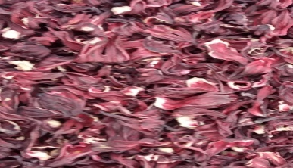 | 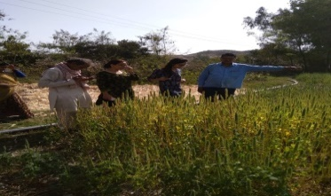 |  | 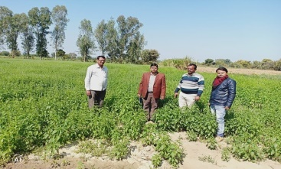
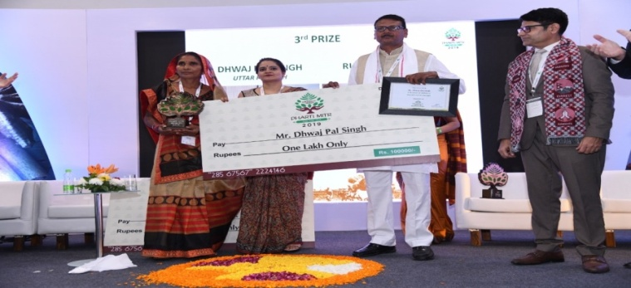 |  | 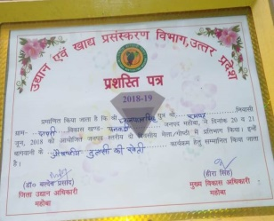

Zone-IV
Duck farming provided lucrative income to a farmer Shri Baijnath Mahto during COVID-19 (KVK, Ramgarh)
Farmers of Ramgarh district, Jharkhand were mainly growing the cereal crops and vegetables. The farmer Sri Baijnath Mahto, Takha, block, Mandu, Ramgarh has started duckery unit under the technical guidance of KVK, Ramgarh. Training and exposure was provided by KVK in the month of January, 2020. He started with 500 breed of Khaki Campbell ducklings which started the egg production from the month of April, 2020 and he received 80-100 eggs per day. Further, he integrated duck farming with fisheries, vegetable cultivation for higher return. For vaccination and diagnostic services, he linked with animal husbandry department, Jharkhand. During COVID-19 period, he lost farm income but he received Rs 72000 income through selling of eggs during the year which was helped his family livelihood.

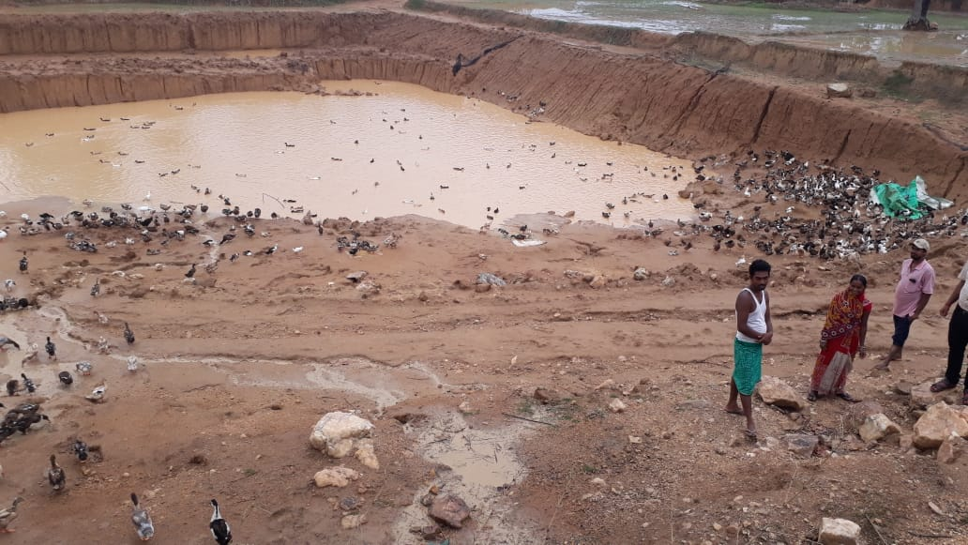 | 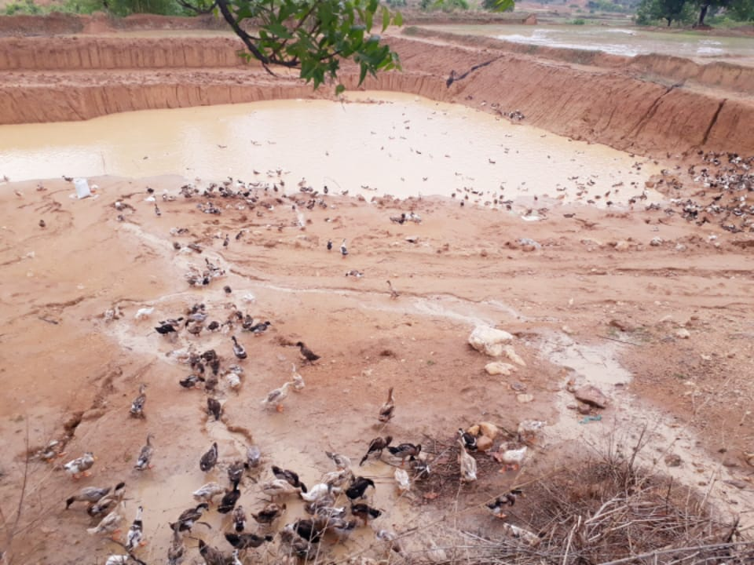

Zone-V

Horticultural Crop Nursery Business for Self-employment in district Nimbudera, Andaman and Nicobar Islands (Nimbudera)

Shri. Om Prakash, a young man, lives in Govindpur village near KVK office in Nimbudera of North and Middle Andaman. He studied up to 10th class. He is the only earning member of his five members family. He has 0.5 ha of agricultural land. In 2018, Shri. Om Prakash approached KVK, Nimbudera for technical guidance and sources of quality planting materials and quality seeds. Further, he attended the training at KVK for learning on scientific nursery management and different plant propagation methods in horticultural crops. Then, he constructed a low-cost shade net and poly house for nurseries (10mx8m) in his farm and purchased various nursery tools and implements. He started plant nursery for the production and supply of ornamental plants for flowering and foliage, vegetable seedlings and superior variety of local fruits. He started nursery by doing grafting in local superior varieties of mangoes, citrus and guava fruits. He also established mother plants of guava, mangoes, sapota and flower plants in his farm. Now he has 10 varieties of local type superior mangos, 4 varieties of citrus fruits, 3 varieties of sapota. Shri Om Prakash is not only practicing different propagation methods but also doing conservation and multiplication of many native flowers, local fruit crops, orchids, ferns and other local ornamental foliage and flowering plants. Besides, he procured some ornamental and good variety of rose plants and started production of flower and ornamental plants and other useful medicinal plants. In 2019, he purchased hybrid seeds of flowering Plants (marigold-inca, petunia, vinca, china aster etc). He is now totally engaged in horticultural crop nursery business and regularly selling various horticultural crop seedlings, plants etc. He benefited net profit of 3.0 lakh from only sale of flowering plants. In 2020, he was able to earn an additional income of Rs.3.5 lakh. The success of Shri. Om Prakash has set an example before the rural youth in the nearby villages for nursery business as a good source of income. Now, Shri. Om Prakash is planning out of aspiration to establish nursery in Port Blair.

Zone-VI

Mushroom as successful enterprise under ARYA in Kokrajhar district of Assam (KVK, Kokrajhar)
KVK developed entrepreneurship in Mushroom production in Rangati village by training 22 youth during 2019-20. On completion of training five youth were selected and provided with inputs for establishing Mushroom production unit. Shri Rajib Baruah is one among them who started his mushroom production unit (Oyster mushroom) with the inputs provided. In first year, he got a production of 7 quintal mushroom which he sold @ Rs.180/ kg. Therefore he could get a return of Rs.1,26,000 . In second year, he got a production of 24 quintal mushroom which he sold @ Rs.200/ kg and got a return of Rs.4,32,000 . He invested his income for increasing the capacity of his unit. In addition to that he also started button mushroom cultivation. He also provides training to local youth as and when needed. Presently 4 youth have got full employment along with particle employment of 15 youths. He has also engaged several youths in his entrepreneurial unit thus providing employment generation. His productions are mostly marketed to nearby state of Arunachal Pradesh as well as within and outside the district and also among the local small entrepreneurs. The mushroom production under ARYA has proved to be a successful enterprise for providing employment opportunity to the rural youth of the district. From the mushroom enterprise, a net profit of approximately Rs. 1,00,000/- was realised by the farmer within eight months’ time.

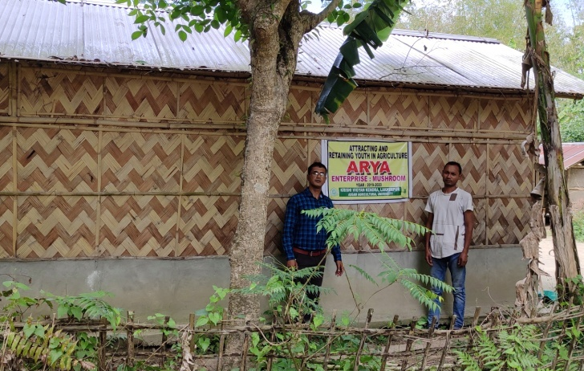 | 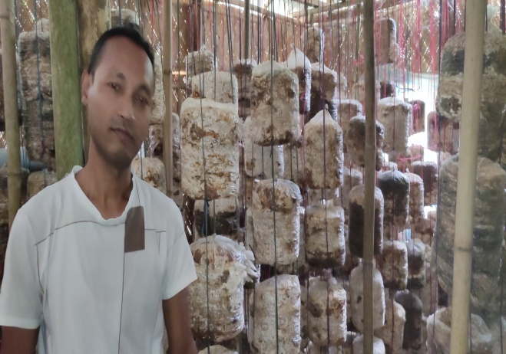
Establishing the Entrepreneurial units of mushroom | Mushroom at blooming stage

Zone-VII

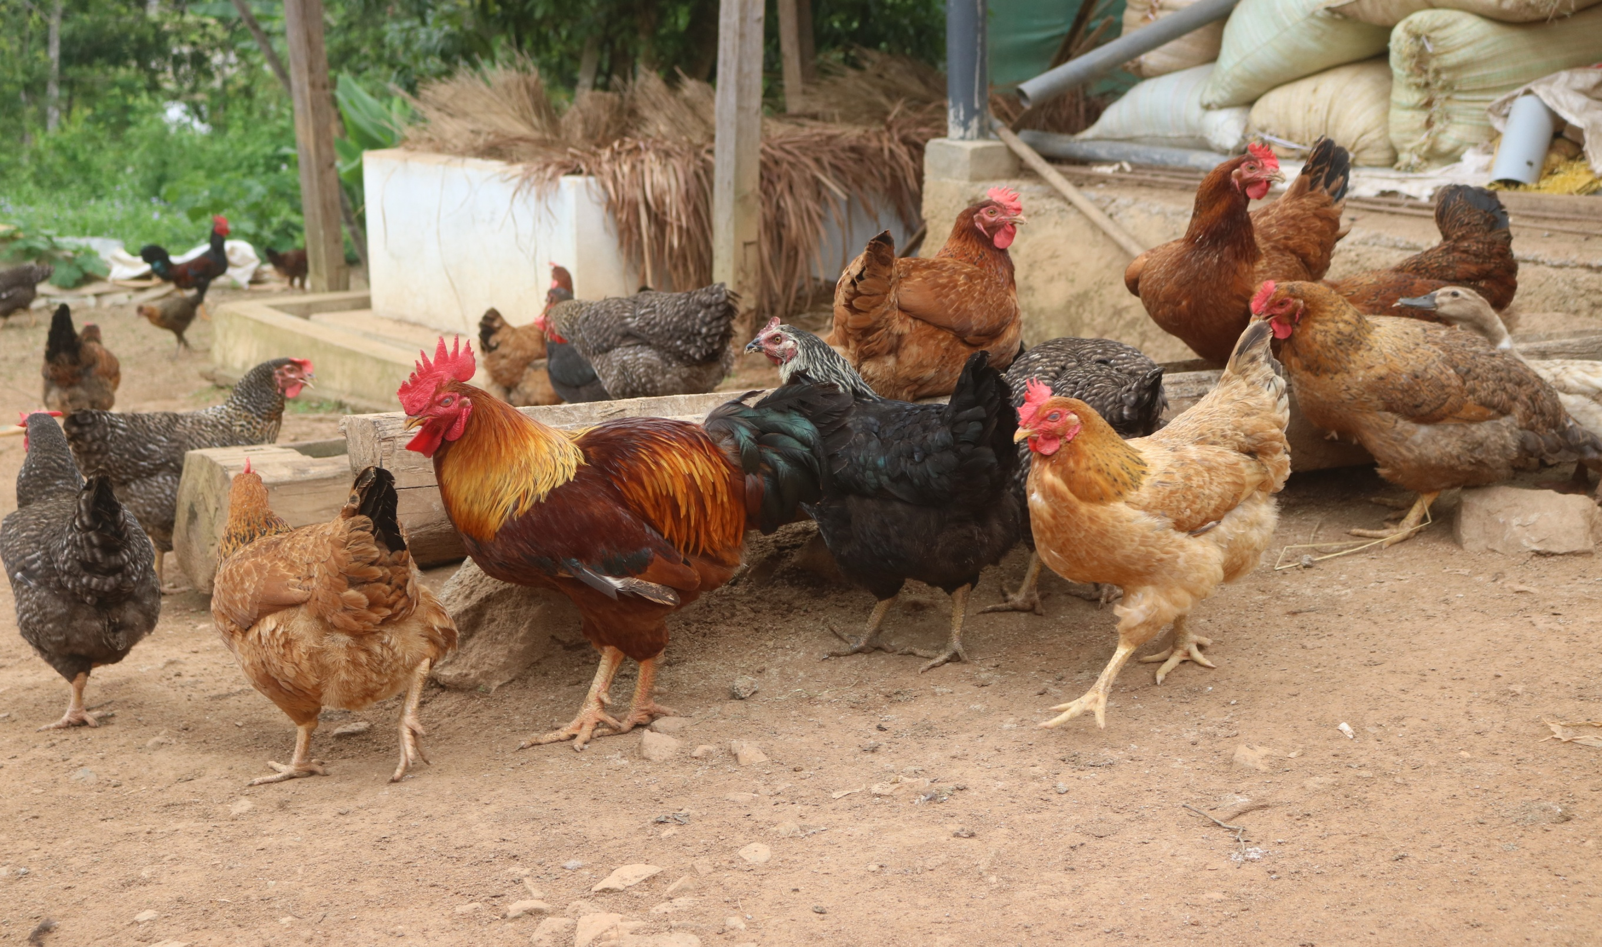
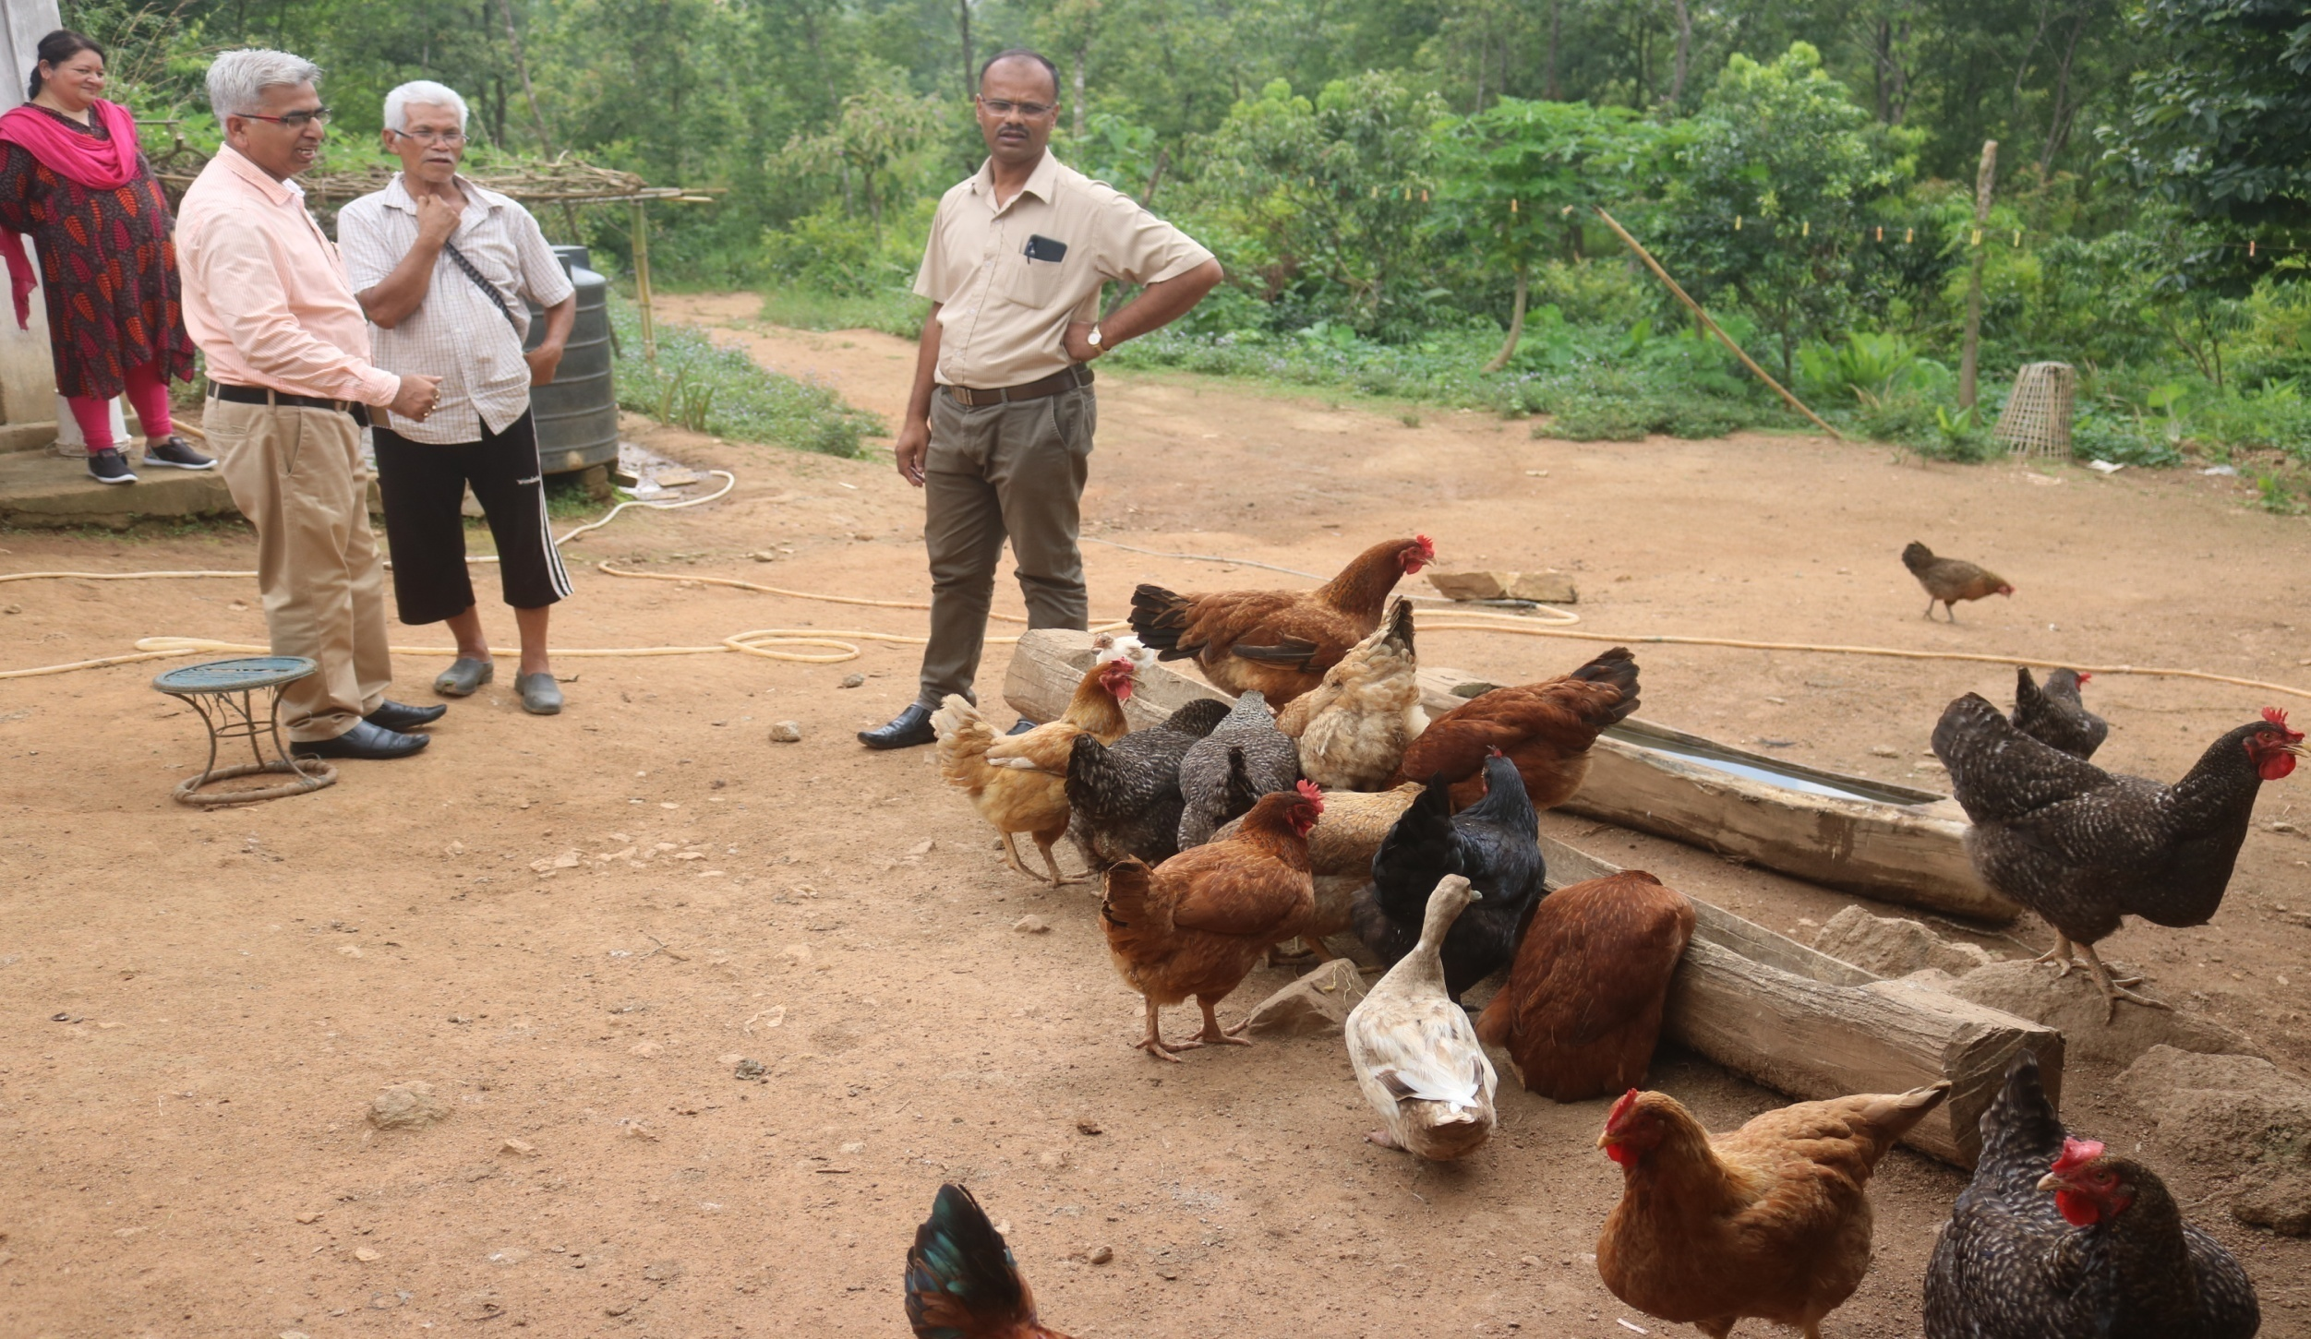
Innovative micro-integrated farming system model (Ri-Bhoi)
IFS is an interdependent, interrelated often interlocking production systems based on few crops, animals and related subsidiary enterprises in such a way that maximize the utilization of resources of each system and minimize the negative effect of enterprises on environment. But the land terrain of Meghalaya hilly regions does not give advantage to the farmers to conquer the idea in large scale. Mrs. Valarie Maring from NICRA village Kyrdem along with KVK Ri-Bhoi has developed a Micro-Integrated Farming System model by utilizing her jalkund, poultry unit and high tech polyhouse to an economically viable innovative model. She established a jalkund unit of size 5x4x2 cu. ft. with a capacity of 40,000 litres of water by lining the jalkund with HDPE 1000 ų for effective storage of rainwater during kharif season followed by release of 100 fish fingerlings of Indian Major Carp into the jalkund unit, construction of poultry shed nearby with 40 numbers of dual purpose Vanaraja breed of poultry which act as a source of nutrients and biomass for fish helps in growth of phytoplankton and zooplankton apart from giving additional income from meat and eggs and establishment of a high tech polyhouse in convergence with District Horticulture Office, Nongpoh for growing of cut flowers gerbera which has an advantageous output in the tribal areas of Ri-Bhoi district. From this micro-integrated farming system model, she could earn a net income of Rs.89410 per year of which Rs.20400 from poultry meat, Rs.22300 from poultry eggs, Rs.4870 from fish, and Rs.41840 from Gerbera. So far this unit was exposed to 112 farmer visitors, 3 SHGs/ FPOs formed through the initiative of the farmer, 30 Entrepreneurs developed from the initiative and inspired other farmers as strategy for doubling their income. The result of the activities mutually complimenting components of micro-integrated farming system by mitigating its negative environmental effect through proper recycling of nutrients and resources.

Zone-VIII

Rural Women became ‘Atma nirbhar’ through Secondary Agriculture (KVK, Ratnagiri)
Mrs Harshada Rajendra Palaye, 38 years old woman and a resident of Kondye village in Lanja Tehsil of Ratnagiri district had involved in family farming. She has an operational land holding of 4 ha. She was cultivating subsistence crops like rice, finger millet, horse gram etc. in the traditional way. Her farm income was very limited due to lack of knowledge and skill about improved agricultural technologies. The leaflet on “vermicompost in enhancing crop productivity” prepared by KVK Ratnagiri made her curious about this technology. She reached to KVK and attended five days vocational training on vermicompost production at KVK Ratnagiri. Subsequently she attended training on Nursery Management. She establishe vermicompost unit under the technical guidance of KVK by availing subsidy of Rs. 30,000/- for construction of shed (15x10m) in the year 2010 from the Department of Agriculture, Government of Maharashtra. KVK also provided vermiculture of Eisenia Fetida sp. for demonstration. The capacity building programme and institutional linkages by KVK helped her to build confidence in agribusiness start-up. She started ornamental, fruit and forest crop nursery along with the vermicompost production. The KVK, Ratnagiri has helped to certify the mother orchards of fruit crops and getting a license. Dr. B.S. Konkan Krishi Vidyapeeth, Dapoli certified the mother orchards. The Department of Agriculture registered the nursery and issued the license.
At first she prepared vermi-compost of 5-6 tons and sold it at nearby villages. Approximately, she earned Rs. 45000-50000 from this small-scale activity. After reaping an economic benefit, she felt that there is a huge demand for vermicompost due to awareness of organic farming in farming community. Therefore, she decided to expand her small-scale activity into a commercial business venture. She joined a Self-Help Group named-Shri. Samarth Shetkari Swayamsahata Gat consisting of five male and five female farmers. She sold vermicompost under trade name of this Self-Help Group. The vermicompost prepared by this group is available in 1 Kg, 5 Kg, 10 Kg and 40 Kg polybags. She used to take part in conferences and exhibitions organized by different agencies at district places and cities like Mumbai and Pune for publicity. Now, Shri. Samarth Vermicompost became a brand name among the farming community in the Konkan region. At present, she reached to the production capacity of more than 100 tonnes per year. On an around, she has a turnover of Rs. 12-13 lakhs per year out of this business venture. Year-round, she employed 7-8 people in Kondye village.
After getting a grand success in vermicompost production, Mrs. Harshada moved to the idea of the ornamental nursery. Vermicompost is the main media for growing ornamental plants and the other reason behind starting ornamental nursery was the demand of ornamental plants in Mumbai for terrace gardening. Considering this opportunity, she has started ornamental, fruit and forest crop nursery. In the beginning, she prepared 1000 vegetable seedlings and sold it out in the weekly market. After getting confidence, she constructed polytonal for preparation of grafts. Since last 3-4 years, she is producing about 10,000 grafts of cashew (Var. Vengule-4), 4000 of Mango (Var. Kesar & Alphonso), 1000 Coconut (Var. Banavali) and 500 Kokum fruits crops. Addition to this, she is preparing about 2000 rose and 5000 Sonchaffa grafts and around 30,000 agroforestry crops viz. teak, Khair, sandalwood, bamboo, Acacia mangium, Aonla and Gulmohar (Delonix regia). She is selling these grafts and seedlings under the same trade name of Shri. Samarth Shetkari Nursery in entire Konkan as well as in western Maharashtra.
Mrs Harshada Palaye, ensured economic stability to her family. Every year, her financial turnover is Rs. 13.50 lakh from vermicompost units and Rs. 19.75 lakh from the nursery unit. The net profit from vermi-compost is Rs. 6 lakh and Rs. 8.4 lakh from the nursery management. She is gaining profit of Rs. 14.04 lakh per year for her family. She is an idol of agribusiness start-up but motivation, inspiration and contribution of her husband are also appreciable. She has not only made her family a self-reliant but also provided assured employment for 10-12 persons throughout the year. Every employee is getting salary of around Rs. 7 to 8 thousand per month. Considering her contribution, Mrs Harshda Palaye and her SHGs has bestowed with ‘Sevavrati Shinde Guruji Smruti Purskar (2019-20)’ from Kunabi Seva Sangh, Dapoli- a NGO and ‘Best Women Farmer Award’ from NGO-Late Tatya Deshmukh Shetinitha Sanstha, Lanja Dist: Ratnagiri.
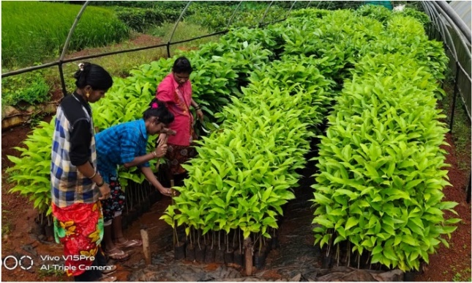 | 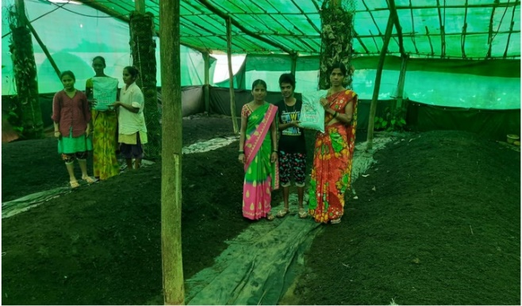

Zone-IX

Dragon Fruit Farming - An Innovative Business in Bastar district , Chhattisgarh (KVK, Bastar)
Mr. Rohit Chavda, a Farmer belonging to Pandanar village in Bakwand block of Bastar district has started dragon fruit cultivation as an innovative agribusiness in the year 2018 along with his father Mr. Bharat Chavda on a commercial scale under the technical guidance of the Krishi Vigyan Kendra, Bastar. The farmer has started cultivating it in his 7 acres of land, in which the profit starts to accrue from the second working year of the crop on the basis of cost. KVK intervention Provided the information regarding profit, availability of plants for cultivation of dragon fruit, Information for propagation and planting technique of dragon fruit and Marketing linkage for sale of the cultivated fruit. Presently, the value of its fruit is easily available from Rs.120 to 150 per kg, resulting in a net income of Rs.1125000 /ha. Since the increase in production every year with time, in the fourth phase i.e., after four years, this net income will increase to Rs.3225000/. Thus, the farmer will continue to receive this income regularly and create awareness about the income generating fruit cultivation technology and availability of nutritious fruits at local market at reasonable price.

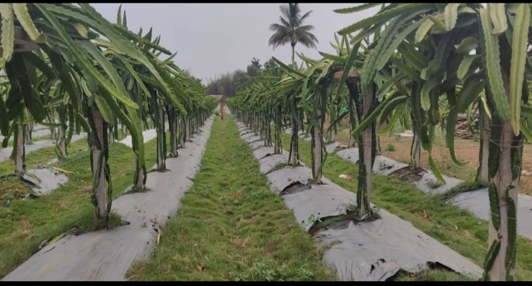 | 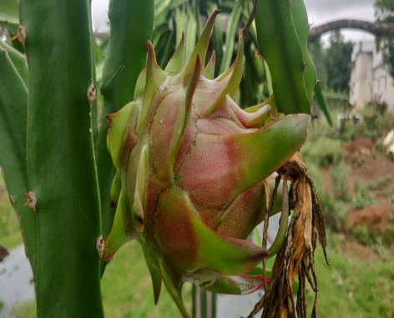 | 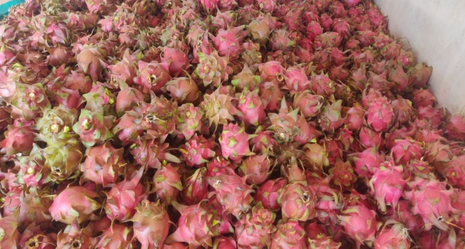

Zone-X

A case study of profitable crop sequence followed by a woman rice farmer in Khamman district of Telangana (Khammam (Wyra ))
)Mrs. Ch. Ramulamma, a woman farmer from Khammam district of Telangana has been cultivating ricefor many years and was not able to gain sufficient income for their livelihood because of the fluctuations in market price, natural disasters that occurred during the crop period, problems with pests and disease that are on the rise and scarcity of labour which is affecting the timely operations in the crop. Under the technical guidance of Scientists from KVK, Khammam (Wyra ), she adopted crop sequence and latest production technologies. She followed direct sowing in rice that helped her to overcome the labour shortage and also to get the produce 10 days earlier compared to traditional practice. This could further helped her to sow maize crop at correct time by practicing zero tillage in maize. From 3 acres of land, she obtained 3000 kg of paddy per acre and earned gross returns of Rs. 1.63 Lakhs with a net profit of Rs. 28,450 and B:C ratio of 2.10:1 during Kharif 2019-20 followed by she realized highest yield of about 50 quintals/acre of maize and got gross returns of Rs.88,000/- with a net profit of Rs.64,500/-per acre and from overall two acres, she realized gross returns of Rs. 1.76 lakhs. In the remaining one acre of land, she had grown sesame crop and achieved an yield of 3 quintals and earned a net profit of Rs. 16,000. Thus, she used land effectively by cultivating three crops and innovatively adopting the cost reducing technologies like direct seeding and zero tillage for paddy and maize, thus setting an example to fellow farmers in adoption of labour reducing and cost reducing technologies. Mrs. Ramulamma received appreciation certificate from Professor Jayashankar Telangana State Agricultural University, Rajendranagar, Hyderabad on 5th University Foundation Day.

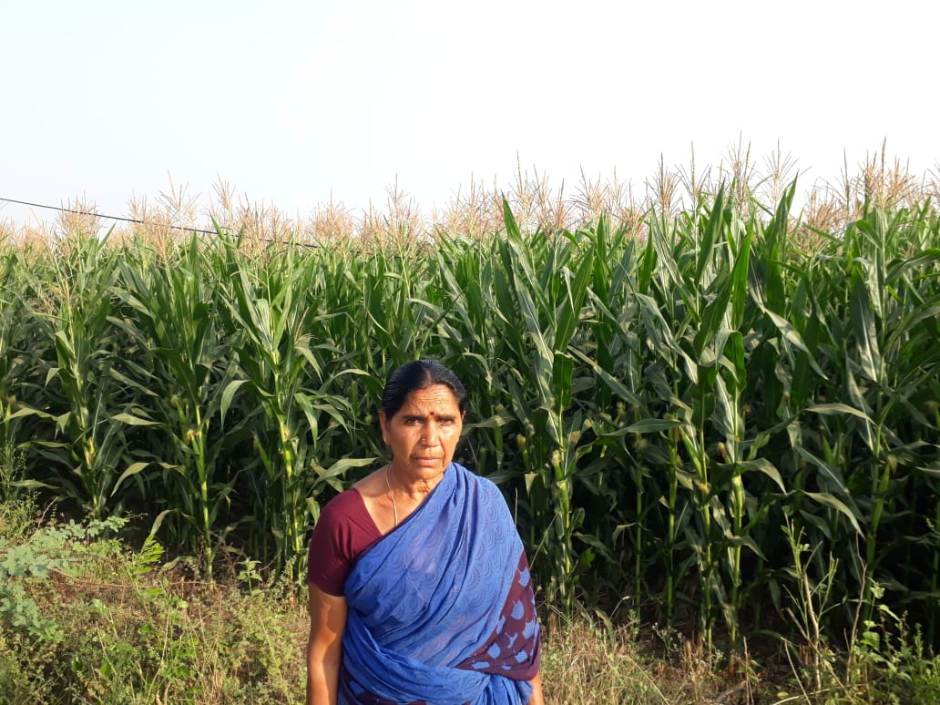
Zero tilled maize field of Mrs. Ramulamma- Khammam , Telangana

Zone-XI

Dsb-21 - a new Soybean variety disseminated (KVK, Belgavi-II)

Bailhongal taluk is known for the production of soybean. Majority of the farmers are cultivating JS-335 variety of soybean which is prone to pod shattering and susceptible to rust. Realizing the gravity of the problem, KVK has demonstrated new variety Dsb-21 which is resistant to rust and tolerant to pod shattering at Chikkabagewadi, Mattikopp, Sampagaon and Deshanur villages of Bailhongal taluk by involving 160 farmers covering of 67.40 ha along with participatory seed production. KVK imparted training to the farmers on seed treatment with bio-fertilizers, agronomic practices like weed and water management, nutrient management through foliar application macro and micro nutrients, environment friendly and cost effective plant protection measures. Year-wise area expansion of soybean variety Dsb-21 in Belagavi is presented in Fig.1. Area expansion of 650 ha with Dsb-21 resulted in production of 13000 q and increase in productivity from 15-20 q/ha. The total additional returns gained is Rs. 1.20 crores due to varietal replacement.

Year-wise area expansion of soybean variety Dsb-21 in Belagavi district
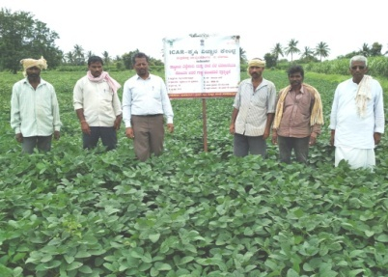 | 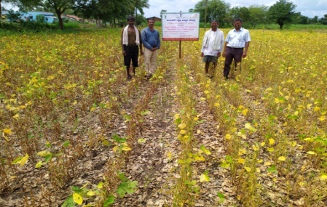
A view of field performance of soybean variety Dsb-21

