Success stories: ICAR-ATARI, Zone-XI, Bengaluru

Value addition in Fig made successful during COVID-19 (KVK, Ballari)

A simple but an effective intervention by KVK, Ballari to convert the artificial glut of fig to its value added product helped farm women of Ballari to script a defining success story that has now caught the eye of many in the state.

Fig is one among the major crops grown in Ballari district of Kalyana-Karnataka. ‘Ballari red’, a locally grown fig variety is one among few varieties grown in India and has high demand because of its good quality, sweetness and color compared to other varieties and is produced throughout the year. Ballari red covers 1800 hectares of farming land in the district. Chennai and Bengaluru are two major markets for Ballari figs. The crisis of COVID-19 lockdown led to a break in supply chain for raw figs as Chennai and Bengaluru witnessed a surge in COVID-19 cases. There was a sudden drop in demand as transport of agricultural produce came to a standstill. As fig has a very short shelf life, it was left un-harvested on the fields as farmers thought that it would burden them further with additional labour cost for picking of fruits. Small holder fig farmers are the most affected among all.

KVK, Ballari has responded quickly to this unprecedented situation in a war footing manner. The proven technology developed by Department of Processing and Food Engineering from UAS, Raichur which was refined to suit the local need was disseminated to the farm women of Shrinivas camp of Kurugodu taluk in Ballari district where the figs are grown extensively. Further, KVK efforts on conducting on line Trainings, online advisories followed by field visits and demonstrations to the farm women amid COVID-19 situations led fruitful results. Self Help Group (SHG) leaders Mrs.Sudha and Mrs.Pooja made efforts to learn the UAS, Raichur recommended post harvesting technology for figs. Enticing fig bar and fig rolls were the outcome of the technology disseminated by KVK. Once the art of making fig bars and rolls was mastered, the samples were sent to Pesticide Residue and Food Quality Analysis Laboratory (PRFQAL), UAS, Raichur for testing its quality parameters. FSSAI licences were got upon meeting the required quality parameters. Branding and labelling were done to get a bigger market share. As unlock of restrictions of COVID-19 lockdown started, solar tunnel dryers and tray dryers were setup to increase the productivity and hygiene in the existing process. One solar tunnel dryer can dry 300 kgs of pulp which yields 100 kg of fig rolls each day, which is three times the outcome that was got earlier by sun drying process practiced during lockdown. A group of youngsters have installed 14 solar tunnel dryers and other required machinery to increase the productivity and meet the market demand of fig rolls. With the market intelligence that they have gained, they are planning to produce 15-20 quintals of fig rolls each day by employing 60 women labours.

Under Prime Minister’s Formalisation of Micro Enterprises (PM FME)-‘One District One Product’ (ODOP) scheme, fig is identified as potential crop for Ballari district. KVK, Ballari arranged a platform for an interaction with the expert advisors of PM FME scheme with these farm women to provide all possible support in the right direction. NABARD is also extending its helping hand to put up a rural mart at Ballari city for expanding their market. Recently NABARD has sent these women to participate in ‘Grameena Habba’ held at Mantri mall in Bengaluru between, 22-26 February, 2021.

KVK established a link between these farmers and Department Horticulture, Ballari. Now, with the help of the Horticulture department progressive farmers have installed Solar Tunnel Dryers for making the value added products. Director of Horticulture department, Karnataka and District collector of Ballari, CEO of Zilla Panchayt, Joint Director of Small Scale industries have made visits to these value addition units and have given the hope to expand their activities.

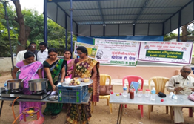 | 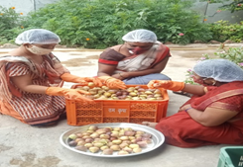
Training on fig value addition by KVK | Grading and cleaning of fig fruits
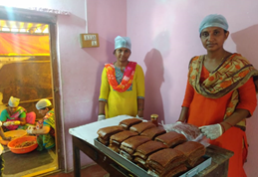 | 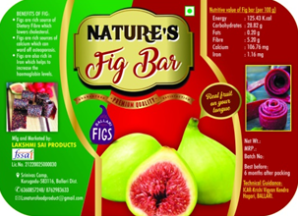
A view of Fig value added product | A view of label of fig bar of an enterprise

Dsb-21 - a new Soybean variety disseminated (KVK, Belgavi-II)

Bailhongal taluk is known for the production of soybean. Majority of the farmers are cultivating JS-335 variety of soybean which is prone to pod shattering and susceptible to rust. Realizing the gravity of the problem, KVK has demonstrated new variety Dsb-21 which is resistant to rust and tolerant to pod shattering at Chikkabagewadi, Mattikopp, Sampagaon and Deshanur villages of Bailhongal taluk by involving 160 farmers covering of 67.40 ha along with participatory seed production. KVK imparted training to the farmers on seed treatment with bio-fertilizers, agronomic practices like weed and water management, nutrient management through foliar application macro and micro nutrients, environment friendly and cost effective plant protection measures. Year-wise area expansion of soybean variety Dsb-21 in Belagavi is presented in Fig.1. Area expansion of 650 ha with Dsb-21 resulted in production of 13000 q and increase in productivity from 15-20 q/ha. The total additional returns gained is Rs. 1.20 crores due to varietal replacement.

Year-wise area expansion of soybean variety Dsb-21 in Belagavi district
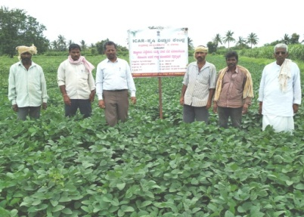 | 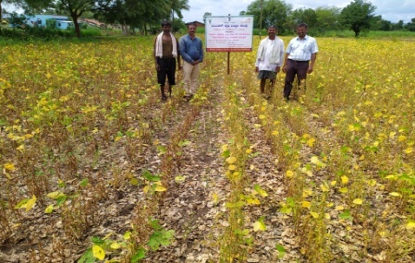
A view of field performance of soybean variety Dsb-21

Farmer participatory Pearl spot seed production and supply (KVK, Ernakulam)

Etroplussuratensis is an indigenous fish endemic to east and south-west coasts of peninsular India and Sri Lanka and is popularly known as Pearl spot in Kerala. Pearl spot is also treated as the most popular and premium variety fish in Kerala southern coastal state of India. The government of Kerala declared Pearl spot as “State Fish of Kerala” and celebrated the year 2010-2011 as the “The Year of “Pearl spot” for creating awareness about the need of Pearl spot conservation and its commercial production potential in the State. Pearl spot is heterosexual, monogamous, gonochoristic and perform external fertilization. Higher consumer demand, price and less availability of Pearl spot directed many of the brackish water fish farmers to commence Pearl spot farming extensively in brackish water ponds and cages using the wild caught fish seeds. The seeds required for Pearl spot fish farming are collected by the inland fisher folk by illegal and unscientific ways. Continuous seed collection from the wild slowly reduced the standing stock of Pearl spot in natural water bodies. Apart from this activity, wetland reclamation, unscientific sand mining, indiscriminate dredging for sub soil lime shell deposits, unscientific fishing practices, pollution, etc., also paved way to destroy the natural breeding ground of Pearl spot and thereby reduced Pearl spots natural availability in backwaters.

Even though Pearl spot possess high price and market demand one of the main issues faced by the Pearl spot farmers are the lack of availability of good quality seeds for commence farming. Massive seed production is the only viable way to meet the ever-increasing demand for Pearl spot seed in India. Even though several attempts have been done by different institutes and researchers hitherto no commercial success was noticed in the massive seed production under hatchery-based method. Main issues reported for seed production in hatchery-based methods are low fecundity rate (780 to 3000), less response to induced breeding method, lengthy larvae rearing period (90 to 120 days) and high cost of production. In this context a farmer participatory seed production has been conducted and attained large-scale seed production of Pearl spot utilizing brackish water ponds by KVK, Ernakulum. In these efforts, KVK trained and equipped the farmers do Pearl spot seed production in BW ponds. The programme covered pond preparation, brood stock selection, breeding, feeding, seed collection, packing and transportation and marketing. Pearl spot seed production technology transfer and technical backstopping from pond selection till harvesting was done by KVK. Annual net income from single (50 cent) seed production unit is 2 lakh. KVK supplied 1.75 lakhs seeds of worth 17.5 Lakh produced by 8 farmers during 2020-21 period. Thereafter, KVK made buy back arrangement from the successful farmers and supplied through KVKs farm store. Seeing the technical viability of the programme 12 more farmers came forward and commenced the programme in Karumaloor Panchayath area alone. Unemployed youth are attracted with the programme as it provides ensured income from unit area.

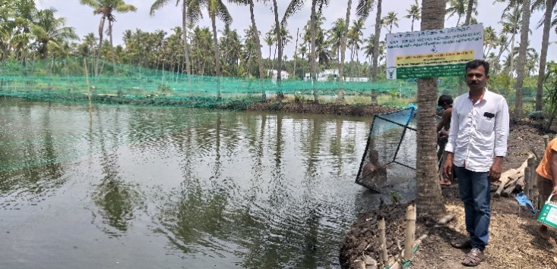 | 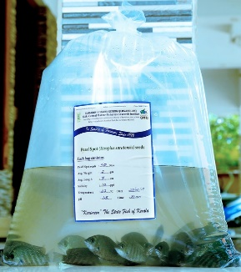
Pearl spot seed production unit of Mr. Ullas A.R, Karumaloor, Ernakulam | Pearlspot seed packed for supply
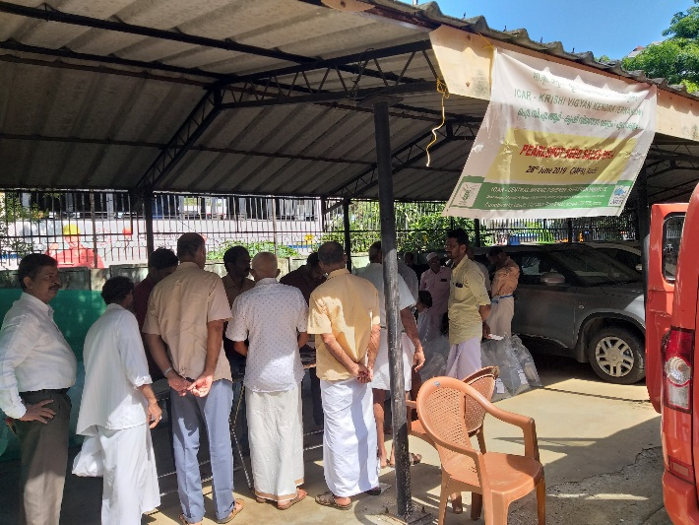 | 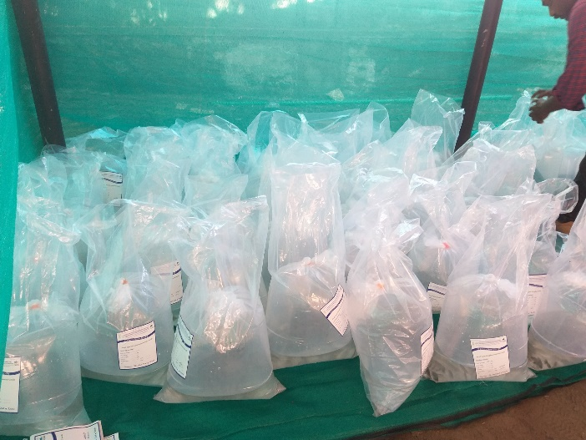
Pearlspot seed supply at KVK Farmstore, CMFRI | Pearlspot seed packed in different salinities for supply

-:O:-

