KRISHI VIGYAN KENDRA, IDUKKI

ANNUAL REPORT- 2021

(FOR THE PERIOD FROM 01 January, 2021 TO 31 December, 2021

ICAR – Krishi Vigyan Kendra,
Bapooji Sevak Samaj,
Pethotty P.O., Santhanpara,
Idukki (Dt.), Pin-685619, Kerala.
Phone: 04868 – 247541, 247715.
E-mail: kvk.Idukki@icar.gov.in, kvksanthanpara@gmail.com
Website URL: www.kvkidukki.org

GENERAL INSTRUCTIONS

Please read the following instructions very carefully before starting preparation of the report.

- Annual report is the most important document for the KVK and it directly reflects the overall achievements pertaining to the reported period. Hence due care needs to be given by each KVK while preparing the report.

- Period of Report is from 01 January, 2021 to 31 December, 2021.

- Action photographs with relevant captions covering all OFTS/FLDS/TRAINING/EXTENSION activities of the KVK in High resolution should be submitted separately in a CD/DVD along with this report. A part from this, soft copy of the activity wise photos may be submitted in JPEG format.

- Prepare Summary tables carefully tallying with the relevant portions of the main report on all aspects.

- Retain the blank column and rows as such and do not merge the cells. Please specify NIL, wherever not applicable or details are not available.

- Check the names of varieties and hybrids and specify in the report.

- Check the units and totals of each data table.

- Extension activity under celebrations for each important day, please insert separate rows and give appropriate data separately. Clubbing of data should be avoided.

- Success stories/case studies should be supported with data tables and graphs. Without photos success stories will not be considered for inclusion in Annual Report of ATARI.

PART I - GENERALINFORMATION ABOUT THE KVK

1.1. Name and address of KVK withphone, fax and e-mail
KVK Address | Telephone |  | E mail | Web Address
ICAR - KrishiVigyan Kendra, BapoojiSevakSamaj, Pethotty P.O., Santhanpara, Idukki (Dt.), Pin-685619, Kerala. | Office  04868 – 247541,  247715. | Fax  Nil | kvk.Idukki@icar.gov.in | www.kvkidukki.org

1.2. Name and address of host organization with phone, fax and e-mail
Address | Telephone |  | E mail | Web Address
 | Office | Fax
BapoojiSevakSamaj,  Kakkattu, Meenadom P.O.,  Pampady, Kottayam (Dt.),  Pin-686 516, Kerala. | 0481-2506271  +91 9446826019 | 04868-247048 | bkvkchairperson@gmail.com | www.kvkidukki.org

1.3. Name of the Programme Coordinator with phone & mobile No.
Name | Telephone / Contact
 | Residence | Mobile | Email
Dr. R. Marimuthu, Senior Scientist& Head | - | 8157895397 | kvksanthanpara@gmail.com

1.4. Year of sanction:1995

1.5. Staff position as on 31 December 2021
Sl.  No. | Sanctioned post | Name of the incumbent | Designation | M/F | Discipline | Highest Qualification  (for PC, SMS and Prog. Asstt.) | Pay  Scale | Basic pay | Date of joining KVK | Permanent  /Temporary | Category (SC/ST/  OBC/  Others)
1 | Head/Senior Scientist | Dr. R. Marimuthu | Senior Scientist& Head | M | Agronomy | Doctorate in Agriculture - Agronomy | 37400-67000 | 50720 | 17-01-2019 | Permanent | OBC
2 | Scientist/SMS | Dr. S. Jayababu | Subject Matter Specialist | M | Animal Science | B.V. Sc. & AH | 15600-39100 | 21000 | 19-06-1995 | Permanent | Others
3 | Scientist/SMS | Manju Jincy Varghese | Subject Matter Specialist | F | Soil Science | M.Sc. Agriculture (Soil Science) | 15600-39100 | 21000 | 10-01-2011 | Permanent | Others
4 | Scientist/SMS | K. Arunkumar | Subject Matter Specialist | M | Horticulture | Msc. Horticulture  (Plantation, Spices, Medicinal and Aromatic crops) | 15600-39100 | 21000 | 25-10-2021 | Permanent | OBC
5 | Scientist/SMS | Sudhakar Soundarajan | Subject Matter Specialist | M | Plant Protection | M.Sc. Agricultural Entomology, MBA | 15600-39100 | 21000 | 27-01-2011 | Permanent | OBC
6 | Scientist/SMS | Ashiba A | Subject Matter Specialist | F | Agronomy | M.Sc. Agronomy | 15600-39100 | 21000 | 07-01-2019 | Permanent | OBC
7 | Scientist/SMS | Preethu K. Paul | Subject Matter Specialist | F | Agri. Extension | M.Sc. Agricultural Extension | 15600-39100 | 21000 | 07-01-2019 | Permanent | Others
8 | Programme Assistant | Vacant | Programme Assistant | F | Vacant | - | 9300-34800 | 13500 | - | - | -
9 | Programme Assistant (Computer) | Biju Narayanan | Programme Assistant | M | Computer Application | M.C.A., PGDCA | 9300-34800 | 13500 | 01-10-2007 | Permanent | OBC
10 | Programme Assistant | Rachel Skariakutty | Programme Assistant | F | Rural Craft | M.A. Sociology (P.G. Diploma in Rural Development) | 9300-34800 | 13500 | 05-06-1995 | Permanent | Others
11 | Assistant | Shaji. K. Kakkattu | Assistant | M | - | - | 9300-34800 | 13500 | 05-06-1995 | Permanent | Others
12 | Jr. Stenographer | Daisy Daniel | Jr. Stenographer | F | - | - | 5200-20200 | 7100 | 05-06-1995 | Permanent | Others
13 | Driver - 1 | P. Nandagopal | Driver | M | - | - | 5200-20200 | 7200 | 05-06-1995 | Permanent | OBC
14 | Driver - 2 | Ayans K Shibu | Driver | - | - | - | 5200-20200 | 7200 | 25-10-2021 | - | OBC
15 | SS-1 | P. Sabu | Skilled Supporting Staff-1 | M | - | - | 5200-20200 | 7000 | 05-06-1995 | Permanent | Others
16 | SS-2 | K.T. Mathew | Skilled Supporting Staff-2 | M | - | - | 5200-20200 | 7000 | 05-06-1995 | Permanent | Others

1.6. Total land with KVK (in ha): 3.24 ha

S. No. | Item | Area (ha)
1 | Under Buildings | 0.075 ha
2. | Under Demonstration Units | 0.087 ha
3. | Under Crops | 2.06 ha
4. | Orchard/Agro-forestry | 0.0 ha
5. | Others | 1.01 ha

1.7. Infrastructural Development:

A) Buildings
S.  No. | Name of building | Source of  funding | Stage
 |  |  | Complete |  |  | Incomplete
 |  |  | Completion  Date | Plinth area (Sq.m) | Expenditure (Rs.) | Starting Date | Plinth area  (Sq.m) | Status of construction
1. | Administrative  Building | ICAR | 2002 | 740 | 47,85,208.10 | - | - | -
2. | Farmers Hostel | NA | - | - | - | - | - | Master Plan & Estimate submitted. Sanction pending.
3. | Staff Quarters | NA | - | - | - | - | - | -
 | 1
 | 2
 | 3
 | 4
 | 5
 | 6
4. | Demonstration Units
 | 1. Duck cum fish culture unit. | RF | 2009 | 50 | 7,000.00 | - | - | -
 | 2. Mushroom unit | Grama Panchayath, Santhanpara | 2002 | 10 | 85,000.00 | - | - | -
 | 3. Spawn production unit | SHM | 2009 | 10 | 3,00,000.00 | - | - | -
 | 4. Mist Chamber | SHM | 2009 | 96 | 2,72,832.00 | - | - | -
 | 5. Rain Shelter | SHM | 2009 | 50 | 1,04,091.00 | - | - | -
 | 6. Bio-Hub | State Planning Board | 2014 | 65 | 1,50,000.00 | - | - | -
 | 7. Karshaka Seva Kendram | Department of Agriculture –Vegetable Scheme | 2015 | 100 | 3,58,000.00 | - | - | -
 | 8. Pheromone Trap Production Unit | RF | 2014 | 10 | 65,000.00 | - | - | -
 | 9. Pseudomonas Production Unit | Department of Agriculture –Vegetable Scheme | 2015 | 25 | 50,000.00 | - | - | -
 | 10. Trichoderma Production Unit | Department of Agriculture –Vegetable Scheme | 2015 | 25 | 50,000.00 | - | - | -
 | 11. EPN Production Unit | Department of Agriculture –Vegetable Scheme | 2015 | 25 | 70,000.00 | - | - | -
 | 12. Low cost mass multiplication centre | Department of Agriculture | 2018 | 25 | 20,000.00 | - | - | -
 | 13. Low cost VAM production Unit | Department of Agriculture | 2018 | 10 | 20,000.00 | - | - | -
5 | Vermicompost | RF | 2018 | 10 | 20,000.00 | - | - | -
6 | Fencing | NA | - | - | - | - | - | Urgent requirement as the area is constantly facing intuition of wild animals and other intruders
7 | Rain Water harvesting system | NA | - | - | - | - | - | -
8 | Threshing floor | NA | - | - | - | - | - | -
9 | Mini Potato production unit | RF | 2021 | 0.02 | 8000.00 | - | - | -
10 | Bio Unit Packaging Unit | RF | 2021 | 150 sq. ft. | 122820.00 | - | - | -
11 | Storage Shed | RF | 2021 | 25 X 15 ft. | 249537.00 | - | - | -
12 | IISR Black Pepper Column Method | RF | 2021 | 150 Sq. m. | 24950.00 | - | - | -
13 | Small cardamom varietal garden | RF | 2021 | 50 Cents | 55000.00 | - | - | -
14 | Poultry unit | RF | 2021 | 900 Sq. ft. | 282762.00 | - | - | -

B) Vehicles

Type of vehicle | Year of purchase | Cost (Rs.) | Total kms. Run | Present status
Mahindra Bolero SLE | May - 2012 | 5,78,380.36 | 147076 Km | Good condition.
Honda Aviator | March - 2009 | 50,000.00 | 14130 Km | Running condition
Motor Bike (Suzuki Shogun) | January - 1995 | 37,972.78 | 8976 Km | Irreparable, to be condemned

C) Equipment & AV aids
Name of the equipment | Year of purchase | Cost (Rs.) | Present status
Television | 1995 | 20,894.00 | Not working
GE OHP | 1996 | 7,100.00 | Good, but not in use
ZETT Slide Projector | 1996 | 11,556.00 | Not working
Sharp Video Player | 1996 | 10,000.00 | Not working
Pentax SLR Camera | 1996 | 13,599.15 | Not working
Ahuja Amplifier SSA 160 636956 | 2003 | 7,010.00 | Good Condition
Ahuja Speaker, SRX50 DX | 2003 | 1,825.00 | Good Condition
Ahuja Mike SHM 1000 XLR | 2003 | 2,295.00 | Good Condition
Ahuja Mike ASMT 80 XLR | 2003 | 1,470.00 | Good Condition
Ahuja mike Stand DGV | 2003 | 510.00 | Good Condition
Ahuja Mike stand DGT | 2003 | 295.00 | Good Condition
Ahuja portable teaching wireless WA 320 AWL 321 | 2003 | 9,700.00 | Good Condition
Honda generator Model EBK 2000 AC | 2003 | 32,490.00 | Good Condition
LPG Generator 5000 CLS | 2011 | 100000.00 | Good Condition
LCD Projector (EPSON_EBW8) | 2010 | 55186.00 | Good Condition
Liberty Show Juno 5 x 7 (MW) Screen | 2010 | 5885.00 | Good Condition
Kodak Knoma Camera | 1995 | 1550.00 | Obsolete
Tripod Screen 52x70 inch | 1996 | 2029.50 | In working condition
KEMI HOT PLATE with Energy Regulator | 2006 | 5,400.00 | Not working
Electronic Balance | 2006 | 1,00,000.00 | Under use but needs repair
Physical Balance | 2006 | 8,991.00 | Good
Spectrophotometer | 2006 | 1,17,499.00 | Not working
Electronic Automatic KEL PLUS model KES 12L (Nitrogen Analyzer) | 2006 | 97,043.00 | Not working
Conductivity Meter (PH Meter Utech 510) | 2006 | 21,935.00 | Not working
HOT AIR OVEN | 2006 | 13,725.00 | Not working
Water bath WDB2 350 x 400 100mm Size 12 | 2006 | 41,895.00 | Not working
Flame Photometer | 2006 | 45,000.00 | Under use but needs repair
Conductivity Meter | 2006 | 13,500.00 | Not working and requires new
LG 280 Litre Fridge Model – GI 296 TM V-Guard Stabilizer | 2006 | 250.00 | Good
Mixer grinder 750 Watts | 2006 | 4,500.00 | Needs replacement
Online UPS System with Battery | 2006 | 36,916.00 | Needs replacement
Fume Cupboard KEMI | 2006 | 2,68,192.00 | Needs replacement
Laminar Flow Chamber | 2000 | 50,000.00 | Under use but needs repair
Refrigerator | 2000 | 10,760.00 | Under use but needs repair
Chemical Balance | 2000 | 1,800.00 | required new
Auto Clave | 2000 | 19,000.00 | required new
Step up Stabilizer | 2008 | 4,595.00 | Good
FACIT Typewriter (Malayalam) | 1995 | 9,735.00 | Obsolete
FACIT Typewriter (English) | 1995 | 9429.00 | Obsolete
Stencil Duplicator | 1995 | 13,700.00 | Obsolete
Ortem sewing machine | 1995 | 2,300.00 | Obsolete
Desktop Computer with Printer | 2003 | 49,750.00 | Obsolete
Photostat Machine | 2003 | 80,000.00 | Obsolete
Brush Cutter | 2009 | 23,726.00 | Good, needs servicing
Fax Machine | 2009 | 15,000.00 | Obsolete
Laptop Computer (DELL Studio 14 N) | 2010 | 37,150.00 | Good
Inkjet Printer (Epson TX 111 AIO) | 2010 | 1,779.00 | Good
Desktop Computers – 3 Nos. (Intel I5 Processor with 20” Monitor [1 no.], 24” Monitor [2 nos.], 600 VA UPS [2 NOS.], USB Speakers [3 nos.] & Other accessories) | 2021 | 1,30,600.00 | Good
HP Neverstop Laser (MFP 1200W) Printer | 2021 | 18,800.00 | Good
Western Digital 1 TB SSD (for backing up and transferring of CCTV Camera videos) | 2021 | 10,000.00 | Good
Computer Table 30/18 (6 nos.) | 2021 | 15,000.00 | Good
Revolving Chair (6 nos.) | 2021 | 19,200.00 | Good
Name Board | 2021 | 13,210.00 | Good
Wireless Modem | 2021 | 3,000.00 | Good
Atlantis Hot & Cool Water Purifier | 2021 | 15,500.00 | Good
Lokza Wireless door bell | 2021 | 1,099.00 | Good
Show case & Kitchen Show case lock fitting | 2021 | 12,391.00 | Good
Half door fitting | 2021 | 4,200.00 | Good
DAMU Scheme
Furniture | 2020 | 41450.00 | Good
Desktop Computer – 1 No. with Original Microsoft Windows-10 (Intel I5 Processor with 20” Monitor & Other accessories) | 2021 | 48,350.00 | Good
HP Neverstop Laser (MFP 1000W) Printer | 2021 | 13,500.00 | Good
Web camera | 2021 | 2,000.00 | Good
Seagate External HDD (2 TB) | 2021 | 6500.00 | Good
Sand disk USB Flash drive 16 GB | 2021 | 400.00 | Good
Sand disk USB Flash drive 32 GB | 2021 | 600.00 | Good
CanoScan Lide 300 - Scanner | 2021 | 4050.00 | Good

1.8. Details of SAC meeting organized : 28.01.2021

PART II - DETAILS OF DISTRICT

2.1 Major farming systems/enterprises (based on the analysis made by the KVK)

S. No | Farming system/enterprise
1 | Cardamom and Pepper based farming system in the High Ranges of the District
2 | Paddy belts in specific locations
3 | Homestead based farming
4 | Coconut, Tea and coffee plantation
5 | Vegetables (Bitter gourd & Cowpea)
6 | Cool season vegetables in Devikulam Block
7 | Banana cropping
8 | Rubber- Pineapple as inter-crop
9 | Dairy cattle, Poultry production & Management
10 | Mixed Fodder Production

2.2 Description of Agro-climatic Zone & major agro ecological situations (based on soil and topography)

S. No | Agro-climatic Zone | Characteristics
1. | Zone-XIII | High Ranges
2. | Zone-VII | Malayoram
3. | High altitude zone-Vattavada & Kanthalloor | Climate suitable for cool season vegetables and temperate fruits

S. No | Agro ecological situation | Characteristics
1. | Agro Ecological Zone-1 | Major part is mono-cropped with rubber, other areas-homestead farming is practiced with tapioca, banana and vegetables, altitude up to 500M above mean sea level, humid tropics spread over the zone. South West and North East monsoon are active and moderately distributed. South West monsoon with June maximum (South of 110 N latitude)
2. | Agro Ecological Zone-2 | Major cropping Pattern-Pepper, Cardamom, Coffee, Areca nut, Cocoa and Rubber intercropped, altitude 500M above mean sea level, humid tropics spread over the zone. Steep slopes
3. | Agro Ecological Zone-3 | High altitude zone-Vattavada & Kanthalloor. Cool season vegetables occupy major area. Potato, temperate fruits are grown in a small scale. Zone includes the only wheat-growing tract of Kerala. North-East monsoon is prominent.

2.3 Soil type/s

S. No | Soil type | Characteristics | Area in ha
1. | Manakkattu series | Clayey very deep, developed from gneissic parent material | NA
2. | Cheenikuzhy series | Fine loamy texture | NA
3. | Thommankuthu series | Clayey texture | NA
4. | Venmani series | Clayey texture | NA
5. | Marayoor series | Clay loam to clayey texture | NA
6. | Pampadumpara series | Clayey texture | NA

2.4. Area, Production and Productivity of major crops cultivated in the district

S. No | Crop | Area (ha) | Production (Metric tons) | Productivity (kg /ha)
1 | Cardamom | 31165 | 16505 | 530
2 | Pepper | 43790 | 18726 | 428
3 | Banana | 7535 | 67469 | 8954
4 | Rice | 695 | 1631 | 2347
5 | Coconut | 16122 | 63 million nuts | 3907
6 | Tapioca | 6998 | 297870 | 42565
7 | Coffee | 12717 | 8310 | 653
8 | Tea | 40590 | 44991 | 2048
* Directorate of Economics and Statistics, Department of Agriculture and Coop

2.5. Weather data
Month | Rainfall (mm) | Temperature ⁰ C |  | Relative Humidity (%)
 |  | Maximum | Minimum
January 2021 | 17 | 29.00 | 21.00 | 70
February 2021 | 28 | 32.00 | 20.00 | 69
March 2021 | 49 | 35.60 | 22.50 | 68
April 2021 | 122 | 35.60 | 24.40 | 73
May 2021 | 179 | 34.40 | 24.40 | 77
June 2021 | 407 | 33.33 | 23.43 | 82
July 2021 | 572 | 32.03 | 22.94 | 85
August 2021 | 352 | 32.32 | 22.65 | 84
September 2021 | 227 | 32.40 | 22.87 | 83
October 2021 | 269 | 31.45 | 24.87 | 84
November 2021 | 163 | 29.43 | 22.03 | 82
December 2021 | 59 | 29.90 | 20.84 | 75
* Source: IMD, Trivandrum

  - Production and productivity of livestock, Poultry, Fisheries etc. in the district

Category | Population | Production | Productivity
Cattle
Crossbred | 97395 | 164559.858 ton (Milk) & 10.276827 MT (meat) | 3.26 ton (milk)
Indigenous | 7155 | 4309 ton (milk) | 2.89 l/day
Buffalo | 5471 | 7779 ton (milk) & 4285.62 MT (meat) | 2.7 ton
Sheep
Crossbred | 9 | - | -
Indigenous | - | - | -
Goats | 102432 | 17298 ton (Milk) & 11892.10 MT (meat) | -
Pigs
Crossbred | 14670 | 23436.5 MT (Meat) | -
Indigenous | - | - | -
Rabbits | 9980 | - | -
Poultry
Hens | 698787 | 758.82198 in lakh nos (Egg) | -
Desi | 60848 | 398 in lakh (Egg)&5840462MT meat | -
Improved | 130924 | - | -
Ducks | 20087 | - | -
Turkey and others | 16456 | -

Category | Area | Production | Productivity
Fish | - | - | -
Marine | - | - | -
Inland | - | - | -
Prawn | - | - | -
Scampi | - | - | -
Shrimp | - | - | -
* Source of Data: - District Animal Husbandry Office, Thodupuzha, Idukki

  - District profile maintained in the KVK has been Updated for 2021: Yes

  - Details of Operational area / Villages

Sl.No. | Taluk | Name of the block | Name of the village | How long the village is covered under operational area of the KVK (specify the years) | Major crops & enterprises | Major problem identified | Identified Thrust Areas
1 | Devikulam | Devikulam | Vattavada | 3 | Potato | Late blight caused significant loss in production | Bio intensive pest management
 |  |  |  |  | Big onion | Lack of high yielding varieties , Incidence of more pest and diseases, Premature bolting, Bulb splitting | Variety Evaluation
 |  |  |  |  | Strawberry | Fruit distortion/Malformed, Shriveled fruits, Snail and Slug damaged fruits | Bio intensive pest management, Integrated Nutrient management
 |  |  |  |  | Carrot | Severely affected by root knot nematodes | Bio intensive pest management
 |  |  |  |  | Garlic | Rubberisation and high incidence of pest and disease due to application of high dose of nitrogen fertilizer | Integrated Nutrient management
 |  |  |  |  | Poultry | Low of protein source, Inadequate composition of feed, Poor growth performance, Low egg production | Scientific management of livestock and poultry
2 | Udumbanchola | Udumbanchola, Nedumkandam, Devikulam | Udumbanchola | 3 | Black Pepper | Low recovery of planting material due to disease in nursery, Quick wilt disease infestation in the field, Inadequate knowledge on soil test based nutrient management, Secondary and micronutrient deficiency disorder, Poor berry settings and less yield
 |  |  |  |  | Paddy | Phosphate induced Zinc deficiency,  Sterile spikelet’s, Low yield | Integrated Nutrient management
 |  |  |  |  | Small cardamom | Withering of plants, Lodging symptoms, Toxicity of Fe and AL, Severely affected by root grub | Integrated Nutrient management,  Bio intensive pest management
 |  |  |  |  | Duck | Shortage of broiler duck meat in festival season | Integrated Farming System
 |  |  |  |  | Dairy cattle | Low milk yield, Low composition in milk | Scientific management of livestock and poultry
 |  |  |  |  | Fish | Non availability of fresh fish, Availability of Chemically preserved fish | Varietal Introduction

2.9 Priority thrust areas

S. No | Thrust area
1 | Varietal Evaluation
2 | Varietal Introduction
3 | Productivity improvement
4 | Integrated Nutrient Management
5 | Bio intensive Pest Management
6 | Feed management
7 | Nutrition management
8 | Integrated Farming System
9 | Scientific management of livestock and poultry

PART III - TECHNICAL ACHIEVEMENTS

3.A. Target and Achievements of mandatory activities
OFT |  |  |  | FLD
1 |  |  |  | 2
OFTs (No.) |  | Farmers (No.) |  | FLDs (No.) |  | Farmers (No.)
Target | Achievement | Target | Achievement | Target | Achievement | Target | Achievement
4 | 4 | 20 | 20 | 11 | 11 | 65 | 65

Training (Farmers/farm women) |  |  |  | Training (Rural youth)
3 |  |  |  | 4
Courses (No.) |  | Participants (No.) |  | Programmes (No.) |  | Participants (No.)
Target | Achievement | Target | Achievement | Target | Achievement | Target | Achievement
67 | 94 | 1642 | 4899 | 10 | 15 | 100 | 346

Training (Extension personnel) |  |  |  | Training (sponsored)
5 |  |  |  | 6
Courses (No.) |  | Participants (No.) |  | Programmes (No.) |  | Participants (No.)
Target | Achievement | Target | Achievement | Target | Achievement | Target | Achievement
9 | 25 | 226 | 949 | - | 2 | - | 103

Training (Vocational) |  |  |  | Extension Programmes
7 |  |  |  | 8
Courses (No.) |  | Participants (No.) |  | Programmes (No.) |  | Participants (No.)
Target | Achievement | Target | Achievement | Target | Achievement | Target | Achievement
- | 1 | - | 15 | 1686 | 20542 | 11359 | 27942

Seed Production (Q) |  | Planting material (Nos.)
9 |  | 10
Target | Achievement | Target | Achievement
- | - | 12000 | 31912

Livestock, poultry strains and fingerlings (No.) |  |  |  | Bio-products (Kg)
11 |  |  |  | 12
Target |  | Achievement |  | Target |  | Achievement
1200 |  | 54 |  | 6500 |  | 32539
Soil, water, plant and manure analysis  (including mobile kits) |  |  |  | Mobile agro advisories provided
13 |  |  |  | 14
Samples (No.) |  | Farmers (No.) |  | Messages including text, voice (No.) |  | Farmers (No.)
Target | Achievement | Target | Achievement | Target | Achievement | Target | Achievement
300 | 388 | 200 | 255 | 10 | 22 | 10000 | 53241

3.B1. Abstract of interventions undertaken
S. No | Thrust area | Crop/  Enterprise | Identified Problem | Interventions
 |  |  |  | Title of OFT if any | Title of FLD if any | Number of Training (farmers) | Number of Training (Youths) | Number of Training (extension personnel) | Extension activities  (No.) | Supply of seeds (Qtl.) | Supply of planting materials (No.) | Supply of livestock (No.) | Supply of bio products  No. Kg
1 | Varietal evaluation | Cassava | Lack of high yielding varieties, high cynogen content | Assessment of cassava varieties in high range | - | 2 | - | - | 6 | - | 1400 | - | - | 57.5
2 | Varietal evaluation | Yard long Bean | Lack of high yielding varieties, more incidence of pest and diseases | Assessment of Yard long Bean Varieties in Idukki district. | - | 2 | - | - | 7 | 0.095 | - | - | - | -
3 | Productivity Improvement | Small cardamom | Lack of knowledge on disposal of cardamom stem, natural composting is time consuming | Assessment of different decomposing cultures in composting of agricultural wastes. | - | 2 | - | - | 11 | - | - | - | 12 | 241
4 | Scientific management of livestock | Dairy cattle | Severe ecto-parasitic infestation, lack of knowledge of EVM | Assessment of EVM preparations for control of ecto parasites in dairy cattle. | - | 1 | - | - | 8 | - | - | - | - | -
5 | Varietal Introduction |  |  |  | Demonstration of paddy variety Manuratna in high ranges | 2 | - | - | 8 | 0.35 | - | - | - | 243
6 | Integrated nutrient management |  |  |  | Demonstration of Zinc Bio fortification in Rice | 2 | - | - | 15 | - | - | - | - | 850
7 | Integrated nutrient management |  |  |  | Demonstration of INM in cabbage | 1 | - | - | 8 | - | - | - | - | 937
8 | Varietal Introduction |  |  |  | Demonstration of new whole pod pea variety- Arka Apoorva | 1 | - | - | 6 | 0.025 | - | - | - | 185
9 | Integrated pest management |  |  |  | AESA based IPM in strawberry | 3 | - | - | 8 | - | - | - | 1500 | 91
10 | Integrated nutrient management |  |  |  | Demonstration of IISR PGPR consortium for growth promotion in black pepper | 3 | - | - | 7 | - | - | - | 50 | 852
11 | Varietal introduction |  |  |  | GAP in Aswathy variety of Ginger | 2 | - | - | 17 | 0.25 | 1276 | - | - | 184
12 | Integrated nutrient management |  |  |  | Demonstration of customized fertilizer in Tapioca | 2 | - | - | 11 | - | 2088 | - | - | 375
13 | Integrated pest management |  |  |  | Bio intensive pest, drought management and deterring crop raiding wild elephants in small cardamom | 2 | - | - | 8 | - | - | -- | - | 149
14 | Scientific management of livestock |  |  |  | Demonstration of estrous synchronization in cattle by using progesterone vaginal sponge | 3 | - | - | 14 | - | - | - | - | -
15 | Scientific management of poultry |  |  |  | Popularization of Ethno veterinary medicine (EVM) for prevention of Ranikhet disease | 3 | - | - | 3 | - | - | - | - | -

3.B2. Details of technology used during reporting period
S. No | Title of Technology | Source of technology | Crop/enterprise | No. of programmes conducted
 |  |  |  | OFT | FLD | Training | Others (Specify)
1 | 2 | 3 | 4 | 5 | 6 | 7 | 8
1 | Assessment of cassava varieties in high range | CTCRI & KAU | Tapioca | 5 | - | 2 | 6
2 | Assessment of Yard long Bean Varieties in Idukki district. | KAU & IIHR | Yard long bean | 5 | - | 2 | 7
3 | Assessment of different composting cultures in composting of agricultural wastes | IIHR, NCOF & KAU | Composting | 5 | - | 2 | 11
4 | Assessment of EVM preparations for control of ecto parasites in dairy cattle | TANUVAS, KAU, KVASU | Dairy cattle | 5 | - | 1 | 8
5 | Demonstration of paddy variety ‘Manuratna’ in high range | KAU | Paddy | 0 | 5 | 2 | 8
6 | Demonstration of new whole pod edible dual purpose pea variety of Arka Apoorva | IIHR | Garden pea | 0 | 5 | 1 | 6
7 | Demonstration of IISR PGPR consortium for growth promotion in Black pepper | IISR | Black pepper | 0 | 5 | 3 | 7
8 | Integrated nutrient management in cabbage | IIHR | Cabbage | 0 | 5 | 1 | 8
9 | Demonstration of customized fertilizer-I in Tapioca | CTCRI | Tapioca | 0 | 5 | 2 | 11
10 | GAP in Aswathy variety of Ginger | KAU | Ginger | 0 | 5 | 2 | 17
11. | Bio intensive intervention of pest, drought management and deterring crop raiding wild elephants in small cardamom | NBAIR, IISR | Small cardamom | 0 | 5 | 2 | 8
12. | AESA based integrated pest management in strawberry | NIPHM | Strawberry | 0 | 5 | 3 | 8
13. | Popularization of Ethno veterinary medicine (EVM) for prevention of Ranikhet disease | VVTRC-TANUVAS | Poultry | 0 | 5 | 3 | 3
14 | Demonstration of estrous synchronization in cattle by using progesterone vaginal sponge | TANUVAS | Dairy Cattle | 0 | 5 | 3 | 14

3.B2 contd..
No. of farmers covered
OFT |  |  |  | FLD |  |  |  | Training |  |  |  | Others (Specify)
General |  | SC/ST |  | General |  | SC/ST |  | General |  | SC/ST |  | General |  | SC/ST
M | F | M | F | M | F | M | F | M | F | M | F | M | F | M | F
9 | 10 | 11 | 12 | 13 | 14 | 15 | 16 | 17 | 18 | 19 | 20 | 21 | 22 | 23 | 24
5 | 0 | 0 | 0 | 0 | 0 | 0 | 0 | 50 | 0 | 0 | 0 | 25 | 9 | 0 | 0
0 | 5 | 0 | 0 | 0 | 0 | 0 | 0 | 25 | 12 | 0 | 0 | 16 | 9 | 0 | 0
1 | 4 | 0 | 0 | 0 | 0 | 0 | 0 | 35 | 235 | 0 | 0 | 76 | 25 | 0 | 0
0 | 5 | 0 | 0 | 0 | 0 | 0 | 0 | 29 | 19 | 0 | 0 | 25 | 16 | 0 | 0
0 | 0 | 0 | 0 | 2 | 3 | 0 | 0 | 35 | 15 | 0 | 0 | 19 | 12 | 0 | 0
0 | 0 | 0 | 0 | 3 | 2 | 0 | 0 | 19 | 21 | 0 | 0 | 19 | 4 | 16 | 24
0 | 0 | 0 | 0 | 4 | 1 | 0 | 0 | 1268 | 26 | 0 | 0 | 45 | 12 | 0 | 0
0 | 0 | 0 | 0 | 0 | 0 | 1 | 4 | 0 | 21 | 26 | 12 | 12 | 29 | 30 | 26
0 | 0 | 0 | 0 | 5 | 0 | 0 | 0 | 26 | 12 | 0 | 0 | 126 | 119 | 0 | 0
0 | 0 | 0 | 0 | 4 | 1 | 0 | 0 | 42 | 28 | 0 | 0 | 36 | 21 | 5 | 9
0 | 0 | 0 | 0 | 4 | 1 | 0 | 0 | 21 | 18 | 5 | 1 | 36 | 15 | 0 | 0
0 | 0 | 0 | 0 | 5 | 0 | 0 | 0 | 25 | 12 | 5 | 2 | 49 | 15 | 2 | 0
0 | 0 | 0 | 0 | 0 | 2 | 0 | 8 | 15 | 16 | 25 | 14 | 15 | 12 | 12 | 14
0 | 0 | 0 | 0 | 4 | 1 | 0 | 0 | 14 | 12 | 5 | 4 | 39 | 30 | 5 | 0

PART IV - On Farm Trial
4.A1. Abstract on the number of technologies assessed in respect of crops
Thematic areas | Cereals | Oilseeds | Pulses | Commercial Crops | Vegetables | Fruits | Flower | Plantation crops | Tuber Crops | TOTAL
Integrated Nutrient Management
Varietal Evaluation |  |  |  |  | 1 |  |  |  | 1 | 2
Integrated Pest Management
Integrated Crop Management
Integrated Disease Management
Small Scale Income Generation Enterprises
Weed Management
Resource Conservation Technology |  |  |  | 1 |  |  |  |  |  | 1
Farm Machineries
Integrated Farming System
Seed / Plant production
Value addition
Drudgery Reduction
Storage Technique
Cropping Systems
Farm Mechanization
Mushroom cultivation
others
Total |  |  |  | 1 | 1 |  |  |  | 1 | 3

4.A2. Abstract on the number of technologies refined in respect of crops: Nil

4.A3. Abstract on the number of technologies assessed in respect of livestock

Thematic areas | Cattle | Poultry | Piggery | Rabbit | Fisheries | TOTAL
Evaluation of Breeds
Nutrition Management
Disease of Management | 1 |  |  |  |  | 1
Value Addition
Production and Management
Feed and Fodder
Small Scale income generating enterprises
Dairy
Others (Pl. specify)
TOTAL | 1 |  |  |  |  | 1

4.A4. Abstract on the number of technologies refined in respect of livestock ; Nil

4.B. Achievements on technologies Assessed and Refined

4.B.1. Technologies Assessed under various Crops

Thematic areas | Crop | Name of the technologies | No. of trials | Number of farmers / locations | Area in ha (Per trial covering all Technological Options in a farm)
Integrated Nutrient Management
Varietal Evaluation | Cassava | Assessment of cassava varieties in high range | 05 | 05 | 1.00
 | Yard long bean | Assessment of Yard long Bean Varieties in Idukki district. | 05 | 05 | 0.20
Integrated Pest Management
Integrated Crop Management
Integrated Disease Management
Small Scale Income Generation Enterprises
Weed Management
Resource Conservation Technology | Small cardamom | Assessment of different decomposing cultures in composting of agricultural wastes. | 05 | 05 | 0.10
Farm Machineries
Integrated Farming System
Seed / Plant production
Value addition
Drudgery Reduction
Storage Technique
Mushroom cultivation
Total |  |  | 15 | 15 | 1.30

4.B.2. Technologies Refined under various Crops : Nil

4.B.3. Technologies assessed under Livestock
Thematic areas | Name of the livestock | Name of the technologies | No. of trials | No. of farmers/locations
Evaluation of breeds
Nutrition management
Disease management | Cattle | Assessment of EVM preparations for control of ecto parasites in dairy cattle | 05 | 05
Processing and Value addition
Production and management
Feed and fodder management
Small scale income generating enterprises
Others, pl. specify
Total |  |  | 05 | 05

4.B.4. Technologies Refined under Livestock and other enterprises: Nil

4.B.5. Technologies assessed under various enterprises by KVKs: Nil

4.B.6.Technologies assessed under various enterprises for women empowerment: Nil

4.C1. Results of Technologies Assessed

Crop/ enterprise | Farming situation | Problem definition | Title of OFT | No. of  trials | Technology Assessed | Source of technology | Yield | Unit of yield | Observations other than yield | Gross Return Rs. / unit | Net Return Rs. / unit | BC Ratio (Gross income/ Gross Cost)
1 | 2 | 3 | 4 | 5 | 6 | 7 | 8 | 9 | 10 | 11 | 12 | 13
Cassava | Irrigated | Lack of High yielding varieties.  High Cyanogen content. | Assessment of cassava varieties in high range. | 5 | TO-1: (Farmer’s practice) | - | 288 | q/ha | Number of Tubers /plant (No)-4  Weight of tubers/plant(Kg)- 3.6 | 432000 | 188000 | 1.77
 |  |  |  |  | TO-2:  Sree Pavithra | CTCRI | 640 | q/ha | Number of Tubers /plant (No)- 7  Weight of tubers/plant(Kg)- 8 | 960000 | 704000 | 3.75
 |  |  |  |  | TO-3:  Vellayani Hraswa | KAU | 480 | q/ha | Number of Tubers /plant (No)- 6  Weight of tubers/plant(Kg)- 6 | 720000 | 465000 | 2.82
 |  |  |  |  | TO-4:  KAU Uthama | KAU | 400 | q/ha | Number of Tubers /plant (No)- 6  Weight of tubers/plant(Kg)- 5 | 600000 | 350000 | 2.40
Yard long Bean | Irrigated | Lack of high yielding varieties.  More incidence of pest and disease | Assessment of Yard long Bean varieties in Idukki district. | 05 | TO-1: (Farmers practice) | - | 130 | q/ha | Length of Pod(cm)- 32  Seeds per pod (no)- 18 | 111000 | 22000 | 1.2
 |  |  |  |  | TO-2: Arka Mangala | IIHR | 210 | q/ha | Length of Pod(cm)- 39.4  Seeds per pod (no)- 20 | 195500 | 110500 | 2.3
 |  |  |  |  | TO-3: Manjari | KAU-2018 | 230 | q/ha | Length of Pod(cm)- 42.1  Seeds per pod (no)- 24 | 205000 | 123000 | 2.5
Organic farming | Homestead | Lack of Knowledge on disposal of cardamom stem  Natural composting is time consuming | Assessment of different decomposing cultures in composting of agricultural wastes | 05 | TO-1: (Farmers practice) | - | 0.22 | t/ha | Decomposition days-91  Volume reduction-22.5 | 1100 | 301 | 1.37
 |  |  |  |  | TO-2: Arka microbial decomposer | IIHR | 0.30 | t/ha | Decomposition days-74 Volume reduction-21 | 1500 | 764 | 2.03
 |  |  |  |  | TO-3: NCOF- waste decomposer | NCOF,UP | 0.45 | t/ha | Decomposition days-60  Volume reduction-20 | 2250 | 1550 | 3.21
 |  |  |  |  | TO-4: Composting inoculum | KAU | 0.35 | t/ha | Decomposition days-67 Volume reduction-21.2 | 1750 | 1033 | 2.44
Cattle | homestead | Severe ecto parasitic infestation in dairy cattle.  Lack of knowledge on the usage of EVM. | Assessment of EVM preparations for control of ecto parasites in dairy cattle. |  | TO-1: (Chemical ecto parisicide) | KAU-2010 | - | - | Parasitic intensity (%)- 50  Reduction in infestation (%)-70 | 35000 | 8000 | 1.29
 |  |  |  |  | TO-2: Herbal preparation of crushed garlic and neem oil | KVASU-2013 | - | - | Parasitic intensity (%)- 40  Reduction in infestation (%)-60 | 152800 | 65800 | 1.75
 |  |  |  |  | TO-3: Preparation of Aloe vera, Tulasi, sweet Flag, Pepper, turmeric | TANUVAS-2015 | - | - | Parasitic intensity (%)- 30  Reduction in infestation (%)-90 | 330000 | 150000 | 1.83

4. C2. Feedback on technologies assessed

Name of technology assessed | Useful characters as well as constraints of technology | Socio-economic as well as administrative constraints for its adoption
Assessment of cassava varieties in high range. | Varieties were found good in cooking quality and taste so consumer preferences were more. The only constraints of the variety is susceptibility to mosaic in high ranges. | Farmers could find difficult to collect the planting materials from mosaic affected plant
Assessment of Yard long Bean varieties in Idukki district. | Manjeri variety was found better in flowering, fruiting as well as yield. The variety seed was found costly as compared to other varieties | Farmers could find it difficult to purchase the seed due to high cost.
Assessment of different decomposing cultures in composting of agricultural wastes | NCOF waste decomposer could decompose the substrate at much faster rate than other also it is cost effective.
Assessment of EVM preparations for control of ecto parasites in dairy cattle. | Farmer friendly technology. | -

4.C3. Details of Successfully completed / concluded technology assessment (support with necessary summary of data and photographs)

1. Title of Technology Assessed: Assessment of Cassava Varieties in high range.
2. Performance of the Technology on specific indicators: Sree Pavithra was found better in terms of cooking quality, taste thus high consumer preferences.
3.Specific Feedback from farmers: The variety was found susceptible to mosaic virus disease
4.Specific Feedback from Extension personnel and other stakeholders: The variety should be widely popularized in the district
5. Feedback to Research System based on results and feedback received: High incidence of mosaic virus.
6. Feedback on usefulness and constraints of technology: Nil
2. Title of Technology Assessed: Assessment of different decomposing cultures in composting of agricultural wastes
2. Performance of the Technology on specific indicators: the inoculum could accelerate the rate of decomposition.
3.Specific Feedback from farmers: The farmers could easily decompose the dried leaves of cardamom plantation.
4.Specific Feedback from Extension personnel and other stakeholders: The technology is highly beneficial in cardamom plantation.
5. Feedback to Research System based on results and feedback received: The NCOF technology is cost effective and user friendly.
6. Feedback on usefulness and constraints of technology: The technology could reduce the days of decomposition.
3. Title of Technology Assessed: Assessment of Yard Long Bean Varieties in Idukki district
2. Performance of the Technology on specific indicators: Pod length, Crispiness, yield, green pod was specific characters as compared to local
3.Specific Feedback from farmers: continuous flowering and fruiting and could fetch better price.
4.Specific Feedback from Extension personnel and other stakeholders: Better returns from the market.
5. Feedback to Research System based on results and feedback received: Farmers acceptance, market preference was better
6. Feedback on usefulness and constraints of technology: stingless nature of the pod.
4.Title of Technology Assessed; Assessment of EVM preparations for control of ecto parasites in dairy cattle.
2. Performance of the Technology on specific indicators: Technology was found effective in control of parasitic infection.
3.Specific Feedback from farmers: the organic combination was easy for preparation and usage.
4.Specific Feedback from Extension personnel and other stakeholders: the technology was well adapted by farmers.
5. Feedback to Research System based on results and feedback received : the technology is well adapted in hilly tract among ruminants.
6. Feedback on usefulness and constraints of technology: user friendly technology

4.D1. Results of Technologies Refined: Nil

4. D2. Feedback on technologies refined: Nil

4.D.2. Details of Technologies refined: Nil

PART V - FRONTLINE DEMONSTRATIONS

5.A. Summary of FLDs implemented
Sl.  No. | Category | Farming  Situation | Season | Crop | Variety/ breed | Hybrid | Thematic area | Technology Demonstrated | Area (ha) |  | Farmers (No.) |  | Farmers (No.)
 |  |  |  |  |  |  |  |  | Proposed | Actual | SC/ST | Others | Small/ Marginal | Others
 | Oilseeds
 | Pulses
 | Cereals | Rainfed | Rabi | Paddy | Manuratna | - | Varietal introduction | Demonstration of paddy variety Manuratna | 1 | 1 | 0 | 5 | 0 | 0
 |  | Irrigated | Kharif | Paddy | Sreya | - | INM | Demonstration of Zinc Biofortification in Rice | 2 | 2 | 0 | 10 | 0 | 0
 | Millets
 | Vegetables | Irrigated | Rabi | Cabbage | - | Cuisor | INM | Demonstration of INM | 1 | 1 | 05 | 0 | 0 | 0
 |  | irrigated | Rabi | Garden pea | Arka Apoorva | - | Varietal introduction | Demonstration of new whole pod pea variety- Arka Apoorva | 0.75 | 0.75 | 0 | 5 | 0 | 0
 | Flowers
 | Ornamental
 | Fruit | Irrigated | Kharif | Strawberry | Red Charley | - | IPM | AESA based IPM | 2 | 2 | 0 | 5 | 0 | 0
 | Spices and condiments | Irrigated | Kharif | Black Pepper | Karimunda | - | INM | Demonstration of IISR PGPR consortium | 1 | 1 | 0 | 5 | 0 | 0
 |  | irrigated | Summer | Ginger | Aswathy | - | ICM | GAP in Aswathy variety of Ginger | 0.2 | 0.2 | 0 | 5 | 0 | 0
 |  | irrigated | Kharif | Small Cardamom | Njallani | - | IPM | Bio intensive pest management in small cardamom | 2 | 2 | 0 | 5 | 0 | 0
 | Commercial
 | Medicinal and aromatic
 | Fodder
 | Plantation
 | Fibre
 | Dairy | Intensive system | Year round | Dairy cattle | Cross bread | Cross breed + HF | Disease management | Demonstration of progesterone vaginal sponge | 5 units | 5 units | 0 | 5 | 0 | 0
 | Poultry | Backyard | Year round | Poultry | poultry | Backyard | Disease management | Popularisation of EVM | 10 units | 10 units | 8 | 2 | 0 | 0
 | Rabbitry
 | Piggery
 | Sheep and goat
 | Duckery
 | Common carps
 | Mussels
 | Ornamental fishes
 | Oyster mushroom
 | Button mushroom
 | Vermicompost
 | Sericulture
 | Apiculture
 | Implements
 | Others (Tuber crops) | Rainfed | Rabi | Tapioca | Sree Pavithra | - | INM | Customized fertilizer demonstration @ 41 g/plant | 1 | 1 | 0 | 5 | 0 | 0

5.A. 1. Soil fertility status of FLDs plots, if analysed
Sl.  No. | Category | Farming  Situation | Season  and  Year | Crop | Variety/ breed | Hybrid | Thematic area | Technology Demonstrated | Season and year | Status of soil |  |  | Previous crop grown
 |  |  |  |  |  |  |  |  |  | N | P | K
 | Oilseeds
 | Pulses
 | Cereals | Rainfed | Rabi | Paddy | Manuratna | - | Varietal introduction | Demonstration of paddy variety Manuratna | Rabi | H | H | L | Paddy
 |  | irrigated | Kharif | Paddy | Sreya | - | INM | Demonstration of Zinc biofortification in Rice | Kharif | H | H | l | Paddy
 | Millets
 | Vegetables | Irrigated | Rabi | Cabbage | - | Cuisor | INM | Demonstration of INM | Rabi | H | H | M | French bean
 |  | irrigated | Rabi | Garden pea | Arka Apoorva | - | Varietal introduction | Demonstration of new whole pod pea variety- Arka Apoorva | Rabi | H | H | M | vegetables
 | Flowers
 | Ornamental
 | Fruit | Irrigated | Kharif | Strawberry | Red Charley | - | IPM | AESA based IPM | Kharif | H | M | L | Cabbage
 | Spices and condiments | Irrigated | Kharif | Black Pepper | Karimunda | - | INM | Demonstration of IISR PGPR consortium | Kharif | H | M | L | Perennial
 |  | irrigated | Summer | Ginger | Aswathy | - | ICM | GAP in Aswathy variety of Ginger | Summer | H | H | M | vegetables
 |  | irrigated | Kharif | Small Cardamom | Njallani | - | IPM | Bio intensive pest management in small cardamom | Kharif | H | H | L | Perennial
 | Commercial
 | Medicinal and aromatic
 | Fodder
 | Plantation
 | Fibre
 | Others (tuber crops) | Rainfed | Rabi | Tapioca | Sree Pavithra | - | INM | Customized fertilizer demonstration @ 41 g/plant | Rabi | H | H | M | vegetables

5.B. Results of FLDs

5.B.1. Crops

Crop | Name of the technology demonstrated | Variety | Hybrid | Farming situation | No. of Demo. | Area  (ha) | Yield (q/ha) |  |  |  | % Increase | Economics of demonstration (Rs./ha) |  |  | Economics of check (Rs./ha)
 |  |  |  |  |  |  | Demo |  |  | Check |  | Gross  Return | Net Return | BCR | Gross  Return | Net Return | BCR
 |  |  |  |  |  |  | H | L | A
Oilseeds
Pulses
Cereals | Demonstration of paddy variety Manuratna | Manuratna | - | Rainfed | 05 | 1 | 62 | 58 | 60 | 45 | 33.33 | 217000 | 128350 | 2.45 | 147000 | 68440 | 1.87
 | Demonstration of Zinc Biofortification in Rice | Sreya | - | Irrigated | 10 | 2 | 68 | 59 | 63.5 | 48 | 32.2 | 210300 | 125300 | 2.47 | 161700 | 66700 | 1.70
Millets
Cabbage | Demonstration of INM | - | Cuisor | irrigated | 05 | 1 | 560 | 548 | 554 | 340 | 62.9 | 330000 | 213000 | 2.82 | 204000 | 96500 | 1.9
Garden Pea | Demonstration of new whole pod pea variety- Arka Apoorva | Arka Apoorva - |  | irrigated | 05 | 0.75 | 82 | 70 | 76 | 63 | 20.6 | 166439 | 89739 | 2.17 | 127049 | 42350 | 1.5
Flowers
Ornamental
Fruit | AESA based IPM | Red charley | - | irrigated | 05 | 2 | 98.5 | 91.0 | 94.75 | 73.5 | 28.9 | 965000 | 381500 | 1.65 | 704000 | 156000 | 1.2
Spices and condiments | Demonstration of IISR PGPR consortium | Karimunda | - | irrigated | 05 | 1 | 7.5 | 7.0 | 7.25 | 6.0 | 20.8 | 243750 | 153688 | 2.70 | 204750 | 104790 | 2.04
 | GAP in Aswathy variety of Ginger | Aswathy | - | irrigated | 05 | 0.20 | 145 | 132 | 138.5 | 92.7 | 49.4 | 362750 | 205250 | 2.30 | 213210 | 98910 | 1.86
 | Bio intensive pest management in small cardamom | Njallani | - | irrigated | 05 | 2 | 12.0 | 10.1 | 11.05 | 7.9 | 39.8 | 1480000 | 790000 | 2.14 | 350000 | 300000 | 1.54
Commercial
Fibre crops like cotton
Medicinal and aromatic
Fodder
Plantation
Fibre
Others (Tuber crops) | Customized fertilizer demonstration @ 41 g/plant | Sree pavithra | - | Rainfed | 05 | 1 | 380 | 210 | 295 | 185 | 59.4 | 737500 | 272500 | 2.12 | 462500 | 188000 | 1.7
* Economics to be worked out based total cost of production per unit area and not on critical inputs alone.
** BCR= GROSS RETURN/GROSS COST
H – Highest Yield, L – Lowest Yield A – Average Yield

Data on additional parameters other than yield (viz., reduction of percentage in weed/pest/diseases etc.)
 | Data on other parameters in relation to technology demonstrated
 | Parameter with unit | Demo | Check
1. | Number of Productive tillers (No) | 30 | 22
 | Test weight (g) | 22.5 | 29.5
2. | Number of productive tillers/hill (No) | 25 | 23
 | Number of panicles per plant (No) | 20 | 15
3. | Average weight of head per plant (Kg) | 3.8 | 1.9
 | Head size (cm) | 18 | 14.5
4. | Duration of Flowering (Days) | 72 | 68
 | Pod weight /plant (g) | 0.31 | 0.20
5. | Incidence of pest and disease (%) | 17 | 45
 | Beneficial insects (%) | 35 | 0
6. | Number of spikes/vine (No) | 1000 | 550
 | Number of berries/spike (No) | 82 | 44
7. | Plant Height (cm) | 41.2 | 31.3
 | Number of tillers/plant (No) | 11 | 8
8. | Incidence of pest and disease (%) | 20 | 40
 | Animal raiding (%) | 14 | 42
9. | Weight of tubers/plant (Kg) | 9 | 5
 | Reduction in deficiency Symptoms (%) | 20 | 0

5. B2. Feedback on technologies demonstrated

Name of technology demonstrated | Useful characters as well as constraints of technology | Socio-economic as well as administrative constraints for its adoption
Demonstration of paddy variety Manuratna | Resistance to water stress, pest and disease | Nil
Demonstration of Zinc Biofortification in Rice | Nutrient uptake increased. Grain filling, number of productive tillers were more | Nil
Demonstration of INM in Cabbage | Nutrient uptake increased. | Nil
Demonstration of new whole pod pea variety- Arka Apoorva | Non fibrous pod | Nil
AESA based IPM in Strawberry |  | Nil
Demonstration of IISR PGPR consortium |  | Nil
GAP in Aswathy variety of Ginger | High yield, tolerance to pest and disease | Nil
Bio intensive pest management in small cardamom |  | Nil
Customized fertilizer demonstration @ 41 g/plant | Nutrient uptake increased | Nil
5.B.3. Livestock and related enterprises
Type of livestock | Name of the technology demonstrated | Breed | No. of Demo | No.  of Units | Name of the parameter with unit | Yield (kg/animal) |  |  |  | % Increase | *Economics of demonstration Rs./unit) |  |  | *Economics of check  (Rs./unit)
 |  |  |  |  |  | Demo |  |  | Check if any |  | Gross  Return | Net Return | **  BCR | Gross  Return | Net Return | **  BCR
 |  |  |  |  |  | H | L | A
Dairy | Demonstration on estrous synchronization in cattle | Cross bred Jersey &HF | 5 | 5 | Consumption rate  (%) | 90 | 50 | 70 | 30 | 133 | 124527.00 | 59277.00 | 1.90 | 109825.00 | 45060.00 | 1.69
Poultry | Popularization of EVM for prevention of Ranikhet disease | Backyard poultry | 10 | 10 | Disease incidence  (%) | 30 | 10 | 20 | 40 | 55 | 28000 | 17000 | 2.54 | 10900 | 5700 | 2.09
Rabbitry
Pigerry
Sheep and goat
Duckery
Others (pl.specify)
* Economics to be worked out based total cost of production per unit area and not on critical inputs alone.
** BCR= Gross Return/Gross Cost

Data on additional parameters other than yield (viz., reduction of percentage diseases, increase in conceiving rate, inter-calving period etc.)
Data on other parameters in relation to technology demonstrated
Parameter with unit | Demo | Check if any
Showing Heat (Days)  AI done (No) | 2  2 | 0  6
Mortality (%) | 0  0 | 10  30
Feather Pecking(%)

5. B4. Feedback on livestock technologies demonstrated

Name of livestock technology demonstrated | Useful characters as well as constraints of technology | Socio-economic as well as administrative constraints for its adoption
Demonstration on estrous synchronization in cattle | Progesterone coated vaginal sponge result in induction of ovulatory heat within short time. Technical hands needed. | Nil
Popularization of EVM for prevention of Ranikhet disease | Very effective in high ranges, farmers friendly technology. | Nil

5.B.5. Fisheries: Nil
5. B6. Feedback on fisheries technologies demonstrated: Nil
5.B.7. Other enterprises: Nil
5.B.9. Farm implements and machinery: Nil
5. B10. Feedback on farm implements demonstrated: Nil

5.B.6.Extension and Training activities under FLD

Sl. No. | Activity | No. of activities organised | Number of participants | Remarks
1 | Field days | 10 | 263 | -
2 | Farmers Training | 19 | 2150 | -
3 | Media coverage | 5 | mass | -
4 | Training for extension functionaries | 0 | 0 | -
5 | Others (Please specify)  Extension Activities | 122 | 1009 | -

PART VI – DEMONSTRATIONS ON CROP HYBRIDS

Demonstration details on crop hybrids : Nil
Type of Breed | Name of the technology demonstrated | Name of the hybrid | No. of Demo | Area (ha) | Yield (q/ha) |  |  |  | % Increase | *Economics of demonstration (Rs./ha) |  |  | *Economics of check  (Rs./ha)
 |  |  |  |  | Demo |  |  | Check |  | Gross  Return | Net Return | **  BCR | Gross  Return | Net Return | **  BCR
 |  |  |  |  | H | L | A
Cereals
Bajra
Maize
Paddy
Sorghum
Wheat
Others (pl.specify)

Total
Oilseeds
Castor
Mustard
Safflower
Sesame
Sunflower
Groundnut
Soybean
Others (pl.specify)
Total
Pulses
Greengram
Blackgram
Bengalgram
Redgram
Others (pl.specify)

Total
Vegetable crops
Bottle gourd
Capsicum
Others (pl.specify)
Total
Cucumber
Tomato
Brinjal
Okra
Onion
Potato
Field bean
Others (pl.specify)

Total
Commercial crops
Sugarcane
Coconut
Others (pl.specify)

Total
Fodder crops
Maize (Fodder)
Sorghum (Fodder)
Others (pl.specify)

Total

H-High L-Low, A-Average

*Please ensure that the name of the hybrid is correct pertaining to the crop specified

Feedback on crop hybrids demonstrated: Nil

Name of crop hybrid demonstrated | Useful characters as well as constraints of technology | Socio-economic as well as administrative constraints for its adoption

PART VII. TRAINING

7.A.. Training of Farmers and Farm Women including sponsored training programmes (On campus)
Area of training | No. of  Courses | No. of Participants
 |  | General |  |  | SC/ST |  |  | Grand Total
 |  | Male | Female | Total | Male | Female | Total | Male | Female | Total
Crop Production
Weed Management
Resource Conservation Technologies | 2 | 36 | 3 | 39 | 0 | 0 | 0 | 36 | 3 | 39
Cropping Systems
Crop Diversification
Integrated Farming
Micro Irrigation/Irrigation | 1 | 10 | 5 | 15 | 0 | 0 | 0 | 10 | 5 | 15
Seed production
Nursery management
Integrated Crop Management | 2 | 28 | 11 | 41 | 0 | 0 | 0 | 28 | 11 | 41
Soil and Water Conservation
Integrated Nutrient Management
Production of organic inputs
Others (Natural farming) | 1 | 34 | 0 | 34 | 0 | 0 | 0 | 34 | 0 | 34
Horticulture
a) Vegetable Crops
Production of low value and high volume crop
Off-season vegetables
Nursery raising
Exotic vegetables
Export potential vegetables | 1 | 16 | 5 | 21 | 0 | 0 | 0 | 16 | 5 | 21
Grading and standardization
Protective cultivation
Others (Organic farming) | 1 | 20 | 0 | 20 | 0 | 0 | 0 | 20 | 0 | 20
b) Fruits
Training and Pruning
Layout and Management of Orchards
Cultivation of Fruit | 1 | 1 | 54 | 55 | 0 | 0 | 0 | 1 | 54 | 55
Management of young plants/orchards
Rejuvenation of old orchards
Export potential fruits
Micro irrigation systems of orchards
Plant propagation techniques
Others (pl.specify)
c) Ornamental Plants
Nursery Management
Management of potted plants
Export potential of ornamental plants
Propagation techniques of Ornamental Plants
Others (pl.specify)
d) Plantation crops
Production and Management technology
Processing and value addition
Others (pl.specify)
e) Tuber crops
Production and Management technology
Processing and value addition
Others (pl.specify)
f) Spices
Production and Management technology
Processing and value addition
Others (pl.specify)
g) Medicinal and Aromatic Plants
Nursery management
Production and management technology
Post-harvest technology and value addition
Others (pl.specify)
Soil Health and Fertility Management
Soil fertility management | 2 | 24 | 40 | 64 | 0 | 0 | 0 | 24 | 40 | 64
Integrated water management
Integrated nutrient management | 1 | 28 | 3 | 31 | 0 | 0 | 0 | 28 | 3 | 31
Production and use of organic inputs
Management of Problematic soils | 1 | 27 | 4 | 31 | 0 | 0 | 0 | 27 | 4 | 31
Micro nutrient deficiency in crops
Nutrient use efficiency | 1 | 61 | 3 | 64 | 0 | 0 | 0 | 61 | 3 | 64
Balanced use of fertilizers | 1 | 25 | 11 | 36 | 0 | 0 | 0 | 25 | 11 | 36
Soil and water testing | 1 | 2 | 5 | 7 | 11 | 11 | 22 | 13 | 16 | 31
Others (pl.specify)
Livestock Production and Management
Dairy Management | 1 | 57 | 8 | 65 | 2 | 0 | 2 | 59 | 8 | 67
Poultry Management | 1 | 19 | 10 | 29 | 0 | 0 | 0 | 19 | 10 | 29
Piggery Management
Rabbit Management
Animal Nutrition Management
Animal Disease Management
Feed and Fodder technology
Production of quality animal products
Others
Home Science/Women empowerment
Household food security by kitchen gardening and nutrition gardening
Design and development of low/minimum cost diet
Designing and development for high nutrient efficiency diet
Minimization of nutrient loss in processing
Processing and cooking | 3 | 18 | 51 | 69 | 0 | 0 | 0 | 18 | 51 | 69
Gender mainstreaming through SHGs
Storage loss minimization techniques
Value addition
Women empowerment
Location specific drudgery production
Rural Crafts
Women and child care
Others (pl.specify)
Agril. Engineering
Farm machinery and its maintenance
Installation and maintenance of micro irrigation systems
Use of Plastics in farming practices
Production of small tools and implements
Repair and maintenance of farm machinery and implements
Small scale processing and value addition
Post-Harvest Technology
Others (pl.specify)
Plant Protection
Integrated Pest Management | 4 | 179 | 37 | 216 | 41 | 19 | 60 | 220 | 56 | 276
Integrated Disease Management | 1 | 1425 | 0 | 1425 | 0 | 0 | 0 | 1425 | 0 | 1425
Bio-control of pests and diseases | 6 | 533 | 27 | 560 | 2 | 2 | 4 | 535 | 29 | 564
Production of bio control agents and bio pesticides
Others (Bee keeping) | 1 | 39 | 2 | 41 | 0 | 0 | 0 | 39 | 2 | 41
Fisheries
Integrated fish farming | 1 | 32 | 5 | 37 | 0 | 0 | 0 | 32 | 5 | 37
Carp breeding and hatchery management
Carp fry and fingerling rearing
Composite fish culture
Hatchery management and culture of freshwater prawn
Breeding and culture of ornamental fishes
Portable plastic carp hatchery
Pen culture of fish and prawn
Shrimp farming
Edible oyster farming
Pearl culture
Fish processing and value addition
Others (pl.specify)
Production of Inputs at site
Seed Production
Planting material production
Bio-agents production
Bio-pesticides production
Bio-fertilizer production
Vermi-compost production
Organic manures production
Production of fry and fingerlings
Production of Bee-colonies and wax sheets
Small tools and implements
Production of livestock feed and fodder
Production of Fish feed
Mushroom production | 4 | 18 | 6 | 24 | 3 | 0 | 3 | 21 | 6 | 27
Apiculture
Others (pl.specify)
Capacity Building and Group Dynamics
Leadership development
Group dynamics | 1 | 41 | 0 | 41 | 0 | 0 | 0 | 41 | 0 | 41
Formation and Management of SHGs
Mobilization of social capital
Entrepreneurial development of farmers/youths
Others (pl.specify)
Agro-forestry
Production technologies
Nursery management
Integrated Farming Systems | 1 | 28 | 4 | 32 | 1 | 0 | 1 | 29 | 4 | 33
Others (Pl. specify)
TOTAL | 42 | 2701 | 294 | 2995 | 60 | 32 | 92 | 2794 | 330 | 3124

7.B Training of Farmers and Farm Women including sponsored training programmes (Off campus)
Area of training | No. of  Courses | No. of Participants
 |  | General |  |  | SC/ST |  |  | Grand Total
 |  | Male | Female | Total | Male | Female | Total | Male | Female | Total
Crop Production
Weed Management | 1 | 27 | 4 | 31 | 0 | 0 | 0 | 27 | 4 | 31
Resource Conservation Technologies
Cropping Systems
Crop Diversification
Integrated Farming
Micro Irrigation/Irrigation
Seed production
Nursery management
Integrated Crop Management | 3 | 34 | 33 | 67 | 0 | 0 | 0 | 34 | 33 | 67
Soil and Water Conservation | 2 | 81 | 20 | 101 | 0 | 0 | 0 | 81 | 20 | 101
Integrated Nutrient Management
Production of organic inputs
Others (pl.specify)
Horticulture
a) Vegetable Crops
Production of low value and high volume crop
Off-season vegetables
Nursery raising
Exotic vegetables
Export potential vegetables
Grading and standardization
Protective cultivation
Others (pl.specify)
b) Fruits
Training and Pruning
Layout and Management of Orchards
Cultivation of Fruit
Management of young plants/orchards
Rejuvenation of old orchards
Export potential fruits
Micro irrigation systems of orchards
Plant propagation techniques
Others (pl.specify)
c) Ornamental Plants
Nursery Management
Management of potted plants
Export potential of ornamental plants
Propagation techniques of Ornamental Plants
Others (pl.specify)
d) Plantation crops
Production and Management technology
Processing and value addition
Others (pl.specify)
e) Tuber crops
Production and Management technology
Processing and value addition
Others (pl.specify)
f) Spices
Production and Management technology
Processing and value addition
Others (pl.specify)
g) Medicinal and Aromatic Plants
Nursery management
Production and management technology
Post-harvest technology and value addition
Others (pl.specify)
Soil Health and Fertility Management
Soil fertility management
Integrated water management
Integrated nutrient management | 3 | 119 | 8 | 127 | 0 | 0 | 0 | 119 | 8 | 127
Production and use of organic inputs
Management of Problematic soils | 1 | 19 | 3 | 22 | 0 | 0 | 0 | 19 | 3 | 22
Micro nutrient deficiency in crops | 1 | 8 | 3 | 11 | 0 | 0 | 0 | 8 | 3 | 11
Nutrient use efficiency | 1 | 7 | 3 | 10 | 0 | 0 | 0 | 7 | 3 | 10
Balanced use of fertilizers | 1 | 34 | 2 | 36 | 0 | 0 | 0 | 34 | 2 | 36
Soil and water testing | 1 | 9 | 0 | 9 | 0 | 0 | 0 | 9 | 0 | 9
Others
Livestock Production and Management
Dairy Management | 1 | 0 | 54 | 54 | 0 | 5 | 5 | 0 | 59 | 59
Poultry Management | 2 | 19 | 24 | 43 | 0 | 0 | 0 | 19 | 24 | 43
Piggery Management
Rabbit Management
Animal Nutrition Management | 4 | 20 | 71 | 91 | 3 | 10 | 13 | 23 | 81 | 114
Animal Disease Management
Feed and Fodder technology | 1 | 10 | 11 | 21 | 0 | 0 | 0 | 10 | 11 | 21
Production of quality animal products
Others (pl.specify)
Home Science/Women empowerment
Household food security by kitchen gardening and nutrition gardening
Design and development of low/minimum cost diet
Designing and development for high nutrient efficiency diet
Minimization of nutrient loss in processing
Processing and cooking | 1 | 3 | 12 | 15 | 0 | 0 | 0 | 3 | 12 | 15
Gender mainstreaming through SHGs
Storage loss minimization techniques
Value addition
Women empowerment
Location specific drudgery production
Rural Crafts
Women and child care
Others (pl.specify)
Agril. Engineering
Farm machinery and its maintenance
Installation and maintenance of micro irrigation systems
Use of Plastics in farming practices
Production of small tools and implements
Repair and maintenance of farm machinery and implements
Small scale processing and value addition
Post-Harvest Technology
Others (pl.specify)
Plant Protection
Integrated Pest Management | 12 | 240 | 3 | 243 | 94 | 27 | 121 | 334 | 30 | 364
Integrated Disease Management | 1 | 92 | 0 | 92 | 0 | 0 | 0 | 92 | 0 | 92
Bio-control of pests and diseases | 2 | 118 | 13 | 131 | 0 | 0 | 0 | 118 | 13 | 131
Production of bio control agents and bio pesticides
Others (pl.specify)
Fisheries
Integrated fish farming
Carp breeding and hatchery management
Carp fry and fingerling rearing
Composite fish culture
Hatchery management and culture of freshwater prawn
Breeding and culture of ornamental fishes
Portable plastic carp hatchery
Pen culture of fish and prawn
Shrimp farming
Edible oyster farming
Pearl culture
Fish processing and value addition
Others (pl.specify)

Production of Inputs at site
Seed Production
Planting material production
Bio-agents production
Bio-pesticides production
Bio-fertilizer production
Vermi-compost production
Organic manures production
Production of fry and fingerlings
Production of Bee-colonies and wax sheets
Small tools and implements
Production of livestock feed and fodder
Production of Fish feed
Mushroom production | 5 | 0 | 41 | 41 | 2 | 32 | 34 | 2 | 73 | 75
Apiculture
Others (pl.specify)
Capacity Building and Group Dynamics
Leadership development
Group dynamics | 1 | 49 | 13 | 62 | 0 | 0 | 0 | 49 | 13 | 62
Formation and Management of SHGs | 2 | 73 | 4 | 77 | 16 | 0 | 16 | 89 | 4 | 93
Mobilization of social capital
Entrepreneurial development of farmers/youths | 4 | 87 | 34 | 121 | 0 | 0 | 0 | 87 | 34 | 121
Others (Crop Insurance)
Agro-forestry
Production technologies
Nursery management
Integrated Farming Systems
Others (Pl. specify)
TOTAL | 50 | 1049 | 356 | 1405 | 115 | 74 | 189 | 1164 | 545 | 1709

7.C.Training for Rural Youths including sponsored training programmes (on campus)
Area of training | No. of  Courses | No. of Participants
 |  | General |  |  | SC/ST |  |  | Grand Total
 |  | Male | Female | Total | Male | Female | Total | Male | Female | Total
Nursery Management of Horticulture crops | 1 | 1 | 3 | 0 | 0 | 0 | 0 | 1 | 1 | 3
Training and pruning of orchards
Protected cultivation of vegetable crops
Commercial fruit production
Integrated farming
Seed production
Production of organic inputs | 2 | 128 | 12 | 140 | 0 | 0 | 0 | 128 | 12 | 140
Planting material production
Vermi-culture
Mushroom Production | 3 | 5 | 6 | 11 | 5 | 2 | 7 | 10 | 8 | 18
Bee-keeping
Sericulture
Repair and maintenance of farm machinery and implements
Value addition
Small scale processing
Post-Harvest Technology
Tailoring and Stitching
Rural Crafts
Production of quality animal products
Dairying
Sheep and goat rearing
Quail farming
Piggery
Rabbit farming
Poultry production
Ornamental fisheries
Composite fish culture
Freshwater prawn culture
Shrimp farming
Pearl culture
Cold water fisheries
Fish harvest and processing technology
Fry and fingerling rearing
Any other (Agricultural waste management) | 1 | 1 | 3 | 4 | 0 | 0 | 0 | 1 | 3 | 4
TOTAL | 7 | 135 | 24 | 159 | 5 | 2 | 7 | 140 | 26 |  | 165

7.D. Training for Rural Youths including sponsored training programmes (off campus)
Area of training | No. of  Courses | No. of Participants
 |  | General |  |  | SC/ST |  |  | Grand Total
 |  | Male | Female | Total | Male | Female | Total | Male | Female | Total
Nursery Management of Horticulture crops | 1 | 34 | 7 | 41 | 0 | 0 | 0 | 34 | 7 | 41
Training and pruning of orchards
Protected cultivation of vegetable crops
Commercial fruit production
Integrated farming
Seed production
Production of organic inputs
Planting material production
Vermi-culture
Mushroom Production
Bee-keeping
Sericulture
Repair and maintenance of farm machinery and implements
Value addition
Small scale processing
Post-Harvest Technology
Tailoring and Stitching
Rural Crafts | 6 | 0 | 16 | 16 | 1 | 82 | 83 | 1 | 98 | 99
Production of quality animal products
Dairying
Sheep and goat rearing
Quail farming
Piggery
Rabbit farming
Poultry production
Ornamental fisheries
Composite fish culture
Freshwater prawn culture
Shrimp farming
Pearl culture
Cold water fisheries
Fish harvest and processing technology
Fry and fingerling rearing
Any other (Group dynamics) | 1 | 37 | 3 | 40 | 0 | 0 | 0 | 37 | 3 | 40
TOTAL | 8 | 71 | 26 | 97 | 1 | 82 | 83 | 72 | 108 | 180

7.E.Training programmes for Extension Personnel including sponsored training programmes (on campus)
Area of training | No. of  Courses | No. of Participants
 |  | General |  |  | SC/ST |  |  | Grand Total
 |  | Male | Female | Total | Male | Female | Total | Male | Female | Total
Productivity enhancement in field crops | 1 | 33 | 2 | 35 | 0 | 0 | 0 | 33 | 2 | 35
Integrated Pest Management | 10 | 425 | 9 | 434 | 0 | 0 | 0 | 425 | 9 | 434
Integrated Nutrient management | 4 | 132 | 5 | 137 | 0 | 0 | 0 | 132 | 5 | 137
Rejuvenation of old orchards
Protected cultivation technology
Production and use of organic inputs | 1 | 34 | 2 | 36 | 0 | 0 | 0 | 34 | 2 | 36
Care and maintenance of farm machinery and implements
Gender mainstreaming through SHGs
Formation and Management of SHGs
Women and Child care
Low cost and nutrient efficient diet designing
Group Dynamics and farmers organization
Information networking among farmers
Capacity building for ICT application | 8 | 267 | 12 | 279 | 0 | 0 | 0 | 267 | 12 | 279
Management in farm animals
Livestock feed and fodder production
Household food security
Any other (pl.specify)
Total | 24 | 891 | 30 | 921 | 0 | 0 | 0 | 891 | 30 | 921

7.F. Training programmes for Extension Personnel including sponsored training programmes (off campus)
Area of training | No. of  Courses | No. of Participants
 |  | General |  |  | SC/ST |  |  | Grand Total
 |  | Male | Female | Total | Male | Female | Total | Male | Female | Total
Productivity enhancement in field crops
Integrated Pest Management
Integrated Nutrient management
Rejuvenation of old orchards
Protected cultivation technology
Production and use of organic inputs
Care and maintenance of farm machinery and implements
Gender mainstreaming through SHGs
Formation and Management of SHGs
Women and Child care
Low cost and nutrient efficient diet designing
Group Dynamics and farmers organization
Information networking among farmers | 1 | 27 | 1 | 28 | 0 | 0 | 0 | 27 | 1 | 28
Capacity building for ICT application
Management in farm animals
Livestock feed and fodder production
Household food security
Any other (pl.specify)
Total | 1 | 27 | 1 | 28 | 0 | 0 | 0 | 27 | 1 | 28

7.G. Sponsored training programmes conducted :
S. No. | Area of training | No. of  Courses | No. of Participants
 |  |  | General |  |  | SC/ST |  |  | Grand Total
 |  |  | Male | Female | Total | Male | Female | Total | Male | Female | Total
1 | Crop production and management
1.a. | Increasing production and productivity of crops
1.b. | Commercial production of vegetables
2 | Production and value addition
2.a. | Fruit Plants
2.b. | Ornamental plants
2.c. | Spices crops
3. | Soil health and fertility management | 1 | 15 | 10 | 25 | 0 | 0 | 0 | 15 | 10 | 25
4 | Production of Inputs at site
5 | Methods of protective cultivation
6 | Others (pl.specify)
7 | Post-harvest technology and value addition
7.a. | Processing and value addition
7.b. | Others (pl.specify)
8 | Farm machinery
8.a. | Farm machinery, tools and implements
8.b. | Others (pl.specify)
9. | Livestock and fisheries
10 | Livestock production and management
10.a. | Animal Nutrition Management
10.b. | Animal Disease Management
10.c | Fisheries Nutrition
10.d | Fisheries Management
10.e. | Others (pl.specify)
11. | Home Science
11.a. | Household nutritional security
11.b. | Economic empowerment of women
11.c. | Drudgery reduction of women
11.d. | Others (pl.specify)
12 | Agricultural Extension |  |  |  |  | 0 | 0 | 0
12.a. | Capacity Building and Group Dynamics | 1 | 74 | 4 | 78 | 0 | 0 | 0 | 74 | 4 | 78
12.b. | Others (pl.specify)
 | Total | 2 | 89 | 14 | 103 | 0 | 0 | 0 | 89 | 14 | 103

Details of sponsoring agencies involved
1.
2.
3.
7.H. Details of Vocational Training Programmes carried out by KVKs for rural youth
S. No. | Area of training | No. of  Courses | No. of Participants
 |  |  | General |  |  | SC/ST |  |  | Grand Total
 |  |  | Male | Female | Total | Male | Female | Total | Male | Female | Total
1 | Crop production and management
1.a. | Commercial floriculture
1.b. | Commercial fruit production
1.c. | Commercial vegetable production
1.d. | Integrated crop management
1.e. | Organic farming
1.f. | Others (pl.specify)
2 | Post-harvest technology and value addition
2.a. | Value addition
2.b. | Others (pl.specify)
3. | Livestock and fisheries
3.a. | Dairy farming
3.b. | Composite fish culture
3.c. | Sheep and goat rearing
3.d. | Piggery
3.e. | Poultry farming
3.f. | Others (pl.specify)
4. | Income generation activities
4.a. | Vermi-composting
4.b. | Production of bio-agents, bio-pesticides,  bio-fertilizers etc.
4.c. | Repair and maintenance of farm machinery  and implements
4.d. | Rural Crafts
4.e. | Seed production
4.f. | Sericulture
4.g. | Mushroom cultivation | 1 | 0 | 15 | 15 | 0 | 0 | 0 | 0 | 15 | 15
4.h. | Nursery, grafting etc.
4.i. | Tailoring, stitching, embroidery, dying etc.
4.j. | Agril. para-workers, para-vet training
4.k. | Others (pl.specify)
5 | Agricultural Extension
5.a. | Capacity building and group dynamics
5.b. | Others (pl.specify)
 | Grand Total | 1 | 0 | 15 | 15 | 0 | 0 | 0 | 0 | 15 | 15

7.F. Details of Skill Training Programmes carried out by KVKs under ASCI
S.  No. | Name of Job Role | Date  of Start | Date of Close | Total  Participants | No. of Participants |  |  |  |  |  |  |  |  | Date  of  Assessment | No of Participants passed  assessment
 |  |  |  |  | General |  |  | SC/ST |  |  | Grand Total
 |  |  |  |  | Male | Female | Total | Male | Female | Total | Male | Female | Total
1 | Beekeeper Batch 1 | 23.04.20 | 25.11.21 | 25 | 23 | 2 | 25 | 0 | 0 | 0 | 23 | 2 | 25 | 25.11.21 | 25
2. | Beekeeper Batch II | 25.04.20 | 25.11.21 | 20 | 0 | 0 | 0 | 20 | 0 | 20 | 20 | 0 | 20 | Not yet completed | -

PART VIII – EXTENSION ACTIVITIES

8.1. Extension Programmes (including extension activities undertaken in FLD programmes)

Nature of Extension Programme | No. of Programmes | No. of Participants (General) |  |  | No. of Participants  SC / ST |  |  | No. of extension personnel
 |  | Male | Female | Total | Male | Female | Total | Male | Female | Total
Advisory services | 17375 | 13656 | 2124 | 15780 | 535 | 452 | 987 | 375 | 233 | 608
Farmers visit to KVKs | 2595 | 1310 | 204 | 1541 | 52 | 2 | 54 | 946 | 54 | 1000
Lectures delivered as resource persons | 1 | 0 | 16 | 16 | 0 | 8 | 8 | 0 | 0 | 0
Diagnostic Visits | 282 | 32 | 142 | 174 | 55 | 11 | 66 | 42 | 0 | 42
Field Days | 10 | 191 | 37 | 228 | 0 | 25 | 25 | 7 | 3 | 10
Group discussions/ meetings | 67 | 623 | 376 | 999 | 113 | 162 | 275 | 235 | 64 | 299
Kisan Gosthies
Film Shows | 19 | 462 | 66 | 528 | 83 | 36 | 119 | 161 | 10 | 171
Self-help group meetings | 6 | 2301 | 22 | 2323 | 115 | 0 | 115 | 2 | 8 | 10
Mahila mandals meetings
Kisan Melas
Exhibitions
Scientist visit to farmers fields | 116 | 345 | 176 | 521 | 45 | 31 | 76 | 38 | 19 | 57
Soil health camps | 2 | 55 | 5 | 60 | 10 | 7 | 17 | 1 | 1 | 2
Animal health camps | 1 | 51 | 15 | 66 | 0 | 0 | 0 | 5 | 0 | 5
Plant health camps
Farm Science Club meetings
Ex-trainees Sammelans | 1 | 0 | 10 | 10 | 0 | 8 | 8 | 0 | 2 | 2
Farmers seminars | 8 | 163 | 19 | 182 | 114 | 23 | 137 | 38 | 02 | 40
Workshops | 2 | 124 | 16 | 140 | 0 | 0 | 0 | 38 | 2 | 40
Method Demonstrations | 41 | 234 | 131 | 365 | 23 | 11 | 34 | 2 | 2 | 4
Celebration of important days | 13 | 381 | 295 | 676 | 8 | 17 | 25 | 12 | 23 | 35
Special day celebrations
Exposure visits | 1 | 1 | 3 | 4 | 0 | 0 | 0 | 3 | 0 | 3
Others, Please specify  Bimonthly meetings | 2 | 25 | 0 | 25 | 0 | 0 | 0 | 30 | 0 | 30
Total | 20542 | 19954 | 3657 | 23638 | 1153 | 793 | 1946 | 1935 | 423 | 2358

8.2 Other extension activities like print and electronic media etc.

Sl. No. | Type of media/activity | Number of activities/Number
1 | Popular articles | 2
2 | Newspaper coverage | 19
3 | Extension Literature | 15
4 | Radio Talks | 2
5 | TV Talks | 6
6 | CD/DVD/Video clips | 0
7 | Animal health camps (no. of animal treated) | 1 ( 11 animals treated)
8 | Others, please specify | 0
 | Total | 45

PART IX – PRODUCTION OF SEED, PLANT AND LIVESTOCK MATERIAL

9.A. Production of seeds by the KVKs: Nil
Crop category | Name of the crop | Name of the  Variety | Quantity of seed  (q) | Value  (Rs) | Number of farmers to whom provided
Cereals (crop wise)
Oilseeds
Pulses
Commercial crops
Vegetables
Flower crops
Spices
Fodder crop seeds
Fiber crops
Forest Species
Others (specify)
Total

9.B. Production of hybrid seeds by the KVKs: Nil
Crop category | Name of crop | Name of the  hybrid | Quantity of seed  (q) | Value  (Rs) | Number of farmers to whom provided
Total

9.C. Production of planting material by the KVKs
Crop category | Name of the crop | Variety | Number | Value (Rs.) | Number of farmers to whom provided
Commercial
Vegetable seedlings | Tomato  Cabbage  Carrot  Beet root  Cucumber  Spinach  Kale  Cauliflower  Pole Beans  Yard long Bean  Coriander  Cow Pea  Onion  Brinjal  Capsicum | NS 526  NS 183  Super Kuroda  Madhur  NS 404  Palak F1  Brassica Oleracea  NS 60 N  Super King  Harry324  Surabhi  Arka IIHR  Arka Kalyan  Arka Harshita  California wonder | 2000  2000  2000  2000  2000  2000  2000  2000  2000  2000  2000  1800  1500  2000  2500 | 4000  4000  4000  4000  4000  4000  4000  4000  4000  4000  4000  3600  3000  4000  5000 | 40  32  52  41  35  54  48  25  42  40  33  32  25  40  38
Fruits | Water melon  Rambuttan  Mangostin  Pappaya  Orange  Amla  Pomegranate | NS 295  Local  Local  Red Lady  Ornamenta  Banarasi  Mrudul | 180  50  50  80  10  5  10 | 360  1000  1000  800  100  100  200 | 25  10  5  8  10  5  5
Ornamental plants | Bougainvillea  Melastoma  Begonia  Orchid  Anthurium  Balsom  Coleus  Indoor plants | Spectabilis  Berberidifolia  Campanulata  Affine  Malabathicum  Red  Pink  Red  Chinese  Yellow  Violet  Uganio  Ugaoo  Money plant  Shriram Areca | 5  4  5  5  15  25  10 | 50  40  500  250  150  250  1000 | 5  4  5  5  15  10  10
Medicinal and Aromatic
Plantation | Coconut | DXT  Suguna  Sukanya | 3  2  3 | 900  600  900 | 1  2  1
Spices | Pepper | Panniyoor 1  Panniyoor 5  Karimunda  Neelamundi  Kottanaadan | 200  250  200  250  250 | 2000  2500  2000  2500  2500 | 10  25  10  10  15
Tuber
Fodder crop saplings
Forest Species | Silver oak | Local | 500 | 5000 | 10
Others(specify) | - | - | 0 | 0 | 0
Total | - | - | 31912 | 84300 | 783

9.D. Production of hybrid planting materials by the KVKs: NIL
Crop category | Name of the crop | Variety | Number | Value (Rs.) | Number of farmers to whom provided
Commercial
Vegetable seedlings
Fruits
Ornamental plants
Medicinal and Aromatic
Plantation
Spices
Tuber
Fodder crop saplings
Forest Species
Others(specify)
Total

9.E. Production of Bio-Products

Bio Products | Name of the bio-product | Quantity (q) | Value (Rs.) | Number of  farmers to  whom provided
Bio Fertilizers | Azospirillum, Phosphobacteria, Potash bacteria, Arka Microbial Consortium and Arka Decomposer, VAM | 9023 | 2199000 | 1919
Bio-pesticide | EPN, Beauveria, Metarhizium and Paecilomyces | 4237 | 827950 | 1724
Bio-fungicide | Trichoderma and Pseudomonas | 15016 | 2402560 | 13690
Bio Agents | PPFM, Bacillus subtilis & Bacillus megatherium | 2374 | 565580 | 1070
Others (specify) | Pheromone traps, Neem oil, Seaweeds & Yellow sticky traps | 1534 | 223015 | 1491
Total |  | 32539 | 6221770 | 18518

9.F. Production of livestock:

Particulars of Livestock | Name of the breed | Number | Value (Rs.) | Number of farmers to whom provided
Dairy animals
Cows
Buffaloes
Calves
Others (Pl. specify)
Poultry
Broilers
Layers | Red Bro and B V 380 | 54 | 10260.00 | 14
Duals (broiler and layer)
Japanese Quail
Turkey
Emu
Ducks | Vigova breed | 3 | 1200.00 | 1
Others (Pl. specify)
Piggery
Piglet
Others (Pl.specify)
Fisheries
Fingerlings
Others (Pl. specify)
Total |  | 57 | 11460.00 | 15

10. A. Literature Developed/Published (with full title, author & reference)

(i) KVK Newsletter:
Date of start: 01.04.2021 Periodicity: yearly Copies printed in each issue: 500

(ii) Summary of Literature developed/published

Item | Number
Research papers- International | 0
Research papers- National | 2
Technical reports | 0
Technical bulletins | 2
Popular articles - English | 1
Popular articles – Local language | 1
Extension literature | 15
Others if any | -

(iii) Details of Literature developed/published
1. Research articles in journals: Complete citation indicating authors, year of publication, title of publication, journal name, volume and page number in sequence.
- Preethu K P, Manju J V and Marimuthu, R, (2020) IIHR vegetable special - A boon for vegetable growers in Idukki District: Trends in Biosciences. 13(12): 789-792.
- Manju J V, Preethu K P and Marimuthu R, (20210. Effect of Integrated Nutrient Management on yield of Black pepper: J Krishi Vigyan.10(1): 73-76.
2. Technical Reports/ bulletins: Authors name, Title of the technical report, name of publishing KVK, number of pages.
1. Sudhakar S, R.Marimuthu , K.Dhanaphal ,T. Vengatashan , G.Sivakumar (2021) “Pink Pigmented Facultative Methylotrophic Bacteria (PPFMs) as Microbial Farmers in Small Cardamom Plantation”.24th Plantation Crop Symposium, : 203.
2. Sudhakar S, R.Marimuthu , K.Dhanaphal ,T. Vengatashan , G.Sivakumar (2021) ““Entomopathogenic Nematode Ecology and Biological Control in Small Cardamom Plantation”. ”.24th Plantation Crop Symposium, : 189.
3. Popular articles: Authors name, Title of the article, date of publication, Name of the newspaper/magazine, page no.
- Manju J V, Preethu K P and Marimuthu R, (2021) Soil test based fertilizer application in small cardamom for sustainable production: Spice India. 34(6): 14-16.
- Preethu, K P, (2021). Improved Techniques-Tissue culture seedlings in ginger cultivation: Karshaka Shree. PP.38
4. Extension literature; Authors name, month and year of publication, Title of extension literature like folders, pamphlets etc., name of publishing KVK, number of pages.
- Sudhakar Soundarajan, Preethu K Paul, Ashiba A, R. Marimuthu, October, 2021, Organic Pest and Disease Management in Small cardamom, BSS publication,12p.
- Sudhakar Soundarajan, Preethu K Paul, Ashiba A, R. Marimuthu, October, 2021, Organic Pest and Disease Management in Black pepper, BSS publication, 11p.
- Sudhakar Soundarajan, Preethu K Paul, R. Marimuthu, October, 2021, Scientific Beekeeping, BSS publication, 28p.
- S Jayababu, Preethu K Paul, October, 2021, Goat Managemental Practices, BSS publication, 8p.
- S Jayababu Preethu K Paul, 2021, Poultry Management, BSS publication, 8p.
- Manju Jincy Varghese, Preethu K Paul, R. Marimuthu October, 2021, Soil health management, BSS publication, 4p
- Manju Jincy Varghese, Preethu K Paul, R. Marimuthu October, 2021, Micronutrients and its importance, BSS publication, 4p
- Ashiba A, Preethu K Paul, R. Marimuthu October, 2021, Cassava cultivation, BSS publication, 4p
- Manju Jincy Varghese, Preethu K Paul, R. Marimuthu, October, 2021, Vermicomposting, BSS publication, 4p
- Jayisy Joseph, Preethu K Paul, R. Marimuthu October, 2021, Organic vegetables for healthy generation, BSS publication, 4p
- Manju Jincy Varghese, Preethu K Paul, R. Marimuthu, October, 2021, Farmers Bill 2020, BSS publication, 2p.
- Preethu K Paul, R. Marimuthu, October, 2021, Package of Practices of Yard long bean, BSS publication, 4p.
- Preethu K Paul, R. Marimuthu October, 2021, Package of Practices of Garden pea, BSS publication, 4p
- Preethu K Paul, R. Marimuthu October, 2021, Package of Practices of Ginger, BSS publication, 4 p
- Jayisy Joseph, Preethu K Paul, R. Marimuthu, October, 2021, Value added products of Pineapple, BSS publication, 4p
10.B. Details of Electronic Media Produced
S. No. | Type of media | Title | Details
1 | CD / DVD | - | -
2 | Mobile Apps | - | -
3 | Social media groups with KVK as Admin | Karshaka Koottayma  KVK IDK Cardamom group  PKVY Group KVK Idukki  Naalikera Karshakar KVK Santhanpara  DAESI group 2020  KVK FLD & OFT Farmers  KVK-DAESI(20-21) group-I  KVK-DAESI(20-21) group-II  DAMU-ICAR, KVK, Idukki  NIPHM Insecticide course group  Vazhakrishi-ICAR, KVK, Idukki  Animal Husbandry -ICAR, KVK, Idukki  ICAR, KVK farmers group  ICAR-KVK Mannum Manasum  ICAR-KVK-ASCI Bee keeper | WhatsApp group with 29 participants of Idukki cardamom growers started on 04.05.2017  WhatsApp group with 183 participants of Idukki cardamom growers started on 15.07.2019  WhatsApp group with 50 participants of Idukki organic farmers started on 13.12.2019  WhatsApp group with 43 participants of Idukki coconut growers started on 11.12.2019  WhatsApp group with 48 participants of Idukki Agri. Input dealers started on 10.01.2020  WhatsApp group with 25 participants of Idukki Agri. Input dealers started on 10.01.2020  WhatsApp group with 52 participants of Idukki Agri. Input dealers started on 15.09.2020  WhatsApp group with 54 participants of Idukki Agri. Input dealers started on 15.09.2020  WhatsApp group with 54 participants of Idukki Agri. Input dealers started on 27.07.2020  WhatsApp group with 61 participants of Idukki Agri. Input dealers started on 18.11.2020  WhatsApp group with 110 participants of Idukki Agri. Input dealers started on 28.07.2020  WhatsApp group with 25 participants of Idukki Agri. Input dealers started on 28.07.2020  WhatsApp group with 225 participants of Idukki Agri. Input dealers started on 18.05.2021  WhatsApp group with 51 participants of Idukki Agri. Input dealers started on 18.05.2021  WhatsApp group with 25 participants of Idukki Agri. Input dealers started on 16.05.2021
4 | Facebook account name | ICAR-KVK(BSS) Santhanpara | 2.5k Friends
5 | YouTube account name | ICAR-Krishi Vigyan Kendra BSS, Santhanpara, Idukki | You tube channel created on 15.12.2019
6 | Others if any

10.C. Success Stories / Case studies, if any (two/three-pages write-up on each case with suitable action photographs. The Success Stories / Case Studies need not be restricted to the reporting period).
Title 1: Demonstration of IISR- PGPR capsule for growth promotion in Black Pepper

1.Background

Black pepper (piper nigrum L.) commonly called as “black gold” on account of its economic importance is widely cultivated in Idukki district. Black pepper (piper nigrum L.) is the most important spice of the world referred as ‘king of spices’. It is commonly called “Black gold” on account of its economic importance. But in India, especially Idukki the productivity of this spice is low owing to several contracts associated with soil health & management. High rainfall in the black pepper growing area made the soil less productive due to leading and erosion losses of nutrients & has effect on growth of the crop. Soil of Black pepper growing areas are low in PH, High Nitrogen, Phosphorus, & medium to low potassium. Black pepper requires porous friable soil , having good drainage & adequate water holding capacity, rich in humus & essential plant nutrients. In Kerala, Black pepper is cultivated in laterite soils, which is acidic, generally low in plant nutrients, low in CEC with weak retention capacity of basis applied as fertilizer. So secondary nutrient &micro nutrient deficiencies are frequent in these soils. Application of secondary micro nutrient is essential for growth of Black pepper. The present investigation was therefore undertaken to study the effect of ISSR IISR PGPR Capsule on yield of Black pepper.
Source of Technology: IISR

2.Intervention process
- Availability of all the basic input resources
- Awareness campaigns on the ill effects of chemical fertilizers
- Hands-on training on Integrated Nutrient Management
- Timely intervention on different stages of growth of Black Pepper
- Advisory services.
- Follow-up visits and technical support as and when required

3.Intervention Technology
- Created a platform, where farmers could understand the importance of PGPR application
- The technology was initiated in the year 2019-21 in the field of 5 progressive farmers.
- Between 2019-21, several trainings, related field demonstrations, field visits and farm tours were organized by the KVK to make the farmers aware, and give them confidence.
- Timely intervention, was provided not just for farming activities, but also for allied support inventory.
4.Impact - Horizontal Spread
KVK intervention to increase the adoption of IISR PGPR reaped successful results as the area under IISR PGPR has increased from 5ha to 20 ha after the demonstration. The number of farmers who expressed their willingness to adopt IISR PGPR has increased in the neighboring areas also through word to word publicity.

5. Impact- Vertical spread.
The impact of IISR PGPR in Black Pepper reflected in the production and productivity during the demonstration period. During 2019-21, the highest yield (2.5kg/vine), number of spikes/vine (188-215), length of spike (14.9-16.5), Number of berries/spike (81-85) respectively were obtained with application IISR PGPR capsule in Black Pepper. The use of microbial capsule increased the availability and absorption of all essential nutrients which led to more uptake and accumulation of nutrients in leaf also higher nutrient uptake by the plants. Increased number of leaves might have increased the photosynthetic activity resulting in higher accumulation of carbohydrates. Relatively higher carbohydrates could have promoted the growth rate and in turn increased yield. Higher yield response owing to application of organics ascribed to improved physical, chemical and biological properties of soil resulting in better supply of plant nutrients, which in turn led to good crop growth and yield.

6.Impact - Economic Gains
Higher net returns of Rs. 153688/- was recorded during 2019 -20 respectively with the adoption IISR PGPR capsule application in Black pepper. The benefit-cost ratio was also higher (2.70) when compared to the BC ratio obtained through conventional practices (1.58).

Conclusion

From the field investigations, it can be concluded that Black pepper responded favorably to IISR PGPR application. Higher yield and better B: C ratio was obtained in fields . Moreover, incidence of recurring problems like, spike shedding, Non uniform berry setting also decreased drastically. Application of IISR PGPR capsule positively influenced the yield attributes along with economics. Hence, application of IISR PGPR capsule has been found to be an ideal option to improve yield besides being economically competitive and productive under the soil and climatic conditions of Idukki district.

Steps for Scaling –up:
- Large Scale demonstrations in convergence with State Department of Agriculture will be conducted
- The KVK will ensure that the majority of the growers are benefited by such programmes.
- Inputs will be supplied to the marginal, financially weak and small growers on credit basis and that too at a subsidized rate.
- Farmers will be given trainings to produce Organic manures and fertilizers in their own fields.
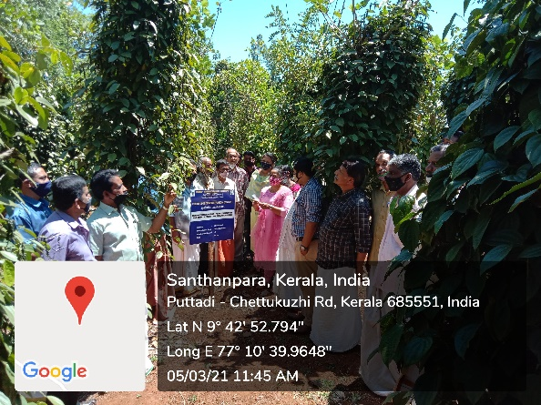
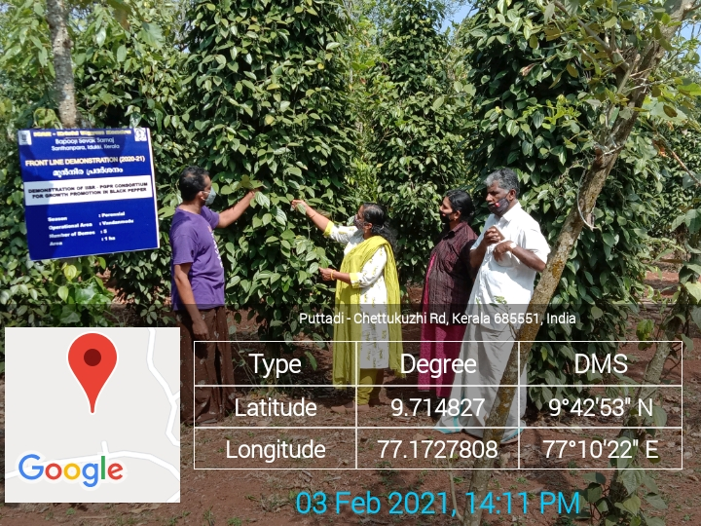
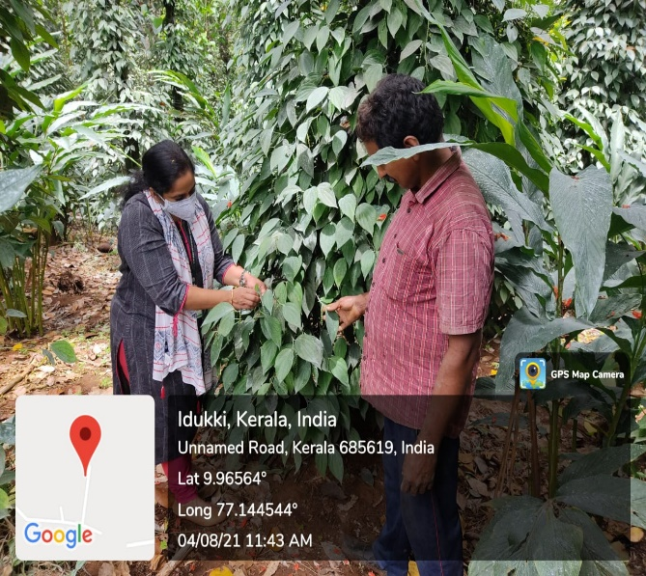
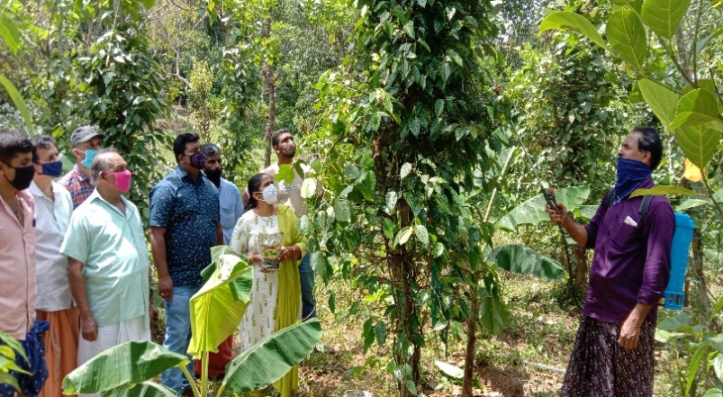
Observation recording in the demo plot
Field visit to IISR PGPR capsule applied Demo field
Awareness campaign application of IISR- PGPR capsule
Spraying of micronutrient mixture in demo plot

Title 2: Management of Phytophthora, Fusarium and Rhizome rot diseases in small cardamom using with ICAR-IIHR Arka Microbial Consortium Technology

Background
Arka Microbial Consortia (AMC) is a novel technology released from ICAR-IIHR, Bengaluru for plant nutrition and health management in horticultural crops. It is a consortium of 3 unique bacterial strains viz. Bacillus, Pseudomonas and Azotobacter. It can be applied either through soil and water. This synergistic effect of the formulated microbes can help in sustainable production of crops at a reasonable cost. This technology was introduced by ICAR-KVK, Santhanpara in IDUKKI district of Kerala for addressing the problems faced by small cardamom farmers of the district who were facing various problems like Azukhal disease and Rhizome rot. The technology gained popularity with the farmers and it is being followed by more than 5327 farmers of the district covering an area of 12452 ha and further popularized through FLDs and other extension activities

Interventions
Process:
The production and productivity of small cardamom (Elettaria cardamomum) is beset with many constraints and among them plant diseases play a major role. The pathogens such as Phytophthora meadli , Pythium vexans, Rhizoctonia solani were mainly responsible for causing an array of diseases in the past in the plantations. The development of plant disease requires suitable host tissue, a compatible pathogen, and prevalence of suitable microclimatic conditions. Rot diseases (Azhukal or capsule rot) caused by Phytophthora meadii and clump rot caused by Pythium vexans occur in a severe form during monsoon season and results in significant crop loss. The disease also occurs in nursery seedlings in the form of damping off or seedling rot. The incidence of capsule rot or clump rot has been reported as a severe problem in the cardamom plantations a decade ago and loses the yield of small cardamom 50 percent. On the infected leaves, water soaked lesions appear first followed by rotting and shredding of leaves along the veins. The infected capsules become dull greenish brown and decay. This emits a foul smell and subsequently shed. Application of different fungicides to manage these problems in soils, has only added to environmental hazards besides increasing the cost of cultivation.
Technology:

This technology was introduced by ICAR-KVK, Santhanpara in IDUUKI district of Kerala for addressing the problems faced by small cardamom farmers of the district who were facing various problems like Azukhal disease, Rhizome rot, Bacterial blight, dropping of capsules and death of roots due to a variety of factors like lack of nutrient uptake, Phytophthora and Clump rot infection. The Microbial consortium technology was taken up as an on-farm trial and FLDs. It was found that drenching of small cardamom plant with Mixing of 20 gm Arka Microbial Consortium per litre of water and drenching 5-6 litre of this solution per small cardamom plant during May-June , August-September and January months (Three times in a year performed significantly better in terms of reduction in Azukal, Clump rot and Nematodes.

Output and outcome:

Technology assessment and demonstration of the technology has shown that AMC applied small cardamom field were showing early initiation of new shoots during pre-monsoon showers, less nematode (5.8%), less Azukal disease incidence (6.2 %), less Rhizome rot disease incidence (4.3 %) and have also recorded higher dry cardamom yield of (1.85 q/ha) compared to farmers practice yield range of (1.32 q/ha) after 4 years of AMC application.

Impact
Horizontal Spread
The technology gained popularity with the farmers and it is being followed by more than 5000 farmers of the district covering an area of 12000 ha and further popularized through FLDs and other extension activities. After adoption of this technology it saves the cost of chemicals application Rs.4,500 per ha.

Economic gains:

The cost of application of AMC is Rs.4400/ha as compared to regular chemical application where it costs Rs.21000/ha. So, the reduction in cost of cultivation per ha is Rs.65, 000. The total net return gained per ha is Rs.279,000/- due to introduction of AMC technology. . The total economic benefits accrued since its release (2017) is estimated at Rs.27.84 crore during the period 2017 to 2021.

Employment Generation
To accelerate the adoption, KVK, Idukki has established AMC Production Unit at KVK premises with the financial support of Revolving fund and 14,846 kg of AMC has been produced and supplied to 5327 no. of farmers since 2017. So the AMC technology has spread to 12452 ha of the small cardamom plantation areas and the KVK is realizing Rs.11.50 lakhs sale annually.

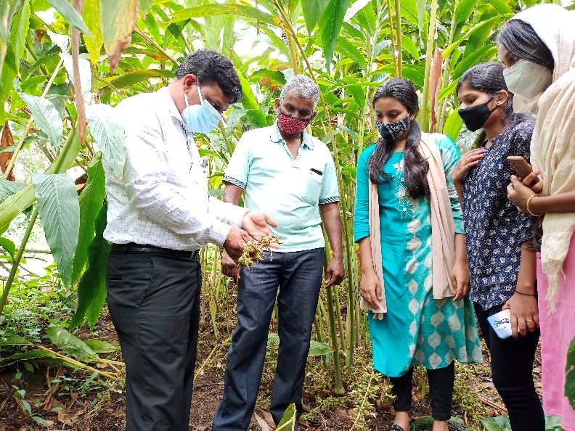
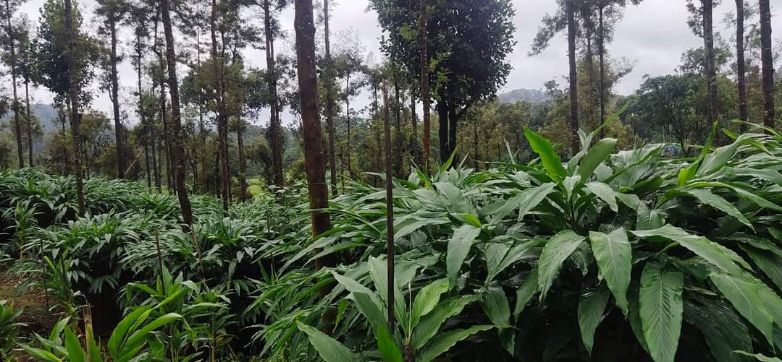
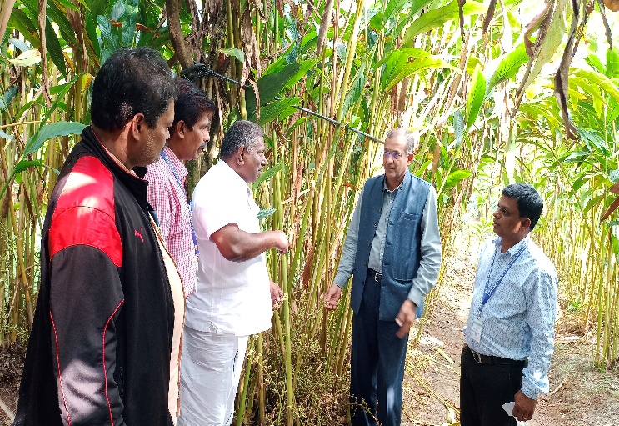
AMC applied small cardamom field
Microbial Consortium applied small cardamom field visited by Dr.V.Venkatasubramanian, Director, ICAR-ATARI, Bengaluru

Capsule formed in AMC applied small cardamom field

Title 3: Strawberry: A Potential Crop for Doubling the Farmer’s Income at Vattavada village in Idukki District, Kerala, South India.

Background
Strawberry (Fragaria amanassa Duch) is cultivated throughout the world, but it grows well in a cold and moist climate. The Kerala states provide ample opportunity for the successful cultivation of strawberry due to its mild and pleasant climatic conditions. The farmers of the region are not acutely aware of the economics for the cultivation of strawberry. Mr. Siva has been active in organic and diversified farming for about 10 years which eventually has given a financial triumph to his crop cultivation. After his initial bitter experiences with strawberry farming, Mr. Siva acquired the knowledge of cultivating strawberries through scientific techniques and earned tremendous success.

Interventions
Process:

Encouraged by the ICAR-Krishi Vigyan Kendra, Idukki to take up strawberry cultivation, as the area (Vattavada Village) was highly favorable for growing such a fruit crop, him desire and passion to become one of the progressive farmers of the area finally took off when he was selected as a beneficiary under SHM scheme during the year 2017-2018. At the beginning, the Department assisted her with 6000 nos. of strawberry runners, which he planted in the open field

Technology:
Front line demonstrated on AESA based strawberry cultivation in Vattavada.

Output and outcome:
Mr. Siva Sankar harvests the fruits twice in a month from Feb-July/Aug with the average yield being 200gms/plant/harvest season. (600 kg/harvest) Amounting Rs. 2, 40,000/- per season.

Impact
Horizontal Spread

Encouraged by the technical advice that she received from the KVK-IDUKKI, he is now planning to set up a Minimal Processing Unit in the area by forming one FEOs named Vattavada Strawberry Farmers Club. Besides the assistance that she received from the ATMA, Idukki.

Economic gains:

Currently, he cultivates the highly productive, hybrid Nebula variety of Strawberry saplings. From around 5000 strawberry plants, Mr. Siva generates a weekly income of Rs.25000. According to him strawberry is a crop with very high market potential and profitability

Employment Generation:

Mr. Siva Sankar received support from him family to extend their hands in managing this large scale cultivation. Excluding the expenditure and input support, Mr. Siva Sankar has made a profit of around Rs.2,90,000/- from him strawberry cultivation. Horticulture Revolution has brought a significance changes in the socio-economic conditions and living standard of many people directly and indirectly engaged in the cultivation of strawberry crop. Southern region has eminence potential to become the largest production hub of strawberry in the country.
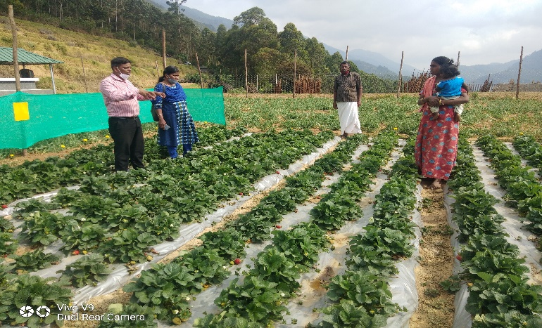
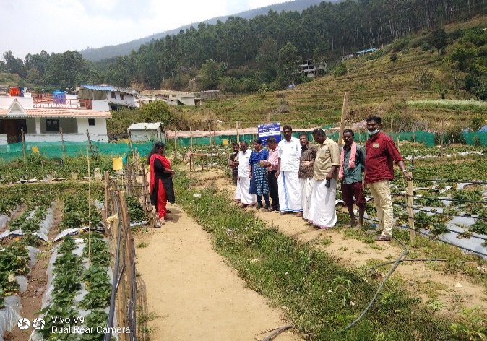
Field visit to AESA Based pest management Demo field
Field visit to AESA Based pest management Demo field
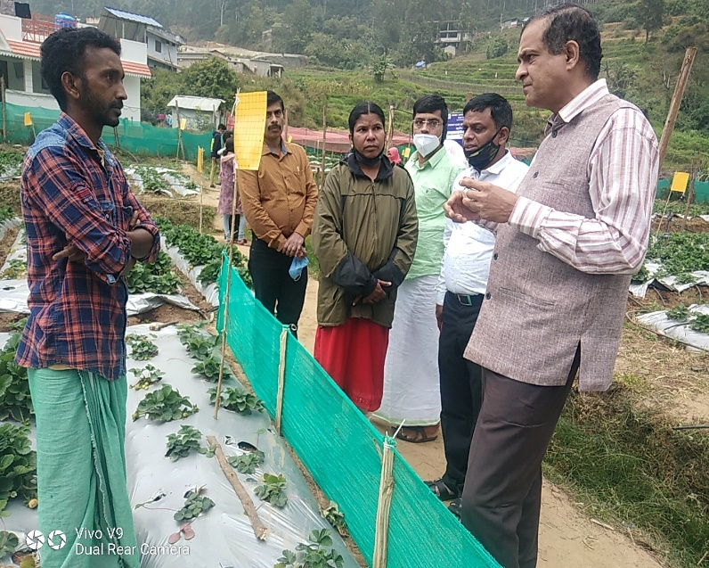

AESA Based strawberry field visited by Dr.V.Venkatasubramanian, Director, ICAR-ATARI, Bengaluru

Title 4: Integrated nutrient Management in cabbage

1. Background
Cabbage (Brassica oleracea L. Capitata group) is a cool season crop which is becoming more popular because of ample marketing opportunities. However, productivity of Cabbage in Idukki district is much below the potential due to inadequate nutrient management strategies for infertile soils. There is increasing concern about use of synthetic chemical fertilizers and pesticides, which may be responsible for declining yields and deterioration of the soil condition. Decreasing yields over the years also indicate that indiscriminate use of synthetic and organic fertilizers may not be able to sustain vegetable production. Other than the above mentioned, the major problems faced by Cabbage farmers also includes Soil acidity and nutrient disorder makes the less marketability. In such a Scenario, KVK Santhanpara has decided to undertake a demonstration at Sandos colony by integrating organic manures and synthetic fertilizers which has the advantage of restoring soil fertility, sustaining productivity and increasing nutrient management.

Source of Technology: IIHR

2.Intervention process
- Accessibility to the technology and availability of all basic resources
- Training on INM in Cabbage.
- Timely intervention on different stages of growth of Cabbage
- Advisory services
- Follow-up visits and technical support as and when required.
3.Intervention Technology
- The technology was initiated during the years 2020-21 in the fields of 5 farmers
- Supply of adequate inputs and consultancy services
- Timely intervention, was provided not just for farming activities, but also for allied support inventory.

4.Impact - Horizontal Spread
Integrated nutrient management (INM) treatments significantly affected growth characteristics and yield attributes of cabbage. INM interaction affected dry matter of the crop and head weight in cabbage. Cabbage plants treated with the INM had higher head weights of 3.7 kg than the check with 2.28. Root volume in cabbage was also higher in treatments when compared to the farmers practice and soil acidity has decreased.

5.Impact - Vertical spread.
For cabbage, a highest yield of 548 q/ha was obtained during the year 2020-21, when the intervention was carried out. However, better dry matter accumulation, higher yield attributes, and yield of crops in 2020 were also likely in part due to climatic effects as air temperature during 2020 was more favorable for these cool season vegetable crops.

6.Impact - Economic Gains
Net returns, and the cost: benefit ratio were affected by INM treatments. A highest net returns (Rs. 211120·ha−1) and cost: benefit ratio of 2.79 was obtained, which was significantly higher than the check with 1.90.
Conclusion
There is concern that use of inorganic fertilizers alone cannot sustain high levels of productivity and cause deterioration of the soil and environment. The use of INM to improve plant nutrition may address these issues. The technologies of KAU and IIHR when used combination with inorganic fertilizers can have a profound impact on growth, yield and soil health of Cabbage.

Steps for Scaling – up:
- Large Scale demonstrations will be conducted in convergence with ATMA-Idukki.
- The KVK will ensure that the majority of the growers are benefited by such programmes.
- Trainings for popularizing such eco- friendly, bio control methods will be organized frequently
- Brochures and other literary works will be published to give the farmers a quick summary
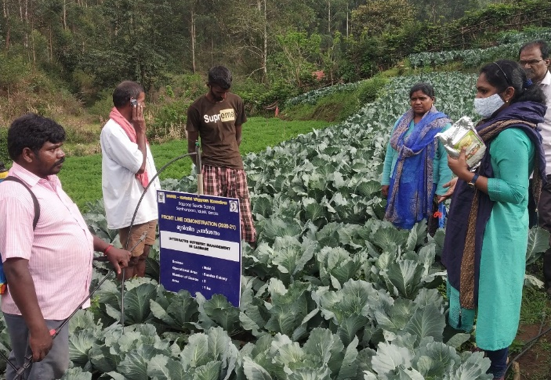
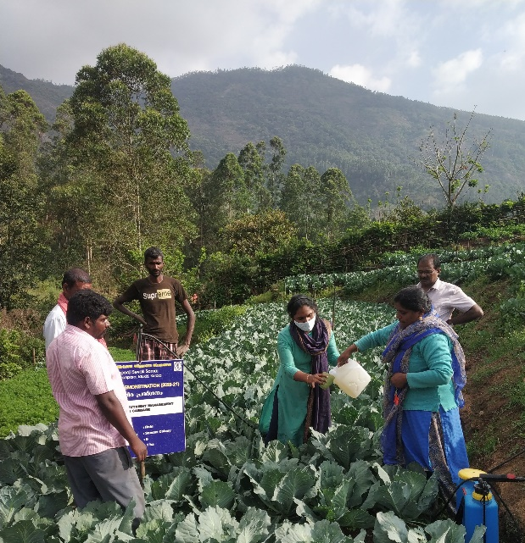
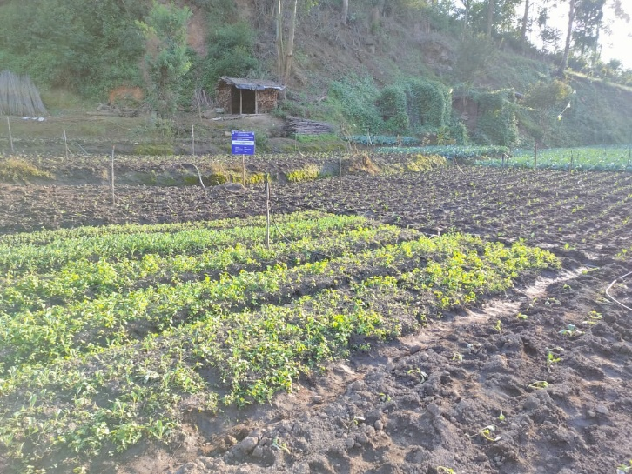
Demonstration on application of Pseudomonas
Demo Plot of cabbage at nursery

Demonstration on spraying of IIHR Vegetable special

Title 5: Rebirth to paddy farming in Idukki district with high yielding variety Manuratna

1.Background
The agriculture in Kerala has undergone significant structural changes in the form of decline in the share of Gross State Domestic Product and commercialization of agriculture. The gross cropped area and the net sown area in the state have declined over a period of time. During 1999-2000, and 2017-18 districts like, Idukki, Ernakulum, Palakkad, Wayanad and Kannur districts have shown declining growth rate in area under paddy cultivation which is less than the state average. Idukki, known as the spice bowl of the state have shown declining trends in both area and production.
To bring about a change in this negative trend, and to create an awareness regarding the importance of paddy cultivation in maintaining ecological balance, KVK, Idukki has started a demonstration on cultivation of Manuratna variety of paddy in 20120-21. Manuratna, is developed by Agricultural Research station, Mannuthy. Manuratna with a better yield than Uma, Swetha and Karuna will help to bring back the lost glory of Idukki in rice cultivation

Source of Technology: Agricultural Research station, Mannuthy

2.Intervention process
- Accessibility to the technology and availability of all basic resources
- Timely intervention on different stages of growth of Rice
- Advisory services.
- Follow-up visits and technical support as and when required.

3.Intervention Technology
- The demonstration was initiated during the years 2020-21 in 1 ha of area with a broad vision to bring back the farmers to rice cultivation.
- In order to educate the farmers regarding the various requisites of rice production, KVK has conducted numerous trainings regarding the production practices of Manuratna variety
- Timely intervention, was provided not just for farming activities, but also for allied support inventory.

4.Impact - Horizontal Spread
After the demonstration, the number of farmers who are interested to take up rice farming has increased. This is evident from the increased requests for more trainings and planting materials.

5.Impact - Vertical spread.
During the period 1980-81 to 2011-12, Idukki, have lower negative cumulative growth rate in area compared to the state average. But through this demonstration farming, KVK was able to obtain a better grain yield of 5.98 t/ ha. This will surely prove to be an eye opener for the farmers, that paddy cultivation can also be profitable in their local conditions.

6.Impact - Economic Gains
On the basis of costs incurred and revenue generated an economic analysis was conducted and we obtained a Benefit Cost ratio of 2.39. The ratio point towards the popular myth that only cash crop cultivation is profitable.

Conclusion
Manuratna variety of paddy when cultivated on 1ha of land was successful with good grain yield.

Steps for Scaling – up:
- Large Scale demonstrations will be conducted in convergence with line departments of Idukki.
- The KVK will ensure that the majority of the growers are benefited by such programmes.
- Trainings will be conducted to popularize paddy framing among the farmers.
- Brochures and other literary works will be published to give the farmers a quick summary.
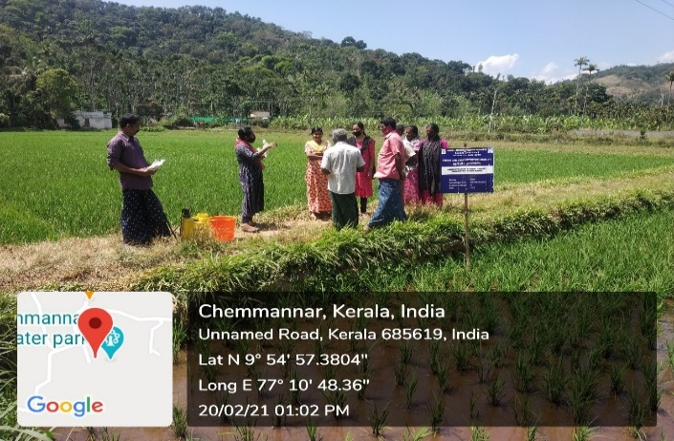
- Feedback will be obtained and their constraints will be met on a timely basis.
Demonstration of application of Pseudomonas in Paddy
Demonstration of application of micronutrient mixture KAU Sampoorna
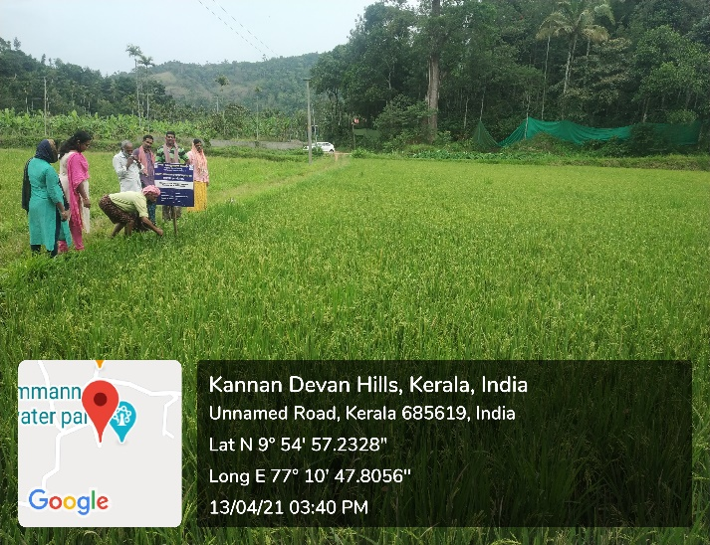
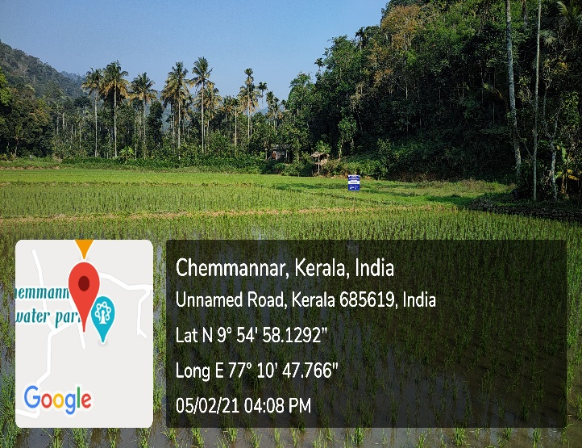
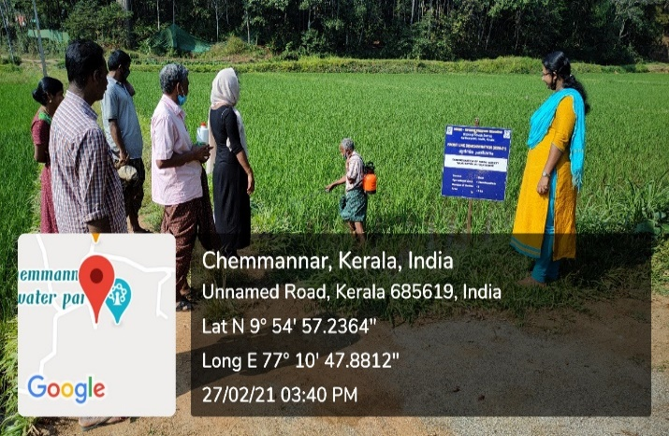
Field Visit to FLD plot of Manuratna variety of Paddy
Demo plot of Manuratna variety of Paddy

Title 6: Women entrepreneurship: A success
1.Back ground:
Rural women and housewives are the important target group that KVK is trying to educate. Often these women have productive skills that have never been realized or utilized. Normally housewives in their village spend majority of their time for cooking and taking care of children and they are not getting the opportunity for education or skill training. KVK works to change some of these traditional routines, so that women can make choices for themselves. Their potential can be developed through creating awareness, developing their functional capability, and organizing them in Self Help Groups. Over the years, KVK has trained a large number of housewives and organized them into Self Help Groups in neighboring villages. The organization of women’s groups has exposed them to the outside world, given them confidence, given them support and a voice. Now, these women are working to improve skills and supplement their family income. The trainings organized by KVK create awareness and imparts knowledge on their rights, capacities, and skills required for day to day activities. This gives confidence especially they feel that they can work in groups to change their traditional role without affecting the family relations as it is an important part of our culture.The group of women attended the hands on training on mushroom production from KVK at their village. Based on the knowledge acquired, they started mushroom cultivation using the inputs received from the KVK as part of the training. After gaining experience in the field, they renovated an unused room of 300 m2 in their village. As paddy straw is easily available in their area, they used it for the mushroom bed preparation. The substrate is disinfected through steaming by aluminum vessel using locally available fire wood as fuel which ensures organic mushroom production. The purely organic produce is being sold as ‘Organic mushroom’. By the sale of 3kg – 5kg fresh mushroom daily, they are realizing a net monthly income of Rs. 36,000/-

2.Intervention process
- To assess their educational needs and to provide essential training.
- To enhance their life-skills by extending life-skill education.
- Skill development vocational training.
- Motivation to start an enterprise.
- Technical guidance for starting the unit.
- Details about availability of raw materials.
- Advisory services.
- Follow-up visit.
- Technical back up in running the unit as when required.

3.Process Technology
- Creation of an environment where women can seek knowledge and information and there by empower them to play positive role in their own development and development of society.
- Enhancement of self-image and self- confidence of women and thereby enabling them to recognize their contribution to the economy as producers and workers, reinforcing their need for participating in skill development programmes.
- Provide women and adolescent girls with the necessary support structures and an informal learning environment to create opportunities for education.
4.Output and outcome
For providing employment to women around the Cluster village, we established a Mushroom production unit which gives employment to 15 women for the last 6 months. An average of Rs. 45,000/- is earning by these women every month which supplement their family income and improves their socio economic status in the community. This unit is initiated as part of the women empowerment programme linked with the women Self Help Groups namely Dhanya(SHG) functioning in the cluster villages around Udumbanchola.

5.Impact
Horizontal Spread.
This enterprise aimed at empowering women in Idukki district by providing skill development training to make them self-sufficiency and self-reliant. This enterprise will enable women deprived, poverty sticken, working as domestic servants,single parent and widows are being given opportunity to undergo free training and inturn they earn and live on their own.The entire family will be benefited, will support the beneficiary to establish small scale units.

6.Economic Gains.

They earn an average Income per month is Rs.45,000/-

Employment Generation.
This programme will empower women for their families wellbeing and for their sustainable living, every batch of women / youth- girls will in turn benefit by this programme and will take this as their profession and train other women community and develop their standard of living. Self-employment is the main source of income.So they are engaged more in self- employed manufacturing and trade activities compared to others.

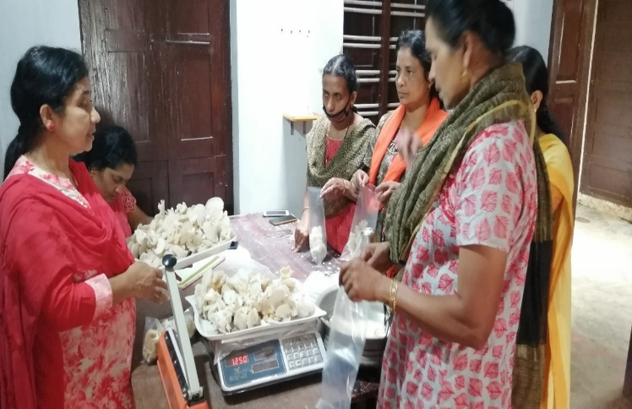
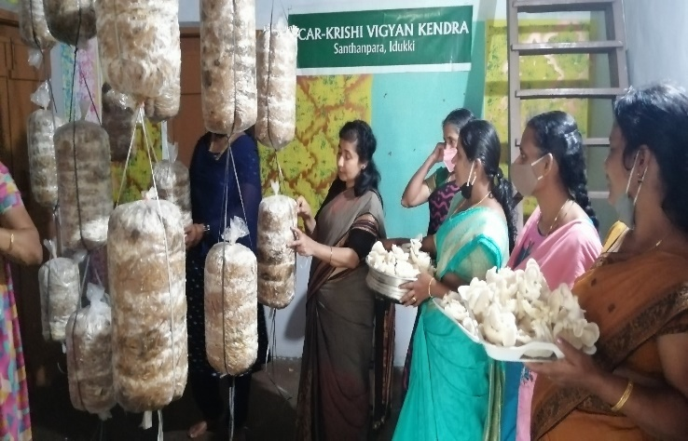
Packaging of Mushrooms
Harvesting Mushrooms by SHG Members

Title 7: Skill development enterprise: A Success.
1.Background
Miss. Bincy Mathew, Puthenpurackal, Muttukaad in Idukki district. She was raised in a below middle class family. She is 7th failed disabled unemployed lady. But all these problems were silly as compared to her great dream. One year ago unfortunately, she got a chance to attend the vocational training on different topics such as Fabric designing, Dry flower making, Jewellery Making, Toys Making, Quilling Art and Home care product preparations conducted under KVK Rural craft discipline. She was inspired by the motivations she received from Mrs. Rachel Skaria, programme assistant of KVK (Rural craft discipline). Her promotion and support brought great changes in Miss. Bincy’s life. The topics that impressed her was the Fabric designing and dry flower making. Motivated from the training, she started a Flower making unit and learn to make fabric designing to meet the modern trends of marketing. She has employed three ladies to work along with her.
They visited various forests, hills, valleys and farms and in the neighbouring state of Tamilnadu to collect raw materials like varieties of dried grasses, areca nut sheaths, palm leaves, corn husk and different types of cereals etc. They met the owners of farms and seek their permission to pick up their agricultural waste to make a different varieties of flowers. Now Miss. Bincy is an example how woman can effectively utilize their talents and leisure time for income generation. She has taken bulk orders from fancy stores, local markets and she has participated in flower shows and exhibitions, now she started online marketing. The main finishing touches is done by her and the rest of the work is done by the women working with her. She purchases the raw materials in bulk at a cheaper rate and the work place is her-own house. Therefore, the profit she gains is comparatively higher.

2.Intervention process
- 6 months vocational training.
- Motivation to start an enterprise.
- Technical guidance for starting the unit.
- Details about availability of raw materials given.
- Advisory services.
- Follow- up visits.
- Technical back up in running the unit as when required.

3.Intervention Technology.
To provide skill development vocational training to make her self- sufficient and self-reliant.

Impact

4.Horizontal Spread.
This enterprise will provide skill development for the women dwellers in identified area, families will be benefited directly and creating a ray of hope for better source of livelihood , and live a sustainable life with self – sufficiency and self –reliance.

5.Economic Gains.
She earn an average profit of Rs. 25000/- per month

6. Employment Generation
Motivated from the above mentioned Miss. Bincy’s successful enterprise,10 rural women formed a self-help group under KVK Rural Craft discipline, they started designing, jewellery making and production of home care products on a commercial basis. In addition to this unit, they are planning to start a small fancy store with loan availing from nearby Co-operative bank for self-sufficiency and self-employment. Also they generate employment opportunities for others.
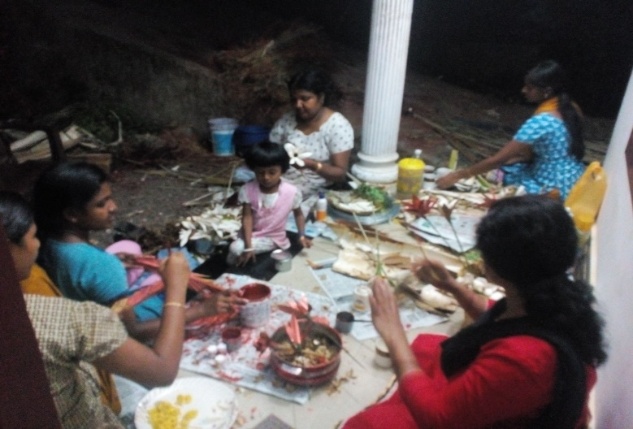
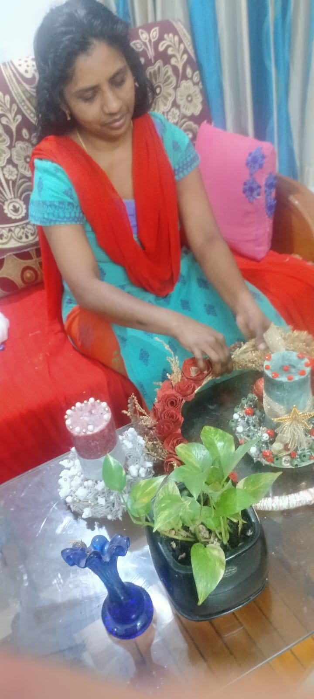

Handicraft prepared by Mrs. Bincy Mathew
Preparation of different Handicraft products

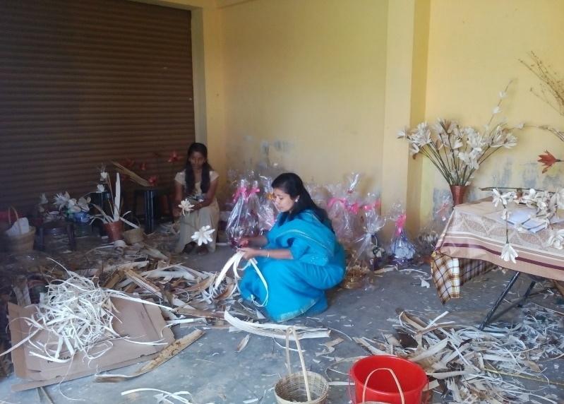

Training on effective waste management in producing items

10.D. Give details of Innovative Methodology or Innovative Approach of Transfer of Technology developed and used during the year: Nil

10.E. Give details of Indigenous Technical Knowledge practiced by the farmers in the KVK operational area which can be considered for technology development (in detail with suitable photographs)
S. No. | Crop / Enterprise | ITK Practiced | Purpose of ITK | Scientific Rationale
1 | Dairy cattle | Cissus Quadrangularis (Pirandai)-200gm, Cumin seed-30gm, Small Onion-30gm,Ginger-30gm,Garlic-30gm,Pepper-30gm and Turmeric-30gm | Control of Bloat –Tympany in Ruminants especially Dairy cattle | Prevention and control Tympany in ruminants
2 | Dairy cattle | Vayambu-20gm,Garlic-20gm and Turmeric-30gm | Control of Ecto parasites in Ruminants | Prevention and control of ecto parasitic infestation in ruminants

10 F. Technology Week celebration: : Nil

Period of observing Technology Week: From to
Total number of farmers visited :
Total number of agencies involved :
Number of demonstrations visited by the farmers within KVK campus :

Other Details
Types of Activities | No. of  Activities | Number of  Farmers | Related crop/livestock technology
Gosthies
Lectures organized
Exhibition
Film show
Fair
Farm Visit
Diagnostic Practicals
Supply of Literature (No.)
Supply of Seed (q)
Supply of Planting materials (No.)
Bio Product supply (Kg)
Bio Fertilizers (q)
Supply of fingerlings
Supply of Livestock specimen (No.)
Total number of farmers visited the technology week

10 E. Recognition and Awards: Please give details about National and State level recognition and awards

PART XI – SOIL AND WATER TEST

11.1 Soil and Water Testing Laboratory

A. Status of establishment of Lab :
1. Year of establishment :2007
2. List of equipment’s purchased with amount :

Sl. No | Name of the Equipment | Qty. | Cost | Status
1. | LPG Cylinder | 1 | 4600.00 | working
2. | Water bath WDB-2 350’400’100mm 12 holes | 1 | 4815.00 | working
3. | Machinery for Homogensing (khan shaker) Model LKS2 platform size 75cmx43cmx10cm | 1 | 20,880.00 | Not working
4. | Rotary Shaker | 1 | 16,200.00 | Not working
5. | Machinery for drying (Hot air oxen) with digital temperature control, size 455’455’455’ | 1 | 13,725.00 | Not working
6. | Conductivity meter (PH meter Eutech 510) | 1 | 21,935.00 | Not working
7. | Genesis 20 visible Spectrophotometer meter | 1 | 1,12,499.00 | Not working
8. | CITIZEN Physical Balance Model CTL-600 | 1 | 8,991.00 | Not working
9. | Microprocessor based conductivity | 1 | 13,500.00 | Not working
10. | Micro Processor Based Flame Photometer with N, K &Ca FILTERS & Compressor | 1 | 45,000.00 | Not working
11. | Electronic Automatic KEL  PLUS Micro processor  Based Twelve Place Micro Block Digestion System | 1 | 97,043.00 | Not working
12. | Electronic Balance  Model: CP 2245  Srl.No.18606016 | 1 | 1,00,000.00 | Not working
13. | Hot plate | 1 | 5,400.00 | Not working
Total |  | 13 | 252089.00

B. Details of samples analyzed since establishment of SWTL:

Details | No. of Samples analyzed | No. of Farmers benefited | No. of Villages | Amount realized (Rs.)
Soil Samples | 35141 | 2882 | 30 | 2072050
Water Samples | 0 | 0 | 0 | 0
Plant samples | 0 | 0 | 0 | 0
Manure samples | 0 | 0 | 0 | 0
Others (specify) | 0 | 0 | 0 | 0
Total | 35141 | 2882 | 30 | 2072050

C. Details of samples analyzed during 2021:

Details | No. of Samples analyzed | No. of Farmers benefited | No. of Villages | Amount realized (Rs.)
Soil Samples | 388 | 255 | 15 | 174600
Water Samples | 0 | 0 | 0 | 0
Plant samples | 0 | 0 | 0 | 0
Manure samples | 0 | 0 | 0 | 0
Others (specify) | 0 | 0 | 0 | 0
Total | 388 | 255 | 15 | 174600

11.2 Mobile Soil Testing Kit
A. Date of purchase and current status
Mobile Kits | Date of purchase | Current status
Two kits | 21-06-2017 | Working (No refilling Possible)

B. Details of soil samples analyzed during 2021 and since establishment with Mobile Soil Testing Kit:

 | During 2020 | During 2021 | Cumulative progress (Total)
Samples analyzed (No.) | 491 | 388 | 879
Farmers benefited (No.) | 486 | 255 | 741
Villages covered (No.) | 20 | 15 | 35

11.3 Details of soil health cards issued based on SWTL & Mobile Soil Testing Kit:

Particulars | Date (s) | Villages (No.) | Farmers (No.) | Samples analyzed (No.) | Soil health cards issued (No.)
SWTL
Mobile Soil Testing Kit | 01-01-21 to 31-12-21 | 15 | 255 | 388 | 388

11.4 World Soil Health Day celebration
Sl. No. | Farmers participated (No.) | Soil health cards issued (No.) | VIPs (MP/ Minister/MLA attended (No.) | Other Public Representatives participated | Officials participated (No.) | Media coverage (No.)
1. | 65 | 30 | 0 | 0 | 07 | 1

PART XII. IMPACT

12.A. Impact of KVK activities (Not restricted for reporting period)
Name of specific technology/skill transferred | No. of participants | % of adoption | Change in income (Rs.)
 |  |  | Before (Rs./Unit) | After (Rs./Unit)
Popularization of innovative approach to manage the deterring crop raiding wild elephants, monkeys and wild boars in hill agriculture at Idukki District, Kerala | 210 | 80 | 2,75,600.00/ha | 4,56200.00/ha
Doubling Income of Small Cardamom Farmer (Mr. Raju) of Idukki District, Kerala through Pollination Service by Apis cerna indica Colonies and Value Addition of bee products | 1250 | 65 | 2,45,000.00/ha | 5,21,000.00/ha
Biological Control of Cardamom Stem borer or Capsule borer or Panicle borer Management with different bio-pesticides and parasites | 405 | 49 | 2,89,000.00/ha | 3,49,000.00/ha
Empowering the livelihood of tribal farmers of Devikulam, Idukki in Kerala through small cardamom, Black pepper, ginger cultivation, Beekeeping and Poultry birds | 100 | 71 | 1,99,000.00/ha | 310,500.00,
Biological Control of Cardamom Root Grub Management with Entomo Pathogenic Nematodes (EPN) | 11,000 | 98 | 3,88,000.00 | 5,16,000.00
Novel farming innovation for high production of black pepper through ICAR-IISR column method in Idukki | 75 | 55 | 2,65,000.00 | 3,89,100.00
Bio-intensive root knot nematode management in carrot | 311 | 89 | 1,15,000.00 | 2,10,000.00
Cardamom special | 520 | 65 | 3,11,100/ha | 4,52,000/ha
Pepper Special | 415 | 45 | 36,522/ha | 3,22,226/ha
Banana Special | 230 | 39 | 5,82,100/ha | 6,50,000/ha
Vegetable Special | 200 | 55 | 3,65,000/ha | 5,40,000/ha

NB: Should be based on actual study, questionnaire/group discussion etc. with ex-participants.

12.B. Cases of large scale adoption (Please furnish detailed information for each case with suitable photographs): Nil

12.C. Details of impact analysis of KVK activities carried out during the reporting period: Nil

PART XIII – LINKAGES

13A. Functional linkage with different organizations
Name of organization | Nature of linkage
ATMA | Group Meetings, Field Visits, Trainings, EAP and Demonstrations
Department Of Animal Husbandry | Field Visits, Trainings, Demonstrations
Department of Forestry | Tribal Development Projects, Trainings
Department of agriculture | Field Visits, Trainings, Demonstrations
VFPCK | Field Visits, Trainings
SFAC | Field Visits, Trainings
Coffee Board | Trainings, Field Visits and Demonstrations
Spices Board | Trainings, Field Visits
NABARD | FPO formation and related activities
Kerala state cooperative bank | Relation with Farmer club formation
MANAGE | DAESI programme
DIC | Trainings, Demonstrations
VHSC | Trainings
District Kudumbasree Mission | Group formation, Training and demonstrations
FAI | Workshop, Seminar and Soil Health campaign
NLC | Technology trial (Humic acid)
IFFCO | Soil Health awareness campaign
SPIC | Soil Health awareness campaign
Tribal Development Board | Training and technology sharing
Social Development Department | Training
Block and District panchayat | Training
NBAIR | Project implementation
NB The nature of linkage should be indicated in terms of joint diagnostic survey, joint implementation, participation in meeting, contribution received for infrastructural development, conducting training programmes and demonstration or any other

13B. List of special programmes undertaken by the KVK and operational now, which have been financed by State Govt./Other Agencies

Name of the scheme | Date/ Month of initiation | Funding agency | Amount (Rs.)
Insecticides Management for Inputs dealers | 08/12/21 | NIPHM | 1,35,000.00
Diploma in Agricultural extension services for input dealers | May | MANAGE | 1304623.00
Supply of Poultry Layer Birds | September 2021 | NBAIR | 75000.00

13C. Details of linkage with ATMA

Coordination activities between KVK and ATMA
S. No. | Programme | Particulars | No. of programmes attended by KVK staff | No. of programmes Organized by KVK | Other remarks (if any)
01 | Meetings | DMC Meetings, AMC and GB Meetings, Proposal finalization | 3 | 6 | -
02 | Research projects
03 | Training programmes | Trainings | 2 | 6 | -
04 | Demonstrations
05 | Extension Programmes
 | Kisan Mela
 | Technology Week
 | Exposure visit
 | Exhibition
 | Soil health camps
 | Animal Health Campaigns
 | Others (Pl. specify)
06 | Publications
 | Video Films
 | Books | Organic farming in small cardamom and Black pepper, beekeeping, Natural farming next farming situation | 1 | 0 | -
 | Extension Literature
 | Pamphlets
 | Others (Pl. specify)
07 | Other Activities (Pl.specify)
 | Watershed approach
 | Integrated Farm Development
 | Agri-preneurs development

13D. Give details of programmes implemented under National Horticultural Mission : Nil

S. No. | Programme | Nature of linkage | Funds received if any Rs. | Expenditure during the reporting period in Rs. | Constraints if any

13E. Nature of linkage with National Fisheries Development Board : Nil
S. No. | Programme | Nature of linkage | Funds received if any Rs. | Expenditure during the reporting period in Rs. | Remarks

13F. Details of linkage with RKVY
S. No. | Programme | Nature of linkage | Funds received if any Rs. | Expenditure during the reporting period in Rs. | Remarks
1. | Seed village programme on tuber crops | ICAR-CTCRI | 8,35,000.00 | 8,35,000.00 | -

13G. Kisan Mobile Advisory Services
Month | No of Advisories | Message type (Text/Voice) | SMS/voice calls sent (No.) |  |  |  |  |  | Total SMS/Voice calls sent (No.) | Farmers benefitted (No.)
 |  |  | Crop | Livestock | Weather | Marketing | Awareness | Other enterprises
January | 1 | Text | 1 | 1 | 0 | 0 | 0 | 0 | 2 | 2530
February | 4 | Text | 2 | 2 | 0 | 0 | 0 | 0 | 4 | 10730
March | 0 | - | 0 | 0 | 0 | 0 | 0 | 0 | 0 | 0
April | 1 | Text | 1 | 0 | 0 | 0 | 0 | 0 | 1 | 1960
May | 3 | Text | 3 | 0 | 0 | 0 | 0 | 0 | 0 | 6028
June | 2 | Text | 2 | 0 | 0 | 0 | 0 | 0 | 0 | 4382
July | 0 | - | 0 | 0 | 0 | 0 | 0 | 0 | 0 | 0
August | 2 | Text | 2 | 0 | 0 | 0 | 0 | 0 | 2 | 4806
September | 3 | Text | 0 | 3 | 0 | 0 | 0 | 0 | 0 | 7209
October | 2 | Text | 0 | 2 | 0 | 0 | 0 | 0 | 0 | 4806
November | 0 | - | 0 | 0 | 0 | 0 | 0 | 0 | 0 | 0
December | 4 | Text | 2 | 2 | 0 | 0 | 0 | 0 | 0 | 10790
Total | 22 |  | 13 | 10 | 0 | 0 | 0 | 0 | 9 | 53241

PART XIV- PERFORMANCE OF INFRASTRUCTURE IN KVK

14A. Performance of demonstration units (other than instructional farm)

Sl. No. | Demo Unit | Year of  establishment | Area  (ha) | Details of production |  |  | Amount (Rs.) |  | Remarks
 |  |  |  | Variety | Produce | Qty. | Cost of inputs | Gross income
1 | Small cardamom Nursery | 2021 | 1 | Different varieties of small cardamom | 7000 | - | 2,10,000.00 | - | Planting materials will be supply in the season
2 | IISR-Black pepper-Column method | 2021 | 0.12 | Different varieties of black pepper | - | - | - | - | Black pepper s in clumping stage
3 | Vermi compost | 2018 | 0.20 | - | - | - | - | - | -
4 | VAM unit | 2019 | 0.01 | - | VAM | 1889 | 143564.00 | 226680.00 | -

14B. Performance of instructional farm (Crops) including seed production

Name  of the crop | Date of sowing | Date of harvest | Area (ha) | Details of production |  |  | Amount (Rs.) |  | Remarks
 |  |  |  | Variety | Type of Produce | Qty. | Cost of inputs | Gross income
Cereals
Pulses
Oilseeds
Fibers
Spices & Plantation crops
1. Small cardamom | 05.06.2019 | 3No ( Perennial) | 2 | Njallani, Thiruthali | Capsules | 175 | 1,21,450.00 | 2,66,250.00 | -
Floriculture
Fruits
Vegetables  1. Potato | 05.09.2021 | 26.12.2021 | 0.02 | Kufri Neelkanth, Kufri Karan, Kufri Surya | Tuber | 200 Kg | 8000.00 | 20000.00 | -
Others (specify)

14C. Performance of production Units (bio-agents / bio pesticides/ bio fertilizers etc.,)

Sl.  No. | Name of the Product | Qty | Amount (Rs.) |  | Remarks
 |  |  | Cost of inputs | Gross income
1. | Pseudomonas | 7722 | 604840 | 634140 | -
2. | Trichoderma | 7625 | 576745 | 613921 | -
3. | Beauveria | 515 | 41200 | 36050 | -
4. | Metarhizium | 492 | 39360 | 34440 | -
5. | EM Solution | 896 | 89600 | 179200 | -
6. | Microbial Consortium | 1894 | 170460 | 208340 | -
7. | Bacillus | 390 | 19060 | 18140 | -
8. | Neem oil | 341 | 85250 | 34100 | -
9. | Azospirillum | 638 | 95700 | 95700 | -
10 | Phosphobacteria | 634 | 93300 | 93300 | -
11. | Potash bacteria | 634 | 95100 | 95100 | -
12 | AMC | 2380 | 297500 | 253200 | -
13 | Decomposer | 1549 | 49410 | 87840 | -
14. | EPN | 780 | 327600 | 195000 | -
15. | PPFM | 1940 | 174600 | 291000 | -
16. | Paecilomyces | 1319 | 149850 | 164875 | -
17 | VAM | 1889 | 147342 | 226680 | -

14D. Performance of instructional farm (livestock and fisheries production)

Sl.  No | Name  of the animal / bird / aquatics | Details of production |  |  | Amount (Rs.) |  | Remarks
 |  | Breed | Type of Produce | Qty. | Cost of inputs | Gross income
1 | Poultry | Red BRO, BV 380 | Layer | 54 | 28000.00 | 39120.00 | -
2 | Duck | Vigova | Layer | 20 | 6970.00 | 1200.00 | -

14E. Utilization of hostel facilities: nil

Accommodation available (No. of beds)
Months | No. of trainees stayed | Trainee days (days stayed) | Reason for short fall (if any)
January
February
March
April
May
June
July
August
September
October
November
December

14F. Database management
S. No | Database target | Database created
1 | Farmers database (FLD, OFT, KMAS, Training) | Database for (2020-21)

14G. Details on Rain Water Harvesting Structure and micro-irrigation system : Nil

- Rain Water Harvesting Structure

Amount sanction (Rs.) | Expenditure (Rs.) | Details of infrastructure created / micro irrigation system etc. | Activities conducted |  |  |  |  | Quantity of water harvested in ‘000 litres | Area irrigated / utilization pattern
 |  |  | No. of Training programmes | No. of Demonstration s | No. of plant materials produced | Visit by farmers  (No.) | Visit by officials  (No.)

- Micro-irrigation systems

Amount sanction (Rs.) | Expenditure (Rs.) | Details of infrastructure created / micro irrigation system etc. | Activities conducted |  |  |  |  | Quantity of water harvested in ‘000 litres | Area irrigated / utilization pattern
 |  |  | No. of Training programmes | No. of Demonstration s | No. of plant materials produced | Visit by farmers  (No.) | Visit by officials  (No.)

PART XV – SPECIAL PROGRAMMES

15.1 Paramparagath Krishi Vikas Yojana (PKVY): Nil
Sl No. | Name of cluster village | Initial soil fertility status (Average of cluster village) |  |  |  | Facilities created for organic source of manure | Name of Crops cultivated | Variety | Organic inputs applied including bio-agents and botanicals treatment | Yield (q/ha) | Economics
 |  | Aval. N | Aval. P | Aval. K | OC % |  |  |  |  |  | Cost of cultivation (Rs/ha) | Net returns (Rs/ha)
1 | 1.
 | 2.
2 | 1.
 | 2.

15.2 District Agriculture Meteorological Unit (DAMU): Nil

 | Agro advisories |  |  | Farmers awareness programmes
Sl No. | No of Agro advisories generated | No of farmers registered for agro advisories | No of farmers benefitted | No of programmes | No of farmers benefitted
1

15.3 Fertilizer awareness programme organised
State | Name of KVK | Details of Activities/programme Organised | Number of Chief Guests | No. of Farmers attended program | Total participants
Kerala | KVK, Idukki | Fertilizer awareness Campaign | 4 | 101 | 105

15.4 Seed Hub: Nil
Crops | Variety | Year of release | Production |  |  |  | No of farmers benefited/Sold to no. of farmers | Quantity seed sold (q)
 |  |  | Target (q) | Area (ha.) | Actual Production  (q) | Category  (FS/CS)

15.5 CFLD on Oilseeds: Nil
Sl.No. | Crop | Varieties demonstrated and check | Allocated |  | Implemented
 |  |  | Area (ha) | Demos (No.) | Area (ha) | Demos (No.)
 | Total

15.6 CFLDs on Pulses: Nil
Sl.No. | Crop | Varieties demonstrated and check | Allocated |  | Implemented
 |  |  | Area (ha) | Demos (No.) | Area (ha) | Demos (No.)
 | Total

15.7 Krishi Kalyan Abhiyan (Aspirational districts): Nil
Type of Activity | Date(s) conducted | No. of farmers (General) |  |  | No. of farmers  SC / ST |  |  | No. of extension personnel
 |  | Male | Female | Total | Male | Female | Total | Male | Female | Total

15.8 Micro-Irrigation: Nil
Type of Activity | Date(s) conducted | No. of farmers (General) |  |  | No. of farmers  SC / ST |  |  | No. of extension personnel
 |  | Male | Female | Total | Male | Female | Total | Male | Female | Total

15.9 Tribal Sub-Plan (TSP)
Farmer Training |  | Women Farmer Training |  | Rural Youths |  | Extension Personnel |  | OFT (No of Technologiess) | Number of farmers involved |  |  | Participants in extension activities (No.) | Production of seed (q) | Production of Planting material (Number in lakh) | Production of Livestock strains (Number in lakh) | Production of fingerlings (Number in lakh) | Testing of Soil, water, plant, manures samples (Number)
No. of Trainings/Demos | No. of Farmers | No. of Trainings/Demos | No. of Women Farmers | No. of Trainings/Demos | No. of Youths | No. of Trainings/Demos | No. of Ext. Person |  | On- farm trials | Frontline demos | Mobile agro- advisory to farmers
7 | 100 | 7 | 28 | 7 | 31 | 1 | 06 | 0 | 0 | 1 | 100 | 100 | 0 | 0 | 0 | 0 | 0
15.10 SCSP: Nil

Farmer Training |  | Women Farmer Training |  | Rural Youths |  | Extension Personnel |  | OFT (No of Technologiess) | Number of farmers involved |  |  | Participants in extension activities (No.) | Production of seed (q) | Production of Planting material (Number in lakh) | Production of Livestock strains (Number in lakh) | Production of fingerlings (Number in lakh) | Testing of Soil, water, plant, manures samples (Number)
No. of Trainings/Demos | No. of Farmers | No. of Trainings/Demos | No. of Women Farmers | No. of Trainings/Demos | No. of Youths | No. of Trainings/Demos | No. of Ext. Person |  | On- farm trials | Frontline demos | Mobile agro- advisory to farmers

15.11 NARI: Nil
Activity | Achievement
 | Number of activity | No. of farmers/ beneficiaries
OFTs – Nutritional Garden (activity in no. of Unit)
OFTs – Bio-fortified Crops (activity in no. of Unit)
OFTs – Value addition (activity in no. of Unit/Enterprise)
OFTs - Other Enterprises (activity in no. of Unit/Enterprise) (activity in no. of Unit/Enterprise)
FLDs – Nutritional Garden (activity in no. of Unit)
FLDs – Bio-fortified Crops (activity in no. of Unit)
FLDs – Value addition (activity in no. of Unit/Enterprise)
FLD- Other Enterprises (activity in no. of Unit/Enterprise) (activity in no. of Unit/Enterprise)
Trainings
Extension Activities

15.12 KVK Portal

No. of Events added by KVKs | No. of Facilities added by KVKs | Filled Report on Package of Practices (Y/N) |  |  |  | Filled Profile Report (Y/N)
 |  | Crop | Livestock | Fisheries | Horticulture | Employees | Posts | Finance | Soil Health Cards | Appliances | Crops | Resources | Fish
552 | 3 | Y | Y | N | Y | Y | Y | Y | Y | Y | Y | Y | N
15.13 KSHAMTA: Nil

Number of Adopted Villages | No. of Activities |  | No. of farmers benefited
 | Demo | Training | Demo | Training

15.14 DFI

Sl. No. | District | Taluks | Villages | Farmers (No.) | Average Benchmark Income (Rs/year) | Crops/ enterprises | KVK Interventions | Additional Net Income generated due to KVK interventions (Rs/year) | Total income of farmer (Rs/year)
1 | Idukki | Udumbanchola | Udumbanchola | 120 | 235595.00 | Cardamom, Fruits/ Vegetables, Dairy | GAP in cardamom, Apiculture, Mushroom,  Value addition, Hygienic milk production | 276965.00 | 512560.00
2. | Idukki | Devikulam | Vattavada | 50 | 45840.00 | Strawberry, carrot, vegetables,  Passion fruit, Poultry | Value addition, GAP in carrot, nutrient management, IPDM, poultry management | 116993.00 | 162833.00

PART XVI - FARMERS FEEDBACK ON ASSESSED/DEMONSTRATED TECHNOLOGIES OF CROPS / LIVESTOCK
16.1 Farmers feedback on performance of crop varieties/hybrids
Sl. No. | Crop varieties/hybrids assessed/ demonstrated | Farmer’s feedback
1 | Potato- Kufri Karan | Kufri Karan, tolerant variety late blight – reduced the amount of fungicidal usage among farmers
2 | Small cardamom - IISR Kodagu Sugasini | This variety is performing best in the climatic conditions as this variety is tolerant against drought and reduced incidence of pest and disease incidence
3 | Manuratna | High yielding nature of the variety makes the farmer more profitable in paddy cultivation. Farmers could reduce the cost in plant protection since the variety has resistance to pest attack. Cooking quality is good
16.2 Farmers feedback on performance of agronomic practices

Sl. No. | Agronomic practices | Farmer’s feedback
1 | Precision farming in strawberry cultivation | Mulching practiced in strawberry increased the water use efficiency, reduced pest, disease and weed population

16.3 Farmers feedback on performance of pest and disease management in crops

Sl. No. | Pest and disease management in crops | Farmer’s feedback
1. | IPDM in small cardamom | Scientifically pest and disease management method are giving good results when compared with the traditional methods of control
2. | GAP in Black pepper | Pesticide residual free black pepper can be produced by employing GAP
3. | Organic vegetable cultivation | Demand of consumption of pesticide free vegetables was increased from the homesteads itself
4. | AESA based strawberry cultivation | AESA based technology was accepted and spread among the co-farmers
5. | AESA based Cool season vegetables cultivation | AESA based technology was accepted and spread among the co-farmers

16.4 Farmers feedback on performance of farm machinery technologies
Sl. No. | Farm machinery technologies | Farmer’s feedback
1 | Paddy trans planter | Farmers are happy in transplanting the paddy seedlings due to labor shortage

16.5 Farmers feedback on performance of livestock and fisheries technologies
Sl. No. | Livestock/fisheries technologies | Farmer’s feedback
1 | Control of Bloat – Tympany in Ruminants especially Dairy cattle by using Cissus Quadrangularis (Pirandai)-200gm,Cumin seed-30 gm, small Onion-30gm,Ginger-30gm,Garlic-30gm,Pepper-30gm and Turmeric-30gm Grind all the ingredients mix with water and drench orally for 2 days for control of tympany. | Well adapted effective farmer friendly technology
2 | Control of Ecto parasites in Ruminants especially Dairy cattle & Goats by using Vayambu-20gm,Garlic-20gm and Turmeric-30gm Grind all the ingredients mix with water and apply over the animal skin for control of ecto parasites. | Well adapted for high ranges as well as farmer friendly technology with no side effects.

PART XVII - FINANCIAL PERFORMANCE

17A. Details of KVK Bank accounts

Bank account | Name of the bank | Location | Branch code | Account Name | Account Number | MICR Number | IFSC Number
With Host Institute | State Bank of India | Rajakumary | 70453 | Bapooji Sevak Samaj Krishi Vigyan Kendra | 57060836995 | 6850002932 | SBIN0070453
With KVK | State Bank of India | Rajakumary | 70453 | Bapooji Krishi Vigyan Kendra (Revolving Fund) | 67155078042 | 6850002932 | SBIN0070453

17B. Utilization of KVK funds during the year 2020-21 (Rs. in lakh)

S.  No. | Particulars | Sanctioned | Released | Expenditure
A. Recurring Contingencies
1 | Pay & Allowances | 163.57 | 163.57 | 163.57
2 | Traveling allowances | 1.0 | 1.0 | 1.0
3 | Contingencies
A | Stationery, telephone, postage and other expenditure on office running, publication of Newsletter and library maintenance (Purchase of News Paper & Magazines) | 4.23 | 4.23 | 4.23
B | POL, repair of vehicles, tractor and equipments | 1.20 | 1.20 | 1.226
C | Meals/refreshment for trainees (ceiling up to Rs.40/day/trainee be maintained) | 1.0 | 1.0 | 1.0
D | Training material (posters, charts, demonstration material including chemicals etc. required for conducting the training) | 0.6 | 0.6 | 0.6
E | Frontline demonstration except oilseeds and pulses (minimum of 30 demonstration in a year) | 2.45 | 2.45 | 2.45
F | On farm testing (on need based, location specific and newly generated information in the major production systems of the area) | 0.82 | 0.82 | 0.82
G | Training of extension functionaries | 0.25 | 0.25 | 0.25
H | Extension Activities | 0.25 | 0.25 | 0.25
I | Farmers Field School | 0.30 | 0.30 | 0.30
J | Maintenance of buildings | 0.60 | 0.60 | 0.60
K | Establishment of Soil, Plant & Water Testing Laboratory | 0.25 | 0.25 | 0.25
L | Nutri garden | 0.25 | 0.25 | 0.25
M | Video Production | 0.30 | 0.30 | 0.30
J | Library | 0.05 | 0.05 | 0.05
TOTAL (A) |  | 177.12 | 177.12 | 177.14
B. Non-Recurring Contingencies
1 | Works | 0 | 0 | 0
2 | Equipment including SWTL & Furniture | 2.43 | 2.43 | 2.43
3 | Vehicle (Four wheeler/Two wheeler, please specify) | 0 | 0 | 0
4 | Library (Purchase of assets like books & journals) | 0 | 0 | 0
TOTAL (B) |  | 2.43 | 2.43 | 2.43
C. REVOLVING FUND |  | 0 | 0 | 0
GRAND TOTAL (A+B+C) |  | 179.55 | 179.55 | 179.57

17C. Status of revolving fund (Rs. in lakh) for the last three years
Year | Opening balance as on 1st January | Income during the year | Expenditure during the year | Net balance in hand as on 31st December of each year
January to December 2019 | 1482646 | 4639886 | 4468127 | 1654405
January to December 2020 | 1654405 | 8524647 | 5783480 | 4395572
January to December 2021 | 4395572 | 7136936 | 6585586 | 4946922

18. Details of HRD activities attended by KVK staff

Name of the staff | Designation | Title of the training programme | Institute where attended | Dates
Preethu K Paul | Subject Matter Specialist (Agricultural Extension) | GAP in Israel and its application in Indian economy | Online- NITI Ayog, GOI | 12.01.2021
Preethu K Paul | Subject Matter Specialist (Agricultural Extension) | PMFME ODOP HRD training for District level EDP trainers | NIFTEM, Sonipat | 10.03.2021  -  19-03.2021
Manju Jincy Varghese | Subject Matter Specialist (Soil Science) | Capacity development programme on virtual farmers field school | ATARI VIII, UAHS,SAHIMOGA | 14.06.2021
Sudhakar. S | Subject Matter Specialist (Plant Protection) | Capacity development programme on virtual farmers field school | ATARI VIII, UAHS,SAHIMOGA | 14.06.2021
Ashiba A | Subject Matter Specialist (Agronomy) | Capacity development programme on virtual farmers field school | ATARI VIII, UAHS,SAHIMOGA | 14.06.2021
Preethu K Paul | Subject Matter Specialist (Agricultural Extension) | Capacity development programme on virtual farmers field school | ATARI VIII, UAHS,SAHIMOGA | 14.06.2021
Manju Jincy Varghese | Subject Matter Specialist (Soil Science) | Agri-export management | Manage, Hyderabad | 15.06.2021-0-17.06.2021
Preethu K Paul | Subject Matter Specialist (Agricultural Extension) | Leadership development of rural youth: Opportunities and adventures | COA, Udaipur | 22.06.2021
Preethu K Paul | Subject Matter Specialist (Agricultural Extension) | Sustainable integrated cropping and farming system models with special reference to banana for enhanced income of farmers | NRCB, Tiruchirapalli | 07.07.2021
Dr .S. Jayababu | Subject Matter Specialist (Animal Husbandry) | Livestock entrepreneurship development through dairy farming | KVK Karnool | 08.08.2021
Dr .S. Jayababu | Subject Matter Specialist (Animal Husbandry) | National workshop on challenges and opportunities in tree ranging and captive elephant management | College of vetinery science, Ayodhya, UP | 11.08.2021
Preethu K Paul | Subject Matter Specialist (Agricultural Extension) | Road map for KVK to enhance mushroom production and consumption | IIHR Bangalore | 09.08.2021-11.08.2021
Rachel Skariakutty | Programme Assistant(Rural Craft) | Road map for KVK to enhance mushroom production and consumption | IIHR Bangalore | 09.08.2021-11.08.2021
Sudhakar. S | Subject Matter Specialist (Plant Protection) | Hi-tech potato cultivation | ICATR-CPRI, Modipuram | 11.11.2021- 13.11.2021
Preethu K Paul | Subject Matter Specialist (Agricultural Extension) | Agrobiodiversity conservation and use for climate resilience and livelihood improvement of small holder framers. | ICAR-VPKAS, Almora | 23.12.2021

19. Please include any other important and relevant information which has not been reflected above (write in detail). :

19.A. FPO Formation

Adimali Block | Application for registration with all relevant documents submitted at Assistant registrar of cooperative society, Adimali
Devikulam Block | Application for registration with all relevant documents submitted at Assistant registrar of cooperative society, Adimali

