KRISHI VIGYAN KENDRA, V.C.FARM, MANDYA (MANDYA DISTRICT)

ANNUAL REPORT- 2021

(FOR THE PERIOD FROM 01 January, 2021 TO 31 December, 2021

KVK Address with QR Code, web site, E-mail, Tel and Host Organization details

University of Agricultural Sciences, Bangalore
ICAR-Krishi Vigyan Kendra
V.C.Farm, Mandya – 571405
Phone: 08232-277456, Mobile: 9449864250
email: kvkmandya@gmail.com, kvk.Mandya@icar.gov.in
website: www.icarkvkmandya.com

PART I – GENERALINFORMATION ABOUT THE KVK

1.1. Name and address of KVK with phone, fax and e-mail
KVK Address | Telephone |  | E mail | Web Address
ICAR - Krishi Vigyan Kendra,  V.C.Farm Campus, Melukote Road  Mandya – 571 405 | Office | Fax | kvk.Mandya@icar.gov.in  kvkmandya@gmail.com | www.icarkvkmandya.com
 | 08232-277456 | -

1.2.Name and address of host organization with phone, fax and e-mail
Address | Telephone |  | E mail | Web Address
 | Office | Fax
University of Agricultural Sciences  GKVK, Bangalore – 560 065 | 080 – 22330153 | 080-23516836 | vcuasb1964@gmail.com | www.uasbangalore.edu.in

1.3. Name of the Programme Coordinator with phone & mobile No.
Name | Telephone / Contact
 | Residence | Mobile | Email
Dr. N.T. Naresh | - | 9449864250 | nareshlt@gmail.com

1.4. Year of sanction:

1.5. Staff position as on 31 December 2021
Sl.  No. | Sanctioned post | Name of the incumbent | Designation | M/F | Discipline | Highest Qualification  (for PC, SMS and Prog. Asstt.) | Pay  Scale | Basic pay | Date of joining KVK | Permanent  / Temporary | Category (SC/ST/ OBC/  Others)
1 | Head/Senior Scientist | Dr. N.T. Naresh | Senior Scientist and Head | M | Agril.Extension | Ph.D | 79800-211150 | 98200 | 28.06.2019 | Permanent | OBC
2 | Scientist/ SMS | Dr. Kamalabai Koodagi | Scientist | F | Home Science | Ph.D | 79800-211150 | 139400 | 28.02.2007 | Permanent | Others
3 | Scientist/ SMS | Dr. Atheefa Munawery | Scientist | F | Soil Science | Ph.D | 57700 –182400 | 63000 | 30.01.2018 | Permanent | Others
4 | Scientist/ SMS | Dr.Roopashree, D.H | Scientist | F | Agronomy | Ph.D | 57700 – 182400 | 63000 | 20.02.2018 | Permanent | Others
5 | Scientist/ SMS | Dr.Pavithra, S. | Scientist | F | Plant Pathology | Ph.D | 57700 –182400 | 63000 | 24.07.2018 | Permanent | SC
6 | Scientist/ SMS | Dr. Jaishankar HP | Scientist | M | Horticulture | Ph.D | - | 45000 | - | Temporary | Others
7 | Scientist/ SMS | Dr. Prakash, B.K. | Scientist | M | Sericulture | Ph.D | - | 45000 | - | Temporary | SC
8 | Programme Assistant  ( Lab Tech.) | Mr. Mahesha H.M. | Training Assistant | M | Sericulture | M.Sc. | 44900-142400 | 53600 | 04.11.10 | Permanent | SC
9 | Programme Assistant (Computer) | Mrs. Saritha, N | Prog. Asst. (Computer) | F | - | M.A., Diploma in Computer | 44900-142400 | 49000 | 29.11.2020 | Permanent | OBC
10 | Programme Assistant/ Farm Manager | Mrs. Apoorva K.B. | Farm Manager | F | Soil Science | M.Sc. | 44900-142400 | 53600 | 29.10.10 | Permanent | SC
11 | Assistant | Mr. Yogesh, D.S | Assistant | M | - | - | - | 21600 | - | Temporary | OBC
12 | Jr. Stenographer | Mrs. Sowjanya Y.P | Typist cum Computer Operator | F | - | - | - | 19642 |  | Temporary | OBC
13 | Driver - 1 | Mr. Ananda | Tractor Driver | M | - | - | 30350-58250 | 37900 | 16.10.2008 | Permanent | OBC
14 | Driver - 2 | Mr. V. Girisha | Driver (LV) | M | - | - | 21400-42000 | 25200 | 14.08.2012 | Permanent | OBC
15 | SS-1 | Mr. Mahadevaiah, N. | Assistant cook cum care taker | M | - | - | 19950-37900 | 24600 | 24.10.2017 | Permanent | SC
16 | SS-2 | Mr. Sannaningaiah | Messenger | M | - | - | - | 12960 | - | Temporary | SC

1.6. Total land with KVK (in ha):….ha

S. No. | Item | Area (ha)
1 | Under Buildings | 0.20
2. | Under Demonstration Units | 1.00
3. | Under Crops | 6.48
4. | Orchard/Agro-forestry | 6.50
5. | Others | 6.03

1.7. Infrastructural Development:

A) Buildings
S.  No. | Name of building | Source of  funding | Stage
 |  |  | Complete |  |  | Incomplete
 |  |  | Completion  Date | Plinth area (Sq.m) | Expenditure (Rs.) | Starting Date | Plinth area  (Sq.m) | Status of construction
1. | Administrative  Building | ICAR | June 2012 | 541.55 | 85,00,000 | - | - | Good Condition
2. | Farmers Hostel | UAS, Bangalore | - | 469.69 |  | - | - | Good Condition
3. | Staff Quarters | - | - | - | - | - | - | -
4. | Demonstration Units
 | 1. Azolla Unit | UAS, Bangalore | - | 50.0 |  | - | - | -
 | 2. Vermi compost | UAS, Bangalore | - | 30.0 |  | - | - | -
 | 3. Low cost Silk worm rearing Unit | UAS (B) under IFSD, GoK | 2014 | 25.0 | 1,25,000 | - | - | Good Condition
5 | Fencing | UAS, Bangalore | - | - | 3,10,000 | - | - | Good Condition
6 | Rain Water harvesting system | - | - | - | - | - | - | -
7 | Threshing floor | - | - | - | - | - | - | -
8 | Farm godown | IIPR, Khanpur | November 2018 | 200.0 | 25,00,000 | - | - | Good Condition
9 | Sheep and goat rearing unit | UAS, Bangalore | January 2021 | 2 gunts | 2,00,000 |  |  | Good Condition
10 | Poultry rearing unit | UAS, Bangalore | January 2021 | 2 gunts | 1,00,000 |  |  | Good Condition
11 | Shade net | UAS, Bangalore | January 2021 | 2 gunts | 2,00,000 |  |  | Good Condition

B) Vehicles

Type of vehicle | Year of purchase | Cost (Rs.) | Total kms. Run | Present status
Tractor | 2001 – Ford | 3,60,000=00 | 5638 hours | Old
Power tiller | 2010 | 1,35,000=00 | Nil | Good
Jeep | 2017 – Mahindra Bolero | 8,00,000=00 | 26,067 | Good
Two wheeler | 2006-TVS Star city | 40,000=00 | 5296 | Good
Two wheeler | 2009- Honda Activa | 49,960=00 | 41,895 | Good

C) Lab equipment & AV aids

Name of the equipment | Year of purchase | Quantity (No.) | Cost (Rs.) | Present status
Personal computers | 2005 |  | - | Good Condition
ERNET | - | 1 | - | Not functioning
Motorised screen | 2008 | 1 | 25,875=00 | Good Condition
Printer | 2008 | 1 | 31,290=00 | Good Condition
KIOSKOS | 2008 | 1 | 1,24,569=00 | Not functioning
Personal computer | 2008 | 1 | 46,000=00 | Good Condition
Linea Lamination Machine with Printer & UPS | - | 1 | 5,99,500=00 | Good Condition
Digital conductivity meter | 2005 | 1 | 7,400=00 | Good Condition
Digital pH meter | 2005 | 1 | 8,550=00 | Good Condition
Physical balance | 2005 | 1 | 12,000=00 | Good Condition
Magnetic stirrer | 2005 | 1 | 5,500=00 | Good Condition
Top loading balance | 2005 | 1 | 48,900=00 | Good Condition
Rotary shaker | 2005 | 1 | 27,600=00 | Good Condition
Double glass distillation unit | 2005 | 1 | 48,850=00 | Good Condition
Macro block digestion system | 2005 | 1 | 52,118=00 | Good Condition
Automatic distillation system | 2005 | 1 | 85,232=00 | Good Condition
Acid neutralizer scrubber | 2005 | 1 | 23,909=00 | Good Condition
Spectrophotometer | 2005 | 1 | 42,000=00 | Good Condition
Flame photometer | 2005 | 1 | 35,200=00 | Good Condition
Micro oven | 2008 | 1 | 14,980=00 | Un Serviceable
Micro scope | 2008 | 1 | 66,555=00 | Good Condition
Refrigerator | 2005 | 1 | 30,750=00 | Good Condition
Refrigerator | 2008 | 1 | 30,750=00 | Good Condition
Digital micro pipettes-one set | 2008 | 1 | 21,180=00 | Good Condition
pH meter | 2008 | 1 | 6,600=00 | Good Condition
Laminar Air flow | 2009 | 1 | 44,900=00 | Good Condition
Auto clave | 2009 | 1 | 28,687=00 | Good Condition
Eliza reader | 2009 | 1 | 1,47,155=00 | Good Condition
Cultivator | 2008 | 1 | 22,596=00 | Good Condition
Disc- plough | 2009 | 1 | 46,154=00 | Good Condition
Power weeder | 2009 | 1 | 27,500=00 | Good Condition
Cage wheel | 2009 | 1 | 5,450=00 | Good Condition
Cage wheel | 2009 | 1 | 25,790=00 | Good Condition
Drum Seeder | 2009 | 1 | 2,750=00 | Good Condition
Cone weeder | 2009 | 1 | 1,250=00 | Good Condition
Rotary weeder | 2009 | 1 | 1,150=00 | Good Condition
Cycle type wheel weeder | 2009 |  | 1,250=00 | Good Condition
Over head projector | 2000 | 1 | 15,500=00 | Not functioning
LCD | 2007 | 1 | 49,323=00 | Good Condition
Video Camera | 2009 | 1 | 1,84,000=00 | Good Condition
Podium with Center Tabl | 2012 | 1 | 33,231=00 | Good Condition
EPABX system | 2012 | 1 | 50,000=00 | Good Condition
Kenstar Air cooler | 2012 | 1 | 4,400=00 | Good Condition
3 Seat visitor Chair (2 No.) | 2012 | 2 | 23,100=00 | Good Condition
Peacock visitor Chair with arms (20 No.) | 2012 | 20 | 57,000=00 | Good Condition
Visitor Chair (30 No.) | 2012 | 30 | 85,500=00 | Good Condition
Visitor Chair (1 No.) | 2012 | 1 | 2,850=00 | Good Condition
Dias Table | 2012 | 1 | 8,360=00 | Good Condition
Dias Chair with wooden frame | 2012 | 1 | 15,400=00 | Good Condition
SMS Tables | 2012 | 7 | 32,340=00 | Good Condition
Conference Table | 2012 | 1 | 26,410=00 | Good Condition
Welcome Board | 2012 | 1 | 4,800=00 | Good Condition
Hand operated Cocoon Deflossing machine | 2012 | 1 | 33,188=00 | Good Condition
LPG stove | 2012 | 1 | 1,447=00 | Good Condition
Executive Office table | 2012 | 1 | 31,350=00 | Good Condition
Executive high back with leather seat (1 No.) | 2012 | 1 | 11,150=00 | Good Condition
Executive visitor Chair with arms & leather seat (4 Nos.) | 2012 | 4 | 20,352=00 | Good Condition
Sofa Set | 2012 | 1 | 18,700=00 | Good Condition
Web Camera | 2013 | 1 | 948=00 | Good Condition
Paddy drum seeder | 2013 | 1 | 4,800=00 | Good Condition
Mixer | 2013 | 1 | 3,000=00 | Good Condition
Display boards (19 Nos.) | 2013 | 19 | 26,208=00 | Good Condition
White Writing Board | 2013 | 1 | 1,500=00 | Good Condition
Iron Magazine stand | 2014 | 1 | 3,800=00 | Good Condition
Iron Rack | 2014 | 1 | 2,100=00 | Good Condition
Iron Board | 2014 | 1 | 8,925=00 | Good Condition
D’Link Wifi Router | 2016 | 1 | 2,500=00 | Good Condition
Xerox Machine | 2016 | 1 | 89,641=00 | Good Condition
Display Showcase with pre laminated | 2016 | 1 | 27,000=00 | Good Condition
Digital Weighing Machine | 2016 | 1 | 3,900=00 | Good Condition
Coconut Tree Climber | 2016 | 1 | 3,100=00 | Good Condition
Hard Disk | 2016 | 1 | 5,200=00 | Good Condition
White writing Board (7 Nos.) | 2016 | 7 | 3150=00 | Good Condition
Steel Almirhas (3 Nos.) | 2016 | 3 | 36,068=00 | Good Condition
Book Case (Steel) | 2016 | 1 | 7,500=00 | Good Condition
Filing Cabinet (Steel) (2 No.) | 2016 | 2 | 21,000=00 | Good Condition
Magazine Rack | 2016 | 1 | 12,489=00 | Good Condition
Personal Weighing balance | 2016 | 1 | 1,250=00 | Good Condition
Hp Desktop system (2 Nos.) | 2016 | 2 | 31,000=00 | Good Condition
Speakers (2 Nos.) | 2016 | 2 | 1,000=00 | Good Condition
Head phone (2 Nos.) | 2016 | 2 | 840=00 | Good Condition
Electronic Balance | 2016 | 1 | 19,923=00 | Good Condition
CCTV Camera and accessories | 2016 | 1 | 19,495=00 | Good Condition
LAN and Accessories | 2016 | 1 | 31,486=00 | Good Condition
Amplifier | 2017 | 1 | 23,615=00 | Good Condition
Hp Laptop | 2017 | 1 | 36,500=00 | Good Condition
Epson Color printer | 2017 | 1 | 10,800=00 | Good Condition
UPS and Batteries with batteries (4 No.) | 2017 | 4 | 51,985=00 | Good Condition
Water Purifier (RO Grand + 12 L storage) | 2017 | 1 | 16,511=00 | Good Condition
Sony 32” LED TV | 2017 | 1 | 31,000=00 | Good Condition
Hard Disk (1 TB) | 2017 | 1 | 4,500=00 | Good Condition
Vertical autoclave | 2020 | 1 | 1,64,000=00 | Good Condition
Electronic weighing scale | 2020 | 1 | 2800=00 | Good Condition
Tractor leveling blade | 2020 | 1 | 27140=00 | Good Condition
Brush cutter | 2020 | 1 | 28500=00 | Good Condition
Rotary tiller | 2021 | 1 | 49000=00 | Good Condition
Steel almirah | 2021 | 1 | 22500=00 | Good Condition
Computer table | 2021 | 4 | 23200=00 | Good Condition
Peacock chair with arms | 2021 | 10 | 38000=00 | Good Condition
Micro scope | 2021 | 1 | 29000=00 | Good Condition

D) Farm equipment and implements

Name of the equipment/implement | Year of purchase | Quantity (No.) | Cost (Rs.) | Present status
Tractor | 2007 | 1 | Book transferred from ZARS | Un Serviceable
Tiller | 2010 | 1 | 126442 | Good Condition
Brush cutter | 2020 | 1 | 16102 | Good Condition
Weeder | 2009 | 1 | 27500 | Good Condition
Sprayer | 2017 | 2 | 4000 | Good Condition
Spade | 2017 | 4 | 250 | Good Condition
Sickle | 2010 | 1 | 600 | Good Condition
V-Guard pumpset | 2010 | 1 | 18304 | Good Condition
Knapsack sprayer | 2013 | 1 | 9500 | Good Condition
Chicken scale | 2019 | 2 | 7350 | Good Condition
Secateurs | 2019 | 2 | 820 | Good Condition

1.8. Details of SAC meeting organized

Date | Number of Participants | Salient Recommendations | Action taken | Remarks, if any
29.12.2021 | 52 | Formation of Farmer Producers Organization under One District One product scheme by Krishi Vigyan Kendra, V.C. Farm, Mandya. As the activities of impact will be more. | The work as discussed in the SAC meeting has been initiated. | -
- | - | Nutri-smart village program should be implemented based on the deficiency symptoms among the farming community in scientific manner | - | -
- | - | Conduct training/awareness program to improve the organic status of the soil of the district. | - | -
- | - | Conduct training programmes on fish/ Fingerlings production in collaboration with Department of Fisheries | - | -
- | - | Conduct training program on animal husbandry practices in collaboration with Department of Animal husbandry and Veterinary services | - | -
- | - | Conduct training programs to the farmers about the recently released technologies from the Directorate of Research, UAS, Bangalore. | - | -
- | - | Provide market linkages to women self-help group members for their value added products. | - | -
- | - | Conduct training programme on popularization of improved bi-voltine silkworm rearing, management of leaf roller, waste management of silkworm rearing and Seri Suvarna Method. | - | -
- | - | Conduct training programme on control measures for Rugose white fly and red palm weevil in Coconut to the farmers of the district. | - | -
- | - | Popularization of fodder variety Super Napier. | - | -
- | - | Include CADA engineer as a member for Scientific Advisory Committee. | - | -
- | - | Develop the district soil status report and it should be shared to the concerned departments. | - | -
- | - | Conduct awareness / training programme on Apiculture and Agro forestry to the farmers of the district. | - | -
- | - | Implementation of extension activities in collaboration with line departments of the district | - | -
- | - | Conduct training programmes on value added products from raw banana powder | - | -
- | - | Continue the awareness programme regarding Sugarcane trash management | - | -

PART II - DETAILS OF DISTRICT

2.1 Major farming systems/enterprises (based on the analysis made by the KVK)
S. No | Farming system/enterprise
1 | Paddy-Paddy
2 | Mulberry-Mulberry
3 | Paddy- Sugarcane
4 | Sugarcane-Sugarcane
5 | Sugarcane-Paddy
6 | Ragi-Ragi
7 | Ragi-Legume-Ragi
8 | Vegetables-Ragi
9 | Vegetables-Ragi-flowers
10 | Vegetables-Vegetables
11 | Banana-Pulses

2.2 Description of Agro-climatic Zone & major agro ecological situations (based on soil and topography)
S. No | Agro-climatic Zone | Characteristics
1. | Zone-6 (Karnataka)- Southern dry zone | Average rainfall-670.6-888.6 mm per annum  Elevation in m- 800-900 m in major areas an 450-800 in remaining area  Soil type- Red sandy loam in major area and small packets of red loam and black soil  Water source- Cauvery command area (46% of cultivable land) Rainfed (54% of cultivable land)

S. No | Agro ecological situation | Characteristics
1. | Agro-ecological sub region-4 | Hot moist, semi arid ecological sub division with length of growing period of 150-180 days

2.3 Soil type/s
S. No | Soil type | Characteristics | Area in ha
1. | Red sandy loam | Colour- Red  Texture: Sandy loam  Soil reaction: Acidic- Neutral (Rainfed),  Neutral- Alkaline (Irrigated)  Organic carbon: Low – Medium | 71-73
2. | Black soil | Colour- Black  Texture: Clay loam  Soil reaction: Neutral – Alkaline  Organic carbon: Low – Medium | 18-20
3. | Shallow sandy loam | Colour- Red  Texture: sandy loam  Soil reaction: Neutral – Alkaline  Organic carbon: Low – Medium | 9-10

2.4. Area, Production and Productivity of major crops cultivated in the district
S. No | Crop | Area (ha) | Production (Metric tons) | Productivity (kg /ha)
1. | Paddy | 68030 | 329545 | 5099
2. | Ragi | 45314 | 67639 | 1571
3. | Sericulture (Cocoon) | 16462.63 | 21213.53 | 1288
4. | Jowar | 3257 | 4474 | 1446
5. | Maize | 3490 | 10884 | 3282
6. | Groundnut | 849 | 357 | 768
7. | Niger | 213 | 27 | 127
8. | Sesamum | 3024 | 2218 | 772
9. | Castor | 36 | 21 | 604
10. | Other oil seeds | 15 | 06 | -
11. | Horse gram | 35110 | 14817 | 496
12. | Cowpea | 8430 | 3115 | 389
13. | Green gram | 302 | 95 | 375
14. | Black gram | 520 | 253 | 512
15. | Other pulses | 43 | 38 | 889
16. | Sugarcane | 34637 | 3718282 | 113
17. | Fruits | 5138 | 99352 | 114.19
18. | Vegetables | 4052 | 96706 | 111.73
19. | Flowers | 1619 | 12731 | 7860
* Please provide latest data from authorized sources. Please quote the source

2.5. Weather data
Month | Rainfall (mm) | Temperature ⁰ C |  | Relative Humidity (%)
 |  | Maximum | Minimum
January | 13.6 | 24.9 | 16.8 | 88.0
February | 36.8 | 30.1 | 16.0 | 84.0
March | 0.0 | 33.0 | 17.0 | 82.0
April | 110.8 | 35.0 | 22.0 | 84.0
May | 112.0 | 32.7 | 21.4 | 96.0
June | 22.4 | 31.8 | 21.0 | 95.0
July | 104.3 | 30.1 | 21.3 | 94.0
August | 49.6 | 30.0 | 21.1 | 95.0
September | 62.6 | 30.0 | 21.0 | 94.0
October | 303.0 | 29.6 | 20.4 | 97.0
November | 149.2 | 27.5 | 20.1 | 99.0
December | 45.0 | 29.0 | 17.1 | 100.0
* AWS, KVK, V.C.Farm, Mandya

  - Production and productivity of livestock, Poultry, Fisheries etc. in the district

Category | Population |  | Production |  | Productivity
Cattle
Crossbred | 366740 |  | 175 (milk) |  | -
Indigenous
Buffalo | 145516 |  | 68 (milk) |  | -
Sheep
Crossbred | 341774 |  | 2324 (meat) |  | -
Indigenous
Goats | 261300 |  | 2735 (meat) |  | -
Pigs | 6305 |  | - |  | -
Crossbred | - |  | - |  | -
Indigenous | - |  | - |  | -
Rabbits | - |  | - |  | -
Poultry
Hens | 541300 |  | - |  | -
Desi | - |  | - |  | -
Improved | - |  | - |  | -
Ducks | - |  | - |  | -
Turkey and others | - |  | - |  | -
Fish |  | - |  | - |  | -
Marine |  | - |  | - |  | -
Inland |  | - |  | - |  | -
Prawn |  | - |  | - |  | -
Scampi |  | - |  | - |  | -
Shrimp |  | - |  | - |  | -

Category | Area | Production | Productivity
Fish
Marine
Inland
Prawn
Scampi
Shrimp
* Source: Department of Animal Husbandry and Veterinary Services, Mandya, Karnataka

  - District profile maintained in the KVK has been Updated for 2021: Yes

2.8 Details of Operational area / Villages

Sl.No. | Taluk | Name of the block | Name of the village | How long the village is covered under operational area of the KVK (specify the years) | Major crops & enterprises | Major problem identified | Identified Thrust Areas
1. | Mandya | Dudda | Hullenahalli, | 2 | Paddy, Ragi, Sericulture & vegetables | Pest & Disease management, lack of awareness improved varieties / hybrids | ICM practices & Integrated Pest and Disease management
2. | Maddur | C.A. Kere | Yadaganahalli, Nellur | 2 | Paddy, Ragi, Sericulture | Pest & Disease management, lack of awareness on farm mechanization | ICM practices & Integrated Pest and Disease management
3. | Malavalli | Kasaba | Nelamakanahalli | 2 | Paddy, Maize, Ragi Vegetables & Sericulture | Pest & Disease management, lack of awareness on improved varieties | Demonstration of improved varieties
4. | Nagamangala | Kasaba | Brahmadevarahalli | 2 | Vegetables | Pest and disease management, Imbalance nutrient application, indiscriminate use of PP chemicals | Integrated Crop Management, Nutrient Management, improved varieties of vegetables
5. | Pandavapura | Melukote | Jakkanahalli | 1 | Vegetables | Pest & disease management, non use of improved varieties | Integrated Pest and Disease management, use of improved varieties

2.9 Priority thrust areas

S. No | Thrust area
1. | Water saving technologies / farm equipments
2. | High yielding varieties, Salt tolerant varieties / hybrids in mulberry, silkworm rearing
3. | Problematic soil and their management
4. | Improved cultivation practices for Vegetables and silkworm rearing practices
5. | Nutrient management in vegetables and mulberry
6. | Insects and Disease management in paddy, pulses, vegetables and Silkworm rearing
7. | Value addition to millets
8. | Precision farming

PART III - TECHNICAL ACHIEVEMENTS
3.A. Target and Achievements of mandatory activities
OFT |  |  |  | FLD
1 |  |  |  | 2
OFTs (No.) |  | Farmers (No.) |  | FLDs (No.) |  | Farmers (No.)
Target | Achievement | Target | Achievement | Target | Achievement | Target | Achievement
3 | 3 | 11 | 11 | 22 | 22 | 230+3 SHGs | 230+3 SHGs

Training (Farmers/farm women) |  |  |  | Training (Rural youth)
3 |  |  |  | 4
Courses (No.) |  | Participants (No.) |  | Programmes (No.) |  | Participants (No.)
Target | Achievement | Target | Achievement | Target | Achievement | Target | Achievement
35 | 46 | 1500 | 1741 | 3 | 4 | 90 | 134

Training (Extension personnel) |  |  |  | Training (sponsored)
5 |  |  |  | 6
Courses (No.) |  | Participants (No.) |  | Programmes (No.) |  | Participants (No.)
Target | Achievement | Target | Achievement | Target | Achievement | Target | Achievement
6 | 180 | 2 | 82 | 0 | 0 | 0 | 0

Training (Vocational) |  |  |  | Extension Programmes
7 |  |  |  | 8
Courses (No.) |  | Participants (No.) |  | Programmes (No.) |  | Participants (No.)
Target | Achievement | Target | Achievement | Target | Achievement | Target | Achievement
0 | 0 | 0 | 0 | 1000 | 1220 | 10000 | 38355

Seed Production (Q) |  | Planting material (Nos.)
9 |  | 10
Target | Achievement | Target | Achievement
100.0 | 50.0 | 2000 | 11648

Livestock, poultry strains and fingerlings (No.) |  |  |  | Bio-products (Kg)
11 |  |  |  | 12
Target |  | Achievement |  | Target |  | Achievement
- |  | - |  | - |  | -
Soil, water, plant and manure analysis  (including mobile kits) |  |  |  | Mobile agro advisories provided
13 |  |  |  | 14
Samples (No.) |  | Farmers (No.) |  | Messages including text, voice (No.) |  | Farmers (No.)
Target | Achievement | Target | Achievement | Target | Achievement | Target | Achievement
1000 | 1202 | 1000 | 1202 | 45 | 45 | 50000 | 47355

3.B1. Abstract of interventions undertaken
S. No | Thrust area | Crop/  Enterprise | Identified Problem | Interventions
 |  |  |  | Title of OFT if any | Title of FLD if any | Number of Training (farmers) | Number of Training (Youths) | Number of Training (extension personnel) | Extension activities  (No.) | Supply of seeds (Qtl.) | Supply of planting materials (No.) | Supply of livestock (No.) | Supply of bio products
1. |  | Hybrid Napier | Low yield due to use of old varieties,  Less palatability & Nutritional  ly low quality fodder | Assessing the performance of Hybrid Napier varieties in Mandya District | - | 2 | - | - | - | - | 4800 | - | - | -
2. |  | Mulberry | Least leaf yield, lack of growth due to infestation and less cocoon yield | Assessment on Management of Mites and Thrips in Mulberry | - | - | - | - | - |  | - | - | - | -
3. |  | Maize | High cost of cultivation, application of imbalanced fertilizer, low fertilizer use efficiency and lack of knowledge on use of nano fertilizer | Assessment of nano fertilizer (N & Zn) on growth and yield of maize | - | - | 1 | - | 3 | - | - | - | - | -
4. |  | paddy | Lack of information on availability of short duration and fine grain varieties with good cooking  quality | - | Demonstration of new paddy variety MSN-99 | 3 | - | - | 2 | 2.5 | - | - | - | 2
5 | - | Finger millet | Low yield , Lack of short duration varieties, Low income | - | Demonstration of short duration ragi variety KMR-630 | 2 | - | - | 2 | 0.5 | - | - | - | 2
6 | - | Maize | Lack of knowledge on pest and disease management | - | Integrated crop management in maize | 2 | - | - | 2 | 0.6 | - | - | - | 2
7 |  | Field bean | Lack of awareness on availability of new var.HA-4 |  | Integrated crop management in Field bean | 2 | - | - | 1 | 1.0 | - | - | - | 2
8 | - | Capsicum | Improper nutrient schedule, and pest and disease management | - | Precision farming in Capsicum under open field condition | - | - | - | 1 | - | - | - | 10 | 60
9 |  | Potato | Awareness on Kufri jyothi var. is lacking |  | Integrated crop management in Potato
10 | - | Paddy | Low yield and quality,  lack of awareness on micro nutrient application, Boron deficiency in soil | - | Nutrient management in paddy for yield enhancement under salt affected soils | 1 | - | - | 2 | 2.5 paddy  2.5 Dhaincha | - | - | - | -
11 | - | Tomato | Severe pest and disease incidence, indiscriminate use of PP chemicals | - | Demonstration of tomato Hyb. Arka Abhed | 1 | - | - | 10 | 0.01 | - | - | 5 | 30
12 | - | Cabbage | DBM (>42%) infestation, Poor quality head, Black rot, Poor nutrient management | - | Integrated crop management in cabbage | 1 | - | - | 4 | - | - | - | 5 | 10
13 |  | Chilli | Murda complex lack of awareness regarding IIHR hybrids |  | Integrated management of murda complex in Chilli |  |  |  |  | 0.03 grams |  |  | 10 kg
14 | - | Banana | Improper nutrient management, Lack of knowledge on bio-agents and ICM practices | - | Integrated crop management in banana | 2 | - | 1 | 10 | - | - | - | - | 80
15 |  | Ridge Gourd | Lack of awareness about early yielding varieties  High incidence of fruit fly |  | Integrated Crop Management in Ridge Gourd | 1 |  |  | 6 |  |  |  | - | -
16 |  | Ginger | High incidence of root rot and leaf spot |  | Integrated Crop Management in Ginger | 1 |  |  | 8 |  |  |  | - | 100kg
17 |  | Chrysanthemum | Improper bud opening, small flower size, Reduction in flower yield and quality |  | Demonstration on growth regulator GA3 foliar spray in enhancing yield of Chrysanthemum var. CO-1 | 1 |  |  | 4 | 0.05 | 20,000 |  | - | -
18 | - | Sericulture | Lack of awareness on Improved hybrids | - | Demonstration of improved silkworm hybrid FC-1 x FC-2 | 2 | - | - | 5 | 100 DFLs | - | - | - | -
19 |  | Mulberry |  |  | Integrated nutrient management in mulberry | 2 | - | - | 5 | - | - | - | - | -
20 |  | Mulberry |  |  | Integrated management of leaf roller in Mulberry
21 |  | Silkworm | Uneven maturation, Wastage of Mulberry leaf |  | Demonstration on Phytoecdysteroid for Synchronized Maturation of Silkworms | 2 | - | - | 6 | - | - | - | - | -
22 | - | Silkworm rearing | Severe infestation of uzifly during rainy and winter, more defective cocoon leads to low cocoon price |  | Integrated uzi fly management in silkworm rearing | - | - | - | - | - | - | - | - | -
23 |  |  |  |  | Urban Terrace Gardening
24 |  |  |  |  | Demonstration of nutrifarms for year round nutrition security among farm families
25 |  |  |  |  | Coconut : Value Addition, Branding and Market Linkage

3.B2. Details of technology used during reporting period
S. No | Title of Technology | Source of technology | Crop/enterprise | No.of programmes conducted
 |  |  |  | OFT | FLD | Training | Others (Specify)
1 | 2 | 3 | 4 | 5 | 6 | 7 | 8
1 | Assessing the performance of Hybrid Napier varieties in Mandya District | PAU, Ludhiana | Fodder | 3 | - | 2 | -
2 | Assessment on Management of Mites and Thrips in Mulberry | NBAIR, Bengaluru | Mulberry | 3 | - | 1 | -
3 | Assessment of nano fertilizer (N & Zn) on growth and yield of maize | IFFCO – NBRC, Gujarath | Maize | 5 | - | 1 | -
4 | Demonstration of new paddy variety MSN-99 | UAS-B | Paddy |  | 15 | 1
5 | Demonstration of short duration ragi variety KMR-630 | UAS-B | Finger millet | - | 10 | 1
6 | Integrated Crop Management in Maize | UAS-B | Maize | - | 10 | 1
7 | Integrated crop management in Field bean
8 | Precision farming in Capsicum under open field condition | IIHR, B’lore | Capsicum | - | 10 | 2
9 | Integrated crop management in Potato | IIHR, B’lore | Potato
10 | Nutrient Management in paddy for yield enhancement under salt affected soils | UAS-B | Paddy | - | 10 | 1
11 | Demonstration of Tomato Hyb. Arka Abhed | IIHR, B’lore | Tomato | - | 10 | 2
12 | Integrated pest Management in Cabbage (Contd.) | IIVR, Varanasi | Cabbage | - | 10 | 1
13 | Integrated management of murda complex in Chilli | IIHR, B’lore | Chilli |  | 10
14 | Integrated Crop Management in Banana | IIHR, B’lore & UAS-B | Banana | - | 10 | 1
15 | Integrated Crop Management in Ridge Gourd | IIHR, B’lore | Ridge Gourd |  | 10 | 2
16 | Integrated Crop Management in ginger | IISR, Kozhikode | Ginger |  | 10 | 2
17 | Demonstration on growth regulator GA3 foliar spray in enhancing yield of Chrysanthemum var. CO-1 | IIHR Bangalore  TNAU, Coimbatore | Chrysanthemum |  | 10 | 1
18 | Demonstration of improved silkworm hybrid  FC-1 X FC-2 | CSRTI, Mysuru | Silkworm rearing | - | 10 | 1
19 | Integrated Nutrient Management in Mulberry | CSRTI, Mysuru | Mulberry |  | 10 | 1
20 | Integrated management of leaf roller in Mulberry | UAS, B & CSRTI, Mysore | Mulberry |  | 10
21 | Demonstration on Phytoecdysteroid for Synchronized Maturation of Silkworms | CSRTI, Mysuru | Silkworm rearing | - | 10 | 1
22 | Integrated uzi fly management in silkworm rearing | CSRTI, Mysuru | Sericulture | 3 | 10 | 1
23 | Urban Terrace Gardening | - | Terrace Gardening |  | 5 | 1
24 | Demonstration of nutrifarms for year round nutrition security among farm families | UAS-B | - |  | 25 | 1
25 | Coconut : Value Addition, Branding and Market Linkage (EDP) | CPCRI, Kasargod | Coconut |  | 5 | 1

3.B2 contd..
No. of farmers covered
OFT |  |  |  | FLD |  |  |  | Training |  |  |  | Others (Specify)
General |  | SC/ST |  | General |  | SC/ST |  | General |  | SC/ST |  | General |  | SC/ST
M | F | M | F | M | F | M | F | M | F | M | F | M | F | M | F
5 | 1 | 3 | 2 | 134 | 38 | 41 | 17 | 1522 | 544 | 371 | 122 | 3216 | 1257 | 2511 | 203

PART IV - On Farm Trial
4.A1. Abstract on the number of technologies assessed in respect of crops
Thematic areas | Cereals | Oilseeds | Pulses | Commercial Crops | Vegetables | Fruits | Flower | Plantation crops | Tuber Crops | TOTAL
Integrated Nutrient Management | 1 |  |  |  |  |  |  |  |  | 1
Varietal Evaluation |  |  |  | 2 |  |  |  |  |  | 2
Integrated Pest Management
Integrated Crop Management
Integrated Disease Management
Small Scale Income Generation Enterprises
Weed Management
Resource Conservation Technology
Farm Machineries
Integrated Farming System
Seed / Plant production
Value addition
Drudgery Reduction
Storage Technique
Cropping Systems
Farm Mechanization
Mushroom cultivation
others
Total | 1 |  |  | 2 |  |  |  |  |  | 3

4.A2. Abstract on the number of technologies refined in respect of crops : Nil

Thematic areas | Cereals | Oilseeds | Pulses | Commercial Crops | Vegetables | Fruits | Flower | Plantation crops | Tuber Crops | TOTAL
Integrated Nutrient Management
Varietal Evaluation
Integrated Pest Management
Integrated Crop Management
Integrated Disease Management
Small Scale Income Generation Enterprises
Weed Management
Resource Conservation Technology
Farm Machineries
Integrated Farming System
Seed / Plant production
Value addition
Drudgery Reduction
Storage Technique
Cropping Systems
Farm Mechanization
Mushroom cultivation
Others
Total

4.A3. Abstract on the number of technologies assessed in respect of livestock : Nil

Thematic areas | Cattle | Poultry | Piggery | Rabbit | Fisheries | TOTAL
Evaluation of Breeds
Nutrition Management
Disease of Management
Value Addition
Production and Management
Feed and Fodder
Small Scale income generating enterprises
Dairy
Others (Pl. specify)
TOTAL

4.A4. Abstract on the number of technologies refined in respect of livestock : Nil

Thematic areas | Cattle | Poultry | Piggery | Rabbit | Fisheries | TOTAL
Evaluation of Breeds
Nutrition Management
Disease of Management
Value Addition
Production and Management
Feed and Fodder
Small Scale income generating enterprises
Dairy
Others (Pl. specify)
TOTAL

4.B. Achievements on technologies Assessed and Refined

4.B.1. Technologies Assessed under various Crops

Thematic areas | Crop | Name of the technologies | No. of trials | Number of farmers / locations | Area in ha (Per trial covering all Technological Options in a farm)
Integrated Nutrient Management | Maize | Assessment of nano fertilizer (N & Zn) on growth and yield of maize | 5 | 5 | 1.0
Varietal Evaluation | Fodder | Assessing the performance of Hybrid Napier varieties in Mandya District | 3 | 3 | 0.24
Integrated Pest Management | Mulberry | Assessment on Management of Mites and Thrips in Mulberry | 3 | 3 | 0.6
Integrated Crop Management
Integrated Disease Management
Small Scale Income Generation Enterprises
Weed Management
Resource Conservation Technology
Farm Machineries
Integrated Farming System
Seed / Plant production
Value addition
Drudgery Reduction
Storage Technique
Mushroom cultivation
Total |  |  | 11 | 11 | 1.84
4.B.2. Technologies Refined under various Crops : Nil

Thematic areas | Crop | Name of the technologies | No. of trials | Number of farmers/locations | Area in ha (Per trial covering all Technological Options in a farm)
Integrated Nutrient Management
Varietal Evaluation
Integrated Pest Management
Integrated Crop Management
Integrated Disease Management
Small Scale Income Generation Enterprises
Weed Management
Resource Conservation Technology
Farm Machineries
Integrated Farming System
Seed / Plant production
Post Harvest Technology/Value addition
Drudgery Reduction
Storage Technique
Mushroom cultivation
Cropping Systems
Farm Mechanization
Others, Pl specify
Total

4.B.3. Technologies assessed under Livestock : Nil
Thematic areas | Name of the livestock | Name of the technologies | No. of trials | No. of farmers/locations
Evaluation of breeds
Nutrition management
Disease management
Processing and Value addition
Production and management
Feed and fodder management
Small scale income generating enterprises
Others, pl. specify
Total

4.B.4. Technologies Refined under Livestock and other enterprises : Nil
Thematic areas | Name of the livestock | Name of the technologies | No. of trials | No. of farmers/locations
Evaluation of breeds
Nutrition management
Disease management
Processing and Value addition
Production and management
Feed and fodder management
Small scale income generating enterprises
Others, pl. specify
Total

4.B.5. Technologies assessed under various enterprises by KVKs

Sl. | Thematic areas | Name of the enterprise | Name of technology(s) | No. of trials | No. of locations
1 | Drudgery reduction
2 | Entrepreneurship Development
3 | Health and nutrition
4 | Processing and value addition | Coconut | Value Addition, Branding and Market Linkage | 5 | 3
5 | Energy conservation
6 | Small-scale income generation
7 | Storage techniques
8 | Household food security
9 | Organic farming
10 | Agroforestry management
11 | Mechanization
12 | Resource conservation technology
13 | Value Addition
14 | Others, pl. specify

4.B.6.Technologies assessed under various enterprises for women empowerment

 | Thematic areas | Name of enterprise | Name of technology(s) | No. of trials | No. of locations
1 | Drudgery Reduction
2 | Entrepreneurship Development
3 | Health and Nutrition | - | Urban Terrace Gardening | 5 | 5
4 | Value Addition
5 | Women Empowerment | Urban Terrace Gardening | Urban Terrace Gardening | 5 | 5
6 | Others, pl. specify

4.C1.Results of Technologies Assessed

OFT-1: Ongoing
Crop/ enterprise | Farming situation | Problem definition | Title of OFT | No. of  trials | Technology Assessed | Source of technology | Yield | Unit of yield | Observations other than yield | Gross Return Rs. / unit | Net Return Rs. / unit | BC Ratio (Gross income/ Gross Cost)
1 | 2 | 3 | 4 | 5 | 6 | 7 | 8 | 9 | 10 | 11 | 12 | 13
Fodder | Irrigated | Low y  ield due to use of old varieties & Less palatability & Nutritionally low quality fodder | Assessing the performance of Hybrid Napier varieties in Mandya District | 3 | TO1 (Farmers practice) CO-3 | Farmers practice | - | - | - | - | - | -
 |  |  |  |  | TO2: BHN-10 | UAS-B | - | - | - | - | - | -
 |  |  |  |  | TO3: PBN-342 | PAU, Ludhiana | - | - | - | - | - | -
 |  |  |  |  | TO4: Super CO-5 | TNAU | - | - | - | - | - | -

4. C2. Feedback on technologies assessed

Name of technology assessed | Useful characters as well as constraints of technology | Socio-economic as well as administrative constraints for its adoption
- | - | -

4.C3. Details of Successfully completed / concluded technology assessment (support with necessary summary of data and photographs)

1. Title of Technology Assessed : Assessing the performance of Hybrid Napier varieties in Mandya District
2. Performance of the Technology on specific indicators
3.Specific Feedback from farmers
4.Specific Feedback from Extension personnel and other stakeholders
5. Feedback to Research System based on results and feedback received
6. Feedback on usefulness and constraints of technology
OFT-2: Ongoing
Crop/ enterprise | Farming situation | Problem definition | Title of OFT | No. of  trials | Technology Assessed | Source of technology | Yield | Unit of yield | Observations other than yield |  | Gross Return Rs. / unit | Net Return Rs. / unit | BC Ratio (Gross income/ Gross Cost)
1 | 2 | 3 | 4 | 5 | 6 | 7 | 8 | 9 | 10 |  | 11 | 12 | 13
 |  |  |  |  |  |  |  |  | Total carbon | pH
Mulberry | Irrigated | Lack of growth due to infestation, deteriorated leaf quality and lower cocoon yield | Assessment on Management of Mites and Thrips in Mulberry | 3 | TO1: Spraying of Dichlorvos (0.2%), Dimethoate 30 EC (0.2%), Neem soap (10gm/L) at 12-15 DAP | Farmer practice
 |  |  |  |  | TO2: Spraying of Dimethoate 30% EC (0.2%) at 8 DAP & propargite 57 EC (0.15%) at 15 DAP | UAS Bengaluru
 |  |  |  |  | TO3: Spraying of Dimethoate 30% EC (0.3%) at 8 DAP & Formathion (0.5%) at 15 DAP | CSRTI, Mysuru
 |  |  |  |  | TO4: Spraying of Fungus (Shatpada-All rounder) - @ 20 gm/litre & Bacteria (Shatpada-Master Blaster) - @ 20 gm/litre | NBAIR, Bengaluru
 |  |  |  |  | TO5: Release of bioagents: Green lacewing (Chrysoperla sp.) and Blaptostheus pallascens (1000 eggs / ac) | CSRTI, Mysuru

4. C2. Feedback on technologies assessed - Ongoing

Name of technology assessed | Useful characters as well as constraints of technology | Socio-economic as well as administrative constraints for its adoption
- | - | -

4.C3. Details of Successfully completed / concluded technology assessment (support with necessary summary of data and photographs)

1. Title of Technology Assessed: Assessment on Management of Mites and Thrips in Mulberry
2. Performance of the Technology on specific indicators:
3.Specific Feedback from farmers: -
4.Specific Feedback from Extension personnel and other stakeholders: -
5. Feedback to Research System based on results and feedback received:
6. Feedback on usefulness and constraints of technology

OFT-3
Crop/ enterprise | Farming situation | Problem definition | Title of OFT | No. of  trials | Technology Assessed | Source of technology | Yield | Unit of yield | Observations other than yield |  | Gross Return Rs. / unit | Net Return Rs. / unit | BC Ratio (Gross income/ Gross Cost)
1 | 2 | 3 | 4 | 5 | 6 | 7 | 8 | 9 | 10 |  | 11 | 12 | 13
 |  |  |  |  |  |  |  |  | Stover yield (q/ha) | Plant ht. (cm)
Maize | Irrigated | High cost of cultivation, application of imbalanced fertilizer, low fertilizer use efficiency and lack of information on use of nano fertilizer | Assessment of nano fertilizer (N & Zn) on growth and yield of maize | 5 | TO1: Application of NP fertilizers as basal dose and top dressing with N fertilizer, no or low use of K fertilizer | (Farmers Practice) | 57.98 | q/ha | 88.40 | 182.42 | 92128 | 35288 | 1.62
 |  |  |  |  | TO2: RDF: 10t/ha FYM + 100:50:25 NPK and Zn 10kg/ha, 50% N & K, full P as basal, 25% N at 30 DAS, 25 & 50% N at tasseling stage | UAS-B | 63.51 | q/ha | 92.72 | 188.28 | 101616 | 42573 | 1.72
 |  |  |  |  | TO3: Application of 25% N as basal dose (25kg N/ha) 50% K & full P as basal, 25% N at 25-30 DAS, 50% K at tasseling stage, N & Zn Nano fertilizer spray at 30 DAS (4ml/lit) and 20 days after first spray | (IFFCO – NBRC, Gujarath) | 66.47 | q/ha | 103.66 | 199.91 | 106349 | 45884 | 1.76

4. C2. Feedback on technologies assessed

Name of technology assessed | Useful characters as well as constraints of technology | Socio-economic as well as administrative constraints for its adoption
Assessment of nano fertilizer (N & Zn) on growth and yield of maize | The use of nano fertilizer (N and Zn) is easy to handle and carry and use as foliar spray but constraint is non availability in near by markets | Awareness is required when the availability in market is enhanced

4.C3. Details of Successfully completed / concluded technology assessment (support with necessary summary of data and photographs)

1. Title of Technology Assessed : Assessment of nano fertilizer (N & Zn) on growth and yield of maize
2. Performance of the Technology on specific indicators: The plant growth was good on use of nano fertilizers as foliar spray as compared to that of application to soil yield increase to 10.82% over farmers practice and 4.66% over UAS, Bangalore practice
3. Specific Feedback from farmers: The growth and fodder yield was good so that its used to cattle
4. Specific Feedback from Extension personnel and other stakeholders: -
5. Feedback to Research System based on results and feedback received:- The use of nano fertilizers as foliar spray have improved the nitrogen use efficiency which helped in increase in grain and stover yield
6. Feedback on usefulness and constraints of technology: It is easy to handle but availability in the near by market is a constraint

4.D1. Results of Technologies Refined : Nil

Crop/ enterprise | Farming situation | Problem definition | Title of OFT | No. of  trials | Technology Refined | Source of technology | Yield | Unit of yield | Observations other than yield | Gross Return Rs. / unit | Net Return Rs. / unit | BC Ratio (Gross income/ Gross Cost)
1 | 2 | 3 | 4 | 5 | 6 | 7 | 8 | 9 | 10 | 11 | 12 | 13
 |  |  |  |  | T.O.1 (Farmers practice)
 |  |  |  |  | T.O.2
 |  |  |  |  | T.O.3

4. D2. Feedback on technologies refined : Nil

Name of technology refined | Useful characters as well as constraints of technology | Socio-economic as well as administrative constraints for its adoption

4.D.2. Details of Technologies refined:

1. Title of Technology Refined
2. Performance of the Technology on specific indicators
3. Specific Feedback from farmers
4. Specific Feedback from Extension personnel and other stakeholders
5. Feedback to Research System based on results/feedback received
6. Feedback on usefulness and constraints of technology

PART V - FRONTLINE DEMONSTRATIONS

5.A. Summary of FLDs implemented
Sl.  No. | Category | Farming  Situation | Season | Crop | Variety/ breed | Hybrid | Thematic area | Technology Demonstrated | Area (ha) |  | Farmers (No.) |  | Farmers (No.)
 |  |  |  |  |  |  |  |  | Proposed | Actual | SC/ST | Others | Small/ Marginal | Others
 | Oilseeds
 | Pulses
 | Cereals
 |  | Irrigated | Kharif | Padddy | MSN-99 | - | Introduction of new variety | - Introduction of new paddy variety MSN-99  - Seed treatment with Azospirillum and PSB  - Integrated weed management : Application of pre emergent herbicide (Ben sulfuron Methyl + Pretilachlor) and hand weeding  - Integrated disease and pest management | 6.0 | 6.0 | 2 | 13 | 15
 |  | Irrigated / Rainfed | Kharif | Maize | - | MAH -14-5 | Introduction of new hybrid | - Introduction of hybrid Maize MAH-14-5.  - Seed treatment with biofertilizer (Azospirillum and PSB @ 200g/acre each)  - Application of Zinc sulphate (8kg/acre)  - Application of pre emergence herbicide  - Atrazine @1 kg a.i. /ha  - Application of need based plant protection chemicals | 4.0 | 4.0 | 2 | 8 | 10 | -
 |  | Irrigated | Kharif | Paddy | Gangavathi sona | - | Nutrient Management | - Rec. dose of fertilizer (RDF): 100:50:50 NPK kg/ha. + ZnSo4 20 kg/ha (25% higher application of Rec. fertilizers under salt affected)  - Advisory green manuring  - Foliar Spray of 0.2% Boron at flowering  - Use of salt tolerant variety | 4.0 | 4.0 | 2 | 8 | 10 | -
 | Millets | Irrigated / Rainfed | Kharif | Ragi | KMR- 630 | - | Introduction of new variety | - Introduction of new and short duration variety KMR 630  - Application of FYM @ 4 t/acre  - Seed treatment with biofertilizer (Azospirillum @ 200g/acre )  - Line sowing | 4.0 | 4.0 | 3 | 7 | 10 | -
 | Vegetables | Irrigated | Rabi | Capsicum | Indra | - | Precision farming | - FYM @ 25t/ha + Trichoderma @ 2kg /ha + Pseudomonas @ 2 kg /ha  - NPK 150:75:50 kg/ha (50% N & 100% P, K as basal dose, remaining 50%N @ 30 DAS) based on soil test results  - Vegetable special 5 g/ L  - Sowing at spacing 60 x 45 cm  - Pongamia/ Neem soap 10gm/l for thrips, mites and aphids  - Yellow sticky traps 25 No./ha  - and need based pp chemicals | 4.0 | 4.0 | 2 | 8 | 10 | -
 |  | Irrigated | Rabi | Potato | Kufri Jyothi |  | ICM | - Introduction of variety Kufri Jyothi  - FYM @ 20-25 tons/ha+ Trichoderma 2kg and Pseudomonas 2kg  - NPK 120:100:120 kg per ha (60:100:120kg as basal dose and topdressing 60kg N at 30 days after planting)  - Sowing at spacing 60cm x 20cm  - Vegetable special  - Need based pp chemicals | 1.0 | 1.0 | 1 | 4 | 5 | -
 |  | Irrigated | Kharif | Tomato | - | Arka Abhed | Pest and disease management | - Hybrid Seed Arka Abhed  - Use of bio-agent enriched FYM  - Growing marigold as trap crop  - Spray of vegetable special  - Use of sticky traps,  - Use of Pheromone traps  - Use of Neem/ Pongamia soap & Need based pp chemicals | 1.2 | 1.2 | 1 | 4 | 5 | -
 |  | Irrigated | Rabi | Cabbage | Local | - | ICM | - Intercropping with Mustard (trap crop) (25:2), Installation of WOTA-T traps (DBM traps)  - Use of Sticky traps, Spray of Bt (1ml/l), Neem Soap (5g/l)  - Entomopathogenic fungi (Beauveria bassiana) (0.2%), Emamectin benzoate 5SG (0.05%), Chlorfenapyr 10SC (0.1%), Spinosad 2.5SC (0.15)%, veg.spl  - Spraying of CoC + Streptocycline | 1.0 | 1.0 | - | 5 | 5 | -
 |  | Irrigated | Kharif | Chilli | Arka Kyati | - | - Integrated management of murda complex in Chilli | - Sucking pest and virus tolerant hybrid Arka Kyati  - Grow boarder crop of maize  - Spray of vegetable special  - Before flowering stage spray 19:19:19 (5 gram/lit)  - Use of sticky traps,  - Use of Neem/ Pongamia soap & Need based pp chemicals | 2.0 | 2.0 | 1 | 9 | 10 | -
 |  | Irrigated | Kharif | Field bean | HA-3 | - | ICM | - Popularization of field bean variety HA-3  - Seed treatment with biofertilizers viz., Rhizobium and PSB  - Foliar spray of DAP @2% at 45 DAS  - Spraying of Imidachloprid @0.5ml /l  - Spraying with Profenophos @ 2ml/l  - Spraying of Emamectin Benzoate @0.4g/l | 4.0 | 4.0 | 2 | 8 | 10 | -
 |  | Irrigated | Kharif | Ridge gourd | - | Arka Vikram | ICM | - Early flowering hybrid: Arka Vikram  - Seed treatment with carbendazim 4g/kg of seeds  - Vegetable special 3g/l  - Spray of neem soap (1%)  - Cucurbits fruit fly trap | 1.0 | 1.0 | - | 5 | 5 | -
 |  | Irrigated | Kharif | Ginger | Local | - | ICM | - Neem cake application  - Seed treatment with Mancozeb 3g/lit  - Ginger special 5g/l  - Trichoderma and Pseudomonas application  - Soil drench with Metalaxyl-Mancozeb (0.125%) | 1.0 | 1.0 | 2 | 8 | 10 | -
 | Flowers | Irrigated | Kharif | Chrysanthemum | CO-1 | - | ICM | - Introduction of variety: CO-1 (Yellow colour)  - Application of GA3 @ 50 ppm on 30 and 45 and 60 days after transplanting. Spraying of Borax- 0.1% at flowering stage, Pinching @ 35 DAT. | 0.5 | 0.5 | - | 5 | 5 | -
 | Ornamental
 | Fruit | Irrigated | Kharif | Banana | Elakki | - | ICM | - Arka Microbial Consortia  - Banana Special spray  - Bunch feeding (7.5g urea + 7.5 g sulphate of potash dissolved in 100 ml water + 500 g fresh cow dung)  - Spraying of propiconazole (1ml/lit) | 2.0 | 2.0 | 1 | 9 | 10 | -
 | Spices and condiments
 | Commercial
 | Medicinal and aromatic
 | Fodder
 | Plantation
 | Fibre
 | Dairy
 | Poultry
 | Rabbitry
 | Piggery
 | Sheep and goat
 | Duckery
 | Common carps
 | Mussels
 | Ornamental fishes
 | Oyster mushroom
 | Button mushroom
 | Vermicompost
 | Sericulture
 |  | Irrigated | Kharif | Silkworm rearing | - | FC-1 x FC-2 | Popularization of improved variety | Silkworm Bivoltine double hybrid  FC-1 x FC-2 | - | - | - | 10 | 10 | -
 |  | Irrigated | Kharif | Mulberry | V-1 | - | Nutrient Management | 7ml of Poshan/lt Spraying on Mulberry leaves after 25-30 days after pruning | 2.0 | 2.0 | 1 | 9 | 10 | -
 |  | Irrigated | Kharif | Mulberry | V-1 | - | Leaf roller in Mulberry | Spray of neem oil @ 1 ml/l (10000 PPM) and Use of Trichogramma chilonis | 4.0 | 4.0 | 10 | 10 | 10 | -
 |  | Irrigated | Kharif | Silkworm rearing | - | PM x CSR2 | Uniform maturation | Phyto ecdysteriod (Sampoorna ) to 5th instar silkworm through mulberry leaf @ 2.5 mg/100 ml water / kg of leaf/1000 silkworms | - | - | 10 | 10 | 10 | -
 |  | Irrigated | Kharif | silkworm rearing | - | FC-1 x FC-2 | uzi fly management | Nylon net + Yellow sticky trap + Sex pheromone lure + Nesolynx thymus | - | - | 10 | 10 | 10 | -
 | Apiculture
 | Implements
 | Others (specify)

5.A. 1. Soil fertility status of FLDs plots, if analysed
Sl.  No. | Category | Farming  Situation | Season  and  Year | Crop | Variety/ breed | Hybrid | Thematic area | Technology Demonstrated | Season and year | Status of soil |  |  | Previous crop grown
 |  |  |  |  |  |  |  |  |  | N | P | K
 | Oilseeds
 | Pulses
 | Cereals
 |  | Irrigated | Kharif | Padddy | MSN-99 | - | Introduction of new variety | - Introduction of new paddy variety MSN-99  - Seed treatment with Azospirillum and PSB  - Integrated weed management : Application of pre emergent herbicide (Ben sulfuron Methyl + Pretilachlor) and hand weeding  - Integrated disease and pest management | Kharif | 298.56 | 29.41 | 198.56 | Paddy
 |  | Irrigated | Kharif | Paddy | Gangavathi sona | - | Nutrient Management | - Rec. dose of fertilizer (RDF): 100:50:50 NPK kg/ha. + ZnSo4 20 kg/ha (25% higher application of Rec. fertilizers under salt affected)  - Advisory green manuring  - Foliar Spray of 0.2% Boron at flowering  - Use of salt tolerant variety | Kharif | 304.42 | 32.83 | 213.18 | Paddy
 |  | Irrigated / Rainfed | Kharif | Maize | - | MAH -14-5 | Introduction of new hybrid | - Introduction of hybrid Maize MAH-14-5.  - Seed treatment with biofertilizer (Azospirillum and PSB @ 200g/acre each)  - Application of Zinc sulphate (8kg/acre)  - Application of pre emergence herbicide  - Atrazine @1 kg a.i. /ha  - Application of need based plant protection chemicals | Kharif | 374.53 | 32.84 | 217.61 | Ragi
 | Millets | Irrigated / Rainfed | Kharif | Ragi | KMR 630 | - | Introduction of new variety | - Introduction of new and short duration variety KMR 630  - Application of FYM @ 4 t/acre  - Seed treatment with biofertilizer (Azospirillum @ 200g/acre )  - Line sowing | Kharif | 324.6 | 37.86 | 185.64 | Maize, Ragi
 | Vegetables
 |  | Irrigated | Rabi | Capsicum | Indra | - | ICM | - FYM @ 25t/ha + Trichoderma @ 2kg /ha + Pseudomonas @ 2 kg /ha  - NPK 150:75:50 kg/ha (50% N & 100% P, K as basal dose, remaining 50%N @ 30 DAS)  - Vegetable special 5 g/ L  - Sowing at spacing 60 x 45 cm  - Pongamia/ Neem soap 10gm/l for thrips, mites and aphids  - Yellow sticky traps 25 No./ha  - Blue sticky traps 20 No./ha and marigold crop as border and need based pp chemicals | Kharif | 266.68 | 42.50 | 215.46 | Capsicum, cabbage, cucumber, Tomato
 |  | Irrigated | Kharif | Tomato | - | Arka Abhed | Pest and disease management | - Hybrid Seed Arka Abhed  - Use of bio-agent enriched FYM  - Growing marigold as trap crop  - Spray of vegetable special  - Use of sticky traps,  - Use of Pheromone traps  - Use of Neem/ Pongamia soap & Need based pp chemicals | Kharif | 301.50 | 43.45 | 198.61 | Small onion
 |  | Irrigated | Rabi | Cabbage | Local | - | ICM | - Intercropping with Mustard (trap crop) (25:2), Installation of WOTA-T traps (DBM traps)  - Use of Sticky traps, Spray of Bt (1ml/l), Neem Soap (5g/l)  - Entomopathogenic fungi (Beauveria bassiana) (0.2%), Emamectin benzoate 5SG (0.05%), Chlorfenapyr 10SC (0.1%), Spinosad 2.5SC (0.15)%, veg.spl  - Spraying of CoC + Streptocycline | Rabi | 294.61 | 34.61 | 208.62 | Cucumber, Bhendi
 |  | Irrigated | Rabi | Potato | Kufri Jyothi |  | ICM | - Introduction of variety Kufri Jyothi  - FYM @ 20-25 tons/ha+ Trichoderma 2kg and Pseudomonas 2kg  - NPK 120:100:120 kg per ha (60:100:120kg as basal dose and topdressing 60kg N at 30 days after planting)  - Sowing at spacing 60cm x 20cm  - Vegetable special  - Need based pp chemicals | Rabi | 294.52 | 38.50 | 235.50 | cabbage, cucumber, Tomato
 | Flowers
 |  | Irrigated | Kharif | Chrysanthemum | CO-1 | - | ICM | - Introduction of variety: CO-1 (Yellow colour)  - Application of GA3 @ 50 ppm on 30 and 45 and 60 days after transplanting. Spraying of Borax- 0.1% at flowering stage, Pinching @ 35 DAT. | Kharif | 312.52 | 48.50 | 259.40 | Ragi  sugarcane
 | Ornamental
 | Fruit | Irrigated | Kharif | Banana | Elakki | - | ICM | - Arka Microbial Consortia  - Banana Special spray  - Bunch feeding (7.5g urea + 7.5 g sulphate of potash dissolved in 100 ml water + 500 g fresh cow dung)  - Spraying of propiconazole (1ml/lit) | Kharif | 297.51 | 29.51 | 206.75 | Pulses
 | Spices and condiments
 | Commercial
 |  | Irrigated | Kharif | Silkworm rearing | - | FC-1 x FC-2 | Popularization of improved variety | Silkworm Bivoltine double hybrid  FC-1 x FC-2 | - | - | - | - | -
 |  | Irrigated | Kharif | Mulberry | V-1 | - | Nutrient Management | 7ml of Poshan/lt Spraying on Mulberry leaves after 25-30 days after pruning | - | - | - | - | -
 |  | Irrigated | Kharif | Mulberry | - | - | Leaf roller in Mulberry | Spray of neem oil @ 1 ml/l (10000 PPM) and Use of Trichogramma chilonis | Kharif | 327.81 | 32.68 | 196.43 | Mulberry
 |  | Irrigated | Kharif | Silkworm rearing | - | PM x CSR2 | Uniform maturation | Phyto ecdysteriod (Sampoorna ) to 5th instar silkworm through mulberry leaf @ 2.5 mg/100 ml water / kg of leaf/1000 silkworms | Kharif | 317.62 | 28.56 | 218.43 | Mulberry as sole crop
 |  | Irrigated | Kharif | silkworm rearing |  |  |  | Nylon net + Yellow sticky trap + Sex pheromone lure + Nesolynx thymus
 | Medicinal and aromatic
 | Fodder
 | Plantation
 | Fibre

5.B. Results of FLDs

5.B.1. Crops

Crop | Name of the technology demonstrated | Variety | Hybrid | Farming situation | No. of Demo. | Area  (ha) | Yield (q/ha) |  |  |  | % Increase | Economics of demonstration (Rs./ha) |  |  | Economics of check (Rs./ha)
 |  |  |  |  |  |  | Demo |  |  | Check |  | Gross  Return | Net Return | BCR | Gross  Return | Net Return | BCR
 |  |  |  |  |  |  | H | L | A
Oilseeds
Pulses
Cereals
Paddy | Demonstration of new paddy variety MSN-99 | MSN-99 | - | Irrigated | 15 | 6.0 | 70.00 | 60.25 | 67.50 | 50.68 | 33.18 | 114750 | 57250 | 1.99 | 76020 | 14270 | 1.23
Paddy | Nutrient management in paddy for yield enhancement under salt affected soils | Gangavathi sona | - | Irrigated | 10 | 4.0 | 48.90 | 38.64 | 43.13 | 33.74 | 27.83 | 65999 | 18762 | 1.40 | 51634 | 45906 | 1.12
Maize | Integrated crop management in maize | - | MAH-14-5 | Irrigated | 10 | 4.0 | 90.00 | 79.90 | 85.00 | 67.50 | 25.92 | 148750 | 111250 | 3.97 | 128250 | 87000 | 3.10
Millets
Ragi | Demonstration of short duration ragi variety  KMR 630 | KMR- 630 | - | Irrigated / Rainfed | 10 | 4.0 | 36.25 | 27.5 | 34.50 | 25.10 | 37.45 | 96600 | 57750 | 2.48 | 67750 | 24900 | 1.58
Vegetables
Capsicum | Precision farming in capsicum under open field condition | - | Indra Private | Irrigated | 10 | 4.0 | 394.00 | 343.00 | 367.27 | 300.32 | 22.29 | 661086 | 543196 | 5.61 | 540576 | 414546 | 4.20
Potato | Integrated crop management in potato | Kufri Jyothi | - | Irrigated |  | Crop at flowering stage
Tomato | Demonstration of tomato Hyb. Arka Abhed | - | Arka Abhed | Irrigated | 6 | 2.5 | 698 | 583 | 655 | 560 | 16.96 | 673200 | 509400 | 4.10 | 586000 | 394600 | 3.06
Cabbage | Integrated crop management in cabbage | Local |  | Irrigated | 5 | 2.0 | 392.5 | 315.2 | 354.0 | 307.2 | 15.23 | 254600 | 169100 | 2.98 | 180150 | 84950 | 1.89
Chilli | Integrated management of murda complex in Chilli | - | Arka Kyati | Irrigated | 10 | 2.0 | 41.4 | 36 | 38.2 | 31.6 | 20.88 | 764000 | 549000 | 3.55 | 632000 | 392000 | 2.63
Field bean | Integrated crop management in Field bean | - | HA-3 | Irrigated | 10 | 4.0 | 8.75 | 5.00 | 6.87 | 5.10 | 34.70 | 51525 | 20275 | 3.10 | 38250 | 5690 | 1.17
Ridge Gourd | Integrated Crop Management in Ridge Gourd | - | Arka Vikram | Irrigated | 05 | 1.0 | 295 | 248 | 276 | 235 | 17.44 | 4,14,000 | 2,45,300 | 2.45 | 3,52,800 | 1,74,000 | 1.97
Ginger | Integrated Crop Management in Ginger | Local | - | Irrigated | 10. | 1.0 | 251 | 202 | 236 | 170 | 38.82 | 7,08,000 | 4,53,000 | 2.77 | 5,10,000 | 244500 | 1.92
Flowers
Chrysanthemum | Demonstration on growth regulator GA₃ foliar spray in enhancing yield of Chrysanthemum var.CO-1 | CO-1 | - | Irrigated | 05 | 0.5 | 160 | 121 | 145 | 105 | 38.00 | 7,25,000 | 5,49,500 | 4.13 | 5,25,000 | 3,33,000 | 2.73
Ornamental
Fruit
Banana | Integrated crop management in banana | Elakki | - | Irrigated | 10 | 2.0 | 380 | 341 | 362.20 | 295.60 | 22.53 | 1086600 | 864700 | 4.90 | 886800 | 627000 | 3.41
Spices and condiments
Commercial
Silkworm rearing | Popularization of improved silkworm hybrid FC-1 x FC-2 | FC-1 x FC-2 | Bivoltine | Irrigated | 10 | 100 DFLs | 94.38 (kg) | 90.97  (kg) | 92.67  (kg) | 79.06 kg | 14.69 | 60111 | 41615 | 3.250 | 34389 | 18578 | 2.175
Mulberry | Integrated nutrient management in mulberry | V-1 | - | Irrigated | 10 | 4.0 | 11730  (kg) | 10570  (kg) | 11150  (kg) | 8780  (kg) | 21.25 | 59331 | 41988 | 3.421 | 42436 | 25298 | 2.476
Mulberry | Integrated management of leaf roller in Mulberry |  |  | Irrigated | 10 | 2.0 | 87.13 kg | 81.87 kg | 84.50 kg | 81.05 kg | 4.256 | 41503 | 26257 | 2.722 | 38091 | 22693 | 2.474
Silkworm rearing | Demonstration of phyto ecdysteroid for synchronized maturation of silkworm | PM x CSR2 | Multi- voltine | Irrigated | 10 | 100  DFLs | 86.08  (kg) | 81.60  (kg) | 83.59  (kg) | 78.72  (kg) | 5.826 | 41799 | 25079 | 2.500 | 37785 | 22435 | 2.462
Silkworm rearing | Integrated uzi fly management in silkworm rearing |  |  | Irrigated | 10 | 100  DFLs | 85.52  (kg) | 70.54  (kg) | 78.03  (kg) | 72.31  (kg) | 7.332 | 40028 | 25618 | 2.778 | 36722 | 21365 | 2.391
Terrace Gardening | Urban Terrace Gardening |  |  |  | 5 | 1 SHG
Farm families | Demonstration of nutrifarms for year round nutrition security among farm families |  |  |  | 25 | 1 SHG | Enclosed
Fibre crops like cotton
Medicinal and aromatic
Fodder
Plantation
Fibre
Value addition | Coconut : Value addition, Branding and Market linkage (EDP) |  |  |  | 5 | 1 SHG | Enclosed
* Economics to be worked out based total cost of production per unit area and not on critical inputs alone.
** BCR= GROSS RETURN/GROSS COST
H – Highest Yield, L – Lowest Yield A – Average Yield

Data on additional parameters other than yield (viz., reduction of percentage in weed/pest/diseases etc.)
 | Data on other parameters in relation to technology demonstrated
 | Parameter with unit | Demo | Check
Demonstration of new paddy variety MSN-99 | Plant height (cm) | 105.56 | 94.85
 | No. of tillers/sqm | 489.80 | 445.54
 | No. of grains/ panicle | 178.45 | 140.67
Nutrient management in paddy for yield enhancement under salt affected soils | Plant height (cm) | 74.66 | 63.56
 | No. of productive tillers | 15.60 | 11.70
 | No. of filled grains per panicle | 217.80 | 142.70
Integrated crop management in maize | Plant height (cm) | 215.0 | 198.0
 | Cob diameter (cm) | 5.50 | 4.80
 | No. of lines/ cob | 15.20 | 12.40
 | No. of grains/ cob | 586.0 | 475.0
 | Cob length (cm) | 18.40 | 18.20
Demonstration of short duration ragi variety KMR-630 | Plant height (cm) | 106.26 | 118.75
 | No. of tillers/ plant | 4.57 | 3.70
 | No. of fingers/panicle | 8.35 | 6.20
 | Finger length (cm) | 9.32 | 7.14
Precision farming in capsicum under open field condition | Plant height (cm) | 72.22 | 68.09
 | No. of fruits per plant | 62.00 | 47.30
 | No. of pickings | 11-13 | 7-8
 | Incidence of thrips (%) | 6.20 | 10.62
Integrated crop management in Potato | Plant height (cm) | 42.86 | 35.89
 | No. of branches | 7.40 | 4.50
Demonstration of tomato Hyb. Arka Abhed | Plant height (cm) | 131 | 108.52
 | Fruit weight (g) | 90.60 | 87.04
 | Pinworm incidence on fruit | 4.12 | 14.55
Integrated crop management in Cabbage | Head weight (kg) | 1.6 | 1.25
 | DBM incidence (30 DAT) | 8.77 | 18.5
 | DBM incidence (60 DAT) | 13.5 | 27.22
Integrated management of murda complex in Chilli | Fruit weight (g) | 12.2 | 10.4
 | Fruit length (cm) | 10.6 | 7.8
Integrated Crop Management in Ridge Gourd | Fruit fly incidence (%) | 6.50 | 32.10
Integrated Crop Management in ginger | Rhizome weight (g) | 85.00 | 58.00
 | Rhizome rot incidence (3 MAP) | 1.5 | 5.0
 | Rhizome rot incidence (6 MAP) | 4.50 | 24.00
Demonstration on growth regulator GA3 foliar spray in enhancing yield of Chrysanthemum var. CO-1 | Flower size (cm) | 5.40 | 5.20
 | Days to flowering | 48.00 | 57.00
Integrated crop management in Banana | Bunch weight (kg) | 16.20 | 12.50
 | Panama wilt incidence (3 MAP) | 0.0 | 2.80
 | Panama wilt incidence (6 MAP) | 1.17 | 5.33
 | Panama wilt incidence (9 MAP) | 3.43 | 9.12
Popularization of improved silkworm hybrid FC-1 x FC-2 | Matured larval weight (g) | 5.707 | 5.157
 | Cocoon weight (g) | 2.128 | 1.914
 | Shell ratio (%) | 21.76 | 21.38
Integrated nutrient management in mulberry | No. of leaf (No.) | 169.8 | 158.0
 | Plant height (cm) | 173.7 | 167.1
Integrated management of leaf roller in Mulberry | No. of leaf (No.) | 152.057 | 136.264
 | Plant height (cm) | 161.7 | 145.2
 | % of leaf roller incidence (%) | 10.05 | 14.70
Demonstration of phyto ecdysteroid for synchronized maturation of silkworm | Matured larval weight (g) | 5.260 | 5.129
 | Cocoon weight (g) | 1.975 | 1.906
 | Shell ratio (%) | 21.40 | 21.20
Integrated uzi fly management in silkworm rearing | No. of worms infested (No.) | 14.00 | 29.00
 | No. of Uzi pierced cocoon (No.) | 13.00 | 25.00
 | Cocoon yield (kg) | 80.52 | 72.31

5. B2. Feedback on technologies demonstrated

Name of technology demonstrated | Useful characters as well as constraints of technology | Socio-economic as well as administrative constraints for its adoption
Demonstration of new paddy variety MSN-99 | Short duration, medium size grains, high yielding | -
Nutrient management in paddy for yield enhancement under salt affected soils | The growth of the crop was good healthy and grain filling was good, even though the grain filling was good but the weight of the crop was bit lower | -
Integrated crop management in maize | High yielding, leaves remain green at harvesting, hence it is also suitable for fodder | -
Demonstration of short duration ragi variety KMR-630 | Short duration, high yielding, No lodging | -
Precision farming in capsicum under open field condition | The flower drop observed in previous crops has reduced and number of fruits per plant has increased, The incidence of thrips is also low | -
Demonstration of tomato Hyb. Arka Abhed | Resistant hybrids help in reduction of disease as well as fungicides sprays. | Availability of IIHR hybrid seeds in local shops
Integrated crop management in Cabbage | Reduction of pesticides usage on cabbage  Low cost inputs helped in reduction of cost of cultivation and got more income | Less availability Bt liquid in market and usage of BT liquid is not feasible near silk worm rearing house
Integrated management of murda complex in Chilli | Leaf curling was very much reduced, flower dropping was reduced | Availability of IIHR hybrid seeds and IIHR Inputs in local shops
Integrated crop management in Field bean | Suitable for all the seasons, good aroma, high yielding | -
Integrated Crop Management in Ridge Gourd | Early flowering, high yielding variety and decrease in fruit borer infestation | Non availability of IIHR hybrid seeds and inputs in local shops
Integrated Crop Management in ginger | Effective Rhizome rot control and high yield was noticed. | Non availability of Ginger rich (Ginger special) at local markets
Demonstration on growth regulator GA3 foliar spray in enhancing yield of Chrysanthemum var. CO-1 | Uniform flower opening, medium flower size and high yield | -
Integrated crop management in Banana | Effective disease and pest control, uniform size development of fingers through bunch feeding and high yield. | -
Popularization of improved silkworm hybrid FC-1 x FC-2 | Productive bivoltine double hybrid enhance better crop stability with commercial farmers to get good quality cocoons and more income | Lack of knowledge about rearing of improved silkworm double hybrids and rearing of PM X CSR2 which yield least cocoon yield
Integrated nutrient management in mulberry | Foliar spray of Poshan to mulberry leaves increases 20% leaf yield, besides improving leaf quality and feeding of poshan sprayed leaves helps in uniform growth of silkworm as well as production of cocoons
Integrated management of leaf roller in Mulberry | Effective control of leaf roller in mulberry by foliar spray of neem oil and intrepid
Demonstration of phytoecdysteroid for synchronized maturation of silkworm | Using phytoecdysteroid enhance uniform maturation of silkworm and cocoons can be marketed one day early
Integrated uzi fly management in silkworm rearing | Adaptation of integrated management of uzi fly during silkworm rearing will get good quality cocoons

5.B.3. Livestock and related enterprises: Nil
Type of livestock | Name of the technology demonstrated | Breed | No. of Demo | No.  of Units | Name of the parameter with unit | Yield (kg/animal) |  |  |  | % Increase | *Economics of demonstration Rs./unit) |  |  | *Economics of check  (Rs./unit)
 |  |  |  |  |  | Demo |  |  | Check if any |  | Gross  Return | Net Return | **  BCR | Gross  Return | Net Return | **  BCR
 |  |  |  |  |  | H | L | A
Dairy
Poultry
Rabbitry
Pigerry
Sheep and goat
Duckery
Others (pl.specify)
* Economics to be worked out based total cost of production per unit area and not on critical inputs alone.
** BCR= Gross Return/Gross Cost

Data on additional parameters other than yield (viz., reduction of percentage diseases, increase in conceiving rate, inter-calving period etc.)
Data on other parameters in relation to technology demonstrated
Parameter with unit | Demo | Check if any

5. B4. Feedback on livestock technologies demonstrated

Name of livestock technology demonstrated | Useful characters as well as constraints of technology | Socio-economic as well as administrative constraints for its adoption

5.B.5. Fisheries : Nil
Type of Breed | Name of the technology demonstrated | Breed | No. of Demo | Units/ Area (m²) | Name of the parameter with unit | Yield (q/ha) |  |  |  | % Increase | *Economics of demonstration (Rs./unit) |  |  | *Economics of check  (Rs./unit)
 |  |  |  |  |  | Demo |  |  | Check if any |  | Gross  Return | Net Return | **  BCR | Gross  Return | Net Return | **  BCR
 |  |  |  |  |  | H | L | A
Common carps
Mussels
Ornamental fishes
Others (pl.specify)
* Economics to be worked out based total cost of production per unit area and not on critical inputs alone.
** BCR= GROSS RETURN/GROSS COST
H-High L-Low, A-Average

Data on additional parameters other than yield (viz., reduction of percentage diseases, effective use of land etc.)
Data on other parameters in relation to technology demonstrated
Parameter with unit | Demo | Check if any

5. B6. Feedback on fisheries technologies demonstrated

Name of fisheries technology demonstrated | Useful characters as well as constraints of technology | Socio-economic as well as administrative constraints for its adoption

5.B.7. Other enterprises :
Enterprise | Name of the technology demonstrated | Variety/ species | No. of Demo | Units/ Area {m²} | Name of the parameter with unit | Yield |  |  |  | % Increase | *Economics of demonstration (Rs./unit) or (Rs./m2) |  |  | *Economics of check  (Rs./unit) or (Rs./m2)
 |  |  |  |  |  | Demo |  |  | Check if any |  | Gross  Return | Net Return | **  BCR | Gross  Return | Net Return | **  BCR
 |  |  |  |  |  | H | L | A
Oyster mushroom
Button mushroom
Vermicompost
Sericulture
Apiculture
Others (pl.specify)
 | Urban Terrace Gardening | Enclosed
 | Demonstration of nutrifarms for year round nutrition security among farm families | Enclosed: Table-1, Table-2, Table-3, Table-4, Table-5,
 | Coconut : Value Addition, Branding and Market Linkage (EDP) | Enclosed
* Economics to be worked out based total cost of production per unit area and not on critical inputs alone.
** BCR= Gross Return/Gross Cost
H-High L-Low, A-Average

Urban Terrace Gardening

Impact of intervention on knowledge and other parameters
Particulars | Pre test | Post test
Consumption of leafy vegetables | 3days /week | 6days/week
Knowledge on vermin composting | yes | Yes
Knowledge on Bio fertilizers | No | Yes
Knowledge on Bio agents | No | Yes
Medical visits | 7times/year | 3times/year

Impact of terrace garden
Parameter | Demo. | Check | Change
Production of vegetables (Kg/8Months) | 313 | 181 | +132
Amount spent on Vegetable (Rs/8 Months | 5500 | 7240 | -1740
Vegetable availability(g/person/day) | 326 | 188 | +138
Compost yield(Kg)/batch | 35 | Nil | +35

Feed Back: Children and women were happy to know about different seeds and planting methods, use of neem and organic cultivation.
Learnt about management and effective usage of space,water, time.
Production and consumption of fresh vegetables by knowing their nutritional importance.

Nutrigarden : Demonstration of nutrifarms for year round nutrition security among farm families

Table :1 Food consumption pattern of the farm family (N=25)
Sl.No. | Food consumption pattern | Category | No. | %
1 | Food habits | Vegetarian | 25 | 100
2 | Meals consumed per day | Thrice a day | 25 | 100

Table 2 Anthropometric measurements of the respondents(N=25)
BMI <18.5 | BMI 18.5-22.9 | BMI 23.0-24.9 | BMI 25.0-29.9 | BMI >29.9
Under weight (No.) | Normal (No.) | Over weight (No.) | Obese G-I (No.) | Obese G-II (No.)
07 | 11 | 3 | 3 | 1

Table.3 Demographic variables of the farm families (N=25)
 | Female | 25
Age(years) | >18 | 22
 | <18 | 3
Type of family | Nuclear Family | 21
 | Joint Family | 4
Family size | Small size(1-4 member) | 18
 | Medium size(5- 6 members) | 7
Occupational status | Home Maker and Agril. | 25
Education | Illiterate | 7
 | Primary and Middle School | 6
 | High School | 7
 | PUC | 3
 | Graduation | 2
Land Holding (ac.) | Small ( <2.5) | 18
 | Medium ( >2.5) | 7
Family Expenditure Pattern(Rs.)/Month | Food | 3414
 | Education | 2268
 | Health and Medicine | 758
 | Vegetables | 821
 | others | 3150

Table 4: Average consumption of food and percentage adequacy before and after implementation of nutri garden (N=25)
Sl. No | Food groups(g)/day | RDA(g) | Average intake (g)  (Average) |  | % Adequacy
 |  |  | Before | After | Before | After
1 | Cereals | 330 | 376 | 368 | 113 | 111
2 | Pulses | 75 | 34 | 55 | 45 | 73
3 | Milk and Milk products | 300 | 89 | 210 | 29 | 70
4 | Roots and tubers | 200 | 59 | 170 | 29 | 85
5 | Green Leafy Vegetables | 100 | 47 | 88 | 37 | 88
6 | Other vegetables | 200 | 65 | 209 | 32 | 104
7 | Fruits | 100 | 25 | 75 | 25 | 75
8 | Sugar | 30 | 28 | 30 | 93 | 100
9 | Fat | 25 | 27 | 25 | 108 | 100

Table 5. Impact of intervention of kitchen garden (2 Season)
Particulars | Vegetable yield (Kg) | Purchased Vegetable (Kg) | Expenditure (Rs.) | Vegetable usage (Kg) | Consumption / person / day (g) | %Adequacy
Before nutri garden establishment | - | 164.16 | 6566.4 | 164.16 | 171 | 34.2
After implementation of nutri garden | 448.32 | - | 2000 | 448.32 | 467 | 93.4

Coconut : Value Addition, Branding and Market Linkage (EDP)
Economics of Demonstration  (Rs/q) |  |  |  | Economics of Check (Rs/q)
Gross Return | Gross Cost | Net return | BCR | 16000
73000 | 24000 | 49000 | 2.04

Consumer Acceptability of Coconut Products (N=100)
Particulars | Consumer Acceptability  (%)
Liked | 78
Disliked | 3
Neither liked nor disliked | 19

Feed Back: Products are tasty and healthy but availability of small machines for chips making at local level is very difficult.

Data on additional parameters other than yield (viz., additional income realized, employment generation, quantum of farm resources recycled etc.)
Data on other parameters in relation to technology demonstrated
Parameter with unit | Demo | Local

5. B8. Feedback on enterprises demonstrated

Name of enterprise demonstrated | Useful characters as well as constraints of technology | Socio-economic as well as administrative constraints for its adoption

5.B.9. Farm implements and machinery : Nil
Name of the implement | Cost of the implement in Rs. | Name of the technology demonstrated | No. of Demo | Area covered under demo  in ha | Name of the operation with unit | Labour requirement in Mandays |  | % save | Savings in labour (Rs./ha) | *Economics of demonstration (Rs./ha) |  |  | *Economics of check  (Rs./ha)
 |  |  |  |  |  | Demo | Check |  |  | Gross  Return | Net Return | **  BCR | Gross  Return | Net Return | **  BCR
* Economics to be worked out based total cost of production per unit area and not on critical inputs alone.
** BCR= Gross Return/Gross Cost

Data on additional parameters other than labour saved (viz., reduction in drudgery, time etc.)
Data on other parameters in relation to technology demonstrated
Parameter with unit | Demo | Local

5. B10. Feedback on farm implements demonstrated

Name of farm implement demonstrated | Useful characters as well as constraints of technology | Socio-economic as well as administrative constraints for its adoption

5.B.6.Extension and Training activities under FLD

Sl.No. | Activity | No. of activities organised | Number of participants | Remarks
1 | Field days | 12 | 557 | -
2 | Farmers Training | 37 | 919 | -
3 | Media coverage | 24 | - | -
4 | Training for extension functionaries | 2 | 82 | -
5 | Others (Please specify) | 42 | 517 | -

PART VI – DEMONSTRATIONS ON CROP HYBRIDS

Demonstration details on crop hybrids
Type of Breed | Name of the technology demonstrated | Name of the hybrid | No. of Demo | Area (ha) | Yield (q/ha) |  |  |  | % Increase | *Economics of demonstration (Rs./ha) |  |  | *Economics of check  (Rs./ha)
 |  |  |  |  | Demo |  |  | Check |  | Gross  Return | Net Return | **  BCR | Gross  Return | Net Return | **  BCR
 |  |  |  |  | H | L | A
Cereals
Bajra
Maize | Integrated crop management in maize | MAH-14-5 | Irrigated | 10 | 4.0 | 90.00 | 79.90 | 85.00 | 67.50 | 25.92 | 148750 | 111250 | 3.97 | 128250 | 87000
Paddy
Sorghum
Wheat
Others (pl.specify)

Total
Oilseeds
Castor
Mustard
Safflower
Sesame
Sunflower
Groundnut
Soybean
Others (pl.specify)
Total
Pulses
Greengram
Blackgram
Bengalgram
Redgram
Others (pl.specify)

Total
Vegetable crops
Bottle gourd
Capsicum | Precision farming in capsicum under open field condition | Indra Private | Irrigated | 10 | 4.0 | 394.00 | 343.00 | 367.27 | 300.32 | 22.29 | 661086 | 543196 | 5.61 | 540576 | 414546
Others (pl.specify)
Total
Cucumber
Tomato | Demonstration of Tomato Hyb. Arka Abhed | Arka Abhed | Irrigated | 6 | 2.5 | 698 | 583 | 655 | 560 | 16.96 | 673200 | 509400 | 4.10 | 586000 | 394600
Chilli | Integrated management of murda complex in Chilli | Arka Kyati | Irrigated | 10 | 2.0 | 41.4 | 36 | 38.2 | 31.6 | 20.88 | 764000 | 549000 | 3.55 | 632000 | 392000
Brinjal
Okra
Onion
Potato
Ridge Gourd | Integrated Crop Management in Ridge Gourd | Arka Vikram | 05 | 1.0 | 295 | 248 | 276 | 235 | 17.44 | 4,14,000 | 2,45,300 | 2.45 | 3,52,800 | 1,74,000 | 1.97
Others (pl.specify)

Total
Commercial crops
Sugarcane
Coconut
Others (pl.specify)

Total
Fodder crops
Maize (Fodder)
Sorghum (Fodder)
Others (pl.specify)

Total

H-High L-Low, A-Average

*Please ensure that the name of the hybrid is correct pertaining to the crop specified

Feedback on crop hybrids demonstrated

Name of crop hybrid demonstrated | Useful characters as well as constraints of technology | Socio-economic as well as administrative constraints for its adoption
- | - | -

PART VII. TRAINING

7.A.. Training of Farmers and Farm Women including sponsored training programmes (On campus)

Area of training | No. of  Courses | No. of Participants
 |  | General |  |  | SC/ST |  |  | Grand Total
 |  | Male | Female | Total | Male | Female | Total | Male | Female | Total
Crop Production
Weed Management
Resource Conservation Technologies
Cropping Systems | 1 | - | - | 52 | - | - | - | - | - | 52
Crop Diversification
Integrated Farming
Micro Irrigation/Irrigation
Seed production | 1 | 30 |  | 30 | - | - | - | - | - | 30
Nursery management
Integrated Crop Management | 5 | 120 | 37 | 157 | - | - | - | - | - | 157
Soil and Water Conservation
Integrated Nutrient Management
Production of organic inputs
Others (pl.specify) | 1 | 45 | - | 45 | - | - | - | - | - | 45
Horticulture
a) Vegetable Crops
Production of low value and high volume crop
Off-season vegetables
Nursery raising
Exotic vegetables
Export potential vegetables
Grading and standardization
Protective cultivation
Others (pl.specify)
b) Fruits
Training and Pruning
Layout and Management of Orchards
Cultivation of Fruit | 1 | 39 | - | 39 | - | - | - | - | - | 39
Management of young plants/orchards
Rejuvenation of old orchards
Export potential fruits
Micro irrigation systems of orchards
Plant propagation techniques
Others (pl.specify)
c) Ornamental Plants
Nursery Management
Management of potted plants
Export potential of ornamental plants
Propagation techniques of Ornamental Plants
Others (pl.specify)
d) Plantation crops
Production and Management technology | 2 | 77 | - | 77 | - | - | - | - | - | 77
Processing and value addition
Others (pl.specify)
e) Tuber crops
Production and Management technology
Processing and value addition
Others (pl.specify)
f) Spices
Production and Management technology | 1 | 30 | - | 30 | - | - | - | - | - | 30
Processing and value addition
Others (pl.specify)
g) Medicinal and Aromatic Plants
Nursery management
Production and management technology | 1 | - | - | 36 |  |  |  |  |  | 36
Post harvest technology and value addition
Others (pl.specify)
Soil Health and Fertility Management
Soil fertility management | 1 | 30 |  | 30 |  |  |  |  |  | 30
Integrated water management
Integrated nutrient management | 1 | 49 |  | 49 |  |  |  |  |  | 49
Production and use of organic inputs
Management of Problematic soils | 1 | 55 |  | 55 |  |  |  |  |  | 55
Micro nutrient deficiency in crops
Nutrient use efficiency | 2 | 81 |  | 81 |  |  |  |  |  | 81
Balanced use of fertilizers | 1 | 60 |  | 60 |  |  |  |  |  | 60
Soil and water testing
Others (pl.specify) | 4 | 112 |  | 112 |  |  |  |  |  | 112
Livestock Production and Management
Dairy Management
Poultry Management
Piggery Management
Rabbit Management
Animal Nutrition Management
Animal Disease Management
Feed and Fodder technology
Production of quality animal products
Others (pl.specify)
Home Science/Women empowerment
Household food security by kitchen gardening and nutrition gardening
Design and development of low/minimum cost diet
Designing and development for high nutrient efficiency diet
Minimization of nutrient loss in processing
Processing and cooking | 1 |  | 34 | 34 |  |  |  |  |  | 34
Gender mainstreaming through SHGs
Storage loss minimization techniques
Value addition | 2 |  | 61 | 61 |  |  |  |  |  | 61
Women empowerment | 1 |  | 100 | 100 |  |  |  |  |  | 100
Location specific drudgery production
Rural Crafts
Women and child care | 1 |  | 37 | 37 |  |  |  |  |  | 37
Others (pl.specify) | 1 |  | 30 | 30 |  |  |  |  |  | 30
Agril. Engineering
Farm machinery and its maintenance
Installation and maintenance of micro irrigation systems
Use of Plastics in farming practices
Production of small tools and implements
Repair and maintenance of farm machinery and implements
Small scale processing and value addition
Post Harvest Technology
Others (pl.specify)
Plant Protection
Integrated Pest Management | 2 | 59 |  | 59 |  |  |  |  |  | 59
Integrated Disease Management
Bio-control of pests and diseases | 1 | 22 |  | 22 |  |  |  |  |  | 22
Production of bio control agents and bio pesticides
Others (pl.specify) | 1 | 45 |  | 45 |  |  |  |  |  | 45
Fisheries
Integrated fish farming
Carp breeding and hatchery management
Carp fry and fingerling rearing
Composite fish culture
Hatchery management and culture of freshwater prawn
Breeding and culture of ornamental fishes
Portable plastic carp hatchery
Pen culture of fish and prawn
Shrimp farming
Edible oyster farming
Pearl culture
Fish processing and value addition
Others (pl.specify)
Production of Inputs at site
Seed Production
Planting material production
Bio-agents production
Bio-pesticides production
Bio-fertilizer production
Vermi-compost production
Organic manures production
Production of fry and fingerlings
Production of Bee-colonies and wax sheets
Small tools and implements
Production of livestock feed and fodder
Production of Fish feed
Mushroom production | 1 | 25 |  | 25 |  |  |  |  |  | 25
Apiculture
Others (pl.specify)
CapacityBuilding and Group Dynamics
Leadership development
Group dynamics
Formation and Management of SHGs
Mobilization of social capital
Entrepreneurial development of farmers/youths
Others (pl.specify) | 2 | 200 |  | 200 |  |  |  |  |  | 200
Agro-forestry
Production technologies | 1 | 40 |  | 40 |  |  |  |  |  | 40
Nursery management
Integrated Farming Systems
Others (Pl. specify)
Sericulture
Mulberry Cultivation | 2 | 71 |  | 71 |  |  |  |  |  | 71
IPM in Mulberry | 1 | 49 |  | 49 |  |  |  |  |  | 49
Rearing Technology | 1 | 28 |  | 28 |  |  |  |  |  | 28
IPDM in Mulberry | 1 | 49 |  | 49 |  |  |  |  |  | 49
TOTAL
7.B Training of Farmers and Farm Women including sponsored training programmes (Off campus)
Area of training | No. of  Courses | No. of Participants
 |  | General |  |  | SC/ST |  |  | Grand Total
 |  | Male | Female | Total | Male | Female | Total | Male | Female | Total
Crop Production
Weed Management
Resource Conservation Technologies
Cropping Systems
Crop Diversification
Integrated Farming
Micro Irrigation/Irrigation
Seed production | 1 | 20 |  | 20 |  |  |  |  |  | 20
Nursery management
Integrated Crop Management
Soil and Water Conservation
Integrated Nutrient Management
Production of organic inputs
Others (pl.specify)
Horticulture
a) Vegetable Crops
Production of low value and high volume crop
Off-season vegetables
Nursery raising
Exotic vegetables
Export potential vegetables
Grading and standardization
Protective cultivation
Others (pl.specify)
b) Fruits
Training and Pruning
Layout and Management of Orchards
Cultivation of Fruit
Management of young plants/orchards
Rejuvenation of old orchards
Export potential fruits
Micro irrigation systems of orchards
Plant propagation techniques
Others (pl.specify)
c) Ornamental Plants
Nursery Management | 1 | 60 |  | 60 |  |  |  |  |  | 60
Management of potted plants
Export potential of ornamental plants
Propagation techniques of Ornamental Plants
Others (pl.specify)
d) Plantation crops
Production and Management technology
Processing and value addition
Others (pl.specify)
e) Tuber crops
Production and Management technology
Processing and value addition
Others (pl.specify)
f) Spices
Production and Management technology
Processing and value addition
Others (pl.specify)
g) Medicinal and Aromatic Plants
Nursery management
Production and management technology
Post harvest technology and value addition
Others (pl.specify)
Soil Health and Fertility Management
Soil fertility management | 1 | 20 | 5 | 25 | 3 | 1 | 4 |  |  | 29
Integrated water management
Integrated nutrient management | 2 | 61 |  | 61 |  |  |  |  |  | 61
Production and use of organic inputs
Management of Problematic soils
Micro nutrient deficiency in crops
Nutrient use efficiency
Balanced use of fertilizers | 1 | 26 | 11 | 37 | 3 | 3 | 6 |  |  | 43
Soil and water testing
Others (pl.specify)
Livestock Production and Management
Dairy Management
Poultry Management
Piggery Management
Rabbit Management
Animal Nutrition Management
Animal Disease Management
Feed and Fodder technology
Production of quality animal products
Others (pl.specify)
Home Science/Women empowerment
Household food security by kitchen gardening and nutrition gardening
Design and development of low/minimum cost diet
Designing and development for high nutrient efficiency diet
Minimization of nutrient loss in processing
Processing and cooking
Gender mainstreaming through SHGs
Storage loss minimization techniques
Value addition | 6 | 193 |  | 193 |  |  |  |  |  | 193
Women empowerment
Location specific drudgery production
Rural Crafts
Women and child care
Others (pl.specify)
Agril. Engineering
Farm machinery and its maintenance
Installation and maintenance of micro irrigation systems
Use of Plastics in farming practices
Production of small tools and implements
Repair and maintenance of farm machinery and implements
Small scale processing and value addition
Post Harvest Technology
Others (pl.specify)
Plant Protection
Integrated Pest Management | 3 | 77 |  | 77 | 2 |  | 2 |  |  | 79
Integrated Disease Management
Bio-control of pests and diseases
Production of bio control agents and bio pesticides
Others (pl.specify) | 1 | 26 |  | 26 |  |  |  |  |  | 26
Integrated Pest and Disease Management | 1 | 23 |  | 23 |  |  |  |  |  | 23
Fisheries
Integrated fish farming
Carp breeding and hatchery management
Carp fry and fingerling rearing
Composite fish culture
Hatchery management and culture of freshwater prawn
Breeding and culture of ornamental fishes
Portable plastic carp hatchery
Pen culture of fish and prawn
Shrimp farming
Edible oyster farming
Pearl culture
Fish processing and value addition
Others (pl.specify)

Production of Inputs at site
Seed Production
Planting material production
Bio-agents production
Bio-pesticides production
Bio-fertilizer production
Vermi-compost production
Organic manures production
Production of fry and fingerlings
Production of Bee-colonies and wax sheets
Small tools and implements
Production of livestock feed and fodder
Production of Fish feed
Mushroom production
Apiculture
Others (pl.specify)
CapacityBuilding and Group Dynamics
Leadership development
Group dynamics
Formation and Management of SHGs
Mobilization of social capital
Entrepreneurial development of farmers/youths
Others (pl.specify)
Agro-forestry
Production technologies
Nursery management
Integrated Farming Systems
Others (Pl. specify)
Sericulture
Integrated pest management in Mulberry | 3 | 59 |  | 59 |  |  |  |  |  | 59
Rearing Technology | 1 | 12 |  | 12 |  |  |  |  |  | 12
Mulberry Cultivation practices | 1 | 27 |  | 27 |  |  |  |  |  | 27
TOTAL

7.C.Training for Rural Youths including sponsored training programmes (on campus)
Area of training | No. of  Courses | No. of Participants
 |  | General |  |  |  |  |  | SC/ST |  |  |  |  |  | Grand Total
 |  | Male | Female |  | Total |  |  | Male |  | Female |  | Total |  | Male |  | Female |  | Total
Nursery Management of Horticulture crops
Training and pruning of orchards
Protected cultivation of vegetable crops
Commercial fruit production
Integrated farming
Seed production
Production of organic inputs
Planting material production
Vermi-culture
Mushroom Production
Bee-keeping
Sericulture
Repair and maintenance of farm machinery and implements
Value addition
Small scale processing
Post Harvest Technology
Tailoring and Stitching
Rural Crafts
Production of quality animal products
Dairying
Sheep and goat rearing
Quail farming
Piggery
Rabbit farming
Poultry production
Ornamental fisheries
Composite fish culture
Freshwater prawn culture
Shrimp farming
Pearl culture
Cold water fisheries
Fish harvest and processing technology
Fry and fingerling rearing
Any other (pl.specify)
Improved technologies in Fish rearing | 1 | 61 |  | 17 |  | 78 |  | 14 |  | 8 |  | 22 |  | 75 |  | 25 |  | 100
TOTAL | 1 | 61 |  | 17 |  | 78 | 14 |  | 8 |  | 22 |  | 75 |  | 25 |  | 100

7.D. Training for Rural Youths including sponsored training programmes (off campus)
Area of training | No. of  Courses | No. of Participants
 |  | General |  |  |  |  |  | SC/ST |  |  |  |  |  | Grand Total
 |  | Male | Female |  | Total |  |  | Male |  | Female |  | Total |  | Male |  | Female |  | Total
Nursery Management of Horticulture crops
Training and pruning of orchards
Protected cultivation of vegetable crops | 2 | 31 |  | 0 |  | 27 |  | 3 |  | 0 |  | 3 |  | 34 |  | 0 |  | 34
Commercial fruit production
Integrated farming
Seed production
Production of organic inputs
Planting material production
Vermi-culture
Mushroom Production
Bee-keeping
Sericulture
Repair and maintenance of farm machinery and implements
Value addition
Small scale processing
Post Harvest Technology
Tailoring and Stitching
Rural Crafts
Production of quality animal products
Dairying
Sheep and goat rearing
Quail farming
Piggery
Rabbit farming
Poultry production
Ornamental fisheries
Composite fish culture
Freshwater prawn culture
Shrimp farming
Pearl culture
Cold water fisheries
Fish harvest and processing technology
Fry and fingerling rearing
Any other (pl.specify)
TOTAL | 2 | 31 |  | 0 |  | 27 | 3 |  | 0 |  | 3 |  | 34 |  | 0 |  | 34

7.E.Trainingprogrammes for Extension Personnel including sponsored training programmes (on campus)
Area of training | No. of  Courses | No. of Participants
 |  | General |  |  |  |  | SC/ST |  |  | Grand Total
 |  | Male | Female |  | Total |  | Male | Female | Total | Male | Female | Total
Productivity enhancement in field crops
Integrated Pest Management
Integrated Nutrient management
Rejuvenation of old orchards
Protected cultivation technology
Production and use of organic inputs
Care and maintenance of farm machinery and implements
Gender mainstreaming through SHGs
Formation and Management of SHGs
Women and Child care | 1 | - |  | 32 |  | 32 | - | - | - | - | - | 32
Low cost and nutrient efficient diet designing | 1 | - |  | 50 |  | 50 | - | - | - | - | - | 50
Group Dynamics and farmers organization
Information networking among farmers
Capacity building for ICT application
Management in farm animals
Livestock feed and fodder production
Household food security
Any other (pl.specify)
Total | 2 | 0 |  | 82 |  | 82 | 0 | 0 | 0 | 0 | 0 | 82

7.F. Training programmes for Extension Personnel including sponsored training programmes (off campus) : Nil
Area of training | No. of  Courses | No. of Participants
 |  | General |  |  |  |  | SC/ST |  |  | Grand Total
 |  | Male | Female |  | Total |  | Male | Female | Total | Male | Female | Total
Productivity enhancement in field crops
Integrated Pest Management
Integrated Nutrient management
Rejuvenation of old orchards
Protected cultivation technology
Production and use of organic inputs
Care and maintenance of farm machinery and implements
Gender mainstreaming through SHGs
Formation and Management of SHGs
Women and Child care
Low cost and nutrient efficient diet designing
Group Dynamics and farmers organization
Information networking among farmers
Capacity building for ICT application
Management in farm animals
Livestock feed and fodder production
Household food security
Any other (pl.specify)
Total | - | - |  | - |  | - | - | - | - | - | - | -

7.G. Sponsored training programmes conducted :
S.No. | Area of training | No. of  Courses | No. of Participants
 |  |  | General |  |  | SC/ST |  |  | Grand Total
 |  |  | Male | Female | Total | Male | Female | Total | Male | Female | Total
1 | Crop production and management
1.a. | Increasing production and productivity of crops
1.b. | Commercial production of vegetables
2 | Production and value addition
2.a. | Fruit Plants
2.b. | Ornamental plants
2.c. | Spices crops
3. | Soil health and fertility management
4 | Production of Inputs at site
5 | Methods of protective cultivation
6 | Others (pl.specify)
7 | Post harvest technology and value addition
7.a. | Processing and value addition
7.b. | Others (pl.specify)
8 | Farm machinery
8.a. | Farm machinery, tools and implements
8.b. | Others (pl.specify)
9. | Livestock and fisheries
10 | Livestock production and management
10.a. | Animal Nutrition Management
10.b. | Animal Disease Management
10.c | Fisheries Nutrition
10.d | Fisheries Management
10.e. | Others (pl.specify)
11. | Home Science
11.a. | Household nutritional security
11.b. | Economic empowerment of women
11.c. | Drudgery reduction of women
11.d. | Others (pl.specify)
12 | Agricultural Extension
12.a. | CapacityBuilding and Group Dynamics
12.b. | Others (pl.specify)
 | Energy Efficient Pumpsets and Water Conservation | 1 | 71 | 8 | 79 | 17 | 4 | 21 | 92 | 12 | 100
 | Total | 1 | 71 | 8 | 79 | 17 | 4 | 21 | 92 | 12 | 100

Details of sponsoring agencies involved

1. Energy Conservation & Energy Efficiency Section
Karnataka Renewable Energy Development Limited

7.H. Details of Vocational Training Programmes carried out by KVKs for rural youth : Nil
S.No. | Area of training | No. of  Courses | No. of Participants
 |  |  | General |  |  | SC/ST |  |  | Grand Total
 |  |  | Male | Female | Total | Male | Female | Total | Male | Female | Total
1 | Crop production and management
1.a. | Commercial floriculture
1.b. | Commercial fruit production
1.c. | Commercial vegetable production
1.d. | Integrated crop management
1.e. | Organic farming
1.f. | Others (pl.specify)
2 | Post harvest technology and value addition
2.a. | Value addition
2.b. | Others (pl.specify)
3. | Livestock and fisheries
3.a. | Dairy farming
3.b. | Composite fish culture
3.c. | Sheep and goat rearing
3.d. | Piggery
3.e. | Poultry farming
3.f. | Others (pl.specify)
4. | Income generation activities
4.a. | Vermi-composting
4.b. | Production of bio-agents, bio-pesticides,  bio-fertilizers etc.
4.c. | Repair and maintenance of farm machinery  and implements
4.d. | Rural Crafts
4.e. | Seed production
4.f. | Sericulture
4.g. | Mushroom cultivation
4.h. | Nursery, grafting etc.
4.i. | Tailoring, stitching, embroidery, dying etc.
4.j. | Agril. para-workers, para-vet training
4.k. | Others (pl.specify)
5 | Agricultural Extension
5.a. | Capacity building and group dynamics
5.b. | Others (pl.specify)
 | Grand Total | - | - | - | - | - | - | - | - | - | -

7.F. Details of Skill Training Programmes carried out by KVKs under ASCI : Nil
S.  No. | Name of Job Role | Date  of Start | Date of Close | Total  Participants | No. of Participants |  |  |  |  |  |  |  |  | Date  of  Assessment | No of Participants passed  assessment
 |  |  |  |  | General |  |  | SC/ST |  |  | Grand Total
 |  |  |  |  | Male | Female | Total | Male | Female | Total | Male | Female | Total
1 | - | - | - | - | - | - | - | - | - | - | - | - | - | - | -
PART VIII – EXTENSION ACTIVITIES

8.1. Extension Programmes (including extension activities undertaken in FLD programmes)

Nature of Extension Programme | No. of Programmes | No. of Participants (General) |  |  | No. of Participants  SC / ST |  |  | No.of extension personnel
 |  | Male | Female | Total | Male | Female | Total | Male | Female | Total
Advisory services | 887 | 0 | 0 | 0 | 0 | 0 | 0 | 0 | 0 | 0
Farmers visit to KVKs | 811 | 521 | 87 | 608 | 165 | 38 | 203 | 0 | 0 | 0
Lectures delivered as resource persons | 84 | 867 | 314 | 1181 | 201 | 138 | 339 | 52 | 45 | 97
Diagnostic Visits | 27 | 81 | 28 | 109 | 23 | 14 | 37 | 28 | 11 | 39
Field Days | 12 | 261 | 137 | 398 | 88 | 32 | 120 | 21 | 18 | 39
Group discussions/ meetings | 21 | 209 | 152 | 361 | 31 | 42 | 73 | 25 | 31 | 56
Kisan Gosthies | - | - | - | - | - | - | - | -
Film Shows | 22 | 237 | 143 | 380 | 110 | 74 | 184 | 12 | 8 | 20
Self help group meetings | 18 | 31 | 232 | 263 | 18 | 42 | 60 | 3 | 6 | 9
Mahilamandals meetings | - | - | - | - | - | - | - | - | - | -
Kisan Melas | 2 | - | - | - | - | - | - | - | - | -
Exhibitions | 4 | 21156 | 8011 | 29167 | - | - | - | 57 | 28 | 85
Scientist visit to farmers fields | 117 | 274 | 178 | 452 | 29 | 35 | 64 | 12 | 8 | 20
Soil health camps | 1 | 61 | 6 | 67 | 0 | 0 | 0 | 0 | 0 | 67
Animal health camps | 2 | - | - | - | - | - | - | - | - | 117
Plant health camps | - | - | - | - | - | - | - | - | - | -
Farm Science Club meetings | - | - | - | - | - | - | - | - | - | -
Ex-trainees Sammelans | - | - | - | - | - | - | - | - | - | -
Farmers seminars | - | - | - | - | - | - | - | - | - | -
Workshops | - | - | - | - | - | - | - | - | - | -
Method Demonstrations | 21 | 211 | 44 | 255 | 42 | 15 | 57 | 21 | 18 | 39
Celebration of important days | 11 | 403 | 109 | 512 | 115 | 87 | 202 | 12 | 8 | 20
Special day celebrations | - | - | - | - | - | - | - | - | - | -
Exposure visits | 1 | 17 | 4 | 21 | - | - | - | - | - | 21
Others, Please specify | - | - | - | - | - | - | - | - | - | -
Total | 2041 | 24329 | 9445 | 33774 | 822 | 517 | 1339 | 243 | 181 | 512

8.2 Other extension activities like print and electronic media etc.

Sl. No. | Type of media/activity | Number of activities/Number
1 | Popular articles | 07
2 | Newspaper coverage | 27
3 | Extension Literature | 4
4 | Radio Talks | -
5 | TV Talks | -
6 | CD/DVD/Video clips | 11
7 | Animal health camps (no. of animal treated) | 2
8 | Others, please specify
 | Total | 51

PART IX – PRODUCTION OF SEED, PLANT AND LIVESTOCK MATERIAL

9.A. Production of seeds by the KVKs
Crop category | Name of the crop | Name of the  Variety | Quantity of seed  (q) | Value  (Rs) | Number of farmers to whom provided
Cereals (crop wise) | Paddy | Jaya | 50 | 94500 | 50
Oilseeds
Pulses
Commercial crops | Mulberry cocoons | Double Hybrid | 205 | 85959 | -
Vegetables | Coconut | Tipatur tall | 1930 | 27025 | 28
 | Coconut seedlings | Tipatur tall | 1237 | 123700 | 16
Flower crops
Spices
Fodder crop seeds
Fiber crops
Forest Species
Others (specify)
Total

9.B. Production of hybrid seeds by the KVKs-Nil
Crop category | Name of crop | Name of the  hybrid | Quantity of seed  (q) | Value  (Rs) | Number of farmers to whom provided
Total

9.C. Production of planting material by the KVKs
Crop category | Name of the crop | Variety | Number | Value (Rs.) | Number of farmers to whom provided
Commercial | Mulberry saplings | V-1 | 1830 | 5490 | 3
Vegetable seedlings | Drumstick seedlings | PKM-1 | 2142 | 42990 | 50
Fruits
Ornamental plants
Medicinal and Aromatic
Plantation
Spices
Tuber
Fodder crop saplings
Forest Species
Others(specify)
Total

9.D. Production of hybrid planting materials by the KVKs
Crop category | Name of crop | Name of the  hybrid | Quantity of seed  (q) | Value  (Rs) | Number of farmers to whom provided
Total

9.C. Production of Bio-Products

Bio Products | Name of the bio-product | Quantity  (q) | Value (Rs.) | Number of  farmers to  whom provided
Bio Fertilizers
Bio-pesticide
Bio-fungicide
Bio Agents | Banana Special | 3.74 | 74,800 | 200
 | Pseudomonas | 2.47 | 24,700 | 120
 | Trichoderma | 2.57 | 25,700 | 130
 | Vegetable Special | 1.40 | 28,000 | 100
 | Ragi malt | 86.0 | 17,200 | 78
 | AMC | 25.0 | 3,750 | 12
Others (specify)
Total |  | 11.29 | 1,74,150 | 640

9.D. Production of livestock-Nil

Particulars of Livestock | Name of the breed | Number | Value (Rs.) | Number of farmers to whom provided
Dairy animals
Cows
Buffaloes
Sheep
Calves
Others (Pl. specify)
Poultry
Broilers
Layers
Duals (broiler and layer)
Japanese Quail
Turkey
Emu
Ducks
Others (Pl. specify)
Piggery
Piglet
Others (Pl.specify)
Fisheries
Fingerlings
Others (Pl. specify)
Total

PART X – PUBLICATIONS, SUCCESS STORY, INNOVATIVE METHODOLOGY, ITK, TECHNOLOGY WEEK

10. A. Literature Developed/Published (with full title, author & reference)

(i) KVK Newsletter: ARAMBHA
Date of start: January 2008, Periodicity: Quarterly, Copies printed in each issue: e-Newsletter

(ii) Summary of Literature developed/published

Item | Number
Research papers- International
Research papers- National | 4
Technical reports
Technical bulletins | 1
Popular articles - English
Popular articles – Local language | 3
Extension literature | 7
Others if any

(iii) Details of Literature developed/published
Research papers:
- Atheefa Munawery, S. Pavithra, N. T. Naresh, D. H. Roopashree and H. M. Mahesh, 2020, Integrated crop management in small onion – An impact of frontline demonstration on yield and economics. Int.J.Curr.Microbiol.App.Sci., 11:3267-3270

- Roopashree, D. H., Kamalabai, S., Nagaraju and Raghavendra, S. 2020, Nutrient uptake and chemical properties of soil after harvest of baby corn (Zea mays L.) as influenced by organic manures and fertilizers. The Bioscan., 15(3):381-384

- Kamalabai Koodagi, S. Pavithra, Jayashree, S, Atheefa Munawery and H. M. Mahesh, 2021, skill development training on mushroom farming for income generation. J.Krishi Vigyan 10 (1) 268-272

- Jayashree, S, Kamalabai Koodagi and Basavarajappa Bhogi, 2021, Awareness of consumers about nutritional labelling, Int.J. of farm sciences 12 (1) : 16-19
2. Technical Reports/ bulletins: Authors name, Title of the technical report, name of publishing KVK, number of pages.
Atheefa Munawery, S. Pavithra, H. M. Mahesh, N. T. Naresh, D. H. Roopashree and Kamalabai Koodagi, 2021, Savayava krishi mathu parisara snehi thantrikategalu
- Popular articles: Authors name, Title of the article, date of publication, Name of the newspaper/magazine, page no.
Kamalabai Koodagi and H. M. Mahesha, 2021, Nimagestu tilidide nimbehannina mahathva, 10.06.2021, Mandya Press, page.2
S. Pavithra and H. M. Mahesha, 2021, Kalpavrukshavannu kaduva dumbigalu, Mandya Press, 13.06.2021, page.4
Atheefa Munawery and H. M. Mahesha, 2021, Mannina punshchetanakkagi balasi “Hasiru honnu”, 19.06.2021, Mandya Press, page.3
- Extension literature; Authors name, month and year of publication, Title of extension literature like folders, pamphlets etc., name of publishing KVK, number of pages.
Jaishankar.H.P, S. Pavithra, N. T. Naresh, Atheefa Munawery, Shambavi,S, 2021, Improved cultivation practicas in tomato, KVK, Mandya, pages.6
Atheefa Munawery, S. Pavithra, , N. T. Naresh, H. M. Mahesha and Roopashree.D.H, 2021, Sugarcane trash management, KVK, Mandya, pages.6
Prakash.B.K., H. M. Mahesha, N. T. Naresh and S. Pavithra, 2021, Integrated thrips management in mulbery, KVK, Mandya, pages.6
Roopashree.D.H, , S. Pavithra, N. T. Naresh and Atheefa Munawery, 2021, Integrated crop management in greengram, 2021, KVK, Mandya, pages.6
Roopashree.D.H, S. Pavithra, N. T. Naresh and Kamalabai Koodagi, 2021, Integrated crop management in maize, 2021, KVK, Mandya, pages.6
Arpitha.S.N, N. T. Naresh and Shambavi,S, 2021, E havamana munsuchane, use maghadoot app, KVK, Mandya, pages.6
Kamalabai Koodagi, Roopashree.D.H, , N. T. Naresh and Atheefa Munawery, 2021, Kudiyuva neerina gunamattada nirvahane hagu samrtha balake, KVK, Mandya, pages.6
Yogesh.G and Atheefa Munawery, 2021, Iron nutrient deficiency management in sugarcane. ADE, Zone-6, pages.2
10.B. Details of Electronic Media Produced
S. No. | Type of media | Title | Details
1 | CD / DVD
2 | Mobile Apps
3 | Social media groups with KVK as Admin | KVK Mandya, DAMU Mandya | 48 Whatsapp group created around 11800 farmers  Sharing of information relating to Agriculture, weather forecasting and allied aspects
4 | Facebook account name | KVK Mandya | 360 friends including KVKs, Officials of ATARI, Official of University and Agriculture Departments and farmers  Posting of important events photos, information and also sharing important information related to Agriculture
5 | Instagram account name
6 | Tweeter | KVK Mandya | @Mandyakvk
7 | Others if any

10.C. Success Stories / Case studies, if any (two/three-pages write-up on each case with suitable action photographs. The Success Stories / Case Studies need not be restricted to the reporting period).

Title: Organic farming for healthy produce

Background: Shri Santhosh, aged 31 a marginal farmer from village Hullenahalli of Mandya district. He owns 2.5 acres of land and had interest in adopting organic farming practices in agriculture and horticultural crops. He grows paddy, sugarcane, banana and papaya as the major crops and vegetables in small quantity during kharif and rabi seasons. He owns two buffaloes, two cows and three goats and was getting dung and used directly in the farm without proper decomposition. Due to lack of awareness regarding organic farming and use of costly organic inputs the income fetched from farming was low.

Interventions: He attended to the trainings related to organic farming conducted in KVK, Mandya and especially the 6 days training STRY entitled “Production technology, usage and importance of organic manures, liquid fertilizers and bio-agents in agriculture” conducted by Krishi Vigyana Kendra, Mandya sponsored by MANAGE, Hyderabad wherein he gained knowledge and hands on experience to prepare the inoculants on their own at farm level. The skill of preparation of Jevamrutha, Beejamrutha, liquid bio-fertilizer and bio-agent during the training programme helped Sri.Santhosh a lot in doing organic farming which resulted in increased humus content and earth worms in the soil. The use of bio pesticide and plant based pesticide helps in reduced cost of cultivation and organic products are fetching high in the market.
Mr. Santhosh started producing improved composts and liquid fertilizer and bio pesticides on his own and using in his farm. He has reduced use of chemical fertilizers and pesticides to horticultural crops. He is producing different extracts scientifically utilizing cow dung and using the same for the crops. He is of the opinion that the techniques he is using for nutrient management and pest and disease management under organic condition are much more effective and he could harvest quality produce from the crops. He could earn 12000/- per month by sale of fruits and vegetables He is sharing the information and knowledge to the neighbor farmers as organic farming is the need of the hour to increase the productivity of the crops, to reduce the cost of cultivation and to maintain the good soil health in turn to keep our health strong.

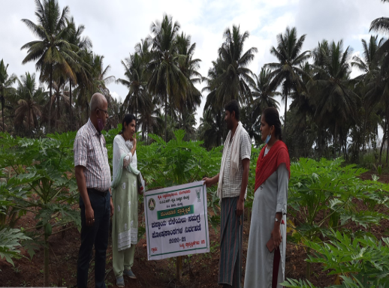 | 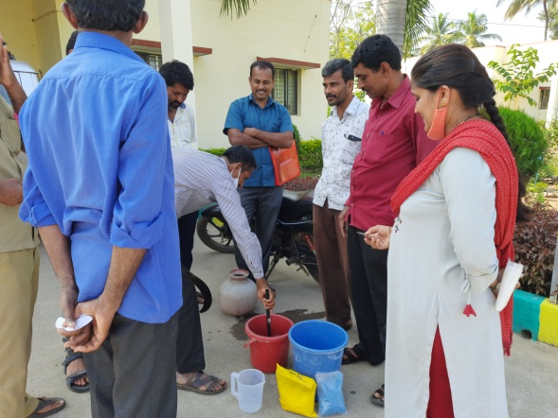
Papaya crop grown | Hands on experience during training
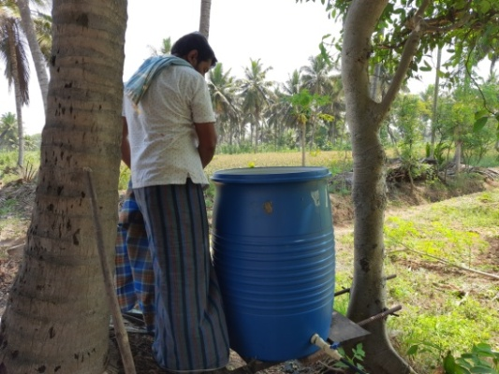
Preparing different inoculm in the farm and providing to crops through drip

10.D. Give details of Innovative Methodology or Innovative Approach of Transfer of Technology developed and used during the year

10.E. Give details of Indigenous Technical Knowledge practiced by the farmers in the KVK operational area which can be considered for technology development (in detail with suitable photographs)
S. No. | Crop / Enterprise | ITK Practiced | Purpose of ITK | Scientific Rationale
1 | Banana | Incorporation of neem, Pongamia, Cactus, ekka etc. before planting | To reduce rhizome weevil and fusarium wilt of Banana | Low yield and low quality fruit
2 | Sugarcane | Growing of Vegetables as in intercropping in Sugarcane | For vegetable purpose | Soil health management and additional income through vegetables
3 | Paddy | Use of Ekka (Aak) plant in paddy field | Green manure & pest and disease management | Soil health management and reduce pest & disease management
4 | Vegetables and nursery | Use of old two wheeler | For spraying of insecticide and fungicide | Cost saving and power saving
5 | Silkworm rearing | Country hen allowed in room after laying the plastic mountage | The pupae of ugi pest picked by country hen | Reduces the cocoon damage

10 F. Technology Week celebration: Nil

Period of observing Technology Week: From to
Total number of farmers visited :
Total number of agencies involved :
Number of demonstrations visited by the farmers within KVK campus :

Other Details
Types of Activities | No. of  Activities | Number of  Farmers | Related crop/livestock technology
Gosthies
Lectures organized
Exhibition
Film show
Fair
Farm Visit
Diagnostic Practicals
Supply of Literature (No.)
Supply of Seed (q)
Supply of Planting materials (No.)
Bio Product supply (Kg)
Bio Fertilizers (q)
Supply of fingerlings
Supply of Livestock specimen (No.)
Total number of farmers visited the technology week

10 E. Recognition and Awards: Please give details about National and State level recognition and awards

PART XI – SOIL AND WATER TEST

11.1 Soil and Water Testing Laboratory

A. Status of establishment of Lab : Good but lacks facility for analysis of plant samples
1. Year of establishment : 15th December 2005
2. List of equipments purchased with amount : Listed below

Sl. No | Name of the Equipment | Qty. | Cost | Status
1 | Digital conductivity meter | 1 No. | 7400 | Good condition
2 | Digital pH meter | 1 No. | 8550 | Good condition
3 | Physical balance | 1 No. | 12000 | Good condition
4 | Hot air oven | 1 No. | 20000 | Good condition
5 | Magnetic stirrer | 1 No. | 5500 | Good condition
6 | Top loading balance | 1 No. | 48900 | Good condition
7 | Rotory shaker | 1 No. | 27600 | Good condition
8 | Double glass distilation unit | 1 No. | 48850 | Good condition
9 | Macro block digestion system | 1 No. | 52118 | Good condition
10 | Automatic distilation system | 1 No. | 85232 | Good condition
11 | Acid neutrilizer scrubber | 1 No. | 23909 | Good condition
12 | Spectrophotometer | 1 No. | 42000 | Good condition
13 | Flame photometer | 1 No. | 35200 | Good condition
14 | Micro oven | 1 No. | 14980 | Good condition
15 | Micro scope | 1 No. | 66555 | Good condition
16 | Refrigerator | 1 No. | 30750 | Good condition
17 | Digital micro pipettes-one set | One set | 21180 | Good condition
18 | pH meter | 1 No. | 6600 | Good condition
19 | Laminar Air flow | 1 No. | 44900 | Good condition
20 | Auto clave | 1 No. | 28687 | Good condition
21 | Eliza reader | 1 No. | 147155 | Good condition
22 | Mridiparikshak soil testing kit | 1 No. | 86000 | Good condition
23 | Atomic absorption spectrophotometer | 1 No. | 2184732 | Good condition
24 | Double distillation unit | 1 No. | 98,000=00 | Good Condition
25 | End to end reciprocatory shaker | 1 No. | 70,00,000=00 | Good Condition
26 | UV vis spectrophotometer | 1 No. | 97000=00 | Good condition

B. Details of samples analyzed since establishment of SWTL:
Details | No. of Samples analyzed | No. of Farmers benefited | No. of Villages | Amount realized (Rs.)
Soil Samples | 5607 | 4554 | 1767 | 447970
Water Samples | 1810 | 1604 | 1280 | 268470
Plant samples | 91 | 52 | 15
Manure samples | 75 | 33 | 21
Others (specify) | - | - | -
Total

C. Details of samples analyzed during 2021:
Details | No. of Samples analyzed | No. of Farmers benefited | No. of Villages | Amount realized (Rs.)
Soil Samples | 560 | 560 | 522 | 112000
Water Samples | 642 | 642 | 612 | 128400
Plant samples
Manure samples
Others (specify)
Total |  |  |  | 240400

11.2 Mobile Soil Testing Kit
A. Date of purchase and current status
Mobile Kits | Date of purchase | Current status
- Pusa Digital STFR Meter Kit  (Model-WST- 201 P-GPS) | December 2015 | Good condition
- Mridi Parikshak | March 2017 | Good condition

B. Details of soil samples analyzed during 2021 and since establishment with Mobile Soil Testing Kit: -
 | During 2020 | During 2021 | Cumulative progress (Total)
Samples analyzed (No.) | - | - | -
Farmers benefited (No.) | - | - | -
Villages covered (No.) | - | - | -

11.3 Details of soil health cards issued based on SWTL & Mobile Soil Testing Kit:
Particulars | Date (s) | Villages (No.) | Farmers (No.) | Samples analyzed (No.) | Soil health cards issued (No.)
SWTL | January 2021 to January 2022 | 555 | 555 | 560 | 560
Mobile Soil Testing Kit
* Used for Electrical conductivity and pH recording

11.4 World Soil Health Day celebration
Sl. No. | Farmers participated (No.) | Soil health cards issued (No.) | VIPs (MP/ Minister/MLA attended (No.) | Other Public Representatives participated | Officials participated (No.) | Media coverage (No.)
1 | 67 | 67 | 02 | - | 05 | -

PART XII. IMPACT

12.A. Impact of KVK activities (Not restricted for reporting period).

Name of specific technology/skill transferred | No. of participants | % of adoption | Change in income (Rs.)
 |  |  | Before (Rs./Unit) | After (Rs./Unit)
Micro nutrient - Banana special | 200 | 70 | 62500 / ha | 864700 / ha
NB: Should be based on actual study, questionnaire/group discussion etc. with ex-participants.

12.B. Cases of large scale adoption (Please furnish detailed information for each case with suitable photographs)

12.C. Details of impact analysis of KVK activities carried out during the reporting period

PART XIII - LINKAGES

13A. Functional linkage with different organizations

Name of organization | Nature of linkage
Department of Agriculture, Mandya | Implemented a project entitled “Evaluation of pre and post emergence herbicides sequence for direct seeded rice (DSR) in Cauvery command area” funded by Department of Agriculture, Mandya
 | Joint Diagnostic visit for management of Fall army worm in Maize in Mandya District
Department of Horticulture | Technical support to FPOs through KVK under CHD programme (Demonstrations, Training programmes, Field visits and Interstate tours)
Department of Animal Husbandry & Veterinary Sciences | NADC, FMD & Brucellosis and artificial Insemination inauguration programme and vaccination to milking animals
NB The nature of linkage should be indicated in terms of joint diagnostic survey, joint implementation, participation in meeting, contribution received for infrastructural development, conducting training programmes and demonstration or any other

13B. List of special programmes undertaken by the KVK and operational now, which have been financed by State Govt./Other Agencies

Name of the scheme | Date/ Month of initiation | Funding agency | Amount (Rs.)
Creation of Seed Hubs for Increasing Indigenous Production of Pulses in India | April 2018 | IIPR, Khanpur | 1,50,00,000
Project entitled “Evaluation of pre and post emergence herbicides sequence for direct seeded rice (DSR) in Cauvery command area” | January 2019 | KSDA, GOK | 5,00,000
Technical support to FPOs through KVK | June 2018 | CHD, SADH | 3,09,750

13C. Details of linkage with ATMA : Nil

Coordination activities between KVK and ATMA
S. No. | Programme | Particulars | No. of programmes attended by KVK staff | No. of programmes Organized by KVK | Other remarks (if any)
01 | Meetings
02 | Research projects
03 | Training programmes
04 | Demonstrations
05 | Extension Programmes
 | Kisan Mela
 | Technology Week
 | Exposure visit
 | Exhibition
 | Soil health camps
 | Animal Health Campaigns
 | Others (Pl. specify)
06 | Publications
 | Video Films
 | Books
 | Extension Literature
 | Pamphlets
 | Others (Pl. specify)
07 | Other Activities (Pl.specify)
 | Watershed approach
 | Integrated Farm Development
 | Agri-preneurs development

13D. Give details of programmes implemented under National Horticultural Mission : Nil

S. No. | Programme | Nature of linkage | Funds received if any Rs. | Expenditure during the reporting period in Rs. | Constraints if any
- | - | - | - | - | -

13E. Nature of linkage with National Fisheries Development Board : Nil
S. No. | Programme | Nature of linkage | Funds received if any Rs. | Expenditure during the reporting period in Rs. | Remarks
- | - | - | - | - | -

13F. Details of linkage with RKVY : Nil
S. No. | Programme | Nature of linkage | Funds received if any Rs. | Expenditure during the reporting period in Rs. | Remarks
- | - | - | - | - | -

13G. Kisan Mobile Advisory Services

Month | No of Advisories | Message type (Text/Voice) | SMS/voice calls sent (No.) |  |  |  |  |  | Total SMS/Voice calls sent (No.) | Farmers benefitted (No.)
 |  |  | Crop | Livestock | Weather | Marketing | Awareness | Other enterprises
January | 18 | Text | 15 | - | 9 | - | - | - | 24 | 57100
February | 31 | Text | 13 | - | 8 | - | - | - | 21
March | 22 | Text | 11 | - | 9 | - | - | - | 20
April | 37 | Text | 9 | - | 9 | - | - | - | 18
May | 25 | Text | 8 | - | 8 | - | - | - | 16
June | 28 | Text | 13 |  | 9 |  | 3 | - | 25
July | 37 | Text | 14 | - | 9 | 1 | 1 | - | 25
August | 40 | Text | 17 | 1 | 9 | 1 |  | - | 28
September | 42 | Text | 13 | - | 8 | - |  | - | 21
October | 32 | Text | 15 | 1 | 9 | - |  | - | 25
November | 38 | Text | 15 | - | 9 | - |  | - | 24
December | 24 | Text | 14 | - | 9 | - |  | - | 23
Total | 374 | - | 157 | 2 | 105 | 2 | 2 | - | 270

PART XIV- PERFORMANCE OF INFRASTRUCTURE IN KVK

14A. Performance of demonstration units (other than instructional farm)

Sl. No. | Demo Unit | Year of  establishment | Area  (ha) | Details of production |  |  | Amount (Rs.) |  | Remarks
 |  |  |  | Variety | Produce | Qty. | Cost of inputs | Gross income
1. | Low cost Silkworm rearing house | 2013 | 800 Sqm | Double hyb. FC1 x FC 2 | Cocoons | 205 Kg | 30000 | 85959 | -
2. | Crop cafeteria | 2019 | 0.04 | - | Vegetables | 783 Kg | 3500 | 11745 | -
3. | Coconut Seedlings | 2018 | - | Tiptur tall | Seedlings | 1297 No. | 25000 | 129700 | -
4. | Coconuts | - | - | Tiptur tall | Coconuts | 1930 | 10000 | 27025 | -

14B. Performance of instructional farm (Crops) including seed production

Name  of the crop | Date of sowing | Date of harvest | Area (ha) | Details of production |  |  | Amount (Rs.) |  | Remarks
 |  |  |  | Variety | Type of Produce | Qty. | Cost of inputs | Gross income
Cereals
Paddy | January 2021 | 2021 | - | Jaya | Seed | 50 q | 25000 | 94500 | -
Pulses | - | - | - | - | - | - | - | - | -
Oilseeds | - | - | - | - | - | - | - | - | -
Fibers | - | - | - | - | - | - | - | - | -
Spices & Plantation crops
Coconut Seedlings | 2020 | 2021 | - | Tiptur tall | Seedlings | 1297 | - | 129700
Arecanut | 2020 | 2021 | - | Tiptur local | Seedlings | 2235 | 5000 | 67050
Betal vine | 2020 | 2021 | - | Mysore local | Seedlings | 106 | 1000 | 3180
Floriculture |  |  |  |  |  |  |  |  | -
Jasmine | 2020 | 2021 | - | Mysore mallige | Seedlings | 78 | 1000 | 2340
Fruits
Guava | 2020 | 2021 | - | Alahabad safed | Seedlings | 816 | 2000 | 48960 | -
Lemon | 2020 | 2021 | - | Balaji | Seedlings | 132 | 2000 | 7920
Sapota | 2020 | 2021 | - | Criket ball | Seedlings | 265 | 1500 | 15900
Mango | 2020 | 2021 | - | Alphenso | Seedlings | 243 | 1500 | 14580
Hanuman pala | 2020 | 2021 | - | Private hybrid | Seedlings | 87 | 1000 | 5220
Jamoon | 2020 | 2021 | - | AJS-85 | Seedlings | 127 | 2000 | 10160
Vegetables
Drumstick |  |  |  |  |  |  |  |  | -
Drumstick | 2020 | 2021 | - | PKM-1 | Seedlings | 2142 | - | 32130 | -
Curry leaf | 2020 | 2021 | - | Suhasini | Seedlings | 164 | - | 4920 | -
Others (specify)
Mulberry | 2020 | 2021 | - | V-1 | Saplings | 2300 | - | 6900 | -
Agase | 2020 | 2021 | - | Local | Seedlings | 656 | 2000 | 6560 | -

14C. Performance of production Units (bio-agents / bio pesticides/ bio fertilizers etc.,)

Sl.  No. | Name of the Product | Qty | Amount (Rs.) |  | Remarks
 |  |  | Cost of inputs | Gross income

14D. Performance of instructional farm (livestock and fisheries production)

Sl.  No | Name  of the animal / bird / aquatics | Details of production |  |  | Amount (Rs.) |  | Remarks
 |  | Breed | Type of Produce | Qty. | Cost of inputs | Gross income
1 | Poultry | BV-380 | Egg | 5944 | 10000 | 35664 | -
2 | Sheep | Bandoor | - | - | - | - | Rearing stage
3 | Goat | Bethal and Shirohi | - | - | - | - | Rearing stage

14E. Utilization of hostel facilities

Accommodation available (No. of beds)
Months | No. of trainees stayed | Trainee days (days stayed) | Reason for short fall (if any)
January | 32 | 5 | -
February | 29 | 4 | -
March | 0 | 0 | -
April | 23 | 6 | -
May | 0 | 0 | -
June | 0 | 0 | -
July | 0 | 0 | -
August | 3 | 4 | -
September | 0 | 0 | -
October | 0 | 0 | -
November | 0 | 0 | -
December | 8 | 5 | -

14F. Database management
S.No | Database target | Database created

14G. Details on Rain Water Harvesting Structure and micro-irrigation system

- Rain Water Harvesting Structure

Amount sanction (Rs.) | Expenditure (Rs.) | Details of infrastructure created / micro irrigation system etc. | Activities conducted |  |  |  |  | Quantity of water harvested in ‘000 litres | Area irrigated / utilization pattern
 |  |  | No. of Training programmes | No. of Demonstration s | No. of plant materials produced | Visit by farmers  (No.) | Visit by officials  (No.)

- Micro-irrigation systems

Amount sanction (Rs.) | Expenditure (Rs.) | Details of infrastructure created / micro irrigation system etc. | Activities conducted |  |  |  |  | Quantity of water harvested in ‘000 litres | Area irrigated / utilization pattern
 |  |  | No. of Training programmes | No. of Demonstration s | No. of plant materials produced | Visit by farmers  (No.) | Visit by officials  (No.)

PART XV – SPECIAL PROGRAMMES

15.1 Paramparagath Krishi Vikas Yojana (PKVY) : Nil
Sl No. | Name of cluster village | Initial soil fertility status (Average of cluster village) |  |  |  | Facilities created for organic source of manure | Name of Crops cultivated | Variety | Organic inputs applied including bio-agents and botanicals treatment | Yield (q/ha) | Economics
 |  | Aval. N | Aval. P | Aval. K | OC % |  |  |  |  |  | Cost of cultivation (Rs/ha) | Net returns (Rs/ha)
1 | 1.
 | 2.
2 | 1.
 | 2.

15.2 District Agriculture Meteorological Unit (DAMU)

Sl No. | Agro advisories |  |  | Farmers awareness programmes
 | No of Agro advisories generated | No of farmers registered for agro advisories | No of farmers benefitted | No of programmes | No of farmers benefitted
1 | 105 | 11837 | 11837 | 11 | 317

15.3 Fertilizer awareness programmeorganised
State | Name of KVK | Details of Activities/ programmeOrganised | Number of Chief Guests | No. of Farmers attended program | Total participants
Karnataka | Mandya | Webinar on ‘importance of fertilizer use based on soil test and fertilizer use efficiency, nano urea | IFFCO manager | 51 | 51

15.4 Seed Hub

Crops | Variety | Year of release | Production |  |  |  | No of farmers benefited/Sold to no. of farmers | Quantity seed sold (q)
 |  |  | Target (q) | Area (ha.) | Actual Production  (q) | Category  (FS/CS)
Greengram | KKM-3 |  | 200 |  | 18.50 | CS | 37 | 18.50
 |  |  |  |  | 2.57 | TL | 51 | 2.5
Blackgram | LBG-791 |  | 300 |  | 117.66 | TL | 235 | 81.84
Cowpea | KBC-9 |  | 150 |  | 15.90 | FS | 318 | 15.90
 | KBC-9 |  |  |  | 6.61 | TL | 132 | 6.61
 | C- 152 |  |  |  | 0.54 | TL | 10 | 0.54
Avare | HA-3 |  |  |  | 0.60 | FS | 12 | 0.4
 | HA-3 |  |  |  | 0.89 | CS | 17 | 0.6
 | HA-3 |  |  |  | 8.87 | TL | 177 | 8.87
 | HA-4 |  |  |  | 2.07 | TL | 41 | 2.07
Redgram/Pigeonpea | BRG-3 |  |  |  | 20.71 | TL | 414 | 18.0
 | BRG-1 |  |  |  | 7.98 | TL | 159 | 7.98
Horsegram | PHG-9 |  |  |  | 4.30 | TL | 86 | 2.8
Total |  |  | 1000 |  | 207.20

15.5 CFLD on Oilseeds: Nil

Sl.No. | Crop | Varieties demonstrated and check | Allocated |  | Implemented
 |  |  | Area (ha) | Demos (No.) | Area (ha) | Demos (No.)
 | - | - | - | - | - | -
 | Total

15.6 CFLDs on Pulses:

Sl.No. | Crop | Varieties demonstrated and check | Allocated |  | Implemented
 |  |  | Area (ha) | Demos (No.) | Area (ha) | Demos (No.)
1 | Redgram | BRG-3 | 10 | 25 | 10 | 25
 | Total |  | 10 | 25 | 10 | 25

15.7 Krishi Kalyan Abhiyan (Aspirational districts) : Nil

Type of Activity | Date(s) conducted | No. of farmers (General) |  |  | No. of farmers  SC / ST |  |  | No. of extension personnel
 |  | Male | Female | Total | Male | Female | Total | Male | Female | Total

15.8 Micro-Irrigation : Nil

Type of Activity | Date(s) conducted | No. of farmers (General) |  |  | No. of farmers  SC / ST |  |  | No. of extension personnel
 |  | Male | Female | Total | Male | Female | Total | Male | Female | Total
- | - | - | - | - | - | - | - | - | - | -

15.9 Tribal Sub-Plan (TSP) : Nil
Farmer Training |  | Women Farmer Training |  | Rural Youths |  | Extension Personnel |  | OFT (No of Technologiess) | Number of farmers involved |  |  | Participants in extension activities (No.) | Production of seed (q) | Production of Planting material (Number in lakh) | Production of Livestock strains (Number in lakh) | Production of fingerlings (Number in lakh) | Testing of Soil, water, plant, manures samples (Number)
No. of Trainings/Demos | No. of Farmers | No. of Trainings/Demos | No. of Women Farmers | No. of Trainings/Demos | No. of Youths | No. of Trainings/Demos | No. of Ext. Person |  | On- farm trials | Frontline demos | Mobile agro- advisory to farmers

15.10 SCSP : Nil

Farmer Training |  | Women Farmer Training |  | Rural Youths |  | Extension Personnel |  | OFT (No of Technologiess) | Number of farmers involved |  |  | Participants in extension activities (No.) | Production of seed (q) | Production of Planting material (Number in lakh) | Production of Livestock strains (Number in lakh) | Production of fingerlings (Number in lakh) | Testing of Soil, water, plant, manures samples (Number)
No. of Trainings/Demos | No. of Farmers | No. of Trainings/Demos | No. of Women Farmers | No. of Trainings/Demos | No. of Youths | No. of Trainings/Demos | No. of Ext. Person |  | On- farm trials | Frontline demos | Mobile agro- advisory to farmers

15.11 NARI : Nil

Activity | Achievement
 | Number of activity | No. of farmers/ beneficiaries
OFTs – Nutritional Garden (activity in no. of Unit)
OFTs – Bio-fortified Crops (activity in no. of Unit)
OFTs – Value addition(activity in no. of Unit/Enterprise)
OFTs - Other Enterprises (activity in no. of Unit/Enterprise) (activity in no. of Unit/Enterprise)
FLDs – Nutritional Garden (activity in no. of Unit)
FLDs – Bio-fortified Crops (activity in no. of Unit)
FLDs – Value addition(activity in no. of Unit/Enterprise)
FLD- Other Enterprises (activity in no. of Unit/Enterprise) (activity in no. of Unit/Enterprise)
Trainings
Extension Activities

15.12 KVK Portal

No. of Events added by KVKs | No. of Facilities added by KVKs | Filled Report on Package of Practices (Y/N) |  |  |  | Filled Profile Report (Y/N)
 |  | Crop | Livestock | Fisheries | Horticulture | Employees | Posts | Finance | Soil Health Cards | Appliances | Crops | Resources | Fish
230 | 8 | Y | N | N | Y | Y | Y | N | Y | N | N | Y | N

15.13 KSHAMTA

Number of Adopted Villages | No. of Activities |  | No. of farmers benefited
 | Demo | Training | Demo | Training
1 | - | - | - | -

15.14 DFI

Sl | District | Taluks | Villages | Farmers (No.) | Average Benchmark Income (Rs/year) | Crops/ enterprises | KVK Interventions | Additional Net Income generated due to KVK interventions (Rs/year) | Total income of farmer (Rs/year)
1 | Mandya | Mandya | Holalu cluster | 10 | 118692.6 | Paddy  Coconut  Vegetable | ICM  IPDM  Animal husbandry | 140039 | 258731.6
2 |  |  | Hadya cluster | 53 | 178267.208 | Paddy  Pulses  Coconut  Mulberry | ICM  IPDM  Animal husbandry | 282715.623 | 460982.8302
3 |  | Nagamangala | Brahmadevarahalli  cluster | 14 | 344058.5 | Vegetable  Coconut  Sheep  Goat | ICM  IPDM  Animal husbandry | 432154.571 | 776213.0714
4 |  | Maddur | Sollepura  Cluster | 5 | 255780 | Paddy  Sugarcane  Ragi | ICM  IPDM  Animal  husbandry | 370624 | 626404
5 |  | Malavalli | Nelamakanahalli | 8 | 162250 | Paddy  Coconut  Ragi  Vegetable | ICM  IPDM | 1005533.333 | 1167783.333
6 |  | Srirangapatna | Hosuru | 6 | 168133.3333 | Paddy  Sugarcane  Coconut  Mulberry | ICM  IPDM  Animal  husbandry | 366237 | 534370.3333
7 |  | Pandavapura | M.Shettihalli | 8 | 298920 | Coconut  Banana  Ginger  Arecanut | ICM  IPDM  Animal husbandry | 370841.25 | 669761.25
8 |  | K.R.Pete | Akkihebbalu | 6 | 184500 | Sugarcane  Banana  Coconut  Ginger | ICM  IPDM  Animal  husbandry | 210500 | 395000

PART XVI - FARMERS FEEDBACK ON ASSESSED/DEMONSTRATED TECHNOLOGIES OF CROPS / LIVESTOCK

16.1 Farmers feedback on performance of crop varieties/hybridds

Sl. No. | Crop varieties/hybrids assessed/ demonstrated | Farmer’s feedback
1 | Paddy : MSN-99 | Short duration, medium size grains, high yielding
2 | Finger millet : KMR-630 | Short duration, high yielding, no lodging
3 | Maize : MAH-14-5 | high yielding, leaves remain green at harvesting, hence it is also suitable for fodder
4 | Field bean : HA-3 | Suitable for all the seasons, good aroma, high yielding
5 | Ridge Gourd: Arka Vikram | Early flowering, high yielding variety and decrease in fruit borer infestation
6 | Chrysanthemum: CO-1 | Yellow colored flower variety, more consumer preference at market and high yield
7 | ArkaKyati | Hybrid having high yielding capacity with low leaf curl incidence But pungency of the fruit is very low
8 | AkraAbhed | Yield of the hybrid is very good with less disease. Some fruits are very big in size which reduces the market price

16.2 Farmers feedback on performance of agronomic practices
Sl. No. | Agronomic practices | Farmer’s feedback
1 | Integrated weed management : Application of pre emergent herbicide (Ben sulfuron Methyl + Pretilachlor) and hand weeding | - Less labour requirement  - Effective weed management  - Low cost of cultivation
2 | - Seed treatment with biofertilizer (Azospirillum and PSB @ 200g/acre each)  - Application of Zinc sulphate (8kg/acre)  - Application of pre emergence herbicide Atrazine @1 kg a.i. /ha | - Increase in yield  - Effective weed management
3 | - Seed treatment with biofertilizers viz., Rhizobium and PSB  - Foliar spray of DAP @2% at 45 DAS | - Increase in pod filling percentage  - Increase in yield
16.3 Farmers feedback on performance of pest and disease management in crops

Sl. No. | Pest and disease management in crops | Farmer’s feedback
1 | Ginger | Rhizome rot was very much reduced with low cost inputs
2 | Banana | IDM practices helps in reduction of Panama wilt by using bio agents
3 | Ridge gourd | Use of pheromone traps helps in reduction of Fruit fly damage and reduced chemicals spay numbers
4 | Cabbage | Use of low cost technologies like pheromone traps, sticky trap, Bt liquid helps is reduction of DBM population with less chemical spray
5 | Tomato | Use of disease resistance hybrid with IPDM practices helps is getting high yield with low cost of cultivation
6 | Chilli | Use of ArkaKyati hybrid gave good yield and IPM practices results in no leaf curl symptom
7 | Capsicum | IPM practices helps in reduction of sucking pest damage with low cost of cultivation

16.4 Farmers feedback on performance of farm machinery technologies-Nil
Sl. No. | Farm machinerytechnologies | Farmer’s feedback

16.5 Farmers feedback on performance of livestock and fisheries technologies-Nil
Sl. No. | Livestock/fisheries technologies | Farmer’s feedback

PART XVII - FINANCIAL PERFORMANCE

17A. Details of KVK Bank accounts

Bank account | Name of the bank | Location | Branch code | Account Name | Account Number | MICR Number | IFSC Number
With Host Institute | State Bank of India | V.C.Farm | 40164 | Saving | 54046591066 | 000006000 | SBIN0040164
With KVK | State Bank of India | V.C.Farm | 40164 | Saving | 54046591066 | 000006000 | SBIN0040164
 | State Bank of India | V.C.Farm | 40164 | Saving | 64004043829 | 000006000 | SBIN0040164

17B. Utilization of KVK funds during the year 2020-21(Rs. in lakh)
S.  No. | Particulars | Sanctioned | Released | Expenditure
A. Recurring Contingencies
1 | Pay & Allowances | 140.0 | 140.0 | 90.10
2 | Traveling allowances | 1.0 | 1.0 | 0.96
3 | Contingencies
A | Stationery, telephone, postage and other expenditure on office running, publication of Newsletter and library maintenance (Purchase of News Paper & Magazines) | 1.95 | 1.95 | 1.85
B | POL, repair of vehicles, tractor and equipments | 1.73 | 1.73 | 1.65
C | Meals/refreshment for trainees (ceiling upto Rs.40/day/trainee be maintained) | 1.0 | 1.0 | 0.87
D | Training material (posters, charts, demonstration material including chemicals etc. required for conducting the training) | 0.50 | 0.50 | 0.47
E | Frontline demonstration except oilseeds and pulses (minimum of 30 demonstration in a year) | 6.50 | 6.50 | 5.80
F | On farm testing (on need based, location specific and newly generated information in the major production systems of the area) | 0.80 | 0.80 | 0.43
G | Training of extension functionaries | 0.30 | 0.30 | 0.13
H | Maintenance of buildings | 0.50 | 0.50 | 0.50
I | Establishment of Soil, Plant & Water Testing Laboratory | 0.10 | 0.10 | 0.02
J | Library
TOTAL (A)
B. Non-Recurring Contingencies
1 | Works
2 | Equipment including SWTL & Furniture | 6.0 | 6.0 | 0
3 | Vehicle (Four wheeler/Two wheeler, please specify)
4 | Library (Purchase of assets like books & journals)
TOTAL (B)
C. REVOLVING FUND
GRAND TOTAL (A+B+C) |  | 160.38 | 160.38 | 102.80

17C. Status of revolving fund (Rs. in lakh) for the last three years
Year | Opening balance as on 1st January | Income during the year | Expenditure during the year | Net balance in hand as on 31st December of each year
January to December 2019 | 3.91 | 28.99 | 20.83 | 8.16
January to December 2020 | 8.16 | 10.14 | 12.23 | 6.06
January to December 2021 | 6.06 | 18.05 | 13.10 | 11.02

18. Details of HRD activities attended by KVK staff

Name of the staff | Designation | Title of the training programme | Institute where attended | Dates
Dr. Naresh, N.T | Senior Scientist & Head  (Agril. Extension) | Promotion of Public Private Partnership in Agriculture and Allied Sectors | National Institute of Agricultural Extension Management (MANAGE) Hyderabad | 27.09.2021 to 01.10.2021
 |  | Agricultural Legislations for Agricultural Extension Professionals | National Institute of Agricultural Extension Management (MANAGE) Hyderabad | 20.10.2021 to 24.10.2021
Dr. Roopashree, D.H | Scientist (Agronomy) | Climate risk assessment and its management through agrometeorological approaches | Dry research centre, Kashmir | 21.10.2020 to 30.10.2020
 |  | Community radio awareness workshops | Vishwas Dnyan Prabodhini and Research Institute, Nashiki | 09.11.2021 to 11.11.2021
Dr. Atheefa Munawery | Scientist (Soil Science) | Agricultural Research methodologies practices and their management | Central Agricultural University, Impal, SVWS | 04.10.2021 to 24.10.2021
 |  | Capacity development program on virtual Farmers Field School | ATARI, Bangalore and Agricultural University, Shimogga | 14.06.2021
 |  | Digital marketing part-2  Effective utilization of digital media | ASSOCHAM, New Delhi | 24.09.2021
 |  | Bio-fortification – A way for sustainable nutrition | ASSOCHAM, New Delhi | 01.10.2021
 |  | International webinar on Business opportunities in exporting if spices | Alumini Association of UAS, Bangalore | 04.07.2021

Dr.Pavithra.S | Scientist (Plant Protection) | Innovative integrated pest management practices | ATARI, CIPMC
 |  | Agricultural Research methodologies practices and their management | Central Agricultural University, Impal, SVWS | 04.10.2021 to 24.10.2021
Dr.Prakash.B.K | Scientist (Sericulture) | Promotion of Public Private Partnership in Agriculture and Allied Sectors | National Institute of Agricultural Extension Management (MANAGE) Hyderabad | 27.09.2021 to 01.10.2021
 |  | Agricultural Legislations for Agricultural Extension Professionals | National Institute of Agricultural Extension Management (MANAGE) Hyderabad | 20.10.2021 to 24.10.2021
 |  | International Virtual Conference on “Improving Rural Economy through Innovative Extension Approaches” | Department of Agricultural Extension, Faculty of Agriculture, Annamalai University, Annamalai Nagar, Tamil Nadu, India. | 1st October, 2021,
Mr. Mahesha, H.M | Programme Assistant (Lab.) | Linking FPO for Agri Exports | National Institute of Agricultural Extension Management | 7th to 9th September, 2021

19. Please include any other important and relevant information which has not been reflected above (write in detail).

Related photos:

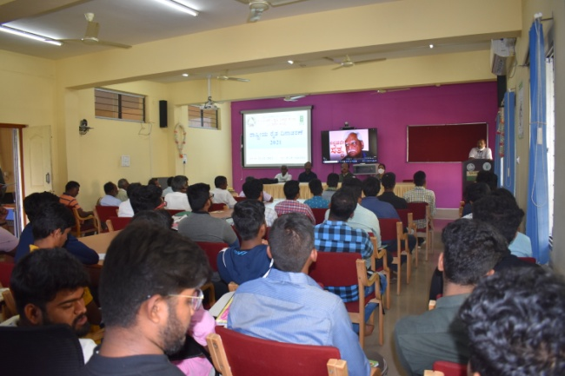 | 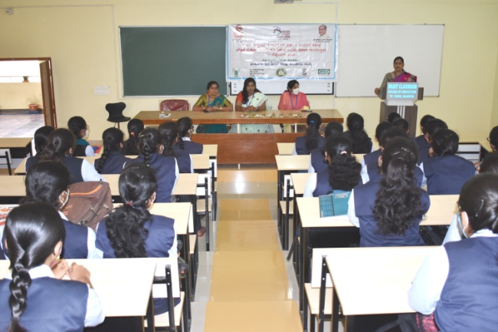
Farmers Day-2021 | Awareness about balanced nutrition in adolescents
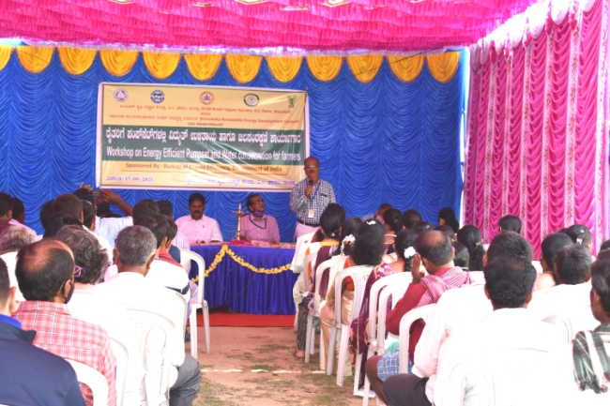 | 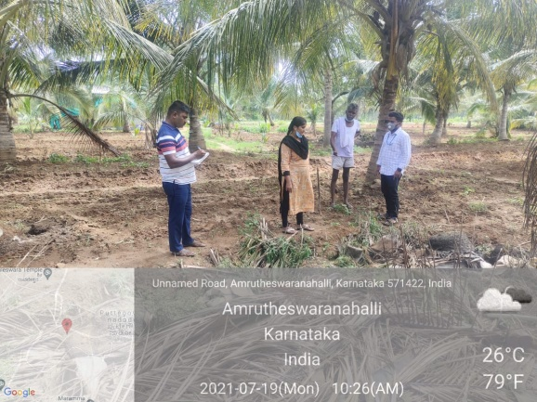
Energy Efficient Pump-sets and Water Conservation | Diagnostic visit to pest infested in coconut orchard
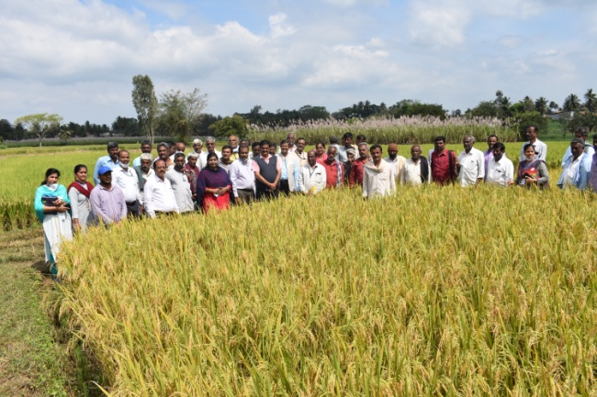 | 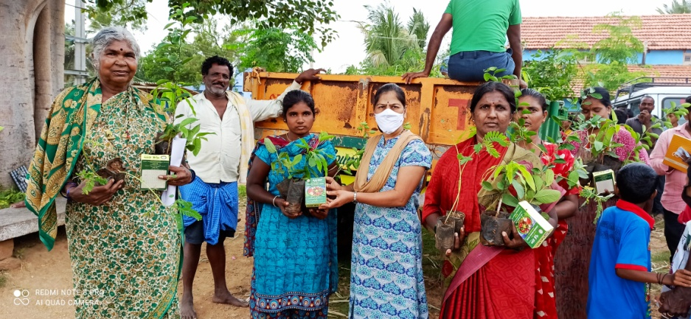
Field day - New paddy variety MSN-99 | Kitchen garden
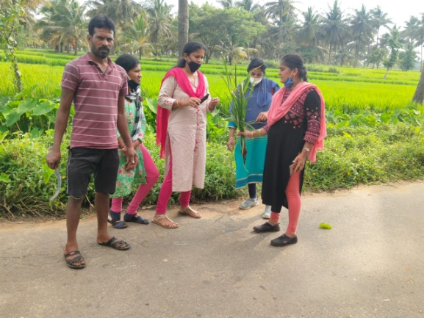 | 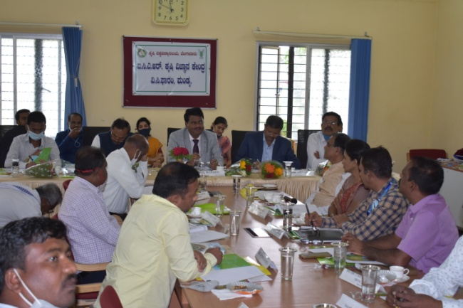
Diagnostic visit | Interaction with the line department officials at 19th SAC meeting
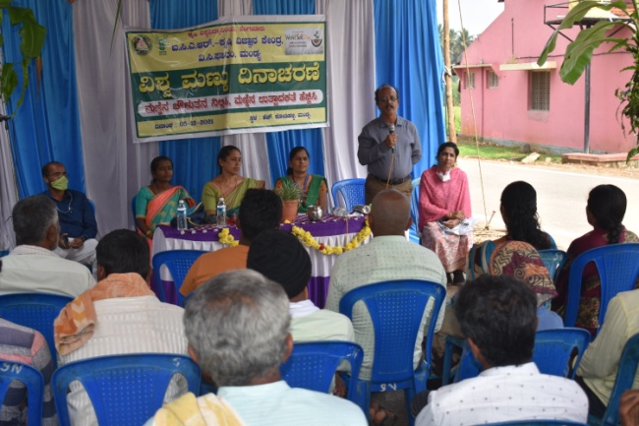 | 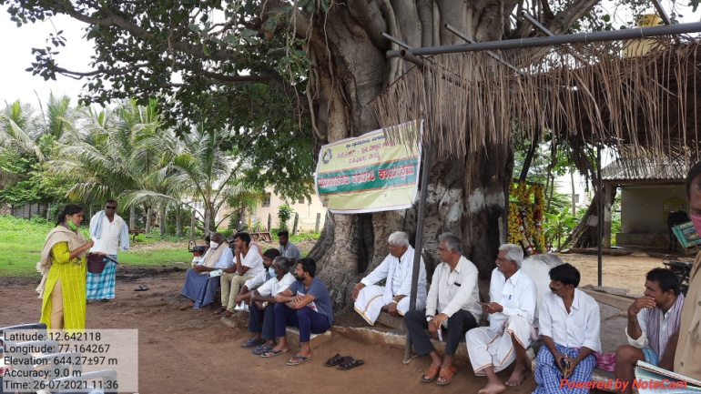
Information on importance of soil | Off campus training progm.
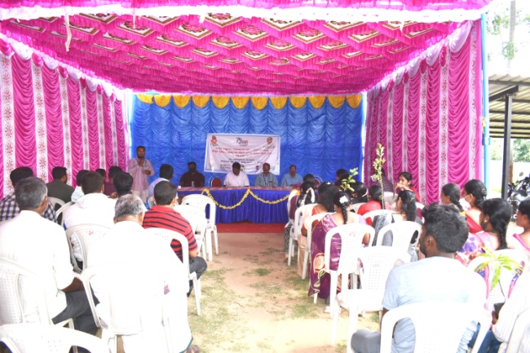 | 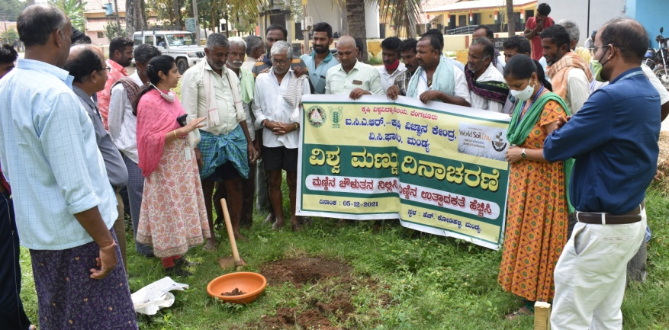
Poshan Mah and Tree Plantation Campaign | Soil sampling demo
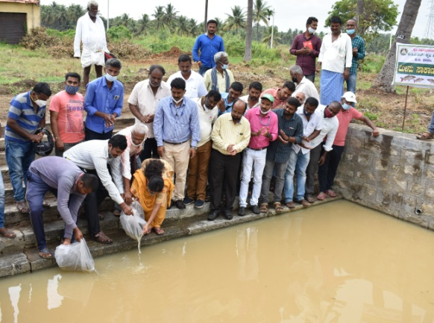 | 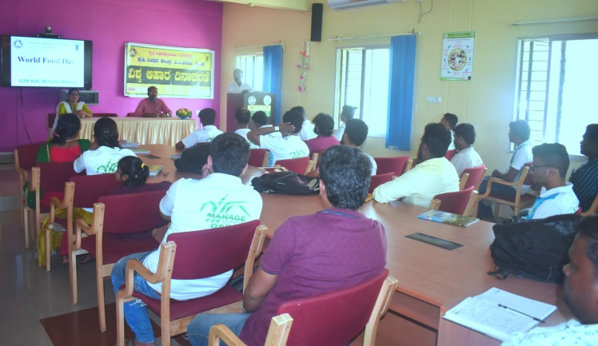
Release of fingerlings in farm pond | World food program
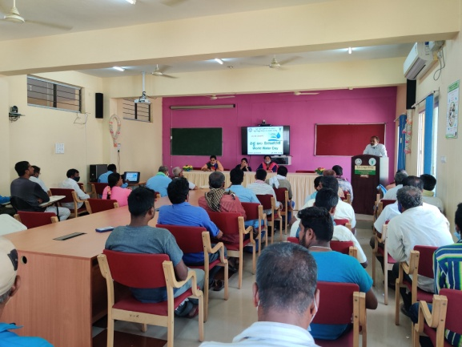 | 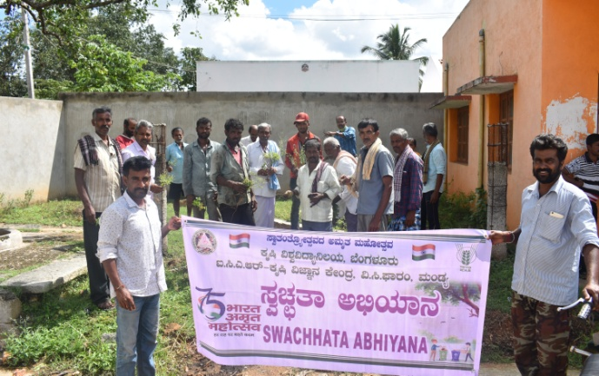
World water day | Swachhta Abiyan

>><<<><><><><>>><<

