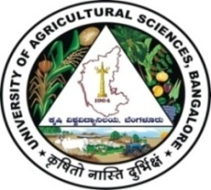 | University of Agricultural Sciences, Bangalore  ICAR-Krishi Vigyan Kendra, Bengaluru Rural District  Krishi Mantana  Vol. 9 Quarterly Newsletter (April - June, 2021) No. 2
Pre Action plan meeting

Pre Action plan meeting of UAS, Bangalore KVKs, KVK Kolar, KVK Tumkur and KVK Mysore for the year 2021-22 was held on 6th and 7th April 2021 at ICAR-Krishi Vigyan Kendra, Hadonahalli under the Chairmanship of Dr. M. Byre Gowda, Director of Extension, UAS, Bangalore. Dr. K. Narayana Gowda, Associate Director of Extension, Dr. Niranjana Murthy, Associate Director of Research, Dr. B.N. Manjunath, Head, ATIC, Dr. H.K. Ramappa, Professor, Dept. of Plant pathology, Dr. K. Murali, Professor, Agronomy, Dr. G.S. Nagaraj, Head, STU and UAS, Bangalore were participated as Technical officers. Senior Scientists and Heads of all the KVKs were presented the Action plan for the year 2021-22 and obtained the approval after modifications. 60 members including Scientists and technical staff were participated in the programme.
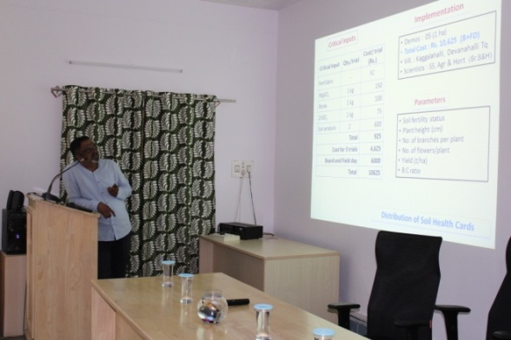 | 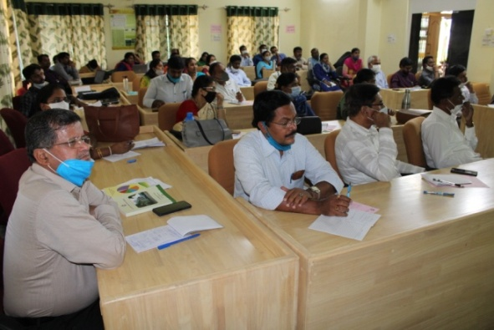

World Environment Day 2021
ICAR – Krishi Vigyan Kendra, Bengaluru Rural District organized ‘World Environment Day 2021’ on 5th June 2021 in collaboration with Indian oil corporation Ltd. Dr. A.P. Mallikarjuna Gowda, Senior Scientist and Head has briefed about the importance of ‘World Environment Day’ in the introductory remarks. Further, explained about the theme of the year “Ecosystem Restoration” and mentioned that, present industrialization and urbanization has increased the pollution, which leads to adverse effect on environment and there is a need to conserve ecosystem. And also stressed on planting more numbers of trees, the duty of everyone and joining together in this drive is very important to conserve environment. The programme was arranged with the Hon’ble Prime Minister Live programme on addressing the occasion.
During the programme Mrs. Megha Singh, Assistant Manager, Indian Oil Corporation Ltd., (LPG Sales Division), Scientists and staff of Krishi Vigyan Kendra and 30 Farmers & Farmwomen were participated in the programme with maintaining proper social distancing.
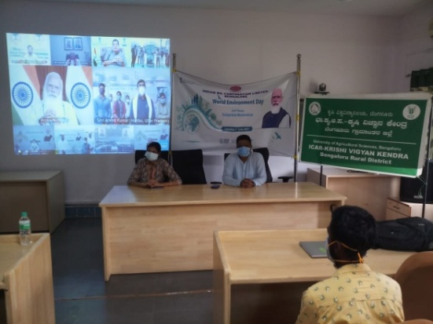 | 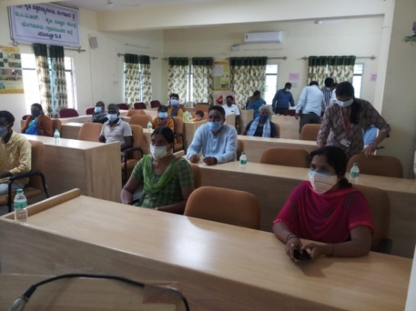
World Environment day celebration

Skill Training Programme on Value addition of Nutri millets sponsored by MANAGE, Hyderabad

ICAR-Krishi Vigyan Kendra, Bengaluru Rural District organized six days Skill development training programme on “Value addition of Nutri millets” sponsored by MANAGE, Hyderabad to Rural youth from 19th to 23rd and 26th April 2021. During the training programme, Scientists explained about the Improved cultivation practices of minor millets, Storage techniques, Value addition, Packing, Labelling, Market linkage, Entrepreneurship development etc. to the trainees. Hands on training on preparation of value added products viz., pakoda, chakkali, papad, shankarpoli, mixture, nippattu was imparted to the trainees. 15 Rural youths were benefited from the training programme.
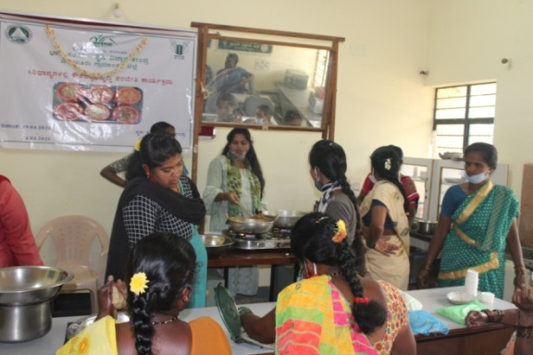 | 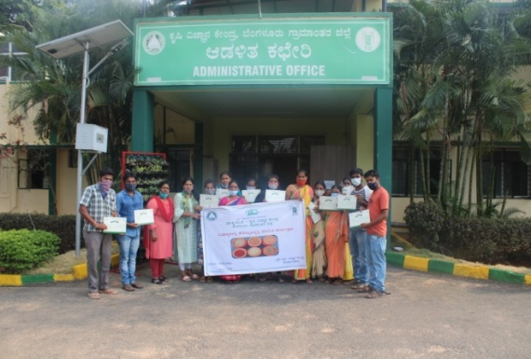

Action taken on agricultural sector during COVID-19 in Bengaluru Rural District through Marketing facilitation to farmers of Bengaluru Rural District for various commodities

KVK, Bengaluru Rural District taken the utmost responsibility to help the farmers in the district during the crisis of COVID-19, the growers were directly linked to consumers. Created market linkage for 59 tonnes of fruits and vegetables, farmers sold 8.5 tonnes of fruits and vegetables directly to the consumers. KVK also advised and assisted farmers to sell their produce in linkage with Ninjacart, Safal, HOPCOMS, APMC etc.

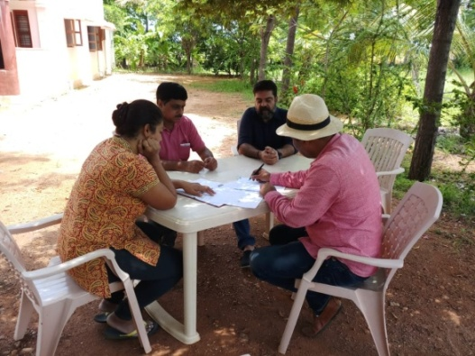 | 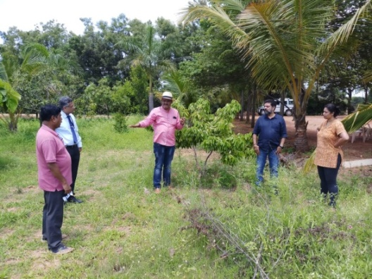
Marketing facilitation to farmers of Bengaluru Rural District for various commodities

Online training programmes/Webinars during COVID-19

Scientists of KVK, Bengaluru Rural District were organized eight online trainings/webinars on various topics viz., Strengthening and feed management in sheep and goat rearing, Construction and maintenance of sheep and goat rearing house, Mushroom cultivation for sustainable livelihood, Soil health in sustainable agriculture, Importance of milk & milk production , Clean milk production, Fertilizer awareness campaign, Management of pests & disease in flower crops, Entrepreneurship opportunities in floriculture, Improved Coconut production practices to 519 farmers and two webinars exclusively for Extension workers.
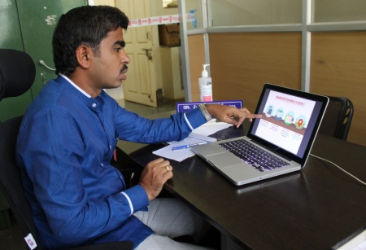 | 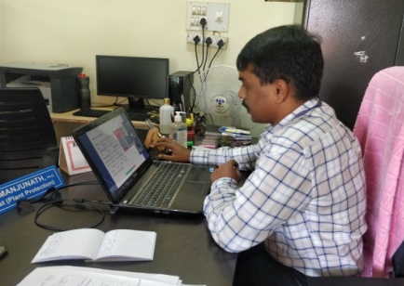
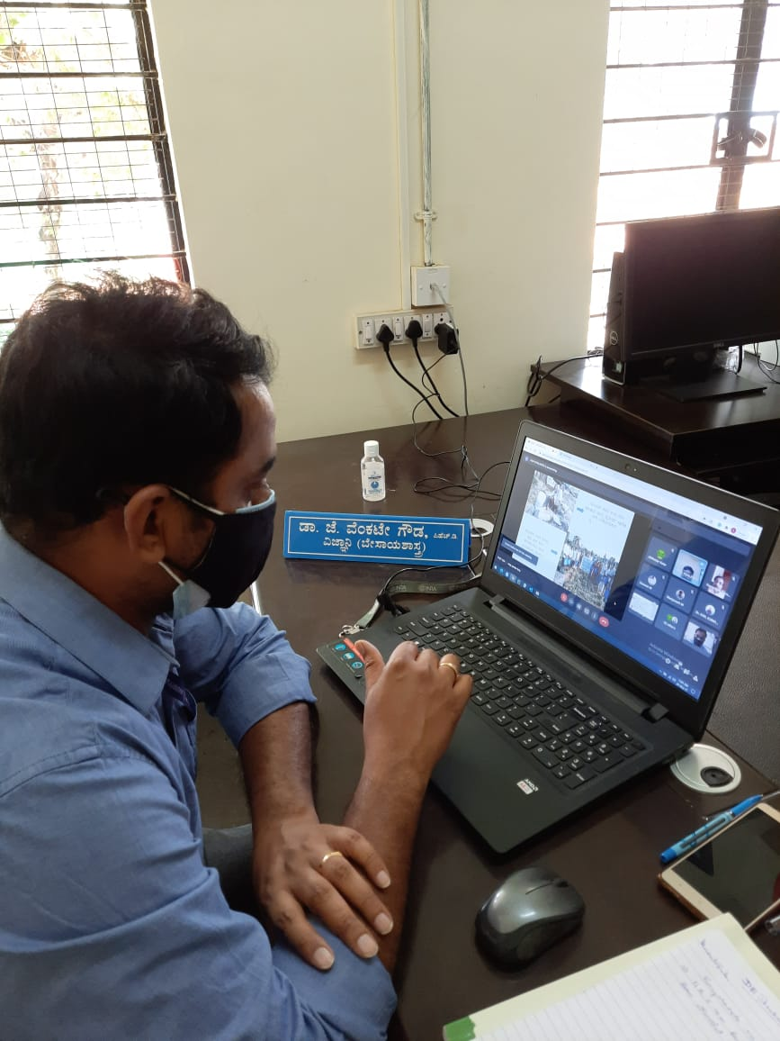 | 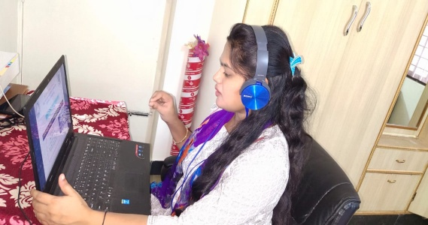

ZREP Workshop
The Director of Research organized online ZREP workshop on 08.04.2021 to present the results of farm trials, multi location trials and PoP. The Senior Scientist and Head, Scientists of ICAR-Krishi Vigyan Kendra, Bengaluru Rural District actively participated in the Webinar and presented the results. Sri Vasudevappa and Sri Kantharaju from Thuruvanahalli were participated in the workshop as farmer representatives.

Bimonthly Workshop
Online Bi-monthly meeting was held on 20.05.2021 and topics like Agronomic practices of field crops, Soil and water conservation methods, Management of pests and diseases in maize, ragi, redgram and field bean and contingent crop plan, cropping system to be followed under rainfed situation in Bengaluru Rural District were
Rejuvenation of farm pond

The existing farm pond was rejuvenated by providing shoring, strutting and bracing, removal of stumps and other detritus matter, dressing of sides and bottom, filling back the excavation earth to the extent required and utilizing/transporting the remaining earth up to 1.00 km by using JCB for 1400 Cum.
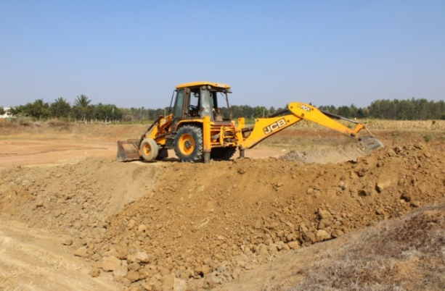 | 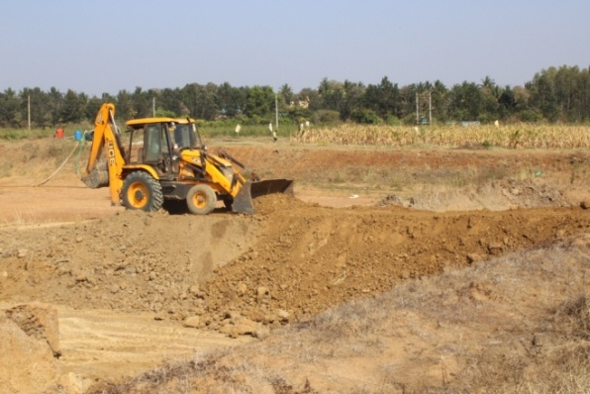

Services available at KVK
- Analysis of soil and water samples and advisory services
- Analysis of infected plant samples and advisory services about IPM practices
- Production and sale of quality planting material and advisory services
- Millets Processing Centre and KVK Marketing Complex
- Production and Sale of Pongamia oil, Pongamia cake and biofuel
Services and Sale of Technological Inputs
- Analysis of 20 Soil and 12 Water samples of farmers and advisory services
- Sale of 1331 quality horticultural planting materials
----------------------------------------------------------------------------------------------------
Chief Editor  Dr. A. P. Mallikarjuna Gowda  Senior Scientist & Head  Editor and Associate Editors  Dr. B. Manjunath, Scientist (Plant Protection)  Dr. J. Venkate Gowda., Scientist (Agronomy)  Dr. P. Veeranagapa., Scientist (Soil Science)  Dr. Y. D. Chithra., Scientist (Agril. Extension)  Sri N. Jagadish, Farm Manager  Smt. B. V. Manjula, Programme Assistant (Lab)  Smt. Sukanya, G.V., Programme Assistant (Computer) | Contact For Further Information:  Senior Scientist & Head  ICAR- Krishi Vigyan Kendra, Hadonahalli Doddaballapura Taluk, Bengaluru Rural District Karnataka – 561205, Phone: 94498 66928  Email: kvkbrd@gmail.com  Website: www.kvkbrd.org  To  -----------------------------------------------------  -----------------------------------------------------  -----------------------------------------------------

