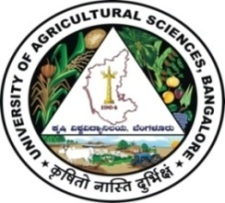 | University of Agricultural Sciences, Bangalore  ICAR-Krishi Vigyan Kendra, Bengaluru Rural District  Krishi Mantana  Vol. 9 Quarterly Newsletter (July - September, 2021) No. 3 | 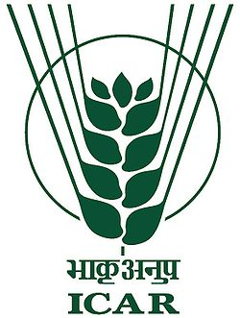
Parthenium Awaress week

Parthenium is major weed causing more damage for cultivation of crops and also mankind. In this regard, Parthenium Awareness Week was celebrated from 16th to 22nd August 2021 at ICAR-KVK, Bengaluru Rural District by conducting series of programmes on 17.08.2021 at Vaddarahalli and on 18.08.2021 at ICAR-Krishi Vigyan Kendra, Hadonahalli, Doddaballapura taluk in collaboration with AICRP on Weed Control Project, Hebbal, UAS, Bengaluru. Dr. A. P. Mallikarjuna Gowda, Senior Scientist and Head, briefed the gathering about significance of celebration and the harmful effects caused by parthenium. Dr. J. Venkate Gowda, Scientist (Agronomy) explained about parthenium control including removing plant before flowering stage and spraying of recommended weedicides.
Dr. K.N. Geetha, Professor and Head, AICRP-Weed Control and Dr. S. Kamala Bai, Junior Agronomist were participated in the programme and briefed about various cultural methods of eradication, various management techniques such as methods of composting and biological control methods for its control. KVK staff and all participants were uprooted parthenium weeds in the campus premises.

Inauguration of 5th batch DAESI programme for input dealers

The inauguration of ‘5th Batch Diploma in Agricultural Extension Services for Input Dealers was held on 02.09.2021 at ICAR Krishi Vigyan Kendra, Hadonahalli, Bengaluru Rural District.
Dr. A.P. Mallikarjuna Gowda, Senior Scientist and Head, KVK, Bengaluru Rural District preamble the programme and introduced the students. He highlighted the mandates of DAESI programme and role of Input dealers in Agriculture as a para Agriculture Extension workers. He mentioned the importance of diploma for input dealers to maintain integrity in their business services. Further he informed all the trainees to maintain punctuality, discipline and sincerity in attending the classes and doing the designated roles.
The programme was inaugurated by Dr. S. Rajendra Prasad, Vice- Chancellor, UAS, Bangalore by pouring water to the plant along with other dignitaries. In his inaugural address, he explained the growth of agriculture from post Independence to till time. He highlighted the role of extension services of input dealers for the farming community to double the farmers income.
Dr. N. Devakumar, Director of Extension, UAS, Bangalore in his presidential remarks, briefed the students about importance of contact classes and urged to provide technical information to the farmers in a benefitting manner not only in a business point of view but in service motto.
Dr. Pennobali Swamy, State nodal officer, Mr. Obaleshappa, Facilitator, DAESI programme and staff of Krishi Vigyan Kendra, Bengaluru Rural District and 40 DAESI students were participated in the programme and visited the KVK demonstration plots.
During this occasion, newly built Conference hall at first floor of KVK administrative building was inaugurated by the dignitaries.
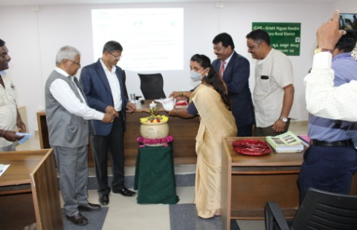 | 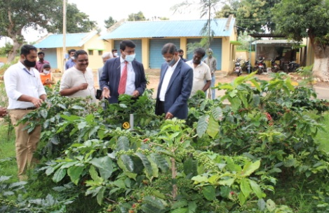 | 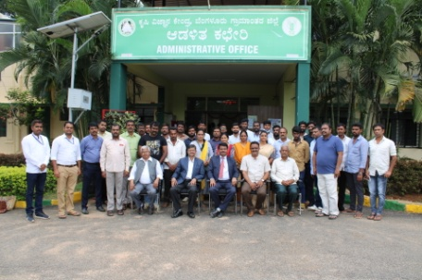
Inaguration of 5th batch DAESI programme | Hon’ble VC visited the KVK demo units | 5th batch DAESI students

Training Programme On Role of Micronutrients in Daily Diet
ICAR-Krishi Vigyan Kendra, Bengaluru Rural District in association with All India Coordinated Research Project (Home Science), GKVK, Bengaluru and Women and Child Welfare Department, Doddaballapura Taluk organized one day training programme to celebrate National Nutrition Week on “Role of Micronutrients in Daily Diet” on 6th September 2021 to farm women with a theme of ‘Feeding Smart Right from Start’. The objective of the training programme was to create awareness about good nutrition and health to make people understand the importance of nutritional and adaptive eating habits so that they can maintain a healthy lifestyle. The occasion was presided by Dr. Manjunath B., Scientist (Plant Protection), KVK, Bengaluru Rural District.
Dr. Shilpa Yathnatti, Research Associate, AICRP (Home Science), GKVK, Bengaluru addressed the importance of food and nutrition, types of malnutrition, role of macro and micronutrients in daily diet, water and fat soluble vitamins, deficiency disorders of vitamins, RDA for vitamins, foods rich in vitamins, macro and micro minerals and their deficiency disorders, RDA for minerals, foods rich in minerals. Also dealt in detail about anaemia, role of red blood cells, formation of red blood cells, WHO classification of anaemia and methods to prevent anaemia. At the end of the programme quiz related to micronutrients was organized for the womens.
Miss Meghana, S. V., Scientist (Home Science), KVK, Hadonahalli, Dr. Chaitra, Scientist (Agril. Extension), KVK, Hadonahalli, Dr. Sneha, SRF, AICRP (Home Science), GKVK, Bengaluru, Smt. Chandana, Anganawadi Worker, Hadonahalli were present in the programme.
At the end of the programme the experts answered to various health related questions of the participants. 30 womens were benefitted from the training programme.
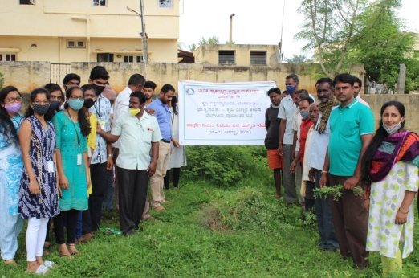 | 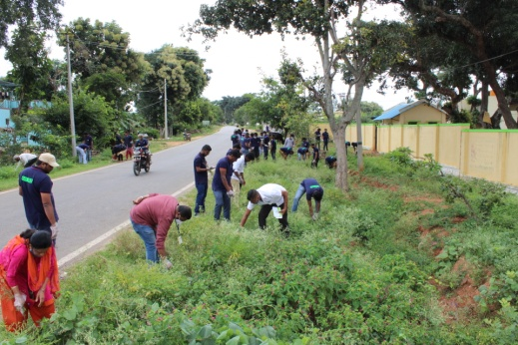 | 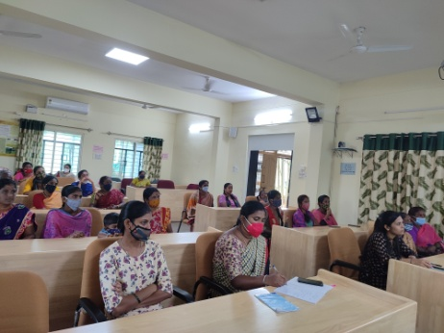
Parthenium awareness programme at Vaddarahalli | Parthenium removal by Shramadhan | Role of Micronutrients in daily diet

Celebration of Poshan vatika Maha Abhiyan and tree plantation
The inauguration programme of Curtain Raiser of International Year of Millets 2023 by Shri Narendra Singh Tomar, Hon,ble Union Minister of A&FW on 17.09.2021 was live streamed at KVK, Hadonahalli, Doddaballapur, Bengaluru Rural District in collaboration with IFFCO, Bengaluru.
Sri H. Appayyanna, ZP Member, participated as Chief Guest and highlighted the importance of Nutri millets. Dr. A.P. Mallikarjuna Gowda, Senior Scientist & Head, KVK briefed about the importance of celebration of Poshan vatika maha abhiyan and tree plantation programme, role of nutri millets and fruits in human health.
Scientists delivered a Lecture on nutri-cereals and their role on human health, role of plantation on sustainable agriculture and rural livelihood. Organized method demonstration on preparation of value addition of nutri millets for farm women and also distributed millets snacks, seed kit, nano urea and fruit plants to participants. Staff of KVK, Students and teachers of Govt. Higher Primary School of Hadonahalli, farmers and farm women were participated. Planted 115 Jack plants and minor fruit plants at KVK farm and farmers field.
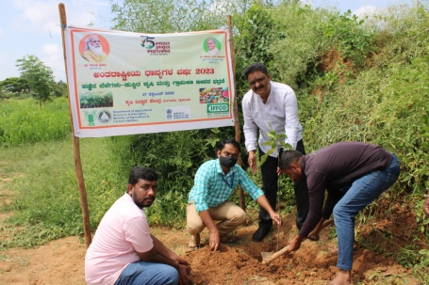 | 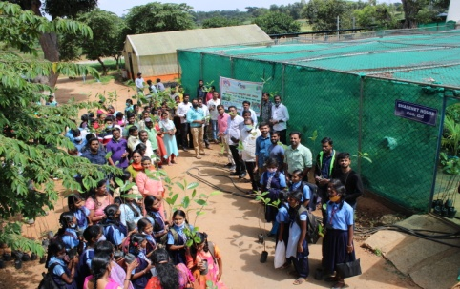 | 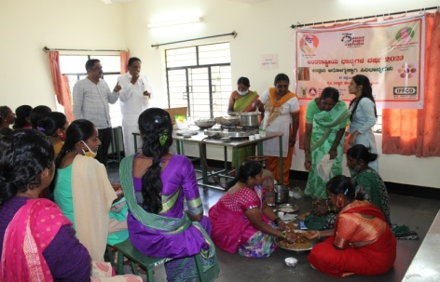
Tree planting | Distribution of plants | Demonstration on Value addition

Training Programmes under ARYA project

Organized three six days skill development trainings on “Bee keeping, Vermi compost, Improved agronomic practices and mechanization in coconut crop” under ARYA project to Rural youths at KVK, Bengaluru Rural District in the month of September 2021.
In Bee Keeping skill training programme, Scientists explained about the importance of honey bees, diseases of honeybee, management of bee colony and it’s role in pollination, production of honey and market linkage. Hands on training on examining bee box, transformation of colony, harvesting, extraction and it’s storage was given to the trainees.
In Vermi compost skill training, 12 technical session were held during the training on different composting methods, preparation of solid waste, rearing of worms and use of vermi compost to various purposes. Hands on training was given on different compost methods including vermi composting and its use.
During Coconut climbing training programme, Scientists explained about the Coconut production technology, planting, insect and disease management, nutrient management, soil testing etc. Hands on training was given on coconut climbing, crown cleaning and disease management and they practiced skills of coconut tree climbing by using coconut climbing machine.
60 Rural youths were benefited from the three training programmes. The training manual implements and equipments were provided to all trainees.
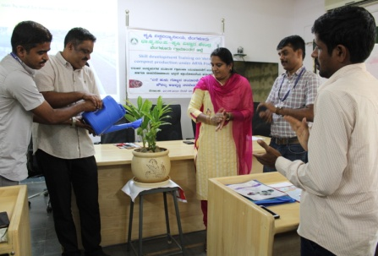 | 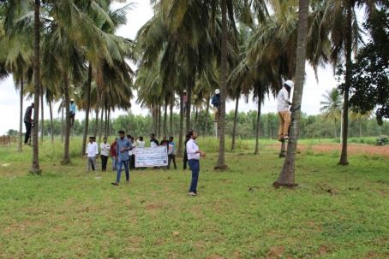 | 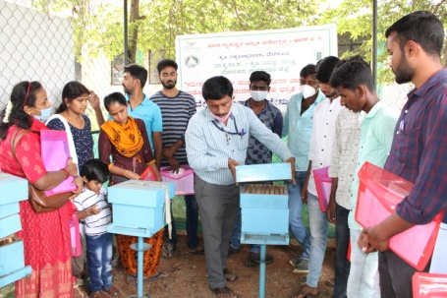
Vermi compost training | Coconut climbing | Bee keeping

Services available at KVK
- Analysis of soil and water samples and advisory services
- Analysis of infected plant samples and advisory services about IPM practices
- Production and sale of quality planting material and advisory services
- Millets Processing Centre and KVK Marketing Complex
- Production and Sale of Pongamia oil, Pongamia cake and biofuel
Services and Sale of Technological Inputs
- Analysis of 81 Soil and 30 Water samples of farmers and advisory services
- Sale of 968 quality horticultural planting materials
----------------------------------------------------------------------------------------------------
Chief Editor  Dr. A. P. Mallikarjuna Gowda  Senior Scientist & Head  Editor and Associate Editors  Dr. B. Manjunath, Scientist (Plant Protection)  Dr. J. Venkate Gowda., Scientist (Agronomy)  Dr. P. Veeranagapa., Scientist (Soil Science)  Sri N. Jagadish, Farm Manager  Smt. B. V. Manjula, Programme Assistant (Lab)  Smt. Sukanya, G.V., Programme Assistant (Computer) | Contact For Further Information:  Senior Scientist & Head  ICAR- Krishi Vigyan Kendra, Hadonahalli Doddaballapura Taluk, Bengaluru Rural District Karnataka – 561205, Phone: 94498 66928  Email: kvkbrd@gmail.com  Website: www.kvkbrd.org  To  -----------------------------------------------------  -----------------------------------------------------  -----------------------------------------------------

