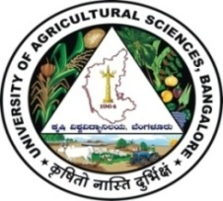 | University of Agricultural Sciences, Bangalore  ICAR-Krishi Vigyan Kendra, Bengaluru Rural District  Krishi Mantana  Vol. 9 Quarterly Newsletter (October- December, 2021) No. 4 | 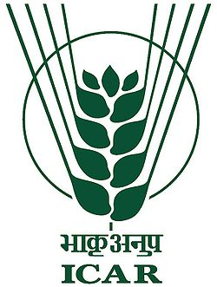
Training and Awareness programme on BEE star labelled Energy Efficient Pumpsets and Water Conservation at ICAR-Krishi Vigyan Kendra, Hadonahalli, Bengaluru Rural District
ICAR-Krishi Vigyan Kendra, Bengaluru Rural District organised one day training and awareness programme for farmers to promote use of BEE star labelled Energy Efficient Pumpsets and Water Conservation at ICAR-Krishi Vigyan Kendra, Hadonahalli on 26.10.2021 with the financial assistance of Karnataka Renewable Energy Development Limited, Government of Karnataka.
The programme was inaugurated by Dr. A.P. Mallikarjuna Gowda, Senior Scientist & Head, ICAR-Krishi Vigyan Kendra and briefed about water saving techniques in Horticulture by adopting micro irrigation system.
Dr. J. Venkate Gowda, Scientist (Agronomy) highlighted the water conservation techniques, Dr. Hulagoora, B.F., General Manager (Retd.), NABARD participated as Resource person and briefed about the Energy conservation methods and Dr. M.N. Thimme Gowda, Professor, AICRP on Agro-meteorology, GKVK, Bengaluru gave a lecture on Water conservation techniques.
Sri Dinesh Kumar, D.K. and Sri Appanna Gowdar, G. from Karnataka Renewable Energy Development Limited were participated as Resource persons and briefed on Electricity conservation by using BEE star labelled pumpsets for lifting the water and electricity saving techniques in household level. During the programme, energy and water conservation tip sheets/brouchers were displayed and 100 members were benefitted from the programme.
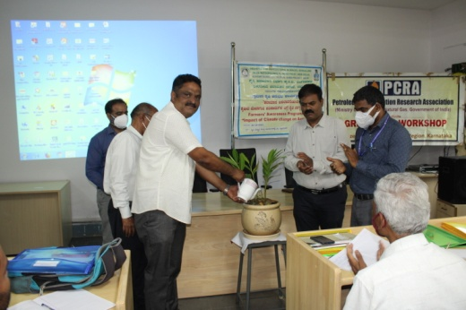 | 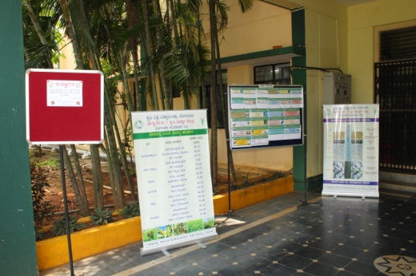 | 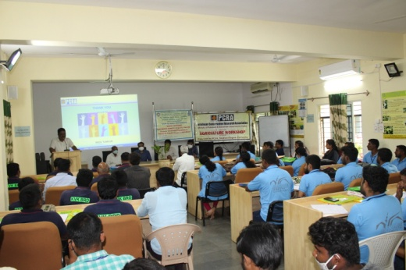
Inaguration of programme | Display of study material | Technical session

Inauguration of 6th batch DAESI programme for input dealers

The inauguration of 6th Batch Diploma in Agricultural Extension Services for Input Dealers was held on 29.11.2021 at ICAR Krishi Vigyan Kendra, Hadonahalli, Bengaluru Rural District. Dr. A.P. Mallikarjuna Gowda, Senior Scientist and Head, KVK, Bengaluru Rural District preamble the programme and introduced the students. He highlighted the mandates of DAESI programme and role of Input dealers in Agriculture as a para Agriculture Extension workers. He mentioned the importance of diploma for input dealers to maintain integrity in their business services. Further, he informed all the trainees to maintain punctuality, discipline and sincerity in attending the classes and doing the designated roles.

The programme was inaugurated by Dr. N. Devakumar, Director of Extension, UAS, Bangalore by pouring water to the plant along with other dignitaries. In his inaugural address, briefed the students about importance of contact classes and urged to provide technical information to the farmers in a benefitting manner not only in a business point of view but in service motto.
Dr. M.N. Thimme Gowda, Professor, UAS, Bangalore, Mr. Obaleshappa, Facilitator, DAESI programme and staff of Krishi Vigyan Kendra, Bengaluru Rural District and 40 DAESI students were participated in the programme and visited the KVK demonstration plots.

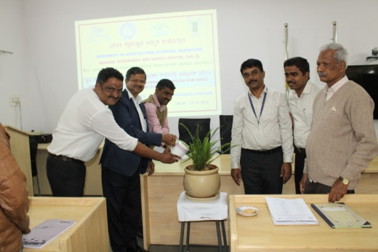 | 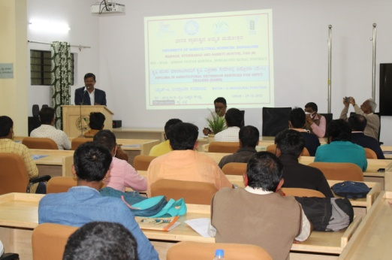 | 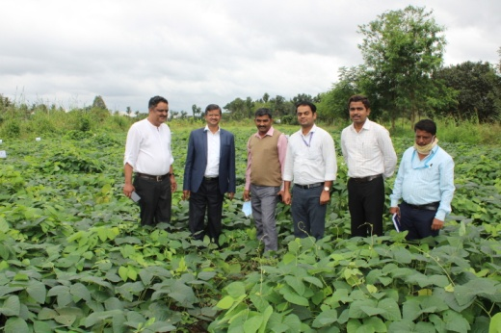
Inaguration of 6th batch DAESI | Hon’ble DE addressing the students | Demo field visit at KVK

Best Farmer awards from Bengaluru Rural district in Krishimela-2021
The University of Agricultural Sciences, Bangalore organized Krishi Mela 2021 from 11th –14th November, 2021 at GKVK Campus, Bengaluru. On this occasion 12 farmers and one Extension worker were selected from Bengaluru Rural District and awarded as Best Farmer / Farmwomen and Extension worker.
S No | Name | Award
1 | Dr. A.P. Mallikarjuna Gowda, Senior Scientist & Head, ICAR-Krishi Vigyan Kendra, Bengaluru Rural District | Dr. R. Dwarakinath State level Best Extension worker award
2 | Sri T.M. Aravinda, S/o T. Muniraju, Dodda Tumakuru, Madhure (H), Doddaballapura (Tq) | Dr. M.H. Mari Gowda State level best Horticulture farmer award
3 | Sri Navikram, C., S/o M. Chandrappa, Lakshmidevipura, Tubagere (H), Hadonahalli (P), Doddaballapura (Tq) | Can bank State level best farmer award
4 | Sri. C. Anand, S/o Channappa, Huskuru, Doddabelavangala (H), Doddaballapur taluk | District level Best Farmer
5 | Smt. Sunandamma, W/o Ramakrishnappa, Antharahalli, Tubagere (H), Doddaballapur taluk | District level Best Farmwoman
6 | Sri Nishanth, V., S/o Vasanth kumar, vabasandra, Gundamagere (H), Doddaballapur Taluk | Taluk level Best Farmer Doddaballapur Taluk
7 | Sri. Yogesh, V.R., S/o Rajanna, Valagerepura, Bediganahalli (H), Hoskote taluk | Taluk level Best Farmer  Hoskote taluk
8 | Sri Umesh, V., S/o Venkateshappa, Dharmapura, Vijayapura (H), Devanahalli taluk | Taluk level Best Farmer  Devanahalli taluk
9 | Sri Madesh, S., S/o Shivanatha, Chikkanahalli, Thyamagondlu (H), Nelamangala taluk | Taluk level Best Farmer  Nelamangala taluk
10 | Smt Jyothi, W/o Naveen, Mallasandra, Sasalu (H), Doddaballapur taluk | Taluk level Best Farmwoman Doddaballapur Taluk
11 | Smt. Savitha, W/o Gopal, B.C., Belamangala, Jadigenahalli (H), Hoskote taluk | Taluk level Best Farmwoman Hosakote taluk
12 | Smt Padmavathi, B.S., W/o Shivakumar, Thirumenahalli, Manduru (H), Devanahalli taluk | Taluk level Best Farmwoman Devanahalli taluk
13 | Smt Sunitha, L., W/o Kemparaju, A.C., Agalakuppe, Sompura (H), Nelamangala taluk | Taluk level Best Farmwoman Nelamangala taluk

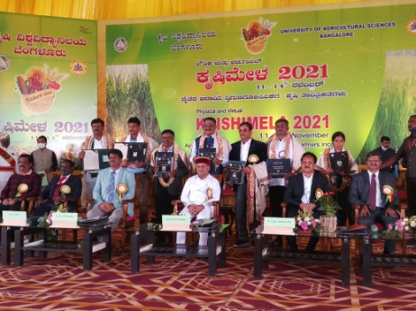 | 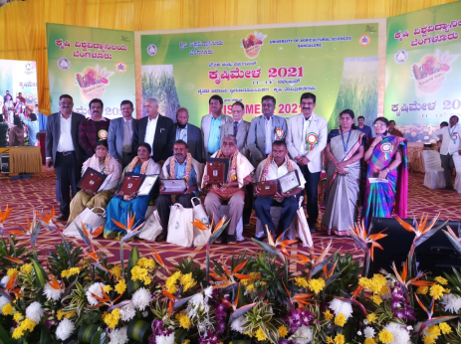 | 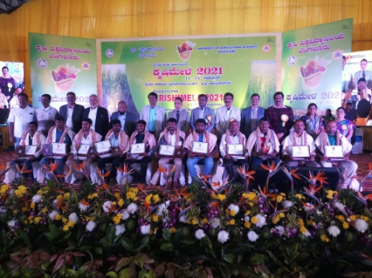
State level award distribution | District level award distribution | Taluk level award distribution

13th Scientific Advisory Committee Meeting
- The 13th Scientific Advisory Committee (SAC) meeting of ICAR-KVK, Bengaluru Rural District was held on 30.12.2021 under the Chairmanship of Vice-Chancellor, UAS, Bangalore. The Senior Scientist and Head welcomed the chairman and members of the committee. The Vice-Chancellor briefed the mandates of KVK in relation to farmers, purpose of SAC meeting and confirmed the proceedings of 12th SAC meeting.
- The Senior Scientist and Head, presented the Action Taken Report on the recommendations of 12th Scientific Advisory Committee meeting, Overall progress report, Major outcome of OFTs and FLDs, Capacity development programmes conducted, Extension programmes organised, Revolving fund activities and proposed Action Plan for the year 2022-23.
- On the occasion, Books on ‘Impact of Diploma in Agricultural Extension Services for Input Dealers (DAESI) programme on Trained input dealers of Bengaluru Rural District’ and ‘Impact of Village adoption programme at Thuruvanahalli’ were released by the dignitaries
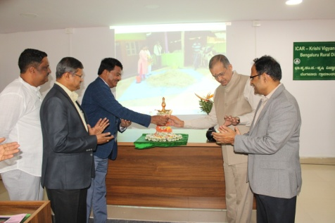 | 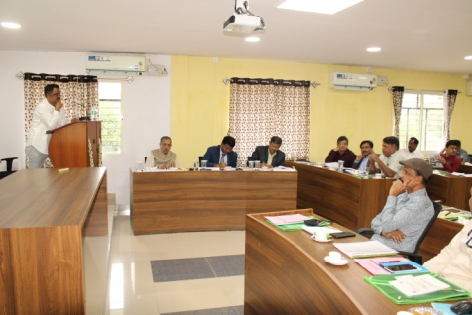 | 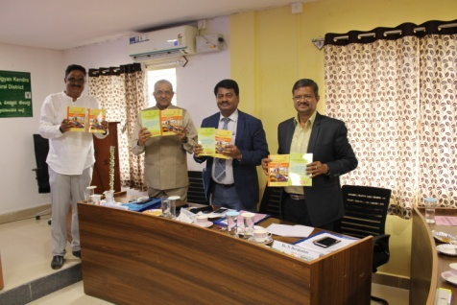
Inaguration of SAC | SS&H presented the KVK activities | Release of impact studies

Brief Report on Celebration of “Jai Jawan Jai Kisan” day

ICAR-KVK, Bengaluru Rural District has organized following three programmes
- ICAR- Krishi Vigyan Kendra, Hadonahalli, Bengaluru Rural District in Collaboration with Mangalore Chemicals and Fertilisers Ltd. has organized “Jai Jawan Jai Kisan” day on 23.12.2021 in KVK premises. The programme was chaired by Dr. A, P. Mallikarjuna Gowda, Senior Scientist and Head, ICAR- Krishi Vigyan Kendra, Bengaluru Rural District and he detailed about the role, importance, responsibilities and goal of farmers in the society and highlighted the this year theme Uttam Kheti-Unnat Kisan. Sri Madan Mohan Pande, MD, ZFHL, Bengaluru inaugurated the programme and expressed his opinion during the occasion as Indian Govt. is supporting farmers by providing Rs. 1,30,333 Crore as a Subsidy to Fertilizer manufacturing companies to produce fertilizers and urged farmers use the fertilizers judiciously for sustainability of soil health. Sri Kuldeep Sharma and Sri Nagesh from Mangalore Chemicals and Fertilizers Ltd. were participated in the programme and explained about various products available in the company. Dr. P. Veeranagappa, Scientist (Soil Science) delivered a lecture on Conservation of soil fertility by enhancing Organic carbon in soil and enrichment of soil micro organisms for better utilization of nutrients. KVK Staff and 80 farmers and farm women were participated in the programme.

- ICAR-Krishi Vigyan Kendra, Bengaluru Rural District in collaboration with KSDA has organized farmers day at Hosakote Taluk by providing technical information on Integrated pest and disease management in various crops. Mr. ChandraShekhar, ADA, Hosakote Taluk presided over the function and Dr. Manjunath, B., Scientist (Plant Protection) delivered the lecture. 130 farmers and farm women were participated in the programme.

- ICAR-Krishi Vigyan Kendra, Bengaluru Rural District in collaboration with KSDA and Krishik Samaj has organized farmers day at Melekote, Doddaballapur Taluk by providing technical information on Soil and water conservation, crop productivity, Reduction in cost of cultivation. Smt. Susheelamma, ADA, Doddaballapura Taluk presided over the function and Dr. J. Venkate Gowda., Scientist (Agronomy) delivered the lecture. 200 farmers and farm women were participated in the programme.
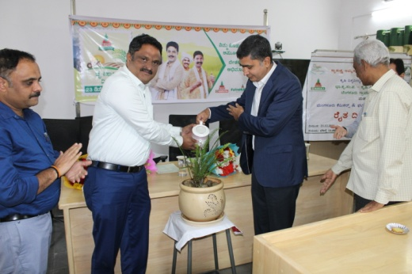 | 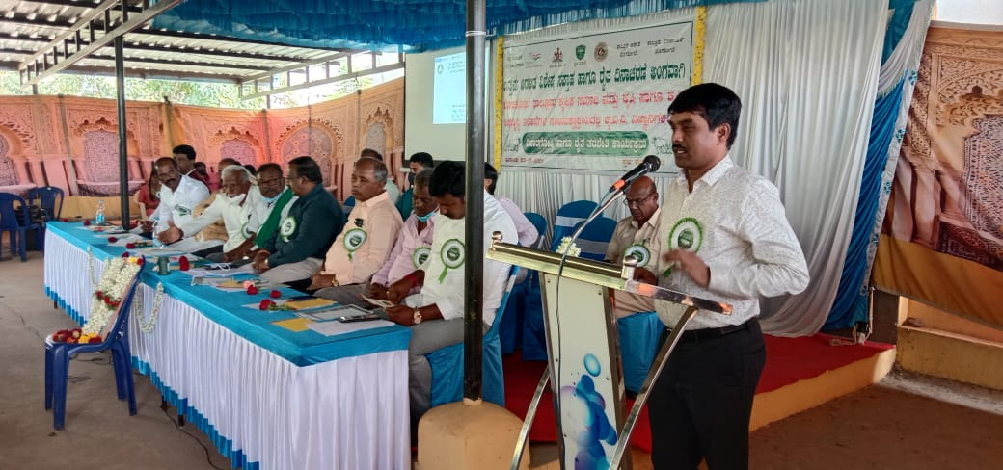 | 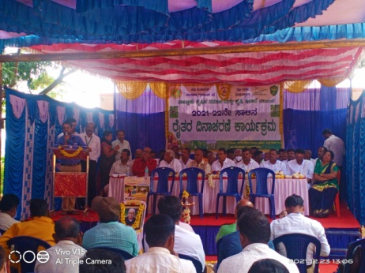
Farmers day ICAR-KVK | Farmers day at Hosakote | Farmers day at Melekote

Services available at KVK
- Analysis of soil and water samples and advisory services
- Analysis of infected plant samples and advisory services about IPM practices
- Production and sale of quality planting material and advisory services
- Millets Processing Centre and KVK Marketing Complex
- Production and Sale of Pongamia oil, Pongamia cake and biofuel
Services and Sale of Technological Inputs
- Analysis of 57 Soil and 43 Water samples of farmers and advisory services
- Sale of quality horticultural planting materials
----------------------------------------------------------------------------------------------------
Chief Editor  Dr. A. P. Mallikarjuna Gowda  Senior Scientist & Head  Editor and Associate Editors  Dr. B. Manjunath, Scientist (Plant Protection)  Dr. J. Venkate Gowda., Scientist (Agronomy)  Dr. P. Veeranagapa., Scientist (Soil Science)  Sri N. Jagadish, Farm Manager  Smt. B. V. Manjula, Programme Assistant (Lab)  Smt. Sukanya, G.V., Programme Assistant (Computer) | Contact For Further Information:  Senior Scientist & Head  ICAR- Krishi Vigyan Kendra, Hadonahalli Doddaballapura Taluk, Bengaluru Rural District Karnataka – 561205, Phone: 94498 66928  Email: kvkbrd@gmail.com  Website: www.kvkbrd.org  To  -----------------------------------------------------  -----------------------------------------------------  -----------------------------------------------------

