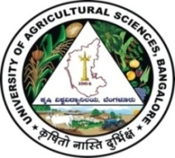 | University of Agricultural Sciences, Bangalore  ICAR-Krishi Vigyan Kendra, Bengaluru Rural District  Krishi Mantana  Vol. 8 Quarterly Newsletter (April - June, 2020) No. 2
Pre Action plan meeting

Pre Action plan meeting of four KVKs viz. Bengaluru Rural District, Chikkaballapur, Kolar and Ramanagara for the year 2020-21 was held on 24.04.2020 at ICAR-Krishi Vigyan Kendra, Hadonahalli under the Chairmanship of Dr. N. S. Shivalinge Gowda, Director of Extension, UAS, Bangalore. Senior Scientists and Heads of all the KVKs were presented the Action plan for the year 2020-21 and obtained the approval after modifications. 23 Scientists and technical staff were participated in the programme.
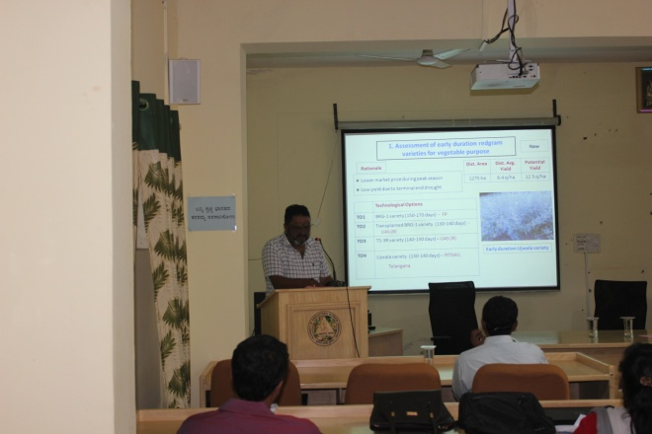 | 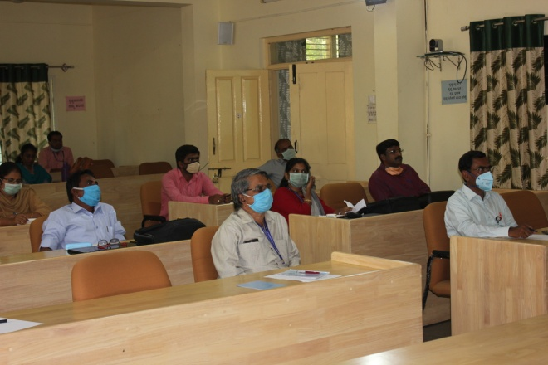

Action taken on agricultural sector during COVID-19 in Bengaluru Rural District through Marketing facilitation to farmers of Bengaluru Rural District for various commodities

KVK, Bengaluru Rural District taken the utmost responsibility to help the farmers in the district during the crisis of COVID-19. In collaboration with Alumni Association, UAS(B), the growers were directly linked to consumers. 24 farmers sold 24,175 kg of fruits and vegetables directly to the consumers. KVK also advised and assisted farmers to sell their produce in linkage with Ninjacart, Safal, HOPCOMS, APMC etc.

Economic analysis of farmers and consumers
Growers |  |  |  |  | Consumers
Crop | Farm gate price /kg | Sale price/kg during COVID-19 | Over head cost/kg | Additional profit (%) | Purchase rate/kg during normal period | Savings (%) for consumers
Grapes | 55 | 70 | 1 | 25.45 | 120 | 71.42
Banana | 25 | 45 | 1 | 76 | 70 | 55.55
Polebean | 20 | 30 | 1 | 45 | 60 | 100
Tomato | 8 | 10 | 1 | 12.5 | 20 | 100
Capsicum | 10 | 18 | 1 | 70 | 40 | 122.22
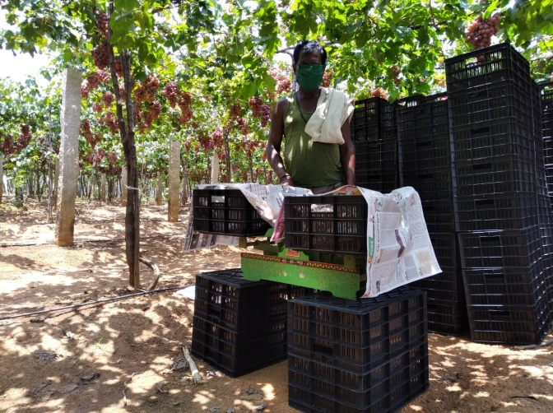 | 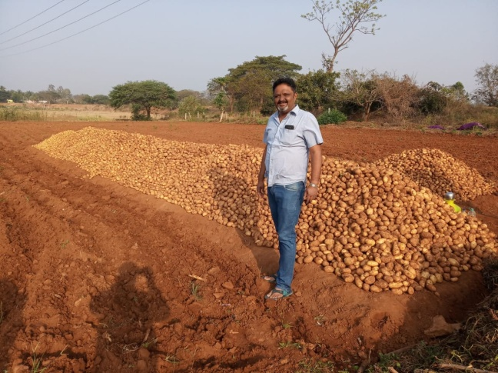 | 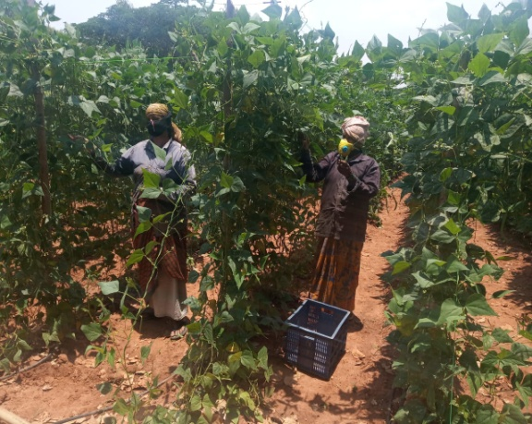

ZREP Workshop
The Director of Research organized online ZREP workshop on 13.05.2020 to present the results of farm trials, multi location trials and PoP. The Senior Scientist and Head, Scientists of ICAR-Krishi Vigyan Kendra, Bengaluru Rural District actively participated in the Webinar and presented the results.

Bimonthly Workshop

Bi-monthly meeting held on 24.06.2020 through online to cover the topics like package of practice for important crops and contingent crop plan, cropping system to be followed under rainfed situation in Bengaluru Rural District.

Services available at KVK
- Analysis of soil and water samples and advisory services
- Analysis of infected plant samples and advisory services about IPM practices
- Production and sale of quality planting material and advisory services
- Production and sale of Vegetable Special
- Millets Processing Centre and KVK Marketing Complex
- Production and Sale of Pongamia oil, Pongamia cake and biofuel

Services and Sale of Technological Inputs
- Analysis of 47 Soil and 21 Water samples of farmers and advisory services
- Sale of 33 kg Vegetable Special for foliar spray in vegetables
- Sale of quality horticultural planting materials
----------------------------------------------------------------------------------------------------
Chief Editor  Dr. A. P. Mallikarjuna Gowda  Senior Scientist & Head  Editor and Associate Editors  Dr. B. Manjunath, Scientist (Plant Protection)  Dr. J. Venkate Gowda., Scientist (Agronomy)  Dr. P. Veeranagapa., Scientist (Soil Science)  Dr. Y. D. Chithra., Scientist (Agril. Extension)  Sri N. Jagadish, Farm Manager  Smt. B. V. Manjula, Programme Assistant (Lab) | Contact For Further Information:  Senior Scientist & Head  ICAR- Krishi Vigyan Kendra, Hadonahalli Doddaballapura Taluk, Bengaluru Rural District Karnataka – 561205, Phone: 94498 66928  Email: kvkbrd@gmail.com  Website: www.kvkbrd.org  To  -----------------------------------------------------  -----------------------------------------------------  -----------------------------------------------------

