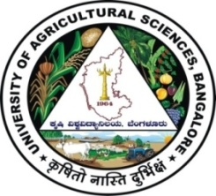 | University of Agricultural Sciences, Bangalore  ICAR-Krishi Vigyan Kendra  Bengaluru Rural District  Krishi Mantana  Vol. 4 Quarterly Newsletter (Jan – March, 2016) No. 1 | 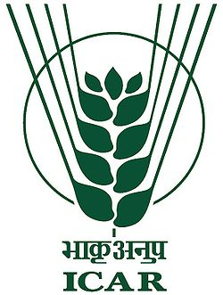
National Convention on Attracting Rural Youth for Agriculture (ARYA)
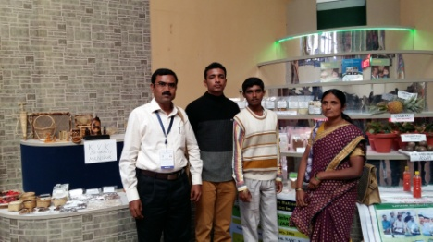
Dr.K.N.Srinivasappa, Programme Coordinator (PC) participated in the National Convention on Attracting Rural Youth towards Agriculture (ARYA) on 27.01.2016 at Indian Agricultural Research Institute (IARI), New Delhi. The convention was organized to highlight the efforts made to attract and retain rural youth in agriculture throughout the country. About 1000 delegates across the country participated in the convention.
Action Plan Meet on ARYA
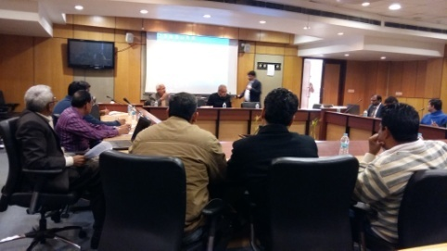
The PC participated in the Action Plan Meet on ARYA on 28.01.2016 at IARI, New Delhi. The meet was organized to review the ARYA project activities of 23 KVKs which are implementing the project across the country. The PC made a presentation about the ARYA proposal of Bengaluru Rural district (Employment and Livelihood Security for Rural Youth through Innovative Entrepreneurship Models). The meet was chaired by Dr.K.Narayana Gowda, Ex-Vice Chancellor, University of Agricultural Sciences (UAS), Bengaluru. About 50 delegates across the country participated in the meet.
Field days
Integrated Crop Management in Field bean (var. HA-4)
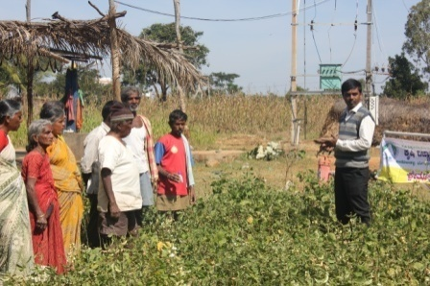
A field day on ‘Photosensitive Field bean variety HA-4 for enhanced returns (NFSM)’ was conducted at Cheelenahalli village, Doddaballapur taluk on 09.01.2016. Dr.B.G.Vasanthi, SMS (Soil Science) explained about the photo insensitive variety of Field bean var. HA-4 cultivation practices and integrated crop production system. Dr.B.Manjunath, SMS (Plant Protection) explained about pests and diseases of field bean and their management. Forty farmers participated in the programme.
Promotion of Fodder Cafeteria
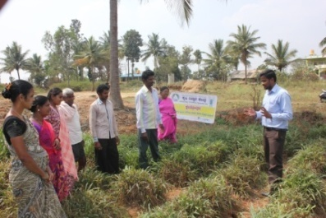
A field day on ‘Promotion of Fodder Cafeteria’ to mitigate drought by introducing annual and perennial fodder crops was organized on 27.01.2016 at Savukanahalli village, Devanahalli taluk, where Frontline Demonstration (FLD) was conducted. On this occasion, Sri A.P.Vikram, Subject Matter Specialist (SMS) (Agronomy) briefed about scientific fodder production techniques, preservation, silage making and use of preserved fodder during lean period.
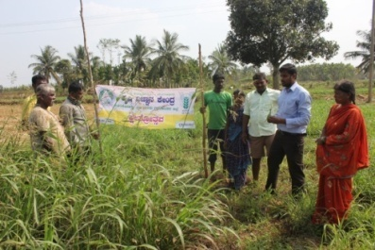
Assessment of multi cut fodder for yield and quality
A field day on ‘Assessment of multi-cut fodder for yield and quality’ at Jakkanahalli village, Nelamangala taluk was organized on 28.01.2016. Sri A.P.Vikram, SMS (Agronomy) explained about the selection of fodder crops based on location and scientific cultivation practices which should be followed in production of multi-cut fodders for effective management. Dr.B.Manjunath, SMS (Plant Protection) attended the field day programme.
Integrated Crop Management in Bengalgram
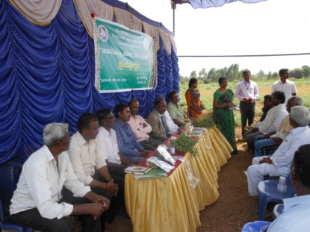
A field day on Bengal gram was organized at Beediganahalli village, Devanahalli taluk on 03.02.2016 where FLD on Integrated Crop Management in Bengalgram was undertaken. On this occasion, Dr.K.Jagadeeshwara, Director of Extension, UAS, Bengaluru briefed the farmers about importance of pulses in Indian economy. Dr. K.N. Srinivasappa, PC briefed about community based approach for improving area under pulses. Dr.B.Manjunath, SMS (Plant Protection) explained about the integrated methods to manage pod borer menace in Bengal gram and safe use of pesticides. Dr Anand G. Manegar, SMS (Animal Science), Dr.B.G.Vasanthi, SMS (Soil Science), Dr.M.Padmavathi, SMS (Agril. Extension) and Sri A.P.Vikram, SMS (Agronomy) participated in the programme.
Integrated Crop Management in Rose
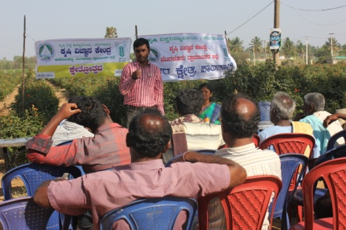
A field day on Integrated Crop Management in Rose was organized at Alappanahalli village, Hosakote taluk on 19-02-2016. Dr.K.N.Srinivasappa, Programme Coordinator briefed about the varieties and scientific cultivation of rose. Dr.B.Manjunath, SMS (Plant Protection) briefed on management of major pests and diseases in rose. Integrated nutrient management techniques of rose cultivation was highlighted by Dr.B.G.Vasanthi, SMS (Soil Science).
Integrated management of late blight in Potato
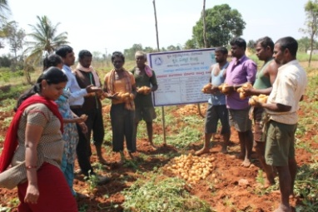
A field day on Integrated management of late blight in Potato was organized on 02nd March, 2016 at K R Pura village, Nelamangala Taluk. On this occasion, Dr.B.Manjunath, SMS (Plant Protection) briefed about the causes of late blight and various measures to reduce the disease incidence and also briefed about safe use of fungicides.
Use of SOP and Arka Microbial Consortia in Potato
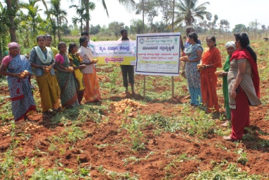
A field day was organized on 03rd March, 2016 at K R Pura village, Nelamangala Taluk on Use of SOP and Arka Microbial Consortia in Potato. Dr.B.G.Vasanthi, SMS (Soil Science) explained about importance of potash nutrient in Potato and the usefulness of sulphate of potash for potato compared to other source of ‘K’ fertilizer. She also explained the role of AMC which increases the activity of soil flora and reduces the wilt incidence. Dr.B.Manjunath, SMS (Plant Protection) explained the importance of plant protection measures in potato which are needed for maintaining healthy plant population.
Vegetable roof gardening and Eco- friendly Management of Kitchen Waste for Health Security
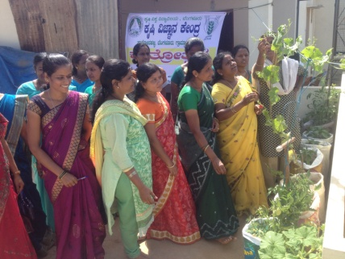
A field day on Vegetable Roof gardening and Eco-friendly Management of Kitchen Waste for Health Security was organized on 12.03.2016 in Doddaballapura town. On this occasion, Dr.Savita,S.M., SMS (Home Science) explained the importance of micro nutrients in daily diet through vegetables grown on the terrace in town areas. Importance of segregation of household waste and converting organic kitchen wastes into compost using terracotta pots was demonstrated. Dr.B.G.Vasanthi, SMS (Soil Science) explained about the importance of use of vegetable special and neem oil in nutrient and pest management for growing organic vegetables on the terrace.
Integrated Crop Management in Pole beans
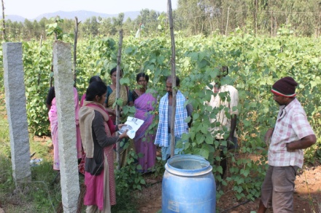
A field day on Integrated Crop Management in Pole beans was conducted at Cheelenahalli village, Doddaballapur Taluk on 16.03.2016. Dr.B.Manjunath, SMS (Plant Protection) explained about pest and diseases of Pole beans and their management. Dr.B.G.Vasanthi, SMS (Soil Science) discussed with the farmers about the nutrient management practices followed, the lacunae and methods of addressing micro nutrient deficiencies.
Celebration of important days
International Women’s Day
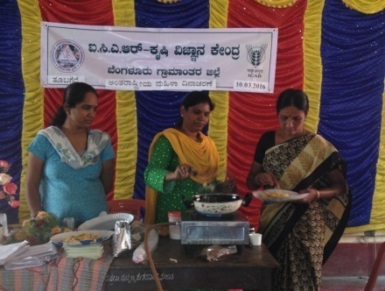
‘International Women’s Day’ was celebrated by KVK 10-03-2016 at Tubagere village, Doddaballapur taluk. Dr.Savita,S.M., SMS (Home Science) revealed the importance of celebration of this important day on 8th March which is being celebrated internationally since 106 years for creating awareness about the achievements contributed to the society as a house wife, mother and even working women managing the dual roles of family and office work. The theme for 2016 International Women's Day celebration is ‘Pledge for Parity’. The theme was discussed in terms of entrepreneurship, education and creating equal opportunities for both men and women in the society. On this occasion, preparation of value added jack products were demonstrated. Fifty three Anganwadi workers participated in the programme. Mrs. Geetha, ICDS Supervisor and Mrs.B.V.Manjula, Training Assistant were present on the occasion.

On campus training programmes
Orientation training Programme on Integrated Pest Management practices in Rabi crops
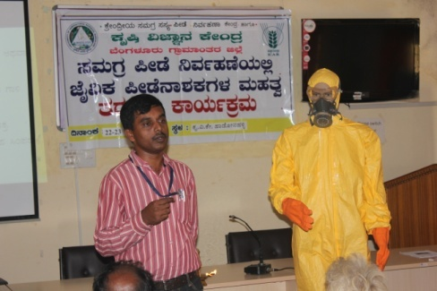
A two day Orientation Training Programme was organized during 22nd and 23rd February, 2016 for the farmers and farm women about Integrated Pest Management practices in Rabi crops. This programme was organized in collaboration with Central Institute for Integrated Pest Management, Kadugodi, Bengaluru. The farmers were involved in discussions about pests and diseases of important rabi crops like Bengal gram, potato, tomato, etc. All the integrated pest management methods were debated and demonstration of biological agents in pest control was organized.
Success stories of farmers practicing Integrated Farming System
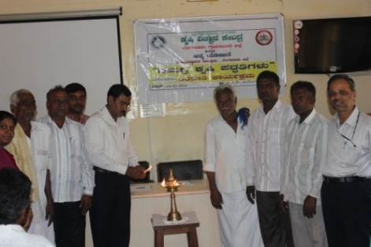
A one day Experience Sharing programme was organized on 19th February, 2016 in which progressive farmers who are practicing Integrated Farming System shared their challenges and experiences with the fellow farmers. Shri Lakshmegowda, District Level Best farmer and Shri Shivappa explained to the farmers about the problems they faced in the agriculture, initial stages of IFS concept and stabilization of IFS concept which is fetching sustainable income and employment.
Livestock Rearing for beneficiaries of Pashu Bhagya Scheme 28.03.16 to 30.03.16 56
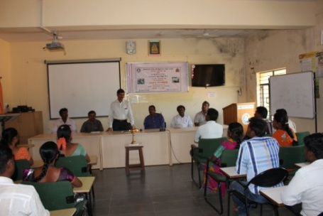
A three day training programme was organized about Livestock Rearing to the beneficiaries of Pashu Bhagya Scheme during 28-30, March 2016 for the farmers and farm women in collaboration the State Department of Animal Husbandry and Veterinary Sciences. The trainees were involved in detailed discussion about principles and practices of livestock rearing, cost effective practices, health management and formation of farmers groups for resource management.
Off campus trainings
Importance of fertigation in Pole beans | 05.01.16 | Cheelenahalli
Use of ‘SOP’ as a source of K-nutrition in Potato | 06.01.16 | K R Pura
Importance of Vegetable Special as foliar spray in Capsicum | 07.01.16 | K R Pura
Balanced Animal nutrition | 12.1.16 | Hosahalli
Soil Health fertility management | 24.02.16 | Sonnahallipura
Integrated nutrient management | 25.02.16 | Doddabelevangala
Use of Vegetable Special and Neem oil in Terrace gardening | 03.03.16 | Doddaballapur
Vegetable roof gardening and eco-friendly management of kitchen waste | 12.03.16 | Doddaballapur
Services available at KVK
- Analysis of soil and water samples and advisory services for soil health and water management
- Analysis of infected plant samples and advisory services about IPM practices
- Production and sale of quality planting material and advisory services
- Production and sale of Vegetable Special
- Millets Processing Centre
- KVK Marketing Complex
- Production and Sale of Pongamia oil, cake and biofuel
Services and Sale of Technological Inputs
- Analysis of 820 soil and 756 water samples of farmers and advisory services
- Sale of 29 kg Vegetable Special as foliar spray in vegetables
- Sale of 263 quality horticultural planting materials
Plant Health Clinic
- Examination of 65 infested plant samples and advisory services to the farmers
- Diagnostic visits in Alappanahalli, Obalapura, Papanahalli, Giddappanahalli, Agalakuppe, Cheelenahalli, Beedaganahalli, Ibasapura, Vanigrahalli, K R Pura, Nelamangala, Appakaranahalli, Thippuru, Nagashettihalli villages

Chief Editor  Dr K N Srinivasappa  Programme Coordinator  Editor  Dr M Padmavathi  SMS (Agril. Extension) | Associate Editors  Dr S M Savita  SMS (Home Science)  Dr B G Vasanthi  SMS (Soil Science)  Sri A Sudarshan Reddy  SMS (Agronomy) |  | Dr Anand B Manegar  SMS (Animal Science)  Dr B Manjunath  SMS (Plant Protection)  Smt B V Manjula  Training Assistant
Contact For Further Information:  Programme Coordinator, Krishi Vigyan Kendra, Hadonahalli, Doddaballapura Taluk, Bengaluru Rural District, Karnataka – 561205 Phone: 080-27652082 Email: kvkbrd@gmail.com Website: www.kvkbrd.org |  | To  ---------------------------------------------------------  -----------------------------------------------------------

