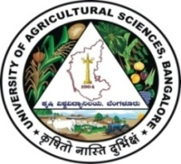 | University of Agricultural Sciences, Bangalore  ICAR-Krishi Vigyan Kendra  Bengaluru Rural District  Krishi Mantana  Vol. 5 Quarterly Newsletter (July - Sept, 2017) No. 3 | 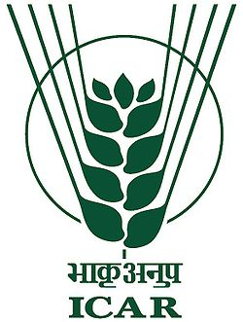
Swacha Bharat Abhiyana - Sewa Divas, Samagra Swachhta Diwas, Sarwatra Swachta
- ICAR – Krishi Vigyan Kendra, Bengaluru Rural district carried out several swachhta activities as a part of Sewa Divas, Samagra Swachhta Diwas, Sarwatra Swachta, etc.
- The objective was to create awareness among the public about the importance of hygiene for good health and role of public in maintenance of clean surroundings.
- All the staff of KVK actively participated in these activities and coordinated the activities with local and public institutions.
- The institutions which collaborated with KVK are Agricultural Technology Application and Research Institute (ATARI), Zone XI, Bengaluru, Commodity Based Associations, Village Youth groups and Village School Management Committees, Village Panchayats and Ghati Temple Management Committees, All India Coordinated Research Project (AICRP - Home Science), GKVK, Bengaluru, Dept. of Women and Child Welfare, Bengaluru Rural district, Alumni Association, UAS, Bengaluru, Sri Kshetra Dharmashtala Rural Development Programme (SKSRDP) and Self Help groups and trainees of DAESI (Diploma in Agricultural Extension Services for Input Dealers) programme
On campus programmes
15.9.2017 | Awareness programme on health and nutrition for Anganwadi helpers
17.9.2017 | Celebration of Sewa Diwas
18.9.2017 | Cleaning of demonstration units at KVK like Apiary unit, Vermicompost unit, etc
19.9.2017 | Cleaning of laboratories at KVK like Soil and Water Testing Laboratory, etc
21.9.2017 | Planting of saplings at KVK by the trainees of DAESI programme
22.9.2017 | Group discussion by Anganwadi helpers about personal hygiene, hygiene during cooking, cleanliness in houses and anganwadi premises, etc
28.9.2017 | Cleaning of farm equipments like sprayers, sickles, etc and tractor, tiller, , etc
2.10.2017 | Gandhi Jayanthi celebration, Felicitation to Dr K N Srinivasappa, Senior Scientist and Head, KVK, Bengaluru Rural by ATARI for best contribution to Swachat Bharat Abhiyan

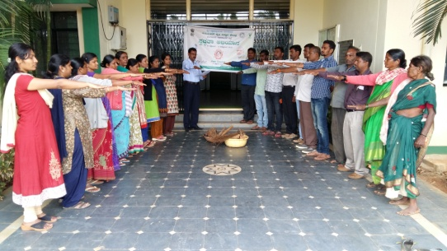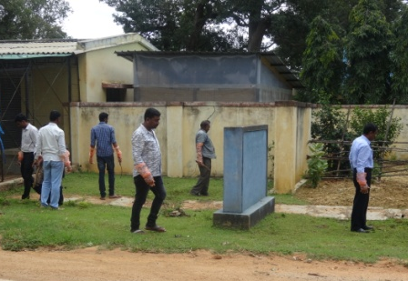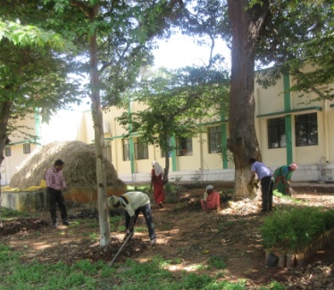

Off campus programmes
20.9.2017  Obalapura | Creation of awareness among school children and villagers about importance of cleanliness, sanitation and hygiene
21.9.2017 Ballagere | Pasting of slogans related to cleanliness in the village and cleaning of Government Higher Primary School Premises
24.9.2017 Perumagondanahalli | Celebration of Samagra Swachhta Diwas and Cleaning of the village by villagers, KVK and ATARI, Bengaluru staff
25.9.2017  Tubagere | Cleaning and removal of parthenium plants near Tubagere bus stop  Essay writing competition for school children and college students
26.10.2017 Tapasihalli | Organization of Integrated Farming System for Sustainable Agriculture programme
01.10.2017  Ghati | Creation of awareness among Ghati Temple Management Committee members and traders about safe disposal of non biodegradable waste
03.10.2017 Lakshmidevipura | Participation of Dr K Geetha, Professor, AICRP (home Science) and discussed about cleanliness, personal hygiene and sanitation
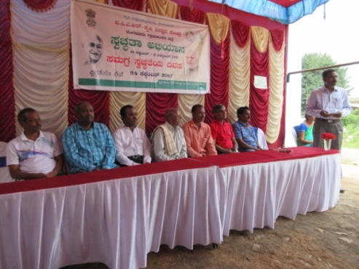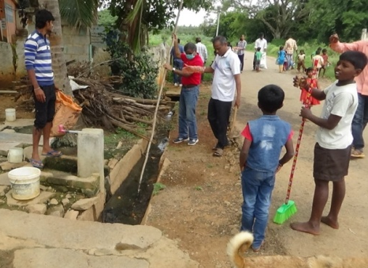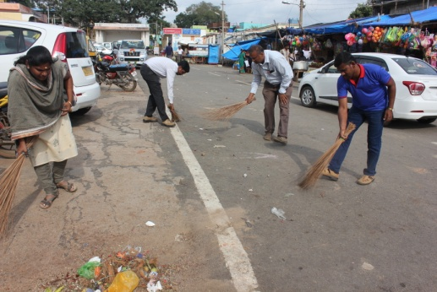
Celebration of Important Days
National Nutrition Week
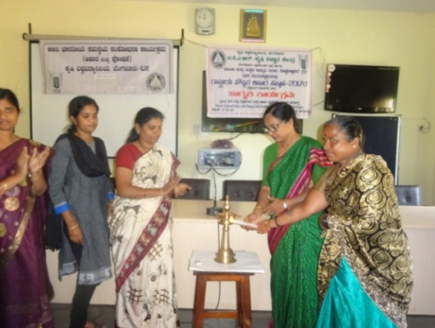
The centre celebrated National Nutrition Week - 2017 on 07.09.2017 for Anganwadi helpers of Doddaballapur Taluk in collaboration with AICRP (Food Science and Nutrition), UAS, Bangalore and Department of Women and Child Welfare, Doddaballapur taluk, Dr. Savita S. Manganavar, Scientist (Home Science) delivered a lecture on ‘Importance of Health and Nutrition’ and stressed the Theme of the year ‘Optimal Infant and young child feeding practices : Better child health’. Dr. K Geeta, Professor, AICRP (Food Science and Nutrition) briefed the importance of breakfast and nutritious food for health and development.

Parthenium Awareness Day
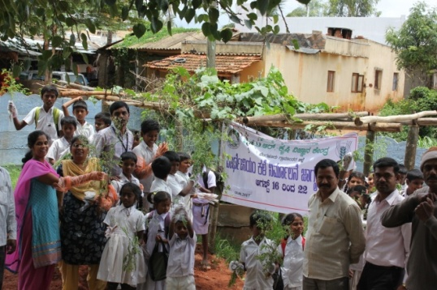
To create awareness about Parthenium weed, Parthenium Awareness Day was conducted on 18.08.2017 at Ballagere village, Nelamangala Taluk. Dr.B.G.Vasanthi, Scientist (SS) briefed the gathering about significance of the day and the harmful effects caused by parthenium in crops. She also explained about its management techniques such as composting, etc. Dr.Manjunath.B, Scientist (PP) explained about biological control methods for eradication of weed. All the school children and staff wore hand gloves and uprooted parthenium weeds.
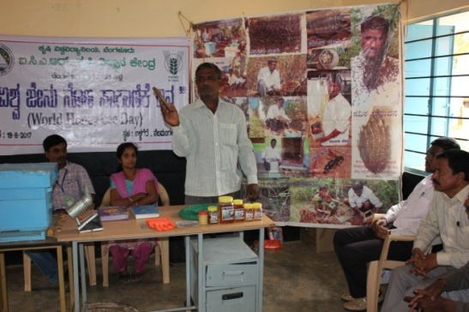
World Honey bee Day
World Honey Bee Day was celebrated at Ballagere village, Nelamangala taluk on 19.08.2017. On this occasion Mr.Lakshme Gowda, innovative farmer of Kuntanahalli village, Doddaballapura taluk, who is practicing apiculture as one of the subsidiary enterprises, briefed the farmers, farm women and school children about importance of honey bees, its advantages in agriculture, their role and beneficial effects. Dr. Manjunath.B, Scientist (PP) briefed the gathering about significance of Honey bee. The scientists of KVK and 68 farmers, farm women and school children participated in the programme.
Village Adoption Scheme activities (Appakaranahalli, Rameshwara)
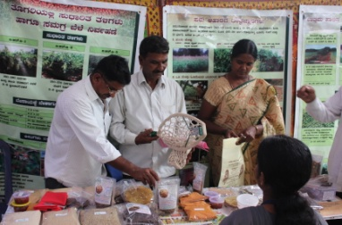
- Safe use of pesticide and use of botanicals in IPM
- Fertility management in dairy animals
- ICM in Redgram Variety BRG-5 and Importance of Vermicompost
- Krishimela organized by Rai Technology University
ARYA activities
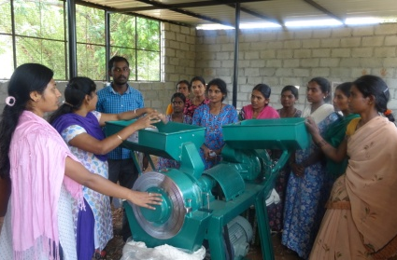
- Production and Value addition of White Finger millet (KMR-340) and Foxtail Millet
- Exposure Visit to Krishi Abhiyaana Programme at Tubgere and Savayava Siridanya Mela
- Exposure visit to Mushroom Growing Unit at Arehalli-Guddadahalli
- Marketing of Jackfruit products and importance of quality packing and labelling
- Marketing of Ragi products and Introduction of savings concept in the group
- Accounts maintainance and book keeping of CBA
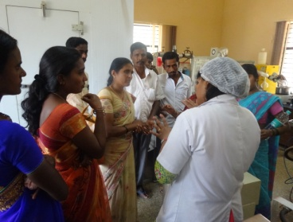
- CBA Meeting of Jack association and Nutri Millet Association
- Exposure visit to Sankalp se siddi programme by Nutri millet and Jack CBAs
- Monthly Meeting of Nutri millet, Jack and Mushroom CBAs
- Awareness about procedures of Mushroom cultivation
- Precautions in mushroom cultivation
- Pest and disease of Mushroom and different substrates used for mushroom cultivation
Services available at KVK
- Analysis of soil and water samples and advisory services
- Analysis of infected plant samples and advisory services about IPM practices
- Production and sale of quality planting material and advisory services
- Production and sale of Vegetable Special
- Millets Processing Centre and KVK Marketing Complex
- Production and Sale of Pongamia oil, Pongamia cake and biofuel
Services and Sale of Technological Inputs
- Analysis of 271 soil and 248 water samples of farmers and advisory services
- Sale of 25 kg Vegetable Special as foliar spray in vegetables
- Sale of 392 quality horticultural planting materials
Plant Health Clinic
- Examination of 105 infested plant samples and advisory services to the farmers
- Diagnostic visits in Tubagere, lakshmidevipura, Rameshwara, C G Hosahalli, Bannimangala, Rajaghatta, Neralaghatta, Suttahalli, Kenchanapura, Kundana, Neralaganahalli, Vishwanathapura, Nagadesahalli, Madhure, Ekashipura, Thimmanahalli, Sulibele villages
--------------------------------------------------------------------------------------------------------------
Chief Editor  Dr K N Srinivasappa  Senior Scientist & Head  Editor  Dr M Padmavathi  Scientist (Agril. Extension) | Associate Editors  Dr S M Savita  Scientist (Home Science)  Dr B G Vasanthi  Scientist (Soil Science)  Dr M Padmanabhan  Scientist (Agronomy) |  | Dr Anand B Manegar  Scientist (Animal Science)  Dr B Manjunath  Scientist (Plant Protection)  Smt B V Manjula  Training Assistant
Contact For Further Information:  Senior Scientist & Head, Krishi Vigyan Kendra, Hadonahalli, Doddaballapura Taluk, Bengaluru Rural District, Karnataka – 561205 Phone: 94498 66928 Email: kvkbrd@gmail.com ,  Website: www.kvkbrd.org |  | To  ---------------------------------------------------------  -----------------------------------------------------------

