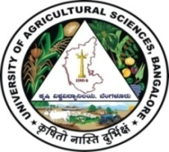 | University of Agricultural Sciences, Bangalore  ICAR-Krishi Vigyan Kendra, Bengaluru Rural District  Krishi Mantana  Vol. 6 Quarterly Newsletter (Jan - Mar, 2018) No. 1 | 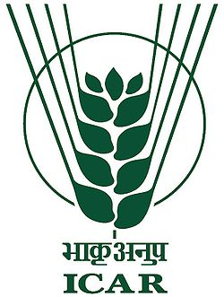
On campus trainings
Capacity Building of Farmers through Progressive and Award winning farmers
ICAR-KVK, BRD organized two training programmes entitled ‘Capacity Building of Farmers through Progressive and Award winning farmers’ during 10-12 January, 2018 and 6-8, March, 2018 for the farmers of Doddaballapura taluk. On the first day, award winning farmers Sri Shivappa, Jakkenahalli village, Sri Lakshmi Narayana Gowda, Neralaghatta village and Sri Lakshme Gowda, Kuntanahalli village shared their experience with the farmers in farming and how they could achieve self sufficiency and satisfaction from farming activities through innovative methods.
On the second day, the trainees visited the fields of Sri Shivappa and Sri Lakshminarayana Gowda and observed the practices in the fields of areca nut, banana, rose, finger millet and also on different agricultural machinery, areca nut processing, nutritional deficiency symptoms in different crops and efficient irrigation techniques. The trainees discussed about the animal husbandry practices followed to maintain 25 cows, feeding practices, balanced nutrition and health care of the animals. The cost benefit ratio in dairy enterprise at the dairy farm of Sri Jayaram,
On the third day, the trainees visited the fields of Sri Lakshme Gowda, who is an apiary entrepreneur and offers training programmes in apiary production, honey processing and marketing. He demonstrated how to identify honey combs, extraction of honey bees, identification of queen bee and maintenance of colonies to the trainees. Sri Sadananda, IFS farmer from Tapasihalli village explained to the farmers about the benefits of following integrated farming practices comprising of agriculture, horticulture, animal husbandry, poultry, seed production, fish production, etc. The trainees were convinced about the utility of training by awardee farmers as it helps to understand the field challenges in a better way.
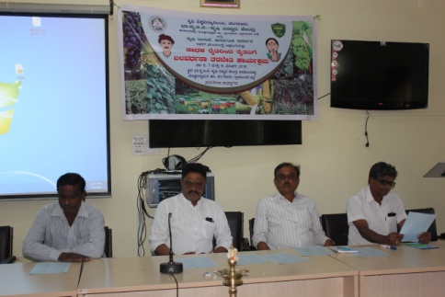 | 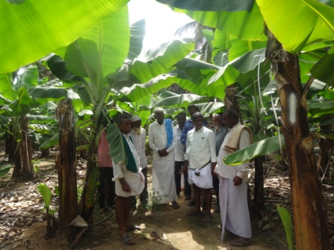 | 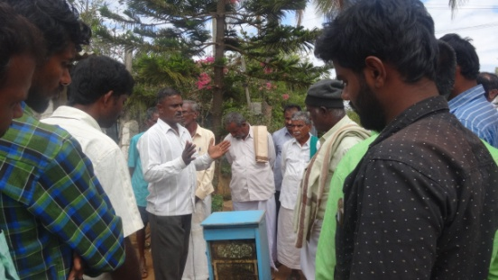

Frugal Innovation Workshop
Frugal innovation workshop was organized on 27th March 2018 at ICAR-Krishi Vigyan Kendra, Hadonahalli. Dr. A.P. Mallikarjuna Gowda, Senior Scientist and Head, delivered a lecture on KVK- Farm Science Centre - An Innovative Institution for Farmer Empowerment. About 15 foreign delegates participated in the programme.
Celebration of Important days
International Women’s Day
International Women’s day was celebrated at ICAR-KVK, BRD on 08.03.2018 for SHG members of Doddaballapur taluk. Dr. B.G.Vasanthi, Soil Physicist, AICRP on Dryland Agriculture, GKVK delivered talk on the role of women in agriculture. Smt. Manjula B.V., Programme Assistant reveled the theme of this year as “Press for progress” and explained the history and importance of celebration of international women’s day. Dr. B. Manjunath explained about the safe and judicious use of pesticides, Dr. Thimme Gowda, Dr. Venkate Gowda and Dr. Veeranagappa and seventy five SHG members of Tubagere hobli participated in the programme.
World water Day
ICAR-KVK celebrated World Water Day on 22.03.2018 and the theme for 2018 was ‘Nature for Water – explores how we can use nature to overcome the water challenges of the 21st century’. Dr. Venkate Gowda, Scientist (Agronomy) delivered a lecture on ‘Judicious use of water and conservation of rain water’. He explained about the history and importance of world water day and advised the farmers about the judicious use of bore well water and conservation of rain water. Dr. K.N. Srinivasappa, Associate Professor, GKVK explained the importance of nature in climate change especially on rainfall pattern. Eighty three farmers / farmwomen were benefitted from the programme.

Field Days

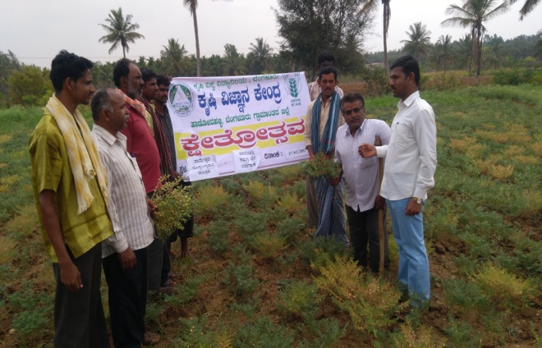 | 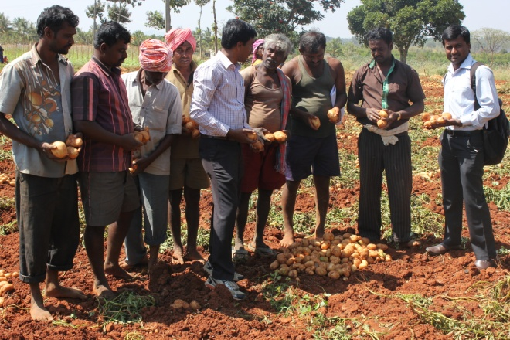
‘Integrated crop management in Bengal gram on 31.01.2018 at Rameshwara village, Doddaballapur Taluk | ‘Management of late blight in Potato through integrated approach’ on 01.02.2018 at Vathakunte, Nelamangala Taluk
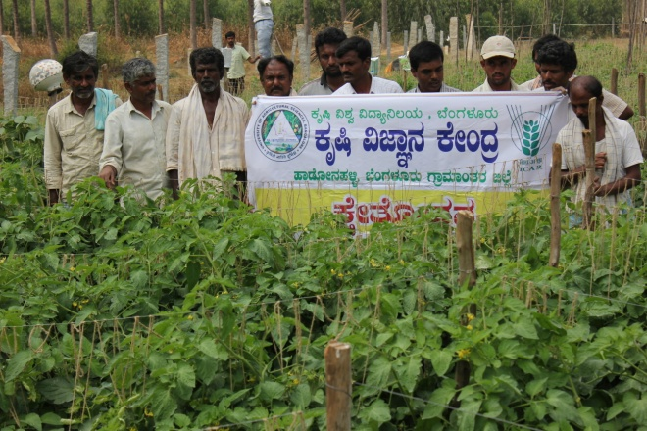 | 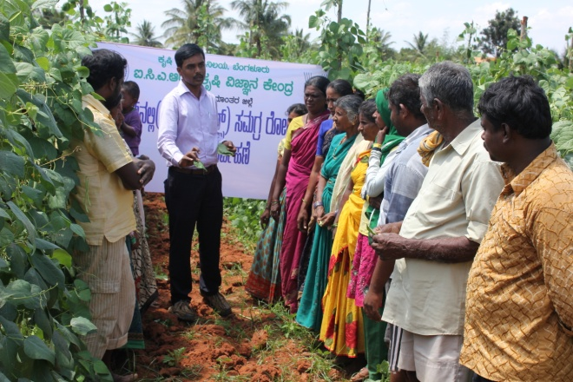
‘Integrated management of pests and diseases in Tomato’ was organized on 06.02.2018 at Vathakunte, Nelamangala Taluk | Integrated crop Management in Pole beans (FFS) at Vathakunte of Nelamangala taluk on 14-02-2018

Off campus trainings

S. No | Title of the programme | Date | Location
1 | Awareness programme on food security, production and food wastage | 05.01.18 | Shirvar
2 | Importance of value addition to white ragi KMR-340 and demonstration of products | 08.01.18 | Ballagere
3 | Fertigation scheduling in tomato | 10.01.18 | Vathakunte
4 | Role of nutrients in mulberry | 11.01.18 | Sonnallipura
5 | Management of major diseases in tomato | 11.01.18 | Vathakunte
6 | Demonstration of preparation of compost from organic wastes in school | 11.01.18 | Ballagere
7 | Importance of value addition to Navane DHFT-101 & Demonstration of products | 12.01.18 | Bannimangala
8 | Awareness programme on avoiding food wastage on daily basis and demonstration of preparation of compost from organic waste | 19.01.18 | Obalapura
9 | Management of late blight in tomato through chemical method | 23.01.18 | Vathakunte
10 | Fertigation in tomato for higher yield | 29.01.18 | Vathakunte
11 | Assessment of ginger varieties for Bengaluru rural district | 30.01.18 | Bannimangala
12 | Assessment of Bengalgram varieties for wilt and drought conditions | 31.01.18 | Sadappanahalli
13 | Management of late blight in potato through integrated approach | 01.02.18 | Vathakunte
14 | Management of pests in pole beans | 03.02.18 | Vathakunte
15 | Integrated management of pest and diseases in tomato | 06.02.18 | Vathakunte
16 | Plant health campaign | 07.03.18 | Rameshwara
17 | Soil health campaign | 16.03.18 | Rameshwara

Village Adoption Scheme activities (Appakaranahalli, Rameshwara)
S. No. | Title of the programme | Date
1 | Mushroom cultivation methods | 04.01.18
2 | Self employment from mushroom cultivation | 05.01.18
3 | Income generation from mushroom cultivation | 09.01.18
4 | Training and demonstration on Kitchen waste management and composting | 10.01.18

Attracting and Retaining Youth in Agriculture (ARYA) activities
S No | Title of the programme | Date | Location
1 | Training and demonstration of mushroom soup mix | 06.01.18 | Tapasihalli
2 | Production and sale of value added millet products for International trade fair | 08.01.18 | Perumagondanahalli
3 | Exposure visit to International organic millet mela | 19.01.18 | Palace grounds, Bangalore
4 | Training and Demonstration of dehydration method of tender jack fruit | 22.01.18 | Kachahalli
5 | Exposure visit to Farmers conclave at NIANP, Bengaluru | 16.02.18 | NIANP, Bengaluru
6 | Training and demonstration of Tambuli from jack fruit seed powder | 23.02.18 | Kachahalli
7 | Training and demonstration of preparation of ragi composite mix | 26.02.18 | Perumagondanahalli
8 | Training on demonstration of preparation of jackfruit seeds chutney powder | 01.03.18 | Kachahalli
9 | Training on introduction of savings concept for CBA members | 02.03.18 | Tapasihalli
10 | Marketing linkage between retail shops at cities and CBA members | 08.03.18 | Kalyan nagar, Bengaluru
11 | Training programme on management of malnutrition through enhanced products | 14.03.18 | GKVK

Bioenergy Research, Information and Demonstration Centre activities
S. No. | Title of the programme | Date | Location
1 | Awareness programme on biodiesel plants | 06.01.18 | Tapasihalli
2 | Biodiesel technologies | 10.01.18 | Shiravara
3 | Training programme on Importance of Biodiesel | 17.01.18 | Rameshwara

Services available at KVK
- Analysis of soil and water samples and advisory services
- Analysis of infected plant samples and advisory services about IPM practices
- Production and sale of quality planting material and advisory services
- Production and sale of Vegetable Special
- Millets Processing Centre and KVK Marketing Complex
- Production and Sale of Pongamia oil, Pongamia cake and biofuel
Services and Sale of Technological Inputs
- Analysis of 178 soil and 164 water samples of farmers and advisory services
- Sale of 61 kg Vegetable Special as foliar spray in vegetables
- Sale of 153 quality horticultural planting materials
Plant Health Clinic
- Examination of 105 infested plant samples and advisory services to the farmers
- Diagnostic visits in Hosakote, Vathakunte, Ballagere, Huskuru, Nelamangala, Tubagere, Rajaghatta
Kittayyana playa and Rameshwara villages
--------------------------------------------------------------------------------------------------------------
Chief Editor  Dr A P Mallikarjuna Gowda  Senior Scientist & Head  Editor  Dr B Manjunath  Scientist (Plant Protection) | Associate Editors  Dr J Venkate Gowda  Scientist (Agronomy)  Dr P Veeranagapa  Scientist (Soil Science) |  | Sri N. Jagadish  Farm Manager  Smt B V Manjula  Training Assistant
Contact For Further Information:  Senior Scientist & Head, ICAR- Krishi Vigyan Kendra, Hadonahalli, Doddaballapura Taluk, Bengaluru Rural District, Karnataka – 561205 Phone: 94498 66928 Email: kvkbrd@gmail.com ,  Website: www.kvkbrd.org |  | To  ---------------------------------------------------------  -----------------------------------------------------------

