Soybean [Glycine max (L.) Merrill]

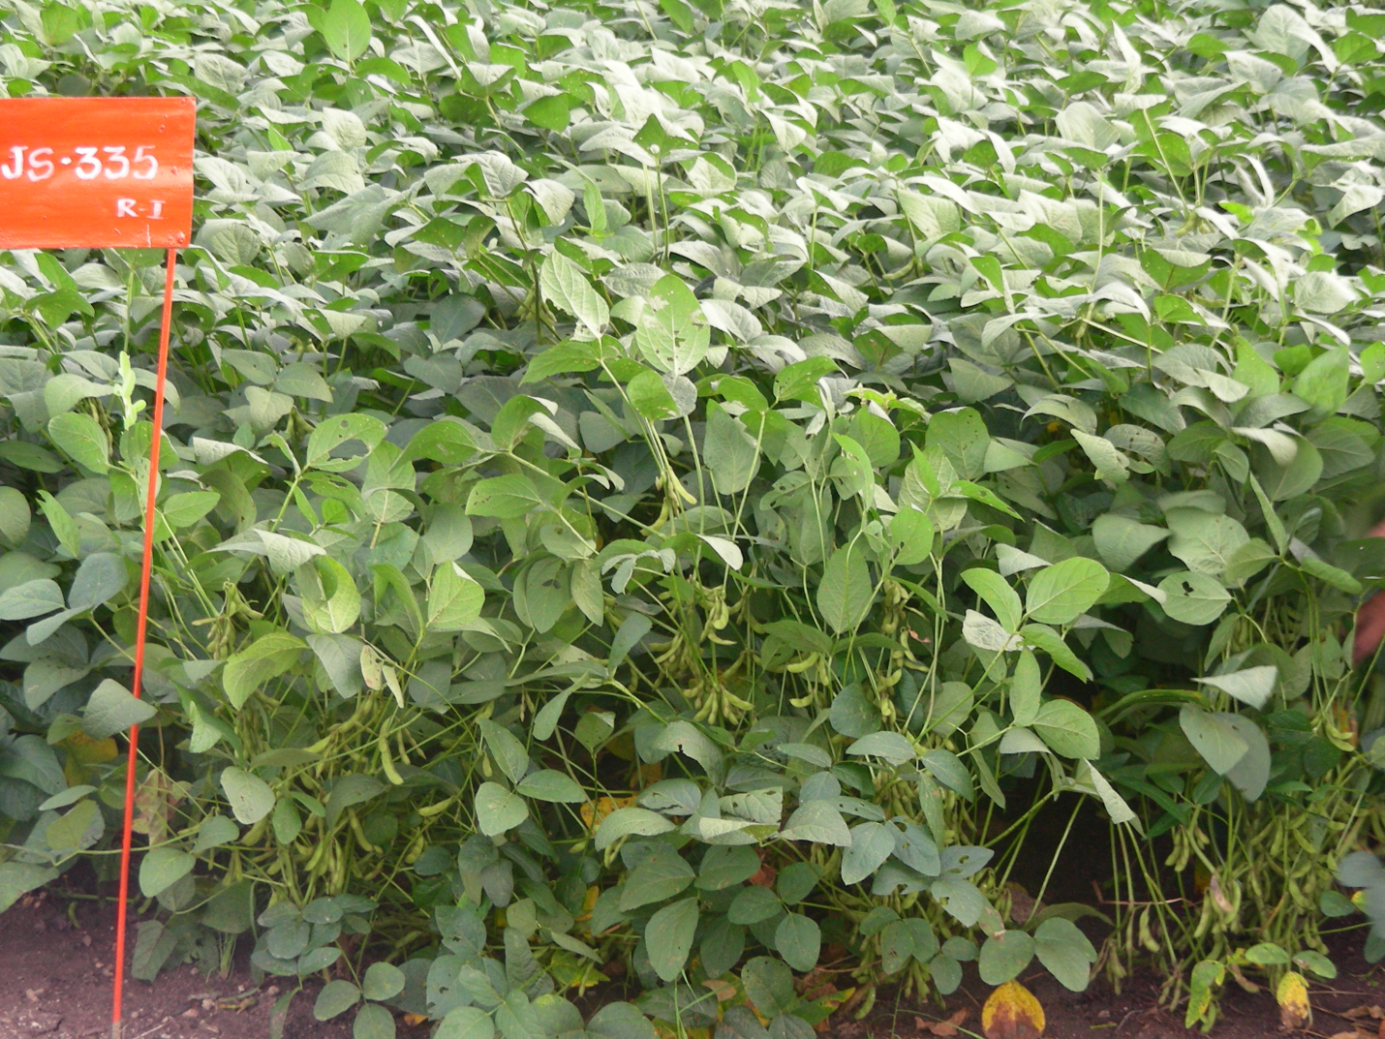

Introduction
Soybean [Glycine max (L.) Merrill] is one of the important oilseed crops grown in Telangana.Besides oil production, its cake is rich in protein used for live stock feeding and is a an ingredient in making feeds for poultry and fish.

Soybean is often called as the miracle bean because of its diverse application for food, feed and non-food uses. Its products are virtually a boon to mankind because of rich source of protein content of 40% and oil content of 20%.

In Telangana,its cultivation is mostly confined to northern districts of the state viz., Adilabad, Nizamabad, Karimnagar, Khammam and Warangal. It is in about 2.4 lakh ha and produced 2.94lakh tonne with a yield of 1225 kg/ha (2011-12) .

Climate
Soybean is cultivated in the tropics and sub tropics during monsoon season from June to October. The normal temperature ranging from 15-30⁰ C is essential for its germination. The optimum temperature requires for its good growth and yield is 30-35⁰C.The temperature, if it goes below 10⁰c,there will effect on growth as well as yield. Similarly, if temperature goes above 38⁰C,crop growth is also retarded.Generally day temperatures around 25 C are congenial for its flowering. It can be grown in areas receiving 600-650mm railfall. But rainfall at maturity deteriorates the grain quality. Even cloudy weather prolongs vegetative phase. It is generally cultivated at an altitude ranges from 1200to 2000 meter.

Soils

Soybean is grown on variety of soils ranging from black light to black cotton soils. However it comes up well in well drained sandy loam to clay soil with medium water holding capacity, reasonable depth, comparatively rich in organic carbon and levelled fields with near neutral pH between 6.5 & 7.5.The crop is sensitive to both saline and acidic conditions as well as water logging is also harmful for the crop.

Varieties
Soybean varieties, which are high yielding and exhibit stable performance across a range of environments, one should be selected. The variety must possess resistance against biotic as well as abiotic stresses.
Suitable varieties to Telangana

NRC 77, MACS 124, MAUS 2, MACS 450, PK 1029, MAUS 61 and JS 335 etc.

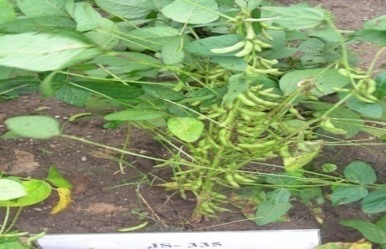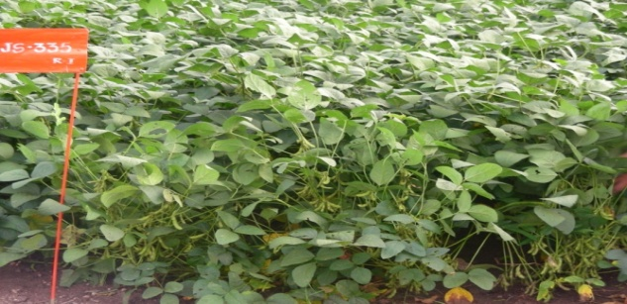

Cropping systems in soybean
Cropping sequence :.Soybean is a short duration crop mostly grown during kharif, so in black soils after soybean another crop can be grown on the same piece of land as sequence. The common sequence cropping systems are as follows:
Soybean-Bengal gram
Soybean – Sunflower
Soybean – Wheat
Soybean- Safflower
Intercropping
Soybean is remunerative ideal intercrop. The most important intercropping systems are as follows.
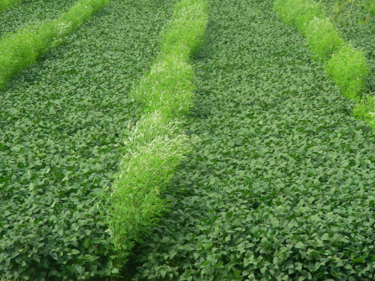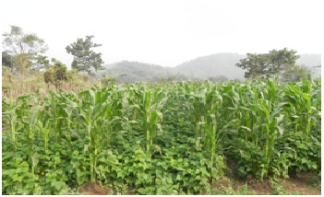

Maize + Soybean
Pegionpea + Soybean
Cotton + Soybean
Groundnut + Soybean
Sesame + Soybean

Agronomic management

Tillage and seed bed preparation

Tillage and seedbed preparation is very important contribution for crop production system, of soybean, often helps in reduction of soil erosion risks and energy inputs. This further leads to higher productivity at lower cost. In soybean, highest yield was recorded with minimum tillage. However, soil preparation for soybean consists of one deep ploughing with mould board plough followed by two horrowings and planking. To protect the crop from soil borne insects specially terminates 25 kg polidol dust/ powder should be mixed in to the soil just before last harrowing.

Seeding time

Planting time is considered to be crucial which greatly influence soybean growth and yield without involving additional cost. Timely sowing is very important in a crop like soybean which is highly photosensitive.

Delayed sowing may result in yield reductions to the extent of 17-39%. Highest soybean grain yield was obtained in June 20th planting and it gradually declined as the planting was delayed till 10th July at Indore.
i) For kharif – Middle of June to end of July
ii) For rabi – First week of October to December
iii) For summer – 2nd fort night of January
Seed rate
It depends up on size of the seed test weight, spacing and method of sowing. Generally 60-70 kg seeds are required per ha. A total of 3 lakh plant population need to be maintained for higher yields.Soybean seeds are costly hence farmers may opt to produce seed of their own. The quality seeds should contain seeds of a specific variety, therefore admixing of other variety seeds should be avoided at harvesting and threshing. The seeds must possess a minimum germination of 70%.

Seed treatment:
In soybean seed treatment is very important for attaining higher yields
i. Fungicidal/Bio-agent: Thiram 75 W5 + Carbendazim 50% WP (2:1) @ 3g/kg seed or Trichoderma viride 10gm/kg seed
ii. Microbial: About 500 g/75 kg seed Rhizobium culture +PSB/ PSM 500 g/75 kg seed

The spacing

It is very important that optimum spacing and plant population is required to harvest optimum yields. A placing of 30-45 cm row to row and 3-5 cm between plants .
Thinning
Thinning is to be done, if necessary under rainfed condition in order to maintain required population.

Manures and fertilizers
Unlike other legume crops, requirement of nitrogen is substantially fulfilled from symbiotic nitrogen fixation through Brady rhizobium. ( good nodulation takes place on root system) not only enhances yield but enriches the soil also. The seeds should be inoculated with effective strain of Rhizobium culture @ 5 g/kg seed just before sowing. The extent of N2 fixation is normally from 60-160 kg/ha in soybean.
Integrated nutrient management
involving use of organic manures, residues and inorganic fertilizer is beneficial. Farm Yard Manure (FYM) 10 ton/ha added to soil and harrowed for mixing in soil. It is better fertilizer to be supplied on the basis of soil analysis. Generally black soils contains potassium, therefore potassium requirement tends to be very less. The following nutrients are required for high yields in soybean.
Table :indicating the dosage of nutrients.
S.no | Nutrient | Quantity (kg/ha)
 | Nitrogen | 20
 | Phosporous | 60-80
 | Potassium | 20
 | Sulphue | 20
a) 43 kg urea or 100 kg Ammonium Sulphate + 400 kg Single Super Phosphate + 30 kg murate of potash. Besides that 200 kg of Gypsum or 100 kg pyrites per hectare need to be applied to meet the sulphur requirement.
b) The above (a) can be replaced, if non-availability of fertilizers with 125 kg DAP + 30 kg Murate of potash. Besides that 200 kg Gypsum or 100 kg pyrites per hectare need to be applied to meet the sulphur requirement.
Intercultural operation and weed management
At least intercultural operations with Guntaka/ Danthe/hoe should be done between 20 and 40 days after sowing keeps weeds under control.
Soybean being a rainy season crop, is heavily infested with many grassy as well as broad leaf weeds. Yield loss on soybean may range from 25-70% depending up on intensity and infestation of weeds. Besides yield loss, quality is also drastically affected. The most critical period for the weed interference is initial 15-45 days. Weeds emerging after this period are being suppressed by smothering action of crop. The crop is sensitive to weed competition in early growth phases. Where ever farmers encounter labour problem they can also go for weedicides to control weeds. However, herbicidal weed control has been found efficient and economical in soybean.
Weed management
A wide variety of weeds can compete with soybean crop at all stages of the growing season. Heavy weed pressure reduces yields and cuts into profits.
The most common weeds are two types and the details are follows
Grassy weeds: Echinochloa colonum, Sorghum halepense, Cypersus rotandus, cynodon dactylon etc.
Broad leaf weeds: Celosia argentia, Digitaria SP; Trienthema Partulactrum, Vernonia SP, Tribulus terristris, Phyllanthus niruri etc.
Common herbicides for weed control in soybean are as follows
Herbicide | Rate | Mode
Fluchlorilin (Basalin) | 2 lit/ha | Pre-emergence
Alachlore | 1.0-2.0 kg/ha | Pre-emergence
Butachlore | 2.0 kg/ha | Pre-emergence
Pendimithalin | 2lit/ha | Pre-emergency
Fluazifop-butyl | 0.25-0.50 kg/ha | Post-emergence  (15-25 DAS)

Moisture conservation practices:
The crop grown during kharif, make dead furrow in alternate row may help in conservation of moisture.

Irrigation management

Irrigate immediately after sowing. Give life irrigation on the 3rd day. Further irrigations at intervals of 7 - 10 and 10 - 15 days during summer and winter season respectively may be given depending on soil and weather conditions. Soybean is very sensitive to excess moisture and the crop is affected, if water stagnates in the fields. The crop should not suffer due to water stress from flowering to maturity. To alleviate moisture stress spray of either Kaolin 3% or liquid paraffin at 1% on the foliage.

Plant protection

Growing a Profitable Soybean crop requires keeping invaders out timely.
Management of Insect pests
Insect name |  | Nature of damage |  | Control measure
Pests
Stem fly  (Melanagromyza phaseoli )  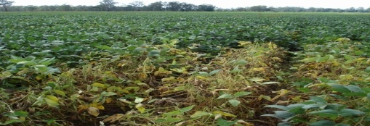 | The eggs are laid on leaves.  After hatching from the egg yellowish maggots bore the nearest vein of the leaf and reach the stem through petiole and bore down the stem as well as root. |  |  | Deep summer ploughing, ,use optimum seed rate and proper crop rotation should be followed.Soil application of phorate10G@ 10 kg/ha or carbofuran 3 G @ 30 kg/ha. or two sprays of Dimethoate 30 EC or quinalphos 25 EC @ 2ml/lit.
Gridle beetle,(Obserea brevis)  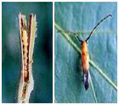 | Beetle makes tunnels in the stem.Cause 50-60% loss in crop yield. |  |  | Application of Monocrotophos 36% Ec@1.6ml/lit
Bihar hairy caterpillar  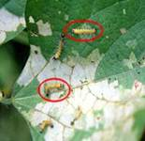 | The young larvae feed voraciously on the chlorophyll of leaves and skeletonize it,later feed on flowers and pods. |  |  | Dusting with folidal powder 2% @25 kg/ha at early stage or  Spraying Monocrotophos 36%@1.6ml/lit
Gram pod borer: Helicoverpa armigera  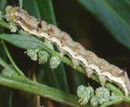 | The young larvae feeds on the chlorophyll of young leaves and skeletonize it.  They feed voraciously on the foliage in early stage, may defoliate the plant and later they feed on flowers and pods. |  |  | Deep summer ploughing,Install pheromone traps 5 traps/ha for each insect pest,erect bird perches @ 50/ha,Clip terminal shoots on 100 days of crop growth,setting of light traps (1 light trap/5 acre) to kill moth population,dusting with Chlorpyriphos 1.5 % DP or quinolphos 1.5% @ 25 to 30 kg/ha,spray with Chlorpyriphos 1.5 % DP @1200 ml/ha or quinolphos 25 EC @ 1.0 lit/ha.
Tobacco caterpillar: Spodoptera litura  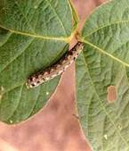 | Larvae feed on the chlorophyll of the leaves.  The eaten leaves give the appearance of whitish yellow web. |  |  | Deep summer ploughing, use of  Optimum seed rate, Collect and destroy infested plant parts, egg masses and larva,Install sex pheromone trap @ 10 traps/ha for early deduction of the pest.  Erection of bird perches @ 10-12/ha.Apply Profenophos 50 % EC @ 2ml/lit or quinolphos 25 EC @ 2ml/lit,dust Deltamethrin 2.8% EC or quinalphos 1.5% @ 25kg/ha when their population is likely to reach 10/m row length (ETL). Repeat it as needed.
White fly: Bemisia tabaci  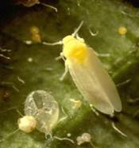 | Due to attack of the insect the leaves turn yellow and become curled.  This insect spread the mosaic disease in soybean. |  |  | Spray quinalphos 25 EC@ 2ml/lit or dimethoate 30 EC @ 2ml /lit at the crop age of 35-40 days and repeat after 15 days if needed.
Soybean Aphid: Aphis spp.  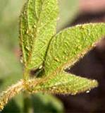 | They suck the plant sap from the stem, leaves and pods which cause reduction in yield. The infested leaves are wilted or curled. plant stunting . |  |  | Spray 0.05 % quinalphos 25 EC, oxydemeton methyl 25 EC, or dimethoate 30 EC @ 2ml /lit at the crop age of 35-40 days
Jassids: Apheliona maculosa  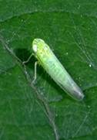 | Infested leaves start yellowing from the margins,In case of severe attack, all the leaves become yellow and eventually fall off from the plants. |  |  | Sprayquinalphos25EC,@2ml/lit or oxydemeton methyl 25 EC, or dimethoate 30 EC @ 2ml /lit at the crop age of 35-40 days and repeat after 15 days if needed
Management of Diseases
Alternaria leaf spot Alternaria tenuissima)   | Appearance of brown, necrotic spots with concentric rings on foliage, which coalesce and form large necrotic areas.  Infected leaves later in the season dry out and drop prematurely.  Seed become small and shrivelled. Dark, irregular, spreading sunken areas occur on the seed. |  | Use healthy/certified seeds  Destroy crop residues from fields.  Seed treatment with thiram + carbendazium (2:1) @ 3g/kg seed,spraying of Mancozeb at 2.5g/l or carbendazim 1 g/lit
Rust (Phakospora pachyrhizi Syd) | The symptoms appear on all above ground parts of the plant. Large number of light brown pustules appears on the dorsal surface of the leaves in the initial stages, later turns to reddish brown to tan colour. The leaves gradually become yellow and premature defoliation occurs resulting in yield loss. |  | Early maturing varieties escapes the infection,growing of resistant, varieties.spraying of Mancozeb 2.5g/lit 3 times effectively reduces infection.Foliar spraying of hexaconazole, propiconazole, triadimefon and oxycorboxin ,1g/lit 2-3 times at 15 days interval found effective.
Frog eye leaf spot ( Cercospora sojina)  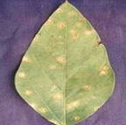 | The disease primarily affect foliage, but, stems, pods and seeds may also be infected.  Leaf lesions are circular or angular, at first brown then light brown to ash grey with dark margins.  The leaf spot may coalesce to form larger spots. |  | Use healthy seeds, rotate crop with cereals,completely remove plant residue by clean ploughing the field soon after harvest.  Seed treatment with Thiram + Carbendazim (2:1) @ 3g/kg seed.  Spray Mancozeb @ 2.5g/lit or Carbendazim 1g/lit or benomyl or chlorothalonil 2g/lit.
Charcoal rot, ashy or stem blight or dry root rot( Macrophomina phaseolina)  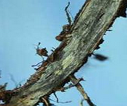 | It occurs when the plants are under moisture stress or under nematode attack or through soil compaction or may be through nutrient deficiencies.  Blacking and cracking of roots is the most common symptom.The fungus survives in soil and crop debris in dry conditions.Dry conditions, relatively low soil moisture and nutrient and temperature ranging from 25o C to 35o C are favourable for disease. |  | Deep ploughing in summer, ensure balanced fertilization of the crop,rotate it with cereals.  Destroy previous years infected stubble.Seed treatment with T. viride @4g/kg or P. fluorescens @ 10g/ kg of seed or Carbendazim or Thiram 2g/kg of seed.Spot drenching with Carbendazim 1g/lit or P. fluorescens / T. viride 2.5 kg/ha with 50 kg FYM
Bacterial blight: Pseudomonas syringae pv. Glycinea   | Seeds may develop raised or sunken lesions and become shrivelled and discoloured.  Small, angular, translucent, water-soaked, yellow to light brown spots appear on leaves.  Young leaves are most infected and are destroyed,  Early defoliation of lower leaves may occur.  Large, black lesions develop on stems and petioles. |  | Deep summer poughing,use healthy/certified seeds.  Destroy infected crop debris  Seed treatment with streptocyclin @ 250 ppm (2.5 g/10 kg seeds).Application of any copper fungicides @ 2 g/lit along with streptocyclin at the rate of 250 ppm (2.5 g/10 lit water). Spraying of neem leaf as well as kernel extract.
Rhizoctonia aerial blight / Web blight: Rhizoctonia solani  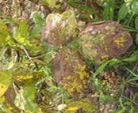 | Infected leaves appears as water soaked at first instance. They soon take on a greenish brown to reddish brown appearance.  The infected portion later turns tan brown or black in colour.  Under high rainfall or high humid conditions, a web like mycelial growth of fungus forms on the leaves.  The pathogen survives as sclerotia in soil.  Humid and cool (24-32o C) are favourable weather condition. |  | Avoid dense planting.  Completely cover plant residue by clean ploughing the field soon  after harvest.  Destroy infected stubble.  Seed treatment with Thiram + Carbendazium (2:1) @ 3g/kg seed. Use Mancozeb or copper fungicide at 2.5gm/l or carbendazim 1 g/lit.
Cercospora leaf blight, leaf spot and Purple seed stain: Cercospora kikuchii  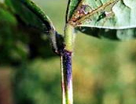 | Infected leaves appear leathery, dark, reddish purple.  Severe infection cause rapid chlorosis and necrosis of leaf tissues, resulting in defoliation.  Lesions on petioles and stems are slightly sunken, reddish purple; severe cause defoliation. |  | Use healthy/certified seeds.  Previous crop debris should be removed.  Seed treatment with Thiram + Carbendazium (2:1) @ 3g/kg seed.  Use Mancozeb or copper oxychloride at 2.5g/l or Carbendazim 1 g/lit.
Collar rot / Sclerotial blight: Sclerotium rolfsii.  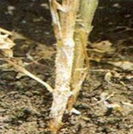 | Infection usually occurs at or just below the soil surface.  Sudden yellowing or wilting of plants is the first symptom.  Light brown lesions, which quickly darken, enlarge until the hypocotyl or stem is girdled.Leaves turn brown, dry and often cling to dead stem.  Numerous tan to brown, spherical sclerotia form on infected plant material. |  | Deep ploughing in summer.  Crop rotation with maize or sorghum.Destroy infected stubble.Seed treatment with T. viride @4g/kg or P. fluorescens @ 10g/ kg of seed or Carbendazim or Thiram 2g/kg of seed.  Spot drenching with Carbendazim 1g/lit or P. fluorescens / T. viride 2.5 kg/ha with 50 kg FYM.

(Source : http://agritech.tnau.ac.in/crop_protection/crop_prot_crop%20diseases_pulses_soybean.html)

Harvesting and post harvest technology

At maturity leaves turn yellow and plant shed them. The seed in the pod is hard and dough. Preferably the crop should be harvested in the morning to avoid losses of shettering. Harvesting is done by uprooting the plants or by cutting with sickle.

Threshing

It should be done by beating with sticks or by bullocks or tractor mounted thresher or by mechanical soybean thresher or by the combine harvester.

Yield

It ranges from 20-25 quintals per hectare.

Post harvest

The grain should be dried under sun till reaches moisture to 10-12% .The seed, which is to be used for next season usually stored under low 0temparature and low humidity conditions, because of oil, bitterness may develop if stored for long time.

Realizable yield potential

Productivity potential of improved technologies of soybean during 2011-14
(Erstwhile AP)

Technology | FLD average yield (kg/ha) |  | Yield gap-I (%) | Yield gap-II (%)
 | IT | FP
Whole package | 2297 | 1672 | 38 | 40

It is clear from the demonstrations that there exists 38% yield and potential yield, the can be narrowed down by adoption of good management practices by the farmers.

Points for remembrance

1. Generally on long period of seed may storage, loose viability, so germinability of seed need to be tested before sowing, on order to adjust the seed rate.
2. Often farmers confused in treating seed with fungicides and colliers. So, one should treat the seed first with fungicides and then with culture just before sowing
3. Fertilizer should never be mixed with seed at the sowing.
4. Fertilizer, need to be applied on the basis if soil analysis for getting higher yields
5. Timely sowing is very important (3rd week of June to first week of July)
6. In places where labour availability is problem there, recommended weedicides should be used at proper time
7. Time of harvest is also important. Crop should be harvested just after the pods lose green colour to avoid the losses due to shattering seeds
8. Threshing of harvested crop should be done after 2-3 days with low spread of thresher cylinders
9. Seeds should be dried for 3-4 days, later keep fill fertilizer bags and storage in the seed in the well ventilated room store.

Oilpalm (Elaeis guineensis )

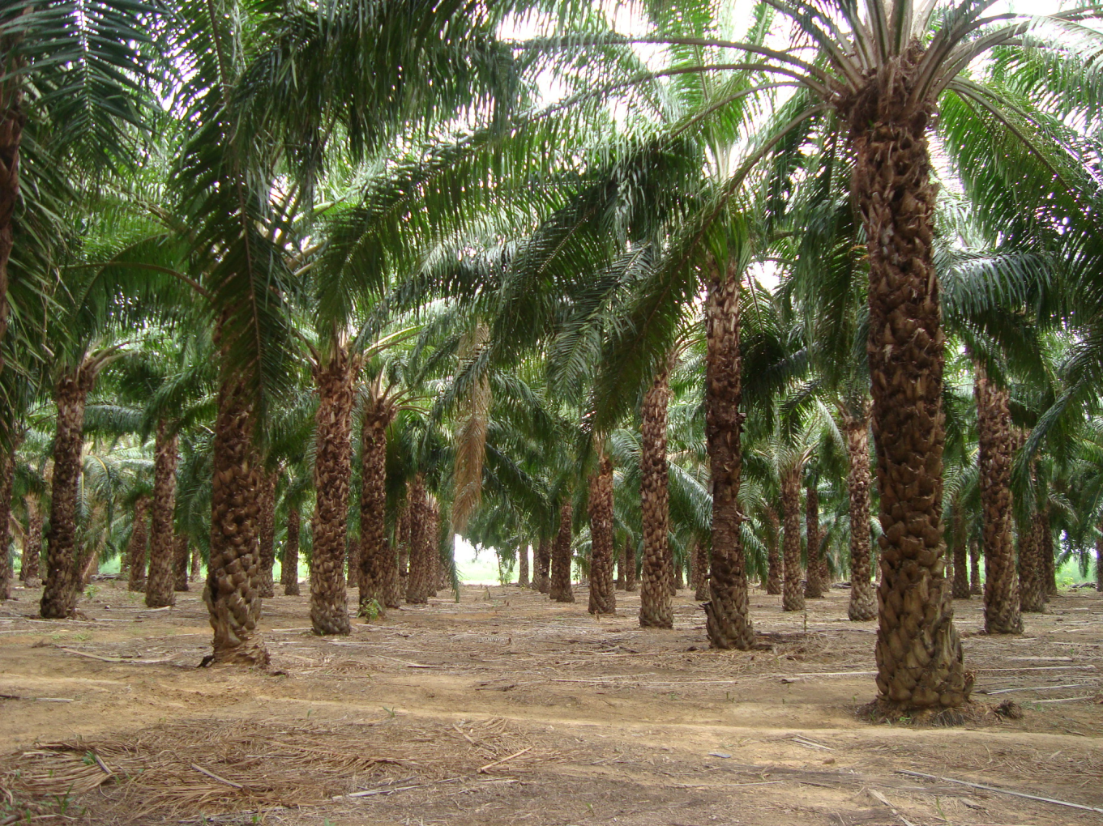

Introduction

Oil palm gives the highest oil yield of 4-6 tons/ha/year with a global average of 3.80 tons/ha/year, which no other annual oilseed crop produces. There is a scope for achieving 6-8 tons of oil/ha/ year in oil palm in India. Palm oil is a source of nutrition and health due to its high calorific value and richness in vitamin A & E content which in turn helps in nutritional security of people. It also provides opportunity for higher employment generation in the plantations and agro-based industries as well. The expert teams identified the potential areas for growing oil palm under irrigation in eighteen states in India.

In Telangana state is also one of the pioneering states for Oil palm cultivation.The suitable districts identified for Oil palm cultivation in the state are Khammam and Nalgonda and the area covered is about 15000ha.

.Climate
Oil palm is a humid crop, requires proper distribution of rainfall of 150 mm/month or 2500 to 4000 mm/year. In the state the rainfall ill distribution and inadequate, hence, suggested to grow under assured irrigation by following recommended practices. It comes up well even up to 45 0c maximum temperature and minimum temperature up to 10-12 ⁰c, with bright sunlight for at least 5 hours per day. However, it can excel where humidity is more than 80%.

Soils
Oil Palm can be grown up to 8.0 soil pH. Best suited soils are moist, well drained, deep loamy alluvial soil, high in organic matter with porous texture and soil depth of at least one meter is required. Its performance is poor in soils which are of highly alkaline, highly saline, water logging and coastal sandy soils. So avoid oil palm cultivation in those soils conditions.

Varieties and hybrids:
Tanera is the hybrid has a thin shell, medium to high mesocarp content and high oil content.

Cropping systems
Oil Palm is a widely spaced perennial crop with a long juvenile period of 3 years. There is scope to use inter and intra space to generate income during the juvenile phase of the crop.
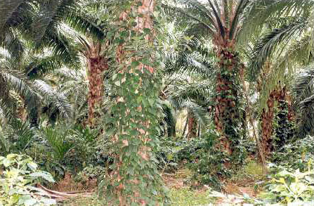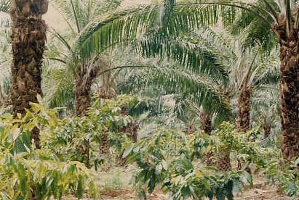
Inter-cropping
Oil Palm is a widely spaced perennial crop with a long juvenile period of 3 years. There is scope to use inter and intra space to generate additional income during the juvenile phase of the crop. Suitable crops for intercropping in oil palm are vegetables, banana, flowers, tobacco, chillies, turmeric, ginger, pineapple etc. Suitable crops for intercropping in matured 8-12 year old oil palm or palms which have attained height of 3 meters are cocoa, pepper, heliconia and ginger lilly (they grow under partially shaded conditions).

Agronomic management

Tillage and land preparation

Basin management: During first year, basins of 1-m radius, second year 2- m radius, and the third year 3- m radius are to be taken around the palm by removing the soil from inside so that the soil will not accumulate at the collar region. Basin area of oil palm represents its active root zone. Hence it must be kept clean and weed free to avoid competition for nutrients and water.

Time of sowing
Best season for planting is June-December i.e., during monsoon. In case of planting during summer, adequate irrigation, mulching and growing cover crops like sun hemp in the basin would help in avoiding hot winds during summer

Planting of saplings and spacing

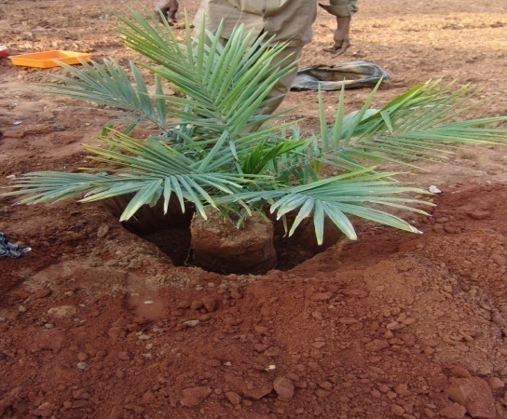
12 -14 months old healthy saplings with 1-1.3m height and 13 functional leaves are recommended for planting. While planting, 143 plants per hectare should be maintained with a spacing of 9m x 9m x 9m (triangular planting). Planting should be done in pit size of 60 cm x 60 cm x 60 cm (length, breadth and depth). A total of 143 plants per hectar should be maintained with a spacing of 9 m x 9 m x 9 m (triangular planting) and the pit size should be 60 cm x 60 cm x 60 cm (length, breadth and depth).

Application of 250 grams of DAP or 400 grams single super phosphate, 50 gram phorate and mix with the soil at the base of the pit. Soon after planting a basin to be formed and watered sufficiently.

Manures and fertilizer management
Oil Palm is a heavy feeder and demands a balanced and adequate supply of macro, secondary and micro nutrients for growth and yield.
The nutrient requirement of oil palm varies widely and depends up on the soil type, ground coverage situations, tanget yield , type of planting material used, spacing between palms, age of palm, as well as climate and other environmental factors. Further, it is also associated with the amount of nutrients removed in harvested fruit bunches, nutrients recycled to the soil through preened fronds, male inflorescences and leaf wash and nutrients immobilized in the palm biomass. Keeping the demand of nutrients four equal split doses of fertilizers are to be applied stanting from June/July T three mouth interval. For the nuery planted crop, the first dose of fertilizer needs to be applied three months after planting. Apply 50-100 kg FYM or 100 kg green mamuse per palm along with second dose of fertilizer application. Five kg neem cake/palm can also be applied. Broad cast the fertilizer around the clean-weeded basin, about 50 cm away from the palm base and incorporate in to the soil with the help of fork. Irrigation is must soon after fertilizer application.
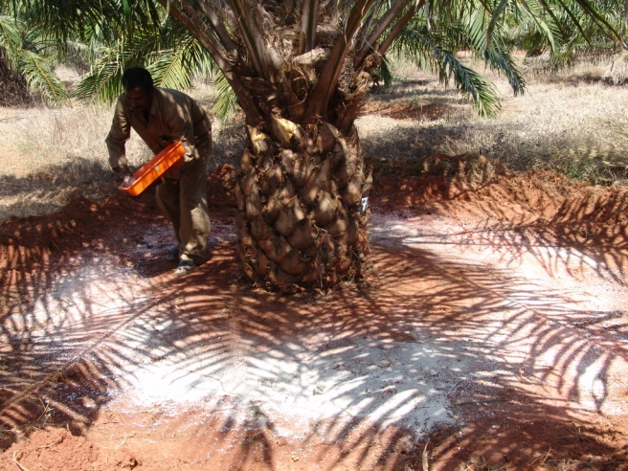

Manures and fertilizers
Age of oil palm | Nitrogen | Phosphorous | Potassium | Magnesium | Boron
 | Urea  (grams/palm/yr) | SSP  (grams/palm/yr) | MOP  (grams/palm/yr) | Magnesium Sulphate  (grams/palm/yr) | Borax  (grams/palm/yr)
1st year | 870 | 1250 | 670 | 125 | 25
2 nd tear | 1740 | 2500 | 1340 | 250 | 50
3rd year | 2610 | 3750 | 2000 | 500 | 100

Ring/Basin management: It is very important during first year, basins of 1-m radius, 2nd year 2-m radius and the third year 3-m radius are to taken around the palm by removing the soil from inside so that the soil will not accumulate at the collar region. Ring or basin area of oil palm indicates its active root zone. So, basin should be kept neat & clean (weed free) to avoid competition for nutrients and water.
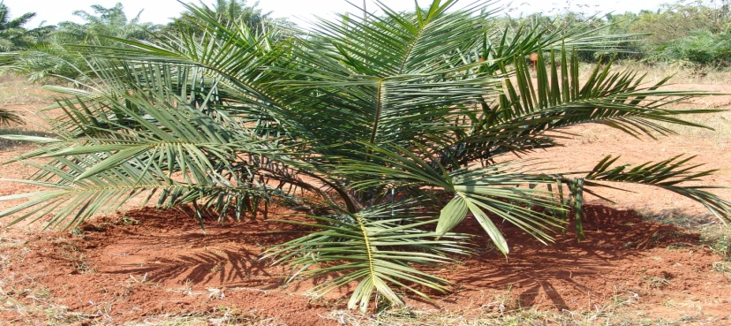
Intercultural operations and weed management
Regular manual weeding is essential .Where ever labour scarsity exists, one can go for chemical weed control. Use only recommended herbicides, parable contact herbicides. Ghyposate – 750 mi/ha/year or 17.5 ml/basin Herbicide mixtures paraquat with Atrazine, monuron and Diuram sprayed on ground twice a year can control the weeds, effectively.
Mulching: Mulching of oil palm basins is essential to conserve moisture as well as to control weeds. Mulching can be done with dried leaves, male flowers, coconut husk, empty bunches etc.
Flowering:
Oil palm generally comes to flowering in 14-18 months after planting.
It produces both male and female flowers separately on the same palm.
Male and Female phases do occur naturally in consequent cycles in a palm.
Ablation:
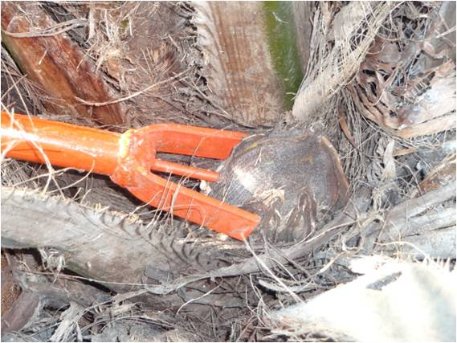
It is nothing but removal of male and female flowers produced at the earlystages of plantation.
This process enables the palm to gain adequate stem growth, vigour and develop root system Start ablaction soon after the appearance on inflorescences on the palms by way of hand pulling or using the tool developed at DOPR. Ablation can be extended from 2 ½ to 3 year depending up on growth and vigour of palms.
Pollination:
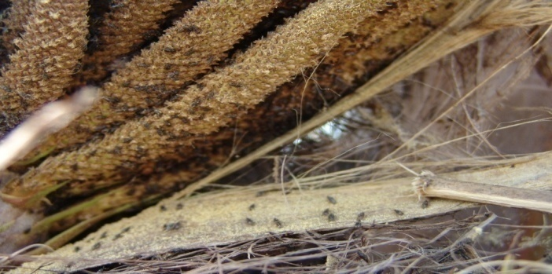
Oil Palm is Highly cross-pollinated crop
Wind and insects assist in pollination
Wind pollination occurs but not adequate
Effective pollinating insect is Elaeidobieus kamerunicus, which helps in good pollination and seed set.
It is advisable the release of this weevil only after 2 ½ years of planting.
In case plants not attained good girth and vigour, release the weevis after 3 years.
Mulching of basin. It is essential to conserve moisture as well as weed control
Materials to be used for mulching are dried leaves, male flowers, coconuthusk, empty bunches, dried up grass, paddy staw etc.
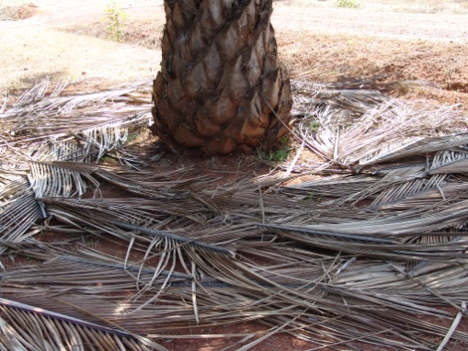

Irrigation Management:

Oil Palm is water loving one, requires sufficient irrigation, as it is a fast growing crop with high productivity and biomass production. It starts beazing from 3 year on wards and a minimum of 150 to 200 lit of water per day required. But in hot summer the requirement may be increased up to 300 litres/plant.
Method of irrigation
Basin method of irrigation: It can be adopted where irrigation water is not constraint. Required quantity of water is be given at 4-5 days interval. Systematic channel id to be prepared and ensuring that the individual palm are connected separately by sub-channel. However, frequency of irrigation in high soils is less compared to heavy soils.
Drip/ Micro jet irrigation: Where land is undulated this method of irrigation is advantageous. Under drip system, four drippers are to be placed for each palm. If each dipper discharges 8 liters of water per hour, 5 hours of irrigation per day is sufficient to discharge 160 lit/day.
In case of micro sprinklers (1800-360) one each on either side of the palm can be installed. Drippers/ Jets needed periodically checking for proper discharge. Basins should be kept under mulching so as to help in conserving moisture.
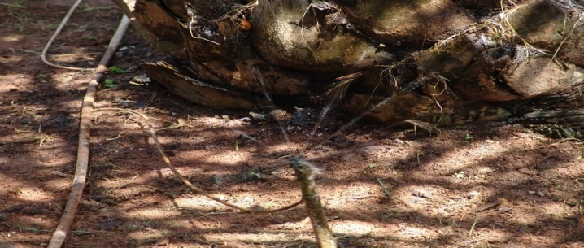

Irrigation management : Oil Palm requires sufficient irrigation for high productivity. Insufficient irrigation will lead to reduction in the rate of leaf production, growth, produce more male inflorescence will lead to yield reduction. Water require meant depends upon age of the plantation, type of the soil and potential evaporation (PET). PET is calculated based on the temperature, relative humidity and wind velocity in respective areas and area of the crop exposed to sunlight.

Plantation having four years and above age, in light soils having PET 3.0 mm would require 210 lits of water per day. As PET increases, water holding capacity of the soil reduces hence plants require more amount of water.
In Pedavegi region of West Godavari district of A.P. if the PET during summer is 3.1-3.8 mm, it is required to provide water @ 215-265 lit/day/palm. Similarly if PET during monsoon is 1.4-2.1 mm, it is required to provide water @100-150 lit/day/palm. If the PET is 2.2 to 2.4 it is required to provide water @ 160-170 lit/day/palm. If the PET recorded is 5.0 mm during summer, it is required to provide water @ 350 lit/day/palm

Insect pests and disease management

Nursery Pests
1. Spindle bug, (Carvalhoia arecae):Nature of damage: Generally noticed in nursery seedlings and field planted young seedlings. Adults and nymphs of spindle bug live suck sap from the spindle of leaves. Necrotic lesions which later on turn into dry brown patches.In severe infestation the spindle fails to open.
Control : Ploythene sachets filled with Phorate 10 G (Thimet 10G) @ 2g per sachet, placed in the innermost two leaf axils (one sachet each in a leaf axil).The same sachets can be used for 6-8 months
Adult palms
2. (Rhinoceros beetle, Oryctes rhinoceros):Nature of damage: Adult beetles bore into the palms and chew the tender tissues,spindle to break and droop,entry holes – presence of chewed-up tissues .The infested leaves – shortened, broken and distorted.
Control : Mechanical Iron Hooking
The adult beetles which burrow deep into the crowns of young palm Extracted by means of a hooked out (metal rod)After extraction of the beetle, the leaf axils around the injured spindle are to be filled with a mixture of mancozeb (fungicide) and fine sand at the ratio of 3g: 1kg.
Chemical control
Leaf axil filling in severely infested young plantation during April-May, September-October and December-January using Sevidol Granule @ 25 g per palm per application mixed with 200 g of sand.
Biological Control
Application of Metarhizium anisopilae in the breeding sites for the control of grubs. Attractants
Pheromone traps:Rhinolure vane trap hanged at a height of 10ft. found effective in trapping adult beetles.Mud pots:Castor seed powder fermented in rice water and kept in mud pots at ground levelfor trapping adult beetles.
3. Red palm weevil, Rhynchophorus ferrugineus
Nature of damage: Rhinoceros beetle attacked palms are more prone to infestation by red palm weevil Grubs bore into stem and feed on softer tissues of stem, meristem and mesocarp of fruits Infested palms – gradual wilting and drying of outer whorl of fronds.
Control: Avoid making wounds on the palm and bunches Prophylactic leaf axil filling is to be done for young palms as in the case of rhinoceros beetle Trunk injection with carbaryl 50% WP at 1% is an effective curative treatment.Attractiants
a. Pheromone traps:Ferrolure placed in specially designed traps and hanged on the palms
b. Log traps:Weevils are trapped and destroyed using split logs of coconut/oil palm or petioles (50 cm long) treated with attractants such as coconut toddy molasses
4. Mealy bugs: Dysmicoccus brevipes
Nature of damage: Mealy bugs infest the spear leaves leading yellowing of young leaves and stunted growth of palms It is also infests the unripe and ripe oil palm fruits
Control: Collect planting material from unaffected plantation Spraying wth dimethoate at 2ml/lit or methyl demeton at 0.025%,Release coccinellid beetle, Cryptolaemus montrouzieri @ 10/tree
5. Mites, Tetranychus piercei
Nature of damage: Mites suck the sap from the leaves Attacked leaves – discoloured and look speckeld Nursery and young palms are severely disrupted
Control: Application of dicoifol 2 ml/lit or Wettable sulphur 2g/lit
Vertebrate Pests
1. . Rodents: Burrowing rat, Tatera indica
Nature of damage: The burrowing rats burrow down to the bole of the palms and make cavities into the hole Feed the sweet inner cabbage portion No external symptoms – entire meristematic region is devoured Suddenly the leaves look wilted or dried and death of the palm
Control: Clean cultivation,Mechanical barrier :At the time of planting –rodent infested areas, can be covered with 22 gauge galvanized iron (chicken) wire mesh around the hole.
Traps :Cage trap, spring death trap, death fall trap, bamboo noose trap etc.Trap shyness may become a problem after continuous use. Changing the places for keeping the traps frequently. Chemical control poison bating :Zinc phosphide – used acute poison, but induces bait shyness in rodents.Single dose anticoagulant – Bromadiolone (0.005%). It is available in wax cake formulations Multiple dose anticoagulants – Warfarin, Fumarin
Biological agents :A large number of predators used to regulate the rodent population in nature.Barn owl (Tyto alba stertens) in controlling rodents
Disease
Disease occurrence is relatively less on oil Palm, however timely management is essential for attaining higher yields. Few diseases that occur on oil palm are given below.
Bud rot
The disease incidence is noticed during rainy season, low temperature and high humidity.
Symptoms:
- Yellowing of the spear leaves which subsequently turns to brown.
- Affected spear bends at the base and seen hanging down in the crown.
- The basal tissues of the spear completely gets rotten as a result it collapses and can easily pulled out.
Management: the affected spear should be pulled out along with the decayed tissues. The affected tissues of the meristem should be removed layer by layer till fresh tissues are seen and paste with carbendazim 20 gm in 100 ml of water and also spray monocrotophos 1ml in 1litre of water as a preventive measure.
Bunch rot:
Symptoms:
- During the early stages of infection strands of mycelium can be seen spreading over the bunch surface offering only the tissues.
- Mycelium development is particularly more at the back of the bunch against the subtending frond where conditions are very moist
- In later stages mycelium grows over the fruit surface and penetrates the mesocarp to produce wet rot.
Causes:
Diseased bunches are left on palms spreading of mycelium from one part to the other parts of the palm can often be seen.
Management:
- Remove the dead inflorescence, bunch stalks, aborted bunches before onset of the monsoon.
- Infected palms should be thoroughly cleaned and spray carbendazim 1 gm in 1 liter of water during pre monsoon, monsoon, post monsoon periods.

Basal stem rot (Ganoderma)
Symptoms
- Withering, yellowing and orange discoloration of the leaves followed by necrosis on one side of older fronds.
- Desiccated fronds drop or break at some point along the rachis.
- Appearance of light brown lesions or rotting of the bole at the stem base is characteristic symptom at the advanced stage of disease.
- The infected palms appear suffering with malnutrition.
- The disease produces dry rot of internal tissues at the base of trunk.
- Trunk roots became friable and disintegrate easily. The internal tissues turn into dry and powdery mass.
Management:
- Removal and destruction of the dead and diseased palms in order to prevent the spread of the disease.
- The palms in the early or middle stages of the disease should be isolated from the neighboring palms by taking trenches of 1 meter deep and 30 cm wide.
- Affected palms should be given 5 kg of Neem cake per year.
- The disease affected and surrounding palms should be given root feeding with Calixin 10 ml in 100 ml of water.
Surgery:
Remove the rotten tissues from the diseased palms and apply Carbendazim paste and apply coal tar layer on it.

Stem wet rot
Symptoms:
- Sudden death of spear leaves including the young expanded fronds sorrounding the spear.
- Remaining fronds shows yellowish discoloration and then rapidly wither and die.
- Some times, the older leaves die first and the symptoms progress to the young fronds.
- For confirmation of disease a sharp iron rod may be pierced into the stem base, which gives out liquid with putrefied smell.
Management:
- Burn the dead and diseased palm after removing from plantation.
- Improvements in agronomic practices, providing drainage, avoid flooding of the field.
- Early detection of the disease and trunk surgery can save the palm.
Trunk surgery:
- Remove the infected and diseased tissues completely. When the surgery is completed a protective covering with carbendazim 1% mixed with monocrotophos paste followed by hot coal tar layer.
- Repeat the surgery after 3 months if symptoms seen again.
Harvesting
Caution should be taken while harvesting the stalk length. Generally a length of 5cm stalk left on trunk in order to avoid mechanical damage to trunk. Harvesting should be followed at an interval of 10-12 days. During rainy season, harvesting should be adjusted at closer interval of 6-7 days as ripening hasten after hot summer. In young plantations ,generally one can get more bunches with less bunch weight, while in matured plantations the bunch weight is more but the bunch number comparatively less.
+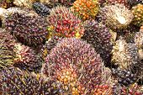
The yield potential is 12 t/ha for stabilizing period (4-8 years) and 220t/ha for stabilized period (> 8 years).
(Source:http://www.dopr.gov.in/Reports/OilPalmCultivation.pdf,http://agropedia.iitk.ac.in, http://agritech.tnau.ac.in)

Output (Yield)
Generally, yield is considered as Fresh Fruit Bunches (FFB) weight obtained from a hectare oil palm plantaion. Plantation attained an age of 4-8 years would yield 12tonnes/ha. The plantations which has more than 8 years can yield 20tonnes/ha.
Palm Oil is an edible vegetable oil derived from the mesocarp (pulp is reddish in colour) of the fruit of the oil palms. The oil is extracted from the fruits is known as Crude Palm Oil (CPO). Oil extracted from kernel is known as Palm Kernal Oil (PKO) .

Castor ( Ricinus Communis L. )

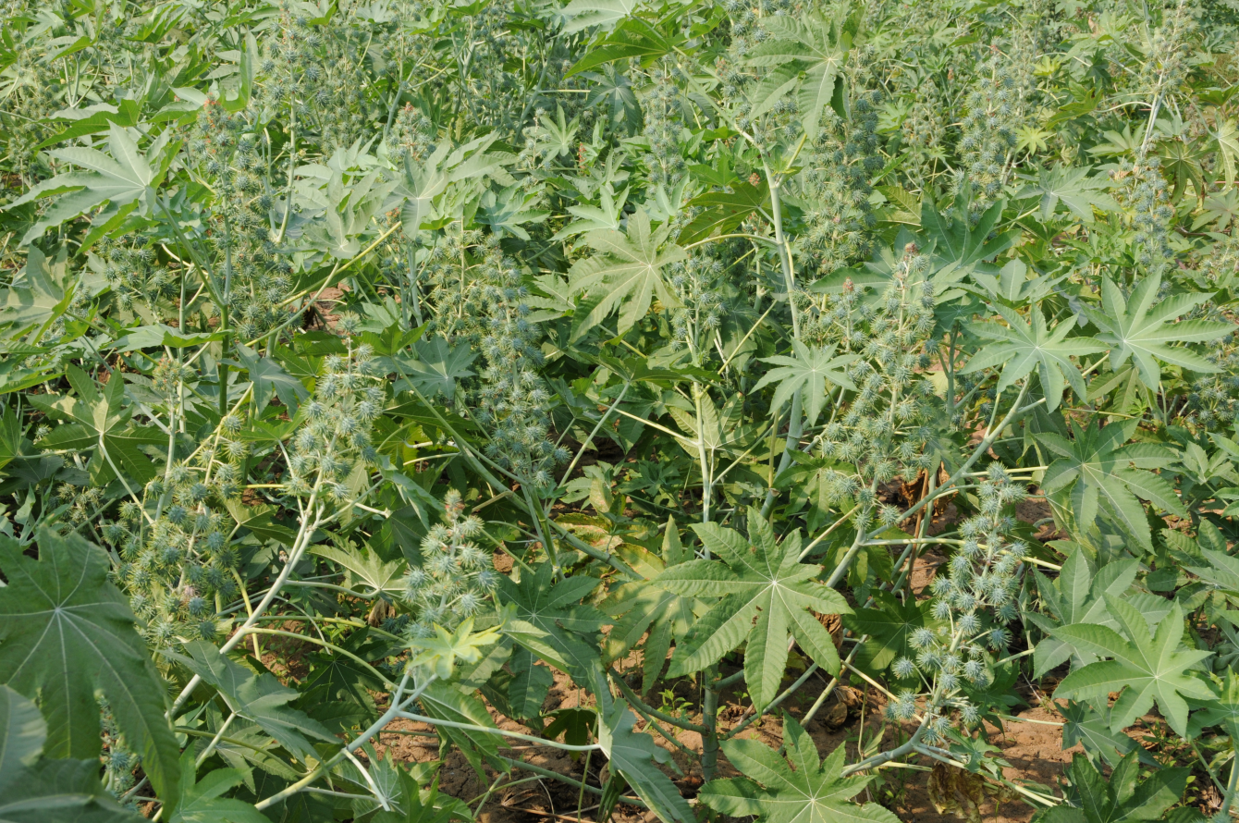

Introduction
Castor is one of the most versatile non-edible oil seed crops grown on large scale in Telangana.Its cultivation is mainly confined to Mahabubnagar, Nalgonda and Rangareddy districts.Traditionally castor is a kharif season grown under rainfed situation. However some farmers who have access to irrigation are also growing castor during rabi season as well.
Its oil is being used in several diverse industrial applications viz., dye, nylon, detergents, plastics, printing ink, varnishes, lubricants, grease, surface coatings, rubber chemicals, soaps, cosmetics, pharmaceuticals etc.
The yields in have been dwindling in rainfed areas due to several factors viz., low and erratic distribution of rains, grown in marginal and sub marginal lands having shallow depth and poor fertility, use of low quality seed, poor management by resource poor farmers, lack of quality seed availability, poor pest management etc.
Climate
Castor has been commercially cultivated from 40S to 52N Latitudes and from sea level up to 2000m above MSL. It grows well in relatively dry and warm regions having good distribution of rainfall ranging between 500 and 750mm. In high rainfall areas plants exhibit excessive vegetative growth and assume a perennial habit. The crop requires a moderately high temperature ranges from 20-36 ⁰ C with low humidity enable it to produce maximum yield. The crop is usually grown in kharif, but also cultivated as rabi crop of late. It can with stand long dry spells as well as heavy rains but is highly susceptible to water logging.

Soils
Castor can be grown on almost all types of well drained soils,provided they are fairly deep and well drained. Generally it is grown in the red chalkas (sandy loams) and shallow textured black soils are the principal soil types on which Castor is currently grown. It can also with stand to some extent salinity .

Varieties and hybrids :
Varieties:
Kranti (PCS 4) : Average Yield: 5.5 quintals/acre : Duration: 90-150 days
Special attribute: Drought tolerant bold seed suitable for late sown conditions
Jyothi (DCS 9) :Average Yield (rainfed): 4 quintals/acre : Average Yield (irrigated): 10 quintals/acre :Duration: 90 -150 days : Special attribute: Resistant to wilt
Haritha (P.C.S 124) : Average Yield: 5.5 to 6.5 quintals/acre : Duration: 90-180 days: Special attribute: Resistant to Wilt
48-1(Jwala) : Average Yield (rainfed): 4.5 quintals/acre :Average Yield (irrigated): 8 quintals/acre : Duration: 130-220 days : Special attribute: Tolerant to wilt and Botrytis disease
DCS-107 : Average Yield : 5 to 6 quintals/acre : Duration: 100-130 days : Special attribute: Resistant to wilt and high seed weight (30g/100 seed)
Hybrids :
DCH-519 : Average Yield (Rainfed): 6 quintals/acre : Average Yield (Irrigated): 9 quintals/acre,duration: 140-150 days : Special attribute: Resistant to wilt and resistant to leafhoppers

DCH-177 : Average Yield (rainfed): 6 quintals/acre : Average Yield (irrigated): 8.5 quintals/acre,duration: 90-100 days : Special attribute: Resistant to Wilt and whitefly. Escapes botrytis in early sown conditions

PCH 111 : Average yield: 7-8 quintals,duration: 90-180 days : Special attribute: Resistant to wilt

Cropping Systems
Intercropping – When castor is grown with leguminous crops, it helps in fixing atmospheric nitrogen to the soil and increases its fertility. In Telangana & Andhra Pradesh following intercropping system is recommended

Intercropping Pattern | Row proportion
Castor + Red gram | 1 row of castor followed by 1 row of Red gram  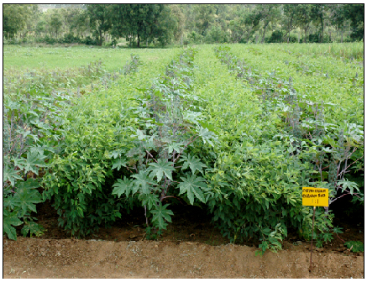
Castor + Cowpea | 1 row of castor followed by 2 rows of Cowpea
Castor + Urdbean | 1 row of castor followed by 2 rows black gram
Castor + Mungbean | 1 row of castor followed by 2 row of green gram
Castor + Cluster bean | 1 row of castor followed by 1 row of cluster bean
Castor + Groundnut | 1 row of castor followed by 5-7 rows of groundnut  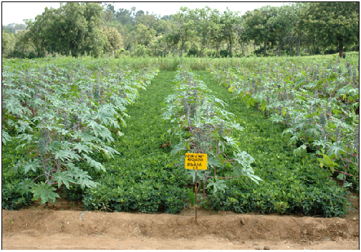

Castor + horse gram(relay cropping) | 1 row of castor followed by 6-8 row of horse gram
Castor + turmeric/ginger | 1 row of castor followed by 5 rows of turmeric/ginger

Crop Rotation

Avoid continuous cropping of castor on the same piece of land year after year. It leads to extraction of same nutrients from the soil and decreases its fertility gradually. Crop rotation helps in:
1. Enhanses soil fertility: If crop rotation is done with leguminous crops, it helps in fixing the atmospheric nitrogen to soil and increase its fertility.
2. Minimises weeds and insect pests and diseases
Crop Rotation | Time gap | Irrigated/Rainfed Conditions
Castor – groundnut | After one year | Irrigated
Castor – sunflower | After one year |  | Irrigated
Castor – pearl millet | After two years |  | Rainfed
Castor – finger millet | After two years |  | Rainfed
Castor – pigeon pea | After two years |  | Rainfed
Castor – groundnut | After two years |  | Rainfed
Castor – Sorghum | After two years |  | Rainfed

Agronomic Mnagement

Tillage and seed bed preparation

For ensuring proper tilth and good seed bed preparation, plough the soil immediately after the receipt of monsoon showers. Later for proper levelling, perform 2-3 harrowings with blade harrow after rains. It helps in root growth thereby increase nutrient and water uptake by plants and increase yields.
Deep summer ploughing –It recommended that deep summer ploughing should be done once in two years. It helps to break the hard soil pan and facilitates easy root penetration and crop growth apart from controlling weeds, insects, pests and diseases. It also helps in proper aeration of soil and moisture conservation. It is done using Mould Bold (MB) plough.

Seeding Time

Time of sowing has a significant effect on the ultimate yield and returns from Castor. The most ideal time to sow kharif castor in dryland is immediately after the receipt of first rains from the south west monsoon.

Season | Time
Kharif | Second fortnight of June - July
Rabi | September – October
Summer Castor | January
In case the other kharif crops could not be sown due to delayed monsoon, castor can form a better contingent crop even for sowing up to 15th August in rainfed areas.

Seed Rate
Season | Variety/Hybrid | Seed Rate/acre
Kharif | Variety | 2- 3 kg
Kharif | Hybrid | 2 – 3 kg
Rabi | Variety | 2.5 kg
Rabi | Hybrid | 2 kg
Seed Priming:
From this technique chaffy seeds can be eliminated and early germination can be ensured by soaking in water for 24 to 48 hours. This can also enhance drought tolerance and early vigour to the seedlings.
Spacing
Spacing plays an important role in the plant growth and final yield. Very close spacing may lead to poor yield because the plants will compete for the nutrients presents in the soil and given externally. Depending upon the season and conditions below mentioned spacing is recommended:
Situation | Variety/Hybrid | Spacing
Rainfed | Variety | 3 feet between rows and two feet between plants in row
Rainfed | Hybrid | 3 feet between rows and 2 feet between plants in row
Rainfed – Late sown conditions | For both Variety and hybrid | 1 feet between rows and 1 feet between plants in row
Irrigated | For both Variety and hybrid | Depending upon the soil, spacing of 3 feet between rows and one and a half feet between plants in row or 3 feet between rows and 2 feet between plants in row or two and a half feet between rows and 2 and half feet between plants is recommended
Abundant soil moisture or cloudy weather | For both variety and hybrid | 3 feet between the rows and 3 feet between the plants in rows or 4 feet between the rows and 2 feet between the plants in rows. This will reduce the excessive vegetative growth and will help it getting optimum yields.

Seed Treatment
Seed treatment helps to protect the plant from seed borne diseases like seeding blight, Alterneria blight and wilt. It can be done either with captan 3g/kg or carbendizam 2g/kg seed or Trichoderma viride 10g/kg seed.

.
Thinning
Maintaining required population is essential for higher yields. After intercultural operations keep only one plant per hill makes lot of defference.

Manures and fertilizers
Application of 10-12 tonnes FYM/ha helps in moisture retention and provide nutrients including micro nutrients to the crop.
The recommended dose for rainfed castor is 60 kg N, 40 kg P and 30 Kg K. Out of which phosphorous and potassium has to be applied as basal dose before sowing. While nitrogen 20 kg N at the time of sowing and the St. In two splits as top dressing at 35-40 and 65-70 days after sowing depending upon the moisture availability in the soil.
Potassium
It plays an active role in the activation of several enzymes, besides regulating transpiration, and providing resistance to pest, disease and environmental stress.
Nitrogen
Adequate supply of nitrogen is essential for optimum leaf growth, with dark green color. It promotes branching, seed setting and seed filling.
Phosphorous
It is essential for root growth, seed and fruit development and for early ripening. Phosphorous deficiency retards plant growth, root growth and delays flowering.
Sulphur and micronutrients for castor
Recently, it has been found that soils of Telangana & Andhra Pradesh are getting deficient in Zinc and sulphur. It is recommended that farmers should go for soil testing at least once in 5 years to know the health of soil. If soils are found deficient in sulphur and micronutrients like Zinc and Iron, then application of 4-8 kg sulphur/acre through elemental sulphur, 4 kg/acre through Zinc sulphate and 12 kg/acre through iron sulphate is recommended
Intercultural operations and weed management
A number of weeds compete with castor crop for nutrients and moisture in its initial stages of growth which is very sensitive to weed competition. They also serve as collateral or alternate hosts to Jassids and whiteflies.
i. In rain fed areas 2 or 3 intercultural operations with the help of bullock drawn blade harrows starting from 25-30 days after planting combined with one manual intra row weeding if necessary around plants or within the row after first interculture effectively check weed growth.
ii. Weeds are a more serious problem even in irrigated castor where the crop may need 2 or 3 hand weedings at intervals of 15-20 days in order to keep weeds under check.
iii. Alternatively, depending on the soil moisture availability and before emergence weeds and at the time of sowing, application of following herbicides is recommended:
Fluchloralin | 1.125 kg/ha | Pre-emergence
Pendimethalin | 1.0 kg/ha | Pre-emergence
Alachlor | 1.25 kg/ha | Pre-emergence
Water management
For Rainfed Situation:
The crop growth and yields are satisfactory if the onset of rainfall and its amount and distribution over the crop period is normal. It should be protected from excess moisture during periods of heavy and continuous rains particularly in heavy soils by providing surface drainage, to drain out excess moisture from seed bed. Having a dead furrow in alternate rows helps in conservation of moisture thereby good plant growth during dry spells.
For Irrigated Conditions:
Castor crop responds well to irrigation. In the initial stages of growth, it requires less water. During prolonged dry spell one protective irrigation at the time of branching or spiking stage will greatly benefit the crop and improves the yield. During rabi, the number of irrigations may go up to 6-8, while in summer as many as 12-15 irrigations are required at an interval of 7-10 days depending on soil type and prevailing weather conditions.Micro irrigation systems like drip and sprinklers are found ideal irrigation methods to improve fertilizer use efficiency and economize water use.
Plant protection

Management of insect pests

Insect pests of castor and their management
Insect Pests | Nature of damage | Management
Semilooper  (Achaea janata)  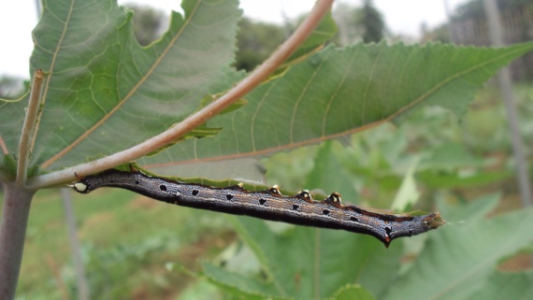 | - Damages crop by defoliation  - Older larvae are voracious feeders which can totally defoliate the plants during outbreaks, leaving only veins, petiole and stem  - Active during July to September | - Hand picking of older larvae during early stages of crop growth.  - Avoid chemical spray when 1-2 larval parasitoid (Microplitis sp.) are observed per plant  - Spray profenofos (1ml/l) or flubendiamide (0.2ml/l) or chlorantraniliprole (0.3ml/l) or monocrotophos (1.5 ml/l), if defoliation is above 25%.  - Spray Bacillus thuringiensis var. kurstaki (1g/l) against early instar larvae
Tobacco caterpillar (Spodoptera litura)  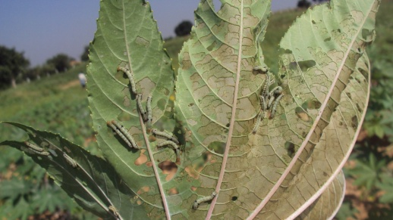 | - Damages crop by defoliation  - Newly hatched larvae feed gregariously and skeletonise the leaves giving mesh like appearance  - During heavy infestations, larvae damages stem and capsules  - Active during August to October | - Collect and destroy egg masses and gregarious stages of the larvae along with damaged leaves.  - Spray chlorpyrifos (2.5ml/l) or profenofos (1ml/l) or flubendiamide (0.2ml/l) or chlorantraniliprole (0.3ml/l)  monocrotophos (1.5ml/l), if defoliation is above 25%.
Capsule borer  (Conogethes punctiferalis)  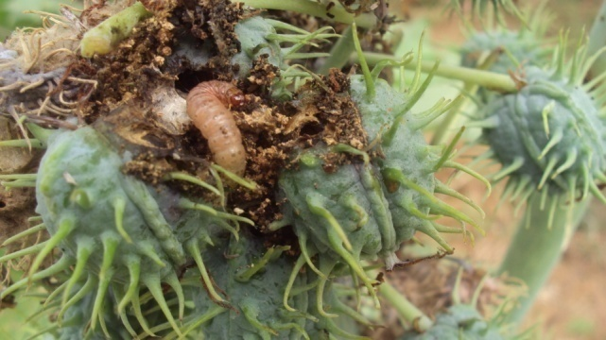 | - Larvae bore and damage the capsules  - Characteristic webbing of capsules along with excreta is seen  - Infestation starts from flowering stage. Usually active during November to March | - Good agronomic management with no or less use of insecticides on the crop usually keeps the borer at low level.  - Spray profenofos (1ml/l) or monocrotophos (1.5ml/l) or dust the spikes with quinalphos (1.5%) or methyl parathion (2%), if at least 10% capsules are damaged.  - Repeat the spray after 2-3 weeks if required. Newer chemical viz., spinosad (0.4ml/l) or indoxacarb (1ml/l) or flubendiamide (0.2ml/l) or chlorantraniliprole (0.3ml/l) can be used if the infestation is severe.
Red hairy caterpillar (Amsacta albistriga)  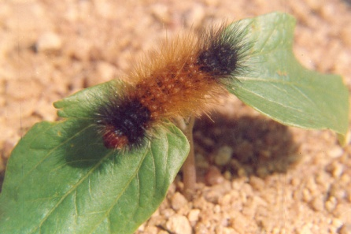 | - Larvae defoliate the crop. Major damage is caused by migrating caterpillars.  - Active during June to August | - Setting of light traps on community basis with the first monsoon rains to attract the moths and kill them.  - Sowing cucumber along with castor. Placing the twigs of Ipomoea, Jatropha or Calotropis to attract the migrating caterpillars and kill them mechanically.  - Opening deep furrows around field area and dusting methyl parathion/ quinalphos  - Spray dichlorvos (0.75ml/l) or monocrotophos (1.6ml/l) or quinalphos (2ml/l)
Hairy caterpillars (Euproctis sp., Spilosoma obliqua)  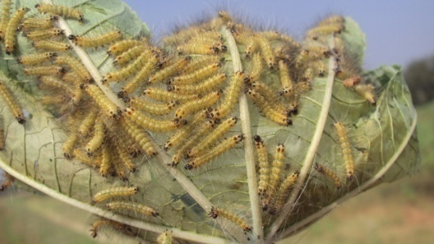 | - Damage is mostly by defoliation, often capsules get damaged.  - Active during October to December | - Collect and destroy egg masses and gregarious stages of the larvae along with damaged leaves.  - Spray dichlorvos (0.75ml/l) or chlorpyrifos (2.5ml/l) or monocrotophos (1.5ml/l), if defoliation is above 25%.
Leafhopper (Empoasca flavescens)  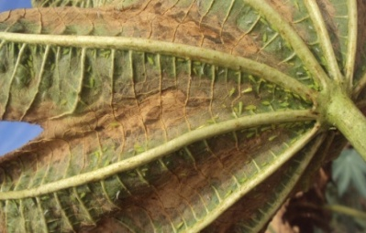 | - Both nymphs and adults suck sap from plants. Hopper burn symptoms are noticed if leafhopper infestation is severe.  - Peak infestation is during November to January. | - Growing double/triple bloom cultivars like DCH-519, GCH-4, GCH-5, which usually do not express damage symptoms.  - Spray dimethoate (1.7ml/l) or monocrotophos (1.5ml/l) or malathion (1.5ml/l). Repeat spray if required after a fortnight.

Diseases of castor and their management
Disease | Nature of damage | Management
Fusarium Wilt  (Fusarium oxysporum f.sp. ricini)  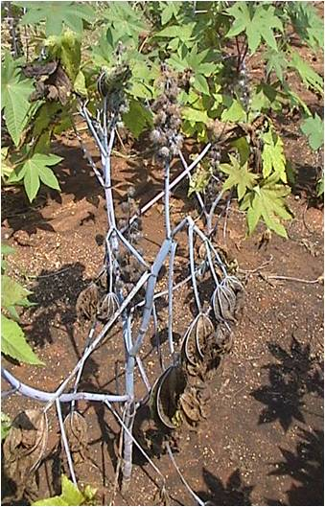 | Discolouration of hypocotyls, loss of turgidity of top leaves and marginal necrosis at the seedling stage.  On adult plants, gradual yellowing and sickly appearance of leaves followed by necrosis, browning of xylem tissues, formation of dark stripe and pinkish overgrowth on the entire stem up to the infected leaves. Irreversible wilting with bending of apical leaves and branches. | Cultivate disease tolerant/ resistant cultivars viz., 48-1 (Jwala), Haritha, DCS-107, DCH-177, DCH-519, and GCH-7.  Seed treatment with carbendazim (slurry 2g/kg or seed soak 1g/l for 12 hrs) or Trichoderma viride 10g/kg and soil application of T.viride 2.5 kg/ha incubated in 125 kg FYM.  Avoid continuous cultivation.  Crop rotation with pearlmillet/ fingermillet or cereals. Removal of wilt infected plants from field.
Root rot/ Die back  (Macrophomina phaseolina)  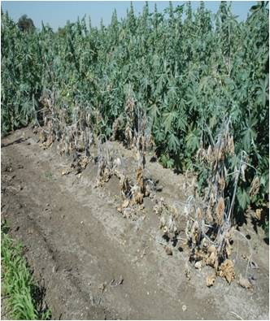 | Plans show signs of water shortage,dark black lesions develop on the stem near ground level. The taproot shows signs of drying and root bark shreds off easily.  In severe infection entire branch or top of branch withers away, wilting of leaves starts from the apex and proceeds downwards. | Burning and destruction of crop debris.  Crop rotation with cereal crops.  Use resistant cultivars like 48-1(Jwala), GCH-6, GCH-7.  Seed treatment with T. viride 4g/kg or thiram/captan 3g/kg seed.
Alternaria blight  (Alternaria ricini)  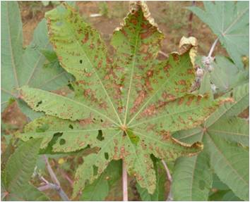 | Light brown circular spots appear on cotylendonary leaves and irregular spots with concentric rings surrounded by yellow halos appear on mature leaves. Spots coalesce and cause foliage blight.  Immature capsules wilt suddenly turn brown and due to collapse of pedicel fall or hang down. Some time spots develop on mature capsules later to cover the whole capsule with black sooty fungal growth. | Seed treatment with thiram / captan 2-3 g/kg seed.  Spraying of mancozeb 2.5g/l or iprodione 0.1% 2-3 times at 15 day interval starting from 90 days of crop growth.
Bacterial leaf spot  (Xanthomonas campestris pv. ricini) | Circular water soaked spots with pale green center and dark margin appear on leaves, which later become angular and turn dark brown. Leaves become brittle and dry up.  Dark elongated lesions develop on stem and petioles. | Remove and destroy infected crop debris.  Hot water seed treatment at 50-60°C for 10 min.  Spray streptocycline 1g/10 l water or a combination of paushamycin 0.025% + copper oxy chloride 0.3%.
Grey rot/grey mould  (Botrytis ricini)  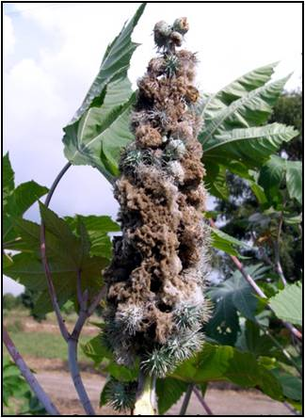 | Initially pale blotch-like spots are formed on capsules/flowers from which drops of yellow liquid exude. Later fungal threads grow from these spots and transform into dense woolly growth. The growth varies from pale to olive grey in colour. Severally infected capsules rot and fall.  Immature seeds become soft and mature ones hollow, exhibiting discoloured seed coat.. Water soaked blackish lesions develop on tender shoots usually when infected spikes fall on them leading to rot and breakage. | Use tolerent variety 48-1 (Jwala).  Adopt wide spacing (90 x 60 cm) between rows.  Give prophylactic spray with carbendazim or thiophanate methyl 1g/l or propiconazole 1ml/l and one more spray soon after disease appearance.  Prophylactic spray with T. viride + Pseudomonas fluorescens 3 g/l.  Remove infected spikes/capsules and destroy.  Top dress with urea 20 kg/ha after cessation of rains for the formation of new spikes

Harvesting and Threshing
Castor being long duration crop with a phenology of different order of branches each emanating with a spike, which are to be harvested at different times( multiple harvests). The physiological maturity is indicated by few capsules turning towards light yellow from dark green in the spike. Removal of spikes can be done by cutting off the whole spike, in the drying yard followed by threshing with beating manually with small plank or by thresher or under tractor wheels and winnowing and cleaning to get seed and fill them in to gunny bags.
Sold it when good market price exists.

Yield: it ranges from 550-750kg/ha

Realizable yield potential

Productivity potential of improved technologies of castor during 2011-14
Technology | FLD average yield (kg/ha) |  | Yield gap-I (%) | Yield gap-II (%)
 | IT | FP
Whole package | 1543 | 1103 | 44 | 194
Improved variety | 1341 | 1153 | 15 | 211

From the table it indicate that there exists 44% gap between frontline demonstrations and the realizable yields. Scope is there the increase yields by following good agricultural practices

Ericulture The silk produced Philosamia ricini is called erisilk. This silk worm is multivoltine and is reared indoors. The eggs are white, hatch in ten days. The hatched larvae are mounted on castor leaves in the searching room and are allowed to grow by periodical feeding. The silk is known as ‘vanya’ or Ahimsa silk. The congenial period for erisilk worm rearing is Oct-January which period 3 rearings can be harvested at 25 days interval each batch yielding 30-40 kg cocoons. By marketing 90-120 kg cocoons from 3 rearings, a return of Rs. 7000-12000/ha can be obtained apart from normal castor seed yield.

