Eighteen markers which showed robust amplification were validated in four wild sesame collections (M20, M21, MLB, and M22 ) and 16 released varieties (G-Til-2, RT-127, TKG-21, VRI(SV)-2, HT-2, G-Til-10, TKG-22, TMV-7, JLT-408, Savithri, RT-351, Nirmala, Hima, RT-346, Swetha, and DS-5 ) to assess the extent of polymorphism (table 1 and figure 1). Figure 1 illustrates polymorphism of two markers, SIM 154 and SIM 197, among released varieties and wild sesame collections.

The polymorphic information content (PIC) value ranged from 0.3 to 0.59 among a set of 16 released varieties. These markers are of practical significance for Indian sesame genotyping.

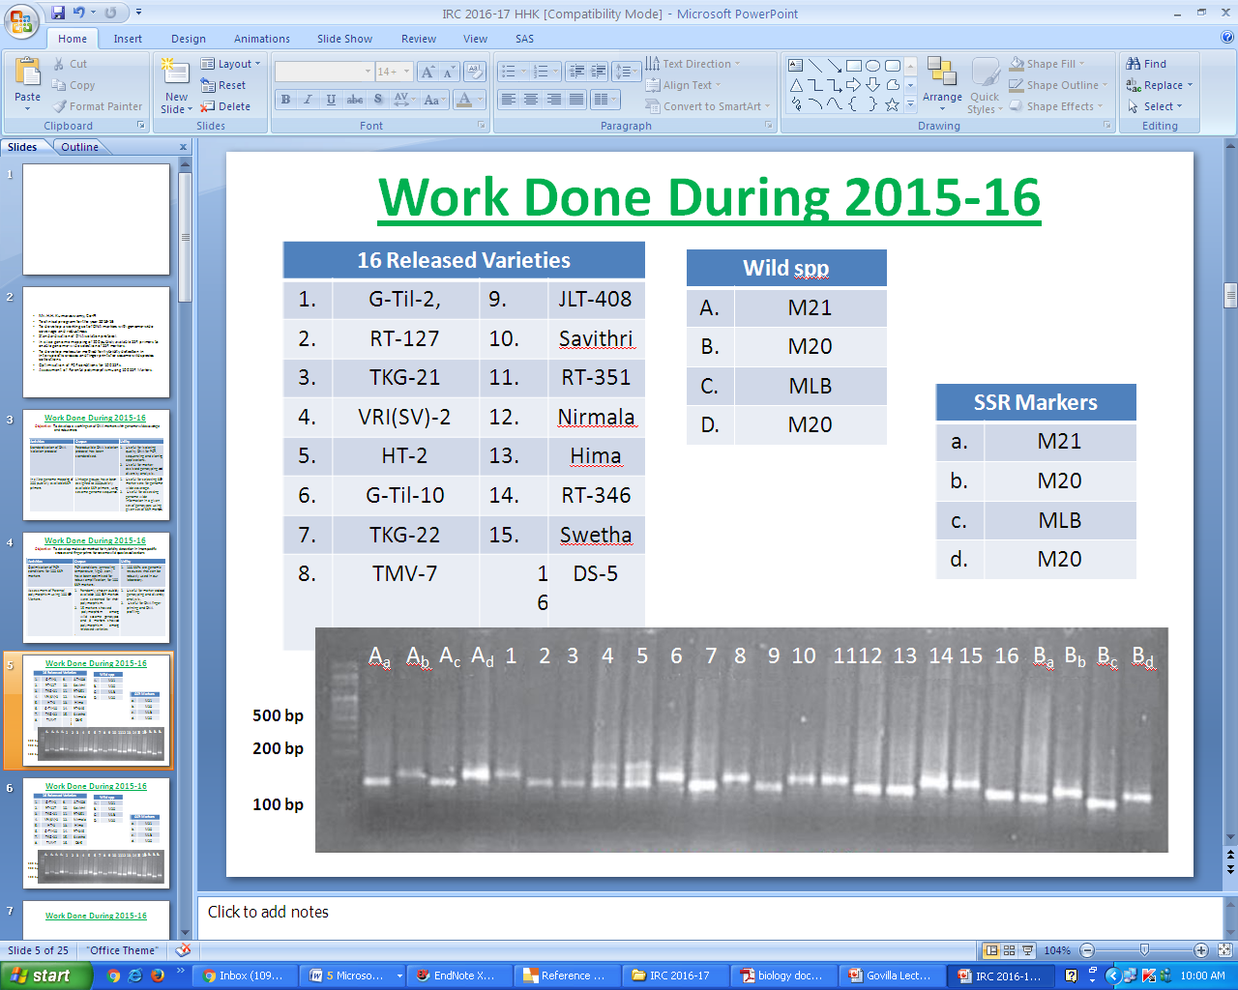

Figure 1: Four percent agarose gel electrophoregram showing the polymorphism of marker SIM 154 among released varieties and wild sesame collections. 1-16, different varites: G-Til-2, RT-127, TKG-21, VRI(SV)-2, HT-2, G-Til-10, TKG-22, TMV-7, JLT-408, Savithri, RT-351, Nirmala, Hima, RT-346, Swetha, and DS-5; A and B, markers SIM 154 and SIM 197; a-d, different wild collections (M20, M21, MLB,M22)

Table 1: List of markers and their polymorphic information content (PIC) value

|  |  |  |  |  |  |
| --- | --- | --- | --- | --- | --- |
| **#** | **Marker** | **PIC** | **#** | **Marker** | **PIC** |
| 1. | SIM006 | 0.4 | 10. | SIM074 | 0.35 |
| 2. | SIM019 | 0.59 | 11. | SIM076 | 0.5 |
| 3. | SIM025 | 0.5 | 12. | SIM079 | 0.5 |
| 4. | SIM028 | 0.48 | 13. | SIM114 | 0.6 |
| 5. | SIM031 | 0.35 | 14. | SIM127 | 0.45 |
| 6. | SIM040 | 0.54 | 15. | SIM154 | 0.4 |
| 7. | SIM053 | 0.46 | 16. | SIM155 | 0.5 |
| 8. | SIM059 | 0.45 | 17. | SIM164 | 0.56 |
| 9. | SIM063 | 0.3 | 18. | SIM197 | 0.5 |