Objective.1.

Activity 1.1. Nature of transmission of Pathogen A. helianthi
Seed borne nature of A. helianthi was studied by component plating technique, Paper towel method and pot culture studies. The fungus was observed more on seed coat (90.7%)followed by cotyledons (67.1%) and embryo (32.3%) in case of fully infected seed. In partially infected seed the fungus was observed on seed coat and cotyledons only, not in embryo. The germination was less in fully infected seed and moderate in partially infected seed in both paper towel method and pot culture studies. Infection of seedlings was observed in fully infected seed in paper towel method (40%) and pot culture method (13.3%).

A. Component plating technique: Apparently healthy seed, partially infected seeds and fully infected seed with Alternaria leaf blight were collected and tested by component plating technique. Embryos and cotyledons of the apparently healthy seeds were devoid of fungal infection, where as 9.4% of the seed coats were found infected. In partially infected seed, the presence of fungus was 46.7% on seed coat, 9.6% on cotyledons and fungus was not observed in embryo. In fully infected seeds, the fungus was observed more (90.7%) on seed coat followed by cotyledons (67.1%) and embryo (32.3%). This indicates that the fungus is both externally as well as internally seed borne
B. Paper towel method: In this method, the germination was less (63.9%) in fully infected seed, moderate (73.5%) in partially infected seed and 90.0% in apparently healthy seed. In fungicide treated seeds, the germination was 100%. The infection on seedlings was more (40%) in fully infected seed, 27% in partially infected seeds and less in apparent healthy seedIn fungicide treated seed there was no infection of seedlings.
C. Pot culture studies: Different types of seeds infected with Alternaria blight were sown in pots, germination and infection of seedlings were recorded. The germination was 60.1% in fully infected seed and 87% in apparently healthy seeds. The seedlings (13.3%) were infected with Alternaria blight in fully infected seeds.
Development of suitable substrate for the growth of A. helianthi :
Barley grains, sorghum grains supported more growth and heavy sporulation of A. helianthi followed by Paddy and maize grains. These substrates can be used for more multiplication of fungus for inoculation studies. The revival capacity of the fungus was more with paddy grains
Activity 1.2 .Epidemiology of Alternaria
To identify the weather factors responsible for the leaf blight development, two sunflower cultivars ie Morden and KBSH 44 were sown at fortnightly intervals (4 sowings). In each sowing, Propiconazole (0.1% - 3 sprays) sprayed plots and unsprayed plots were maintained. Leaf blight severity was recorded weekly in each plot and spore load of Alternariaster helianthi was recorded by spore traps weekly. The weather parameters were recorded during the crop period at different centers.
Leaf blight severity was more in 30th July and 16th August sown crops. In 30th July sown crop, the disease severity was 94.1% and 88.1% in Morden and KBSH-44 respectively with spore load of 41.6 (Table 3.6.c). Sporeload, relative humidity and dew point are contributing factors for 16th July, 30th July and 31st August sown crops while minimum temperature, wind speed are contributing factors for 16th August sown crop. In stepwise regression analysis, spore load and dew point were significant contributors for increasing the disease severity having equation of PDI = + 1.90034 Spl + 0.39736* dew period. These results indicated that spore load, dew point, relative humidity, minimum temperature were the most influencing weather parameters for the disease severity. Disease severity was more in 16th July and 31st July sown crop than other dates of sowing. Disease progression was rapid in 16th July sown crop however it was moderate in 31st August sown crop. In 16th July sown crop, the disease severity was 94% in Morden and 64 % in KBSH-44 with spore load of 29/week. In 31st July sown crop, the disease severity was 92.7% and 77.7% in Morden and KBSH-44 respectively with spore load of 41. Significant correlations were observed with spore load, minimum temperature, RH2 and dew point for both cultivars
Variability in isolates of Alternaria helianthi - Leaf blight of sunflower : Thirty isolates of A. alternata of sunflower were clustered into 3 groups based on morphological and cultural characters. Pathogenic variability of 220 A. helianthi isolates on different sunflower cultivars by artificially inoculation method revealed seven groups based on disease severity. None of the isolate was resistant to all seven sunflower cultivars tested (Fig.4). Among cultivars, most of A. helianthi isolates showed moderately resistant reaction on KBSH-1 followed by SCG-99. Morden was susceptible to most of the isolates whereas DRSF-108 was susceptible to all A. helianthi isolates. Thirty isolates of A. alternata grouped into 3 major groups based on disease severity on sunflower cultivars (Fig.5).

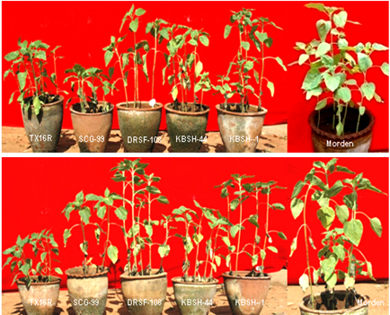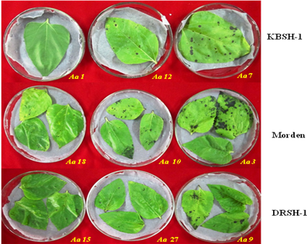
Ah 200
Ah 188
Fig 4: Disease reaction of isolates of Fig 5: Leaf spots on different cultivars with
A. helianthi on different cultivars. isolates of A. alternata.

Molecular variability of 30 isolates of A. alternata exhibited four major groups. A total of 185 bands were obtained with 142 bands (76%) polymorphic from PCR amplification with 12 primers using genomic DNA of A. alternata isolates.

Activity 1. 3. Nature of transmission of Virus and vector
Sap/mechanical transmission: Sap/ inoculum extracted from necrosis infected young leaves prepared in chilled 0.1M phosphate buffer (pH 7.2) containing 0.1%,2-mercaptoethonal. The extracted sap was smeared over to the ten days old seedling dusted with carborandum powder. Within 48h. of inoculation, the initial symptoms were developed and after 4-5 days, full-blown symptoms were manifested, which remained till the plant died over a month after.
The disease has been successfully transmitted through mechanical sap inoculation from sunflower to sunflower, sunflower to cowpea and back from cowpea to sunflower
Transmission by grafting: Young leaves infected with necrotic symptoms were successfully grafted to the sunflower seedlings but failed to develop the viral symptoms.
Seed transmission:. Sunflower seeds from healthy, infected but with good seed setting and from infected heads were collected and sown (pot culture). The seedlings were observed for necrosis disease incidence for 30 days after germination none of the seedlings produced any diseased plants, Similarly the crop raised from the seeds collected from of infected plants (previous season) had not produced symptoms of viral disease . Thus indicates not seed borne -transmitting nature a of the disease. To test the presence of TSV in/on seed, the seeds in developing stage collected from infected flower heads directly from field had shown ELISA positive in 6/11 samples. But the seeds collected from similar type of infected heads after the maturity stage from the same field were ELISA negative, which indicated that the virus may be present in the infected flower head till the plant is alive and subsequently it does not carry along with seeds after harvest.
Insect vector transmission: Four types of thrips viz; Scirtothrips dorsalis, Franklinella schultzai, Thrips palmi and Meglurothrips ustilatus were usually observed on sunflower. Thrips (mixed) collected from the infected flower heads, leaves of sunflower and parthenium were released at various stages on to the healthy sunflower plants grown under insect proof cages/ glasshouse. Thrips collected from sunflower heads observed that they could carry 20-150 pollen grains along with them. Thrips with pollen grains collected from infected sunflower heads dusted /released on to the plants at vegetative & flower opening stage. Forty four percent of plants got infected when release was made at flowering stage against 20 percent at vegetative stage.
Vector transmission studies of SND:
The studies on TSV/SND transmission were under taken using insect proof cages to establish the thresh hold levels of vector population/ infected pollen and minimum time for acquisition/contact of inoculum by thrips. The results indicated, the disease/inoculum can be successfully transmitted (up to 90%) to the host with a minimum of two thrips and acquisition/contact on infected pollen for less than two minutes.
Table .3.TSV/SND transmission studies -Determination of thresh hold levels of vector, inoculumn acquisition and disease development
Sr.no | No.of thrips /unit | Acquisition time (min) | No.of seedlings/cage | No.of seedlings got infected | Transmission (%)
1 | 4 | 2 | 10 | 3 | 30
2 | 6 | 2 | 10 | 4 | 40
3 | 8 | 2 | 10 | 9 | 90
4 | 10 | 2 | 10 | 9 | 90
5 | 4 | 5 | 10 | 3 | 30
6 | 6 | 5 | 8 | 3 | 38
7 | 8 | 5 | 10 | 9 | 90
8 | 10 | 5 | 10 | 9 | 90
9 | 4 | 10 | 10 | 3 | 30
10 | 6 | 10 | 10 | 4 | 40
11 | 8 | 10 | 10 | 9 | 90
12 | 10 | 10 | 10 | 8 | 80
Thrips without pollen
13 | 5 | - | 5 | 0 | Nil
Infected pollen with out thrips
14 | - | - | 5 | 0 | Nil
Weed flora
Prevalence of weed flora in and around sunflower fields surveyed . Parthenium hysterophorus was found in most of the sunflower fields surveyed and frequency of occurrence of P. hysterophorus was maximum (82 per cent) followed by Euphorbia geniculata (68.25 per cent), Achyranthus aspera (68.25 per cent), Commelina bengalensis (48 per cent), Abutilon indicum (41.87 per cent), Acanthospermum hispidum (26.62 per cent), Ageratum conyzoides (23.12 per cent), Malvestrum coromandelianum (17 per cent), Digeria arvensis (12.5 per cent) and Trianthema portulacastrum (11.62 per cent). Twenty weed species were found in all the surveyed fields across locations, type of soils and seasons. It is interesting to note that, of the twenty weed species found in and around sunflower fields surveyed, ten of them are known host species harboring the TSV. Therefore inoculum of the virus was brought on to the sunflower crop by the thrips vector from these sources under field conditions. The weed species viz., P. hysterophorus, E. geniculata, A. aspera, C. bengalensis and A. indicum were found to be prevalent in the most of the fields surveyed during both the years. As all these weed species are reported to be infected by the virus and harboring thrips under natural conditions and are the common TSV sources in the fields (Prasada Rao et al., 2003a), as all these weed species are widely distributed and occurred at all locations of survey might have served as sources of virus inoculum within and between sunflower fields. Further, more disease incidence has been observed near the field bunds of sunflower crop suggesting that source of virus inoculums is from outside i.e., from crop plants and weed flora present on bunds, uncultivated and barren lands.
Parthenium was widely distributed and occurred at all sunflower growing areas surveyed, and where incidence of SND was recorded. Since P. hysterophorus was a very common weed both in cultivated and barren fields, it is quite possible that P. hysterophorus being perennial can serve as reservoir of TSV and act as primary source of inoculum for sunflower crop throughout the season. Therefore, measures to eliminate Parthenium from field bunds, waste lands and from within the crop are also expected to be beneficial in reducing the incidence of SND. The incidence of disease in sunflower may be correlated with the presence of infected Parthenium plants in and sunflower. Asymptomatic weeds (eg. Parthenium) that host the virus as well as thrips and produce copious pollen throughout season act as a primary source of inoculum initiating and sustaining the TSV infection during a crop season. Thrips colonizing flowers of these plants can become externally contaminated with pollen and movement of these thrips to new hosts results in introduction of the virus into fields
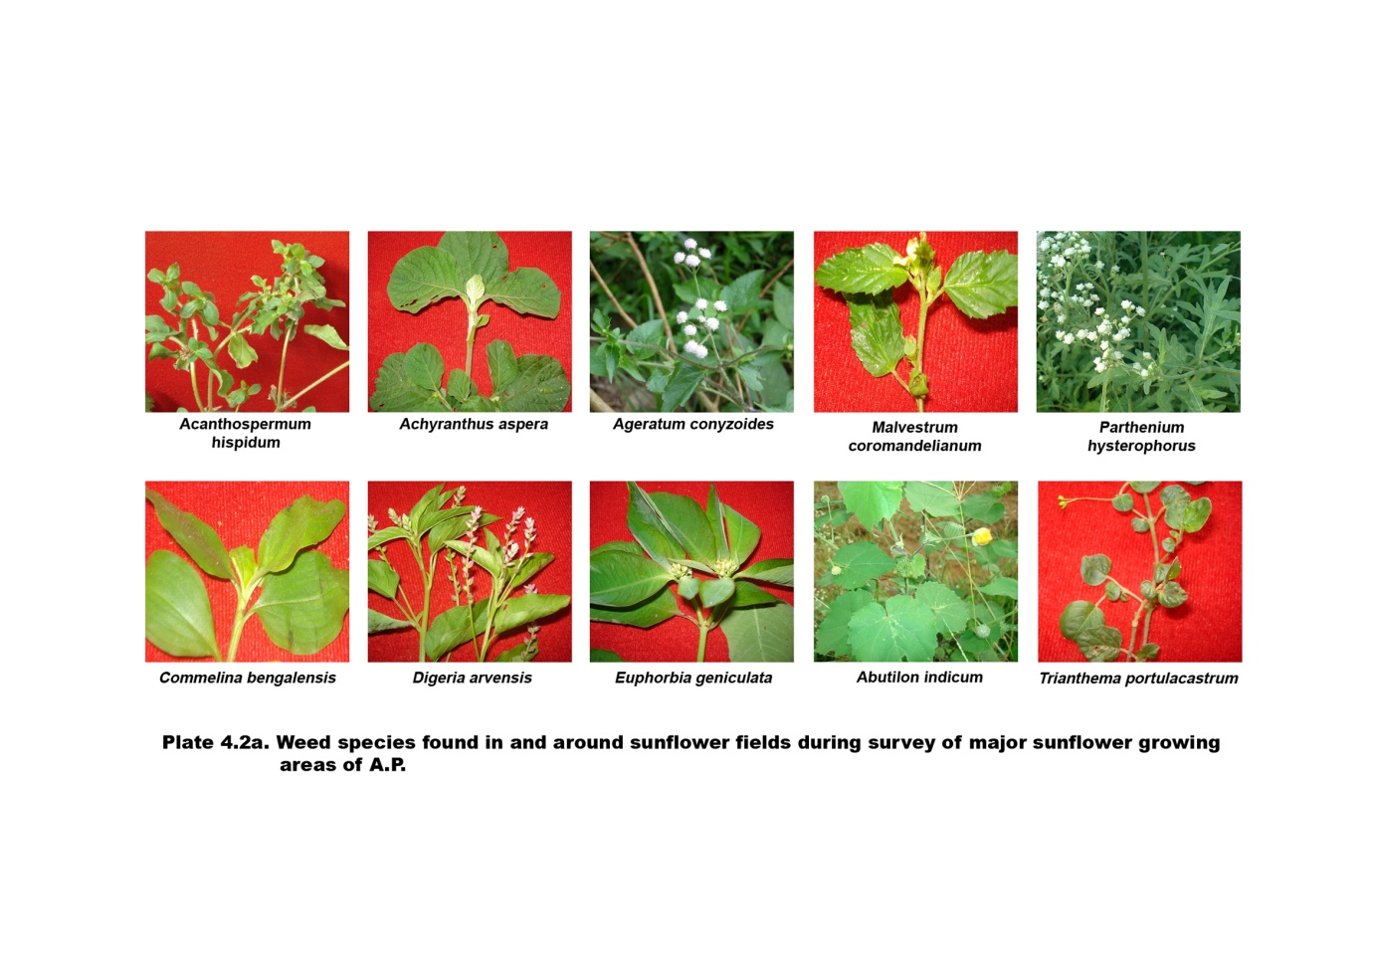
Activity 1.4 .Host range of TSV and Epidemiology of SND

Host range and Epidemiology:
Through sap inoculation technique several crop plants, weeds were tested and found the virus had a very wide host range .Out of 32 plants of 17 families tested 21 plants of 11 families were found infective to the TSV . The important among the crop plants are - groundnut, cowpea, soybean, ridge gourd, bitter gourd, cluster bean, tomato, amaranthus, chrysanthemum etc. Among the weeds, species of Azeratum, Commelina, Achiranthus aspera Euphorbia hista, showed local lesions and on Parthenium hysterophorus though no local lesions were seen but it had reacted highly positive to SFNV antisera and found as major source of inoculum in harbouring and spreading of the disease.
The host range of the virus causing SND was restricted to the members of Asteraceae, Chenopodiaceae, Cucurbitaceae, Leguminaceae, Malvaceae and Solanaceae tested. The virus under study could not infect the members of Cruciferae and Pedaliaceae. The host range reaction of the virus infecting sunflower is quite similar to that of groundnut in India (Reddy et al., 2002; Prasada Rao et al., 2003a ;Vemana and Jain, 2010), soybean in Brazil (Almeida et al., 2005) and lettuce in Iran (Abtahi and Motlagh, 2009). The plant species C. annum, L. esculentum, N. benthamiana and S. melongena were not infected,) who reported that sunflower necrosis virus failed to infect the members of Solanaceae. Further, C. sativus, P. sativum and R. sativus were not infected, N. tabacum var. Samsun produced characteristic symptom such as white ring like pattern and oak leaf pattern Out of 43 plant species tested, only 10 plant species did not show any symptom when back inoculated on assay host, cowpea cv. C-152. This is further confirmed by DAC-ELISA using polyclonal antiserum of TSV. The plant species (33) which showed visible symptoms after sap inoculation tested positive for the virus when back inoculated on assay host, cowpea cv. C-152 and in DAC-ELISA
Usually the disease incidence is found to be high in kharif and rabi-summer crops. The vegetative crop stage followed by flowering stage was found to be more vulnerable to the disease. The weather parameters compared with occurrence of the disease and the population of thrips indicated, highest disease incidence and maximum thrips population during prolonged dry periods immediately after heavy rains. Experiments on monthly sowings recorded highest disease incidence during July-September and January- March months .Whereas, during October-December the disease incidence was very less
Overall correlation matrix of SND with weather parameters in sunflower cv. Morden

 | Temp. (max) | Temp. (min) | RH I  (%) | RH II (%) | Rainfall (mm) | Sunshine (h) | Windspeed (km/h) | Per cent SND
Temp. (max) | 1.0000 | 0.3401 | -0.3902 | -0.3742 | -0.0652 | 0.3766 | 0.1267 | 0.1138
Temp. (min) |  | 1.0000 | 0.2580 | 0.6119 | 0.5166 | -0.6604 | 0.4992 | 0.6031**
RH I (%) |  |  | 1.0000 | 0.5985 | 0.4688 | -0.4284 | -0.2110 | 0.2442
RH II (%) |  |  |  | 1.0000 | 0.6481 | -0.7936 | 0.2289 | 0.5107**
Rainfall(mm) |  |  |  |  | 1.0000 | -0.5374 | 0.0584 | 0.5726**
Sunshine (h) |  |  |  |  |  | 1.0000 | -0.5063 | -0.5323**
Windspeed (km/h) |  |  |  |  |  |  | 1.0000 | 0.2988*
Per cent SND |  |  |  |  |  |  |  | 1.0000

