**Integrated disease management of SND**

## Several experiments were conducted and the integrated strategies developed are as :-

As the disease is of viral nature, presently emphasis has been given more on controlling of insect vector through chemicals. Among the various insecticides tested Imidacloprid (Gaucho 70 WS) @ 5 g/kg as seed dressing found to be effective against thrips during the early stages of crop growth. Prophylactic sprays with Imidacloprid (Confidor 200 SL) 0.05% at 15 days interval reduced the incidence during the vegetative/flowering stages of the crop. Under high disease severity levels the chemical protection had a limited scope**.**

The following management practices were evolved for control of the disease.

* Remove weeds particularly parthenium from the field and adjoining areas of crop.
* Avoid growing of chrysanthemum and marigold close to sunflower
* Avoid monocropping of sunflower year after year in the same field. Avoid cultivation of highly susceptible cultivars
* Seed treatment with Imidacloprid (Gaucho 70 WS) @ 5 g/kg of seed followed by spray with Imidacloprid (Confidor) 200 SL 0.05% 15 days intervals for 2-3 times.
* Uproot and destroy the disease-affected plants as and when observed.

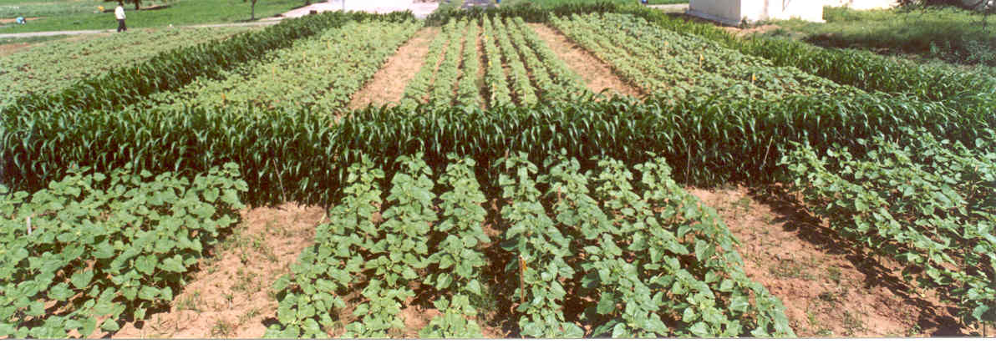 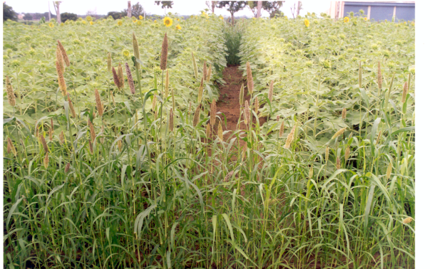

Grow 5-7 border crop all around Sunflower fields with sorghum or pearl millet.