KRISHI VIGYAN KENDRA (IDUKKI)

ANNUAL REPORT- 2019

(FOR THE PERIOD FROM 01 January 2019 TO 31 December 2019)

ICAR - KrishiVigyan Kendra,
BapoojiSevakSamaj,
Pethotty P.O., Santhanpara,
Idukki (Dt.), Pin-685619, Kerala.
Phone: 04868 – 247541, 247715.
E-mail: kvk.Idukki@icar.gov.in, kvksanthanpara@gmail.com
Website URL: www.kvkidukki.org

GENERAL INSTRUCTIONS

Please read the instructions very carefully before starting preparation of the report

- Annual report is the most important document for the KVK and it directly reflects the overall achievements pertaining to the reported period. Hence due care need to be given by each KVK while preparing the report.

- Period of Report is from 01 January 2019 to 31 December 2019

- Action photographs with relevant captions covering various activities of the KVK in High resolution should be submitted separately in a CD/DVD along with this report.

- Prepare Summary tables carefully tallying with the relevant portions of the main report on all aspects.

- Retain the blank column and rows as such and do not merge the cells. Please specify NIL, wherever not applicable or details are not available.

- Check the names of varieties and hybrids and specify in the report.

- Check the units and totals of each data table

- Extension activity under celebrations for each important day, please insert separate rows and give appropriate data separately. Clubbing of data should be avoided.

- Success stories/case studies should be supported with data tables, graphs and photos.

PART I - GENERALINFORMATION ABOUT THE KVK

1.1. Name and address of KVK with phone, fax and e-mail
KVK Address | Telephone |  | E mail | Web Address
 | Office | Fax
ICAR - KrishiVigyan Kendra, Bapooji Sevak Samaj, Pethotty P.O., Santhanpara, Idukki (Dt.), Pin-685619, Kerala. | 04868 – 247541,  247715. | Nil | kvksanthanpara@gmail.com | www.kvkidukki.org

1.2 .Name and address of host organization with phone, fax and e-mail
Address | Telephone |  | E mail | Web Address
 | Office | Fax
Bapooji Sevak Samaj,  Kakkattu, Meenadom P.O.,  Pampady, Kottayam (Dt.),  Pin-686 516, Kerala. | 0481-2506271  +91 9446826019 | 04868-247048 | bkvkchairperson@gmail.com | www.kvkidukki.org

1.3. Name of the Programme Coordinator with phone & mobile No
Name | Telephone / Contact
 | Residence | Mobile | Email
Dr. R. Marimuthu, Senior Scientist& Head | - | 8157895397 | kvksanthanpara@gmail.com

1.4. Year of sanction:

1.5. Staff position as on 31 December 2019
Sl.  No. | Sanctioned post | Name of the incumbent | Designation | M/F | Discipline | Highest Qualification  (for PC, SMS and Prog. Asstt.) | Pay  Scale | Basic pay | Date of joining KVK | Permanent  /Temporary | Category (SC/ST/  OBC/  Others)
1 | Head/Senior Scientist | Dr. R. Marimuthu | Senior Scientist& Head | M | Agronomy | Doctorate in Agriculture - Agronomy | 37400-67000 | 50720 | 17-01-2019 | Permanent | OBC
2 | Scientist/SMS | Dr. S. Jayababu | Subject Matter Specialist | M | Animal Science | B.V. Sc. & AH | 15600-39100 | 21000 | 19-06-1995 | Permanent | Others
3 | Scientist/SMS | Manju Jincy Varghese | Subject Matter Specialist | F | Soil Science | M.Sc. Agriculture (Soil Science) | 15600-39100 | 21000 | 10-01-2011 | Permanent | Others
4 | Scientist/SMS | Vacant | Subject Matter Specialist | - | Vacant | - | - | - | - | - | -
5 | Scientist/SMS | Sudhakar Soundarajan | Subject Matter Specialist | M | Plant Protection | M.Sc. Agricultural Entomology, MBA | 15600-39100 | 21000 | 27-01-2011 | Permanent | OBC
6 | Scientist/SMS | Ashiba A | Subject Matter Specialist | F | Agronomy | M.Sc. Agronomy | 15600-39100 | 21000 | 07-01-2019 | Permanent | Others
7 | Scientist/SMS | Preethu K. Paul | Subject Matter Specialist | F | Agri. Extension | M.Sc. Agricultural Extension | 15600-39100 | 21000 | 07-01-2019 | Permanent | Others
8 | Programme Assistant (Lab Tech.) | Jayisy Joseph | Programme Assistant | F | Home Science | M. Sc. Home Science (Extension for Rural Development) | 9300-34800 | 13500 | 20-06-1995 | Permanent | Others
9 | Programme Assistant (Computer) | Biju Narayanan | Programme Assistant | M | Computer Application | M.C.A., PGDCA | 9300-34800 | 13500 | 01-10-2007 | Permanent | OBC
10 | Programme Assistant/ Farm Manager | Rachel Skariakutty | Programme Assistant | F | Rural Craft | M.A. Sociology (P.G. Diploma in Rural Development) | 9300-34800 | 13500 | 05-06-1995 | Permanent | Others
11 | Assistant | Shaji. K. Kakkattu | Assistant | M | - | - | 9300-34800 | 13500 | 05-06-1995 | Permanent | Others
12 | Jr. Stenographer | Daisy Daniel | Jr. Stenographer | F | - | - | 5200-20200 | 7100 | 05-06-1995 | Permanent | Others
13 | Driver - 1 | P. Nandagopal | Driver | M | - | - | 5200-20200 | 7200 | 05-06-1995 | Permanent | OBC
14 | Driver - 2 | Vacant | Driver | - | Vacant | - | - | - | - | - | -
15 | SSS-1 | P. Sabu | Skilled Supporting Staff-1 | M | - | - | 5200-20200 | 7000 | 05-06-1995 | Permanent | Others
16 | SSS-2 | K.T. Mathew | Skilled Supporting Staff-2 | M | - | - | 5200-20200 | 7000 | 05-06-1995 | Permanent | Others

1.6. Total land with KVK (in ha): 27.60

S. No. | Item | Area (ha)
1 | Under Buildings | 0.074 ha
2. | Under Demonstration Units | 0.5 ha
3. | Under Crops | 0.5 ha
4. | Orchard/Agro-forestry | 0.5 ha
5. | Others | 26.026 ha

1.7. Infrastructural Development:

A) Buildings
S.  No. | Name of building | Source of  funding | Stage
 |  |  | Complete |  |  | Incomplete
 |  |  | Completion  Date | Plinth area (Sq.m) | Expenditure (Rs.) | Starting Date | Plinth area  (Sq.m) | Status of construction
1. | Administrative  Building | ICAR | 2002 | 740 | 47,85,208.10 | - | - | -
2. | Farmers Hostel | NA | - | - | - | - | - | Master Plan & Estimate submitted. Sanction pending.
3. | Staff Quarters | NA | - | - | - | - | - | -
 | 1
 | 2
 | 3
 | 4
 | 5
 | 6
4. | Demonstration Units
 | 1. Duck cum fish culture unit. | RF | 2009 | 50 | 7,000.00 | - | - | -
 | 2. Mushroom unit | GramaPanchayath, Santhanpara | 2002 | 10 | 85,000.00 | - | - | -
 | 3. Spawn production unit | SHM | 2009 | 10 | 3,00,000.00 | - | - | -
 | 4. Mist Chamber | SHM | 2009 | 96 | 2,72,832.00 | - | - | -
 | 5. Rain Shelter | SHM | 2009 | 50 | 1,04,091.00 | - | - | -
 | 6.Bio-Hub | State Planning Board | 2014 | 65 | 1,50,000.00 | - | - | -
 | 7.KarshakaSevaKendram | Department of Agriculture –Vegetable Scheme | 2015 | 100 | 3,58,000.00 | - | - | -
 | 8. Pheromone Trap Production Unit | RF | 2014 | 10 | 65,000.00 | - | - | -
 | 9.Pseudomonas Production Unit | Department of Agriculture –Vegetable Scheme | 2015 | 25 | 50,000.00 | - | - | -
 | 10.Trichoderma Production Unit | Department of Agriculture –Vegetable Scheme | 2015 | 25 | 50,000.00 | - | - | -
 | 11.EPN Production Unit | Department of Agriculture –Vegetable Scheme | 2015 | 25 | 70,000.00 | - | - | -
 | 12.Low cost mass multiplication centre | Department of Agriculture | 2018 | 25 | 20,000.00 | - | - | -
 | 13.Low cost VAM production Unit | Department of Agriculture | 2018 | 10 | 20,000.00 | - | - | -
5 | Fencing | NA | - | - | - | - | - | Urgent requirement as the area is constantly facing intuition of wild animals and other intruders
6 | Rain Water harvesting system | NA | - | - | - | - | - | -
7 | Threshing floor | NA | - | - | - | - | - | -
8 | Farm godown | NA | - | - | - | - | - | -
9 | - | - | - | - | - | - | - | -
10 | - | - | - | - | - | -- | - | -

B) Vehicles

Type of vehicle | Year of purchase | Cost (Rs.) | Total kms. Run | Present status
Mahindra Bolero SLE | May - 2012 | 5,78,380.36 | 121234 | Good condition.
Honda Aviator | March - 2009 | 50,000.00 | 12965 | Running condition
Motor Bike (Suzuki Shogun) | January - 1995 | 37,972.78 | 8864 | Irreparable, to be condemned

C) Equipment & AV aids

Name of the equipment | Year of purchase | Cost (Rs.) | Present status
A.V. aids (Specify)
Television | 1995 | 20,894.00 | Not working
GE OHP | 1996 | 7,100.00 | Good, but not in use
ZETT Slide Projector | 1996 | 11,556.00 | Not working
Sharp Video Player | 1996 | 10,000.00 | Not working
Pentax SLR Camera | 1996 | 13,599.15 | Not working
Ahuja Amplifier SSA 160 636956 | 2003 | 7,010.00 | Good Condition
Ahuja Speaker, SRX50DX | 2003 | 1,825.00 | Good Condition
Ahuja Mike SHM 1000XLR | 2003 | 2,295.00 | Good Condition (serviced)
Ahuja Mike ASMT 80 XLR | 2003 | 1,470.00 | Good Condition
Ahuja mike Stand DGV | 2003 | 510.00 | Good Condition
Ahuja Mike stand DGT | 2003 | 295.00 | Good Condition
Ahuja portable teaching wireless WA 320 AWL 321 | 2003 | 9,700.00 | Good Condition
Honda generator Model EBK 2000 AC | 2003 | 32,490.00 | Good Condition
LPG Generator 5000 CLS | 2011 | 100000.00 | Good Condition
LCD Projector (EPSON_EBW8) | 2010 | 55186.00 | Good Condition
Liberty Show Juno 5 x 7 (MW) Screen | 2010 | 5885.00 | Good Condition
Kodak Knoma Camera | 1995 | 1550.00 | Obsolete
Tripod Screen 52x70 inch | 1996 | 2029.50 | In working condition
Soil Science Lab Equipments (Specify)
KEMI HOT PLATE with Energy Regulator | 2006 | 5,400.00 | Not working
Electronic Balance | 2006 | 1,00,000.00 | Under use but needs repair
Physical Balance | 2006 | 8,991.00 | Good
Spectrophotometer | 2006 | 1,17,499.00 | Not working
Electronic Automatic KEL PLUS model KES 12L (Nitrogen Analyzer) | 2006 | 97,043.00 | Not working
Conductivity Meter (PH Meter Utech 510) | 2006 | 21,935.00 | Not working
HOT AIR OVEN | 2006 | 13,725.00 | Not working
Water bath WDB2 350 x 400 100mm Size 12 | 2006 | 41,895.00 | Not working
Flame Photometer | 2006 | 45,000.00 | Under use but needs repair
Conductivity Meter | 2006 | 13,500.00 | Not working and requires new
LG 280 Litre Fridge Model – GI 296 TM V-Guard Stabilizer | 2006 | 250.00 | Good
Mixer grinder 750 Watts | 2006 | 4,500.00 | Needs replacement
Online UPS System with Battery | 2006 | 36,916.00 | Needs replacement
Fume Cupboard KEMI | 2006 | 2,68,192.00 | Needs replacement
Bio-control Lab Equipments
Laminar Flow Chamber | 2000 | 50,000.00 | Under use but needs repair
Refrigerator | 2000 | 10,760.00 | Under use but needs repair
Chemical Balance | 2000 | 1,800.00 | required new
Auto Clave | 2000 | 19,000.00 | required new
Step up Stabilizer | 2008 | 4,595.00 | Good

Other Equipments
FACIT Typewriter (Malayalam) | 1995 | 9,735.00 | Obsolete
FACIT Typewriter (English) | 1995 | 9429.00 | Obsolete
Stencil Duplicator | 1995 | 13,700.00 | Obsolete
Ortem sewing machine | 1995 | 2,300.00 | Obsolete
Computer with Printer | 2003 | 49,750.00 | Obsolete, needs to be replaced by a Desktop computer
Photostat Machine | 2003 | 80,000.00 | Obsolete
Brush Cutter | 2009 | 23,726.00 | Good, needs servicing
Fax Machine | 2009 | 15,000.00 | Obsolete
Laptop Computer (DELL Studio 14 N) | 2010 | 37,150.00 | Good
Inkjet Printer (Epson TX 111 AIO) | 2010 | 1,779.00 | Good

1.8. Details of SAC meeting conducted during 2019: Nil.

PART II - DETAILS OF DISTRICT
2.1 Major farming systems/enterprises (based on the analysis made by the KVK)
S. No | Farming system/enterprise
1 | Cardamom and Pepper based farming system in the High Ranges of the District
2 | Paddy belts in specific locations
3 | Homestead based farming
4 | Coconut, Tea and coffee plantation
5 | Vegetables (Bitter gourd & Cowpea)
6 | Cool season vegetables in Devikulam Block
7 | Banana cropping
8 | Rubber- Pineapple as inter-crop
9 | Dairy cattle, Poultry production & Management
10 | Mixed Fodder Production

2.2 Description of Agro-climatic Zone & major agro ecological situations (based on soil and topography)
S. No | Agro-climatic Zone | Characteristics
1. | Zone-XIII | High Ranges
2. | Zone-VII | Malayoram
3. | High altitude zone-Vattavada & Kanthalloor | Climate suitable for cool season vegetables and temperate fruits

S. No | Agro ecological situation | Characteristics
1. | Agro Ecological Zone-1 | Major part is mono-cropped with rubber, other areas-homestead farming is practiced with tapioca, banana and vegetables, altitude up to 500M above mean sea level, humid tropics spread over the zone. South West and North East monsoon are active and moderately distributed. South West monsoon with June maximum (South of 11⁰ N latitude)
2. | Agro Ecological Zone-2 | Major cropping pattern-Pepper, Cardamom, Coffee, Areca nut, Cocoa and Rubber intercropped, altitude 500M above mean sea level, humid tropics spread over the zone. Steep slopes
3. | Agro Ecological Zone-3 | High altitude zone-Vattavada&Kanthalloor.Cool season vegetables occupy major area. Potato, temperate fruits are grown in a small scale. Zone includes the only wheat-growing tract of Kerala. North-East monsoon is prominent.

2.3 Soil type/s
S. No. | Soil type | Characteristics | Area in ha
1. | Manakkattu series | Clayey very deep, developed from gneissic parent material | NA
2. | Cheenikuzhy series | Fine loamy texture | NA
3. | Thommankuthu series | Clayey texture | NA
4. | Venmani series | Clayey texture | NA
5. | Marayoor series | Clay loam to clayey texture | NA
6. | Pampadumpara series | Clayey texture | NA
* Please provide latest data from authorized sources. Please quote the source

2.4. Area, Production and Productivity of major crops cultivated in the district
S. No | Crop | Area (ha) | Production (Metric tons) | Productivity (kg /ha)
1 | Cardamom | 31165 | 16505 | 530
2 | Pepper | 43790 | 18726 | 428
3 | Banana | 7535 | 67469 | 8954
4 | Rice | 695 | 1631 | 2347
5 | Coconut | 16122 | 63 million nuts | 3907
6 | Tapioca | 6998 | 297870 | 42565
7 | Coffee | 12717 | 8310 | 653
8 | Tea | 40590 | 44991 | 2048
* Directorate of Economics and Statistics, Department of Agriculture and Cooperation.
2.5. Weather data
Month | Rainfall (mm) | Temperature ⁰ C |  | Relative Humidity (%)
 |  | Maximum | Minimum
January 2019 | 22 | 27.9 | 18.4 | 87.0
February 2019 | 31 | 29.2 | 19.1 | 79.0
March 2019 | 55 | 30.7 | 20.6 | 65.0
April 2019 | 122 | 37.0 | 24.0 | 60.0
May 2019 | 190 | 36.0 | 24.0 | 65.0
June 2019 | 356 | 34.0 | 24.0 | 70.0
July 2019 | 454 | 32.0 | 23.0 | 73.0
August 2019 | 287 | 31.0 | 22.0 | 76.0
September 2019 | 184 | 32.0 | 22.0 | 75.0
October 2019 | 271 | 31.0 | 22.0 | 78.0
November 2019 | 181 | 30.0 | 21.0 | 78.0
December 2019 | 73 | 29.0 | 20.0 | 80.0
* IMD, Trivandrum

  - Production and productivity of livestock, Poultry, Fisheries etc. in the district

Category | Population | Production | Productivity
Cattle
Crossbred | 97395 | 164559.858 ton (Milk) & 10.276827 MT (meat) | 3.26 ton (milk)
Indigenous | 7155 | 4309 ton (milk) | 2.89 l/day
Buffalo | 5471 | 7779 ton (milk) & 4285.62 MT (meat) | 2.7 ton
Sheep
Crossbred | 9 | - | -
Indigenous | - | - | -
Goats | 102432 | 17298 ton (Milk) & 11892.10 MT (meat) | -
Pigs
Crossbred | 14670 | 23436.5 MT (Meat) | -
Indigenous | - | - | -
Rabbits | 9980 | - | -
Poultry
Hens | 698787 | 758.82198 in lakh nos (Egg) | -
Desi | 60848 | 398 in lakh (Egg)&5840462MT meat | -
Improved | 130924 | - | -
Ducks | 20087 | - | -
Turkey and others | 16456 | -

Category | Area | Production | Productivity
Fish | - | - | -
Marine | - | - | -
Inland | - | - | -
Prawn | - | - | -
Scampi | - | - | -
Shrimp | - | - | -
*Source of Data: - District Animal Husbandry Office, Thodupuzha, Idukki

  - District profile maintained in the KVK has been Updated for 2019: Yes.

2.8 Details of Operational area / Villages
Sl. No. | Taluk | Name of the block | Name of the village | How long the village is covered under operational area of the KVK (specify the years) | Major crops & enterprises | Major problem identified | Identified Thrust Areas
1 | Devikulam | Devikulam | Kannan Devan Village,  Vattavada | 2 years | Finger Millet  Cabbage  Carrot  Passion Fruit  Kiwi  Poultry | Lodging (Yield loss 16 - 19%), Shattering losses, Severe disease incidence (Yield loss 28%),Non availability of improved variety  Inadequate knowledge on soil test based nutrient management in cabbage, Indiscriminate use of chemical inputs, Ignorance on banned chemicals in Idukki district, Severe incidence of pest & disease  Severe damage to the roots of carrot by Root Knot Nematode causing malformation, thereby affecting both quality and quantity, Soil borne pathogen (soft rot) cause huge crop losses, Rot occurring during transportation of harvested carrots also leads to post harvest losses  Less juice and soft seeds, Vine keeps flowering but less fruit set, High fruit drop, Malformed / Shriveled fruits, Low TSS and high acidity of juice  Lack of awareness on the scope of exotic fruits  Non availability of quality layer chicks, low growth rate, poor laying performance and feather pecking | Variety Evaluation  Integrated crop management  Bio intensive pest management  Integrated Nutrient management  Variety introduction  Scientific management of livestock and poultry
2 | Udumbanchola | Kattappana | Vandanmedu | 2 years | Cowpea  Passion fruit  Bitter gourd  Black Pepper | Soil acidity - 4.7, Tips of primary leaves necrotic and tissues between the veins tend to ridge, White, yellow or orange chlorotic spots or stripes on older leaves, Upper leaves near the growing point turns yellow and sometimes red, leaves short, show crinkling, little leaf and internodes become shorter.  Less juice and soft seeds, Vine keeps flowering but less fruit set, High fruit drop, Malformed / Shriveled fruits, Low TSS and high acidity of juice  High soil acidity (3.5-4.0), Marginal chlorosis of older leaves, Leathery and brittle upper leaves, Upward cupping of leaves, Distortion of new leaves, buds, malformed/shriveled fruits, Rosette appearance.  Poor quality planting material, Quick wilt incidence, Non availability of climbers, as today's youth are unwilling to take up this job, Chances of falling from the poles are very high, Causes severe physical and health problems, Wastage of produce during manual harvest, Causes health problems like itching and other skin diseases, High price fluctuation in Season, Middle man exploitation, Lack of value addition in black pepper | Integrated Nutrient management, Bio intensive pest management.  Integrated Nutrient management  Bio intensive pest management  Crop improvement
3 | Udumbanchola | Nedumkandam | Udumbanchola | 6 years | Paddy  Banana  Small cardamom  Nutritional Garden | High acidity  Iron toxicity leading to tiny brown spots from leaf tip to base.  Stunted growth, damaged root, less grain filling, Continuous cultivation of Traditional variety, Heavy incidence of pest & disease (yield loss 17-26%)  High soil acidity (nearly-4.4), Inward marginal yellowing of older leaf followed by marginal necrosis, Yellow stripes parallel to leaf midrib and crinkling of leaves, Unfolding of leaf is delayed, Flag leaf deformed, Distal part of the inflorescence comes out and the basal part get stuck up at the throat, growth retardation  Panicles become stunted.  Shedding of flowers and immature capsules thus reducing the total number of capsules formed.  Infestation causes formation of corky encrustation on pods resulting in their malformed and shriveled condition  Inadequate knowledge on the benefits of nutritional garden in households,  Dietary deficiencies among tribal folk | Integrated Nutrient management, Varietal Popularization  Integrated Nutrient management  Bio intensive pest management  Organic farming
 |  |  |  |  | Dairy Cattle | Feeding of more grains/concentrates, Cassava leaves and jack rind, Incidence of Mastitis in high yielders  Mastitis-Coliform & Mycoplasma 50-60%  Sub clinical-30%  Milk yield reduction-30% | Fodder production and management, Scientific management of livestock and poultry

  - Details of Benchmark Information collected from DFI villages

Sl. No. | Taluk | Name of the block | Name of the village | Name of the Head of Household | Annual Gross Income (Rs.) | Annual Expenditure (Rs.) | Annual Net Income (Rs.)
1. | Udumbanchola | Nedumkandam | Udumbanchola | - Biju M Paul  - SajimonSkaria  - Mary Thankachan  - Sibiskaria  - Ratheesh V. R  - Biju Mathew  - Soman  - Binu M Paul  - Bex V Mathew  - V P. Rajendran  - Baby Binu  - Joby K George  - ShaibySaji  - ValsaSasi  - LeelammaScaria  - Thankachan P.V  - Alicekutty Manuel  - Benny V. D  - Biju Mathew  - LathaShaji  - Yamuna Siby  - ManjuVijayakumar  - Lalitha Ravi  - .Lysamma Sunil  - Tressy Augustine  - Paul Kuriakose  - Asha Rajappan  - Suresh P. Joseph  - RajeshwariAyyappan  - Reghunath Pillai  - Thankachan P.V  - Baby Binu  - Jobin K George  - Sajimon V S  - Selvam S  - Jiji Thomas  - Reji  - ThulasiMurugan  - BeenaEldhose  - Sinesh James  - Shilvy Titus  - Sunil Francis  - SasidharanSreedharan  - ShajiKumaran  - Manoj K. T  - Leelamma George  - Eldhose K C  - Chacko Mathai  - LissyJaison  - AjiMadhavan  - Indira Bhai  - ReshmiVijayakumar  - Shaji K. S  - George Joseph  - Manij V.G  - C.K. Narayanan  - Mary Thankachan  - Madhu P.K  - Prabhakaran  - P. N Gopalakrishnan  - Prabhakaran K. K  - Mathew Joseph  - Benny V.M  - Biju Mon M  - V. K. Mohanan  - Santhosh O. T.  - Parameshwaran O. K  - Anil Kumar K K  - Sasidharan K. G  - Varghese K. J  - Eldhose Cherian  - Satheeshan T. N  - Johnson Abraham  - Jameskutty Chacko  - Mathew M. V  - Joseph P. M  - Clitus Manual  - ShajiSukumaran  - Eldhose V. M  - Johny V. S  - Dasan V. R  - Alexkutty Manuel  - Jose Thomas  - Cyriac Mani  - Saji Mathew  - K. V Kuttappan  - Manu Gopal  - Ashokan P. G  - Xaviour Varghese  - Sreenivasan K. N.  - Anilkumar  - Sojan P. L  - Madhavan K. E  - N. U Paul  - Manianpillai P. R  - Kuttappan Nair  - Joseph Joseph  - Raju E N  - E. K. Jananrdhanan  - P. M Antony | Rs.763200  Rs.576000  Rs.1092000  Rs.660000  Rs.492000  Rs.504000  Rs.474000  Rs. 658800  Rs.660000  Rs.578400  Rs. 427200  Rs. 540000  Rs.1020000  Rs.672000  Rs. 474000  Rs. 678000  Rs.780000  Rs. 72000  Rs.711600  Rs. 780000  Rs. 546000  Rs. 547200  Rs. 942000  Rs. 547560  Rs. 678000  Rs. 600000  Rs.42000  Rs.480000  Rs. 72000  Rs.1826400  Rs.711600  Rs.624000  Rs.552000  Rs.1668000  Rs. 72000  Rs. 864000  Rs.72000  Rs. 72000  Rs. 600000  Rs. 600000  Rs. 576000  Rs. 474000  Rs. 654000  Rs. 1103280  Rs.663200  Rs.576000  Rs.1002000  Rs.760000  Rs.598000  Rs.354000  Rs.896000  Rs. 458800  Rs.780000  Rs. 988400  Rs. 657200  Rs. 230000  Rs. 452000  Rs. 676000  Rs. 458000  Rs. 768000  Rs. 234000  Rs. 64000  Rs.614600  Rs. 780000  Rs. 446000  Rs. 447200  Rs. 672000  Rs. 457560  Rs. 878000  Rs. 840000  Rs.56700  Rs.678000  Rs. 65000  Rs.786400  Rs.781600  Rs.344000  Rs.562000  Rs.768000  Rs. 56000  Rs. 674000  Rs.72600  Rs. 62300  Rs. 600000  Rs. 450000  Rs. 566000  Rs. 494000  Rs. 667000  Rs. 267280  Rs.766700  Rs.567800  Rs.1093300  Rs.660000  Rs.692000  Rs.804000  Rs.774000  Rs. 858800  Rs.550000  Rs. 878400  Rs. 667200  Rs. 780000 | Rs.456000  Rs.384000  Rs.696000  Rs.240000  Rs.396000  Rs.276000  Rs.276000  Rs. 504000  Rs.504000  Rs. 477600  Rs. 312000  Rs. 492000  Rs.744000  Rs. 432000  Rs. 240000  Rs. 342000  Rs. 540000  Rs.24000  Rs.576000  Rs. 474000  Rs 318000  Rs. 456000  Rs. 672000  Rs. 420000  Rs. 342000  Rs.420000  Rs.24000  Rs.300000  Rs.24000  Rs.840000  Rs.576000  Rs.540000  Rs.396000  Rs.924000  Rs.54000  Rs.504000  Rs.24000  Rs. 48000  Rs.300000  Rs.480000  Rs. 312000  Rs.456000  Rs. 456000  Rs.504000  Rs.408000  Rs.452000  Rs.798000  Rs.621000  Rs.421000  Rs.167000  Rs.469000  Rs. 39400  Rs.549000  Rs. 678600  Rs. 437000  Rs. 134000  Rs.243000  Rs. 367000  Rs. 356000  Rs. 542000  Rs. 120000  Rs.44000  Rs.512000  Rs. 664000  Rs 238000  Rs. 256000  Rs. 372000  Rs. 210000  Rs. 132000  Rs.343000  Rs.34000  Rs.500000  Rs.34000  Rs.546000  Rs.676000  Rs.140000  Rs.296000  Rs.624000  Rs.34000  Rs.307000  Rs.46000  Rs.46000  Rs.390000  Rs.267000  Rs. 416000  Rs.341000  Rs. 520000  Rs.128000  Rs.345000  Rs. 457000  Rs.797000  Rs.610000  Rs.453000  Rs.576000  Rs.603000  Rs. 673000  Rs.345000  Rs. 725600  Rs. 543000  Rs. 568000 | Rs.307200  Rs.192000  Rs.396000  Rs. 420000  Rs.96000  Rs.228000  Rs.198000  Rs. 154800  Rs.156000  Rs.100800  Rs. 115200  Rs. 48000  Rs. 276000  Rs. 240000  Rs. 234000  Rs. 336000  Rs. 240000  Rs.48000  Rs.135600  Rs. 306000  Rs. 228000  Rs. 91200  Rs. 270000  Rs. 127560  Rs. 336000  Rs.180000  Rs.18000  Rs.180000  Rs.48000  Rs.986400  Rs.135600  Rs.84000  Rs.156000  Rs.744000  Rs.18000  Rs.360000  Rs.48000  Rs. 24000  Rs.300000  Rs. 120000  Rs.264000  Rs.18000  Rs.19800  Rs.599280  Rs. 255200  Rs.255200  Rs. 798000  Rs.139000  Rs.177000  Rs.187000  Rs. 427000  Rs. 419400  Rs.231000  Rs.309800  Rs.220200  Rs. 96000  Rs.209000  Rs.309000  Rs.102000  Rs.226000  Rs. 114000  Rs.20000  Rs. 102600  Rs. 116000  Rs.208000  Rs.191200  Rs.300000  Rs.247560  Rs.746000  Rs.497000  Rs.22700  Rs.178000  Rs. 31000  Rs. 240400  Rs.105600  Rs.330000  Rs.266000  Rs. 144000  Rs.22000  Rs.367000  Rs.26600  Rs. 56300  Rs.210000  Rs.183000  Rs.150000  Rs.153000  Rs.147000  Rs.139280  Rs. 421700  Rs.110800  Rs.296300  Rs.50000  Rs. 239000  Rs.228000  Rs. 171000  Rs.185800  Rs. 205000  Rs.152800  Rs.124200  Rs. 212000
2. | Devikulam | Devikulam | KDH Village | G. Kumar  G. Gnanadurai  Rani D  Muthulakshmi  L. Jaya  Subha  Satheesh Kumar  Srikanth  S. Madasamy  SudheeshReghu  Kavitha  Mariammal  Nagaraj  MuruganGaneshan  Selvaraj  Vijayakanth  V. Karuppaswamy  Henry  Amaravathi  Vallammal  Padma Devi  Premdas  Santhosh  Senthil Kumar  Amitraj  Reghu  Sethu  Babu  Marimuthu  Devendran  Ayyanar  Ramakrishnan  Jayram  Ramesh  Ravi  Kaliappa  Manoj  A. K. Chinnaswamy  Bose  Rajendran  Anthony Amma  V. Velmurugan  A. P Ravi  G. Madhu  Vijayalakshmi  Palani Kumar  Ponnamma  Arjun  Subrani  Bastin | Rs.144000  Rs.168000  Rs.60000  Rs.48000  Rs. 144000  Rs. 115200  Rs.216000  Rs. 132000  Rs.168000  Rs. 150000  Rs. 96000  Rs. 150000  Rs. 198000  Rs. 144000  Rs. 132000  Rs.90000  Rs.144000  Rs. 114000  Rs.204000  Rs.168000  Rs.186000  Rs.162000  Rs.1500000  Rs. 198000  Rs.132000  Rs.163200  Rs.180000  Rs.150000  Rs.180000  Rs.102000  Rs.132000  Rs.198000  Rs.46000  Rs.151200  Rs. 174000  Rs.234000  Rs.163200  Rs.168000  Rs.150000  Rs.90000  Rs.182400  Rs.93600  Rs.198000  Rs.66000  Rs.102000  Rs.180000  Rs.116400  Rs.103200  Rs.174000  Rs198000 | Rs.72000  Rs.74400  Rs.25200  Rs.26400  Rs. 108000  Rs. 54000  Rs. 84000  Rs.72000  Rs.102000  Rs. 84000  Rs.60000  Rs. 84000  Rs. 96000  Rs. 90000  Rs.66000  Rs.25200  Rs.108000  Rs.60000  Rs.120000  Rs.96000  Rs.120000  Rs.102000  Rs.78000  Rs. 96000  Rs.102000  Rs.102000  Rs.120000  Rs.120000  Rs.150000  Rs.50400  Rs.90000  Rs. 144000  Rs.30000  Rs.67200  Rs.120000  Rs.144000  Rs.60000  Rs.102000  Rs.78000  Rs.62400  Rs.54000  Rs.54000  Rs.102000  Rs.32400  Rs.60000  Rs.117600  Rs.56400  Rs.62400  Rs.72000  Rs.102000 | Rs.72000  Rs.93600  Rs.34900  Rs.21600  Rs. 133200  Rs. 61200  Rs.132000  Rs.60000  Rs. 66000  Rs. 66000  Rs.36000  Rs.66000  Rs. 102000  Rs.54000  Rs. 66000  Rs. 64800  Rs.36000  Rs.54000  Rs.84000  Rs.72000  Rs.66000  Rs.60000  Rs.72000  Rs.102000  Rs.30000  Rs.61200  Rs.60000  Rs.30000  Rs.30000  Rs.51600  Rs.42000  Rs.54000  Rs.16000  Rs.84000  Rs.54000  Rs.90000  Rs.103200  Rs.66000  Rs.150000  Rs.27600  Rs.128400  Rs.39600  Rs.96000  Rs.33600  Rs.42000  Rs.62400  Rs.60000  Rs.40800  Rs.102000  Rs.96000
2.9 Priority thrust areas
S. No | Thrust area
1 | Integrated crop management practices.
2 | Crop Diversification
3 | Farm Mechanization
4 | Soil Health management
5 | Demonstration of high yielding varieties
6 | Bio intensive crop health management
7 | Drought management
8 | Scientific management of dairy animals
9 | Value addition

PART III - TECHNICAL ACHIEVEMENTS (2019)

3.A. Target and Achievements of mandatory activities
OFT |  |  |  | FLD
1 |  |  |  | 2
OFTs (No.) |  | Farmers (No.) |  | FLDs (No.) |  | Farmers (No.)
Target | Achievement | Target | Achievement | Target | Achievement | Target | Achievement
06 | 06 | 15 | 15 | 14 | 14 | 68 | 68

Training |  |  |  | Extension Programmes
3 |  |  |  | 4
Courses (No.) |  | Participants (No.) |  | Programmes (No.) |  | Participants (No.)
Target | Achievement | Target | Achievement | Target | Achievement | Target | Achievement
82 | 138 | 1895 | 4869 | 1837 | 851 | 8008 | 5617

Seed Production (Q) |  | Planting material (Nos.)
5 |  | 6
Target | Achievement | Target | Achievement
5 | 0 | 33260 | 5695

Livestock, poultry strains and fingerlings (No.) |  | Bio-products (Kg)
7 |  | 8
Target | Achievement | Target | Achievement
800 | 0 | Bio-agent - 15000 & Bio-fertilizer - 10000 | 12780

3.B1. Abstract of interventions undertaken
S. No | Thrust area | Crop/  Enterprise | Identified Problem | Interventions
 |  |  |  | Title of OFT if any | Title of FLD if any | Number of Training (farmers) | Number of Training (Youths) | Number of Training (extension personnel) | Extension activities  (No.) | Supply of seeds (Qtl.) | Supply of planting materials (No.) | Supply of livestock (No.) | Supply of bio product
 |  |  |  |  |  |  |  |  |  |  |  |  | No. | Kg
1. | Integrated Nutrient Management | Tapioca | Secondary and micronutrient deficiencies | Assessing the effect of customized fertilizer formulation for Cassava and Elephant Foot Yam intercropped in coconut garden | - | 01 | 0 | 0 | 06 | 0 | 25 | 0 | 0 | 0
2. | Integrated Nutrient Management | Passion Fruit | Less juice and soft seeds  2) Vine keeps flowering but less fruit set  3) High fruit drop  4) Malformed / Shriveled fruits  5) Low TSS and high acidity of juice | Assessment of micro-nutrient sprays for mitigating irregularities in passion fruit | - | 0 | 0 | 0 | 04 | 0 | 0 | 0 | 0 | 28
3. | Varietal Evaluation | Finger Millet | Lodging (Yield loss 16 - 19%),  Shattering losses,  Severe disease incidence (Yield loss 28%),  Non availability of improved variety&  Low yield due to poor fertilizer response | Assessment of finger millet varieties in tribal belts of Idukki district |  | 0 | 0 | 0 | 03 | 30 | 0 | 0 | 2 | 2
4. | Integrated Pest Management | Plantation crop | Crop raiding by elephants targeting field , pose serious socio economic and conservation problems in Idukki district | Assessment of different innovative technologies for deterring crop raiding wild elephants | - | 02 | 0 | 0 | 0 | 0 | 0 | 0 | 0 | KrishiRakshik..@ 1  Panchagavya based herbal extract .@ 10 L  Bee boxes.@ 3 nos.
5. | Integrated Pest Management | Small cardamom | Panicles become stunted.  Shedding of flowers and immature capsules thus reducing the total number of capsules formed.  Infestation causes formation of corky encrustation on pods resulting in their malformed and shriveled condition | Assessment of different biological control agents for the management of thrips in small cardamom | - | 02 | 0 | 0 | 0 | 0 | 0 | 0 | 0 | Lecanicllium @ 25L  Steinernema@ 15kg
6. | Seed/ Plant Production | Black Pepper | 1.Low recovery of planting material due to disease in nursery  2.Quick wilt disease | Assessment of different potting mixture to produce healthy planting material of black pepper | - | 01 | 0 | 0 | 03 | 0 | 0 | 0 | 0 | 104
7. | Evaluation of breeds | Poultry | Non availability of quality layer chicks, low growth rate, poor laying performance and feather pecking | Assessment of production performance of different breeds of poultry under homesteads in Idukki districts | -
8. | Integrated Nutrient mangement | Paddy | High acidity  Iron toxicity leading to tiny brown spots from leaf tip to base.  Stunted growth, damaged root, less grain filling | - | Demonstration of Fine Silica in paddy. | 02 | 0 | 0 | 15 | 0 | 0 | 0 | 0 | 260
9 | Varietal popularization | Paddy | Continuous cultivation of Traditional variety  Heavy incidence of pest & disease (yield loss 17-26%) | -- | Demonstration of Akshaya variety of Paddy | 01 | 0 | 0 | 10 | 60 | 0 | 0 | 0 | 206
10 | Integrated Nutrient Management | Vegetable cowpea | 1) Soil acidity- 4.7  2) Necrotic leaf tip and tissues between the veins tend to ridge  3) Chlorotic stripes on older leaves.  4) yellow and crinkling in growing tips  5) little leaf and internodes become shorter | - | Enhancing Productivity and Nitrogen Use efficiency in cowpea | 01 | 0 | 0 | 03 | 0 | 0 | 0 | 0 | 260
11 | Integrated Pest and Disease management | Vegetable cowpea | Indiscriminate use of chemical inputs | - | Bio- intensive pest and disease management in cowpea | 02 | 0 | 0 | 0 | 0 | 0 | 0 | 0 | 1.Trichoderma @10L 2.Hansenia spora uvaram@ 8L  3.Lecanicillium @5 L.  4. Beauveria @5L.  PPFM@2L.
12 | Integrated Nutrient Management | Cabbage | 1) Inadequate knowledge on soil test based nutrient management in cabbage  2) Indiscriminate use of chemical inputs  3) Ignorance on banned chemicals in Idukki district  4) Severe incidence of pest & disease | - | Integrated Nutrient Management in Cabbage. | 01 | 0 | 0 | 03 | 0 | 0 | 0 | 0 | 8
13 | Integrated Pest and Disease managemnet | Bitter Gourd | Indiscriminate use of chemical inputs | - | Bio- intensive pest and disease management in Bitter Gourd | 01 | 0 | 0 | 0 | 0 | 0 | 0 | 0 | 1.Seed pro 200gm,  2.Phermone treap@20 nos  3.Lecanicillium@5L  4.Beauveria@ 3L.  Pesudomonas@15 L.
14 | Integrated Pest and Disease management | Carrot | Root knot nematode is damaged to roots, affected both quality and quantity.  Soil borne pathogen (soft rot) cause huge crop losses. | - | Bio- intensive pest management of root knot nematode and soft rot in carrot. | 02 | 0 | 0 | 0 | 0 | 0 | 0 | 0 | Bacillus subtillis @25 L
15 | Crop introduction | Pepino | Cultivation of Pepino (Sweet Cucumber, Melon Pear) as an exotic salad vegetable | - | Cultivation of Pepino (sweet cucumbet, melon pear) as an exotic salad vegetables. | 01 | 0 | 0 | 01 | 0 | 0 | 0 | 0 | 0
16 | Integrated Nutrient management | Banana | 1) High soil acidity (nearly-4.4)  2) Inward marginal yellowing of older leaf followed by marginal necrosis  3) Yellow stripes parallel to leaf midrib and crinkling of leaves.  4) Unfolding of leaf is delayed  5) Flag leaf deformed  6) Distal part of the inflorescence comes out and the basal part get stuck up at the throat  7) growth retardation | - | Integrated Nutrient management in Banana | 01 | 0 | 0 | 16 | 0 | 0 | 0 | 0 | 254.50
17 | Crop introduction | Kiwi | Lack of awareness on the scope of exotic fruits | - | Cultivation of Kiwi Fruit which requires relatively less chilling period. | 01 | 0 | 0 | 02 | 0 | 21 | 0 | 0 | 3
18 | Varietal popularization | Amorphophallus | Lack of acrid free variety | - | Demonstration of acrid free variety of Gajendra in high ranges | 01 | 0 | 0 | 07 | 0 | 275 | 0 | 0 | 0
19 | Oragnic Farming | All suitable vegetables | 1) Inadequate knowledge on the benefits of nutritional garden in households  2) Dietary deficiencies among tribal folk | - | Implementation of homestead garden, easy availability of nutritional plants | 04 | 0 | 0 | 07 | 0 | 800 | 0 | 0 | 0
20 | Disease Management | Dairy | Feeding of more grains/concentrates, Cassava leaves and jack rind | - | Demonstration on ethno veterinary (EVM) for bloat in dairy cattle | 02 | 0 | 0 | 03 | 0 | 0 | 0 | 0 | 0
21 | Disease Management | Dairy | Incidence of Mastitis in high yielders | - | Mastiguard germicidal teat product spary for preventing common mastitis bacteria from entering teat canal and extended antimicrobial protection | 02 | 0 | 0 | 08 | 0 | 0 | 0 | 0 | 0
22 | Disease management | Dairy cattle | Infertility problem | - | Demonstration on estrous synchronization in cattle | 01 | 0 | 0 | 02 | 0 | 0 | 0 | 0 | 0
 | Evaluation of breeds | Poultry | Non- availability of quality layer chicks | Assessment of different breeds of poultry under homestead in Idukki district. |  | 03 | 0 | 0 | 0 | 0 | 0 | 0 | 0 | 0

3.B2. Details of technology used during reporting period
S.No | Title of Technology | Source of technology | Crop/enterprise | No.of programmes conducted
 |  |  |  | OFT | FLD | Training | Others (Specify)
1 | 2 | 3 | 4 | 5 | 6 | 7 | 8
1. | Assessing the effect of customized fertilizer formulation in Tapioca and EFY intercropped in coconut garden | CTCRI | Tapioca and EFY | 05 | 0 | 01 | 06
2. | Assessment of Finger Millet Varieties in Tribal belt of Idukki District | TNAU & PC unit, Bengaluru | Finger Millet | 03 | 0 | 0 | 02
3. | Assessment of Micronutrient sprays for mitigating irregularities in passion fruit. | KAU | Passion Fruit | 02 | 0 | 0 | 04
4. | Assessment of different innovative technologies for deterring crop raiding wild elephants | Kerala State Forest Depatment-2017 and  TNAU-2018 | Small cardamom | 01 | 0 | 02 | 05
5. | Assessment of different potting mixture to produce healthy planting material of Black Pepper. | KAU, TNAU | Black Pepper nursery | 02 | 0 | 01 | 02
6. | Assessment of different biological control agents for the management of thrips in small cardamom | IISR -2018 and  ICRI-2017 | Small Cardamom | 02 | 0 | 03 | 05
7. | Assessment of different breeds of poultry under homestead in Idukki district | CPDO, Bangaluru & DPR, Hyderabad | Poultry | 03 | 0 | 03 | 0
8. | Demonstration on the effect of fine silica in iron toxic soils of Paddy. | KAU | Paddy | 0 | 05 | 02 | 15
9. | Demonstration on Akshaya Variety of Rice | KAU | Paddy | 0 | 05 | 01 | 10
10. | Cultivation of Kiwi fruit which require relatively less chilling period | SKUAST, J&K | KIWI | 0 | 03 | 01 | 02
11. | Cultivation of Pepino (Sweet Cucumber, Melon Pear) as an exotic salad vegetable | TNAU | Pepino | 0 | 05 | 01 | 01
12. | Integrated Nutrient Management in Banana | KAU | Banana | 0 | 5 | 01 | 16
13. | Enhancing Productivity and Nitrogen Use Efficiency in Cowpea | KAU | Vegetable cowpea | 0 | 5 | 01 | 02
14. | Integrated Nutrient Management in Cabbage | IIHR | Cabbage | 0 | 05 | 01 | 02
15. | Bio- intensive pest and disease management in cowpea | ICAR-NBAIR | Cowpea | 0 | 5 | 02 | 0
16. | Bio- intensive pest and disease management in Bitter Gourd | KAU | Bitter gourd | 0 | 5 | 01 | 0
17. | Bio- intensive pest management of root knot nematode and soft rot in carrot. | ICAR-IIHR | Carrot | 0 | 5 | 02 | 0
18. | Implementation of homestead garden, easy availability of nutritional plants | KAU | All suitable nutritive plants | 0 | 05 | 04 | 07
19. | Demonstration of acrid free variety of Gajendra of Amorphophallus in high ranges. | CTCRI | Amorphophallus | 0 | 05 | 01 | 05
20. | Demonstration on ethno veterinary (EVM) for bloat in dairy cattle | VUTRC, Tanjavur | Dairy Cattle | 0 | 05 | 02 | 03
21. | Mastiguard germicidal teat product spary for preventing common mastitis bacteria from entering teat canal and extended antimicrobial protection | TANUVAS | Dairy Cattle | 0 | 05 | 02 | 08
22. | Demonstration on estrous synchronization in cattle | TANUVAS | Dairy Cattle | 0 | 05 | 01 | 03

3.B2 contd..
No. of farmers covered
OFT |  |  |  | FLD |  |  |  | Training |  |  |  | Others (Specify)
General |  | SC/ST |  | General |  | SC/ST |  | General |  | SC/ST |  | General |  | SC/ST
M | F | M | F | M | F | M | F | M | F | M | F | M | F | M | F
9 | 10 | 11 | 12 | 13 | 14 | 15 | 16 | 17 | 18 | 19 | 20 | 21 | 22 | 23 | 24
0 | 5 | 0 | 0 | 0 | 0 | 0 | 0 | 0 | 7 | 0 | 0 | 2 | 28 | 0 | 0
0 | 0 | 3 | 0 | 0 | 0 | 0 | 0 | 0 | 0 | 0 | 0 | 0 | 0 | 12 | 0
2 | 0 | 0 | 0 | 0 | 0 | 0 | 0 | 0 | 0 | 0 | 0 | 18 | 2 | 5 | 1
1 | 0 | 0 | 0 | 0 | 0 | 0 | 0 | 25 | 15 | 0 | 0 | 0 | 0 | 0 | 0
2 | 0 | 0 | 0 | 0 | 0 | 0 | 0 | 10 | 0 | 0 | 0 | 10 | 1 | 0 | 0
2 | 0 | 0 | 0 | 0 | 0 | 0 | 0 | 18 | 12 | 0 | 0 | 0 | 0 | 0 | 0
0 | 0 | 0 | 3 | 0 | 0 | 0 | 0 | 35 | 30 | 26 | 31 | 0 | 0 | 0 | 0
0 | 0 | 0 | 0 | 4 | 1 | 0 | 0 | 29 | 15 | 0 | 0 | 46 | 43 | 0 | 0
0 | 0 | 0 | 0 | 5 | 0 | 0 | 0 | 10 | 1 | 0 | 0 | 58 | 11 | 0 | 0
0 | 0 | 0 | 0 | 0 | 0 | 2 | 1 | 0 | 0 | 27 | 14 | 0 | 0 | 5 | 2
0 | 0 | 0 | 0 | 5 | 0 | 0 | 0 | 27 | 2 | 0 | 0 | 16 | 0 | 0 | 0
0 | 0 | 0 | 0 | 5 | 0 | 0 | 0 | 10 | 0 | 0 | 0 | 30 | 19 | 0 | 0
0 | 0 | 0 | 0 | 5 | 0 | 0 | 0 | 14 | 0 | 0 | 0 | 13 | 0 | 0 | 0
0 | 0 | 0 | 0 | 0 | 0 | 5 | 0 | 0 | 0 | 8 | 12 | 0 | 0 | 9 | 2
0 | 0 | 0 | 0 | 5 | 0 | 0 | 0 | 16 | 10 | 0 | 0 | 0 | 0 | 0 | 0
0 | 0 | 0 | 0 | 0 | 0 | 0 | 0 | 21 | 11 | 0 | 0 | 0 | 0 | 0 | 0
0 | 0 | 0 | 0 | 0 | 0 | 3 | 2 | 0 | 0 | 0 | 0 | 0 | 0 | 0 | 0
0 | 0 | 0 | 0 | 0 | 0 | 0 | 5 | 0 | 0 | 0 | 49 | 0 | 0 | 1 | 85
0 | 0 | 0 | 0 | 5 | 0 | 0 | 0 | 5 | 5 | 0 | 0 | 42 | 18 | 0 | 0
0 | 0 | 0 | 0 | 2 | 3 | 0 | 0 | 7 | 25 | 0 | 0 | 28 | 39 | 0 | 0
0 | 0 | 0 | 0 | 0 | 5 | 0 | 0 | 19 | 30 | 0 | 0 | 47 | 88 | 0 | 0
0 | 0 | 0 | 0 | 0 | 5 | 0 | 0 | 2 | 13 | 0 | 0 | 15 | 21 | 0 | 0

PART IV - On Farm Trial (2019)
4.A1. Abstract on the number of technologies assessed in respect of crops
Thematic areas | Cereals | Oilseeds | Pulses | Commercial Crops | Vegetables | Fruits | Flower | Plantation crops | Tuber Crops | TOTAL
Integrated Nutrient Management |  |  |  |  |  | 1 |  |  | 1 | 2
Varietal Evaluation | 1 |  |  |  |  |  |  |  |  | 1
Integrated Pest Management | 0 | 0 | 0 | 2 | 0 | 0 | 0 | 0 | 0 | 2
Integrated Crop Management
Integrated Disease Management
Small Scale Income Generation Enterprises
Weed Management
Resource Conservation Technology
Farm Machineries
Integrated Farming System
Seed / Plant production |  |  |  |  |  |  |  | 1 |  | 1
Value addition
Drudgery Reduction
Storage Technique
Mushroom cultivation
Total | 1 |  |  | 2 |  | 1 |  | 1 | 1 | 6

4.A2. Abstract on the number of technologies refined in respect of crops: Nil.
4.A3. Abstract on the number of technologies assessed in respect of livestock enterprises

Thematic areas | Cattle | Poultry | Piggery | Rabbit | Fisheries | TOTAL
Evaluation of Breeds |  | 1 |  |  |  | 1
Nutrition Management
Disease of Management
Value Addition
Production and Management
Feed and Fodder
Small Scale income generating enterprises
TOTAL |  | 1 |  |  |  | 1
4.A4. Abstract on the number of technologies refined in respect of livestock enterprises: Nil.

4.B. Achievements on technologies Assessed and Refined

4.B.1. Technologies Assessed under various Crops
Thematic areas | Crop | Name of the technology assessed | No. of trials | Number of farmers | Area in ha (Per trial covering all Technological Options in a farm)
Integrated Nutrient Management | Tuber crop | Assessing the effect of customized fertilizer formulation for Cassava and Elephant Foot Yam intercropped in coconut garden | 05 | 05 | 0.02
 | Passion Fruit | Assessment of micro-nutrient sprays for mitigating irregularities in passion fruit | 02 | 02 | 1.0
Varietal Evaluation | Finger Millet | Assessment of finger millet varieties in tribal belts of Idukki district | 03 | 03 | 1.0
Integrated Pest Management | Plantation crop | Assessment of different innovative technologies for deterring crop raiding wild elephants | 01 | 01 | 1.0
 | Small cardamom | Assessment of different biological control agents for the management of thrips in small cardamom | 02 | 02 | 1.0
Integrated Crop Management
Integrated Disease Management
Small Scale Income Generation Enterprises
Weed Management
Resource Conservation Technology
Farm Machineries
Integrated Farming System
Seed / Plant production | Black pepper | Assessment of different potting mixture to produce healthy planting material of black pepper | 02 | 02 | 2 unit
Value addition
Drudgery Reduction
Storage Technique
Mushroom cultivation
Total |  |  | 15 | 15 | 4.02 & 2 units

4.B.2. Technologies Refined under various Crops: Nil.

4.B.3. Technologies assessed under Livestock and other enterprises
Thematic areas | Name of the livestock enterprise | Name of the technology assessed | No. of trials | No. of farmers
Evaluation of breeds | Poultry | Assessment of production performance of different breeds of poultry under homesteads in Idukki districts | 03 | 03
Nutrition management
Disease management
Value addition
Production and management
Feed and fodder
Small scale income generating enterprises
Total |  |  | 03 | 03

4.B.4. Technologies Refined under Livestock and other enterprises: Nil.

4.C1.Results of Technologies Assessed

Crop/ enterprise | Farming situation | Problem definition | Title of OFT | No. of  trials | Technology Assessed | Source of technology | Yield | Unit of yield | Observations other than yield | Gross Return Rs. / unit | Net Return Rs. / unit | BC Ratio (Gross income/ Gross Cost)
1 | 2 | 3 | 4 | 5 | 6 | 7 | 8 | 9 | 10 | 11 | 12 | 13
Finger Millet | Irrigated | Lodging and Shattering losses | Assessment of finger millet varieties in tribal belt of Idukki district. | 03 | T.O.1 (Farmers practice- Local Variety) | - | Ongoing- tillering stage
 |  |  |  |  | T.O.2 – CO 15 | TNAU
 |  |  |  |  | T.O.3 – GPU-67 | UAS, Bengaluru
Passion Fruit | Irrigated | High fruit drop, Malformed/shriveled fruits | Assessment of micronutrient spray for mitigating irregularities in passion fruit | 02 | T.O.1 (Farmers practice - Basal application of FYM and complex fertilizers + secondary nutrients) | - | Ongoing- vegetative stage
 |  |  |  |  | T.O.2 – FYM @ 10 kg, N- 20g, P- 20 g and K- 15 g per plant + Boron spray | TNAU
 |  |  |  |  | T.O.3 – FYM @ 10 kg, N- 110g, P- 60 g and K- 110 g per plant + Micronutrient spray | IIHR
 |  |  |  |  | T.O.4 – FYM @ 10 kg, N- 110g, P- 60 g and K- 110 g per plant + Ayar | KAU
Small cardamom | Irrigated | Crop raiding by elephants targeting field , pose serious socio economic and conservation problems in Idukki district | Assessment of different innovative technologies for deterring crop raiding wild elephants | 01 | T.O.1 (Farmers practice) Nil | - | 0.38 | t/ha | 1.No.of wild elephants raids.  2.Percentage of crop damage  3.B:C ratio | Small cardamom | Irrigated | Crop raiding by elephants targeting field , pose serious socio economic and conservation problems in Idukki district
 |  |  |  |  | T.O.2 - Place of 10 units (Krishi Rakshak) per acre to keep the light units at 8 feet height for the wild elephants. | Kerala State Forest Department-2017 | 0.65 | t/ha | 1.No.of wild elephants raids.  2.Percentage of crop damage  3.B:C ratio
 |  |  |  |  | T.O.3 - Spray Panchagavya based Herbal Extract @ 100ml/ L of water ( 20-days intervals). | TNAU-2018 | 0.59 | t/ha | 1.No.of wild elephants raids.  2.Percentage of crop damage  3.B:C ratio
 |  |  |  |  | T.O.4 - Place of 10 bee boxes with colonies per acre. | TNAU-2017 | 0.41 | t/ha | 1.No.of wild elephants raids.  2.Percentage of crop damage  3.B:C ratio
Black Pepper | Irrigated | Low recovery of planting material due to disease in nursery | Assessment of different potting mixture to produce healthy planting material in black pepper | 02 | T.O.1 (Farmers practice- | - | Ongoing- vegetative stage
 |  |  |  |  | T.O.2 – Coir pith compost + soil + Trichoderma | KAU
 |  |  |  |  | T.O.3 – Arka fermented cocopeat+ Soil+ cow dung | IIHR
Small cardamom | Irrigated | Panicles become stunted.  Shedding of flowers and immature capsules thus reducing the total number of capsules formed.  Infestation causes formation of corky encrustation on pods resulting in their malformed and shriveled condition | Assessment of different biological control agents for the management of thrips in small cardamom | 02 | T.O.1 (Farmers practice) Recommended Insecticides |  | 0.41 | t/ha | 1.Per cent reduction over control  2.Yield | 1189000 | 629000 | 2.12
 |  |  |  |  | T.O.2 - spray of Lecanicillium psalliotae @ 10 ml/L of water during March, April, May, August, September and December | IISR-2018 | 0.67 | t/ha |  | 1943000 | 1268000 | 2.87
 |  |  |  |  | T.O.3 - Spray of Steinernema sp @ 3g/L of water during March, April, May , August, September and December | NBAIR-2015 | 0.54 | t/ha |  | 1566000 | 891000 | 2.32
Tapioca | irrigated | Secondary and micronutrient deficiency | Assessing the effect of customized fertilizer formulation in Tapioca and Amorphophallus intercropped in coconut gardens. | 05 | T.O.1 (Farmers practice- indiscriminate use of fertilizers) |  | 10.11 | t/ha | 1.Weight of tubers/plant  2. Number of tubers/plant | 303300.00 | 63300.00 | 1.26
 |  |  |  |  | T.O.2 – Recommended POP | KAU | 12.89 | t/ha | 1.Weight of tubers/plant  2. Number of tubers/plant | 386700.00 | 122348.00 | 1.46
 |  |  |  |  | T.O.3 – Customized Fertilizer-1 @ 500 kg/ha | CTCRI | 15.82 | t/ha | 1.Weight of tubers/plant  2. Number of tubers/plant | 474600.00 | 264495.00 | 2.25
 |  |  |  |  | T.O.4 - Customized Fertilizer-2 @ 625 kg/ha | CTCRI | 14.23 | t/ha | 1.Weight of tubers/plant  2. Number of tubers/plant | 426900.00 | 195000.00 | 1.84
Poultry | Homestead | Non availability of quality layer chicks. | Assessment of different breeds of Poultry under homestead in Idukki District. | 03 | T.O.1 (Farmers practice)- Rearing of non descript breeds | - | Ongoing
 |  |  |  |  | T.O.2 – Rearing of Bv-380 chicks | CPDO, Bengaluru
 |  |  |  |  | T.O.3 – Rearing of Kalinga Brown | CPDO, Bengaluru | Ongoing
 |  |  |  |  | T.O.4 – Rearing of Krishi Bro | DPR, Hyderabad

4.C2. Details of Successfully completed / concluded technology assessment (support with necessary summary of data and photographs)

1)
1. Title of Technology Assessed: Assessing the effect of customized fertilizer formulation in Tapioca and Amorphophallus intercropped in coconut gardens.
2. Performance of the Technology on specific indicators: Customized fertilizer-1 gave better result in respect of yield, managing deficiency symptoms in Tapioca,
3. Specific Feedback from farmers: Customized fertilizer-1 @ 500 kg/ha showed better result in respect of growth in Tapioca, Yield increased, Deficiency symptoms were corrected, Good cooking quality
4. Specific Feedback from Extension personnel and other stakeholders: Customized fertilizer-1 should be made available through KVK so that it can reach to more farming community.
5. Feedback to Research System based on results and feedback received: Technology should be commercialized so that it can be made available to the farming community through KVK

2)
1. Title of Technology Assessed: Assessment of different innovative technologies for deterring crop raiding wild elephants
2. Performance of the Technology on specific indicators: Krishi Rakshak, Panchagavya based Herbal Extract and Bee box
3. Specific Feedback from farmers: Krishi Rakshak LED light placed area of small cardamom plantation was observed crop raiding wild elephant not entered in the field.
4. Specific Feedback from Extension personnel and other stakeholders: Nil
5. Feedback to Research System based on results and feedback received: Nil

3)
1. Title of Technology Assessed: Assessment of different biological control agents for the management of thrips in small cardamom
2. Performance of the Technology on specific indicators:
3. Specific Feedback from farmers: Spray of Lecanicillium psalliotae applied field of small cardamom was observed less population of thrips when compare with Steinernema field.
4. Specific Feedback from Extension personnel and other stakeholders: Nil.
5. Feedback to Research System based on results and feedback received: Nil.

4.D1. Results of Technologies Refined: Nil.

4.D.2. Details of Technologies refined: Nil.

1. Title of Technology Refined
2. Performance of the Technology on specific indicators
3. Specific Feedback from farmers
4. Specific Feedback from Extension personnel and other stakeholders
5. Feedback to Research System based on results/feedback received

PART V - FRONTLINE DEMONSTRATIONS (2019)

5.A. Summary of FLDs implemented
Sl.  No. | Category | Farming  Situation | Season | Crop | Variety/ breed | Hybrid | Thematic area | Technology Demonstrated | Area (ha) |  | Farmers (No.) |  | Farmers (No.)
 |  |  |  |  |  |  |  |  | Proposed | Actual | SC/ST | Others | Small/ Marginal | Others
 | Oilseeds
 | Pulses
 | Cereals | irrigated | Kharif | Paddy | Sreyas | - | Integrated Nutrient management | Demonstration of Fine Silica in paddy. | 2 ha | 2 ha | 0 | 05 | 05 | 0
 |  | irrigated | Kharif | Paddy | Akshaya | - | Varietal popularization | Demonstration of Akshaya variety of Paddy | 2 ha | 2 ha | 0 | 05 | 05 | 0
 | Millets
 | Vegetables | Irrigated | Rabi | Vegetable cowpea | - | Lola | Integrated Nutrient Management | Enhancing Productivity and Nitrogen Use efficiency in cowpea | 1 ha | 1 ha | 0 | 05 | 05 | 0
 |  | Irrigated | Rabi | Vegetable cowpea | - | Lola | Integrated Pest and Disease management | Bio- intensive pest and disease management in cowpea | 2 ha | 2ha | 0 | 05 | 05 | 0
 |  | Irrigated | Rabi | cabbage | - | Quisor | Integrated Nutrient Management | Integrated Nutrient Management in Cabbage. | 2 ha | 2 ha | 05 | 0 | 05 | 0
 |  | Irrigated | Rabi | Bitter Gourd | - | - | Integrated Pest and Disease management | Bio- intensive pest and disease management in Bitter Gourd | 2 ha | 2 ha | 0 | 05 | 05 | 0
 |  | Irrigated | Rabi | Carrot | - | - | Integrated Pest and Disease management | Bio- intensive pest management of root knot nematode and soft rot in carrot. | 1 ha | 1 ha | 05 | 0 | 05 | 0
 |  | irrigated | Rabi | Pepino | - | - | Crop introduction | Cultivation of Pepino (sweet cucumber, melon pear) as an exotic salad vegetables. | 0.25 ha | 0.25 | 0 | 05 | 05 | 0
 | Flowers
 | Ornamental
 | Fruit | irrigated | Kharif | Banana | Nendran | - | Integrated Nutrient management | Integrated Nutrient management in Banana | 1 ha | 1ha | 0 | 05 | 05 | 0
 |  | irrigated | Perinnial | Kiwi | - | Bruno | Crop introduction | Cultivation of Kiwi Fruit which requires relatively less chilling period. | 0.5 ha | 0.5 ha | 03 | 0 | 03 | 0
 | Spices and condiments
 | Commercial
 | Medicinal and aromatic
 | Fodder
 | Plantation
 | Fibre
 | Dairy | Homestead | Throughout the year | Livestock- cattle | Cross bread Jersey & HF- | Cross bread Jersey & HF- | Disease Management | Masti Guard Germicidal Teat protect spray for preventing common Mastitis Bacteria from entering Teat canal and extended Anti- Microbial protection | 5 | 5 | 0 | 5 | 5 | 0
 | Dairy | Homestead | Throughout the year | Livestock- cattle | Cross bread Jersey & HF- | Cross bread Jersey & HF- | Disease Management | Demonstration on Ethno Veterinary medicine for bloat in Dairy cattle | 5 | 5 | 0 | 5 | 5 | 0
 | Dairy | Homestead | Throughout the year | Livestock- cattle | Cross bread Jersey & HF- | Cross bread Jersey & HF- | Disease Management | Demonstration on Estrus Synchronization in Cattle | 5 | 5 | 0 | 5 | 5 | 0
 | Poultry
 | Rabbitry
 | Piggery
 | Sheep and goat
 | Duckery
 | Common carps
 | Mussels
 | Ornamental fishes
 | Oyster mushroom
 | Button mushroom
 | Vermicompost
 | Sericulture
 | Apiculture
 | Implements
 | Other (Amorphophallus) | Irrigated | Summer | Gajendra | - | - | Varietal popularization | Demonstration of acrid free variety of Gajendra in high ranges | 0.02 | 0.02 | 0 | 05 | 05 | 0
 | Others Nutritional garden) | irrigated | Rabi | All suitable Nutritive vegetables | - | - | Organic Farming | Implementation of homestead garden, easy availability of nutritional plants | 0.2 ha | 0.2 ha | 05 | 0 | 05 | 0

5.A. 1. Soil fertility status of FLDs plots, if analysed
Sl.  No. | Category | Farming  Situation | Season  and  Year | Crop | Variety/ breed | Hybrid | Thematic area | Technology Demonstrated | Season and year | Status of soil |  |  | Previous crop grown
 |  |  |  |  |  |  |  |  |  | N | P | K
 | Oilseeds
 | Pulses
 | Cereals | Irrigated | Kharif and 2019 | Paddy | Sreyas | - | Integrated Nutrient management | Demonstration of fine silica in paddy | Kharif and 2019 | H | H | M | Paddy
 |  | Irrigated | Kharif and 2019 | Paddy | Akshaya | - | Varietal popularization | Demonstration of Akshaya variety in paddy | Kharif and 2019 | H | H | M | Paddy
 | Millets
 | Vegetables | Irrigated | Summer 2020 | Pepino | Local |  | Crop introduction | Cultivation of pepino (sweet cucumber, melon pear) as an exotic salad vegetable | Summer 2020 | H | H | M | Pepino
 |  | Irrigated | Rabi 2019 | Cowpea | - | Lola | INM | Enhancing productivity and nitrogen use efficiency in cowpea | Rabi 2019 | H | H | M | Cowpea
 |  | Irrigated | Rabi 2019 | Cabbage | - | Quisor | INM | Integrated nutrient management in cabbage | Rabi 2019 | H | H | L | Cabbage
 |  | Irrigated | Rabi 2019 | Cowpea |  | Lola | IPDM | Bio-intensive pest and disease management in cowpea | Rabi 2019 | H | H | M | Cowpea
 |  | Irrigated | Rabi 2019 | Bitter gourd | Local |  | IPDM | Bio-intensive pest and disease management in bitter gourd | Rabi 2019 | H | H | M | Bitter gourd
 |  | Irrigated | Rabi 2019 | Carrot | - |  | IPDM | Bio-intensive pest management of root knot nematode and soft rot in carrot | Rabi 2019 | H | H | L | Carrot
 | Flowers
 | Ornamental
 | Fruit | Irrigated | Kharif 2019 | Banana | Nendran | - | INM | INM in banana | Kharif 2019 | H | H | M | Banana
 |  | Irrigated | Perennial | kiwi | Bruno | - | Crop introduction | Cultivation of kiwi fruit which require relatively less chilling period | Perennial | H | H | L | kiwi
 | Spices and condiments
 | Commercial
 | Medicinal and aromatic
 | Fodder
 | Plantation
 | Others (Tuber crops) | Irrigated | Summer 2019 | Amorphophallus | Gajendra | - | Varietal Popularization | Demonstration of acrid free variety of Gajendra of Amorphophallus in high ranges | Summer | H | H | L | Amorphophallus
 | Others (Nutritional garden) | Irrigated | Rabi 2019 | All suitable nutritive crops | - | - | Organic farming | Implementation of homestead garden, easy availability of nutritional plants | Rabi | H | H | L | All suitable nutritive crops

5.B. Results of FLDs

5.B.1. Crops
Crop | Name of the technology demonstrated | Variety | Hybrid | Farming situation | No. of Demo. | Area  (ha) | Yield (q/ha) |  |  |  | % Increase | Economics of demonstration (Rs./ha) |  |  | Economics of Check (Rs./ha)
 |  |  |  |  |  |  | Demo |  |  | Check |  | Gross  Return | Net Return | BCR | Gross  Return | Net Return | BCR
 |  |  |  |  |  |  | H | L | A
Oilseeds
Pulses
Cereals | Demonstration on the effect of fine silica in iron toxic soils of paddy | Sreyas | - | Irrigated | 5 | 2 ha | 680 | 590 | 680 | 510 | 25 | 367857 | 232857 | 2.72 |  | 167800 | 2.31
 | Demonstration on Akshaya variety of paddy | Akshya | - | Irrigated | 5 | 2 ha | 710 | 960 | 700 | 511 | 27 | 397500 | 257500 | 2.83 | 298910 | 158910 | 2.13
Millets
Vegetables | Enhancing productivity and nitrogen use efficiency in cowpea | - | Lola | Irrigated | 5 | 1 ha | - | - | - | - | - | Ongoing-flowering stage | - | - | - | - | -
 | Bio-intensive pest and disease management in cowpea | - | lola | Irrigated | 5 | 2 ha | - | - | - | - | - | Ongoing-flowering stage | - | - | - | - | -
 | INM in cabbage | - | Quisor | Irrigated | 5 | 2 ha | - | - | - | - | - | Ongoing-vegetative stage | - | - | - | - | -
 | Bio-intensive pest and disease management in bitter gourd | local | - | Irrigated | 5 | 2 ha | - | - | - | - | - | Ongoing-flowering stage | - | - | - | - | -
 | Bio-intensive pest management of root knot nematode and soft rot in carrot | Local |  | Irrigated | 5 | 1 ha | 85 | 70 | 75 | 60 | 20 | 112500 | 72500 | 2.80 | 90000 | 50000 | 2.25
 | Cultivation of pepino (sweet cucumber, melon pear) as an exotic salad vegetable | local | - | Irrigated | 5 | 0.25 ha | - | - | - | - | - | Ongoing-vegetative stage | - | - | - | - | -
Flowers
Ornamental
Fruit | INM in banana | Nendran | - | Irrigated | 5 | 1 ha | - | - | - | - | - | Ongoing-vegetative stage | - | - | - | - | -
 | Cultivation of kiwi fruit which require relatively less chilling period | Bruno | - | Irrigated | 3 | 0.5 ha | - | - | - | - | - | Ongoing-vegetative stage | - | - | - | - | -
Spices and condiments
Commercial
Fibre crops like cotton
Medicinal and aromatic
Fodder
Plantation
Fibre
Others ( Tuber crops) | Demonstration of acrid free variety of Gajendra in Amorphophallus | Gajendra | - | Irrigated | 5 | 0.02 | 3500 | 2900 | 3000 | 2500 | 16 | 900000 | 520000 | 2.4 | 560000 | 210000 | 1.6
Others (Nutrition ) | Implementation of homestead garden, easy availability of nutritional plants | All suitable nutritive plants | - | Irrigated | 5 | 0.2 ha | - | - | - | - | - | Ongoing | - | - | - | - | -

* Economics to be worked out based total cost of production per unit area and not on critical inputs alone.
** BCR= GROSS RETURN/GROSS COST
H – Highest Yield, L – Lowest Yield A – Average Yield

Data on additional parameters other than yield (viz., reduction of percentage in weed/pest/diseases etc.)
Data on other parameters in relation to technology demonstrated
Parameter with unit | Demo | Check
1.Demo on fine silica in paddy
- % reduction in iron toxicity | 33 % | 0
- Number of Panicles /hill | 23 numbers | 18 numbers
- Number of productive tillers/hill | 23 numbers | 18 numbers
- Number of grains /panicle | 136 numbers | 105 numbers
- pH | 3.5 | 5.9
- % Chaffiness | 15% | 35%
- % of root rot incidence | 10 % | 25%
2.Demonstration of Akshaya Variety in Paddy
- Number of productive tillers/hill | 24 numbers | 19 numbers
- Number of Panicles /hill | 24 numbers | 18 numbers
- Number of grains /panicle | 158 numbers | 120 numbers
- Test weight | 29.5 g | 25.0 g
1.Demo of acrid free variety of Gajendra in Amorphophallus
- Weight of corms/plant | 15 kg | 10 kg
- Consumer acceptability | 5 in scale unit | 4 in scale unit

5.B.2. Livestock and related enterprises
Type of livestock | Name of the technology demonstrated | Breed | No. of Demo | No.  of Units | Name of the parameter with unit | Yield (kg/animal) |  |  |  | % Increase | *Economics of demonstration Rs./unit) |  |  | *Economics of check  (Rs./unit)
 |  |  |  |  |  | Demo |  |  | Check if any |  | Gross  Return | Net Return | **  BCR | Gross  Return | Net Return | **  BCR
 |  |  |  |  |  | H | L | A
Dairy | Demonstration on ethno veterinary (EVM) for bloat in dairy cattle | Cross bred Jersey &HF | 5 | 5 | Milk Yield (l) | 7773 | 4589 | 4175.2 | 3417.89 | 18.13 | 152981.68 | 65982 | 1.85 | 125240.8 | 47840.82 | 1.67
 | Masti Guard germicidal teat product spray for preventing common mastitis bacteria from entering teat canal and extended antimicrobial protection | Cross bred Jersey & HF | 5 | 5 | Milk Yield (l) | 6304.05 | 3049 | 3381.50 | 2586.35 | 24 | 118236.64 | 52236.64 | 1.77 | 90349.62 | 35749.62 | 1.59
 | Demonstration on estrous synchronization in cattle | Cross bred Jersey & HF | 5 | 5 | ongoing
Poultry
Rabbitry
Pigerry
Sheep and goat
Duckery
Others (pl.specify)
* Economics to be worked out based total cost of production per unit area and not on critical inputs alone.
** BCR= GROSS RETURN/GROSS COST

Data on additional parameters other than yield (viz., reduction of percentage diseases, increase in conceiving rate, inter-calving period etc.)
Data on other parameters in relation to technology demonstrated
Parameter with unit | Demo | Check if any
1.Demonstration on ethno veterinary (EVM) for bloat in dairy cattle
- Treatment Duration (Days) | 1.5 | 3
- Days of Recovery (Days) | 2 | 3.5
2.Mastiguard germicidal teat product spray for preventing common mastitis bacteria from entering teat canal and extended antimicrobial protection
- Quantity of Milk production (l) | 957.84 | 728
- Quality- Fat (%) | 3.89 | 3.28
- Quality- SNF (%) | 7.75 | 7.34
- Incidence of Mastitis (%) | 0 | 14

5.B.3. Fisheries: Nil.

Data on additional parameters other than yield (viz., reduction of percentage diseases, effective use of land etc.)
Data on other parameters in relation to technology demonstrated
Parameter with unit | Demo | Check if any

5.B.4. Other enterprises: Nil.

5.B.5. Farm implements and machinery: Nil.

5.B.6. Extension and Training activities under FLD

Sl. No. | Activity | No. of activities organised | Number of participants | Remarks
1 | Field days | 6 | 176 | -
2 | Farmers Training | 33 | 549 | -
3 | Media coverage | 8 | Mass | -
4 | Training for extension functionaries | 1 | 51 | -
5 | Others (Extension Activities) | 98 | 724 | -

PART VI – DEMONSTRATIONS ON CROP HYBRIDS (2019): Nil

PART VII. TRAINING (2019)

7.A.. Training of Farmers and Farm Women including sponsored training programmes (On campus)
Area of training | No. of  Courses | No. of Participants
 |  | General |  |  | SC/ST |  |  | Grand Total
 |  | Male | Female | Total | Male | Female | Total | Male | Female | Total
Crop Production
Weed Management
Resource Conservation Technologies
Cropping Systems
Crop Diversification
Integrated Farming
Micro Irrigation/Irrigation
Seed production
Nursery management | 1 | 19 | 10 | 29 | 8 | 12 | 20 | 27 | 22 | 49
Integrated Crop Management | 1 | 59 | 5 | 64 | 2 | 0 | 2 | 61 | 5 | 66
Soil and Water Conservation
Integrated Nutrient Management | 2 | 41 | 0 | 41 | 11 | 0 | 11 | 52 | 0 | 52
Production of organic inputs
Others (pl.specify)
Horticulture
a) Vegetable Crops
Production of low value and high volume crop
Off-season vegetables
Nursery raising
Exotic vegetables
Export potential vegetables
Grading and standardization
Protective cultivation
Others (Organic farming) | 7 | 384 | 92 | 476 | 46 | 54 | 100 | 430 | 146 | 576
Others (pl.specify)
b) Fruits
Training and Pruning
Layout and Management of Orchards
Cultivation of Fruit
Management of young plants/orchards
Rejuvenation of old orchards
Export potential fruits
Micro irrigation systems of orchards
Plant propagation techniques
Others (pl.specify)
c) Ornamental Plants
Nursery Management
Management of potted plants
Export potential of ornamental plants
Propagation techniques of Ornamental Plants
Others (pl.specify)
d) Plantation crops
Production and Management technology
Processing and value addition
Others (pl.specify)
e) Tuber crops
Production and Management technology
Processing and value addition
Others (pl.specify)
f) Spices
Production and Management technology | 2 | 130 | 14 | 144 | 0 | 0 | 0 | 130 | 14 | 144
Processing and value addition
Others (pl.specify)
g) Medicinal and Aromatic Plants
Nursery management
Production and management technology
Post harvest technology and value addition
Others (pl.specify)
Soil Health and Fertility Management
Soil fertility management | 2 | 41 | 10 | 51 | 14 | 16 | 30 | 55 | 26 | 81
Integrated water management
Integrated nutrient management | 1 | 10 | 0 | 10 | 0 | 0 | 0 | 10 | 0 | 10
Production and use of organic inputs
Management of Problematic soils | 2 | 7 | 1 | 8 | 34 | 17 | 51 | 41 | 18 | 59
Micro nutrient deficiency in crops | 1 | 12 | 5 | 17 | 7 | 2 | 9 | 19 | 7 | 26
Nutrient use efficiency | 1 | 9 | 4 | 13 | 5 | 12 | 17 | 14 | 16 | 30
Balanced use of fertilizers | 1 | 20 | 2 | 22 | 0 | 0 | 0 | 20 | 2 | 22
Soil and water testing
Others (pl.specify)
Livestock Production and Management
Dairy Management | 1 | 2 | 13 | 15 | 0 | 0 | 0 | 2 | 13 | 15
Poultry Management
Piggery Management
Rabbit Management
Animal Nutrition Management
Animal Disease Management
Feed and Fodder technology
Production of quality animal products
Others (pl.specify)
Home Science/Women empowerment
Household food security by kitchen gardening and nutrition gardening
Design and development of low/minimum cost diet
Designing and development for high nutrient efficiency diet
Minimization of nutrient loss in processing
Processing and cooking | 1 | 23 | 28 | 51 | 3 | 3 | 6 | 26 | 31 | 57
Gender mainstreaming through SHGs
Storage loss minimization techniques
Value addition | 1 | 0 | 7 | 7 | 0 | 0 | 0 | 0 | 7 | 7
Women empowerment
Location specific drudgery production
Rural Crafts
Women and child care
Others (pl.specify)
Agril. Engineering
Farm machinery and its maintenance | 1 | 44 | 0 | 44 | 0 | 0 | 0 | 44 | 0 | 44
Installation and maintenance of micro irrigation systems
Use of Plastics in farming practices
Production of small tools and implements
Repair and maintenance of farm machinery and implements
Small scale processing and value addition
Post Harvest Technology
Others (pl.specify)
Plant Protection
Integrated Pest Management | 2 | 76 | 9 | 85 | 5 | 0 | 5 | 81 | 9 | 90
Integrated Disease Management | 1 | 40 | 0 | 40 | 0 | 0 | 0 | 40 | 0 | 40
Bio-control of pests and diseases | 1 | 27 | 0 | 27 | 0 | 0 | 0 | 27 | 0 | 27
Production of bio control agents and bio pesticides | 2 | 48 | 0 | 48 | 28 | 6 | 34 | 76 | 6 | 82
Others (pl.specify)
Fisheries
Integrated fish farming
Carp breeding and hatchery management
Carp fry and fingerling rearing
Composite fish culture
Hatchery management and culture of freshwater prawn
Breeding and culture of ornamental fishes
Portable plastic carp hatchery
Pen culture of fish and prawn
Shrimp farming
Edible oyster farming
Pearl culture
Fish processing and value addition
Others (pl.specify)
Production of Inputs at site
Seed Production
Planting material production
Bio-agents production | 1 | 5 | 0 | 5 | 17 | 21 | 38 | 22 | 21 | 43
Bio-pesticides production
Bio-fertilizer production
Vermi-compost production
Organic manures production | 2 | 19 | 6 | 25 | 25 | 19 | 44 | 44 | 25 | 69
Production of fry and fingerlings
Production of Bee-colonies and wax sheets
Small tools and implements
Production of livestock feed and fodder
Production of Fish feed
Mushroom production
Apiculture
Others (pl.specify)
CapacityBuilding and Group Dynamics
Leadership development
Group dynamics
Formation and Management of SHGs
Mobilization of social capital
Entrepreneurial development of farmers/youths
Others (pl.specify)
Agro-forestry
Production technologies
Nursery management
Integrated Farming Systems
Others (Pl. specify)
TOTAL | 34 | 1016 | 206 | 1222 | 205 | 162 | 367 | 1221 | 368 | 1589

7.B Training of Farmers and Farm Women including sponsored training programmes (Off campus)
Area of training | No. of  Courses | No. of Participants
 |  | General |  |  | SC/ST |  |  | Grand Total
 |  | Male | Female | Total | Male | Female | Total | Male | Female | Total
Crop Production
Weed Management
Resource Conservation Technologies
Cropping Systems
Crop Diversification
Integrated Farming
Micro Irrigation/Irrigation
Seed production
Nursery management | 1 | 1 | 0 | 1 | 3 | 7 | 10 | 4 | 7 | 11
Integrated Crop Management | 1 | 39 | 0 | 39 | 0 | 0 | 0 | 39 | 0 | 39
Soil and Water Conservation
Integrated Nutrient Management | 1 | 24 | 27 | 51 | 0 | 0 | 0 | 24 | 27 | 51
Production of organic inputs
Others (pl.specify)
Horticulture
a) Vegetable Crops
Production of low value and high volume crop | 1 | 50 | 0 | 50 | 0 | 0 | 0 | 50 | 0 | 50
Off-season vegetables | 2 | 0 | 0 | 0 | 24 | 17 | 41 | 24 | 17 | 41
Nursery raising
Exotic vegetables
Export potential vegetables
Grading and standardization
Protective cultivation
Others (Specify)
b) Fruits
Training and Pruning
Layout and Management of Orchards
Cultivation of Fruit | 1 | 0 | 0 | 0 | 27 | 14 | 41 | 27 | 14 | 41
Management of young plants/orchards
Rejuvenation of old orchards
Export potential fruits
Micro irrigation systems of orchards
Plant propagation techniques
Others (pl.specify)
c) Ornamental Plants
Nursery Management
Management of potted plants
Export potential of ornamental plants
Propagation techniques of Ornamental Plants
Others (pl.specify)
d) Plantation crops
Production and Management technology
Processing and value addition
Others (pl.specify)
e) Tuber crops
Production and Management technology
Processing and value addition
Others (pl.specify)
f) Spices
Production and Management technology | 4 | 156 | 85 | 241 | 0 | 0 | 0 | 156 | 85 | 241
Processing and value addition
Others (Organic farming) | 3 | 118 | 15 | 133 | 7 | 4 | 11 | 125 | 19 | 144
Others (pl.specify)
g) Medicinal and Aromatic Plants
Nursery management
Production and management technology
Post harvest technology and value addition
Others (pl.specify)
Soil Health and Fertility Management
Soil fertility management | 4 | 69 | 18 | 87 | 0 | 0 | 0 | 69 | 18 | 87
Integrated water management
Integrated nutrient management | 1 | 21 | 12 | 33 | 0 | 0 | 0 | 21 | 12 | 33
Production and use of organic inputs
Management of Problematic soils | 1 | 3 | 30 | 33 | 0 | 0 | 0 | 3 | 30 | 33
Micro nutrient deficiency in crops
Nutrient use efficiency | 1 | 33 | 0 | 33 | 6 | 2 | 8 | 39 | 2 | 41
Balanced use of fertilizers | 2 | 5 | 5 | 10 | 23 | 3 | 26 | 28 | 8 | 36
Soil and water testing | 2 | 51 | 2 | 53 | 0 | 0 | 0 | 51 | 2 | 53
Others (pl.specify)
Livestock Production and Management
Dairy Management | 5 | 30 | 50 | 80 | 88 | 39 | 127 | 118 | 89 | 207
Poultry Management | 3 | 20 | 25 | 45 | 41 | 36 | 77 | 61 | 61 | 122
Piggery Management
Rabbit Management
Animal Nutrition Management
Animal Disease Management | 5 | 30 | 56 | 86 | 38 | 2 | 40 | 68 | 58 | 126
Feed and Fodder technology
Production of quality animal products
Others (Goat) | 1 | 3 | 28 | 31 | 0 | 3 | 3 | 3 | 31 | 34
Home Science/Women empowerment
Household food security by kitchen gardening and nutrition gardening | 2 | 0 | 0 | 0 | 1 | 24 | 25 | 1 | 24 | 25
Design and development of low/minimum cost diet
Designing and development for high nutrient efficiency diet
Minimization of nutrient loss in processing
Processing and cooking
Gender mainstreaming through SHGs | 1 | 2 | 20 | 22 | 0 | 0 | 0 | 2 | 20 | 22
Storage loss minimization techniques
Value addition | 5 | 33 | 101 | 134 | 1 | 4 | 5 | 34 | 105 | 139
Women empowerment
Location specific drudgery production
Rural Crafts | 35 | 0 | 328 | 328 | 0 | 236 | 236 | 0 | 564 | 564
Women and child care
Others (pl.specify)
Agril. Engineering
Farm machinery and its maintenance
Installation and maintenance of micro irrigation systems
Use of Plastics in farming practices
Production of small tools and implements
Repair and maintenance of farm machinery and implements
Small scale processing and value addition
Post Harvest Technology
Others (pl.specify)
Plant Protection
Integrated Pest Management | 2 | 66 | 27 | 93 | 0 | 0 | 0 | 66 | 27 | 93
Integrated Disease Management
Bio-control of pests and diseases | 1 | 20 | 0 | 20 | 0 | 0 | 0 | 20 | 0 | 20
Production of bio control agents and bio pesticides
Others (pl.specify)
Fisheries
Integrated fish farming
Carp breeding and hatchery management
Carp fry and fingerling rearing
Composite fish culture
Hatchery management and culture of freshwater prawn
Breeding and culture of ornamental fishes
Portable plastic carp hatchery
Pen culture of fish and prawn
Shrimp farming
Edible oyster farming
Pearl culture
Fish processing and value addition
Others (pl.specify)

Production of Inputs at site
Seed Production
Planting material production
Bio-agents production
Bio-pesticides production
Bio-fertilizer production
Vermi-compost production
Organic manures production
Production of fry and fingerlings
Production of Bee-colonies and wax sheets
Small tools and implements
Production of livestock feed and fodder
Production of Fish feed
Mushroom production
Apiculture | 2 | 0 | 0 | 0 | 230 | 100 | 330 | 230 | 100 | 330
Others (pl.specify)
CapacityBuilding and Group Dynamics
Leadership development | 1 | 40 | 0 | 40 | 0 | 0 | 0 | 40 | 0 | 40
Group dynamics
Formation and Management of SHGs
Mobilization of social capital | 1 | 39 | 0 | 39 | 0 | 0 | 0 | 39 | 0 | 39
Entrepreneurial development of farmers/youths
Others (Extension methods and Rural credit) | 2 | 77 | 3 | 80 | 0 | 0 | 0 | 77 | 3 | 80
Agro-forestry
Production technologies
Nursery management
Integrated Farming Systems
Others (Pl. specify)
TOTAL | 91 | 930 | 832 | 1762 | 489 | 491 | 980 | 1419 | 1323 | 2742

7.C.Training for Rural Youths including sponsored training programmes (on campus)
Area of training | No. of  Courses | No. of Participants
 |  | General |  |  |  |  | SC/ST |  |  | Grand Total
 |  | Male | Female |  | Total |  | Male | Female | Total | Male | Female | Total
Nursery Management of Horticulture crops
Training and pruning of orchards
Protected cultivation of vegetable crops
Commercial fruit production
Integrated farming
Seed production
Production of organic inputs
Planting material production
Vermi-culture
Mushroom Production | 1 | 19 |  | 10 |  | 29 | 8 | 12 | 20 | 27 | 22 | 49
Bee-keeping
Sericulture
Repair and maintenance of farm machinery and implements
Value addition
Small scale processing
Post Harvest Technology
Tailoring and Stitching
Rural Crafts
Production of quality animal products
Dairying
Sheep and goat rearing
Quail farming
Piggery
Rabbit farming
Poultry production
Ornamental fisheries
Composite fish culture
Freshwater prawn culture
Shrimp farming
Pearl culture
Cold water fisheries
Fish harvest and processing technology
Fry and fingerling rearing
Any other (pl.specify)
TOTAL | 1 | 19 |  | 10 |  | 29 | 8 | 12 | 20 | 27 | 22 | 49

7.D. Training for Rural Youths including sponsored training programmes (off campus)
Area of training | No. of  Courses | No. of Participants
 |  | General |  |  |  |  | SC/ST |  |  | Grand Total
 |  | Male | Female |  | Total |  | Male | Female | Total | Male | Female | Total
Nursery Management of Horticulture crops
Training and pruning of orchards
Protected cultivation of vegetable crops
Commercial fruit production
Integrated farming
Seed production
Production of organic inputs | 1 | 29 |  | 5 |  | 34 | 0 | 0 | 0 | 29 | 5 | 34
Planting material production
Vermi-culture
Mushroom Production
Bee-keeping
Sericulture
Repair and maintenance of farm machinery and implements
Value addition
Small scale processing
Post Harvest Technology
Tailoring and Stitching
Rural Crafts
Production of quality animal products
Dairying
Sheep and goat rearing
Quail farming
Piggery
Rabbit farming
Poultry production
Ornamental fisheries
Composite fish culture
Freshwater prawn culture
Shrimp farming
Pearl culture
Cold water fisheries
Fish harvest and processing technology
Fry and fingerling rearing
Any other (pl.specify)
TOTAL | 1 | 29 |  | 5 |  | 34 | 0 | 0 | 0 | 29 | 5 | 34

7.E.Training programmes for Extension Personnel including sponsored training programmes (on campus): Nil.
Area of training | No. of  Courses | No. of Participants
 |  | General |  |  |  |  | SC/ST |  |  | Grand Total
 |  | Male | Female |  | Total |  | Male | Female | Total | Male | Female | Total
Productivity enhancement in field crops
Integrated Pest Management
Integrated Nutrient management
Rejuvenation of old orchards
Protected cultivation technology
Production and use of organic inputs
Care and maintenance of farm machinery and implements
Gender mainstreaming through SHGs
Formation and Management of SHGs
Women and Child care
Low cost and nutrient efficient diet designing
Group Dynamics and farmers organization
Information networking among farmers
Capacity building for ICT application
Management in farm animals
Livestock feed and fodder production
Household food security
Any other (pl.specify)
Total

7.F. Training programmes for Extension Personnel including sponsored training programmes (off campus)
Area of training | No. of  Courses | No. of Participants
 |  | General |  |  |  | SC/ST |  |  | Grand Total
 |  | Male | Female |  | Total | Male | Female | Total | Male | Female | Total
Productivity enhancement in field crops
Integrated Pest Management
Integrated Nutrient management
Rejuvenation of old orchards
Protected cultivation technology
Production and use of organic inputs
Care and maintenance of farm machinery and implements
Gender mainstreaming through SHGs
Formation and Management of SHGs | 1 | 40 |  | 0 | 40 | 0 | 0 | 0 | 40 | 0 | 40
Women and Child care
Low cost and nutrient efficient diet designing
Group Dynamics and farmers organization | 1 | 20 |  | 5 | 25 | 0 | 0 | 0 | 20 | 5 | 25
Information networking among farmers
Capacity building for ICT application | 1 | 77 |  | 3 | 80 | 0 | 0 | 0 | 77 | 3 | 80
Management in farm animals
Livestock feed and fodder production
Household food security
Any other (pl.specify)
Total | 3 | 137 |  | 8 | 145 | 0 | 0 | 0 | 137 | 8 | 145

7.G. Sponsored training programmes conducted
S.No. | Area of training | No. of  Courses | No. of Participants
 |  |  | General |  |  | SC/ST |  |  | Grand Total
 |  |  | Male | Female | Total | Male | Female | Total | Male | Female | Total
1 | Crop production and management
1.a. | Increasing production and productivity of crops
1.b. | Commercial production of vegetables | 3 | 75 | 15 | 90 | 35 | 17 | 52 | 110 | 32 | 142
2 | Production and value addition
2.a. | Fruit Plants
2.b. | Ornamental plants
2.c. | Spices crops
3. | Soil health and fertility management | 1 | 25 | 9 | 34 | 0 | 0 | 0 | 25 | 9 | 34
4 | Production of Inputs at site
5 | Methods of protective cultivation
6 | Others (pl.specify)
7 | Post harvest technology and value addition
7.a. | Processing and value addition | 2 | 0 | 0 | 0 | 0 | 28 | 28 | 0 | 28 | 28
7.b. | Others (pl.specify)
8 | Farm machinery
8.a. | Farm machinery, tools and implements
8.b. | Others (pl.specify)
9. | Livestock and fisheries
10 | Livestock production and management
10.a. | Animal Nutrition Management | 1 | 9 | 1 | 10 | 39 | 19 | 58 | 48 | 20 | 68
10.b. | Animal Disease Management
10.c | Fisheries Nutrition
10.d | Fisheries Management
10.e. | Others (pl.specify)
11. | Home Science
11.a. | Household nutritional security
11.b. | Economic empowerment of women
11.c. | Drudgery reduction of women
11.d. | Others (pl.specify)
12 | Agricultural Extension
12.a. | CapacityBuilding and Group Dynamics
12.b. | Others (pl.specify)
 | Total | 7 | 109 | 25 | 134 | 74 | 64 | 138 | 183 | 89 | 272

Details of sponsoring agencies involved
1. Department of Agriculture - Vegetable Development Programme (VDP)
2. IFFCO
3. Coffee Board
4. DIC, Idukki
5. Oxfam, Thadiyampadu

7.H. Details of Vocational Training Programmes carried out by KVKs for rural youth
S.No. | Area of training | No. of  Courses | No. of Participants
 |  |  | General |  |  | SC/ST |  |  | Grand Total
 |  |  | Male | Female | Total | Male | Female | Total | Male | Female | Total
1 | Crop production and management
1.a. | Commercial floriculture
1.b. | Commercial fruit production
1.c. | Commercial vegetable production
1.d. | Integrated crop management
1.e. | Organic farming
1.f. | Others (pl.specify)
2 | Post harvest technology and value addition
2.a. | Value addition
2.b. | Others (pl.specify)
3. | Livestock and fisheries
3.a. | Dairy farming
3.b. | Composite fish culture
3.c. | Sheep and goat rearing
3.d. | Piggery
3.e. | Poultry farming
3.f. | Others (pl.specify)
4. | Income generation activities
4.a. | Vermi-composting
4.b. | Production of bio-agents, bio-pesticides,  bio-fertilizers etc.
4.c. | Repair and maintenance of farm machinery  and implements | 1 | 16 | 12 | 38 | 0 | 0 | 0 | 16 | 12 | 38
4.d. | Rural Crafts
4.e. | Seed production
4.f. | Sericulture
4.g. | Mushroom cultivation
4.h. | Nursery, grafting etc.
4.i. | Tailoring, stitching, embroidery, dying etc.
4.j. | Agril. para-workers, para-vet training
4.k. | Others (pl.specify)
5 | Agricultural Extension
5.a. | Capacity building and group dynamics
5.b. | Others (pl.specify)
 | Grand Total | 1 | 16 | 12 | 38 | 0 | 0 | 0 | 16 | 12 | 38

7.I. Details of Skill Training Programmes carried out by KVKs under ASCI
S.  No. | Name of Job Role | Date  of Start | Date of Close | Total  Participants | No. of Participants |  |  |  |  |  |  |  |  | Date  of  Assessment | No of Participants passed  assessment
 |  |  |  |  | General |  |  | SC/ST |  |  | Grand Total
 |  |  |  |  | Male | Female | Total | Male | Female | Total | Male | Female | Total
1. | Mushroom Grower | 18-02-2019 | 20-03-2019 | 20 | 5 | 8 | 13 | 2 | 5 | 7 | 7 | 13 | 20 | 21-03-2019 | 15
2. | Beekeeper | 21-01-2019 | 27-03-2019 | 20 | 18 | 1 | 19 | 1 | 0 | 1 | 19 | 1 | 20 | 27-03-2019 | 20

PART VIII – EXTENSION ACTIVITIES (2019)

8.1. Extension Programmes (including extension activities undertaken in FLD programmes)

Nature of Extension Programme | No. of Programmes | No. of Participants (General) |  |  | No. of Participants  SC / ST |  |  | No. of extension personnel
 |  | Male | Female | Total | Male | Female | Total | Male | Female | Total
Field Day | 6 | 88 | 57 | 145 | 10 | 5 | 15 | 10 | 6 | 16
Kisan Mela | 0 | 0 | 0 | 0 | 0 | 0 | 0 | 0 | 0 | 0
Kisan Ghosthi | 0 | 0 | 0 | 0 | 0 | 0 | 0 | 0 | 0 | 0
Exhibition | 1 | 4 | 117 | 121 | 0 | 0 | 0 | 13 | 7 | 20
Film Show | 0 | 0 | 0 | 0 | 0 | 0 | 0 | 0 | 0 | 0
Method Demonstrations | 40 | 365 | 113 | 478 | 19 | 13 | 32 | 13 | 0 | 13
Farmers Seminar & Workshop | 4 | 79 | 13 | 358 | 16 | 39 | 55 | 16 | 2 | 18
Group meetings | 29 | 40 | 196 | 236 | 41 | 139 | 180 | 4 | 54 | 58
Lectures delivered as resource persons | 1 | 21 | 10 | 31 | 2 | 2 | 4 | 2 | 0 | 2
Newspaper coverage | 8 | 0 | 0 | 0 | 0 | 0 | 0 | 0 | 0 | 0
Radio talks | 1 | 0 | 0 | 0 | 0 | 0 | 0 | 0 | 0 | 0
TV talks | 0 | 0 | 0 | 0 | 0 | 0 | 0 | 0 | 0 | 0
Popular articles | 0 | 0 | 0 | 0 | 0 | 0 | 0 | 0 | 0 | 0
Extension Literature | 0 | 0 | 0 | 0 | 0 | 0 | 0 | 0 | 0 | 0
Advisory Services | 66 | 302 | 95 | 397 | 35 | 20 | 55 | 13 | 3 | 16
Scientific visit to farmers field | 73 | 184 | 64 | 248 | 5 | 38 | 43 | 0 | 0 | 0
Farmers visit to KVK | 561 | 1472 | 222 | 1694 | 213 | 184 | 397 | 37 | 7 | 44
Diagnostic visits | 39 | 58 | 11 | 69 | 2 | 0 | 2 | 3 | 0 | 3
Exposure visits | 1 | 50 | 0 | 50 | 0 | 0 | 0 | 3 | 0 | 3
Ex-trainees Sammelan | 2 | 48 | 11 | 59 | 0 | 0 | 0 | 2 | 0 | 2
Soil health & Test Campaign | 6 | 259 | 72 | 331 | 41 | 11 | 52 | 4 | 2 | 6
Animal Health Camp | 0 | 0 | 0 | 0 | 0 | 0 | 0 | 0 | 0 | 0
Agri mobile clinic | 0 | 0 | 0 | 0 | 0 | 0 | 0 | 0 | 0 | 0
Farm Science Club Conveners meet | 2 | 110 | 12 | 122 | 2 | 2 | 4 | 4 | 2 | 6
Self Help Group Conveners meetings
Mahila Mandals Conveners meetings | 0 | 0 | 0 | 0 | 0 | 0 | 0 | 0 | 0 | 0
Celebration of important days | 7 | 119 | 64 | 183 | 50 | 21 | 71 | 7 | 1 | 8
Any Other (Formation of SHGs) | 3 | 0 | 13 | 13 | 0 | 14 | 14 | 0 | 5 | 5
Any Other (Bimonthly Meeting) | 1 | 0 | 0 | 0 | 0 | 0 | 0 | 66 | 0 | 66
Total | 851 | 3199 | 1070 | 4535 | 436 | 488 | 924 | 197 | 89 | 286

8.2 Special Extension Programmes

Nature of Extension Programme | Date(s) conducted | No. of farmers (General) |  |  | No. of farmers  SC / ST |  |  | No. of extension personnel
 |  | Male | Female | Total | Male | Female | Total | Male | Female | Total
Jal Shakti Abhiyan | - | 0 | 0 | 0 | 0 | 0 | 0 | 0 | 0 | 0
Fertilizer Use Awareness Campaign | 22-10-2019 | 110 | 73 | 183 | 0 | 0 | 0 | 6 | 1 | 7
National Animal Disease Control Programme | 11-09-2019 | 54 | 13 | 67 | 0 | 0 | 0 | 3 | 1 | 4
Tree Plantation Campaign | 17-09-2019 | 20 | 15 | 35 | 0 | 0 | 0 | 6 | 5 | 11
Any other (Swachhta Pakhwada) | 16-12-2019 to 31-12-2019 | 132 | 640 | 772 | 0 | 0 | 0 | 29 | 24 | 53
PART IX – PRODUCTION OF SEED, PLANT AND LIVESTOCK MATERIAL (2019)

9.A. Production of seeds by the KVKs: Nil.
Crop category | Name of the crop | Name of the  Variety | Name of the Hybrid | Quantity of seed  (q) | Value  (Rs) | Number of farmers to whom provided
Cereals (crop wise)
Oilseeds
Pulses
Commercial crops
Vegetables
Flower crops
Spices
Fodder crop seeds
Fiber crops
Forest Species
Others (specify)
Total

9.B. Production of planting material by the KVKs
Crop category | Name of the crop | Variety | Hybrid | Number | Value (Rs.) | Number of farmers to whom provided
Commercial
Vegetable seedlings
Fruits | Kadaplavu | Local | - | 4 | 640 | 4
 | Cashew | Local | - | 4 | 1700 | 4
 | Butter fruit | Avacado | - | 4 | 2000 | 4
 | Rambuttan | E35 | - | 4 | 1850 | 4
 | Chaamba | Roseapple | - | 7 | 2100 | 7
 | Ari Nelli | Local | - | 4 | 200 | 4
 | Papaya | Redlady | - | 5 | 390 | 5
 | Sweet Athi | - | Fig sweet | 5 | 780 | 5
 | Jack | Maleshian | - | 5 | 1250 | 5
 | Orange | Local | - | 5 | 750 | 5
 | Mango | Tayland | - | 2 | 500 | 2
 | Mangostin | Local | - | 2 | 800 | 2
 | Chaamba | Small Local | - | 1 | 600 | 1
 | Lime | Local | - | 2 | 280 | 2
 | Apple Green | Local | - | 2 | 700 | 2
 | Custard | Mullatha | - | 2 | 200 | 2
Ornamental plants | Arali | Miniature | - | 3 | 300 | 2
 | Chenbagam | Local | - | 2 | 400 | 3
 | Chrysanthemum | Local | - | 9 | 820 | 6
 | Chethi | Local | - | 3 | 300 | 1
 | Poinsettia | Local | - | 7 | 1400 | 7
 | Petunia | Local | - | 1 | 250 | 1
 | Orchid | Local | - | 1 | 250 | 1
 | Shrub | Local | - | 1 | 150 | 1
 | Bush | Local | - | 1 | 150 | 1
 | Fern | Local | - | 2 | 120 | 2
 | Mayuuri | Local | - | 1 | 120 | 1
 | Balsam | Local | - | 10 | 20 | 2
 | Bougainville | Local | - | 3 | 450 | 3
 | Rose | Local | - | 7 | 700 | 10
 | Rose | Miniature | - | 1 | 150 | 1
 | Gerbera | Big | - | 2 | 200 | 2
 | Creepers | Violet | - | 1 | 40 | 1
 | Duranda | Local | - | 1 | 80 | 1
 | Marigold | Local | - | 2 | 160 | 2
Medicinal and Aromatic
Plantation
Spices | Black Pepper | Karimunda | - | 1866 | 25222 | 65
 |  | Panniyoor-1 | - | 2040 | 21980 | 58
 |  | Kottakodiyan | - | 182 | 2040 | 15
 |  | Panniyoor- 5 | - | 1302 | 15624 | 50
 | Small cardamom | Njallany | - | 170 | 8500 | 2
 | Clove | Local | - | 16 | 1240 | 16
 | Curry Leaf | Local | - | 2 | 120 | 2
 | Red chilly | Local | - | 1 | 60 | 1
Tuber
Fodder crop saplings
Forest Species
Others(specify)
Total |  |  |  | 5695 | 95586 | 315

9.C. Production of Bio-Products

Bio Products | Name of the bio-product | Quantity  (q) | Value (Rs.) | Number of  farmers to  whom provided
Bio Fertilizers | VAM | 17.85 | 178450 | 395
 | Arka microbial consortium | 13.94 | 197050 | 298
 | Phosphobacteria (Solid form) | 6.99 | 103100 | 181
 | Potash bacteria | 7.84 | 104450 | 210
 | Vermi compost | 0.31 | 465 | 5
 | Azospirillum (Solid form) | 9.25 | 109500 | 194
Bio-pesticide | Metarhizium | 6.06 | 82845 | 268
 | Beauveria | 6.82 | 91105 | 363
 | EPN | 2.00 | 152700 | 193
 | Neem | 6.99 | 136400 | 284
Bio-fungicide | Trichoderma viride | 14.27 | 187170 | 406
 | Paecilomyces | 6.15 | 172500 | 377
Bio Agents | Pseudomonas | 18.14 | 250920 | 521
 | Decomposer | 0.69 | 20700 | 19
 | PPFM | 2.22 | 66600 | 65
 | EM-Solution | 8.01 | 187600 | 301
Others (Mushroom Spawn) | Oyster Mushroom spawn | 0.23 | 3790 | 8
Total |  | 127.8 | 2045345 | 4088

9.D. Production of livestock: Nil.

Particulars of Livestock | Name of the breed | Number | Value (Rs.) | Number of farmers to whom provided
Dairy animals
Cows
Buffaloes
Calves
Others (Pl. specify)
Poultry
Broilers
Layers
Duals (broiler and layer)
Japanese Quail
Turkey
Emu
Ducks
Others (Pl. specify)
Piggery
Piglet
Others (Pl.specify)
Fisheries
Fingerlings
Others (Pl. specify)
Total

PART X – PUBLICATIONS, SUCCESS STORY, INNOVATIVE METHODOLOGY, ITK, TECHNOLOGY WEEK

10. A. Literature Developed/Published (with full title, author & reference)

(A) KVK Newsletter:
Date of start:_6-12-2018 Periodicity: Annual Copies printed in each issue:500

(B) Literature developed/published

Item | Number
Research papers- International | 0
Research papers- National | 0
Technical reports | 0
Technical bulletins | 4
Popular articles - English | 0
Popular articles – Local language | 0
Extension literature | 17
Others (Pl. specify)
TOTAL | 21

10.B. Details of Electronic Media Produced
S. No. | Type of media | Title | Details
 | CD / DVD | - | -
 | Mobile Apps | - | -
 | Social media groups with KVK as Admin | Karshaka Koottayma  KVK IDK Cardamom group  PKVY Group KVK Idukki  Naalikera Karshakar KVK Santhanpara  DAESI group 2020 | Whatsapp group with 29 participants of Idukki cardamom growers started on 04.05.2017  Whatsapp group with 183 participants of Idukki cardamom growers started on 15.07.2019  Whatsapp group with 50 participants of Idukki organic farmers started on 13.12.2019  Whatsapp group with 43 participants of Idukki coconut growers started on 11.12.2019  Whatsapp group with 48 participants of Idukki Agri. Input dealers started on 10.01.2020
 | Face book account name | ICAR KVK Santhanpara, Idukki | Face book account with 394 friends were KVK activities are updated
 | Instagram account name | - | -
 | You tube channel name | ICAR-KrishiVigyan Kendra BSS, Santhanpara, Idukki | You tube channel created on 15.12.2019

10.C. Success Stories / Case studies, if any (two or three pages write-up on each case with suitable action photographs. The Success Stories / Case Studies need not be restricted to the reporting period).

1. Title of the success stories: Biological Control of Cardamom Root Grub Management with Entomo Pathogenic Nematodes (EPN)

Details of success stories:

1.Background

Cardamom, well deservingly known as the ‘Queen of spices’ is one of the biggest revenue generator for the Kerala state, and Idukki is one of the largest cardamom markets in the world. As the largest producer and exporter of cardamom in India, the district has created an assiduous industry around the spice. Cardamom plays a distinct role in Kerala culture and its powder form are used as flavoring agents around the world in everything from baked foods and confectionaries to savory dishes. However, just like every other crop, cardamom is susceptible to the attack of pests and diseases. Cardamom root grub, Basileptafulvicorne Jacoby is a major pest of cardamom widely noticed in nurseries and main fields of Kerala. It is a serious pest damaging cardamom roots, causing 70% yield loss under various levels of infestation. The grubs feed and damage roots and portions of rhizomes; sometimes the entire root system is eaten away. The pest has been managed with chemical pesticides viz. Chlorpyrifos or Phorate. Due to the highly toxic nature, the Government of Kerala has now imposed a ban on these pesticides.

In such a scenario, KVK Santhanpara, has come up with a novel initiative of controlling this damaging pest with the help of Entomo Pathogenic Nematodes (EPN). Entomo Pathogenic Nematodes are a group of nematodes (thread worms), causing death to insects. They carry symbiotic bacteria and represent one of the best non chemical strategies for pest management. The program which had its inception in the year 2011, continued till 2019 and proved to be successful in controlling the most dreaded pest of cardamom in Idukki.

2.Source of Technology : ICAR- NBAIR

3.Intervention process
- Availability of all the basic input resources
- Project formulation and onward submission to District Panchayat for grant.
- Hands-on training on EPN production and usage
- Timely intervention on different stages of growth of cardamom.
- Advisory services.
- Follow-up visits and technical support as and when required.

3.Intervention Technology
- Created a platform, where farmers could understand the various stages of the pest attack and the mode of application of EPN.
- The technology was initiated in the year 2011 in 690 ha of small cardamom benefiting more than 13070 farmers.
- Between 2011 and 2019, several trainings, On Farm Trials and Field Demonstrations were organized by the KVK to make the farmers skilled and proficient in biological control of Cardamom root grub by EPN.
- Timely intervention was provided not just for farming activities, but also for allied support inventory.

4.Impact - Horizontal Spread
KVK intervention to increase the utilization of EPN among the farmers saw a tremendous rise in the area under EPN technology. In Senapathy, the area under EPN technology has increased from 2ha to 50 ha after KVK intervention. Similarly, the area has increased from 35 to 160 ha in Konnthady, 100 to 345 ha in Bison Valley, 180 to 690 ha in Nedumkandam and in Santhanpara, the area has remained the same. Over the years, the number of farmers who adopted the technology for the pest control also increased steadily. This has reduced the cost of cultivation at the farmers end, making the demand increase every year.

5. Impact- Vertical spread.
The impact of EPN on the control of cardamom root borer is reflected in the production and productivity of cardamom during the trial period. From the year 2011, the cardamom production and productivity increased steadily. During the year 2011-12, the production and productivity of cardamom was 824 kg/ha and 3.94 q/ha respectively. It increased to 912 kg/ha and 4.68 q/ha in 2012-13, 1022 kg/ha and 4.90 q/ha in 2013-14 and 1120kg/ha and 5.50 q/ha in 2014-15. However, the production and productivity declined to 904 kg/ha and 4.38 q/ha in 2015-16 due to erratic climatic conditions like increased day temperature and acute drought. When the climatic conditions became favorable, the production and productivity again increased to 1175 kg/ha and 5.61 q/ha in 2016-17 and 1282 kg/ha and 5.72 q/ha in 2017-18. The production faced a steep decline in 2018- 19 due to the worst floods we have seen in this century.

6.Impact - Economic Gains
An economic analysis was conducted to study the impact of adoption of EPN over the economic returns of the farmers. It was found that, there was a 98% reduction in root grub attack in EPN adopted fields when compared to the fields with chemical application. The gross returns obtained per ha by the adoption of EPN was 7,76,000 rupees and it was only 4,88,000 with chemical application. Even though the cost of application was higher compared to the local practice with chemicals, the Benefit Cost ratio was higher in the case of EPN demonstration (2.16) than in the case of chemical application (1.57)

Conclusion
Soil application of EPN infected Galleria cadavers implanted @ 4 cadavers /plant was effective in controlling cardamom root grub and the technology is well accepted by the farmers in Idukki district of Kerala. The identified potential of the EPN indicated the scope for utilization of EPN as a bio-control agent for Cardamom root grub management

Steps for Scaling –up:
- Large Scale demonstrations in convergence with State Department of Agriculture will be conducted
- The KVK will ensure that the majority of the growers are benefited by such programmes.
- EPN used for plant protection will be supplied to the marginal, financially weak and small growers on credit basis and that too at a subsidized rate.

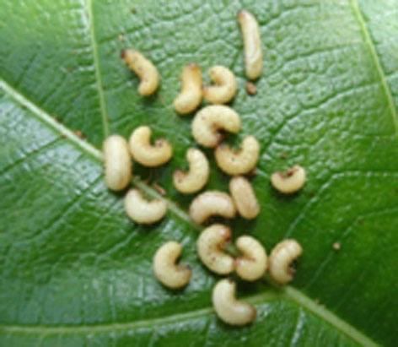 | 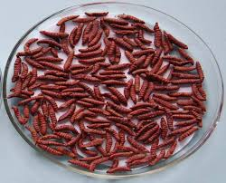
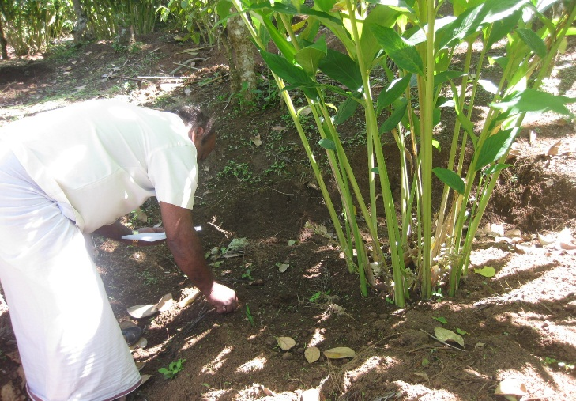 | 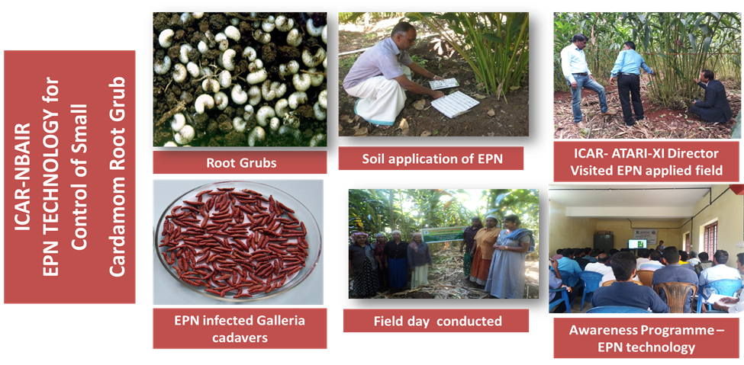

2. Title of the success stories: Control of Cardamom Stem borer/ Capsule borer/Panicle borer Management with different bio-pesticides and parasites

Details of success stories:

1.Background
High Ranges of Kerala is famous for its variety of spices. Cardamom is one of the main spices produced here. It is one of the most exotic and highly priced spices and Indian cardamom has a history as old as human civilisation. Cardamom is often named as the third most expensive spice in the world after saffron and vanilla. In Kerala, Idukki district provides all the favorable conditions for the growth of cardamom. Differential cultivation patterns make Idukki cardamom highly unique in the national and international markets.
Unfortunately, presence of high level of pesticide residues has decreased the export of cardamom by 80% from India and the analytical test reports from Pesticide Residue Research and Analytical Laboratory, College of Agriculture, Vellayani, Thiruvananthapuram have justified the occurrence of such residues.
The crop is prone to infestation by various insect pests like cardamom stem borer, which deteriorate the quality of the produce and this necessitates frequent application of pesticides even at 15-20 days interval towards the capsule bearing spikes. Current agricultural practices for intensive cardamom production focus on boosting cardamom yields by adequate supply of nutrients and blanket application of available pesticides for tackling insect pests. Moreover, the farmers are unaware of the various aspects of pesticide application including dosages, time of application, precautions to be taken, methods of storage and disposal of containers. Spraying pesticides resulted in large-scale environmental pollution, mortality of bees, and other pollinators and birds besides animal and human health problems.
Considering the gravity of the situation, the KVK Santhanpara, has decided to take up the management of Cardamom Stem borer with different bio-pesticides and parasites. The major objective of such an initiation was to reduce the trend of pesticide application among the farmers by making them aware regarding the ill effects of pesticide usage and its consequences on health and environment.
2. Source of Technology: ICAR-NBAIR & Indian Cardamom Research Institute

3.Intervention process
- Accessibility to the technology and availability of all basic resources
- Project formulation and onward submission to District Panchayat for grant.
- Hands-on training on bio pesticide production and usage
- Identification and culture of beneficial parasites
- Timely intervention on different stages of growth of cardamom.
- Advisory services.
- Follow-up visits and technical support as and when required.

3.Intervention Technology
- Provided an opportunity, where farmers could understand the various methods of production of organic pesticides.
- The technology was initiated during the years 2015-16 in 365 ha of small cardamom benefiting more than 1260 farmers.
- Between 2015 and 2018, in order to popularise these organic methods of pest control among the farmers, KVK has conducted more than 10 On Farm Trials, 50 Field Level Demonstrations and 1200 trainings.
- During the period of trial and applications, the major interventions that were taken up includes spraying of Bacillus thuringiensis @ 2g/L of water at First - instar larvae stage, spraying of Beauveria bassiana @ 5g/L of water at 3rd& 4th instar larvae and Adult stage, releasing of Apantele sp. @ 20000 Larval parasites /ha at 2nd& 3rd instar larvae and releasing of Friona sp @ 20000 Larval parasites /ha in effective control of stem borer and thrips.
- Timely intervention, was provided not just for farming activities, but also for allied support inventory.

4.Impact - Horizontal Spread
Before the intervention of KVK, only nominal farmers were adopting bio control methods in pest management. However after the well needed intervention of KVK, the area under bio intensive pest management took a positive hike. In Senapathy, the area has increased from 0 ha to 15 ha after KVK intervention. Similarly, the area has increased from 0 to 52 ha in Parathode, 04 to 69 ha in Santhanpara, 25 to 94 ha in Kattappana and 08 to 125 ha in Udumbanchola. The positive impact of the KVK intervention is visible from the data which shows the increase in area under bio control.

5. Impact - Vertical spread.
In this case, the popular notion that only commercial chemical pesticides can effectively control the pests has been proved otherwise. The data of production and productivity during the years 2015 to 2019 reveals that bio intensive pest management if put into proper use can give us good yield, returns and a less poisonous environment. Even though the farming community suffered decreased production and productivity during the year 2015-16 due to climatic vagaries, the production and productivity steadily increased to 1065 kg/ha and 4.71 q/ha in 2016- 17 and 1104kg/ha and 4.81 q/ha during 2017-18. The production again took a negative turn during 2018-19, due to the deadly Kerala floods of 2018 and 19.

6.Impact - Economic Gains

Every project and program is incomplete without an economic appraisal and it is not viable if it fails to provide economic returns to the farmer. As per the economic analysis conducted it was found that even in this first phase of application of bio pesticides, there was a 30% reduction in stem borer infestation. The gross costs incurred per ha by the adoption of bio pesticides was only 2, 69,000 rupees which is less when compared to the 390000 rupees incurred for the chemical application. Moreover, the gross returns obtained by the farmer is 6,45,000 rupees per ha which is much higher when compared to the revenue obtained by chemical application at the cost of deteriorating environment. With a BC ratio of 2.39 when compared to 1.46 BC ratio of chemical application, we can strongly recommend this bio intensive pest management as a viable and eco-friendly alternative.

Conclusion
Bacillus thuringiensis var kurstakiwas found to be effective when used in combination with Beauveria bassiana. Bacillus thuringiensis var kurstaki sprays in combination with the releases of parasites Apantele sp. and Friona sp. gave effective control of stem and capsule borer and the technology is well accepted by the farmers in Idukki district of Kerala. With the advent and popularization of these technologies, the number of farmers who adopted the bio intensive pest management has increased and the number of chemical pesticides in use has decreased from 14 to 6, thereby paving the way for a healthy and resilient farming system.

Steps for Scaling – up:
- Large Scale demonstrations will be conducted in convergence with ATMA-Idukki.
- The KVK will ensure that the majority of the growers are benefited by such programmes.
- Trainings for popularizing such eco- friendly, bio control methods will be organized frequently
- Brochures and other literary works will be published to give the farmers a quick summary
- Feedback will be obtained and their constraints will be met on a timely basis

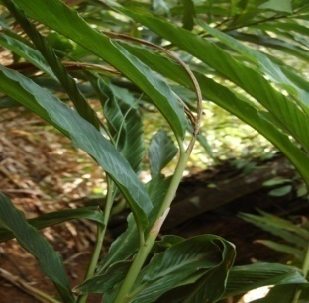 | 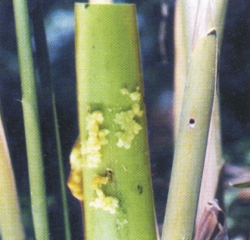
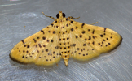 | 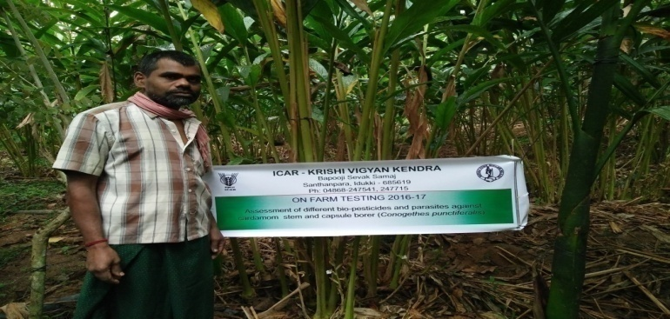

3. Title of the success stories: Doubling Income of Small Cardamom Farmer of Idukki District, Kerala through Pollination Service by Apiscerna indica Colonies and Value Addition of bee products

Details of success stories:

1. Background
Spices are important as earners of foreign exchange, as employer of labour, as a provider of revenue to the State and Central Government and as the most progressive of agricultural sectors in India. Among the various spices, cardamom, occupies a place of indubitable importance. Small cardamoms or green cardamoms are the 'true' dried cardamom and are sweetly fragrant with a slightly pungent flavour and they are cultivated on a large scale in Idukki district of Kerala. Unfortunately, cardamom cultivation is uneconomical on account of low productivity and fluctuating prices. Even then, farmers are compelled to stick on to this crop because the terms of lease or permit does not allow them to divert to other profitable crops or they are unaware regarding the alternative livelihood options. The major reason identified for low productivity in Cardamom was inadequate pollination and inadequate pollination in crops is due to several factors including lack of adequate number and diversity of pollinators.
When, KVK Santhanpara identified these problems of Small Cardamom cultivation, they came up with such a solution that can rectify the two problems of low productivity and absence of viable livelihood option, i.e. Bee keeping. Apiculture in small cardamom plantations can provide adequate number of pollinators and it can also generate additional revenue to the farmers.

Training programmes were organized during 2013-14 for bee farming and value addition of bee products. Of the many participants, Mr. Raju from Rajakumari, adopted this venture on a large scale and is one of the most successful bee farmers of the District. Mr. Raju learnt bee-farming and value addition with the technical support of KVK and he started beekeeping in 2007 with the financial support from KVK. He started with an initial investment of Rs.10, 000 and twenty boxes to rear the bees. Even though the initial years were of struggle and hardships, Raju now earns about one lakh rupee per month, and rears bees in more than 22,000 boxes and also runs a High range Beekeeping Society in Idukki. His marketing network is extended to all the 14 districts in Kerala and he has become a familiar face of Bee keeping across the country.

2. Intervention process
- Feasibility assessment of the site earmarked for bee keeping
- Availability of all the basic input resources
- Project formulation and onward submission to District Panchayat for grant.
- Hands-on training on bee farming and value addition of bee products.
- Intervention for getting adequate sales tenders
- Advisory services.
- Follow-up visits and technical support as and when required.
3. Intervention Technology

- Created a platform, where farmers could conduct a SWOT analysis, and identify the areas of strength and opportunities.
- Farmers with entrepreneurial urge and vision is supported both technically and financially to promote result oriented agri-business concepts.
- Timely intervention, not just for farming activities, but also for allied support inventory.
- Corrective deliberations and fool proof measures in all the stages of entrepreneurial development.

4.Impact - Horizontal Spread

The high range bee keeping society, is now providing newer employment opportunities and sources of additional income for the farmers. This is evident from the increase in the number of bee colony frames that has been sold over the years from 2014 to 2019.

5.Impact Economic Gains
An economic gain of around Rs. 67.56 lakhs per annum is now being realized on an average from the sale of honey and bee colonies alone.. Moreover an annual income of Rs. 27.16 lakhs is obtained from the value added products of honey namely amla honey, Honey with Garlic & Ginger, Honey with Pomegranate, Pollen, Royal Jelly and Bee Wax

6.Impact on Employment Generation

Agriculture is now being progressively considered as an uneconomical venture and the younger generation is hesitant to take up agriculture as a livelihood option. This is mainly due to the decreased productivity, uncertain climatic conditions, and low prices. But this situation can be changed, if there are alternative livelihood options in agriculture. In such a scenario, one such major sector that demands attention is value addition. In this case bee farming along with value addition of bee products is providing employment opportunities to many. Those benefitted through these ventures are indirectly getting hands on experience also to be independent at a point of time. It also acts as a knowledge hub of bee keeping and processing, that will ultimately benefit the farming community of the district.
Conclusion:
Bee farming, even though an age old practice its potential is still not exploited on a large extent. Through the demonstration practices conducted by the KVK, it was found that, it is not only a profitable enterprise but can also boost the production of small carsamom by acting as a source of pollinators. The unknown vistas of apiculture or bee farming need to be researched upon as it can be a viable livelihood option for many.

Scaling up:
- Frequent demonstrations regarding setting upmof bee hives, honey harvesting and production of value added products will be conducted.
- Active participation of farm women and youth will be ensured to provide them a stable souurce of income.
- Trainings will be conducted for the dissemination of new information and upgradation of the old
- Brochures and other literary works will be published to give the farmers a quick summary
- Feedback will be obtained and their constraints will be met on a timely basis

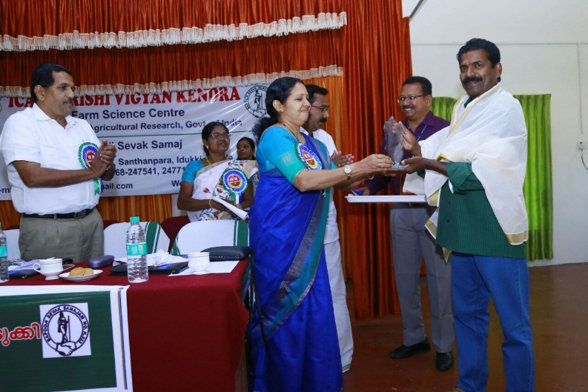 | 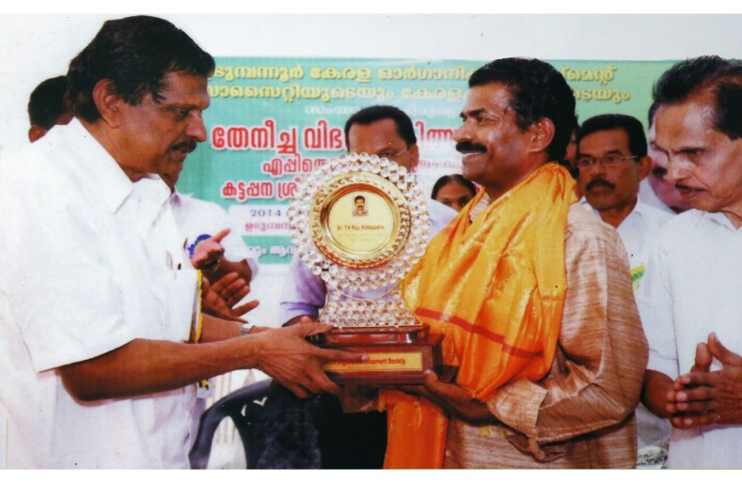
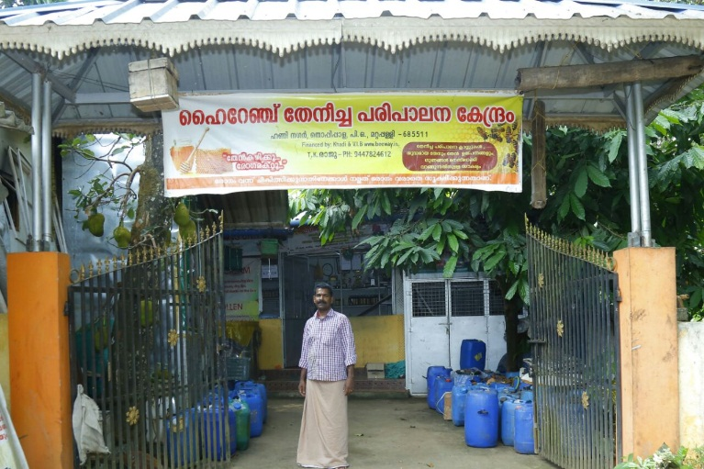

4. Title of the success stories: Revitalization of rice farming in Idukki District with high yielding Akshaya variety of rice

Details of success stories:

1. Background
The agriculture in Kerala has undergone significant structural changes in the form of decline in the share of Gross State Domestic Product and commercialization of agriculture. The gross cropped area and the net sown area in the state have declined over a period of time. During 1999-2000, and 2017-18 districts like, Idukki, Ernakulum, Palakkad, Wayanad and Kannur districts have shown declining growth rate in area under paddy cultivation which is less than the state average. Idukki, known as the spice bowl of the state have shown declining trends in both area and production.
To bring about a change in this negative trend, and to create an awareness regarding the importance of rice cultivation in maintaining ecological balance, KVK, Idukki has started a demonstration on cultivation of Akshaya variety of rice in 2019-20. Akshaya (PTB-62), is developed from the two varieties of Pranav and Chettadi by Regional Agricultural Research station, Pattambi. Akshaya with a better yield than Uma, Swetha and Karuna will help to bring back the lost glory of Idukki in rice cultivation

2. Source of Technology: Regional Agricultural Research station, Pattambi

3.Intervention process
- Accessibility to the technology and availability of all basic resources
- Timely intervention on different stages of growth of Rice
- Advisory services.
- Follow-up visits and technical support as and when required.

3.Intervention Technology
- The demonstration was initiated during the years 2019-20 in 2 ha of area with a broad vision to bring back the farmers to rice cultivation.
- Between 2019 and 2020, in order to educate the farmers regarding the various requisites of rice production, KVK has conducted numerous trainings regarding the production practices of Akshaya variety of Rice.
- Timely intervention, was provided not just for farming activities, but also for allied support inventory.

4.Impact - Horizontal Spread
Before the intervention of KVK, rice cultivation was almost getting wiped away from the agricultural map of Idukki. After the demonstration farming on 2ha of land, the number of farmers who are interested to take up rice farming has increased. This is evident from the increased requests for more trainings and planting materials.

5. Impact- Vertical spread.
During the period 1980-81 to 2011-12, Idukki, have lower negative cumulative growth rate in area compared to the state average. But through this demonstration farming, KVK was able to obtain a better grain yield of 7 t/ ha and a straw yield of 14 t/ha. This will surely prove to be an eye opener for the farmers, that rice cultivation can also be profitable in their local conditions.

6.Impact - Economic Gains
On the basis of costs incurred and revenue generated an economic analysis was conducted and we obtained a Benefit Cost ratio of 2.8. The ratio point towards the popular myth that only cash crop cultivation is profitable.

Conclusion
Akshaya variety of rice when cultivated on 2ha of land was successful with good grain and straw yield. This initiative of KVK, will throw light upon the forgotten rice cultivation history of the district.

Steps for Scaling – up:
- Large Scale demonstrations will be conducted in convergence with line departments of Idukki.
- The KVK will ensure that the majority of the growers are benefited by such programmes.
- Trainings will be conducted to popularize rice framing among the farmers.
- Brochures and other literary works will be published to give the farmers a quick summary.
- Feedback will be obtained and their constraints will be met on a timely basis.

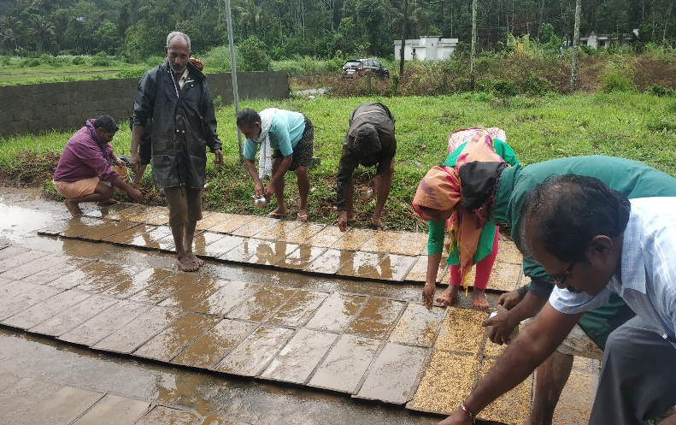 | 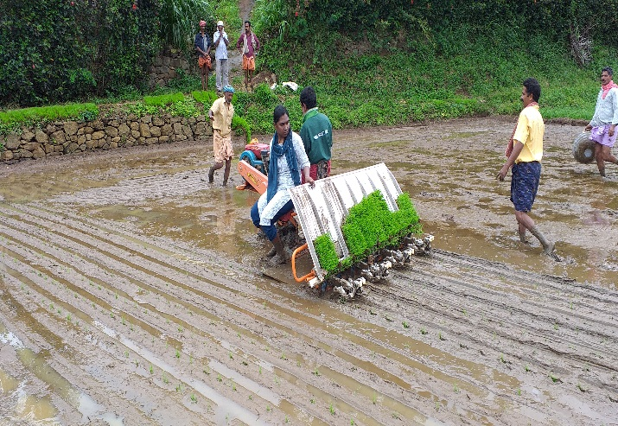
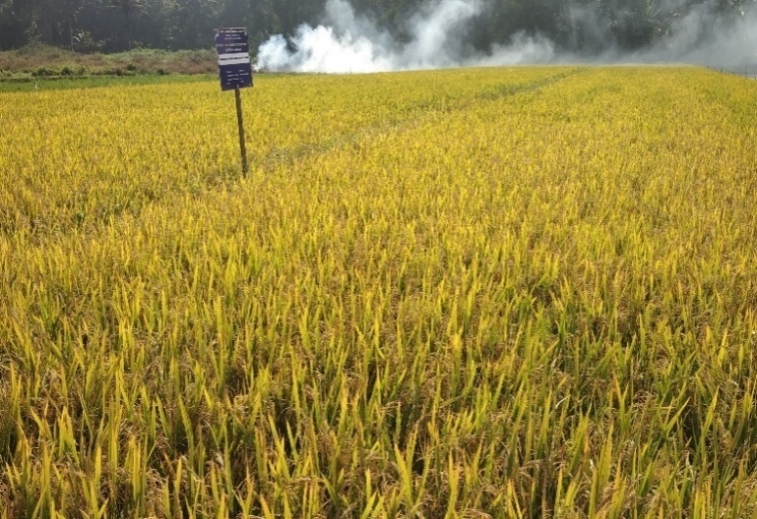 | 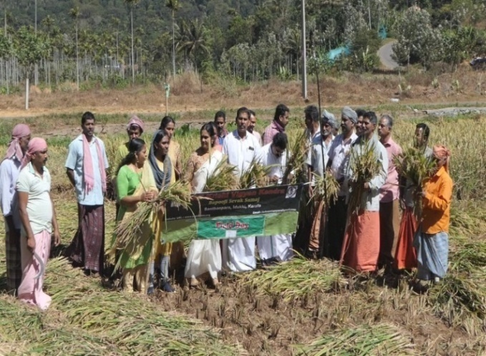

4. Title of the success stories: Effect of IIHR Black Pepper Special on yield potential and reduction of nutritional disorders in Black Pepper

Details of success stories:

1. Background
Black pepper (Piper nigrum L.), christened as the ‘King of Spices’, is one of the important agricultural commodities of commerce and trade in India since pre-historic period. The crop is the major source of income and employment for rural households in the predominantly pepper growing state of Kerala where more than 2.5 lakh farm families are involved in pepper cultivation. Idukki district is a major producer of black pepper in the state. Over the years, the share of modern varieties of black pepper in cultivation is found to increase.

Major problem faced by pepper growers is the soil acidity. Nutrient disorders and deficiencies are often encountered in the field of pepper leading to their decreased yield and productivity. Malnutrition often pre-disposes the pepper plants to diseases and deficiencies of nutrients like P and K have also been indicated as the reason for diseases. But applying chemical fertilizers is not viable as they pose threats to both environment and health of the people. It is in such a scenario, where the KVK Idukki has decided to conduct a trial with a Micronutrient mixture, developed by IIHR Bangalore known as IIHR Black Pepper Special and this has achieved wide spread attention and appreciation from the farmers

2. Source of Technology: Indian Institute of Horticultural Research, Bangalore

3. Intervention process
• Ensuring the availability of adequate Black Pepper special for the trial period
• Timely intervention on different stages of growth of Black pepper
• Timely diagnosis of deficiencies and diseases of black pepper.
• Advisory services.
• Follow-up visits and technical support as and when required.

3. Intervention Technology
• The black pepper cultivation utilizing this technology was conducted during the years 2018-19 in 2 ha of area
• The program aimed at reducing the deficiency disorders of black pepper and diseases caused due to the deficiencies.
• Between 2018 and 2019, KVK has conducted several field visits, field tours and trainings to popularise the technology and to educate the farmers regarding the mode of application.
• Timely intervention was provided not just for farming activities, but also for allied support inventory.

4.Impact - Horizontal Spread
Problems such as High Soil Acidity, Potassium, Magnesium micronutrient deficiency, reduced growth, interveinal chlorosis of immature and recently matured leaves, malformation of young leaves, and interveinal chlorosis are commonly found in the pepper vines of Idukki district. After the inculcation of IIHR- Black pepper special in the cultivation practices of pepper, there is a huge decrease in the deficiency disorders and the same is reflected in the increased yield obtained during this time period.

5. Impact- Vertical spread.
Pepper farmers of Idukki, has always been concerned regarding the low productivity of pepper as a result of deficiency disorders. But after the adoption of this technology, the farmers were able to obtain an increased yield of 1200kg/ha

6.Impact - Economic Gains
An economic analysis was conducted, on the basis of costs incurred and revenue generated. The pepper cultivation with the application of IIHR Black pepper technology gave a Benefit Cost ratio of 2.33 which shows that it is both feasible and profitable.

Conclusion
IIHR Black pepper special when applied in two sprays to the pepper at vine setting and vine maturation stages, helped the crops to meet its nutritional requirements and major nutritional disorders found in pepper were absent when applied with IIHR Black pepper special. The spike length increased as compared to normal spike. Berry formation was found uniform and fungal diseases were found decreased. As a result, the farmers have accepted this technology on a wide scale and the demand is increasing day by day.

Steps for Scaling –up:
- More demonstration plots will be made under this technology
- The technology will be made available to the farmers at reduced rates.
- Trainings will be conducted to popularize the technology among the farmers
- Brochures and other literary works will be published to give the farmers a quick summary
- Feedback will be obtained and their constraints will be met on a timely basis

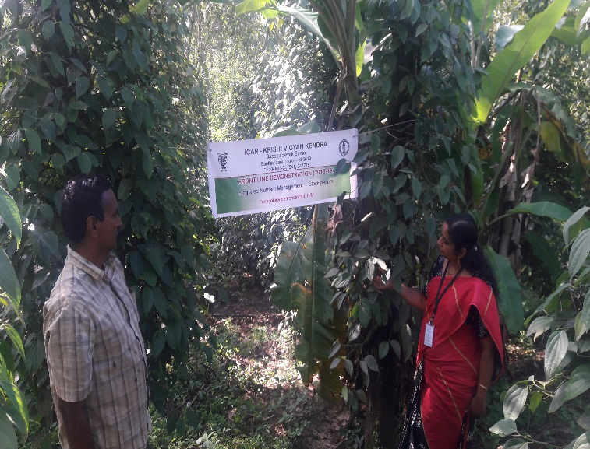 | 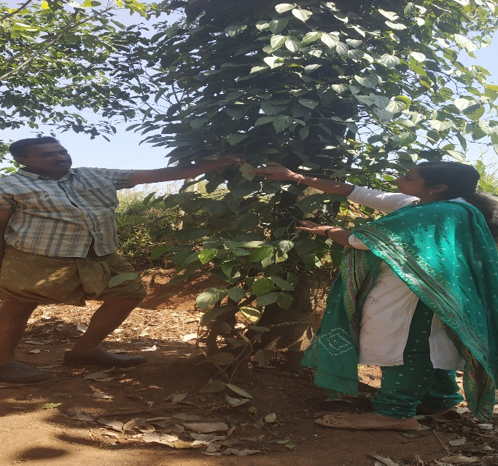
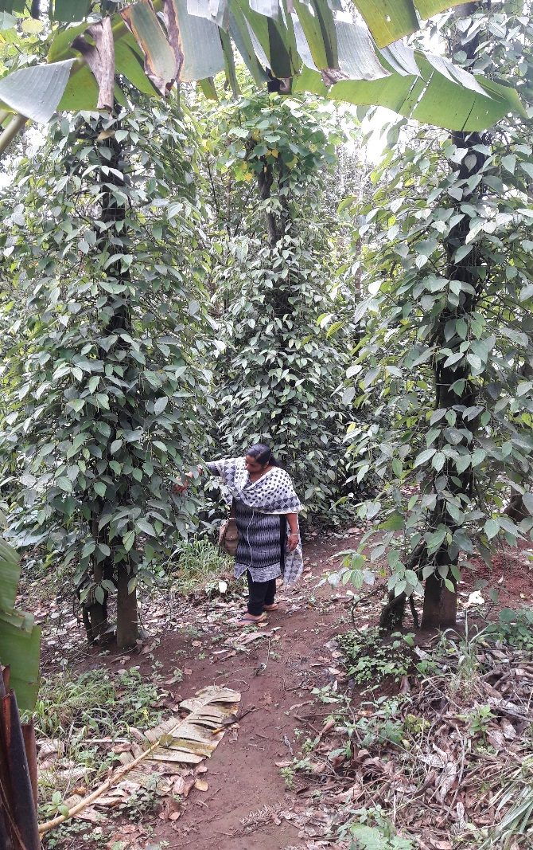 | 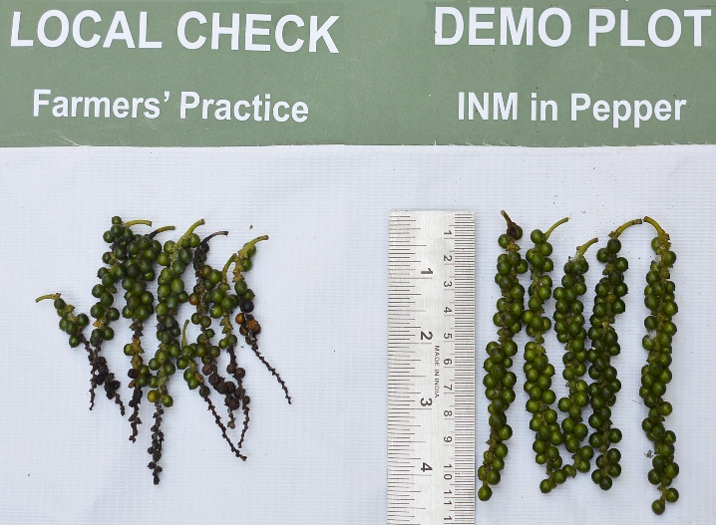

10.D. Give details of Innovative Methodology or Innovative Approach of Transfer of Technology developed and used during the year: Nil.

10.E. Give details of Indigenous Technical Knowledge practiced by the farmers in the KVK operational area which can be considered for technology development (in detail with suitable photographs): Nil.
S. No. | Crop / Enterprise | ITK Practiced | Purpose of ITK | Scientific Rationale

10 F. Technology Week celebration during 2019: Nil.

Period of observing Technology Week: From to
Total number of farmers visited :
Total number of agencies involved :
Number of demonstrations visited by the farmers within KVK campus:

Other Details
Types of Activities | No. of  Activities | Number of  Farmers | Related crop/livestock technology
Gosthies
Lectures organized
Exhibition
Film show
Fair
Farm Visit
Diagnostic Practicals
Supply of Literature (No.)
Supply of Seed (q)
Supply of Planting materials (No.)
Bio Product supply (Kg)
Bio Fertilizers (q)
Supply of fingerlings
Supply of Livestock specimen (No.)
Total number of farmers visited the technology week

10 E. Recognition and Awards:
- Best stall awarded by ATMA, Idukki

PART XI – SOIL AND WATER TEST

PART XI – SOIL AND WATER TEST

11.1 Soil and Water Testing Laboratory:

A. Status of establishment of Lab : Functioning
1. Year of establishment : 2005-06
2. List of equipments purchased with amount :

Sl. No | Name of the Equipment | Qty. | Cost | Status
1. | LPG Cylinder | 1 | 4600.00 | working
2. | Water bath WDB-2 350’400’100mm 12 holes | 1 | 4815.00 | working
3. | Machinery for Homogensing (khan shaker) Model LKS2 platform size 75cmx43cmx10cm | 1 | 20,880.00 | Not working
4. | Rotary Shaker | 1 | 16,200.00 | Not working
5. | Machinery for drying (Hot air oxen) with digital temperature control, size 455’455’455’ | 1 | 13,725.00 | Not working
6. | Conductivity meter (PH meter Eutech 510) | 1 | 21,935.00 | Not working
7. | Genesis 20 visible Spectrophotometer meter | 1 | 1,12,499.00 | Not working
8. | CITIZEN Physical Balance Model CTL-600 | 1 | 8,991.00 | Not working
9. | Micro processor based conductivity | 1 | 13,500.00 | Not working
10. | Micro Processor Based Flame Photometer with N, K &Ca FILTERS & Compressor | 1 | 45,000.00 | Not working
11. | Electronic Automatic KEL  PLUS Micro processor  Based Twelve Place Micro Block Digestion System | 1 | 97,043.00 | Not working
12. | Electronic Balance  Model: CP 2245  Srl.No.18606016 | 1 | 1,00,000.00 | Not working
13. | Hot plate | 1 | 5,400.00 | Not working
Total |  | 12 | 4,64,588.00

B. Details of samples analyzed since establishment of SWTL:

Details | No. of Samples analyzed | No. of Farmers benefited | No. of Villages
Soil Samples | 33954 | 1955 | 20
Water Samples | 0 | 0 | 0
Plant samples | 0 | 0 | 0
Manure samples | 0 | 0 | 0
Others (specify) | 0 | 0 | 0
Total | 33954 | 1955 | 20

C. Details of samples analyzed during the 2019:

Details | No. of Samples analyzed | No. of Farmers benefited | No. of Villages
Soil Samples | 308 | 186 | 40
Water Samples | 0 | 0 | 0
Plant samples | 0 | 0 | 0
Manure samples | 0 | 0 | 0
Others (specify) | 0 | 0 | 0
Total | 308 | 186 | 40

11.2 Mobile Soil Testing Kit
A. Date of purchase and current status
Mobile Kits | Date of purchase | Current status
1.Two Mridaparikshak Kits | 21-06-2017 | working
2.

B. Details of soil samples analyzed during 2019 and since establishment with Mobile Soil Testing Kit:

 | Progress during 2019 | Cumulative progress
Samples analyzed (No.) | 308 | 1152
Farmers benefited (No.) | 186 | 740
Villages covered (No.) | 40 | 62

11.3 Details of soil health cards issued based on SWTL & Mobile Soil Testing Kit during 2019:

Particulars | Date (s) | Villages (No.) | Farmers (No.) | Samples analyzed (No.) | Soil health cards issued (No.)
SWTL | 0 | 0 | 0 | 0 | 0
Mobile Soil Testing Kit | 01-01-2019 to 31-12-2019 | 40 | 186 | 308 | 308

11.4 World Soil Health Day celebration
Sl. No. | Farmers participated (No.) | Soil health cards issued (No.) | VIPs (MP/ Minister/MLA attended (No.) | Other Public Representatives participated | Officials participated (No.) | Media coverage (No.)
1. | 80 | 25 | 0 | 2 | 3 | 2

PART XII. IMPACT

12.A. Impact of KVK activities (Not restricted for reporting period).

Name of specific technology/skill transferred | No. of participants | % of adoption | Change in income (Rs.)
 |  |  | Before (Rs./Unit) | After (Rs./Unit)
EPN | 1600 | 70 | 305000/ha | 423000/ha
VAM | 220 | 22 | 130000/ha | 175000/ha
Microbial Consortium | 460 | 80 | 280000/ha | 460000/ha
Neem Soap | 320 | 39 | 165000/ha | 256000/ha
EM Decomposer | 1250 | 48 | 280000/ha | 410000/ha
Cardamom special | 525 | 65 | 324100/ha | 402000/ha
Pepper Special | 312 | 32 | 45538/ha | 122226/ha
Banana Special | 250 | 24 | 570000/ha | 630000/ha
Vegetable Special | 175 | 15 | 335000/ha | 440000/ha
Protray production of vegetable seedlings | 55 | 50 | 150000/1 acre | 450000/1acre
NB: Should be based on actual study, questionnaire/group discussion etc. with ex-participants.

12.B. Cases of large scale adoption (Please furnish detailed information for each case with suitable photographs): Nil.

12.C. Details of impact analysis of KVK activities carried out during the reporting period: Nil.

PART XIII - LINKAGES

13A. Functional linkage with different organizations
Name of organization | Nature of linkage
Vegetable Development Programme | MDDT and Field Visits
ATMA | MDDT, Field Visits, Trainings, EAP and Demonstrations
Department Of Animal Husbandry | Field Visits, Trainings, Demonstrations
Department of Forestry | Tribal Development Projects, Trainings
Department of agriculture | Field Visits, Trainings, Demonstrations
VFPCK | MDDT, Field Visits, Trainings
Coffee Board | Trainings, Field Visits and Demonstrations
Spices Board | Trainings, Field Visits
VOSARD Agency | Trainings
NABARD | FPO formation and related activities
Kerala state cooperative bank | Relation with Farmer club formation
MANAGE | DAESI programme
DIC | Trainings, Demonstrations
VHSC | Trainings
District Kudumbasree Mission | Group formation, Training and demonstrations
FAI | Workshop, Seminar and Soil Health campaign
NLC | Technology trial (Humic acid)
IFFCO | Soil Health awareness campaign
SPIC | Soil Health awareness campaign
Tribal Development Board | Training and technology sharing
Social Development Department | Training
Block and District panchayat | Training
NB The nature of linkage should be indicated in terms of joint diagnostic survey, joint implementation, participation in meeting, contribution received for infrastructural development, conducting training programmes and demonstration or any other

13B. List of special programmes undertaken by the KVK and operational now, which have been financed by State Govt./Other Agencies

Name of the scheme | Date/ Month of initiation | Funding agency | Amount (Rs.)
Value addition of vegetables & Fruits | 27-03-2019 | Department of Agriculture | 9,500
DAESI Programme | 11-04-2019 | MANAGE-ATMA-IDUKKI | 16,00,000
PKVY | 29-07-2019 | ATARI | 3,30,000
Tree planting programme | 16-09-2019 | ATARI | 10,000
ASCI (RKVY) | 24-10-2019 | ATARI | 2,99,200
NADCP of vaccination for FMD & Brucellosis | 03-01-2020 | ATARI | 15,000
Swachhta action plan | 20-01-2020 | ATARI | 37,500
Biennial Fertilizer Application awareness programme | 13-01-2020 | ATARI & IFFCO | 1,00,000

13C. Details of linkage with ATMA

Coordination activities between KVK and ATMA
S. No. | Programme | Particulars | No. of programmes attended by KVK staff | No. of programmes Organized by KVK | Other remarks (if any)
01 | Meetings | Meetings | Monthly Technology meetings | - | Due to lack of fund
02 | Research projects | Research projects | -
03 | Training programmes | Low cost production of bio inputs | 2 | 2 | -
 |  | Micro-nutrient deficiency | 1 | 1 | -
04 | Demonstrations | Soil sampling methods | 1 | 1 | -
 |  | PPFM | 1 | 1 | -
 |  | Hanseniaspora | 2 | 1 | -
05 | Extension Programmes
 | Kisan Mela | Technology Week (Thalir-2019) | 1 | 1 | -
 | Exposure visit | DAESI | 2 | 0 | -
 | Exhibition |  | 1 | 0 | -
 | Soil health camps | Soil Test Campaign | 2 | 2 | -
 | Others (Pl. specify)
 |  | Publications | 0 | 0 | -
 |  | Video Films | 0 | 0 | -
 |  | Books | 0 | 0 | -
 |  | Extension Literature | 0 | 0 | -
 |  | Pamphlets | 0 | 0 | -
 |  | Others (Pl. specify) | 0 | 0 | -
 | Other Activities (Pl.specify)
 |  | Watershed approach | 0 | 0 | -
 |  | Integrated Farm Development | 0 | 0 | -
 |  | Agri-preneurs development | 0 | 0 | -

13D. Give details of programmes implemented under National Horticultural Mission: Nil.

S. No. | Programme | Nature of linkage | Funds received if any Rs. | Expenditure during the reporting period in Rs. | Constraints if any

13E. Nature of linkage with National Fisheries Development Board: Nil.
S. No. | Programme | Nature of linkage | Funds received if any Rs. | Expenditure during the reporting period in Rs. | Remarks

13F. Details of linkage with RKVY
S. No. | Programme | Nature of linkage | Funds received if any Rs. | Expenditure during the reporting period in Rs. | Remarks
1 | Bee Keeper | Skill Training | Yes, Rs.133600.00 | - | -
2 | Bee Keeper | Skill Training | Yes, Rs.133600.00 | - | -

13G. Kisan Mobile Advisory Services

Month | Message type (Text/Voice) | SMS/voice calls sent (No.) |  |  |  |  |  | Total SMS/Voice calls sent (No.) | Farmers benefitted (No.)
 |  | Crop | Livestock | Weather | Marketing | Awareness | Other enterprises
January | - | - | - | - | - | - | - | -
February | - | - | - | - | - | - | - | -
March | - | - | - | - | - | - | - | -
April | - | - | - | - | - | - | - | -
May | - | - | - | - | - | - | - | -
June | - | - | - | - | - | - | - | -
July | - | - | - | - | - | - | - | -
August | Text | 2 | - | - | - | - | - | - | 1710
September | Text | 1 | - | - | - | - | - | - | 855
October | Text | 3 | 1 | - | - | - | - | - | 3420
November | Text | 4 | 2 | - | - | - | - | - | 5330
December | Text | 5 | - | - | - | - | - | - | 5475
Total |  | 14 | 2 | 1 | - | - | - | - | 16790

PART XIV- PERFORMANCE OF INFRASTRUCTURE IN KVK

14A. Performance of demonstration units (other than instructional farm): Nil.

Sl. No. | Demo Unit | Year of  establishment | Area  (ha) | Details of production |  |  | Amount (Rs.) |  | Remarks
 |  |  |  | Variety | Produce | Qty. | Cost of inputs | Gross income

14B. Performance of instructional farm (Crops) including seed production: Nil.

Name  of the crop | Date of sowing | Date of harvest | Area (ha) | Details of production |  |  | Amount (Rs.) |  | Remarks
 |  |  |  | Variety | Type of Produce | Qty. | Cost of inputs | Gross income
Cereals
Pulses
Oilseeds
Fibers
Spices & Plantation crops
Floriculture
Fruits
Vegetables
Others (specify)

14C. Performance of production Units (bio-agents / bio pesticides/ bio fertilizers etc.,)
Sl.  No. | Name of the Product | Qty (Qtl.) | Amount (Rs.) |  | Remarks (No. of farmers benefitted)
 |  |  | Cost of inputs | Gross income
1. | VAM | 17.85 | 171348 | 178450 | 395
2. | Arka microbial consortium | 13.94 | 139400 | 197050 | 298
3. | Phosphobacteria (Solid form) | 6.99 | 69900 | 103100 | 181
4. | Potash bacteria | 7.84 | 78400 | 104450 | 210
5. | Vermi compost | 0.31 | 217 | 465 | 5
6. | Azospirillum (Solid form) | 9.25 | 92500 | 109500 | 194
7. | Metarhizium | 6.06 | 48480 | 82845 | 268
8. | Beauveria | 6.82 | 54560 | 91105 | 363
9. | EPN | 2.00 | 92000 | 152700 | 193
10. | Neem | 6.99 | 111840 | 136400 | 284
11. | Trichoderma viride | 14.27 | 114160 | 187170 | 406
12. | Paecilomyces | 6.15 | 61500 | 172500 | 377
13. | Pseudomonas | 18.14 | 145120 | 250920 | 521
14. | Decomposer | 0.69 | 5520 | 20700 | 19
15. | PPFM | 2.22 | 22200 | 66600 | 65
16. | EM-Solution | 8.01 | 80100 | 187600 | 301
17. | Oyster Mushroom spawn | 0.23 | 1380 | 3790 | 8

14D. Performance of instructional farm (livestock and fisheries production): Nil.

14E. Utilization of hostel facilities: Nil.

14F. Database management
S. No | Database target | Database created
1. | Farmers database (FLD, OFT, DBT, KMAS, Training) | Database for (2019-20)

14G. Details on Rain Water Harvesting Structure and micro-irrigation system: Nil.

PART XV – SPECIAL PROGRAMMES

15.1 Paramparagath Krishi Vikas Yojana (PKVY)
Sl. No. | Name of cluster village | Initial soil fertility status (Average of cluster village) |  |  |  | Facilities created for organic source of manure | Name of Crops cultivated | Variety | Organic inputs applied including bio-agents and botanicals treatment | Yield (q/ha) | Economics
 |  | Aval. N | Aval. P | Aval. K | OC % |  |  |  |  |  | Cost of cultivation (Rs/ha) | Net returns (Rs/ha)
1 | 1. Sandoz SC Colony (KDH Village - Vattavada) | 346.6 | 19.9 | 496.2 | 1.91 | Vermicompost, VAM, Organic compost, Neem cake | Vegetables – Cabbage | Quisor | Pseudomonas, Trichoderma, Azospirillum, Phospho bacteria | (On going) | - | -
 | 2. |  |  |  |  |  | Carrot | Kuroda
 | 3.
 | 4.
 | 5.
2 | 1.
 | 2.
 | 3.
 | 4.
 | 5.

15.2 District Agriculture Meteorological Unit (DAMU): Nil.

15.3 Fertilizer awareness programme 2019
State | Name of KVK | Details of Activities/programme Organised | Number of Chief Guests | No. of Farmers attended program | Total participants
Kerala | Idukki | Biennial fertilizer application awareness programme | 07 | 183 | 190
Kerala | Idukki | Demonstration on Humic acid spray for Cardamom, Pepper and Nutmeg | 3 | 30 | 33

15.4 Seed Hub: Nil.

15.5 CFLD on Oilseed : As per the excel sheet enclosed: Nil.

15.6 Seed on Pulses : As per the excel sheet enclosed: Nil.

15.7 Krishi Kalyan Abhiyan: Nil.

15.8 Micro-Irrigation: Nil.

PART XVI - FINANCIAL PERFORMANCE

16A. Details of KVK Bank accounts

Bank account | Name of the bank | Location | Branch code | Account Name | Account Number | MICR Number | IFSC Number
With Host Institute | Nil
With KVK (KVK General Fund Account) | State Bank of India | Rajakumary | 70453 | Bapooji Sevak samaj Krishi Vigyan Kendra | 57060836995 | 6850002932 | SBIN0010453
With KVK (Revolving Fund Account) | State Bank of India | Rajakumary | 70453 | Bapooji Krishi Vigyan Kenrda (Revolving Fund) | 67155078042 | 6850002932 | SBIN0010453

16B. Utilization of KVK funds during the year 2019-20 (Rs. in lakh) – (April’19 – Dec.’19)

S.  No. | Particulars | Sanctioned BE | Released | Expenditure
A. Recurring Contingencies
1 | Pay & Allowances | 123.98 | 102.65 | 102.65
2 | Traveling allowances | 1.0 |  | 0.60
3 | Contingencies | 8.86 | 7.395
A | Stationery, telephone, postage and other expenditure on office running, publication of Newsletter and library maintenance (Purchase of News Paper & Magazines) | 2.0 |  | 1.31
B | POL, repair of vehicles, tractor and equipments | 1.50 |  | 0.97
C | Meals/refreshment for trainees (ceiling upto Rs.40/day/trainee be maintained) | 1.0 |  | 0.56
D | Training material (posters, charts, demonstration material including chemicals etc. required for conducting the training) | 0.35 |  | 0.35
E | Frontline demonstration except oilseeds and pulses (minimum of 30 demonstration in a year) | 1.93 |  | 1.83
F | On farm testing (on need based, location specific and newly generated information in the major production systems of the area) | 0.80 |  | 0.67
G | Training of extension functionaries | 0.25 |  | 0.0
 | Extension Activities | 0.25 |  | 0.12
 | Farmers Field School | 0.25 |  | 0.10
H | Maintenance of buildings | 0.0 |  | 0.0
I | Establishment of Soil, Plant & Water Testing Laboratory | 0.25 |  | 0.24
 | Nutri Garden | 0.25 |  | 0.20
J | Library | 0.03 |  | 0.017
TOTAL (A) |  | 133.84 |  | 109.62
B. Non-Recurring Contingencies
1 | Works | 0.0 |  | 0.0
2 | Equipment including SWTL & Furniture | 0.0 |  | 0.0
3 | Vehicle (Four wheeler/Two wheeler, please specify) | 0.0 |  | 0.0
4 | Library (Purchase of assets like books & journals) | 0.0 |  | 0.0
TOTAL (B) |  | 0.0 |  | 0.0
C. REVOLVING FUND |  | 0.0 |  | 0.0
GRAND TOTAL (A+B+C) |  | 133.84 | 110.046 | 109.62

16C. Status of revolving fund (Rs. in lakh) for the last three years
Year | Opening balance as on 1st April | Income during the year | Expenditure during the year | Net balance in hand as on 1st April of each year
April 2017 to March 2018 | 410526.00 | 2453736.00 | 1522669.00 | 1341593.00
April 2018 to March 2019 | 1341593.00 | 3033360.00 | 3022873.00 | 1352080.00
April 2019 to Dec. 2019 (including stock value) | 1352080.00 | 4214026.00 | 3963498.00 | 1602608.00  (Opening balance on January 2020)

17. Details of HRD activities attended by KVK staff

Name of the staff | Designation | Title of the training programme | Institute where attended | Dates
Sudhakar. S | Subject Matter Specialist (Plant Protection) | Mass culturing of Bio agents | ICAR – NBAIR, Bengaluru. | 16.7.2019 -17.7.2019
Ashiba. A | Subject Matter Specialist (Agronomy) | Farm Mechanization | ICAR – KVK, Malappuram | 18.07.2019
Ashiba. A | Subject Matter Specialist (Agronomy) | Orientation training | ICAR – KVK, CPCRI, Kasargode | 23.09.2019 – 27.09.2019
Preethu K Paul | Subject Matter Specialist (Agrl. Extension | Orientation training | ICAR – KVK, CPCRI, Kasargode | 23.09.2019 – 27.09.2019
Jayisy joseph | Programme Assistant (Home science) | Workshop on Nutri Graden | DE, KAU Mannuthy | 24.10.2019

18. Please include any other important and relevant information which has not been reflected above (write in detail).

