KRISHI VIGYAN KENDRA (IDUKKI)

ANNUAL REPORT-(2018-19)

(FOR THE PERIOD FROM 01 APRIL 2018 TO 31 MARCH 2019)

ICAR - KrishiVigyan Kendra,
BapoojiSevakSamaj,
Pethotty P.O., Santhanpara,
Idukki (Dt.), Pin-685619, Kerala.
Phone: 04868 – 247541, 247715.
E-mail: kvk.Idukki@icar.gov.in, kvksanthanpara@gmail.com
Website URL: www.kvkidukki.org

GENERAL INSTRUCTIONS

Please read the instructions very carefully before starting preparation of the report

- Annual report is the most important document for the KVK and it directly reflects the overall achievements pertaining to the reported period. Hence due care need to be given by each KVK while preparing the report.

- Period of Report is from 01April 2018 to 31 March 2019

- Action photographs with relevant captions covering various activities of the KVK in High resolution should be submitted separately in a CD/DVD along with this report.

- Prepare Summary tables carefully tallying with the relevant portions of the main report on all aspects.

- Retain the blank column and rows as such and do not merge the cells. Please specify NIL, wherever not applicableor details are not available.

- Check the names of varieties and hybrids and specify in the report.

- Check the units and totals of each data table

- Extension activity under celebrations for each important day, please insert separate rows and give appropriate data separately. Clubbing of data should be avoided.

- Success stories/case studies should be supported with data tables, graphs and photos.

PART I –GENERALINFORMATION ABOUT THE KVK

1.1. Name and address of KVK withphone, fax and e-mail
KVK Address | Telephone |  | E mail | Web Address
 | Office | Fax
ICAR - KrishiVigyan Kendra, BapoojiSevakSamaj, Pethotty P.O., Santhanpara, Idukki (Dt.), Pin-685619, Kerala. | 04868 – 247541,  247715. | Nil | kvksanthanpara@gmail.com | www.kvkidukki.org

1.2 .Name and address of host organization with phone, fax and e-mail
Address | Telephone |  | E mail | Web Address
 | Office | Fax
BapoojiSevakSamaj,  Kakkattu, Meenadom P.O.,  Pampady, Kottayam (Dt.),  Pin-686 516, Kerala. | 0481-2506271  +91 9446826019 | 04868-247048 | bkvkchairperson@gmail.com | www.kvkidukki.org

1.3. Name of the Programme Coordinator with phone & mobile No
Name | Telephone / Contact
 | Residence | Mobile | Email
Dr. R. Marimuthu, Senior Scientist& Head | - | 8157895397 | kvksanthanpara@gmail.com

1.4. Year of sanction:1994.
1.5. Staff position as on 31 March 2019
Sl.  No. | Sanctioned post | Name of the incumbent | Designation | M / F | Discipline | Highest Qualification  (for PC, SMS and Prog. Asst.) | Pay  Scale | Basic pay | Date of joining KVK | Permanent  /Temporary | Category (SC/ST/  OBC/  Others)
1 | Head/Senior Scientist | Dr. R. Marimuthu | Senior Scientist& Head | M | Agronomy | Doctorate in Agriculture - Agronomy | 37400-67000 | 50720 | 17-01-2019 | Permanent | OBC
2 | Scientist/SMS | Dr. S. Jayababu | Subject Matter Specialist | M | Animal Science | B.V. Sc. & AH | 15600-39100 | 21000 | 19-06-1995 | Permanent | Others
3 | Scientist/SMS | Manju Jincy Varghese | Subject Matter Specialist | F | Soil Science | M.Sc. Agriculture (Soil Science) | 15600-39100 | 21000 | 10-01-2011 | Permanent | Others
4 | Scientist/SMS | Dr. Binu John Sam | Subject Matter Specialist | M | Horticulture | Doctorate in Agriculture - Horticulture | 15600-39100 | 21000 | 17-01-2011 | Permanent | Others
5 | Scientist/SMS | Sudhakar Soundarajan | Subject Matter Specialist | M | Plant Protection | M.Sc. Agricultural Entomology, MBA | 15600-39100 | 21000 | 27-01-2011 | Permanent | OBC
6 | Scientist/SMS | Ashiba A | Subject Matter Specialist | F | Agronomy | M.Sc. Agronomy | 15600-39100 | 21000 | 07-01-2019 | Permanent | Others
7 | Scientist/SMS | Preethu K. Paul | Subject Matter Specialist | F | Agri. Extension | M.Sc. Agricultural Extension | 15600-39100 | 21000 | 07-01-2019 | Permanent | Others
8 | Programme Assistant (Lab Tech.) | Jayisy Joseph | Programme Assistant | F | Home Science | M. Sc. Home Science (Extension for Rural Development) | 9300-34800 | 13500 | 20-06-1995 | Permanent | Others
9 | Programme Assistant (Computer) | Biju Narayanan | Programme Assistant | M | Computer Application | M.C.A., PGDCA | 9300-34800 | 13500 | 01-10-2007 | Permanent | OBC
10 | Programme Assistant / Farm Manager | Rachel Skariakutty | Programme Assistant | F | Rural Craft | M.A. Sociology (P.G. Diploma in Rural Development) | 9300-34800 | 13500 | 05-06-1995 | Permanent | Others
11 | Assistant | Shaji. K. Kakkattu | Assistant | M | - | - | 9300-34800 | 13500 | 05-06-1995 | Permanent | Others
12 | Jr. Stenographer | Daisy Daniel | Jr. Stenographer | F | - | - | 5200-20200 | 7100 | 05-06-1995 | Permanent | Others
13 | Driver-1 | P. Nandagopal | Driver | M | - | - | 5200-20200 | 7200 | 05-06-1995 | Permanent | OBC
14 | Driver-2 | P. Sabu | Driver | M | - | - | 5200-20200 | 7000 | 05-06-1995 | Permanent | Others
15 | SSS-1 | K.O. Jose | Skilled Supporting Staff-1 | M | - | - | 5200-20200 | 7000 | 05-06-1995 | Permanent | Others
16 | SSS-2 | K.T. Mathew | Skilled Supporting Staff-2 | M | - | - | 5200-20200 | 7000 | 05-06-1995 | Permanent | Others

1.6. Total land with KVK (in ha) : 27.60 ha.
S. No. | Item | Area (ha)
1. | Under Buildings | 0.074 ha
2. | Under Demonstration Units | 0.5 ha
3. | Under Crops | 0.5 ha
4. | Orchard/Agro-forestry | 0.5 ha
5. | Others | 26.026 ha

1.7. Infrastructural Development:

A) Buildings
S.  No. | Name of building | Source of  funding | Stage
 |  |  | Complete |  |  | Incomplete
 |  |  | Completion  Date | Plinth area (Sq.m) | Expenditure (Rs.) | Starting Date | Plinth area  (Sq.m) | Status of construction
1. | Administrative  Building | ICAR | 2002 | 740 | 47,85,208.10 | - | - | -
2. | Farmers Hostel | NA | - | - | - | - | - | Master Plan & Estimate submitted. Sanction pending.
3. | Staff Quarters | NA | - | - | - | - | - | -
 | 1
 | 2
 | 3
 | 4
 | 5
 | 6
4. | Demonstration Units
 | 1. Duck cum fish culture unit. | RF | 2009 | 50 | 7,000.00 | - | - | -
 | 2. Mushroom unit | Grama Panchayath, Santhanpara | 2002 | 10 | 85,000.00 | - | - | -
 | 3. Spawn production unit | SHM | 2009 | 10 | 3,00,000.00 | - | - | -
 | 4. Mist Chamber | SHM | 2009 | 96 | 2,72,832.00 | - | - | -
 | 5. Rain Shelter | SHM | 2009 | 50 | 1,04,091.00 | - | - | -
 | 6.Bio-Hub | State Planning Board | 2014 | 65 | 1,50,000.00 | - | - | -
 | 7.KarshakaSevaKendram | Department of Agriculture –Vegetable Scheme | 2015 | 100 | 3,58,000.00 | - | - | -
 | 8. Pheromone Trap Production Unit | RF | 2014 | 10 | 65,000.00 | - | - | -
 | 9.Pseudomonas Production Unit | Department of Agriculture –Vegetable Scheme | 2015 | 25 | 50,000.00 | - | - | -
 | 10.Trichoderma Production Unit | Department of Agriculture –Vegetable Scheme | 2015 | 25 | 50,000.00 | - | - | -
 | 11.EPN Production Unit | Department of Agriculture –Vegetable Scheme | 2015 | 25 | 70,000.00 | - | - | -
 | 12.Low cost mass multiplication centre | Department of Agriculture | 2018 | 25 | 20,000.00 | - | - | -
 | 13.Low cost VAM production Unit | Department of Agriculture | 2018 | 10 | 20,000.00 | - | - | -
5 | Fencing | NA | - | - | - | - | - | Urgent requirement as the area is constantly facing intuition of wild animals and other intruders
6 | Rain Water harvesting system | NA | - | - | - | - | - | -
7 | Threshing floor | NA | - | - | - | - | - | -
8 | Farm godown | NA | - | - | - | - | - | -
9 | - | - | - | - | - | - | - | -
10 | - | - | - | - | - | -- | - | -

B) Vehicles
Type of vehicle | Year of purchase | Cost (Rs.) | Total kms. Run | Present status
Mahindra Bolero SLE | May - 2012 | 5,78,380.36 | 114433.6 | Good condition.
Honda Aviator | March - 2009 | 50,000.00 | 13146 | Running condition
Motor Bike (Suzuki Shogun) | January - 1995 | 37,972.78 | 8864 | Irreparable, to be condemned

C) Equipment & AV aids
Name of the equipment | Year of purchase | Cost (Rs.) | Present status
A.V. aids (Specify)
Television | 1995 | 20,894.00 | Not working
GE OHP | 1996 | 7,100.00 | Good, but not in use
ZETT Slide Projector | 1996 | 11,556.00 | Not working
Sharp Video Player | 1996 | 10,000.00 | Not working
Pentax SLR Camera | 1996 | 13,599.15 | Not working
Ahuja Amplifier SSA 160 636956 | 2003 | 7,010.00 | Good Condition
Ahuja Speaker, SRX50DX | 2003 | 1,825.00 | Good Condition
Ahuja Mike SHM 1000XLR | 2003 | 2,295.00 | Good Condition (serviced)
Ahuja Mike ASMT 80 XLR | 2003 | 1,470.00 | Good Condition
Ahuja mike Stand DGV | 2003 | 510.00 | Good Condition
Ahuja Mike stand DGT | 2003 | 295.00 | Good Condition
Ahuja portable teaching wireless WA 320 AWL 321 | 2003 | 9,700.00 | Good Condition
Honda generator Model EBK 2000 AC | 2003 | 32,490.00 | Good Condition
LPG Generator 5000 CLS | 2011 | 100000.00 | Good Condition
LCD Projector (EPSON_EBW8) | 2010 | 55186.00 | Good Condition
Liberty Show Juno 5 x 7 (MW) Screen | 2010 | 5885.00 | Good Condition
Kodak Knoma Camera | 1995 | 1550.00 | Obsolete
Tripod Screen 52x70 inch | 1996 | 2029.50 | In working condition
Soil Science Lab Equipments (Specify)
KEMI HOT PLATE with Energy Regulator | 2006 | 5,400.00 | Not working
Electronic Balance | 2006 | 1,00,000.00 | Under use but needs repair
Physical Balance | 2006 | 8,991.00 | Good
Spectrophotometer | 2006 | 1,17,499.00 | Not working
Electronic Automatic KEL PLUS model KES 12L (Nitrogen Analyzer) | 2006 | 97,043.00 | Not working
Conductivity Meter (PH Meter Utech 510) | 2006 | 21,935.00 | Not working
HOT AIR OVEN | 2006 | 13,725.00 | Not working
Water bath WDB2 350 x 400 100mm Size 12 | 2006 | 41,895.00 | Not working
Flame Photometer | 2006 | 45,000.00 | Under use but needs repair
Conductivity Meter | 2006 | 13,500.00 | Not working and requires new
LG 280 Litre Fridge Model – GI 296 TM V-Guard Stabilizer | 2006 | 250.00 | Good
Mixer grinder 750 Watts | 2006 | 4,500.00 | Needs replacement
Online UPS System with Battery | 2006 | 36,916.00 | Needs replacement
Fume Cupboard KEMI | 2006 | 2,68,192.00 | Needs replacement
Bio-control Lab Equipments
Laminar Flow Chamber | 2000 | 50,000.00 | Under use but needs repair
Refrigerator | 2000 | 10,760.00 | Under use but needs repair
Chemical Balance | 2000 | 1,800.00 | required new
Auto Clave | 2000 | 19,000.00 | required new
Step up Stabilizer | 2008 | 4,595.00 | Good

Other Equipments
FACIT Typewriter (Malayalam) | 1995 | 9,735.00 | Obsolete
FACIT Typewriter (English) | 1995 | 9429.00 | Obsolete
Stencil Duplicator | 1995 | 13,700.00 | Obsolete
Ortem sewing machine | 1995 | 2,300.00 | Obsolete
Computer with Printer | 2003 | 49,750.00 | Obsolete, needs to be replaced by a Desktop computer
Photostat Machine | 2003 | 80,000.00 | Obsolete
Brush Cutter | 2009 | 23,726.00 | Good, needs servicing
Fax Machine | 2009 | 15,000.00 | Obsolete
Laptop Computer (DELL Studio 14 N) | 2010 | 37,150.00 | Good
Inkjet Printer (Epson TX 111 AIO) | 2010 | 1,779.00 | Good

1.8. Details of SAC meeting conducted during 2018-19
Date | Number of Participants | Salient Recommendations | Action taken | Remarks, if any
07.12.18 | 36 | - Introduce and explain the quality of Bio 21 product for cardamom plants. This will reduce the cost of cultivation and improve cardamom production and can be promoted by KVK.  - For wild elephants and monkey nuisance KVK should try repellant products of KAU and PDCB for testing and then recommend it for future and also make the product available in KVK always.  - KVK should recommend foliar spray and cardamom special for post flood management due to heavy soil erosion.  - KVK should test milky mushrooms for suitable season and it should be popularized.  - EPN technology should be transferred widely to many places, through OFT and FLD.  - Plantation crops like coffee should be promoted more, with the assistance from Coffee Board and should concentrate more on value added products like coffee juice, coffee flower powder, leaf powder and it should also be used for baking purpose. Horticulture and Home Science Scientists should concentrate on Coffee juice extraction and should conduct trails on the same.  - KVK programmes and major events should be broadcasted via, All India Radio, Devikulam, through KisanVaniProgramme.  - KVK should support All India Radio, Devikulam station to implement a model Kitchen garden at their premises.  - KVK should encourage and enhance quality layer poultry bird production.  - All the mandatory technologies should be linked with ATMA.  - Farm mechanization should be popularized.  - Farmers should be made aware on the usage of Banned pesticides.  - Value addition in Jack Products should be popularized.  - Increase the number of campaigns on IPM | - Test sample given to ICAR NBAIR, Bengaluru.  - OFT proposed to mitigate the problem.  - OFT proposed to mitigate the problem.  - FLD completed recently.  - OFT & FLD done, EPN production and supply are being undertaken with the technical support of ICRI, Myladumpara and NBAIR, Bengaluru.  - Newly released varieties are being promoted by KVK, Idukki.  - Details of all the current programmes are being broadcasted/telecasted in the print and electronic media.  - OFT has been initiated and is in progress.  - Popularization of technologies through ATMA technology demonstration mode.  - OFT has been proposed.  - 5 nos. of awareness campaigns have been conducted for the same.  - Vocational training programmes on value addition in jack has been proposed.  - Campaigns have been proposed in association with the state Department of Agriculture. | Discussions are on with the coffee board regarding value addition aspects.  A model kitchen garden shall be laid out and implemented at AIR, Devikulam during August-September.
PART II - DETAILS OF DISTRICT

2.1 Major farming systems/enterprises (based on the analysis made by the KVK)
S. No | Farming system/enterprise
1 | Cardamom and Pepper based farming system in the High Ranges of the District
2 | Paddy belts in specific locations
3 | Homestead based farming
4 | Coconut, Tea and coffee plantation
5 | Vegetables (Bitter gourd & Cowpea)
6 | Cool season vegetables in Devikulam Block
7 | Banana cropping
8 | Rubber- Pineapple asinter-crop
9 | Dairy cattle, Poultry production & Management
10 | Mixed Fodder Production

2.2 Description of Agro-climatic Zone & major agro ecological situations (based on soil and topography)
S. No | Agro-climatic Zone | Characteristics
1. | Zone-XIII | High Ranges
2. | Zone-VII | Malayoram
3. | High altitude zone-Vattavada&Kanthalloor | Climate suitable for cool season vegetables and temperate fruits

S. No | Agro ecological situation | Characteristics
1. | Agro Ecological Zone-1 | Major part is mono-cropped with rubber, other areas-homestead farming is practiced with tapioca, banana and vegetables, altitude up to 500M above mean sea level, humid tropics spread over the zone. South West and North East monsoon are active and moderately distributed. South West monsoon with June maximum (South of 11⁰ N latitude)
2. | Agro Ecological Zone-2 | Major cropping pattern-Pepper, Cardamom, Coffee, Areca nut, Cocoa and Rubber intercropped, altitude 500M above mean sea level, humid tropics spread over the zone. Steep slopes
3. | Agro Ecological Zone-3 | High altitude zone-Vattavada&Kanthalloor.Cool season vegetables occupy major area. Potato, temperate fruits are grown in a small scale. Zone includes the only wheat-growing tract of Kerala. North-East monsoon is prominent.

2.3 Soil type/s
S. No. | Soil type | Characteristics | Area in ha
1. | Manakkattu series | Clayey very deep, developed from gneissic parent material | NA
2. | Cheenikuzhy series | Fine loamy texture | NA
3. | Thommankuthu series | Clayey texture | NA
4. | Venmani series | Clayey texture | NA
5. | Marayoor series | Clay loam to clayey texture | NA
6. | Pampadumpara series | Clayey texture | NA

2.4. Area, Production and Productivity of major crops cultivated in the district
S. No | Crop | Area (ha) | Production (Metric tons) | Productivity (kg /ha)
1 | Cardamom | 31165 | 16505 | 530
2 | Pepper | 43790 | 18726 | 428
3 | Banana | 7535 | 67469 | 8954
4 | Rice | 695 | 1631 | 2347
5 | Coconut | 16122 | 63 million nuts | 3907
6 | Tapioca | 6998 | 297870 | 42565
7 | Coffee | 12717 | 8310 | 653
8 | Tea | 40590 | 44991 | 2048
* Directorate of Economics and Statistics, Department of Agriculture and Cooperation.

2.5. Weather data
Month | Rainfall (mm) | Temperature ⁰ C |  | Relative Humidity (%)
 |  | Maximum | Minimum
April 2018 | 122 | 30.9 | 21.8 | 64.5
May 2018 | 190 | 30.4 | 22.1 | 62.2
June 2018 | 156 | 28.3 | 21.3 | 92.1
July 2018 | 454 | 27.2 | 20.7 | 94.3
August 2018 | 287 | 27.5 | 20.8 | 94.0
September 2018 | 184 | 28.1 | 20.7 | 92.8
October 2018 | 271 | 27.6 | 20.5 | 83.3
November 2018 | 181 | 27.0 | 19.9 | 83.0
December 2018 | 73 | 27.3 | 18.8 | 93.0
January 2019 | 22 | 27.9 | 18.4 | 87.0
February 2019 | 31 | 29.2 | 19.1 | 79.0
March 2019 | 55 | 30.7 | 20.6 | 65.0
* IMD, Trivandrum

  - Production and productivity of livestock, Poultry, Fisheries etc. in the district
Category | Population | Production | Productivity
Cattle
Crossbred | 195581 | 637938 ton (Milk) & 28090.87 MT (meat) | 3.26 ton (milk)
Indigenous | 2522 | 7309 ton (milk) | 2.89 l/day
Buffalo | 9177 | 247779 ton (milk) & 14285.62 MT (meat) | 2.7 ton
Sheep
Crossbred | 24 | - | -
Indigenous | - | - | -
Goats | 173475 | 17298 ton (Milk) & 11892.10 MT (meat) | -
Pigs |  |  | -
Crossbred | 27350 | 23436.5 MT (Meat) | -
Indigenous
Rabbits | 34678 | - | -
Poultry
Hens | 937005 | 15.84 crores (Egg) | -
Desi | - | 398 crores (Egg) | -
Improved | - | 10.25 crores (Egg) & 45119.8 MT (Meat) | -
Ducks | - | 2.98crores (Egg) | -
Turkey and others | - | -

Category | Area | Production | Productivity
Fish | - | - | -
Marine | - | - | -
Inland | - | - | -
Prawn | - | - | -
Scampi | - | - | -
Shrimp | - | - | -
Source of Data: - District Animal Husbandry Office, Thodupuzha, Idukki.
* Please provide latest data from authorized sources. Please quote the source

  - District profile maintained in the KVK has been Updated for 2018-19: Yes / No: Yes.

2.8 Details of Operational area / Villages
Sl. No. | Taluk | Name of the block | Name of the village | How long the village is covered under operational area of the KVK (specify the years) | Major crops & enterprises | Major problem identified | Identified Thrust Areas
1 | Udumbanchola | Nedumkandam | Anakkara | 2016-2018 | Bitter gourd | Heavy dosage of fungicides are applied for the control of downy mildew | Bio-Intensive disease management in bitter gourd
2 | Devikulam | Devikulam | Kanthaloore | 2017-2019 | Sugarcane | Excessive use of termiticides is harmful for environment and the results are not sustainable | Bio-Intensive pest management in sugarcane
3 | Devikulam | Adimali | Bison valley | 2017-2019 | Small Cardamom | Indiscriminate use PPC chemical in cardamom plantation | Bio-intensive intervention of pest and drought management in small cardamom
4 | Devikulam | Adimali | Bison valley | 2017-2019 | Cowpea | Indiscriminate use PPC chemical in cowpea | Bio-Intensive pest management in cowpea
5 | Devikulam | Devikulam | Kanthalloor | 2016-2019 | Coconut | RSW is an invasive pest and cause direct damage by sucking sap, profuse honey dew excretion, which get deposited on upper leaf surface cause sooty mould which reduces the photosynthetic efficiency of plants. | Biological control of RugoseSpiralling Whitefly-RSW (Aleurodicusrugioperculatus) in Coconut plantation
6 | Devikulam | Adimali | Bison valley | 2017-2019 | Cucumber | Heavy dosage of fungicides/Nematicide are applied for the control of nematodes and root rot | Bio-intensive root rot and root knot nematodes management of cucumber under poly house conditions
7 | Udumbanchola | Nedumkandam | Kanthipara | 2017-18  2018-19 | Paddy | Iron Toxicity | Integrated Nutrient Management
8 | Udumbanchola | Nedumkandam | Rajakumary | 2017-18  2018-19 | Pepper | Soil acidity, Potassium, magnesium, Micronutrient deficiency | Integrated Nutrient Management
9 | Udumbanchola | Nedumkandam | Kollaparachal | 2018-19 | Cowpea | Soil acidity, Secondary and micronutrient deficiency | Integrated Nutrient Management
10 | Udumbanchola | Nedumkandam | Valiathovala | 2018-19 | Tapioca and Elephant Foot Yam | Secondary and micronutrient deficiencies | Integrated Nutrient Management
11 | Udumbanchola | Nedumkandam | Manjappara | 2018-19 | Amorphophallus | Lack of acrid free variety | Crop improvement
12 | Udumbanchola | Nedumkandam, Devikulam | Muickumthotty, Santhanpara | 10 years | Commercial crops and vegetables | Non-availability of quality vegetables and inadequate intake | Growing organic vegetables
13 | Idukki | Idukki | Murickasserry | 2 years | - | High spoilage &Under utilization of Jack | Diversified jack products preparation and its marketing
14 | Udumbanchola | Nedumkandam | Manjappara, Thovala,  Rajakumary | 1 Year | livestock & Poultry | Non availability of Hybrid poultry birds | Scientific management of poultry
15 | Udumbanchola | Nedumkandam | Rajakumary | 3 Years | livestock & Poultry | Occurrence of Mastitis | Livestock & Fodder production and management
16 | Udumbanchola | Nedumkandam | Kanthippara, Rajakumary | 3 Years | livestock & Poultry | Lower milk production | Scientific management of livestock.
17 | Udumbanchola | Nedumkandam | Rajakumary | 2 Years | livestock & Poultry | Infertility problem | Scientific Disease management of livestock .
18 | Udumbanchola | Devikulam | Santhanpara | 10 Years | livestock & Poultry | Non availability of quality fodder slips and low milk production | Scientific livestock production and Management
19
20

2.9 Priority thrust areas
S. No. | Thrust area
1. | Integrated Nutrient Management in major crops
2. | IPDM in major Plantation and Vegetable crops
3. | Integrated sustainable farming system models
4. | Organic agriculture
5. | Value addition of farm produce
6. | Crop improvement
7. | Scientific management of livestock and poultry
8. | Scientific Disease Management in dairy cattle and Poultry
9. | Fodder production and management
10. | Popularization of poultry breeds

PART III - TECHNICAL ACHIEVEMENTS (2018-19)

3.A. Target and Achievements of mandatory activities
OFT |  |  |  | FLD
1 |  |  |  | 2
OFTs (No.) |  | Farmers (No.) |  | FLDs (No.) |  | Farmers (No.)
Target | Achievement | Target | Achievement | Target | Achievement | Target | Achievement
06 | 06 | 38 | 38 | 13 | 13 | 161 | 161
 |  |  |  | EDP - 1 | 1 | 4 | 4

Training |  |  |  | Extension Programmes
3 |  |  |  | 4
Courses (No.) |  | Participants (No.) |  | Programmes(No.) |  | Participants (No.)
Target | Achievement | Target | Achievement | Target | Achievement | Target | Achievement
123 | 98 | 2706 | 3207 | 1164 | 495 | 15562 | 10465
Seed Production (Q) |  |  |  | Planting material (Nos.)
5 |  |  |  | 6
Target |  | Achievement |  | Target |  | Achievement
0.46 |  | 0 |  | 10000 |  | 10000

Livestock, poultry strains and fingerlings (No.) |  | Bio-products (Kg)
7 |  | 8
Target | Achievement | Target | Achievement
300 | 30 | 19000 litres | 5429.5 litres
 |  | 3000 kg | 3219 kg

3.B1. Abstract of interventions undertaken
S. No | Thrust area | Crop/  Enterprise | Identified Problem | Interventions
 |  |  |  | Title of OFT if any | Title of FLD if any | Number of Training (farmers) | Number of Training (Youths) | Number of Training (extension personnel) | Extension activities  (No.) | Supply of seeds (Qtl.) | Supply of planting materials (No.) | Supply of livestock (No.) | Supply of bio products
 |  |  |  |  |  |  |  |  |  |  |  |  | No. | Kg
1. | Organic farming | Bitter gourd | Heavy dosage of fungicides are applied for the control of downy mildew | Assessment of different biological control agents for the management of downy mildew (Pseudoperonosporacubensis) on cucurbits | - | 2 | 0 | 1 | 4 | 0 | 0 | 0 | 1.Extract of licorice  2.Pseudomonas  3.Effective Microorganisms | 50 L  50 L  25 L
2. | Organic farming | Sugar cane | Excessive use of termiticides is harmful for environment and the results are not sustainable | Assessment of different biological control agents and herbal based repellents for the management of termites in sugarcane crop | - | 1 | 1 | 0 | 1 | 0 | 0 | 0 | NBAIR-Herbal Extract  EPN  Metarhiziumanisopliae | 35 L  15 kg  50 kg
3. | IPM | Small cardamom | Indiscriminate use PPC chemical in cardamom plantation | - | Bio-intensive intervention of pest and drought management in small cardamom | 2 | 2 | 1 | 0 | 0 | 0 | 0 | Bacillus thuringiensis  Beauveriabassiana  Apantelessp  Friona sp  Yellow sticky trap  Blue sticky trap  Neem oil  EPN  Trichoderma  Pseudomonas  Methylobacterium | 10 L  20 L  20000 nos  20nos  20nos  7.5 L  4500  20 L  20 L  10 L
4. | IPM | Cowpea | Indiscriminate use PPC chemical in cowpea | - | Bio-intensive Pest Management in cowpea | 2 | 2 | 0 | 0 | 0 | 0 | 0 | Trichodermaharzianum  Hanseniasporauvarum  Lecanicilliumsaksenae  Beauveriabassiana  Blue sticky trap  Yellow sticky trap | 10 L  25 L  20 L  20L  50nos  50nos
5. | IPM | Coconut | RSW is an invasive pest and cause direct damage by sucking sap, profuse honey dew excretion, which get deposited on upper leaf surface cause sooty mould which reduces the photosynthetic efficiency of plants | - | Biological control of RugoseSpiralling Whitefly-RSW (Aleurodicusrugioperculatus) in Coconut plantation | 1 | 1 | 0 | 0 | 0 | 0 | 0 | Encarsiaguadeloupae and E. dispersa | 25000
6. | IPM | Cucumber | Heavy dosage of fungicides/Nematicide are applied for the control of nematodes and root rot | - | Bio-intensive root rot and root knot nematodes management of cucumber under poly house conditions | 1 | 1 | 0 | 0 | 0 | 0 | 0 | IIHR-organic plant growth enhancer and yield promoters.  Paecilomyceslilacinus  Pseudomonas | 10 kg  15kg  10L
7. | Small Scale Income Generation | Bush Pepper | Lateral shoots wasted after pepper production |  | Cultivation of Bush Pepper for Additional Income | 1 | 1 | 0 | 4 | 0 | 200 | 0 | 0 | 200
8. | Production and Management | Milky Mushroom | Poor Productivity of Oyster Mushrooms during Summer Months |  | Demonstration of Milky Mushroom var. Bheema | 1 | 0 | 0 | 4 | 0 | 100 | 0 | 0 | 0
9. | Integrated Nutrient Management | Paddy | Iron Toxicity | Assessing the effect of Silicate Solubilizing Bacteria in iron Toxic Soils in Rice Cultivation | - | 1 | 0 | 0 | 2 | 0 | 0 | 0 | 0 | 0
10. | Integrated Nutrient Management | Pepper | Soil acidity, Potassium , magnesium, Micronutrient deficiency | - | Integrated Nutrient Management in Black Pepper | 1 | 0 | 0 | 2 | 0 | 0 | 0 | 0 | 0
11. | Integrated Nutrient Management | Cowpea | Soil acidity, Secondary and micronutrient deficiency | Assessing the effect of Sampoorna in Cowpea | - | 2 | 0 | 0 | 1 | 0 | 0 | 0 | 0 | 0
12. | Integrated Nutrient Management | Tapioca and Elephant Foot Yam | Secondary and micronutrient deficiencies | Assessing the effect of Customized Fertilizer Formulation in Tapioca and Elephant Foot Yam Intercropped in coconut gardens | - | - | 0 | 0 | 0 | 0 | 0 | 0 | 0 | 0
13. | Crop improvement | Amorphophallus | Lack of acrid free variety | - | Demonstration of acrid free variety Gajendra I amorphophallus in high ranges | - | 0 | 0 | 1 | 0 | 0 | 0 | 0 | 0
14. | Growing organic vegetables through nutritional garden | Vegetables | Inadequate intake of vegetables and improper nutritional balance | - | Growing organic vegetables at home through nutritional garden | 3 | 0 | 0 | 10 | 0 | 250 | 0 | Microfact  Neem cake  Quick lime super | 1 kg  50 kg  10 kg
15. | Value addition | Jack | Under utilization of jackfruit, high spoilage and low income | - | EDP on production and marketing of jack based diversified products through SHG | 4 | 0 | 0 | 30 | 0 | 0 | 0 | 0 | 0
16. | Disease management | Hybrid dairy cattle | Infertility problem | - | Popularization of GnRH treatment in prolonged estrus animals for improvement of fertility | 1 | 0 | 0 | Field visit-3  Method demonstration -2 | Medicines and Supplements | 0 | 0 | 0 | 14 litre
17. | Disease Management | Hybrid dairy cattle | Occurrence of mastitis disease | - | Management of Sub clinical mastitis in dairy cows | 3 | 0 | 0 | Field visit-3  Method demonstration -2 | Medicines and supplements | 0 | 0 | 0 | 0
18. | Feed and fodder management | Fodder | Lack of nutritious, Palatable high yielding fodder variety for dairy farming | - | Demonstration of hydroponics method of fodder production | 0 | 0 | 0 | 0 | 0 | Fodder Slips –Maize Sorghum | 0 | 0 | 0
19. | Disease management | Hybrid dairy cattle | Occurrence of Milk fever disease | - | Demonstration on feeding Anionic Mixture to prevent Milk Fever in dairy cows | 3 | 0 | 0 | Field visit-3,  Method demostration-3 | Anionic Mixture | 0 | 0 | 0 | 0
20. | Evaluation of Breeds | Hybrid Poultry | Unawareness about new breeds | Assessment of Production performance of diff breeds of poultry under homested. | - | 2 | 2 | 0 | Field visit-5 | 0 | 0 | 45 day old poultry birds,supplements feed | 0 | 0

3.B2. Details of technology used during reporting period
S. No | Title of Technology | Source of technology | Crop/enterprise | No.of programmes conducted
 |  |  |  | OFT | FLD | Training | Others (Specify)
1 | 2 | 3 | 4 | 5 | 6 | 7 | 8
1. | Assessment of different biological control agents for the management of downy mildew (Pseudoperonosporacubensis) on cucurbits | JKI, Institute of Biological Control, Darmstadt  ,Germany,Kerala Agricultural University and Plant Pathology Research Institute, Agricultural Research Centre, Giza | Bitter gourd | 5 | 0 | 1 | 0
2. | Assessment of different biological control agents and herbal based repellents for the management of termites in sugarcane crop | ICAR-NBAIR,Bharathidasan University and TNAU | Sugarcane | 10 | 0 | 1 | 0
3. | Bio-intensive intervention of pest and drought management in small cardamom | CRS-KAU,ICRI, TNAU & KVK-Idukki | Small Cardamom | 0 | 5 | 1 | 0
4. | Bio-intensive Pest Management in cowpea | KAU-2015 & NBAIR | Cowpea | 0 | 10 | 1 | 0
5. | Biological control of RugoseSpiralling Whitefly-RSW (Aleurodicusrugioperculatus) in Coconut plantation | ICAR-NBAIR | Coconut | 0 | 50 | 1 | 0
6. | Bio-intensive root rot and root knot nematodes management of cucumber under poly house conditions | ICAR-IIHR | Cucumber | 0 | 5 | 1 | 0
7. | Cultivation of Bush Pepper | KAU, IISR | Black Pepper |  | 1 | 0 | 0
8. | HYV of Milky Mushroom | KAU | Mushroom |  | 1 | 0 | 0
9. | Assessing the effect of Silicate Solubilizing Bacteria in iron Toxic Soils in Rice Cultivation | KAU, TNAU | Paddy | 3 | 0 | 1 | 0
10. | Integrated Nutrient Management in Black Pepper | KAU | Black Pepper | 0 | 5 | 1 | 0
11. | Assessing the effect of Sampoorna in Cowpea |  | Cowpea | 5 | 0 | 1 | 0
12. | Assessing the effect of Customized Fertilizer Formulation in Tapioca and Elephant Foot Yam Intercropped in coconut gardens | CTCRI | Tapioca and Elephant Foot Yam | 5 | 0 | 0 | 0
13. | Demonstration of acrid free variety Gajendra of Amorphophallus in high ranges | CTCRI | Amorphophallus | 0 | 3 | 0 | 0
14. | Growing organic vegetables at home through nutritional garden | KAU | Vegetables | 0 | 1 | 3 | Field visit – 8  FAS -16
15. | EDP on production and marketing of jack based diversified products through SHG | KAU | Jack | 0 | 1 | 5 | Method demonstration -6  FAS- 30  Unit Visit- 3
16. | Popularization of GnRH treatment in prolonged estrus animals for improvement of fertility | KVASU | Hybrid dairy cattle | 0 | 1 | 1 | Field visit-3  Method demo-2  FAS-20
17. | Management of Sub clinical mastitis in dairy cows | NDRI | Hybrid dairy cattle | 0 | 1 | 3 | Field visit-3  Method demo-2  FAS-15
18. | Demonstration of hydroponics method of fodder production | NIANP | Fodder | 0 | 1 | 0 | 0
19. | Demonstration on feeding Anionic Mixture to prevent Milk Fever in dairy cows | TANUVAS | Hybrid dairy cattle | 0 | 1 | 3 | Field visit-3  Method demostration-3  FAS-15
20. | Assessment of Production performance of diff breeds of poultry under homestead | KVASU,PDP,CODO | Hybrid poultry | 1 | 0 | 2 | Field visit-5  FAS-30

3.B2 contd..
No. of farmers covered
OFT |  |  |  | FLD |  |  |  | Training |  |  |  | Others (Specify)
General |  | SC/ST |  | General |  | SC/ST |  | General |  | SC/ST |  | General |  | SC/ST
M | F | M | F | M | F | M | F | M | F | M | F | M | F | M | F
9 | 10 | 11 | 12 | 13 | 14 | 15 | 16 | 17 | 18 | 19 | 20 | 21 | 22 | 23 | 24
5 | 0 | 0 | 0 | 0 | 0 | 0 | 0 | 20 | 10 | 0 | 0 | 0 | 0 | 0 | 0
9 | 1 | 0 | 0 | 0 | 0 | 0 | 0 | 30 | 5 | 0 | 0 | 0 | 0 | 0 | 0
0 | 0 | 0 | 0 | 5 | 0 | 0 | 0 | 25 | 30 | 0 | 0 | 0 | 0 | 0 | 0
0 | 0 | 0 | 0 | 10 | 0 | 0 | 0 | 30 | 5 | 0 | 0 | 0 | 0 | 0 | 0
0 | 0 | 0 | 0 | 37 | 13 | 0 | 0 | 115 | 25 | 0 | 0 | 0 | 0 | 0 | 0
0 | 0 | 0 | 0 | 4 | 1 | 0 | 0 | 25 | 10 | 0 | 0 | 0 | 0 | 0 | 0
0 | 0 | 0 | 0 | 6 | 14 | 0 | 0 | 11 | 18 | 0 | 0 | 0 | 0 | 0 | 0
0 | 0 | 0 | 0 | 0 | 5 | 0 | 0 | 5 | 12 | 0 | 0 | 0 | 0 | 0 | 0
3 | 0 | 0 | 0 | 0 | 0 | 0 | 0 | 20 | 5 | 0 | 0 | 0 | 0 | 0 | 0
0 | 0 | 0 | 0 | 5 | 0 | 0 | 0 | 30 | 0 | 0 | 0 | 0 | 0 | 0 | 0
0 | 5 | 0 | 0 | 0 | 0 | 0 | 0 | 15 | 5 | 0 | 0 | 0 | 0 | 0 | 0
0 | 5 | 0 | 0 | 0 | 0 | 0 | 0 | 0 | 0 | 0 | 0 | 0 | 0 | 0 | 0
0 | 0 | 0 | 0 | 5 | 0 | 0 | 0 | 0 | 0 | 0 | 0 | 0 | 0 | 0 | 0
0 | 0 | 0 | 0 | 0 | 5 | 0 | 0 | 0 | 13 | 0 | 0 | 0 | 0 | 0 | 0
0 | 0 | 0 | 0 | 0 | 4 | 0 | 0 | 0 | 30 | 0 | 0 | 0 | 0 | 0 | 0
0 | 0 | 0 | 0 | 3 | 7 | 0 | 0 | 9 | 17 | 0 | 0 | 0 | 0 | 0 | 0
0 | 0 | 0 | 0 | 6 | 14 | 0 | 0 | 43 | 37 | 0 | 0 | 0 | 0 | 0 | 0
0 | 0 | 0 | 0 | 1 | 0 | 0 | 0 | 0 | 0 | 0 | 0 | 0 | 0 | 0 | 0
0 | 0 | 0 | 0 | 3 | 17 | 0 | 0 | 58 | 68 | 0 | 0 | 0 | 0 | 0 | 0
5 | 5 | 0 | 0 | 0 | 0 | 0 | 0 | 24 | 17 | 0 | 0 | 0 | 0 | 0 | 0

PART IV - On Farm Trial(2018-19)
4.A1. Abstract on the number of technologies assessed in respect of crops
Thematic areas | Cereals | Oilseeds | Pulses | Commercial Crops | Vegetables | Fruits | Flower | Plantation crops | Tuber Crops | TOTAL
Integrated Nutrient Management | 1 | 0 | 0 | 0 | 1 | 0 | 0 | 0 | 1 | 3
Varietal Evaluation
Integrated Pest Management | 0 | 0 | 0 | 1 | 0 | 0 | 0 | 0 | 0 | 1
Integrated Crop Management
Integrated Disease Management | 0 | 0 | 0 | 0 | 1 | 0 | 0 | 0 | 0 | 1
Small Scale Income Generation Enterprises
Weed Management
Resource Conservation Technology
Farm Machineries
Integrated Farming System
Seed / Plant production
Value addition
Drudgery Reduction
Storage Technique
Mushroom cultivation
Total | 1 | 0 | 0 | 1 | 2 | 0 | 0 | 0 | 1 | 5

4.A2. Abstract on the number of technologies refined in respect of crops: Nil.
Thematic areas | Cereals | Oilseeds | Pulses | Commercial Crops | Vegetables | Fruits | Flower | Plantation crops | Tuber Crops | TOTAL
Integrated Nutrient Management
Varietal Evaluation
Integrated Pest Management
Integrated Crop Management
Integrated Disease Management
Small Scale Income Generation Enterprises
Weed Management
Resource Conservation Technology
Farm Machineries
Integrated Farming System
Seed / Plant production
Value addition
Drudgery Reduction
Storage Technique
Mushroom cultivation
Total

4.A3. Abstract on the number of technologies assessed in respect of livestock enterprises
Thematic areas | Cattle | Poultry | Piggery | Rabbit | Fisheries | TOTAL
Evaluation of Breeds | 0 | 1 | 0 | 0 | 0 | 1
Nutrition Management
Disease of Management
Value Addition
Production and Management
Feed and Fodder
Small Scale income generating enterprises
TOTAL | 0 | 1 | 0 | 0 | 0 | 1

4.A4. Abstract on the number of technologies refined in respect of livestock enterprises: Nil.
Thematic areas | Cattle | Poultry | Piggery | Rabbit | Fisheries | TOTAL
Evaluation of Breeds
Nutrition Management
Disease of Management
Value Addition
Production and Management
Feed and Fodder
Small Scale income generating enterprises
TOTAL
4.B. Achievements on technologies Assessed and Refined

4.B.1. Technologies Assessed under various Crops
Thematic areas | Crop | Name of the technology assessed | No. of trials | Number of farmers | Area in ha (Per trial covering all the Technological Options)
Integrated Nutrient Management | Paddy | Assessing the effect of Silicate Solubilizing Bacteria in iron toxic soils in rice cultivation | 03 | 03 | 0.2
 | Cowpea | Assessing the effect of sampoorna in cowpea cultivation | 03 | 05 | 0.06
 | Tuber crop | Assessing the effect of customized fertilizer formulation for Cassava and Elephant Foot Yam intercropped in coconut garden | 05 | 05 | 0.02
Varietal Evaluation
Integrated Pest Management | Sugarcane | Assessment of different biological control agents and herbal based repellents for the management of termites in sugarcane crop | 10 | 10 | 1
Integrated Crop Management
Integrated Disease Management | Bitter gourd | Assessment of different biological control agents for the management of downy mildew (Pseudoperonosporacubensis) on cucurbits | 5 | 5 | 1
Small Scale Income Generation Enterprises
Weed Management
Resource Conservation Technology
Farm Machineries
Integrated Farming System
Seed / Plant production
Value addition
Drudgery Reduction
Storage Technique
Mushroom cultivation
Total |  |  | 26 | 28 | 2.28

4.B.2. Technologies Refined under various Crops:Nil.
Thematic areas | Crop | Name of the technology assessed | No. of trials | Number of farmers | Area in ha (Per trial covering all the Technological Options)
Integrated Nutrient Management
Varietal Evaluation
Integrated Pest Management
Integrated Crop Management
Integrated Disease Management
Small Scale Income Generation Enterprises
Weed Management
Resource Conservation Technology
Farm Machineries
Integrated Farming System
Seed / Plant production
Value addition
Drudgery Reduction
Storage Technique
Mushroom cultivation
Total

4.B.3. Technologies assessed under Livestock and other enterprises
Thematic areas | Name of the livestock enterprise | Name of the technology assessed | No. of trials | No. of farmers
Evaluation of breeds | Poultry | Assessment of Production performance of diff breeds of poultry under homestead. | 10 | 10
Nutrition management
Disease management
Value addition
Production and management
Feed and fodder
Small scale income generating enterprises
Total |  |  | 10 | 10

4.B.4. Technologies Refined under Livestock and other enterprises:Nil.
Thematic areas | Name of the livestock enterprise | Name of the technology assessed | No. of trials | No. of farmers
Evaluation of breeds
Nutrition management
Disease management
Value addition
Production and management
Feed and fodder
Small scale income generating enterprises
Total

4.C1.Results of Technologies Assessed

Results of On Farm Trial
Crop/ enterprise | Farming situation | Problem definition | Title of OFT | No. of  trials | Technology Assessed | Source of technology | Yield | Unit of yield | Observations other than yield | Net Return Rs. / unit | BC Ratio | Remarks if any
1 | 2 | 3 | 4 | 5 | 6 | 7 | 8 | 9 | 10 | 11 | 12 | 13
Bitter gourd | Irrigated | Heavy dosage of fungicides are applied for the control of downy mildew | Assessment of different biological control agents for the management of downy mildew (Pseudoperonosporacubensis) on cucurbits | 5 | TO1- Farmers practice | - | 5.6 | t/ha | Disease Intensity | 122000 | 1.50 | -
 |  |  |  |  | TO2- Spray extract of licorice @ 20ml/L of water from 10-day intervals between each spray | JKI, Institute of Biological Control,  Germany | 7.5 | t/ha | Disease Intensity | 187500 | 3.14 | Licorice extract was performed well by recording the low downy mildew incidence and higher economic return
 |  |  |  |  | TO3- Spray Pseudomonas @ 20g/L of water from 10-day intervals between each spray | Kerala Agricultural University | 6.2 | t/ha | Disease Intensity | 155000 | 2.66
 |  |  |  |  | TO4-Spray Effective Microorganisms @ 5ml/L of water from 10-day intervals between each spray | Plant Pathology Research Institute, Agricultural Research Centre, Giza | 6.3 | t/ha | Disease Intensity | 157500 | 1.96
Sugar cane | Irrigated | Excessive use of termiticides is harmful for environment and the results are not sustainable | Assessment of different biological control agents and herbal based repellents for the management of termites in sugarcane crop | 10 | TO1- Farmers practice | - | 66.5 | t/ha | - | 112850 | 2.4
 |  |  |  |  | TO2- Drench (NBAIR-Herbal Extract )@ 25ml/L of water. (Three spray in 20 day intervals) | ICAR-NBAIR | 70.2 | t/ha | Per cent reduction over control | 136600 | 3.10 | EPN was performed well by recording the low termites incidence and higher economic return
 |  |  |  |  | TO3- Drench EPN @ 5g/L of water.  (Two spray in 20-day intervals) | Bharathidasan University | 80.6 | t/ha |  | 164000 | 3.34
 |  |  |  |  | TO4- Drench Metarhiziumanisopliae @ 30g/L of water.  (Four spray in 20-day intervals) | KAU & TNAU | 80.1 | t/ha |  | 160000 | 3.17
Paddy | Rainfed | Soil Acidity, Iron Toxicity | Assessing the effect of Silicate Solubilizing Bacteria in iron toxic soils in rice cultivation. | 03 | TO1- Farmers practice | - | 3.12 | t/ha | 1. Plant Height.  2. No of panicles / sq. m. | 45250 | 1.81 | Application of Fine silica reduced iron toxicity and also increased the yield
 |  |  |  |  | TO2- Recommended POP fertilizers + Fine Silica(100 kg/ha) + Lime (150 kg/ha) | KAU | 3.75 | t/ha |  | 65000 | 2.18
 |  |  |  |  | TO3- Recommended POP fertilizers + SSB (3 kg / ha) + Lime (600 kg / ha) | TNAU | 3.50 | t/ha |  | 58500 | 2.08
Cowpea | Irrigated | Soil Acidity, Nutrient deficiency | Assessing the effect of sampoorna in cowpea cultivation | 05 | TO1- Farmers practice | - | 12.6 | t/ha | 1. Average Length of pod.  2. No of seeds / pod. | 150000 | 1.81 | Foliar application of sampoorna showed good result in yield, less deficiency symptoms
 |  |  |  |  | TO2- Recommended POP fertilizers | KAU | 13.5 | t/ha |  | 170500 | 2.02
 |  |  |  |  | TO3- Soil test nutrients + Foliar application of Sampoorna @ 5 g/l- 30,45,60 DAS | KAU | 15.9 | t/ha |  | 222500 | 2.30
Tuber crops | Irrigated |  | Assessing the effect of customized fertilizer formulation in Tapioca and Amorphophallus intercropped | 05 | TO1- Farmers practice | - | Ongoing (Planting done)
 |  |  |  |  | TO2- Recommended POP fertilizers | KAU
 |  |  |  |  | TO3- Customized fertilizer formulation @ 500 kg/ha | CTCRI
 |  |  |  |  | TO4- Customized fertilizer formulation @ 625 kg/ha | CTCRI
Poultry | Homestead | Poor growth performance and low egg production | Assessment of Production performance of diff breeds of poultry under homestead | 10 | TO1- Rearing of Gramasree chicks as per recommended concentrate feed along with mineral mixture and vitamin supplements | KVASU | 1440 | Nos. | Age at sexual maturity  150 days | 2300.00 | 1.46 | -
 |  |  |  |  | TO2- Rearing of B V 380 chicks as per recommended concentrate feed along with mineral mixture and vitamin supplements | PDP | 2640 | Nos. | Age at sexual maturity  140 days | 4700.00 | 1.76 | -
 |  |  |  |  | TO3- Rearing of Kalinga brown chicks as per recommended concentrate feed along with mineral mixture and vitamin supplements | CPDO | 1440 | Nos. | Age at sexual maturity  150 days | 2100.00 | 1.41 | -

4.C2. Details of Successfully completed / concluded technology assessment (Support with necessary summary of data and photographs)

1)
1. Title of Technology Assessed: Assessment of different biological control agents for the management of downy mildew (Pseudoperonosporacubensis) on cucurbits
2. Performance of the Technology on specific indicators: Licorice extract was performed well by recording the low downy mildew incidence and higher economic return.
3. Specific Feedback from farmers: Spray extract of licorice @ 20ml/L of water from 10-day intervals between each spray.
4. Specific Feedback from Extension personnel and other stakeholders: Nil.
5. Feedback to Research System based on results and feedback received: Nil.

2)
1. Title of Technology Assessed: Assessment of different biological control agents and herbal based repellents for the management of termites in sugarcane crop
2. Performance of the Technology on specific indicators: EPN was performed well by recording the low termites incidence and higher economic return.
3. Specific Feedback from farmers: Drench EPN @ 5g/L of water. (Two spray in 20-day intervals).
4. Specific Feedback from Extension personnel and other stakeholders: Nil.
5. Feedback to Research System based on results and feedback received: Nil.

3)
1. Title of Technology Assessed: Assessing the effect of silicate Solubilizing Bacteria in iron toxic soils in rice cultivation
2. Performance of the Technology on specific indicators: Fine silica application reduced iron toxicity.
3.Specific Feedback from farmers: Fine silica @ 100 kg/ha + lime was found effective in controlling iron toxicity symptoms.
4.Specific Feedback from Extension personnel and other stakeholders: Nil.
5. Feedback to Research System based on results and feedback received: Nil.

4)
1. Title of Technology Assessed: Assessing the effect of sampoorna in cowpea
2. Performance of the Technology on specific indicators: The treatment with sampoorna gave better result in yield, less deficiency symptoms.
3. Specific Feedback from farmers: Secondary and micronutrient deficiencies were reduced.
4. Specific Feedback from Extension personnel and other stakeholders: Nil.
5. Feedback to Research System based on results and feedback received: Nil.
5)
1. Title of Technology Assessed: Assessing the effect of customized fertilizer formulation in Tapioca and Elephant Foot yam intercropped in coconut garden
2. Performance of the Technology on specific indicators: Ongoing.
3. Specific Feedback from farmers: Ongoing..
4. Specific Feedback from Extension personnel and other stakeholders: Ongoing.
5. Feedback to Research System based on results and feedback received: Ongoing.
6)
1. Title of Technology Assessed: Assessment of Production performance of diff breeds of poultry under homestead
2. Performance of the Technology on specific indicators: Among these 3 breeds, B V 380 have high production characteristics and well popularized by farmers.
3. Specific Feedback from farmers: Among these 3 breeds, B V 380 have high production characteristics and well popularized by farmers.
4. Specific Feedback from Extension personnel and other stakeholders: Nil.
5. Feedback to Research System based on results and feedback received: Nil.

4.D1. Results of Technologies Refined: Nil.
Crop/ enterprise | Farming situation | Problem definition | Title of OFT | No. of  trials | Technology Refined | Source of technology | Yield | Unit of yield | Observations other than yield | Net Return Rs. / unit | BC Ratio | Remarks if any
1 | 2 | 3 | 4 | 5 | 6 | 7 | 8 | 9 | 10 | 11 | 12 | 13
 |  |  |  |  | T.O.1 (Farmers practice)
 |  |  |  |  | T.O.2
 |  |  |  |  | T.O.3

4.D.2. Details of Technologies refined:Nil.

1. Title of Technology Refined
2. Performance of the Technology on specific indicators
3. Specific Feedback from farmers
4. Specific Feedback from Extension personnel and other stakeholders
5. Feedback to Research System based on results/feedback received

PART V - FRONTLINE DEMONSTRATIONS (2018-19)

5.A. Summary of FLDs implemented
Sl.  No. | Category | Farming  Situation | Season | Crop | Variety/ breed | Hybrid | Thematic area | Technology Demonstrated | Area (ha) |  | Farmers (No.) |  | Farmers (No.)
 |  |  |  |  |  |  |  |  | Proposed | Actual | SC/ST | Others | Small/ Marginal | Others
 | Oilseeds
 | Pulses | Irrigated | Kharif | Cowpea | Arka Managala | - | Integrated Pest Management | Bio-intensive Pest and Disease Management in cowpea | 1 ha | 1 ha | 0 | 10 | 0 | 0
 | Cereals
 | Millets
 | Vegetables | Irrigated | Rabi | Cucumber | Local | - | Integrated Pest and disease Management | Bio-intensive root rot and root knot nematodes management of cucumber under poly house conditions | 0.25 ha | 0.25 ha | 0 | 5 | 0 | 0
 |  | Homestead farming | Rabi | Brinjal, green chilli, cabbage, cauliflower, tomato, cowpea, bitter gourd, beans, amaranthus | Local | - | Growing organic vegetables through nutritional garden | Growing organic vegetables at home through nutritional garden | 0.2 | 0.2 | 0 | 0 | 5 | 0
 | Jack | Homestead farming | - | Jack | Local | - | Value addition | EDP on production and marketing of jack based diversified products through SHG | 1 unit | 1 unit | 0 | 0 | 4 | 0
 | Flowers
 | Ornamental
 | Fruit
 | Spices and condiments | Irrigated | Kharif | Small Cardamom | Njallani | - | Organic Farming | Bio-intensive intervention of pest and drought management in small cardamom | 3 ha | 3 ha | 0 | 05 | 0 | 0
 |  | Homestead | Perennial | Black Pepper | Panniyur 1 |  | Small Scale Income Generation | Cultivation of Bush Pepper for Additional Income | 200 growbags | 200 growbags |  | 20 | 20 | 0
 |  | Irrigated | Kharif | Black pepper | Local | - | INM | Integrated Nutrient management in black pepper | 0.2 ha | 0.2 ha | 0 | 05 | 0 | 0
 | Commercial
 | Medicinal and aromatic
 | Fodder | Mixed Farming | Throughout the year | Dairy Cattle | Jersey and HF | Cross bred | Fodder production | Demonstration of Hydroponics method of Fodder cultivation | 1 | 1 | 0 | 0 | 1 | 0
 | Plantation | Irrigated | Kharif | Coconut | Local | - | Integrated Pest Management | Biological control of Rugose Spiraling Whitefly-RSW (Aleurodicusrugioperculatus) in Coconut plantation | 25 ha | 25 ha | 0 | 50 | 0 | 0
 | Fibre
 | Dairy | Mixed Farming | Throughout the year | Dairy Cattle | Jersey and HF | Cross bred | Disease management | Popularization of GnRH treatment in prolonged estrus animals for improvement of fertility | 10 | 10 | 0 | 0 | 3 | 7
 |  | Mixed Farming | Throughout the year | Dairy Cattle | Jersey and HF | Cross bred | Nutrition Management | Management of Sub clinical Mastitis in dairy cows | 20 | 20 | 0 | 0 | 6 | 14
 |  | Mixed Farming | Throughout the year | Dairy Cattle | Jersey and HF | Cross bred | Disease Management | Demonstration on feeding Anionic Mixture to prevent Milk Fever in dairy cows | 20 | 20 | 0 | 0 | 3 | 17
 | Poultry
 | Rabbitry
 | Piggery
 | Sheep and goat
 | Duckery
 | Common carps
 | Mussels
 | Ornamental fishes
 | Oyster mushroom
 | Milky Mushroom | Homestead | Summer | Milky Mushroom | Bheema | - | Production and Management | Demonstration of Milky Mushroom var. Bheema | 100 beds | 100 beds | 0 | 5 | 5 | 0
 | Button mushroom
 | Vermicompost
 | Sericulture
 | Apiculture
 | Implements
 | Others (Tuber crops) | Irrigated | Summer | Elephant Foot yam | Variety | Gajendra | Varietal Introduction | Demonstration of acrid free variety | 0.02 | 0.02 | 0 | 05 | 0 | 0
 | Others (specify)

5.A. 1. Soil fertility status of FLDs plots, if analysed
Sl.  No. | Category | Farming  Situation | Season  and  Year | Crop | Variety/ breed | Hybrid | Thematic area | Technology Demonstrated | Season and year | Status of soil |  |  | Previous crop grown
 |  |  |  |  |  |  |  |  |  | N | P | K
 | Oilseeds
 | Pulses | Irrigated | Kharif 2018 | Cowpea | Variety | ArkaMangala | Integrated Pest Management | Bio-intensive Pest and Disease Management in cowpea | Kharif 2018 | M | M | M | Bitter gourd
 | Cereals
 | Millets
 | Vegetables | Irrigated | Rabi 2019 | Cucumber | Variety | Local | Integrated Pest Management | Bio-intensive root rot and root knot nematodes management of cucumber under poly house conditions | Rabi 2019 | H | M | L | Cowpea
 | Tuber Crops | Irrigated | Summer 2019 | Elephant Foot yam | Variety | Gajendra | Varietal Introduction | Demonstration of Acrid free variety of Gajendra | Summer-2019 | H | M | L | Vegetables
 | Flowers
 | Ornamental
 | Fruit
 | Spices and condiments | Irrigated | Kharif- 2018 | Small Cardamom | Variety | Njallani | Organic farming | Bio-intensive intervention of pest and drought management in small cardamom | Kharif- 2018 | M | M | M | -
 |  | Irrigated | Kharif- 2018 | Black pepper | Local | - | INM | Integrated Nutrient management in Black Pepper | Kharif-2018 | H | H | M | Black Pepper
 | Commercial
 | Medicinal and aromatic
 | Fodder
 | Plantation | Irrigated | Kharif  2018 | Coconut | Variety | local | Integrated Pest Management | Biological control of RugoseSpiralling Whitefly-RSW (Aleurodicusrugioperculatus) in Coconut plantation | Kharif  2018 | M | M | M | -
 | Fibre

5.B. Results of FLDs

5.B.1. Crops
Crop | Name of the technology demonstrated | Variety | Hybrid | Farming situation | No. of Demo. | Area  (ha) | Yield (q/ha) |  |  |  |  | % Increase | *Economics of demonstration (Rs./ha) |  |  |  | *Economics of check  (Rs./ha)
 |  |  |  |  |  |  | Demo |  |  | Check |  |  | Gross  Cost | Gross  Return | Net Return | **  BCR | Gross  Cost | Gross  Return | Net Return | **  BCR
 |  |  |  |  |  |  | H | L | A
Oilseeds
Pulses | Bio-intensive Pest and Disease Management in cowpea | ArkaManagala | - | Irrigated | 10 | 1 | 155 | 125 | 135 | 112 |  | 21 | 175000 | 387500 | 212500 | 2.21 | 165000 | 300500 | 135500 | 1.82
Cereals
Millets
Vegetables | Bio-intensive root rot and root knot nematodes management of cucumber under poly house conditions | Local | - | Irrigated | 5 | 0.25 | 46 | 34 | 42 | 32 |  | 17 | 31250 | 82800 | 51550 | 2.64 | 36000 | 58000 | 22000 | 1.61
 | Growing organic vegetables at home through nutritional garden | Local | - | Homestead farming | 5 | 0.2 | 135 | 130 | 132.75 | 84.75 |  | 37.85 | 130000 | 262677 | 132650 | 2.01 | 37000 | 53500 | 16500 | 1.44
Jack | EDP on production and marketing of jack based diversified products through SHG | Local | - | Homestead farming | 4 | 1 unit | 0 | 0 | 0 | 0 |  | 0 | 95000 | 173250 | 78250 | 1.82 | 0 | 0 | 0 | 0
Flowers
Ornamental
Fruit
Spices and condiments | Bio-intensive intervention of pest and drought management in small cardamom | Njallani | - | Rainfed | 5 | 3 | 62 | 54 | 57 | 45 |  | 30 | 310000 | 690000 | 380000 | 2.22 | 365000 | 540000 | 175000 | 1.47
 | Integrated Nutrient Management in Black pepper | Local | - | Irrigated | 05 | 0.2 | 4.9 | 4.6 | 4.8 | 3.2 |  | 33 | 84094 | 196320 | 112226 | 2.33 | 90062 | 175600 | 85538 | 1.94
Black Pepper | Cultivation of Bush Pepper for Additional Income | Panniyur 1 | - | Homestead | 20 | 10 growbags each | 0 | 0 | 0 | 0 |  | 0 | 800 | 1560 | 760 | 1.95 | 0 | 0 | 0 | 0
Commercial
Fibre crops like cotton
Medicinal and aromatic
Fodder
Plantation | Biological control of RugoseSpiralling Whitefly-RSW (Aleurodicusrugioperculatus) in Coconut plantation | Local | - | Rainfed | 50 | 25 | 9600 nos. | 7200 nos. | 8200 nos. | 6350 nos. |  | 15 | 65000 | 150000 | 85000 | 2.30 | 50000 | 98000 | 48000 | 1.96
Fibre
Others (Tuber Crops) | Demonstration of acrid free varietyGajendra of Amorphophallus in high ranges | Variety | Gajendra | Irrigated | 05 | 0.02 |  |  |  |  |  |  |  |  |  |  |  | Ongoing (Planting done)
Others (pl.specify)
* Economics to be worked out based total cost of production per unit area and not on critical inputs alone.
** BCR= GROSS RETURN/GROSS COST
H – Highest Yield, L – Lowest Yield A – Average Yield

Data on additional parameters other than yield (viz., reduction of percentage in weed/pest/diseases etc.)
Data on other parameters in relation to technology demonstrated
Parameter with unit | Demo | Check
Biological control of RugoseSpiralling Whitefly-RSW (Aleurodicusrugioperculatus) in Coconut plantation
Pest Reduction (%) | 18 | 52
Bio-intensive intervention of pest and drought management in small cardamom
Pest Reduction (%) | 29 | 40
Disease incidence (%) | 26 | 61
Bio-intensive root rot and root knot nematodes management of cucumber under poly house conditions
Disease incidence (%) | 26 | 45
Bio-intensive Pest and Disease Management in cowpea
Pest Reduction (%) | 29 | 40
Disease incidence (%) | 16 | 32
INM in Pepper
No of Spikes/vine (No) | 200 | 148
Spike Length (cm) | 10 cm | 6 cm
Growing organic vegetables at home through nutritional garden
Acceptability | High | Average
Demonstration of Milky Mushroom Var. Bheema
Shelf Life | 4 days | 2 days
Consumer acceptance | Moderate to High | Moderate

5.B.2. Livestock and related enterprises
Type of livestock | Name of the technology demonstrated | Breed | No. of Demo | No.  of Units | Yield (kg/animal) |  |  |  | % Increase | *Economics of demonstration Rs./unit) |  |  |  | *Economics of check  (Rs./unit)
 |  |  |  |  | Demo |  |  | Check if any |  | Gross  Cost | Gross  Return | Net Return | **  BCR | Gross  Cost | Gross  Return | Net Return | **  BCR
 |  |  |  |  | H | L | A
Dairy | Demonstration on feeding Anionic Mixture to prevent Milk Fever in dairy cows | Jersey and HF | 20 | 20 | 18 | 13 | 15 | 14 | 28.57 | 45675 | 83872.5 | 38197.5 | 1.86 | 45307.5 | 70242.5 | 24935 | 1.55
Dairy | Popularization of GnRH treatment in prolonged estrus animals for improvement of fertility | Jersey and HF | 10 | 10 | 90 | 50 | 70 | 30 | 133.33 | 45620 | 85995 | 40375 | 1.88 | 45175 | 71295 | 26120 | 1.58
Dairy | Management of Sub clinical Mastitis in dairy cows | Jersey and HF | 20 | 20 | 23 | 19 | 20 | 18 | 27.77 | 45250 | 84525 | 39275 | 1.86 | 44765 | 69825 | 25060 | 1.56
Fodder crops | Demonstration of Hydroponics method of Fodder cultivation | On going | 1 | 1
Poultry
Rabbitry
Pigerry
Sheep and goat
Duckery
Others (pl.specify)
* Economics to be worked out based total cost of production per unit area and not on critical inputs alone.
** BCR= GROSS RETURN/GROSS COST

Data on additional parameters other than yield (viz., reduction of percentage diseases, increase in conceiving rate, inter-calving period etc.)
Data on other parameters in relation to technology demonstrated
Parameter with unit | Demo | Check if any
Demonstration on feeding Anionic Mixture to prevent Milk Fever in dairy cows
Disease Incidence (%) | 0 | 40%
Popularization of GnRH treatment in prolonged estrus animals for improvement of fertility
Number of AI | 02 | 04
Management of Sub clinical Mastitis in dairy cows
Disease Incidence (%) | 0 | 40 %

5.B.3. Fisheries: Nil.
Type of Breed | Name of the technology demonstrated | Breed | No. of Demo | Units/ Area (m²) | Yield (q/ha) |  |  |  | % Increase | *Economics of demonstration Rs./unit) or (Rs./m2) |  |  |  | *Economics of check  Rs./unit) or (Rs./m2)
 |  |  |  |  | Demo |  |  | Check if any |  | Gross  Cost | Gross  Return | Net Return | **  BCR | Gross  Cost | Gross  Return | Net Return | **  BCR
 |  |  |  |  | H | L | A
Common carps
Mussels
Ornamental fishes
Others (pl.specify)
* Economics to be worked out based total cost of production per unit area and not on critical inputs alone.
** BCR= GROSS RETURN/GROSS COST
H-High L-Low, A-Average

Data on additional parameters other than yield (viz., reduction of percentage diseases, effective use of land etc.)
Data on other parameters in relation to technology demonstrated
Parameter with unit | Demo | Check if any

5.B.4. Other enterprises
Enterprise | Name of the technology demonstrated | Variety/ species | No. of Demo | Units/ Area {m²} | Yield |  |  |  | % Increase | *Economics of demonstration (Rs./unit) or (Rs./m2) |  |  |  | *Economics of check  (Rs./unit) or (Rs./m2)
 |  |  |  |  | Demo |  |  | Check if any |  | Gross  Cost | Gross  Return | Net Return | **  BCR | Gross  Cost | Gross  Return | Net Return | **  BCR
 |  |  |  |  | H | L | A
Oyster mushroom
Milky Mushroom | Demonstration of Milky Mushroom var. Bheema | Bheema | 5 | 100 beds | 1.6 | 1.22 | 1.37 | 1.25 | 0.96 | 85 | 410 | 325 | 4.82 | 90 | 375 | 285 | 4.16
Button mushroom
Vermicompost
Sericulture
Apiculture
Others (pl.specify)
* Economics to be worked out based total cost of production per unit area and not on critical inputs alone.
** BCR= GROSS RETURN/GROSS COST
H-High L-Low, A-Average

Data on additional parameters other than yield (viz., additional income realized, employment generation, quantum of farm resources recycled etc.)
Data on other parameters in relation to technology demonstrated
Parameter with unit | Demo | Local

5.B.5. Farm implements and machinery: Nil.
Name of the implement | Cost of the implement in Rs. | Name of the technology demonstrated | No. of Demo | Area covered under demo  in ha | Labour requirement in Mandays |  | % save | Savings in labour (Rs./ha) | *Economics of demonstration (Rs./ha) |  |  |  | *Economics of check  (Rs./ha)
 |  |  |  |  | Demo | Check |  |  | Gross cost | Gross  Return | Net Return | **  BCR | Gross  Cost | Gross  Return | Net Return | **  BCR
* Economics to be worked out based total cost of production per unit area and not on critical inputs alone.
** BCR= GROSS RETURN/GROSS COST

Data on additional parameters other than laboursaved(viz., reduction in drudgery, time etc.)
Data on other parameters in relation to technology demonstrated
Parameter with unit | Demo | Local

5.B.6.Extension and Training activities under FLD
Sl.No. | Activity | No. of activities organized | Number of participants | Remarks
1 | Field days | 1 | 25 | -
2 | Farmers Training | 6 | 93 | -
3 | Media coverage | 1 | Mass | -
4 | Training for extension functionaries | 6 | 185 | -
5 | Method Demonstration | 5 | 35 | -
6 | Field visit | 13 | 45 | -

PART VI – DEMONSTRATIONS ON CROP HYBRIDS(2018-19): Nil.

Demonstration details on crop hybrids
Type of Breed | Name of the technology demonstrated | Name of the hybrid | No. of Demo | Area (ha) | Yield (q/ha) |  |  |  | % Increase | *Economics of demonstration (Rs./ha) |  |  |  | *Economics of check  (Rs./ha)
 |  |  |  |  | Demo |  |  | Check |  | Gross  Cost | Gross  Return | Net Return | **  BCR | Gross  Cost | Gross  Return | Net Return | **  BCR
 |  |  |  |  | H | L | A
Cereals
Bajra
Maize
Paddy
Sorghum
Wheat
Others (pl.specify)

Total
Oilseeds
Castor
Mustard
Safflower
Sesame
Sunflower
Groundnut
Soybean
Others (pl.specify)
Total
Pulses
Greengram
Blackgram
Bengalgram
Redgram
Others (pl.specify)

Total
Vegetable crops
Bottle gourd
Capsicum
Others (pl.specify)
Total
Cucumber
Tomato
Brinjal
Okra
Onion
Potato
Field bean
Others (pl.specify)

Total
Commercial crops
Sugarcane
Coconut
Others (pl.specify)

Total
Fodder crops
Maize (Fodder)
Sorghum (Fodder)
Others (pl.specify)

Total

H-High L-Low, A-Average

*Please ensure that the name of the hybrid is correct pertaining to the crop specified

PART VII. TRAINING(2018-19)

7.A.. Training of Farmers and Farm Women including sponsored training programmes (On campus)
Area of training | No. of  Courses | No. of Participants
 |  | General |  |  | SC/ST |  |  | Grand Total
 |  | Male | Female | Total | Male | Female | Total | Male | Female | Total
Crop Production
Weed Management
Resource Conservation Technologies
Cropping Systems
Crop Diversification
Integrated Farming
Micro Irrigation/Irrigation
Seed production
Nursery management
Integrated Crop Management
Soil and Water Conservation
Integrated Nutrient Management
Production of organic inputs
Others (pl.specify)
Horticulture
a) Vegetable Crops
Production of low value and high volume crop
Off-season vegetables
Nursery raising
Exotic vegetables
Export potential vegetables
Grading and standardization
Protective cultivation
Others (pl.specify)
b) Fruits
Training and Pruning
Layout and Management of Orchards
Cultivation of Fruit
Management of young plants/orchards
Rejuvenation of old orchards
Export potential fruits
Micro irrigation systems of orchards
Plant propagation techniques
Others (pl.specify)
c) Ornamental Plants
Nursery Management
Management of potted plants
Export potential of ornamental plants
Propagation techniques of Ornamental Plants
Others (pl.specify)
d) Plantation crops
Production and Management technology
Processing and value addition
Others (pl.specify)
e) Tuber crops
Production and Management technology
Processing and value addition
Others (pl.specify)
f) Spices
Production and Management technology
Processing and value addition
Others (pl.specify)
g) Medicinal and Aromatic Plants
Nursery management
Production and management technology
Post harvest technology and value addition
Others (pl.specify)
Soil Health and Fertility Management
Soil fertility management
Integrated water management
Integrated nutrient management
Production and use of organic inputs
Management of Problematic soils
Micro nutrient deficiency in crops
Nutrient use efficiency
Balanced use of fertilizers | 2 | 59 | 18 | 77 | 0 | 0 | 0 | 59 | 18 | 77
Soil and water testing
Others (pl.specify)
Livestock Production and Management
Dairy Management
Poultry Management | 1 | 6 | 4 | 10 | 0 | 0 | 0 | 6 | 4 | 10
Piggery Management
Rabbit Management
Animal Nutrition Management
Animal Disease Management
Feed and Fodder technology
Production of quality animal products
Others (pl.specify)
Home Science/Women empowerment
Household food security by kitchen gardening and nutrition gardening
Design and development of low/minimum cost diet
Designing and development for high nutrient efficiency diet
Minimization of nutrient loss in processing
Processing and cooking | 3 | 51 | 18 | 69 | 0 | 0 | 0 | 51 | 18 | 69
Gender mainstreaming through SHGs
Storage loss minimization techniques
Value addition
Women empowerment
Location specific drudgery production
Rural Crafts
Women and child care
Others (pl.specify)
Agril. Engineering
Farm machinery and its maintenance
Installation and maintenance of micro irrigation systems
Use of Plastics in farming practices
Production of small tools and implements
Repair and maintenance of farm machinery and implements
Small scale processing and value addition
Post Harvest Technology
Others (pl.specify)
Plant Protection
Integrated Pest Management | 1 | 40 | 0 | 40 | 0 | 0 | 0 | 40 | 0 | 40
Integrated Disease Management
Bio-control of pests and diseases
Production of bio control agents and bio pesticides
Others (Post flood crop management) | 1 | 25 | 5 | 30 | 0 | 0 | 0 | 25 | 5 | 30
Others (pl.specify)
Fisheries
Integrated fish farming
Carp breeding and hatchery management
Carp fry and fingerling rearing
Composite fish culture
Hatchery management and culture of freshwater prawn
Breeding and culture of ornamental fishes
Portable plastic carp hatchery
Pen culture of fish and prawn
Shrimp farming
Edible oyster farming
Pearl culture
Fish processing and value addition
Others (pl.specify)
Production of Inputs at site
Seed Production
Planting material production
Bio-agents production
Bio-pesticides production
Bio-fertilizer production | 1 | 15 | 0 | 15 | 0 | 0 | 0 | 15 | 0 | 15
Vermi-compost production
Organic manures production
Production of fry and fingerlings
Production of Bee-colonies and wax sheets
Small tools and implements
Production of livestock feed and fodder
Production of Fish feed
Mushroom production
Apiculture
Others (pl.specify)
Capacity Building and Group Dynamics
Leadership development | 1 | 20 | 10 | 30 | 0 | 0 | 0 | 20 | 10 | 30
Group dynamics
Formation and Management of SHGs
Mobilization of social capital
Entrepreneurial development of farmers/youths | 1 | 8 | 15 | 23 | 0 | 0 | 0 | 8 | 15 | 23
Others (pl. specify)
Agro-forestry
Production technologies
Nursery management
Integrated Farming Systems
Others (Pl. specify)
TOTAL | 11 | 224 | 70 | 294 | 0 | 0 | 0 | 224 | 70 | 294

7.B Training of Farmers and Farm Women including sponsored training programmes (Off campus)
Area of training | No. of  Courses | No. of Participants
 |  | General |  |  | SC/ST |  |  | Grand Total
 |  | Male | Female | Total | Male | Female | Total | Male | Female | Total
Crop Production
Weed Management
Resource Conservation Technologies
Cropping Systems
Crop Diversification
Integrated Farming
Micro Irrigation/Irrigation
Seed production
Nursery management
Integrated Crop Management
Soil and Water Conservation
Integrated Nutrient Management
Production of organic inputs
Others (pl.specify)
Horticulture
a) Vegetable Crops
Production of low value and high volume crop
Off-season vegetables
Nursery raising
Exotic vegetables
Export potential vegetables
Grading and standardization
Protective cultivation
Others (pl.specify)
b) Fruits
Training and Pruning
Layout and Management of Orchards
Cultivation of Fruit
Management of young plants/orchards
Rejuvenation of old orchards
Export potential fruits
Micro irrigation systems of orchards
Plant propagation techniques
Others (pl.specify)
c) Ornamental Plants
Nursery Management
Management of potted plants
Export potential of ornamental plants
Propagation techniques of Ornamental Plants
Others (pl.specify)
d) Plantation crops
Production and Management technology
Processing and value addition
Others (pl.specify)
e) Tuber crops
Production and Management technology
Processing and value addition
Others (pl.specify)
f) Spices
Production and Management technology
Processing and value addition
Others (pl.specify)
g) Medicinal and Aromatic Plants
Nursery management
Production and management technology
Post harvest technology and value addition
Others (pl.specify)
Soil Health and Fertility Management
Soil fertility management | 2 | 70 | 25 | 95 | 0 | 0 | 0 | 70 | 25 | 95
Integrated water management
Integrated nutrient management | 2 | 100 | 50 | 150 | 0 | 0 | 0 | 100 | 50 | 150
Production and use of organic inputs
Management of Problematic soils | 1 | 35 | 10 | 45 | 0 | 0 | 0 | 35 | 10 | 45
Micro nutrient deficiency in crops | 1 | 30 | 3 | 33 | 0 | 0 | 0 | 30 | 3 | 33
Nutrient use efficiency
Balanced use of fertilizers | 2 | 75 | 15 | 90 | 0 | 0 | 0 | 75 | 15 | 90
Soil and water testing | 1 | 20 | 5 | 25 | 0 | 0 | 0 | 20 | 5 | 25
Others (Post flood crop management) | 1 | 20 | 0 | 20 | 0 | 0 | 0 | 20 | 0 | 20
Others (pl.specify)
Livestock Production and Management
Dairy Management | 4 | 23 | 69 | 92 | 0 | 0 | 0 | 23 | 69 | 92
Poultry Management
Piggery Management
Rabbit Management
Animal Nutrition Management
Animal Disease Management
Feed and Fodder technology
Production of quality animal products
Others (pl.specify)
Home Science/Women empowerment
Household food security by kitchen gardening and nutrition gardening
Design and development of low/minimum cost diet
Designing and development for high nutrient efficiency diet
Minimization of nutrient loss in processing
Processing and cooking | 5 | 20 | 133 | 153 | 0 | 0 | 0 | 20 | 133 | 153
Gender mainstreaming through SHGs
Storage loss minimization techniques
Value addition | 1 | 0 | 22 | 22 | 0 | 0 | 0 | 0 | 22 | 22
Women empowerment
Location specific drudgery production
Rural Crafts
Women and child care
Others (pl.specify)
Agril. Engineering
Farm machinery and its maintenance
Installation and maintenance of micro irrigation systems
Use of Plastics in farming practices
Production of small tools and implements
Repair and maintenance of farm machinery and implements
Small scale processing and value addition
Post Harvest Technology
Others (pl.specify)
Plant Protection
Integrated Pest Management | 5 | 92 | 13 | 105 | 103 | 53 | 156 | 195 | 66 | 261
Integrated Disease Management | 2 | 83 | 33 | 116 | 0 | 0 | 0 | 83 | 33 | 116
Bio-control of pests and diseases | 3 | 35 | 2 | 37 | 84 | 0 | 84 | 119 | 2 | 121
Production of bio control agents and bio pesticides
Others (Organic vegetable cultivation) | 1 | 25 | 10 | 35 | 31 | 2 | 33 | 56 | 12 | 68
Others (Organic spice cultivation) | 1 | 70 | 35 | 105 | 0 | 0 | 0 | 70 | 35 | 105
Others (Organic spice cultivation) | 1 | 40 | 2 | 42 | 0 | 0 | 0 | 40 | 2 | 42
Others (Liquid fertilizers and growth promoters) | 1 | 77 | 3 | 80 | 0 | 0 | 0 | 77 | 3 | 80
Others (GAP-Small cardamom) | 5 | 189 | 12 | 201 | 25 | 0 | 25 | 214 | 12 | 226
Others (Post Flood management in small cardamom) | 1 | 40 | 2 | 42 | 10 | 2 | 12 | 50 | 4 | 54
Others (pl.specify)
Fisheries
Integrated fish farming
Carp breeding and hatchery management
Carp fry and fingerling rearing
Composite fish culture
Hatchery management and culture of freshwater prawn
Breeding and culture of ornamental fishes
Portable plastic carp hatchery
Pen culture of fish and prawn
Shrimp farming
Edible oyster farming
Pearl culture
Fish processing and value addition
Others (pl.specify)
Production of Inputs at site
Seed Production
Planting material production
Bio-agents production
Bio-pesticides production
Bio-fertilizer production | 1 | 8 | 0 | 8 | 0 | 0 | 0 | 8 | 0 | 8
Vermi-compost production
Organic manures production
Production of fry and fingerlings
Production of Bee-colonies and wax sheets
Small tools and implements
Production of livestock feed and fodder
Production of Fish feed
Mushroom production
Apiculture
Others (pl.specify)
CapacityBuilding and Group Dynamics
Leadership development
Group dynamics
Formation and Management of SHGs
Mobilization of social capital
Entrepreneurial development of farmers/youths
Others (pl.specify)
Agro-forestry
Production technologies
Nursery management
Integrated Farming Systems
Others (Pl. specify)
TOTAL | 41 | 1052 | 444 | 1496 | 253 | 57 | 310 | 1305 | 501 | 1806

7.C.Training for Rural Youths including sponsored training programmes (on campus)
Area of training | No. of  Courses | No. of Participants
 |  | General |  |  |  |  | SC/ST |  |  | Grand Total
 |  | Male | Female |  | Total |  | Male | Female | Total | Male | Female | Total
Nursery Management of Horticulture crops
Training and pruning of orchards
Protected cultivation of vegetable crops
Commercial fruit production
Integrated farming
Seed production
Production of organic inputs
Planting material production
Vermi-culture
Mushroom Production (ASCI Training on Mushroom grower) | 1 | 7 |  | 13 |  | 20 | 0 | 0 | 0 | 7 | 13 | 20
Bee-keeping
Sericulture
Repair and maintenance of farm machinery and implements
Value addition
Small scale processing
Post Harvest Technology
Tailoring and Stitching
Rural Crafts
Production of quality animal products
Dairying
Sheep and goat rearing
Quail farming
Piggery
Rabbit farming
Poultry production
Ornamental fisheries
Composite fish culture
Freshwater prawn culture
Shrimp farming
Pearl culture
Cold water fisheries
Fish harvest and processing technology
Fry and fingerling rearing
Any other (pl.specify)
TOTAL | 1 | 7 |  | 13 |  | 20 | 0 | 0 | 0 | 7 | 13 | 20

7.D. Training for Rural Youths including sponsored training programmes (off campus)
Area of training | No. of  Courses | No. of Participants
 |  | General |  |  |  |  | SC/ST |  |  | Grand Total
 |  | Male | Female |  | Total |  | Male | Female | Total | Male | Female | Total
Nursery Management of Horticulture crops
Training and pruning of orchards
Protected cultivation of vegetable crops
Commercial fruit production
Integrated farming
Seed production
Production of organic inputs
Planting material production
Vermi-culture
Mushroom Production
Bee-keeping | 1 | 20 |  | 0 |  | 20 | 15 | 5 | 20 | 35 | 5 | 40
Sericulture
Repair and maintenance of farm machinery and implements
Value addition
Small scale processing
Post Harvest Technology
Tailoring and Stitching
Rural Crafts | 36 | 0 |  | 159 |  | 159 | 2 | 579 | 581 | 2 | 738 | 740
Production of quality animal products
Dairying
Sheep and goat rearing
Quail farming
Piggery
Rabbit farming
Poultry production
Ornamental fisheries
Composite fish culture
Freshwater prawn culture
Shrimp farming
Pearl culture
Cold water fisheries
Fish harvest and processing technology
Fry and fingerling rearing
Any other (pl.specify)
TOTAL | 37 | 20 |  | 159 |  | 179 | 17 | 584 | 601 | 37 | 743 | 780

7.E.Training programmes for Extension Personnel including sponsored training programmes (on campus)
Area of training | No. of  Courses | No. of Participants
 |  | General |  |  |  |  | SC/ST |  |  | Grand Total
 |  | Male | Female |  | Total |  | Male | Female | Total | Male | Female | Total
Productivity enhancement in field crops
Integrated Pest Management
Integrated Nutrient management
Rejuvenation of old orchards
Protected cultivation technology
Production and use of organic inputs
Care and maintenance of farm machinery and implements
Gender mainstreaming through SHGs
Formation and Management of SHGs
Women and Child care
Low cost and nutrient efficient diet designing
Group Dynamics and farmers organization
Information networking among farmers
Capacity building for ICT application
Management in farm animals
Livestock feed and fodder production
Household food security
Any other (Value addition) | 1 | 13 |  | 2 |  | 15 | 0 | 0 | 0 | 13 | 2 | 15
Any other (pl.specify)
Total | 1 | 13 |  | 2 |  | 15 | 0 | 0 | 0 | 13 | 2 | 15

7.F. Training programmes for Extension Personnel including sponsored training programmes (off campus)
Area of training | No. of  Courses | No. of Participants
 |  | General |  |  |  |  | SC/ST |  |  | Grand Total
 |  | Male | Female |  | Total |  | Male | Female | Total | Male | Female | Total
Productivity enhancement in field crops
Integrated Pest Management | 2 | 38 |  | 10 |  | 48 | 2 | 2 | 4 | 54 | 12 | 66
Integrated Nutrient management | 2 | 65 |  | 3 |  | 68 | 0 | 0 | 0 | 65 | 3 | 68
Rejuvenation of old orchards
Protected cultivation technology
Production and use of organic inputs
Care and maintenance of farm machinery and implements
Gender mainstreaming through SHGs
Formation and Management of SHGs
Women and Child care
Low cost and nutrient efficient diet designing
Group Dynamics and farmers organization
Information networking among farmers
Capacity building for ICT application
Management in farm animals
Livestock feed and fodder production
Household food security
Any other (Importance of soil testing, problematic soil) | 1 | 36 |  | 0 |  | 36 | 0 | 0 | 0 | 36 | 0 | 36
Any other (pl.specify)
Total | 5 | 139 |  | 13 |  | 152 | 2 | 2 | 4 | 155 | 15 | 170

7.G. Sponsored training programmesconducted
S.No. | Area of training | No. of  Courses | No. of Participants
 |  |  | General |  |  | SC/ST |  |  | Grand Total
 |  |  | Male | Female | Total | Male | Female | Total | Male | Female | Total
1 | Crop production and management
1.a. | Increasing production and productivity of crops
1.b. | Commercial production of vegetables
2 | Production and value addition
2.a. | Fruit Plants
2.b. | Ornamental plants
2.c. | Spices crops
3. | Soil health and fertility management | 1 | 50 | 10 | 60 | 0 | 0 | 0 | 50 | 10 | 60
4 | Production of Inputs at site | 1 | 10 | 5 | 15 | 39 | 8 | 47 | 49 | 13 | 62
5 | Methods of protective cultivation
6 | Others (pl.specify)
7 | Post harvest technology and value addition
7.a. | Processing and value addition
7.b. | Others (pl.specify)
8 | Farm machinery
8.a. | Farm machinery, tools and implements
8.b. | Others (pl.specify)
9. | Livestock and fisheries
10 | Livestock production and management
10.a. | Animal Nutrition Management
10.b. | Animal Disease Management
10.c | Fisheries Nutrition
10.d | Fisheries Management
10.e. | Others (pl.specify)
11. | Home Science
11.a. | Household nutritional security
11.b. | Economic empowerment of women
11.c. | Drudgery reduction of women
11.d. | Others (pl.specify)
12 | Agricultural Extension
12.a. | CapacityBuilding and Group Dynamics
12.b. | Others (pl.specify)
 | Total | 2 | 60 | 15 | 75 | 39 | 8 | 47 | 99 | 23 | 122
Details of sponsoring agencies involved
1. IMISHREE Milk Producers Company
2. DIC
3. ATMA
4. Coffee Board
5. KADS
6. High-Range Producer Federation
7. i-STED
8. Department of Agriculture
9. State Horticulture Mission
10. MANAGE, Hyderabad
11. ASCI, New Delhi

7.H. Details of Vocational Training Programmes carried out by KVKs for rural youth : Nil.
S.No. | Area of training | No. of  Courses | No. of Participants
 |  |  | General |  |  | SC/ST |  |  | Grand Total
 |  |  | Male | Female | Total | Male | Female | Total | Male | Female | Total
1 | Crop production and management
1.a. | Commercial floriculture
1.b. | Commercial fruit production
1.c. | Commercial vegetable production
1.d. | Integrated crop management
1.e. | Organic farming
1.f. | Others (pl.specify)
2 | Post harvest technology and value addition
2.a. | Value addition
2.b. | Others (pl.specify)
3. | Livestock and fisheries
3.a. | Dairy farming
3.b. | Composite fish culture
3.c. | Sheep and goat rearing
3.d. | Piggery
3.e. | Poultry farming
3.f. | Others (pl.specify)
4. | Income generation activities
4.a. | Vermi-composting
4.b. | Production of bio-agents, bio-pesticides,  bio-fertilizers etc.
4.c. | Repair and maintenance of farm machinery  and implements
4.d. | Rural Crafts
4.e. | Seed production
4.f. | Sericulture
4.g. | Mushroom cultivation
4.h. | Nursery, grafting etc.
4.i. | Tailoring, stitching, embroidery, dying etc.
4.j. | Agril. para-workers, para-vet training
4.k. | Others (pl.specify)
5 | Agricultural Extension
5.a. | Capacity building and group dynamics
5.b. | Others (pl.specify)
 | Grand Total | 0 | 0 | 0 | 0 | 0 | 0 | 0 | 0 | 0 | 0

7.I. Details of Skill Training Programmes carried out by KVKs under ASCI
S.  No. | Name of Job Role | Date  of Start | Date  of  Assessment | Total  Expenditure  (Rs.) | No. of Participants |  |  |  |  |  |  |  |  | No of Participants passed  assessment
 |  |  |  |  | General |  |  | SC/ST |  |  | Grand Total
 |  |  |  |  | Male | Female | Total | Male | Female | Total | Male | Female | Total
1 | Mushroom Grower | 18-02-2019 | 21-03-2019 | 165200 | 5 | 8 | 13 | 2 | 5 | 7 | 7 | 13 | 20 | 15
2. | Beekeeper | 21-01-2019 | 27-03-2019 | 141300 | 18 | 1 | 19 | 1 | 0 | 1 | 19 | 1 | 20 | 20

PART VIII – EXTENSION ACTIVITIES(2018-19)

Extension Programmes (including extension activities undertaken in FLD programmes)
Nature of Extension Programme | No. of Programmes | No. of Participants (General) |  |  | No. of Participants  SC / ST |  |  | No. of extension personnel
 |  | Male | Female | Total | Male | Female | Total | Male | Female | Total
Field Day | 1 | 20 | 04 | 24 | 0 | 0 | 0 | 1 | 0 | 01
KisanMela | 0 | 0 | 0 | 0 | 0 | 0 | 0 | 0 | 0 | 0
KisanGhosthi | 0 | 0 | 0 | 0 | 0 | 0 | 0 | 0 | 0 | 0
Exhibition | 2 | 2629 | 2829 | 5458 | 220 | 330 | 550 | 206 | 146 | 352
Film Show | 0 | 0 | 0 | 0 | 0 | 0 | 0 | 0 | 0 | 0
Method Demonstrations | 9 | 82 | 16 | 98 | 0 | 0 | 0 | 4 | 5 | 9
Farmers Seminar / Workshop | 6 | 206 | 90 | 296 | 0 | 0 | 0 | 25 | 30 | 55
Workshop | 0 | 0 | 0 | 0 | 0 | 0 | 0 | 0 | 0 | 0
Group meetings | 10 | 85 | 48 | 133 | 0 | 93 | 93 | 10 | 30 | 40
Lectures delivered as resource persons | 6 | 375 | 366 | 741 | 0 | 0 | 0 | 0 | 28 | 28
Newspaper coverage | 2 | 0 | 0 | 0 | 0 | 0 | 0 | 0 | 0 | 0
Radio talks | 2 | 0 | 0 | 0 | 0 | 0 | 0 | 0 | 0 | 0
TV talks | 1 | 0 | 0 | 0 | 0 | 0 | 0 | 0 | 0 | 0
Popular articles | 3 | 0 | 0 | Mass | 0 | 0 | 0 | 0 | 0 | 0
Newsletter | 1 | 0 | 0 | Mass | 0 | 0 | 0 | 0 | 0 | 0
Extension Literature | 7 | 0 | 0 | Mass | 0 | 0 | 0 | 0 | 0 | 0
Advisory Services | 90 | 142 | 109 | 251 | 15 | 0 | 15 | 8 | 4 | 12
Scientific visit to farmers field | 40 | 136 | 51 | 187 | 0 | 0 | 0 | 29 | 25 | 54
Farmers visit to KVK | 246 | 290 | 25 | 315 | 0 | 0 | 0 | 13 | 1 | 14
Diagnostic visits | 10 | 54 | 6 | 60 | 0 | 0 | 0 | 5 | 8 | 13
Exposure visits | 0 | 0 | 0 | 0 | 0 | 0 | 0 | 0 | 0 | 0
Ex-trainees Sammelan | 2 | 26 | 16 | 42 | 0 | 35 | 35 | 6 | 14 | 20
Soil health Camp | 6 | 161 | 42 | 203 | 0 | 0 | 0 | 6 | 6 | 12
Animal Health Camp | 0 | 0 | 0 | 0 | 0 | 0 | 0 | 0 | 0 | 0
Agri mobile clinic | 0 | 0 | 0 | 0 | 0 | 0 | 0 | 0 | 0 | 0
Soil test campaigns | 0 | 0 | 0 | 0 | 0 | 0 | 0 | 0 | 0 | 0
Farm Science Club Conveners meet | 0 | 0 | 0 | 0 | 0 | 0 | 0 | 0 | 0 | 0
Self Help Group Conveners meetings | 34 | 3 | 160 | 163 | 0 | 287 | 287 | 6 | 89 | 95
MahilaMandals Conveners meetings | 0 | 0 | 0 | 0 | 0 | 0 | 0 | 0 | 0 | 0
Celebration of important days (World Soil Day) | 1 | 110 | 7 | 117 | 0 | 0 | 0 | 02 | 01 | 03
Celebration of important days (World Food Day) | 1 | 10 | 20 | 30 | 0 | 0 | 0 | 0 | 0 | 0
Celebration of important days (specify) | 15 | 250 | 249 | 499 | 0 | 0 | 0 | 62 | 98 | 160
Any Other (Specify) | 0 | 0 | 0 | 0 | 0 | 0 | 0 | 0 | 0 | 0
Total | 495 | 4579 | 4038 | 8617 | 235 | 745 | 980 | 383 | 485 | 868

PART IX – PRODUCTION OF SEED, PLANT AND LIVESTOCK MATERIAL (2018-19)

9.A. Production of seeds by the KVKs: Nil.
Crop category | Name of the crop | Name of the  Variety | Name of the Hybrid | Quantity of seed  (q) | Value  (Rs) | Number of farmers to whom provided
Cereals (crop wise)
Oilseeds
Pulses
Commercial crops
Vegetables
Flower crops
Spices
Fodder crop seeds
Fiber crops
Forest Species
Others (specify)
Total

9.B. Production of planting material by the KVKs
Crop category | Name of the crop | Variety | Hybrid | Number | Value (Rs.) | Number of farmers to whom provided
Commercial
Vegetable seedlings
Fruits
Ornamental plants
Medicinal and Aromatic
Plantation
Spices | Black Pepper | Panniyur-1,2 | - | 10000 | 120000.00 | 90
Tuber
Fodder crop saplings
Forest Species
Others(specify)
Total |  |  |  | 10000 | 120000.00 | 90

9.C. Production of Bio-Products
Bio Products | Name of the bio-product | Quantity  (q) | Value (Rs.) | Number of  farmers to  whom provided
Bio Fertilizers | VAM | 2495 | 249500.00 | 345
Bio-pesticide | Beauveria, Beauveria Test tube, Metarhizium, Metarhizium test tube, Entomo Pathogenic Nematode, Neem oil &Neem Soap | 1074 | 382225.00 | 788
Bio-fungicide | Pseudomonas, Pseudomonas Test tube, Trichoderma, Trichoderma Test tube, Paceliomyces& Downy controller | 4076 | 529100.00 | 1785
Bio Agents | Pheromone trap | 40 | 6000.00 | 15
Others (Micronutrient mixtures) | Effective Microorganisms | 964 | 289200.00 | 256
Total |  | 8649 | 14,56,025.00 | 3189

9.D. Production of livestock
Particulars of Livestock | Name of the breed | Number | Value (Rs.) | Number of farmers to whom provided
Dairy animals
Cows
Buffaloes
Calves
Others (Pl. specify)
Poultry
Broilers
Layers | Gramasree, BV 380 &Kalinga brown | 12 | 3600.00 | 4
Duals (broiler and layer)
Japanese Quail
Turkey
Emu
Ducks
Others (Pl. specify)
Piggery
Piglet
Others (Pl.specify)
Fisheries
Fingerlings
Others (Pl. specify)
Total |  | 12 | 3600.00 | 4

PART X – PUBLICATIONS, SUCCESS STORY, INNOVATIVE METHODOLOGY, ITK, TECHNOLOGY WEEK

10. A. Literature Developed/Published (with full title, author & reference)

(A) KVK Newsletter:
Date of start:6-12-18Periodicity: Annual, Copies printed in each issue: 500

(B) Literature developed/published

Item | Number
Research papers- International | 0
Research papers- National | 0
Technical reports | 3
Technical bulletins | 42
Popular articles– English | 0
Popular articles – Local language | 3
Extension literature | 7
Others (Pl. specify)  News Paper coverage  News Letter | 2  1
TOTAL | 58

10.B. Details of Electronic Media Produced:
S. No. | Type of media | Title | Details
1 | CD / DVD
2 | Mobile Apps
3 | Social media groups with KVK as Admin | Kallar Grower Association | Small Cardamom Group
 |  | Mushroom Grower | Mushroom Farmers group
 |  | Mushroom Gang | Mushroom Growers Club
 |  | Healthy Agriculture | Vegetable Farmers
 |  | Honey Bee Grower association | Honey Bee farmers
4 | Facebook account name | BapoojiKVKSanthanpara | Updation of KVK activities
5 | Instagram account name | - | -

10.C. Success Stories / Case studies, if any (two or three pages write-up on each case with suitable action photographs. The Success Stories / Case Studies need not be restricted to the reporting period).

This will be considered only with suitable photos for further reporting/reference.

1. Title of the success stories :Vegetable Seedling Production Unit

Details of success stories :

1.Background
Nedumkandam is an area which is mostly regarded as a hub for vegetable cultivation in the district. Many interventions were carried out over the years for the holistic development of vegetable farmers. All these were channelized and overall improvement was observed, but the cost of farming remained bit on the higher side despite of many labour saving methods adopted and input channelization. On critical analysis of the scenario, it was found that a majority of the initial input cost was towards planting material which was sourced from a distant place and at a high price. Further, the follow-up for gap filling on the main field posed a more greater non-visualized problem, which lead to the ultimate reduction in yield. This lead to a thought among the vegetable growing folk of the region to have a well established vegetable nursery in the region, which can cater to their needs round the year.

Training programmes were organized during 2013-14 for vegetable seedling production and nursery management. Of the many participants, Ms. Manju Mathew, Ullathu, Anjumukku, Valiyathovala, 685514, (mob: 9544761240), a lady with an urge to have this venture as livelihood approached ICAR KVK, Idukki and submitted an initial project proposal to start a vegetable seedling nursery in an area of just 5 cents. On scrutiny of their site with their proposal, it was found that the site could be made to ten cents with limited extra effort and could be submitted to the district panchayat for full funding. The unit, christened as Harithasree Nursery, was initiated during December, 2014 with limited resources. Ms. Manju Mathew, along with her family members and relatives struggled hard to get things into shape. The initial years were hardships for them as they could not get sales orders correctly at the right time. ICAR KVK Idukki intervened in this aspect also by meeting government machinery and clearing the obstacles. During the third year of their venture, they could break even on the input costs and move on with a minimum profit. During the year 2018-19, her input cost for the 10 cent poly house was Rs. 7.12 lakhs for producing 5 lakhs of seedlings and the Gross returns were Rs. 11.84 lakhs, getting Ms. Manju a net profit of Rs. 4.72 lakhs. During this period, she had constructed additional rain shelters too for hardening the plantlets and for further expanding her venture.

2.Intervention process
- Feasibility assessment of the site earmarked for construction of rain shelter.
- Availability of all the basic input resources
- Project formulation and onward submission to District Panchayat for grant.
- Hands-on training on nursery production and management of vegetable seedlings.
- Timely intervention on different stages of seedling growth.
- Intervention for getting adequate sales tenders from department machinery.
- Advisory services.
- Follow-up visits and technical support as and when required.
3.Intervention Technology
- Created a platform, where farmers could understand their strengths, weaknesses, opportunities and threats in current system of farming.
- Hand holding activities to all those who had entrepreneurial urge and to promote result oriented agri-business concepts.
- Timely intervention, not just for farming activities, but also for allied support inventory.
Corrective deliberations and fool proof measures in all the stages of entrepreneurial development.

4.Impact Horizontal Spread
M/s. Harithasree Vegetable Seedling Nursery, Valiyathovala is aimed at giving employment directly to 50 rural youth and many multiples of it, indirectly through the never ending increase in demand for quality vegetable seedlings at the right planting season ex-situ. This would reduce the cost of cultivation at the farmers end, making the demand increase every year. This is evident from the increase in seedling requirement in the vegetable growing area of Nedumkandam and adjoining blocks of Idukki district.

5.Impact Economic Gains
An economic gain of around Rs. 5.00 lakhs per annum is now being realized on an average after getting the unit to a breakeven point.

6.Impact on Employment Generation
Employment generation through self-employment ventures is the need of the hour. Those benefitted through these ventures are indirectly getting hands on experience also to be independent at a point of time. This venture provides employment to over 50 persons every year. It will also provide as a knowledge hub for trainings related to vegetable seedling, thereby paving way for further chance of employment generation.

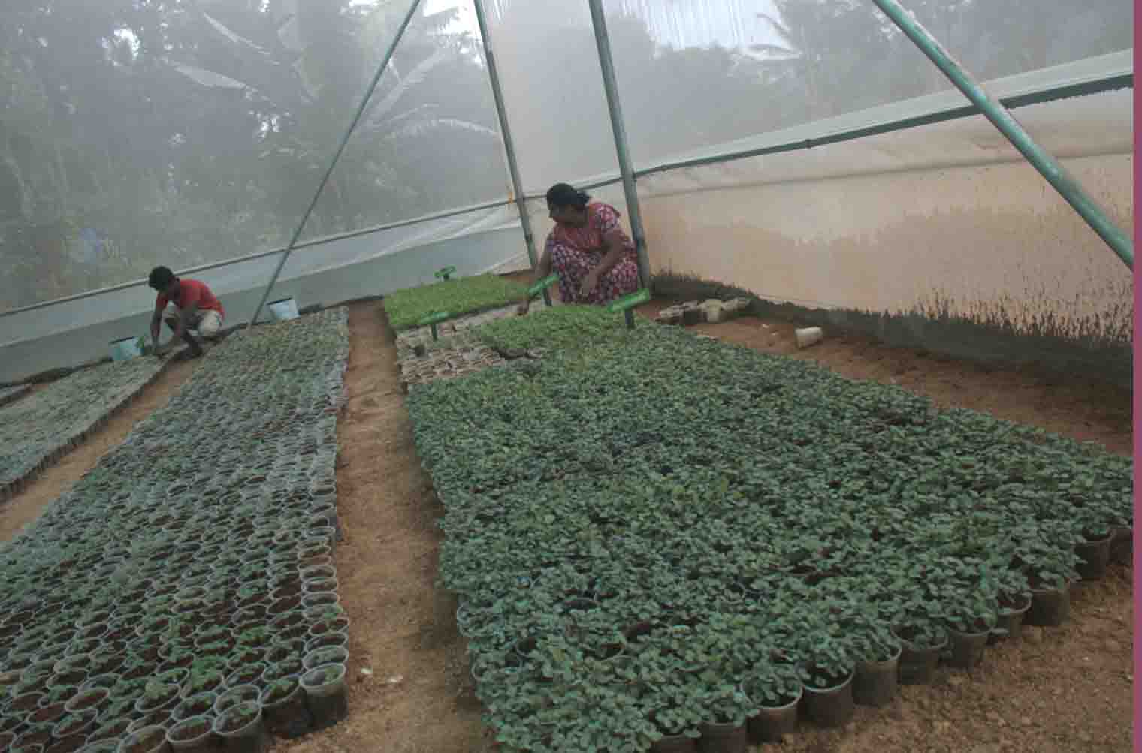 | 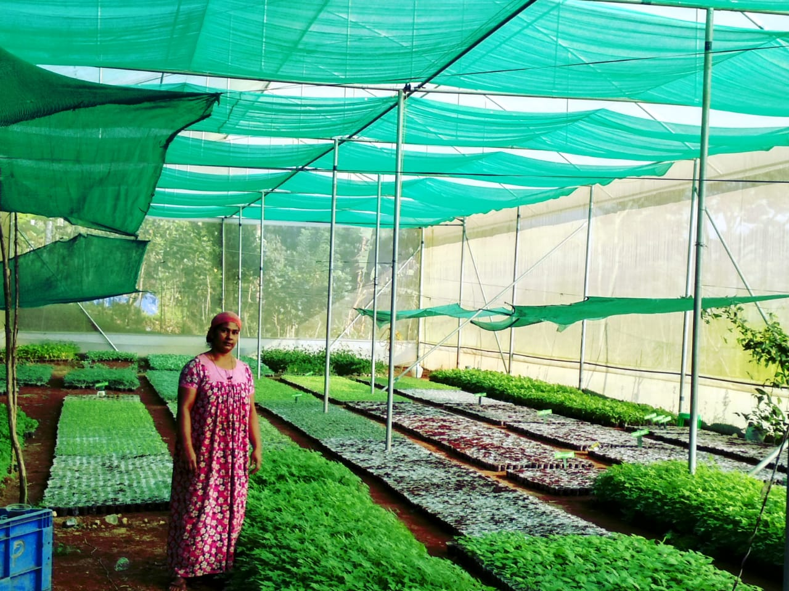

2. Title of the success stories :Skill development enterprise for Rural youth

Details of success stories :

1.Background
A group of 45 tribal school drop-outs is an example how rural youth can effectively utilize their talents, which would help to lead towards personality development and to reduce poverty. The objective of this group is to mainstream scheduled tribes girl children who have been pushed out. With this objective, the academic orientation is not sufficient and it was realized that vocational and life – skill based training is essential. Following this, in collaboration with KVK Rural craft section, we are engaged in vocational skill development training as well as supportive education for the children in adivasi colonies. To livelihood and starvation issues in these colonies are severe. Hence, the plan is to train adivasi girl children and start a production unit for fabric designing and Jewellery making.

2.Intervention process
- To assess their educational needs and to provide essential training.
- To enhance their life-skills by extending life-skill education.
- Skill development vocational training .
- Motivation to start an enterprise.
- Technical guidance for starting the unit.
- Details about availability of raw materials.
- Advisory services.
- Follow-up visit.
- Technical back up in running the unit as when required.
3.Intervention Technology
- To create an environment where women can seek knowledge and information and there by empower them to play positive role in their own development and development of society.
- To enhance the self-image and self- confidence of women and thereby enabling them to recognize their contribution to the economy as producers and workers, reinforcing their need for participating in educational programmes.
- To provide women and adolescent girls with the necessary support structures and an informal learning environment to create opportunities for education.
4.Impact Horizontal Spread
This enterprise aimed at empowering 100 rural youth in tribal areas of Idukki district by providing skill development training to make them self-sufficiency and self-reliant. This enterprise will enable women deprived, poverty sticken, working as domestic servants, single parent and widows are being given opportunity to undergo free training and in turn they earn and live on their own. The entire family will be benefited, will support the beneficiary to establish small scale units.

5.Impact Economic Gains
They earn an average Income per month of Rs.22000/-

6.Impact on Employment Generation
This programme will empower women for their families well being and for their sustainable living, every batch of women / youth-girls will inturn benefit by this programme and will take this as their profession and train other women community and develop their standard of living. Self-employment is the main source of income.So they are engaged more in self-employed manufacturing and trade activities compared to others.

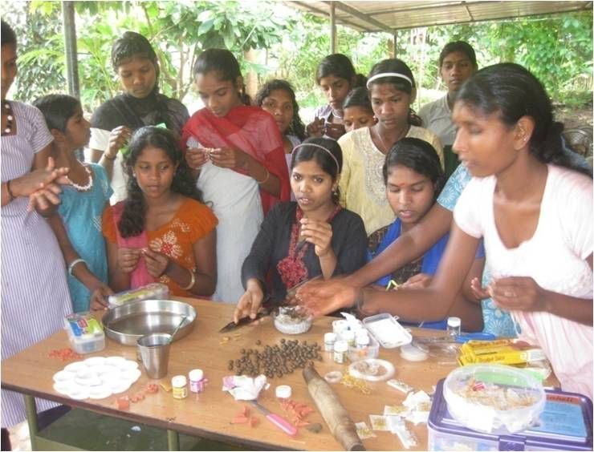 | 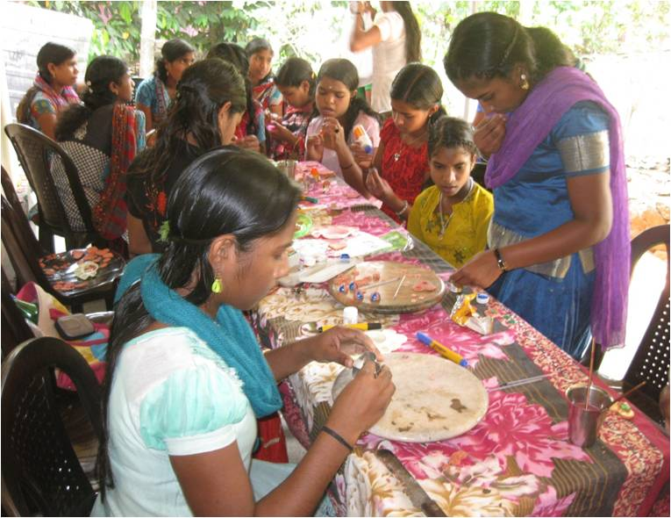
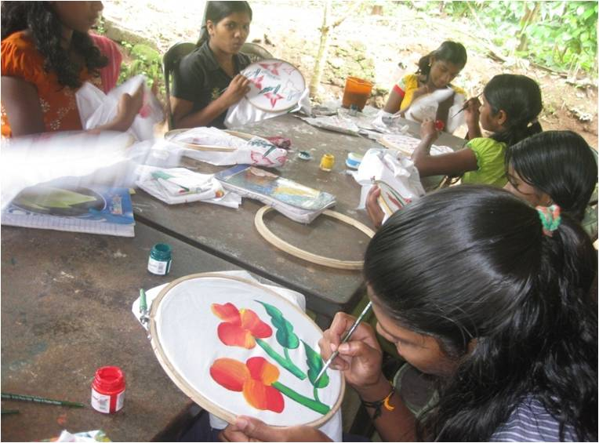 | 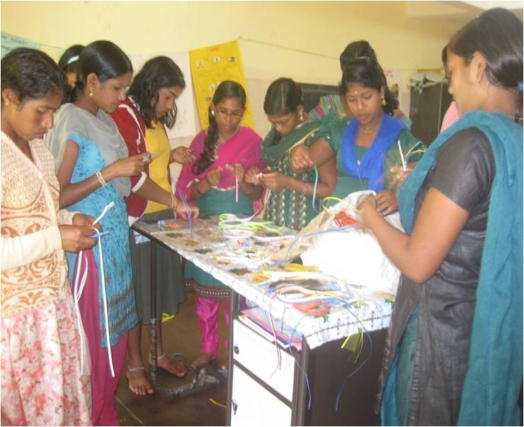

3. Title of the success stories :Women Entrepreneurship - A Success

Details of success stories :

1.Background
Mrs. Lovely Babu, Kollarackal, Rajakumarypanchayat in Idukki district. She was raised in a below middle class family. She always dreamt of reaching the sky, but all her talents and dreams were buried due to the responsibilities of her family since she was the elder child. She always had the desire to make varieties of artificial flowers and handicrafts. In her childhood days she used to collect dry leaves and flowers from the forest nearby and used to make different varieties of bouquet arrangements but no one realized her talents and abilities. Even after her marriage, she had been struggling for twenty years to bring up her children and to look after her in laws. But all these problems were silly as compared to her great dream. She always kept in touch with her interest and dreams. Six months ago fortunately, she got a chance to attend the vocational training conducted under KVK Rural craft discipline. She was inspired by the motivations she received from Mrs. Rachel Skaria, Programme Assistant of Rural craft discipline, KVK. Her support brought great changes in Mrs. Lovely’s hidden talents. Both of them combined their ideas and brought a change in their creations and marketing trends. They visited various forests, hills, valleys and farms in the neighbouring states of Kerala, Tamil Nadu and Karnataka to collect raw-materials like varieties of dried grasses, areca sheets, palm leaves, corn husk, different types of cereals etc. They met owners of farms and seek their permission to pick up agricultural wastes; they visited bread factories to collect discarded bread to make different varieties of flowers. Now Mrs. Lovely is an example how a woman can effectively utilize their talents and leisure time for income generation. She has taken bulk orders from fancy stores, local markets and she has participated in flower shows and exhibitions, now she started online marketing. She has employed two ladies to work along with her. The main finishing work is done by her and the rest of the work is done by the women working with her. She purchases the raw materials in bulk at a cheaper rate and the work place is her-own house. Therefore, the profit she gains is comparatively higher.

2.Intervention process
- 6 months vocational training.
- Motivation to start an enterprise.
- Technical guidance for starting the unit.
- Details about availability of raw materials given.
- Advisory services.
- Follow-up visits.
- Technical back up in running the unit as when required.
3.Intervention Technology
To provide skill development vocational training to make her self-sufficient and self-reliant.

4.Impact Horizontal Spread
This enterprise will provide skill development for the women dwellers in identified area, families will be benefited directly and creating a ray of hope for better source of livelihood, and live a sustainable life with self- sufficiency and self-reliance.

5.Impact Economic Gains
She earns an average profit of Rs. 25000 / month

6.Impact on Employment Generation
Motivated from the above mentioned Mrs. Lovely’s successful enterprise, 12 rural women formed a self help group named Arts Vigyan SHG under Rural Craft discipline KVK; they started designing, jewelry making and production of home care products on a commercial basis. In addition to this unit, they are planning to start a small fancy store with loan availing from nearby Co-operative bank for self-sufficiency and self employment. Also they generate employment opportunities for others.

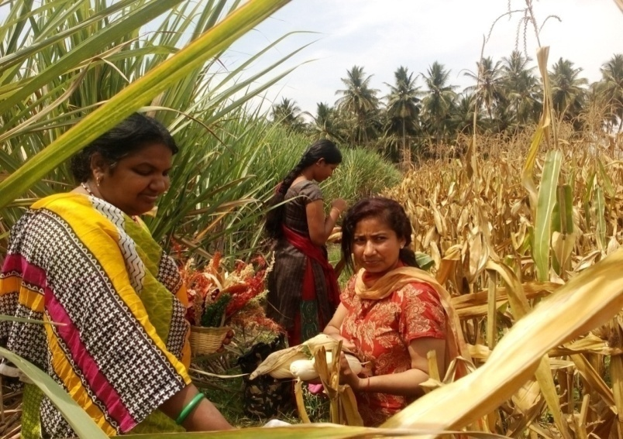 | 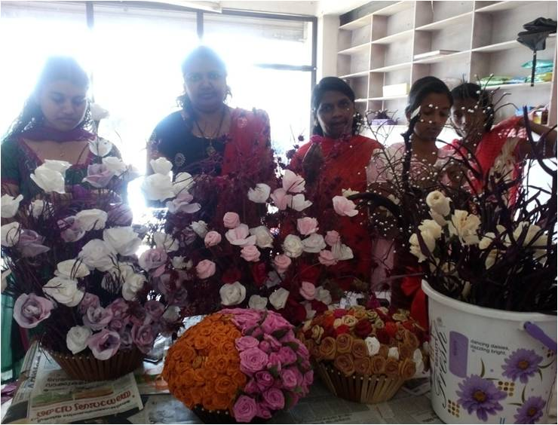
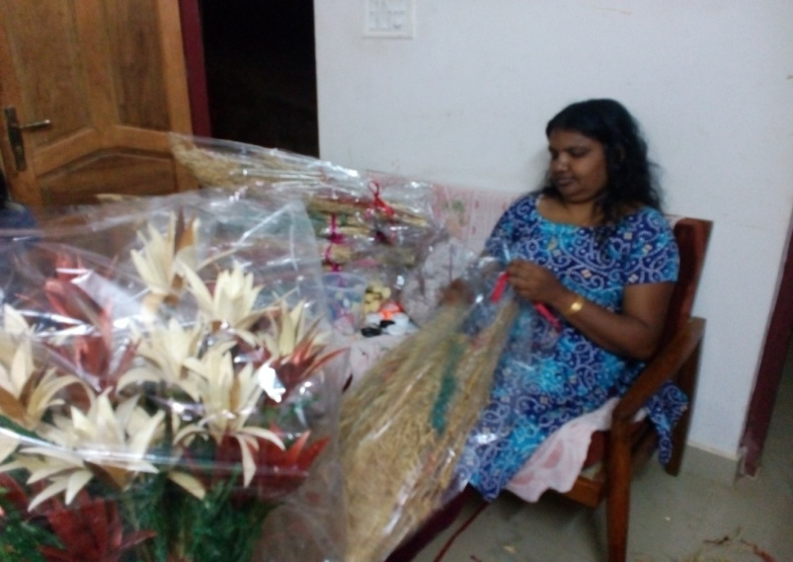 | 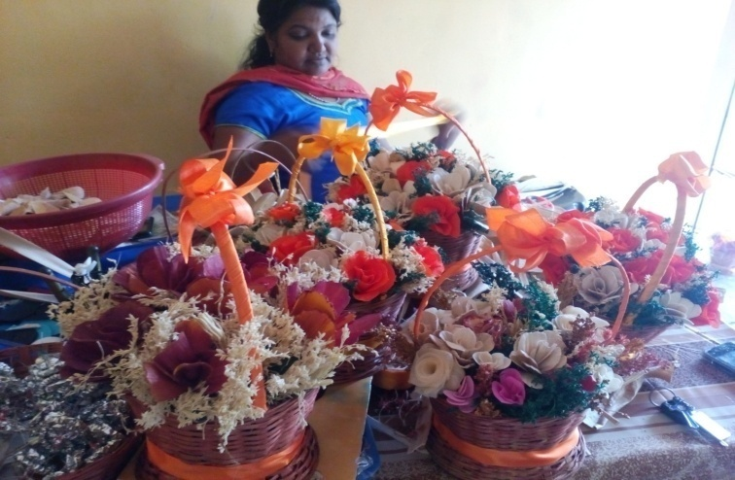

10.D. Give details of innovative methodology or innovative technology of Transfer of Technology developed and used during the year

10.E. Give details of indigenous technology practiced by the farmers in the KVK operational area which can be considered for technology development (in detail with suitable photographs)
S. No. | Crop / Enterprise | ITK Practiced | Purpose of ITK
1. | Mushrooms | Use of spinning machine | To get the media dried quickly
2. | Mushrooms | Use of hand held blower | To get rid of small insects on mushroom beds

10 F. Technology Week celebration during 2018-19:

Period of observing Technology Week : From 13.02.2019 to 15.02.2019
Total number of farmers visited : 1140
Total number of agencies involved : 8
Number of demonstrations visited by the farmers within KVK campus : 684

Other Details
Types of Activities | No. of  Activities | Number of  Farmers | Related crop/livestock technology
Gosthies
Lectures organized | 13 | 1009 | Cardamom, Pepper , Fruits and Vegetables
Exhibition | 45 | 2168 | Dept. of Agriculture, Fisheries, CRS, ICRI, ATMA, VFPCK, Animal Husbandry, Private Agencies.
Film show
Fair
Farm Visit
Diagnostic Practicals
Supply of Literature (No.) | 45 | 100
Supply of Seed (q)
Supply of Planting materials (No.)
Bio Product supply (Kg) | 13.5 | 12
Bio Fertilizers (q) | 0.27 | 18
Supply of fingerlings
Supply of Livestock specimen (No.) | 12 | 5
Total number of farmers visited the technology week |  | 1680

PART XI – SOIL AND WATER TEST

11.1 Soil and Water Testing Laboratory

A.Status of establishment of Lab :Functioning.
1. Year of establishment :2005-06
2. List of equipments purchased with amount :
Sl. No | Name of the Equipment | Qty. | Cost
1. | LPG Cylinder | 1 | 4600.00
2. | Water bath WDB-2 350’400’100mm 12 holes | 1 | 4815.00
3. | Machinery for Homogensing (khan shaker) Model LKS2 platform size 75cmx43cmx10cm | 1 | 20,880.00
4. | Rotary Shaker | 1 | 16,200.00
5. | Machinery for drying (Hot air oxen) with digital temperature control, size 455’455’455’ | 1 | 13,725.00
6. | Conductivity meter (PH meter Eutech 510) | 1 | 21,935.00
7. | Genesis 20 visible Spectrophotometer meter | 1 | 1,12,499.00
8. | CITIZEN Physical Balance Model CTL-600 | 1 | 8,991.00
9. | Micro processor based conductivity | 1 | 13,500.00
10. | Micro Processor Based Flame Photometer with N, K &Ca FILTERS & Compressor | 1 | 45,000.00
11. | Electronic Automatic KEL  PLUS Micro processor  Based Twelve Place Micro Block Digestion System | 1 | 97,043.00
12. | Electronic Balance  Model: CP 2245  Srl.No.18606016 | 1 | 1,00,000.00
13. | Hot plate | 1 | 5,400.00
Total |  | 12 | 4,64,588.00

B. Details of samples analyzed since establishment of SWTL:
Details | No. of Samples analyzed | No. of Farmers benefited | No. of Villages | Amount realized (Rs.)
Soil Samples | 2792 | 1735 | 42 | 229600.00
Water Samples | 0 | 0 | 0 | 0
Plant samples | 0 | 0 | 0 | 0
Manure samples | 0 | 0 | 0 | 0
Others (specify) | 0 | 0 | 0 | 0
Total | 2792 | 1735 | 42 | 2,29,600.00

C. Details of samples analyzed during the 2018-19:

Details | No. of Samples analyzed | No. of Farmers benefited | No. of Villages
Soil Samples | 450 | 220 | 20
Water Samples | 0 | 0 | 0
Plant samples | 0 | 0 | 0
Manure samples | 0 | 0 | 0
Others (specify) | 0 | 0 | 0
Total | 450 | 220 | 20

11.2 Mobile Soil Testing Kit
A. Date of purchase and current status
Mobile Kits | Date of purchase | Current status
- Two Mridaparikshak kit | 21/6/17 | Working
2.

B. Details of soil samples analyzed during 2018-19 and since establishment with Mobile Soil Testing Kit:

 | Progress during 2018-19 | Cumulative progress
Samples analyzed (No.) | 450 | 844
Farmers benefited (No.) | 220 | 554
Villages covered (No.) | 20 | 42

11.3 Details of soil health cards issuedbased on SWTL &Mobile Soil Testing Kitduring 2018-19:

Particulars | Date (s) | Villages (No.) | Farmers (No.) | Samples analyzed (No.) | Soil health cards issued (No.)
SWTL | - | - | - | - | -
Mobile Soil Testing Kit | 25/4/18 | 01 | 27 | 45 | 45
 | 28/5/18 | 02 | 08 | 18 | 18
 | 22/6/18 | 03 | 05 | 09 | 09
 | 18/7/18 | 01 | 08 | 08 | 08
 | 13/8/18 | 01 | 01 | 03 | 03
 | 20/9/18 | 05 | 41 | 53 | 53
 | 25/10/18 | 01 | 06 | 08 | 08
 | 27/11/18 | 01 | 38 | 62 | 61
 | 31/12/18 | 01 | 21 | 30 | 30
 | 29/1/19 | 01 | 14 | 44 | 44
 | 28/2/19 | 01 | 25 | 78 | 78
 | 25/3/19 | 02 | 26 | 93 | 93

11.4 World Soil Health Day celebration
Sl. No. | Farmers participated (No.) | Soil health cards issued (No.) | VIPs (MP/ Minister/MLA attended (No.) | Other Public Representatives participated | Officials participated (No.) | Media coverage (No.)
1. | 120 | 100 | 0 | SanthanparaPanchayatPresident | 3 | 1

PART XII. IMPACT

12.A. Impact of KVK activities (Not restricted for reporting period).

Name of specific technology/skill transferred | No. of participants | % of adoption | Change in income (Rs.)
 |  |  | Before (Rs./Unit) | After (Rs./Unit)
EPN | 1250 | 65 | 295000/ha | 383000/ha
Neem Soap | 260 | 35 | 135000/ha | 212000/ha
EM Decomposer | 1050 | 40 | 230000/ha | 360000/ha
Cardamom special | 550 | 55 | 264100/ha | 372000/ha
Pepper Special | 300 | 30 | 41538/ha | 102226/ha
Banana Special | 150 | 15 | 550000/ha | 620000/ha
Vegetable Special | 100 | 10 | 315000/ha | 390000/ha
SOP Sprays for Nendran Banana | 150 | 45 | 600/bunch | 830/bunch
Protray production of vegetable seedlings | 45 | 35 | 120000/0.5 acres | 320000/0.5 acres
NB: Should be based on actual study, questionnaire/group discussion etc. with ex-participants.

12.B. Cases of large scale adoption (Please furnish detailed information for each case with suitable photographs)

12.C. Details of impact analysis of KVK activities carried out during the reporting period

PART XIII - LINKAGES

13A. Functional linkage with different organizations

Name of organization | Nature of linkage
Department Of Agriculture | MDDT, Field Visits, Trainings, EAP
ATMA | MDDT, Field Visits, Trainings, EAP
Department Of Animal Husbandry | Field Visits, Trainings
Department of Forestry | Tribal Development Projects, Trainings
VFPCK | MDDT, Field Visits, Trainings
PDS | Sub-centre for organic farming
Coffee Board | Trainings, Field Visits
Spices Board | Trainings, Field Visits
NB The nature of linkage should be indicated in terms of joint diagnostic survey, joint implementation, participation in meeting, contribution received for infrastructural development, conducting training programmes and demonstration or any other

13B. List of special programmes undertaken by the KVK and operational now, which have been financed by State Govt./Other Agencies

Name of the scheme | Date/ Month of initiation | Funding agency | Amount (Rs.)
DAESI Programme | 19/05/2018 | MANAGE-ATMA-IDUKKI | 18,00,000.00

13C. Details of linkage with ATMA

Coordination activities between KVK and ATMA
S. No. | Programme | Particulars | No. of programmes attended by KVK staff | No. of programmes Organized by KVK | Other remarks (if any)
01 | Meetings | Monthly Technology meetings | 6 | 2 | -
02 | Research projects | - | 0 | 0 | -
03 | Training programmes | Low cost production of bio inputs | 8 | 8 | -
04 | Demonstrations | Soil sampling methods | 2 | 1 | -
 |  | PPFM | 10 | 10 | -
 |  | Hanseniaspora | 5 | 5 | -
05 | Extension Programmes | - | 0 | 0 | -
 | KisanMela | - | 0 | 0 | -
 | Technology Week | Thalir-2019 | 1 | 1 | -
 | Exposure visit | DAESI | 3 | 3 | -
 | Exhibition | Thalir-2019 | 1 | 1 | -
 | Soil health camps | Soil Test Campaign | 2 | 2
 | Animal Health Campaigns | - | 0 | 0 | -
 | Others (Pl. specify) | - | 0 | 0 | -
06 | Publications | - | 0 | 0 | -
 | Video Films | - | 0 | 0 | -
 | Books | - | 0 | 0 | -
 | Extension Literature | - | 1 | 0 | -
 | Pamphlets | - | 0 | 0 | -
 | Others (Pl. specify) | - | 0 | 0 | -
07 | Other Activities (Pl.specify) | - | 0 | 0 | -
 | Watershed approach | - | 0 | 0 | -
 | Integrated Farm Development | - | 0 | 0 | -
 | Agri-preneurs development | - | 0 | 0 | -
 | Farmers Field School | FS | 8 | 0 | -

13D. Give details of programmes implemented under National Horticultural Mission: Nil.

S. No. | Programme | Nature of linkage | Funds received if any Rs. | Expenditure during the reporting period in Rs. | Constraints if any

13E. Nature of linkage with National Fisheries Development Board:Nil.
S. No. | Programme | Nature of linkage | Funds received if any Rs. | Expenditure during the reporting period in Rs. | Remarks

13F. Details of linkage with RKVY :
S. No. | Programme | Nature of linkage | Funds received if any Rs. | Expenditure during the reporting period in Rs. | Remarks
1 | Bee Keeper | Skill Training | Yes, Rs.141300.00 | Rs.141300.00 | -
2 | Mushroom Grower | Skill Training | Yes, Rs.165200.00 | Rs.165200.00 | -

13G. Kisan Mobile Advisory Services: Nil.
Month | Message type (Text/Voice) | SMS/voice calls sent (No.) |  |  |  |  |  | Total SMS/Voice calls sent (No.) | Farmers benefitted (No.)
 |  | Crop | Livestock | Weather | Marketing | Awareness | Other enterprises
April 2018
May
June
July
August
September
October
November
December
January 2019
February
March
Total

PART XIV- PERFORMANCE OF INFRASTRUCTURE IN KVK

14A. Performance of demonstration units (other than instructional farm): Nil.

Sl. No. | Demo Unit | Year of  establishment | Area  (ha) | Details of production |  |  | Amount (Rs.) |  | Remarks
 |  |  |  | Variety | Produce | Qty. | Cost of inputs | Gross income

14B. Performance of instructional farm (Crops) including seed production

Name  of the crop | Date of sowing | Date of harvest | Area (ha) | Details of production |  |  | Amount (Rs.) |  | Remarks
 |  |  |  | Variety | Type of Produce | Qty. | Cost of inputs | Gross income
Cereals
Pulses
Oilseeds
Fibers
Spices & Plantation crops
Floriculture
Fruits
Vegetables
Others (specify)

14C. Performance of production Units (bio-agents / bio pesticides/ bio fertilizers etc.)
Sl.  No. | Name of the Product | Qty | Amount (Rs.) |  | Remarks
 |  |  | Cost of inputs | Gross income
1. | Pseudomonas | 1449 | 72450.00 | 173880.00 | -
2. | Pseudomonas Test tube | 11 | 1100.00 | 5500.00 | -
3. | Trichoderma | 2456 | 122800.00 | 294720.00 | -
4. | Trichoderma Test tube | 60 | 6000.00 | 30000.00 | -
5. | Beauveria | 159 | 7950.00 | 19080.00 | -
6. | Beauveria Test tube | 17 | 1700.00 | 8500.00 | -
7. | Metarhizium | 161 | 8050.00 | 19320.00 | -
8. | Metarhizium test tube | 2 | 200.00 | 1000.00 | -
9. | Effective Microorganisms | 964 | 115680.00 | 289200.00 | -
10. | VAM | 2495 | 187215.00 | 249500.00 | -
11. | Entomo Pathogenic Nematode | 248.5 | 106855.00 | 161525.00 | -
12. | Neem oil | 360 | 45000.00 | 135000.00 | -
13. | Pheromone trap | 40 | 3000.00 | 6000.00 | -
14. | Paceliomyces | 50 | 5000.00 | 15000.00 | -
15. | Downy controller | 50 | 5000.00 | 10000.00 | -
16. | Neem Soap | 126 | 15120.00 | 37800.00 | -
Total |  | 8,648.50 | 7,03,120.00 | 14,56,025.00 | -

14D. Performance of instructional farm (livestock and fisheries production):
Sl.  No | Name  of the animal / bird / aquatics | Details of production |  |  | Amount (Rs.) |  | Remarks
 |  | Breed | Type of Produce | Qty. | Cost of inputs | Gross income
1. | Hybrid poultry birds | B V 380 | layer | 30 | 4800.00 | 1200.00 | -

14E. Utilization of hostel facilities: NA.

Accommodation available (No. of beds)
Months | No. of trainees stayed | Trainee days (days stayed) | Reason for short fall (if any)
April 2018
May
June
July
August
September
October
November
December
January 2019
February
March

14F. Database management
S.No | Database target | Database created
1. | Farmers database (FLD, OFT & DBT, Training) | Database for (2018-19)

14G. Details on Rain Water Harvesting Structure and micro-irrigation system: Nil.
Amount sanction (Rs.) | Expenditure (Rs.) | Details of infrastructure created / micro irrigation system etc. | Activities conducted |  |  |  |  | Quantity of water harvested in ‘000 litres | Area irrigated / utilization pattern
 |  |  | No. of Training programmes | No. of Demonstration s | No. of plant materials produced | Visit by farmers  (No.) | Visit by officials  (No.)

PART XV - FINANCIAL PERFORMANCE

15A. Details of KVK Bank accounts
Bank account | Name of the bank | Location | Branch code | Account Name | Account Number | MICR Number | IFSC Number
Revolving Fund Account | State Bank of India | Rajakumary | 70453 | BapoojiKrishiVigyan Kendra (Rev Fund) | 67155078042 | 6850002932 | SBIN0070453
Main Grant Account | State Bank of India | Rajakumary | 70453 | BapoojiSevakSamajKrishiVigyan Kendra | 57060836995 | 6850002932 | SBIN0070453

15B. Utilization of KVK funds during the year 2018-2019(Rs. in lakh)
S.  No. | Particulars | Sanctioned | Released | Expenditure
A. Recurring Contingencies
1 | Pay & Allowances | 107.81 | 107.81 | 107.14108
2 | Traveling allowances | 1.25 | 1.25 | 1.25
3 | Contingencies
A | Stationery, telephone, postage and other expenditure on office running, publication of Newsletter and library maintenance (Purchase of News Paper & Magazines) | 2.15 | 2.15 | 2.15
B | POL, repair of vehicles, tractor and equipments | 1.90 | 1.90 | 1.90
C | Meals/refreshment for trainees (ceiling upto Rs.40/day/trainee be maintained) | 1.00 | 1.00 | 1.00
D | Training material (posters, charts, demonstration material including chemicals etc. required for conducting the training) | 0.35 | 0.35 | 0.35
E | Frontline demonstration except oilseeds and pulses (minimum of 30 demonstration in a year) | 2.72 | 2.72 | 2.72
F | On farm testing (on need based, location specific and newly generated information in the major production systems of the area) | 1.50 | 1.50 | 1.50
G | Training of extension functionaries | 0.20 | 0.20 | 0.20
H | Maintenance of buildings | 0.50 | 0.50 | 0.50
I | Establishment of Soil, Plant & Water Testing Laboratory | 0.25 | 0.25 | 0.24999
J | Library | 0.03 | 0.03 | 0.03
K | Extension activities | 0.38 | 0.38 | 0.38
L | Farmers Field School (FFS) | 0.30 | 0.30 | 0.30
M | EDP | 0.37 | 0.37 | 0.37
N | ARM | 1.20 | 1.20 | 1.20
TOTAL (A)
B. Non-Recurring Contingencies
1 | Works | 0.00 | 0.00 | 0.00
2 | Equipments including SWTL & Furniture | 0.00 | 0.00 | 0.00
3 | Vehicle (Four wheeler/Two wheeler, please specify) | 0.00 | 0.00 | 0.00
4 | Library (Purchase of assets like books & journals) | 0.00 | 0.00 | 0.00
TOTAL (B) |  | 0.00 | 0.00 | 0.00
C. REVOLVING FUND |  | 0.00 | 0.00 | 0.00
GRAND TOTAL (A+B+C) |  | 121.91 | 121.91 | 121.24

15C. Status of revolving fund (Rs. in lakh) for the last three years
Year | Opening balance as on 1st April | Income during the year | Expenditure during the year | Net balance in hand as on 1st April of each year
April 2016 to March 2017 | 4,27,760.00 | 19,86,677.00 | 20,03,911.00 | 4,10,526.00
April 2017 to March 2018 | 4,10,526.00 | 24,53,736.00 | 15,22,669.00 | 13,41,593.00
April 2018 to March 2019 | 13,41,593.00 | 30,33,360.00 | 30,22,873.00 | 13,52,080.00
16. Details of HRD activities attended by KVK staff

Name of the staff | Designation | Title of the training programme | Institute where attended | Dates
SudhakarSoundarajan | SMS-Plant Protection | AESA based PHM in conjunction with Ecological Engineering (EE) for Pest Management (PM) | ICAR-NBAIR | 03/02/2019
SudhakarSoundarajan | SMS-Plant Protection | Bio-Intensive pest management in vegetables | ICAR-IIHR | 04/02/2019
SudhakarSoundarajan | SMS-Plant Protection | GAP-Strawberry cultivation | ICAR-KVK,Baramarthi | 06/09/2018
Ashiba A | SMS- Agronomy | Documentation of KVK mandatory activities | ICAR-KVK, Erode | 04/02/2019 to 05/02/2019
Preethu K. Paul | SMS- Agrl Extension

17. Please include any other important and relevant information which has not been reflected above (write in detail).

