Mobile apps (m-apps)) for Agriculture

K.Alivelu, G.D.Satish Kumar, C.Sarada and M.Padmaiah

DOR, Rajendranagar

Hyderabad

Mobile communications technology has quickly become the world’s most common way of transmitting voice, data, and services in the developing world. Mobile applications (m-apps) for agriculture hold significant potential for advancing development. A mobile application is a piece of software on a portable device such as a mobile phone handset, personal digital assistant, or tablet computer that enables a user to carry out one or more specific tasks that are not directly related to the operation of the device itself. Simple apps may make use of the built-in low-speed data communication facilities of digital mobile phones, such as short message service (SMS) or unstructured supplementary service data (USSD). On many low-cost phones, applications are available through Java software. More complex apps use the Internet protocol-based data communication facilities of higher-speed networks on third- or fourth-generation mobile phone networks.

For most parts of Africa, the agriculture sector is a major source of employment. IT News Africa gives following ten best agriculture apps.

(Source:http://www.itnewsafrica.com/2013/11/top-10-mobile-agriculture-applications/)

1. iCow

The iCow platform has a series of dairy agri products that are available over a simple menu system. Farmers dial a short code, *285#, and access a simple menu that guides them on how to subscribe to the various products. After subscribing, the system sends messages to users at intervals – depending on the product choice.

2. Rural eMarket

Developed for rural Africa, Rural eMarket is a simple yet powerful solution to communicate market information, using smartphones, tablets or computers. Rural eMarket is multi-lingual, easy, quick to adopt, and most of all, affordable for most rural projects. However, there are many regions in Africa that do not benefit from these new technologies because of illiteracy, the weakness of connectivity or the inability to find an affordable and adapted solution.

3. mFisheries

mFisheries is a suite of open-source mobile and web applications for small scale fisheries. It was developed at the University of the West Indies with International Development Research Centre (IDRC) support and comprises a virtual marketplace application, which displays market prices using open data.

4. Esoko

Esoko is Africa’s most popular mAgric platform for tracking and sharing market intelligence. It links farmers to markets with automatic market prices and offers from buyers, disseminate personalised extension messages based on crop & location, and manages extension officers and lead farmers with SMS messaging.

5. FarmerConnect

The FarmerConnect Platform is a cloud-based and mobile-enabled platform that delivers personalised agricultural extension services and text/audio information intelligence in local languages to smallholders and farmers who otherwise do not have access to- or can comprehend information from traditional sources.

6. M-Shamba

M-Shamba is an interactive platform that provides information to farmers through the use of a mobile phone. It provides customised information to farmers based on their location and crop/animal preference. Farmers can also share information on various topics with each other. M-shamba is currently being used by 4000 rice farmers in Kenya to help them adopt new technologies in rice farming.

7. Mobile Agribiz

Mobile Agribiz (mogribu.com) is a web and SMS mobile application that helps farmers decide when and how to plant crops, select the best crops for a given location using climate and weather data, and connect to the available market. It helps connect farmers to buyers, and helps them to source important, relevant information (e.g. how to plant crops, how to use fertilizers) and necessary data aggregates (e.g. weather, crop pricing) from various sources.

8. AgroSim

AgroSim is a valuable tool for decision-making in agricultural projects. It is an event simulator able to anticipate the quality and quantity of the productivity of a desired crop by taking into account data related to seed, soil, hydraulic climate, geography, macro-economy and the demographic of the targeted area. Agrosim is an adaptable and portable application which is universally used by both novices and professionals in the agricultural sector.

9. amAgriculture

amAgriculture is an analytical tool that helps agri-businesses understand underlying business trends, manage transactions, cut costs, increase revenues and mitigate risk. web-based and mobile analytics; web-based push/pull SMS system for agents and farmer communication; and data export capabilities in Microsoft Excel.

10. Farming Instructor

Farming Instructor is a mobile app that provides online and offline agricultural information (text, speeches and animations) to farmers and their communities. With this app, the user or farmer can source all the necessary information related to agriculture, as well as share and comment on other farming tips and advice.

Apps To Help Agriculture In the Country

Here are some great apps farmers can use to boost and manage their yields.

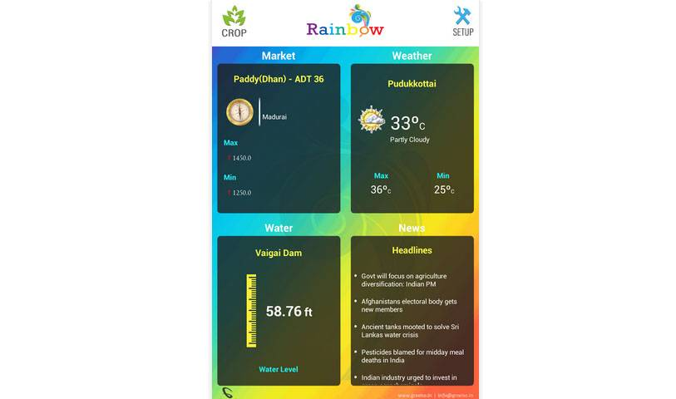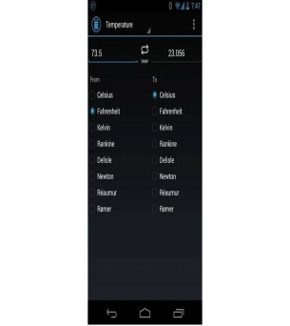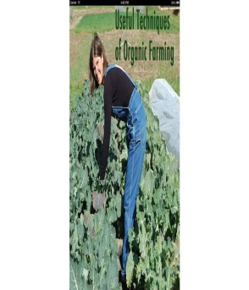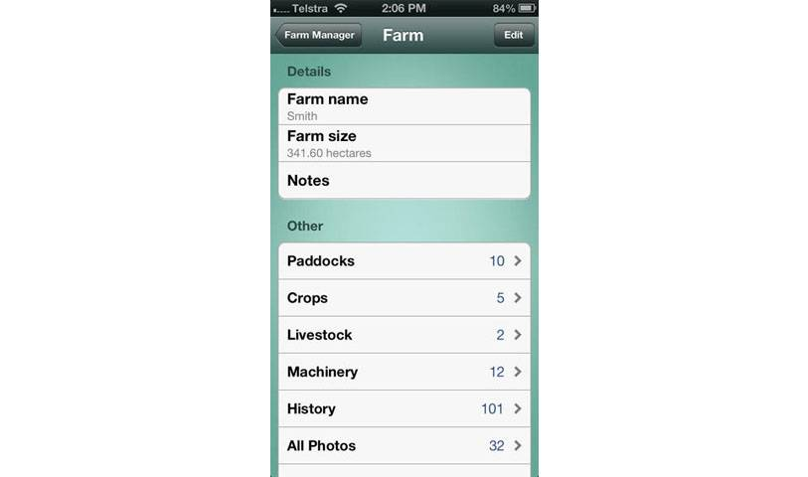

Source(http://www.businessinsider.in/4-Apps-To-Help-Agriculture-In-the-Country/articleshow/29552770.cms)

1) Rainbow By Green Tech Solutions

This is an app developed by two Indian IT executives who left their jobs to help the agriculture community. This app enables the Indian farmers make informed decision for better yield of crops. Users will get latest agro news, location based climate updates and contacts for the nearest seed and fertilizer dealers. Availableon:Android.

2)Unit Converter Ultimate

This is a popular app used by farmers all over the globe. It is simple to use and has a wealth of conversion capabilities. Farmers can quickly convert Kg's into pounds into tons. Just key in the numbers, choose the conversion and you will get the right answer. Available on: Android, for iOS try Unit Converter by Incpt Mobis.

3) Organic Farming

This app puts various neat techniques under one hub that shows how to grow vegetables and herbs at home in a kitchen garden. People with extra room around the house or in farms can easily use these techniques to organically grow food. Available on: iOS

4) Farm Manager

This is another great utility app that allows farmers manage livestock, crops and more in their ranch or large gardens with ease. Farmers can keep track of the crops and check the history in a matter of few taps. Available on: iOS

Nokia Life Tools: (Source: Nokia)

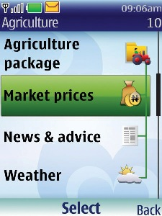

Life Tools is aimed at rural, predominantly agricultural communities of the developing world. It is available on a number of Nokia handsets uses SMS to communicate, making it affordable and widely accessible. Additionally, because SMS can be delayed, users need not have perpetual network coverage. In India, Nokia has collaborated with multiple partners across the Indian government and private enterprises, including Tata DOCOMO, MSAMB, Syngenta, Pearson, RML, and EnableM to create a rich ecosystem to deliver the services. Content is divided into:

Basic agriculture and Premium agriculture. The basic plan, at 30 rupees (Rs) per month, provides daily weather updates and agricultural news, advice, and tips. The premium plan, at Rs 60 per month, provides the closest market prices for three crops chosen by the subscriber, as well as weather information, news, advice, and tips. Nokia Life Tools supports 11 Indian languages: Hindi, Malayalam, Kannada, Tamil, Telugu, Punjabi, Marathi, Bengali, Gujarati, Oriya, and English. Because most subscribers are prepaid users who do not have a contract, the charges are subtracted weekly. To facilitate this payment, Nokia has partnered with the MNO IDEA Cellular.

Here is a top 20 list of apps for agriculture, with descriptions and compatible mobile devices:(Source: matt@croplife.com)

Agronomy Apps

1. Agrian Mobile Information Center. Enables access to Agrian’s label database anywhere, any time. Search by product name, registered states, pest controlled and specific product use rates. (iPhone, iPod Touch)

2. Dekalb Plant Population Calculator. Provides planting populations for corn and soybeans. (BlackBerry)
3. Farm Progress Growing Degree Days. Measures the maturity of a crop by viewing current and past growing degree days data for a specific farm’s location. (Android, BlackBerry, iPhone, iPod Touch)
4. From the Field from Pioneer. Alerts users with the latest information from Pioneer’s agronomy team while they’re in the field. (BlackBerry)
5. Genuity Seed Selector. Helps growers find seed varieties with Genuity traits that are adapted to their soil type and maturity zone. (BlackBerry)
6. NPIPM Soybean Guide. Provides current management options for insect and other arthropod pests affecting soybeans grown in North Dakota, South Dakota, Nebraska, Iowa, Minnesota and Kansas. (iPhone, iPod Touch, iPad)

Commodity Pricing Apps

7. Farm Futures Mobile from Pioneer. Offers access to news, weather, quotes, cash bids and more wherever you are. (Android, iPhone, iPod Touch, iPad; soon on BlackBerry)
8. Farmer’s Partner. Lets growers input dozens of variables to create an overview of the farm operation. (Android)
9. KIS Futures. Allows users to track prices on commodity futures and options and gives a detailed snapshot of high, low, last and net change of multiple markets-options. (iPhone, iPod Touch, iPad)

Precision Ag Apps

10. ArcGIS by ESRI. Extends the reach of a GIS from the office to the field. Users can query the map, search and find interesting information, measure distances and share maps with others. (iPhone, iPad, Windows Phone 7; available soon on Android devices)
11. FieldNET Mobile from Lindsay. Allows users to control and monitor their irrigation pivots from anywhere. The interface features real-time text alerts, water usage reports and more. (Android, BlackBerry, iPhone)
12. PureSense Irrigation Manager. Allows users to monitor their real-time field conditions and irrigation activity from their phones. (Android, iPhone)
13. SoilWeb. Provides GPS-based, real-time access to USDA-NRCS soil survey data. The app retrieves graphical summaries of soil types associated with the user’s current geographic location. (iPhone)

Tank Mix Apps

14. Mix Tank from Precision Laboratories. Assists users in determining the mixing sequence for pesticides, adjuvants and foliar products. (iPhone, iPod Touch, iPad)
15. Mobile Ag Tank Mix Calculator from Marrone Bio Innovations. Helps growers and applicators quickly calculate the proper ratios of up to any three products to be mixed together in the spray tank. (iPhone, iPod Touch)
16. TankMix from DuPont. Allows users to calculate the amount of product or water needed to treat a specific field area, as well as the amount of product needed to the get the volume-to-volume ratio. (iPhone, iPod Touch, iPad)

17. Agriculture Regulations. Provides growers with complete text of Title 7 CFR, Agriculture and bookmark the particular rules that apply to their operation. (iPhone, iPad)
18. DriveSafe.ly. Speaks text and e-mails aloud so users can concentrate on the road or field. It lets users chat by sending text responses by voice and use voice commands like “repeat message”or “call back sender.” (BlackBerry)
19. My-Cast from Garmin. Displays animated radar, predicted storm paths and watches/warnings from the National Weather Service. (Android, BlackBerry, iPhone)
20. Weather Channel. Features customizable local weather applications, including an ag app where growers can access soil moisture conditions, precipitation reports, forecasts, wind speed and direction. (iPhone, iPod Touch, iPad)

The following apps help you choose the right agriculture apps for mobile device, helping ag professionals do their jobs more efficiently. (Source: Crop life Magazine)

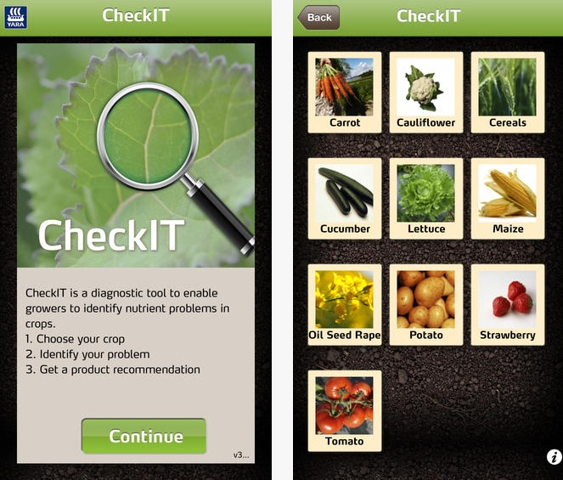

Optimizer 2.0

The new function from Advanced Ag Solutions LLC models anticipated irrigation to reduce data entry for farmers and their crop advisors. It is part of the company’s Optimizer 2.0 app, which also recently unveiled the ability to download variable rate files to control seed and nitrogen rates within the field in its Solver feature. The app utilizes weather forecasts and soil moisture levels along with crop needs and common practices of area farmers to estimate when the farmer may have turned on or off his irrigation pivot. The software then allows the user to easily edit irrigated rates and timing in cases where estimates of irrigation might be off. (Available on most devices)

Apache on the Go.

This mobile app from Equipment Technologies enables users to learn about the features and benefits of the Apache sprayer with a virtual 360 walk around, detailed specs and photos and videos on each Apache sprayer model. (iPad)

CP Products Calculators.

These mobile apps allow users to set up calculations for all CP’s nozzles, both for aerial and ground. Need to know what is the best tip for your aircraft? CP Products’ calibration app will help you figure it out. Meanwhile, the flow rate calculator app will help users determine the best tip and orifice for their sprayer. (Android, iPad, iPhone)

totheshelf.

This mobile app from Agrotypos SA links growers to traders and vice versa. totheshelf intends to build a global network of agricultural products sellers and buyers. Farmers, cooperatives, wholesalers, brokers, importers, exporters, industry, retailers and anyone who involves in animal or plant products trading can download the app and seek new customers or business partners. The app is available in all countries and in two languages, English and Greek. (iPad, iPhone)

VRPETERS

(Vehicle Rollover Prevention Education Training Emergency Reporting System). Developed by University of Missouri researchers, VRPETERS can detect vehicle collisions, side and rear overturns and rollovers due to centrifugal forces while turning curves. In case of an accident, VRPETERS transmits emergency notifications to predefined contacts automatically. VRPETERS can save lives by changing the human behavior as a training tool; providing warning messages to the operator to prevent an accident; reducing the deployment time of rescue teams; and providing the GPS coordinates, the date and time of an accident. (Android, iPad, iPhone)

Climate App.

This University of Nebraska-Lincoln app helps agricultural producers track key temperatures. The Climate App publishes maps that show recent highs, lows and soil temperatures. The High Plains Regional Climate Center in UNL’s School of Natural Resources released the app to keep agricultural producers aware of the temperature ranges that could affect production timelines. (Available on most mobile devices)

iCropTrak Soil App:

iCropTrak Soil can go from login to your field sample in three clicks; add new growers, farms, field boundaries and zones from the iPad while in the field; and export soil sampling results while in the field using one button via e-mail to the lab and customer using synchronization with the cloud, other iCT users and export to iCloud. (iPad)

Android App on Google Play

Agriculture traders and farmers in India will be able to get up to date pricing information on palm of their hands at free of cost. Also, farmers will be able to get precise agriculture weather data in India. The agriculture news will keep you most updates on current market dynamics. The application is offered in Hindi, Gujarati and English languages.

(Source :http://www.youtube.com/watch?v=JCXgWtdIlTs).

