**No. UPENGO3865/**

**Research Review Article**

*Current Horticulture* **5**(1): 3–14, January–June 2017 ISSN: 2347-7377; RNI No.: UPENG03865/24/1/2013-TC

January–June 2017] TRIPATHI *ET AL.*

**Micro irrigation in onion *(Allium cepa)* and garlic *(A. sativum)* – a review**

P C Tripathi1*, V Sankar2 and K E Lawande3

*National Research Centre for Onion and Garlic, Rajgurunagar, Pune, Maharashtra, India*

**Received:** February 2016; **Revised:** January 2017

**ABSTRACT**

The objective of this paper was to review the microirrigation studies in onion *(Allium cepa* L.*)* and garlic (*A. sativum* L.) carried out in different parts of the world with special reference to India which is largest producer and consumer of the short-day onion and garlic in the world. Despite of leading producer of both onion and garlic, the productivity in our country is lesser than other countries. Water availability is one of the crucial inputs for productivity. The efforts were made by several organizations to develop and evaluate microirrigation methods and systems to increase the production and productivity of both onion and garlic. The experiments showed that drip irrigation increases yield (15-40%), bulb size and storability of bulbs. The drip irrigation was found to be more effective than sprinkler irrigation. The water saving (30-40%) was higher in drip irrigation with higher use efficiency. Besides, drip irrigation was found beneficial in reduction weed population, disease infection and labour requirement.

**KEY WORDS**: Microirrigation, Yield, Quality, Water-use Efficiency, Bulb size, sprinkler irrigation.

Onion (*Allium cepa* L.) and garlic (*A. sativum* L.) are most important bulbous vegetable crops grown and consumed all over the world. In India, onion is grown in 1.173 million ha, whereas garlic is grown 0.262 million ha, The annual production of onion is about 18.939 million tonnes and that of garlic 1.425 million tonnes. The productivity of onion and garlic are 16.1 and 5.04 tonnes/ha respectively. The highest productivity of onion is in Gujarat (25.43 tonnes/ha), while productivity of garlic is highest in West Bengal (11.94 tonnes/ha) (NHB 2015), (Figs 1 and 2). Onion is grown in 3.0 million ha, in world whereas garlic is grown in 1.0 million ha. The annual production of onion is about 54 million tonnes and that of garlic 14 million tonnes. The major onion-growing countries are China, India and USA, whereas major garlic-growing countries are China and India. The productivity of onion is highest in Republic of Korea (57.03 tonnes/ha), while productivity of garlic is highest in Egypt (24.34 tonnes/ha) (FAO, 2013, Figs 3 and 4).

*Corresponding author : [prakaashtripathii2000@yahoo.co.in](mailto:prakaashtripathii2000@yahoo.co.in)

1 Division of Plant Genetic Resources, ICAR- Indian Institute of Horticultural Research, Bangalore 560 089.

2 CHES-IIHR, Chettalli, Karnataka,

3 Formerly-Director, DOGR and Vice-Chancellor, BSKKV, Dapoli, Maharashtra

The low productivity of onion and garlic in India could be attributed to low inheritance potential of short- day onion and garlic varieties predominately grown in the country, higher disease incidence and shortage of timely inputs, particularly of water (Singh, 2000; Lawande, 2005). Irrigation is one of the most crucial inputs for onion and garlic. The shortage of irrigation at bulb development, which usually coincides with summer season, affect the yield drastically. Water scarcity is an increasingly important issue in many parts of the world. Climate change predictions of increase in temperature and decrease in rainfall may enhance water scarcity. Restricted supply of good quality water is the most important factor limiting their production. Thus, efficient management of water resources is essential to meet the increasing competition for water between agricultural and non-agricultural sectors.

The availability of water has continuously reduced during last five decade from 90% share of water used for agriculture to 75-80% .Ground water in many parts of the country is fast depleting due to over exploitation. Also per hectare investment on irrigation has doubled over the past 50 years. It is also expected that the share of agriculture in total water demand by the year 2025 is expected to be about 75 per cent. The availability of

MICROORRIGATION IN ONION AND GARLIC

[*Current Horticulture* **5** (1)

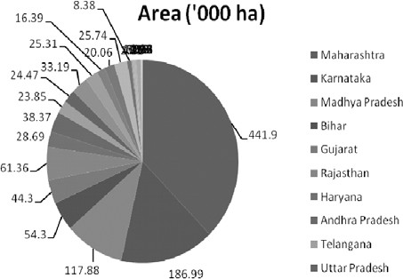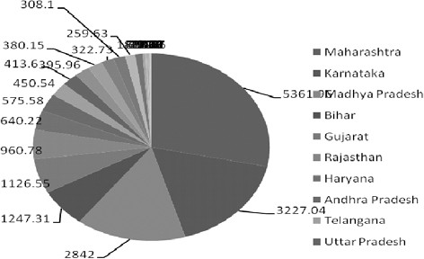

**Production (‘000 tonnes)**

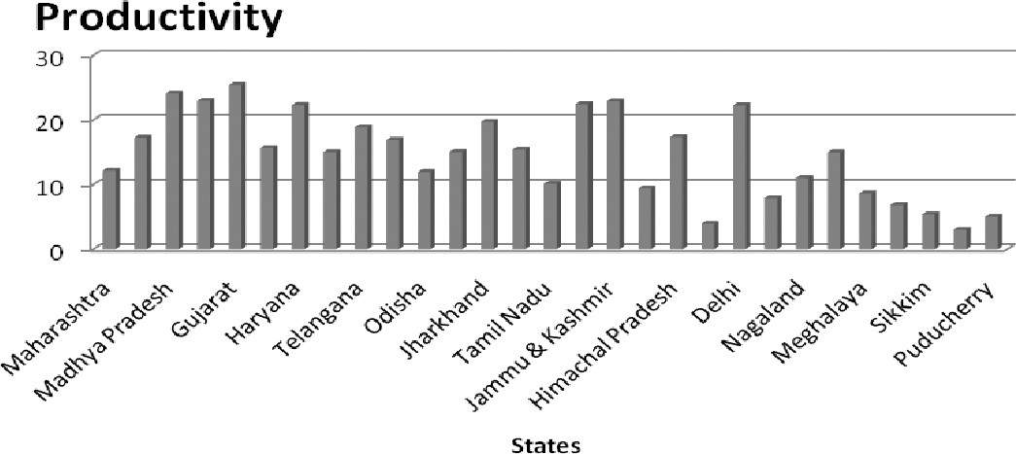**Fig. 1.** Area production and productivity of onion in India (2014-15)

**Productivity (tonnes/ha)**

water for agriculture is declining since independence and it is expected to decrease further by 2050 (Fig. 5). Thus, increasing efficiency in irrigation is only option. In last few decades, emphasis has been given in enhancing the productivity of irrigation water. Therefore, efficient use of water by irrigation is becoming increasingly important, and alternative water application method such as microirrigation methods may contribute substantially to attain the twin objectives of higher productivity and optimum use of water. The trend in recent years has been towards conversion of surface to microirrigation because cost of installation has relatively decreased with the easy in access to

subsidized drip irrigation equipments.

#### Water requirement

Water requirement of any crop depends upon the nature of crop, soil, evapotranspiration rate of that particular locality and also stage of growth of plant. Water requirement for onion and garlic would be different in different seasons and localities and therefore

water requirement estimated in a particular area would not be exactly applicable in other areas. Onion and garlic are shallow-rooted and frequent irrigation is necessary for their optimum growth and better bulb development. These crops are very sensitive to moisture stress conditions during bulb initiation and development stages. Onion is grown in *kharif* (rainy), late-*kharif* (late-rainy) as well as *rabi* (winter)season in India, while garlic is grown in *rabi* (winter) season except a few exceptions. The active root zone of these crops is between 20 and 30 cm depth.

The important growth stages in onion are initial vegetative growth period, bulb initiation, bulb development and maturity. In garlic, initial vegetative growth period, bulb initiation and bulb development are the most critical stages. Seedling stage can withstand for water stress or fluctuations and water requirement is less at bulb maturity stage but moisture stress during bulb initiation and bulb development may cause drastic reduction in yield and bulb quality. Excess moisture or waterlogged conditions during later stages of bulb

January–June 2017] TRIPATHI *ET AL.*

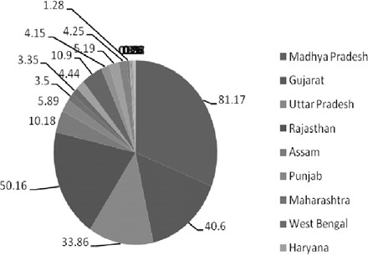

**Area (‘000 ha)**

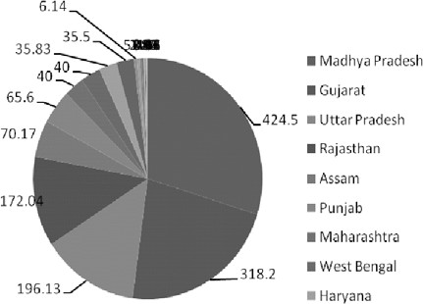

**Production (000 tonnes)**

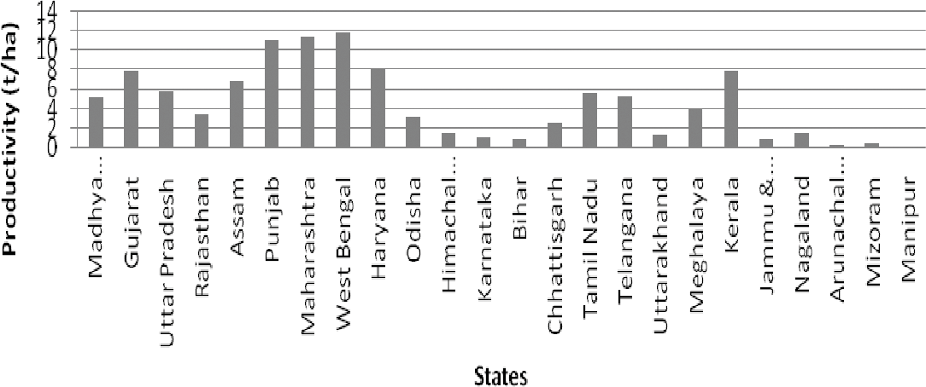

**Productivity (tonnes/ha)**

**Fig. 2.** Area, production and productivity of garlic in India (2014-15)

growth and maturity may lead to higher disease infection, particularly bulb rot, secondary rooting new sprouts *etc*.

Further, losses can be enhanced by the infection of basal rot and purple blotch, withholding of irrigation for 2-3 weeks prior to harvesting in onion is very essential. However, for garlic some amount of moisture is necessary at harvesting for easy lifting of bulbs. The maintenance of soil water potential of -0.85 bar or less either during pre-bulb development (20 - 60 days after transplanting) or bulb development stages (60-110 days after transplanting) significantly reduced onion yield and bulb development stage was found to be to more sensitive to moisture than pre-bulb development.

Onion requires 64-72 cm water during growth and development. This requirement may be as per the climatic conditions and soil type. Joshi (1963) reported 16 irrigations with total 64 cm water are required for onion crop, while Narang and Dastane (1969) reported that 18 irrigations with 72.2 cm water are required for Delhi conditions. Hegde (1986) reported 20 irrigations

with 38-39 cm consumptive use of water are required for onion grown under Bengaluru conditions. In field experiment, on two soils of different texture, highest yields of fresh and dry matter of bulbs were obtained at the lowest soil water potential (-0.15 bars). Mandke and Arakeri (1956) reported that onions consume less water immediately after the establishment of the crop but water consumption increases with advance in the season. They found that irrigation application at 13 days interval during November-December, 10 days interval during January and 7 days interval during February was optimum for onion under Pune conditions. In clay soils, irrigation at 5 days interval gave higher yield of winter season crop. Moisture deficit occurring at any period reduces yield but moisture stress occurring early in the season are not as detrimental as those occurring late. Bulb development and enlargement stages are critical in their demand for water (Parashar, 1979, Table 1).

Dimitrov (1974) reported that onion and garlic grow faster and mature early and produced higher yields

MICROORRIGATION IN ONION AND GARLIC

[*Current Horticulture* **5** (1)

### 

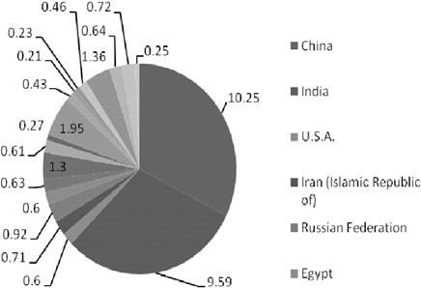

**Area (lakh ha)**

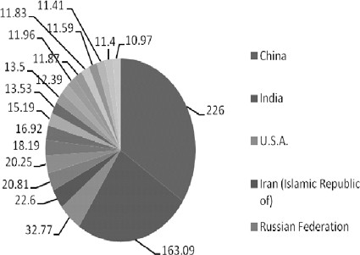

**Production (lakh tonnes)**

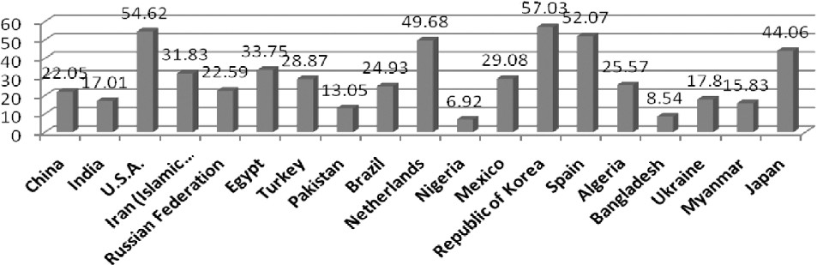

**Productivity (tonnes/ha)**

**Fig. 3.** Area, production and productivity on onion in world (2012-13)

**Table 1.** Water requirement of onion in locations

|  |  |  |  |  |  |  |
| --- | --- | --- | --- | --- | --- | --- |
| Location | Source | Optimum soil moisture | No. of irrigations | Depth of irrigation | Total water requirement | Consumptive use of water |
|  |  |  |  | (cm) | (mm) | (mm) |
| Hyderabad | Rao (1954) | - | 5-6 *(kharif)*\12-15  *(rabi)* 1 5 -20 (summer) | - | - | - |
| Rahuri | Patil *et al.* (1958) | - | 13 | - | - | - |
| Delhi | Joshi (1963) | 0.65 bar tension | 16 | 8.0 | 640 | 464 |
| Delhi | Dastane and Joshi (1964) | - | 16 (sandy loam soil) 12 (clay loam soil) | - | - | - |
| Delhi | Narang and Dastane (1969) | 0.6 | 18 | 7.5 | 722 | 637 |
| Bangalore | Hegde (1986) | -0.65 | 20 | 8.0 | - | 380 - 396 |
| Faizabad | Singh *et al.* (1987) | - | 4 | 5.0 |  |  |
| Nargund | Pallad *et al.* (1988) | 0.7IW/CPE | - | 6.0 | - | - |

when moisture was maintained at 80-90% of field capacity. The keeping quality of bulbs was poorer than that of plants grown at lower soil moisture, because the

large cells and thinner cuticle led to greater transpiration. Irrigating when soil water potential reached 0.45-0.65 bar resulted in maximum dry matter production,

January–June 2017] TRIPATHI *ET AL.*

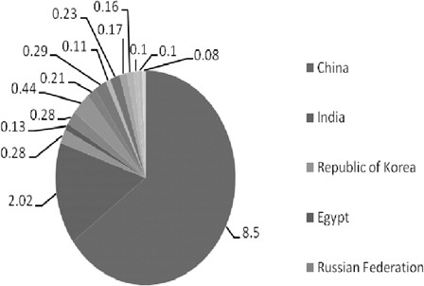

**Area (lakh ha)**

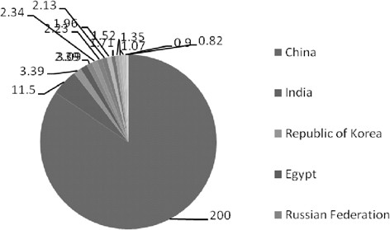

**Production (lakh tonnes)**

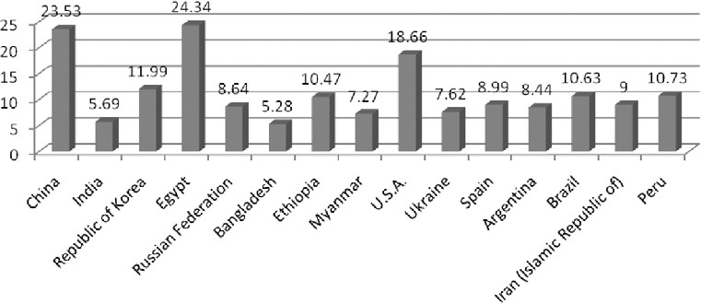

**Productivity (tonnes/ha)**

**Fig. 4.** Area, production and productivity of garlic in world (2012-13)

**Fig. 5.** Per caput water availability in India

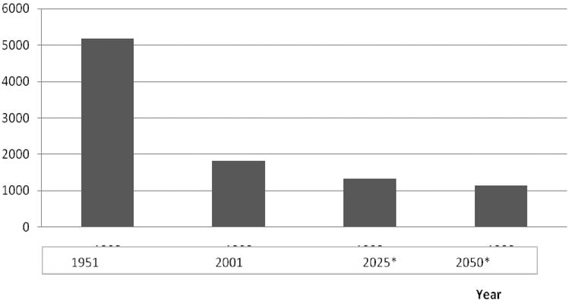

**India’s per caput annual water availability cu.m/caput/year**

**Water availability**

MICROORRIGATION IN ONION AND GARLIC

[*Current Horticulture* **5** (1)

nutrient uptake and yield (Hegde, 1986). Pirov (2001) reported that maximum yield of onion can be achieved at 80-90% of field capacity. However, 70% field capacity throughout growing season helped for improving the post-harvest storage life.

#### Methods of irrigation

Onion and garlic are mostly grown as irrigated crops in India. The most common method of applying water to onion crop is to irrigate it with bed or border strip flooding or furrow method irrigation. The productivity of water in surface irrigation is low due to higher percolation, distribution and evaporation losses. The modern systems of irrigation such as drip, sprinkler ensures higher water-use efficiency. First experimental system of drip irrigation was established in 1959 by Blass who partnered later (1964) with Kibbutz Hatzerim to create an irrigation company and developed first practical surface drip irrigation emitter. Microirrigation methods are found increasing plant growth and yield by increase availability of soil moisture, and better soil consistency. Abrol and Dixit (1972) also obtained higher yield and water-use efficiency under drip irrigation. Two method of microirrigation, *i.e.* drip irrigation and sprinkler irrigation are extensively used for onion and garlic cultivation in India.

#### Advantages of microirrigation

Microirrigation system water is saved through different ways such as reducing loss of water in conveyance, reducing loss of water through evaporation, run off, and by deep percolation, water supply source with limited flow rates such as small water wells or city/rural water can be used in this type of irrigation system. Microirrigation system requires a smaller power unit and consumes less energy. This is helpful in inhibiting growth of weeds as it keeps limited wet areas. It also reduces the incidence of disease. Fertilizers and chemicals can be applied with water through microirrigation system. This systems can be automated which reduces labour requirements.

It Improves production on marginal land, hilly terrain, and can operate in undulated land with no run off. There are some disadvantages of microirrigation systems such as higher maintenance requirements, clogging of devices, damage by animals, rodents and insects may cause damage to some components. Further, initial investment cost is high. Initially microirrigation systems were used for orchards, vineyards, greenhouses, and nurseries but gradually these were used in vegetable cultivation.

There were several issues of use of microirrigation for onion and garlic such as size, type of beds and method of irrigation. In drip irrigation, thickness of

hydrogols, number of drippers, discharge of drippers, number of laterals/bed, distance between two laterals, length of laterals were major issues to be answered, while in sprinkler number of sprinklers, discharge of sprinklers, number of sprinklers/bed, coverage, droplet size, distance between two sprinklers, length of laterals were major concerns. A lot of experiment have been done on various combinations in drip and sprinkler irrigation system during last 20 years all over the onion- and-garlic growing belts of India.

It has been amply proved that even onion and garlic can be taken on drip irrigation system. The results supported drip irrigation and its technical feasibility is an undisputed fact in most of the states.

#### Crop growth and yield

The production of healthy seedlings is one of the crucial steps of onion cultivation. The nursery produc- tion with surface irrigation requires more water, low seed germination and uneven seedling growth. The nursery raising with on drip irrigation under 50% agri shade net or hessian cloth ensures 80-83% of seed germination with 58% final seedling stand in summer against 49% and 27% respectively in surface irrigation with no shade (Tripathi and Lawande, 2011). In late- *kharif* and winter season nurseries on onion, the drip and sprinkler irrigation resulted 90-95 per cent germi- nation with 80-85 percent transplanted seedlings as compared 55-60 per cent transplanted seedlings in surface irrigation (Tripathi *et al.*, 2002).

The trickle irrigation shortened the time of emergence, good seedling growth and uniform crop stand. The growth and diseases incidence are lesser in drip irrigated crop. Other benefits are prevention of soil erosion, feasibility in undulation land, saving fertilizer through fertigation *etc*. There is an ample scope extending are under drip irrigation. Drip irrigation can save up to 50% of water and increase yield by 15- 20%. Dixit *et al.* (1971) reported that drip irrigation significantly increased the yield and diameter of bulbs as compared to surface irrigation. Drip irrigation system has high water-use efficiency and does not require land levelling.

Microirrigation methods are found increasing plant growth and yield by increase availability of soil moisture, and better soil consistency. The crop growth and final stand in onion was higher in all three season under Maharashtra conditions. The plant height was highest in drip irrigation as compared to sprinkler and surface irrigation conditions (Table 1) (Tripathi *et al.,* 2010). Abrol and Dixit (1972) also obtained higher yield and water use efficiency under drip irrigation. Drip irrigation with the recommended rate of solid fertilizer in 2 applications gave the highest bulb yield (496.35 q/

January–June 2017] TRIPATHI *ET AL.*

**Table 2.** Yield of onion (cv. N-2-4-1) as influenced by various systems of irrigation

|  |  |  |  |  |  |
| --- | --- | --- | --- | --- | --- |
| Treatment Bulb yield (q/ha) | | Water applied (cm) | Water -use efficiency | Water saving (%) | Yield increase over 75mm CPE |
|  | |  | (Q/ha.cm) |  |  |
| **Surface irrigation**  50mm CPE | 359.6 | 108 | 3.61 |  | 9.87 |
| 75 mm CPE | 334.9 | 78 | 4.53 | - | - |
| 100mm CPE | 274.0 | 60 | 4.73 | 23.08 | - |
| 125mm CPE | 216.0 | 54 | 4.28 | 30.7 | - |
| **Sprinkler irrigation**  75 mm CPE at 40 mm depth | 412.7 | 52 | 8.47 | 33.3 | 24.6 |

CD ( 0.05) 31.01

ha) while drip fertigation at 50% of the recommended rate gave the highest bulb quality.

The annual irrigation water requirement of onion through drip irrigation was 46.27 cm. Field experimenta- tions on drip irrigation at Hissar conditions resulted significantly higher yields of onion. Field experimentations on sprinkler irrigation resulted significantly higher yields of onion (Table 2). The water requirement of onion by drip irrigation method was

45.12 cm as against 60.2 cm in surface irrigation. The water use efficiency was also higher in drip irrigation (63%) compared to 55.5% in surface irrigation treatment. The highest yield (441.76q/ha.), higher water-use efficiency (10.04 q/ha) and bulk density of bulb (10.04 q/ha cm) were obtained with sprinkler irrigation. The yield of onion was higher in drip irrigated plots than furrow irrigated plots. But the increase was non- significant.

Usage of water was low with the drip method stated that onion yields were consistently 35% higher in drip irrigation than regular furrow irrigated onions in a three year trial. Moreover, it saved more 50 % water and 20% fertilizer. Patil *et al.* (2000) reported significant performance with respect to yield and quality of white onion cv.Phule Safed during summer season over the control. Through microirrigation system 53- 69% water saving was achieved. Maximum water-use efficiency (0.91 q.ha/mm) was observed through both the micro irrigation system. Balasubrahmanyam *et al* (2000) reported that optimum yield of acceptable quality of bulbs obtained from irrigation through drip system at 60000 litres/ha/day and fertigation using NPK liquid fertilizer at 150:125:200 kg/ha are necessary.

Tripathi and Lawande (2008) reported that planting of onion cv. Baswant-780 on Broad Based Furrows (BBF) with drip resulted in higher yield (31.2 tonnes/ha) as compared to flat bed, raised bed and ridge and furrow planting in *kharif* season under Maharashtra conditions.

(Anon, 1986-87)

Studies on microirrigation on growth, yield and yield contributing characters of onion under western Maharashtra conditions revealed that both drip and micro sprinkler irrigation improved growth yield and yield contributing parameters of onion. Among different irrigation methods and levels tested, the drip irrigation at 100% pan evaporation recorded the highest marketable bulb yield onion followed by micro sprinkler irrigation at 100% pan evaporation.

Moreover, it was clearly indicated from the experiment that the saving of irrigation water was to the tune of 37.8% in drip and 32.5% in sprinkler system under best treatment as compared to surface irrigation, when it was scheduled at 50 mm CPE with 7 cm depth (Table 3, NRCOG, 2001, 2002, 2003; Sankar *et al.,* 2008a).

According to Tripathi *et al.* (2010) studies on effect of various irrigation methods, *i.e.* drip, mini sprinkler, big sprinkler and surface irrigation on the growth, yield and storage of onion cv. N-2-4-1. The highest yield was recorded in drip irrigation (47.47 tonnes/ha) followed by big sprinkler (31.21 tonnes/ha). The lowest yield was recorded in surface irrigation (22.79 tonnes/ha).

The plant height, percentage of big size bulbs, equatorial and polar diameter of bulbs was higher in drip irrigation method (Table 4). The study of Bagali *et al.* (2012) shown that short interval of irrigation (one day) recorded significantly higher bulb yield (46.93 tonnes/ha). 100 per cent PE recorded significantly higher bulb yield (50.92 tonnes/ha) compared to 80 and 60 per cent PE and flood irrigation Significantly higher bulb yield was recorded in one day interval of irrigation at 100 per cent PE (54.91 tonnes/ha) which was on par with two days interval of irrigation at 100 per cent PE (52.83 tonnes/ha).

Microirrigation is found successful in garlic to increase yield, quality and water use efficiency. A study revealed that there was 28.3% water saving and 4.3 percent increase in yield of Garlic cv. Jamnagar under

MICROORRIGATION IN ONION AND GARLIC

[*Current Horticulture* **5** (1)

**Table 3.** Effect of irrigation systems on growth and yield of onion cv. N 2-4-1.

|  |  |  |  |
| --- | --- | --- | --- |
| Treatment | Plant height (cm) | Marketable yield (tonnes/ha) | Bulb weight (g) |
| Drip irrigation 50 % PE | 55.2 | 26.1 | 47.1 |
| Drip irrigation 75 % PE | 63.3 | 33.9 | 56.6 |
| Drip irrigation 100 % PE | 66.9 | 39.6 | 56.8 |
| Sprinkler irrigation 50 % PE | 55.0 | 22.8 | 41.5 |
| Sprinkler irrigation 50 % PE | 61.5 | 25.3 | 40.2 |
| Sprinkler irrigation 50 % PE | 65.2 | 28.1 | 46.4 |
| Surface irrigation at 50 mm CPE | 62.6 | 31.8 | 54.5 |
| CD ( 0.05) | 1.98 | 0.67 | 3.41 |

(Sankar *et al.,* 2008a)

**Table 4.** Effect of irrigation systems on growth and yield of onion cv. N-2-4-1.

|  |  |  |  |
| --- | --- | --- | --- |
| Treatment | Plant height | Yield | Per cent Bulb grade bulbs |
|  | (cm) | (t/ha) | A (>60mm ED) B (50-60mm ED) C (35 -50mm ED) |
| Surface irrigation | 53.42 | 22.79 | 9.05 49.73 37.08 |
| Drip irrigation | 58.78 | 47.47 | 36.03 50.04 8.75 |
| Sprinkler (big) irrigation | 55.24 | 31.21 | 15.81 46.22 22.32 |
| Sprinkler (micro) irrigation | 54.12 | 24.74 | 13.84 44.21 35.38 |
| CD (0.05) | 4.70 | 6.83 | 7.38 NS 12.64 |

(Tripathi *et al.,* 2010)

sprinkler irrigation. Patel *et al.* (1996) recorded higher marketable bulb yield of garlic under drip irrigation system. In garlic, clove germination was higher and uniform as compared to surface irrigation. Among the different irrigation methods and levels tested, drip irrigation at 100% PE recorded the highest marketable bulb yield of garlic followed by sprinkler irrigation at 100% PE. The study indicated that in the best treatment compared to surface method of irrigation, a saving of 37.9% irrigation water in drip and 36.4% in sprinkler system can be achieved (Table 5, Sankar *et al.* 2008b). Mohammad Ghanbari *et al.* (2013) indicated that the

use of drip irrigation and weed control increased cloves number, cloves weight and bulb yield. Mean comparisons of interaction effects also showed that the highest economical yield was registered in using drip method with manual weed control in garlic cv. China in Turkey. The results revealed that in places with limitation of water, using of drip irrigation causes both decreasing weeds and increasing yield in garlic cultivars.

#### Quality of bulbs

Microirrigation have influence the size and quality

**Table 5.** Effect of irrigation systems on growth and yield of garlic cv. G-41.

|  |  |  |  |  |  |
| --- | --- | --- | --- | --- | --- |
| Treatment | Plant height (cm) | Yield (tonnes/ha) | A-grade bulbs (%) | B-grade bulbs (%) | C-grade bulbs (%) |
| Drip irrigation 50 % PE | 53.9 | 9.07 | 40.9 | 41.9 | 17.2 |
| Drip irrigation 75 % PE | 61.7 | 11.9 | 48.8 | 40.2 | 11.1 |
| Drip irrigation 100 % PE | 62.7 | 13.2 | 53.5 | 39.1 | 7.3 |
| Sprinkler irrigation 50 % PE | 49.5 | 7.31 | 30.8 | 38.2 | 31.0 |
| Sprinkler irrigation 50 % PE | 5.1 | 10.4 | 39.9 | 40.0 | 19.6 |
| Sprinkler irrigation 50 % PE | 58.6 | 12.3 | 46.9 | 40.8 | 15.6 |
| Surface irrigation at 50 mm CPE | 46.7 | 11.6 | 46.7 | 40.2 | 13.2 |
| CD ( 0.05) | 3.84 | 0.23 | 2.97 | 2.43 | 1.03 |

(Sankar *et al.,* 2008b)

January–June 2017] TRIPATHI *ET AL.*

of bulb in onion and garlic. Tripathi *et al.* (2010) reported that the percentage of bigger size bulbs of onion were more in drip irrigation than surface and sprinkler irrigation (Table 6). Similar results were reported by Sankar *et al.* (2008 and Table 4). The study also found that the percentage of rooted bulbs were ore under sprinkler irrigation and surface irrigations. Although there was no significant difference in Total soluble solids (TSS) content of bulbs. In almost all the micro irrigation studies in onion and garlic revealed in the bulbs size and percentage of big size bulbs. In fact the yield increase by microirrigation may be attributed to higher plant stand per unit area and higher number of bigger size bulbs.

#### Weed growth and soil conditions

Weed population in drip irrigated plot was lower than the surface irrigation and sprinkler irrigation. The results revealed that in places with limitation of water, using of drip irrigation causes both decreasing weeds and increasing yield in garlic cultivars (Mohammad Ghanbari *et al.,* 2013). Further, soil of drip and sprinkler irrigated field remains fragile and less compact than field irrigated with surface irrigation. These soil conditions favour easy weeding and harvesting operations. The lower weed population was recorded in drip irrigated onion nursery (Tripathi *et al.,* 2002).

#### Water saving and water-use efficiency

Higher water saving, water productivity of water in drip irrigation system is due to the reduction of various types of water losses during irrigation. Al- Jamal *et al.* (2000 and 2001) elucidated that maximum irrigation efficiency (100%) obtained with sprinkler irrigation followed by drip irrigation method (79-82%) compared with 54-80% obtained from furrow irrigation at farmers field. Sankar *et al.* (2008a) indicated that the saving of irrigation water was to the tune of 37.8% in drip and 32.5% in sprinkler system under best treatment as compared to surface irrigation, when it was scheduled at 50 mm CPE with 7 cm depth (Table 7).

There was around 30 per cent water saving in drip irrigation system as compared to surface system while it was between 7 and 16 per cent in sprinkler irrigation systems. The highest water use efficiency was recorded in drip irrigation system, which was 770 kg/ha-cm of water (NRCOG, 2001, 2002, 2003 and Table 3). higher water use efficiency in drip irrigation (770 kg/ha-cm) than micro sprinkler(344.6 kg/ha-cm), big sprinkler (386.5 kg/ha-cm) and surface irrigation (252.5 kg/ha- cm) (Tripathi *et al.,* 2010) . Bagali *et al.* (2012) found that both one day (M1) and two days (M2) interval of irrigation and 60 per cent PE (S1) recorded significantly higher WUE, The intervals and levels of irrigation and

**Table 6.** Effect of irrigation systems on different grades of bulbs in onion

|  |  |  |  |
| --- | --- | --- | --- |
| Treatment |  | Bulb grade bulbs (%) |  |
|  | A (>60 mm diameter) | B (50-60 mm diameter) | C (35 to 50 mm diameter) |
| Surface irrigation | 9.05 | 49.73 | 37.08 |
| Drip irrigation | 36.03 | 50.04 | 8.75 |
| Sprinkler (Big) irrigation | 15.81 | 46.22 | 22.32 |
| Sprinkler (Micro) irrigation | 13.84 | 44.21 | 35.38 |
| CD ( 0.05) | 7.38 | NS | 12.64 |

Tripathi *et al.* (2010)

**Table 7.** Effect of irrigation systems on water saving and water-use efficiency in onion

|  |  |  |  |
| --- | --- | --- | --- |
| Treatment | Water applied (ha cm) | Water saving (%) over surface | Water-use efficiency (kg/ha-cm) |
| Drip irrigation 50 % PE | 29.8 | 63.6 | 1080 |
| Drip irrigation 75 % PE | 40.4 | 50.1 | 959 |
| Drip irrigation 100 % PE | 56.0 | 37.8 | 867 |
| Sprinkler irrigation 50 % PE | 30.0 | 63.1 | 828 |
| Sprinkler irrigation 50 % PE | 45.7 | 44.1 | 615 |
| Sprinkler irrigation 50 % PE | 57.3 | 32.5 | 525 |
| Surface irrigation at 50 mm CPE | 79.3 | 0 | 414 |

(Sankar *et al.* 2008a)

MICROORRIGATION IN ONION AND GARLIC

[*Current Horticulture* **5** (1)

**Table 8.** Effect of irrigation systems on water saving and water-use efficiency in garlic

|  |  |  |  |
| --- | --- | --- | --- |
| Treatment | Water applied (ha cm) | Water saving (%) over surface | Water-use efficiency (kg/ha-cm) |
| Drip irrigation 50 % PE | 28.2 | 63.7 | 343.1 |
| Drip irrigation 75 % PE | 38.6 | 50.7 | 318.8 |
| Drip irrigation 100 % PE | 48.7 | 37.9 | 274.4 |
| Sprinkler irrigation 50 % PE | 28.3 | 63.6 | 256.0 |
| Sprinkler irrigation 50 % PE | 38.9 | 50.1 | 304.8 |
| Sprinkler irrigation 50 % PE | 50.0 | 36.4 | 248.9 |
| Surface irrigation at 50 mm CPE | 78.7 | 0 | 145.1 |

(Sankar *et al.,* 2008b)

their combinations were significantly superior for WUE, compared to flood irrigation.

In garlic , Sankar *et al.* (2008b) reported that among the levels of irrigation evaluated, drip irrigation system at 50% PE recorded the highest water-use efficiency (343.1 kg/ha/cm) but there was a marked reduction in marketable bulb yield at minimum water applied per either through drip or sprinkle irrigation(Table 8).

Microirrigation has another advantage of utilization of saline and brackish water for irrigation. The studies have proved that these irrigation systems can minimized the effect of salinity. The sprinkler irrigation with brackish water reduced onion yields by 60%, compared to fresh water. This reduction was due to reductions in both bulb size and bulb number per unit area. Drip irrigation with brackish water shown yield reduction of 30%, and only the bulb number was affected. With drip irrigation, seedling death occurred in the first 40 days after emergence; yield reduction was eliminated by using fresh water during the establishment phase, changing to brackish water at 45 days after sowing.

#### Storage losses

Storage losses in the onion bulbs produced under micro irrigation are reported lower than surface irrigation. Tripathi *et al.* (2010) found that total storage losses after three months of storage were lowest in drip irrigation (13.38%) and surface irrigation (17.15%). While higher losses were found in micro-sprinkler irrigation (22.58%) and big sprinkler irrigation (32.25%) systems. Similarly, these losses were 32.72 and 36.18% in drip and surface irrigation, respectively in comparison to 46.18% in micro-sprinkler and 57.73% in big sprinkler after 6 months of storage. The rotting losses were significantly higher in both types of sprinklers than drip and surface irrigation. Brice *et al.* (1997) reported higher storage losses in overhead irrigation. The reason may be due to the fact that the overhead irrigation allows the entry of disease causing microorganisms in the later stage of bulb maturity.

#### Seed production

Microirrigation system has been found effective in yield enhancement and reduction in water requirement in onion seed crop. Large scale seed production programme carried out at NRC onion and Garlic farms at Rajgurunagar and Manjari showed that higher yield of quality seed of onion can be produced with less use of water (Tripathi *et al.,* 2004). According to Sankar *et al.* (2015) growth, yield and yield contributing characters of onion seed crop as significantly influenced by different methods and levels of irrigation practices. Among the methods and levels of irrigation, drip irrigation at 100% PE daily improved the growth, yield and yield contributing parameters. Higher seed yield was recorded at drip irrigation at 100 PE (582.6 kg/ha) in daily interval followed by drip irrigation at 100% PE at 3 days interval (506.4 kg/ha).

The results indicated saving of irrigation water to the tune of 37.5% in drip system as compared to surface irrigation (Table 9). Dingre *et al.* (2012) also observed that drip irrigation resulted into 41-62% water saving with 4-26% increase in yield of onion seed as compared to surface irrigation. The growth and yield attributes in drip irrigated treatments showed decreasing trend with increase in irrigation interval and CPE. When drip irrigation applied daily at 100% of CPE, the yield increased up to 26% as compared to control. The drip application at every 3 days interval with 75% CPE was found to be optimum and effective for growth, yield, and quality as well as economically viable for onion seed production (Dingre *et al.* 2012).

#### Economics

The yield of onion was higher in drip irrigated plots than furrow irrigated plots. But the increase was non-significant. Usage of water was low with the drip method. Tripathi *et al.* (2010) reported that the benefit : cost ratio was highest in onion grown under drip irrigation (1.98) followed by big sprinkler (1.50) while it was lowest in surface irrigation. Patel *et al.* (1996)

January–June 2017] TRIPATHI *ET AL.*

reported that the benefit: cost ratio was highest in garlic grown under drip irrigation. The higher benefit: cost ratio in drip irrigation suggests that despite of higher initial cost of the system; the drip irrigation is more profitable than sprinklers and surface irrigation.

The microirrigation studies carried out in onion and garlic during last 30 years in various parts of the country revealed that both drip irrigation and sprinkler irrigation system increased yield and quality onion and garlic bulbs with a considerable saving of water. There is variation in yield enhancement and water saving by these systems in different regions and locations. But it is no doubt that these systems have potential to mitigate water scaring without affecting the yield and quality of onion and garlic. Moreover, most of the studies have proved the superiority of drip irrigation over sprinkler irrigation. But in some locations sprinkler system outpassed drip irrigation with respect to yield. The microirrigation systems have been successfully adopted by farmers of major onion-and garlic-growing regions of the country.

#### REFERENCES

Abbey L and Joyce D C. 2004, Water deficit stress and soil type effects on spring onion growth. *J. Veg. Crop Prod.* **10**(2): 5-18

Abrol I P and Dixit S P. 1972. Studies of the drip method of irrigation. *Expl. Agric.* **8**: 172-75.

Al-Jamal M S, Sammis T W, Ball S and Smeal D. 2000. Computing the crop water production function for onion. *Agricultural Water Management* **46**(1): 29-41.

Al-Jamal M S, Ball, S. and Sammis, T W. 2001. Comparison of sprinkler, trickle and furrow irrigation efficiencies for onion production. *Agricultural Water Management* **46**(3): 253-66.

NHB, Gurgaon. 2015. *Data Book-2015*. National Horticulture Board, Gurgoan, India.

FAO, Rom. 2013. *FAO Year Book-2013*. Food and Agriculture Organization, Rome.

NRCOG, Rajgurunagar. 2001. *Annual Report 2000-01*. NRCOG, Rajgurunagar, Maharashtra, India 60.

NRCOG, Rajgurunagar. 2002. *Annual Report 2001-02*. NRCOG, Rajgurunagar, Maharashtra, India 70.

NRCOG, Rajgurunagar. 2003. *Annual Report 2002-03*. NRCOG, Rajgurunagar, Maharashtra, India 64.

Bagali A N, Patil H B, Guled M B and Patil R V. 2012. Effect of scheduling of drip irrigation on growth, yield and water use efficiency of onion (*Allium cepa* L.). *Karnataka Journal of Agricultural Science* **25**(1): 116-19.

Balasubrahmanyam, V R, Dhake A V and Moitra P. 2001. Micro-irrigation and fertigation in onion. *In: Proceedings of International Conference on Micro and Sprinkler irrigation Systems*, held at Jalgoan, Maharashtra.

Bandyopadhyay P K, Mallick S and Rana S K. 2003. Actual evapotranspiration and crop coefficients of onion (*Allium cepa* L.) under varying soil moisture levels in the humid tropics of India. *Trop. Agric.* **80**(2) : 83-90.

Bose T K and Som M G. 1986. *Vegetable Crops in India*, Nayaprakash, Calcutta, India.

Brice J, Currah L, Malins A and Bancroft R. 1997. *Onion Storage in the Tropics: A Practical Guide to Methods of Storage and their Selection*. Chaltham, UK: Natural Resources Institute.

Carrijio O A, Olitta A F L, Miami K and Menezes A. 1982. Effect of different water quantities on the productivity of two garlic cultivars under drip irrigation. *Pesquisa Agropecuaria Brasileira* **17**: 783-80.

Dingre S K, Pawar D D and Kadam K G. 2012. Productivity, water use and quality of onion *(Allium cepa)* seed production under different irrigation scheduling through drip. *Indian Journal of Agronomy* **57**(2): 186-90.

Dixit S P, Agrawal M C and Singh K. 1971. Studies on subsurface drip irrigation method of irrigation for vegetable onion and sugar beet, *Indian J. Hort*. **28**(30): 221- 23.

Gajbhiye K R, Kale M U and Wadatkar S B. 2009. Effect of different irrigation methods on yield of garlic. *Green Farm.* **13**(1): 963-64.

Gethe R M, Pawar V S, Sonawane D A and Kadlag A D. 2006. Infuence of planting layouts, irrigation regimes and fertilizer levels and yield of onion under micro sprinkler. *Journal of Maharashtra Agricultural University* **31**: 272-74.

Hegde D M. 1986. Effect of irrigation regimes on dry matter production, yield nutrient uptake and water use efficiency in onion. *Indian J. Agron.* **31**: 343-48.

Kadam U S, Gorantiwar S D, Kadam S A, Gurav G B and Patil H M. 2006. Effects of different moisture regimes on yield potential of onion (*Allium cepa* L.) under micro sprinkler irrigation system. *J. Maharashtra Agric. Univ.* **31**(3) : 342- 45.

Lawande K E. 2005. Onion improvement-Present status and future thrust. *In: National Symposium on Current Trends in Onion, Garlic, Chillies and Seed Spices - Production, Marketing and Utilization,* held at Rajgurunagar, Pune.

Mohammad Ghanbari, Gholam-Reza Zaboli and Behrooz Mir. 2013. Comparing irrigation methods and weed control on yield of garlic (*Allium sativum* L.) cultivars. *World of Science Journal* **3**: 78-78

Patel B G, Khanpara V D, Malavia D D, Maraviya R B and Kaneria B B. 1996. Economic feasibility of drip irrigation in garlic. *Indian Journal of Agronomy* **45**: 143-45.

Patil R S, More S C, Firake N N, Bhalekar M N and Desale M

N. 2000. Effect of microirrigation system and nitrogen fertigation levels on yield and quality of white onion (cv. Phule Safed) during summer season. Approaches for sustainable development of onion and garlic. *Proceedings of the National Symposium on Onion-Garlic Production and Post harvest Management – Challenges and Strategies,* held at Nasik, pp. 277-81.

MICROORRIGATION IN ONION AND GARLIC

[*Current Horticulture* **5** (1)

Pawar C Y, Kadam U S, Gorantiwar S D and Pampattiwar S P 1998. Efficacy of the micro sprinkler irrigation method for garlic. *Journal of Maharashtra Agricultural. University.* **23**: 156-59.

Quadir M, Boulton A, Ekman J, Hickey M and Hoogers R. 2005. Influence of drip irrigation on onion yield and quality. *IREC Farmers' Newsletter,* **170**: 29-31.

Saman S. 2002. Microirrigation in onion cultivation. In: *Consultative Meeting on Accelerated Production and Export of Onion and Garlic,* held at New Delhi, during 19-20 April 2002. National Horticultural Research and Development Foundation, Nasik.

Sankar V, Qureshi A A, Tripathi P C and Lawande K E. 2001. Micro irrigation studies in garlic. *South Indian Horticulture* **49**: 379-81.

Sankar V, Lawande K E and Tripathi P C. 2008a. Effect of micro irrigation on growth, yield and water use efficiency of onion *(Allium cepa)* under western Maharashtra condi- tions. *Indian Journal of Agricultural Science* **78**(7): 584-88.

Sankar V, Lawande K E and Tripathi P C. 2008b. Effect of micro irrigation practices on growth and yield of garlic (*Allium sativum* L.) var. G. 41. *Journal of Spices and Aromatic Crops* **17**(3): 230-34.

Sankar V, Thangasamy A and Lawande K E. 2015. Effect of

drip irrigation on onion seed production under western Maharashtra conditions. *International Journal of Tropical Agriculture* **33**(2): 622-25.

Singh Kriti. 2000. Current status of onion and garlic research in India and future prospects: Approaches for sustainable development of onion and garlic. *Proceedings of the National Symposium on Onion*–*Garlic Production and Post-harvest Management Challenges and Strategies,* held at Nasik, pp. 1- 13.

Tripathi P C, Lawande K E and Mahajan V. 2002. Onion Cultivation (in Hindi). *Technical Bulletin No*. 4 Published by NRC Onion and Garlic, Rajgurunagar p. 52.

Tripathi P C and Lawande K E. 2004. Onion seed production (in Hindi). *Technical Bulletin No.* 8 Published by NRC Onion and Garlic, Rajgurunagar p. 20.

Tripathi P C and Lawande K E. 2008. *Kharif* onion production Technology. *Technical Bulletin No.* 18. NRC Onion and Garlic, Rajgurunagar, p. 10.

Tripathi P C, Sankar V and Lawande K E. 2010. Influence of micro-irrigation methods on growth, yield and storage of rabi onion. *Indian J. Hort.* **67**(1): 61-65.

Tripathi P C and Lawande K E. 2011. Evaluation of irrigation and shading methods on nursery production of onion (*Allium cepa* L.). *Vegetable Science* **38**(1): 22-25.

roceedings of the Ist International Symposium on Tropical Tomato, Oct. 23-27, 1978 at Shanhua, Taiwan, Republic of China. *Asian Vegetable Research Development Center* Publication No. **78-59**: 94-108.

Kuo C G, Chen H M, Shen B J and Chen H C. 1989. Relationship between hormonal levels in pistils and tomato fruit-set in hot and cool seasons: Green SK, Griggs TD, McLean BT, (Eds). Tomato and Pepper Production in the Tropics.

Mane R S. 2009. Stability analysis in tomato (Solanum lycopersicum Mill.) genotypes. M. Sc. Thesis, Department of Genetics and Plant Breeding, College of Agriculture, University of Agricultural Sciences, Dharwad, India.

Peet M M, Willits D H and Gardner R. 1997. Response of ovule development and post-pollen production processes in male sterile tomato to chronic, sub-acute high temperature stress. *Journal of Experimental Botany* **48**: 101- 111.

Prasanna H C, Chaubey T, Kumar R, Rai M, Verma A and Singh S. 2007. Identification of stable variety for yield and quality attributes in tomato. *Vegetable Science* **34**: 131-134.

Prasanth K and Kumary S. 2014. Utilization of male sterility for hybrid seed production in vegetables. *Current Horticulture* **2**(2): 3-14.

Saeed A, Hayat K, Khan A A and Iqbal S. 2007. Heat Tolerance Studies in Tomato (*Lycopersicon esculentum* Mill.). *International Journal of Agriculture and Biology* 1560-8530 /

/09-4: 649-652, [http://www.fspublishers.org](http://www.fspublishers.org/) .

Shalini M. 2009. ‘Studies on heterosis and combining ability in tomato (*Solanum lycopersicum* L.)’. Ph. D. Thesis, Department of Horticulture, College of Agriculture, University of Agricultural Sciences, Dharwad, India.

Singh AK, Rai N, Singh RK, Singh S and Singh RP. 2014. Evaluation of combiners for resistance to early blight disease using interspecific crosses in tomato *(Solanum lycopersicum)*. *Current Horticulture* **2**(2): 21-26.

Stevens MA and Rudich J. 1978. Genetic potential for overcoming physiological limitations on adaptability, yield and quality in the tomato. *Hort Science* **13**: 673-678.

Upadhay R, Lal G and Ram HH. 2001. Genotype environment interaction and stability analysis in tomato. *Progressive Horticulture* **33**(2): 190-93.