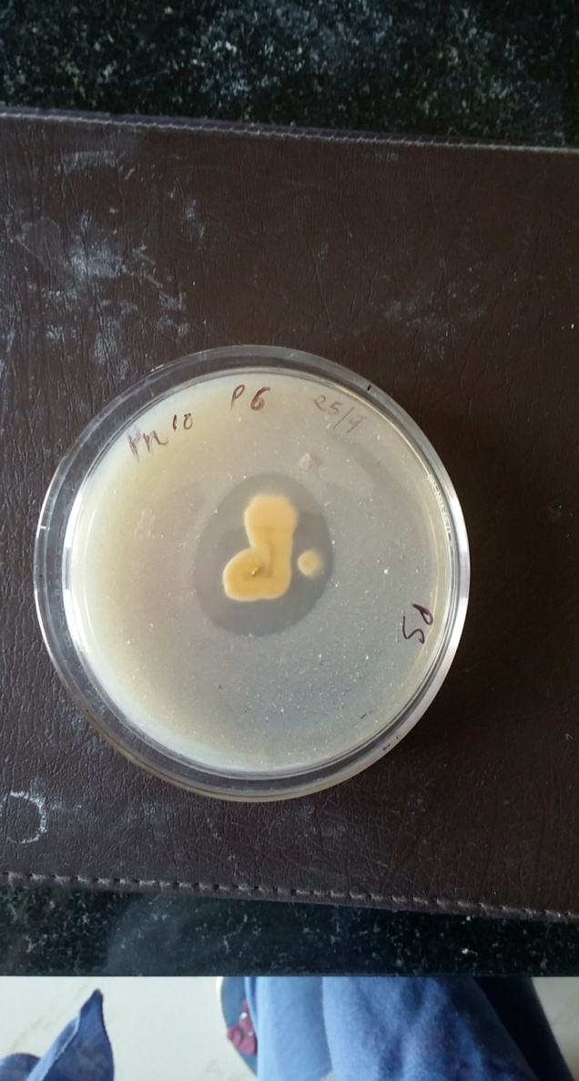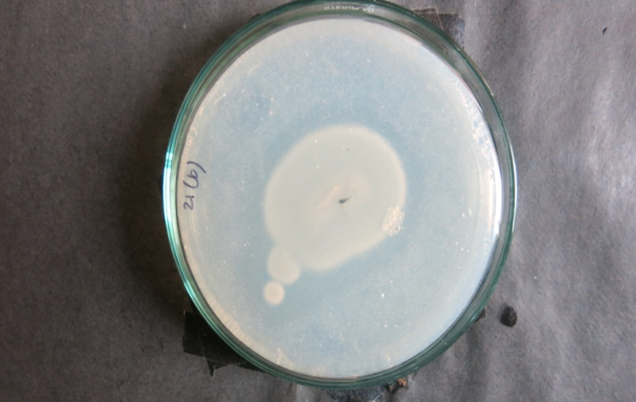

**Figure 1: Fungi showing positive phosphorus solubilizing activity.**

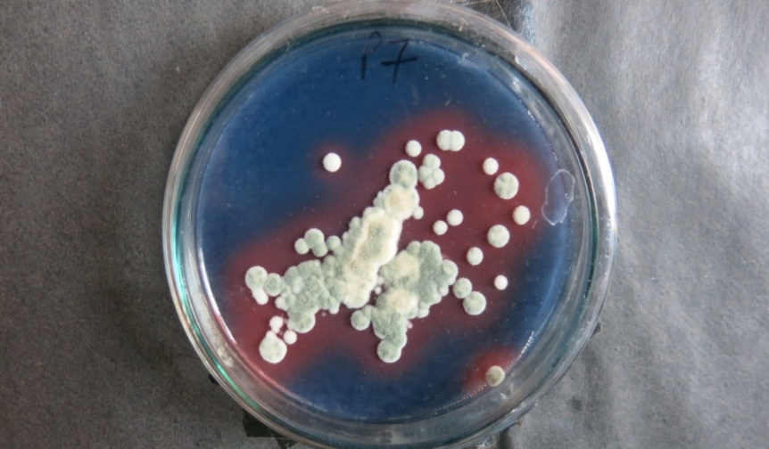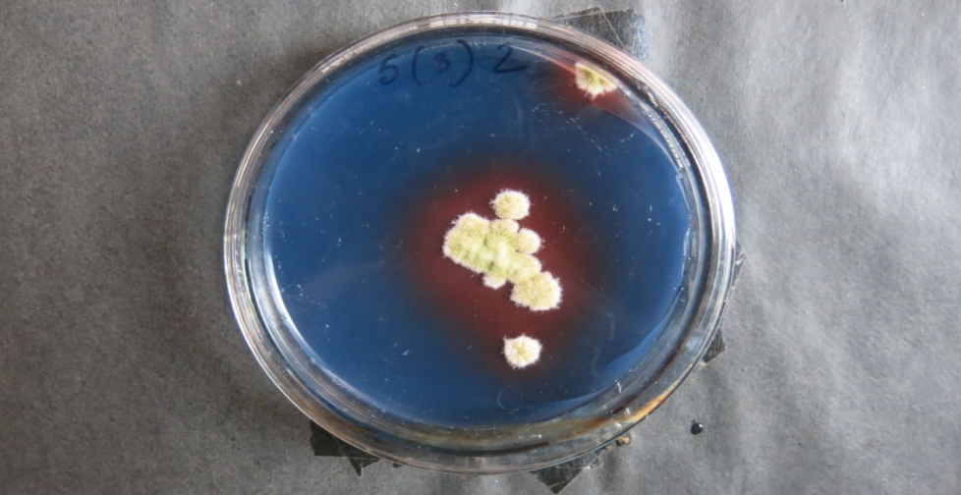

**Figure 2: Fungi showing positive results for siderophore production**

**Table 1: Nutrient acquisition activities of selected salt tolerant fungi at pH 10**

|  |  |  |  |
| --- | --- | --- | --- |
| **Code** | **Phosphate solubilization (Zone of solubilization in mm)** | **Zinc solubilization** | **Siderophore production** |
| P1 | 6 | + | +++ |
| P2 | 4 | + | ++ |
| P3 | 4 | + | ++ |
| P4 | 3.5 | + | - |
| P5 | 4 | + | + |
| P6 | 2 | + | +++ |
| P7 | 5 | + | +++ |
| P8 | 2.5 | - | - |
| P9 | 5 | + | ++ |
| P10 | 4 | - | ++ |
| P11 | 2 | + | + |
| P12 | 4.5 | + | ++ |

**+: intensity of activity (+++ being highest/ strong); - : negative results; Values presented in table is mean of two replications**

**Table 2: Nutrient acquisition activities of selected fungi at 5% NaCl**

|  |  |  |  |
| --- | --- | --- | --- |
| **Code** | **Phosphate solubilization (Zone of solubilization in mm)** | **Zinc solubilization** | **Siderophore production** |
| N1 | 4 | + | ++ |
| N2 | 3 | - | - |
| N3 | 3.4 | - | ++ |
| N4 | 3.5 | - | ++ |
| N5 | 4.6 | ++ | - |
| N6 | 2 | - | +++ |
| N7 | 4 | - | +++ |
| N8 | 4.5 | ++ | ++ |
| N9 | 5 | ++ | +++ |
| N10 | 4 | +++ | +++ |
| N11 | 3.8 | ++ | - |
| N12 | 4.2 | + | - |
| N13 | 3 | + | +++ |
| N14 | 4.8 | + | + |
| N15 | 4 | - | ++ |

**+: intensity of activity (+++ being highest/ strong); - : negative results; Values presented in table is mean of two replications**