Table: Block-wise electrical conductivity (dS/m) distribution in groundwater of Panipat district
Block | No. of  samples | % water with EC_{iw} (dS/m)
 |  | < 2 | 2-4 | > 4
Panipat | 185 | 93.1 | 6.9 | -
Ishrana | 276 | 38.2 | 53.7 | 8.0
Matlauda | 254 | 66.9 | 32.6 | 0.4
Samlakha | 217 | 93.0 | 7.0 | -
Bapoli | 176 | 100.0 | - | -

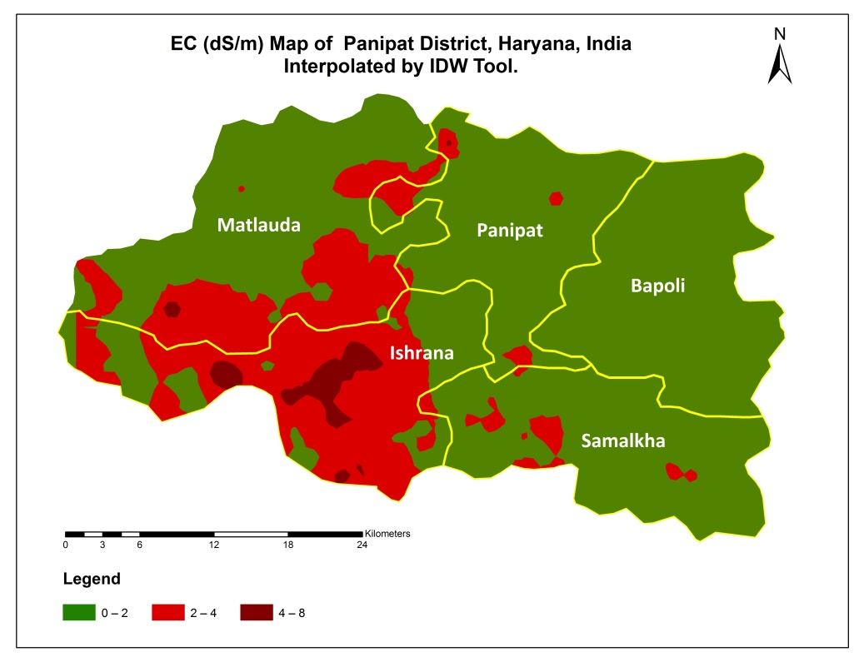

Table: Block-wise sodium adsorption ratio (SAR) distribution in groundwater of Panipat district
Block | No. of  samples | % water with SAR
 |  | < 10 | 10-20 | > 20
Panipat | 185 | 96.5 | 3.5 | -
Ishrana | 276 | 83.8 | 15.1 | 1.1
Matlauda | 254 | 92.1 | 7.9 | -
Samlakha | 217 | 100.0 | - | -
Bapoli | 176 | 100.0 | - | -

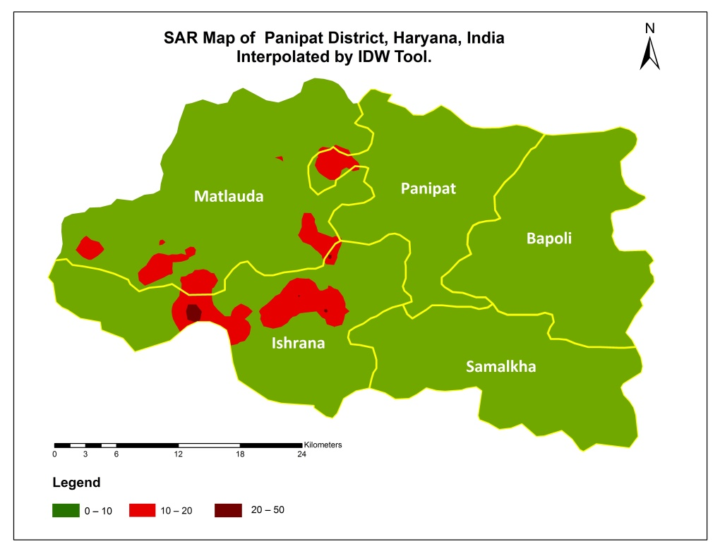

Table: Block-wise residual sodium carbonate (RSC) distribution in groundwater of Panipat district
Block | No. of  samples | % water with RSC (me/l)
 |  | < 1.25 | 1.25-2.5 | 2.5-5 | 5-10 | > 10
Panipat | 185 | 18.4 | 34.0 | 28.0 | 19.0 | 0.6
Ishrana | 276 | 37.7 | 34.3 | 24.6 | 3.3 | 0.1
Matlauda | 254 | 10.3 | 24.3 | 49.8 | 15.6 | -
Samlakha | 217 | 23.5 | 41.1 | 31.6 | 3.8 | -
Bapoli | 176 | 16.8 | 46.7 | 34.9 | 1.5 | -

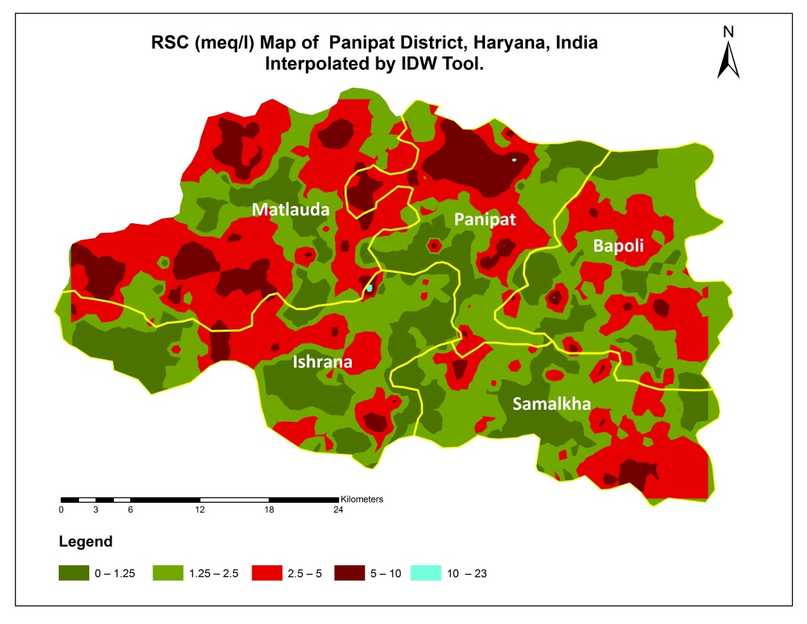

Table: Block-wise water quality distribution in groundwater of Panipat district
Block | No. of  samples | % water
 |  | Good water | Marginally Alkali | Alkali | High SAR Alkali | Marginally Saline | Saline | High SAR Saline
Panipat | 185 | 55.9 | 15.0 | 10.3 | 9.7 | 1.0 | 0.4 | 7.7
Ishrana | 276 | 31.7 | 15.7 | 5.9 | 4.6 | 22.5 | 9.8 | 9.7
Matlauda | 254 | 37.2 | 14.7 | 13.4 | 15.3 | 14.1 | 1.9 | 3.5
Samlakha | 217 | 51.7 | 16.7 | 11.9 | 9.4 | 9.3 | 0.5 | 0.6
Bapoli | 176 | 61.7 | 15.8 | 11.2 | 9.1 | 1.1 | 0.6 | 0.6

