Project: Morpho-physiological characterization and standardization of agronomic practices of quinoa (Chenopodium quinoa) for salt affected ecosystems.
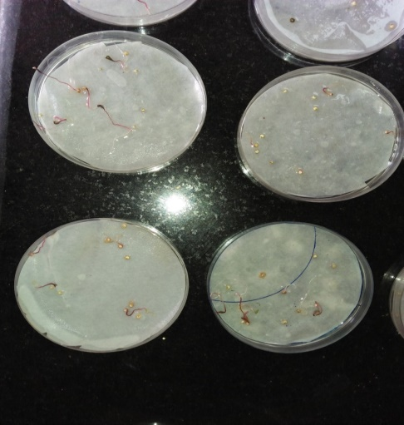
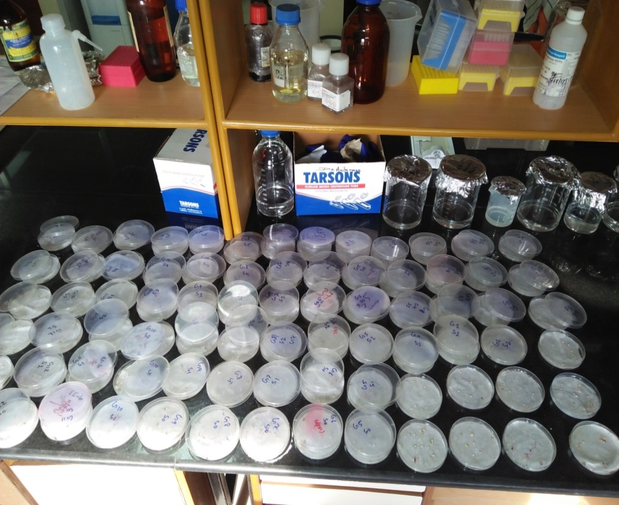

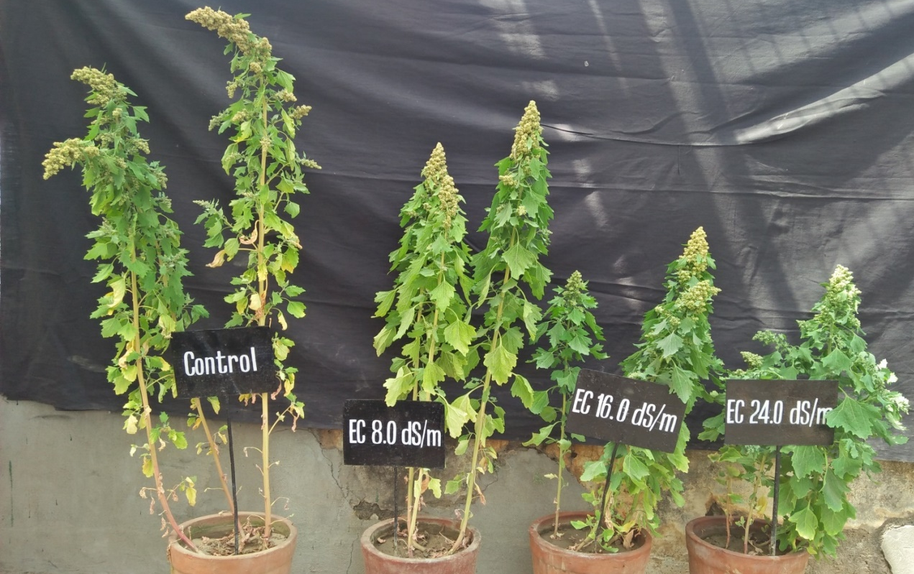
Figure 1: Germination test in petri plats
Figure 2: Effect of salinity on quinoa
Table1: Effect of irrigation water salinity on RWC in leaves of quinoa germplasms
Germplasm | Salinity (EC of irrigation water, dS/m) |  |  |  | Mean
 | BAW | 08 | 16 | 24
EC507744 | 82.8 | 75.6 | 75.7 | 69.7 | 75.9
EC507742 | 79.7 | 80.5 | 73.0 | 72.3 | 76.4
IC411824 | 81.3 | 79.8 | 79.8 | 75.0 | 79.0
EC507741 | 76.8 | 69.5 | 74.8 | 70.9 | 73.0
EC507746 | 78.4 | 74.2 | 75.3 | 68.7 | 74.2
EC507738 | 77.4 | 76.4 | 75.7 | 75.0 | 76.1
EC507748 | 80.0 | 75.0 | 74.9 | 68.7 | 74.7
EC507739 | 77.8 | 84.0 | 85.3 | 76.8 | 81.0
EC411824 | 82.4 | 74.5 | 73.6 | 70.7 | 75.3
EC507740 | 81.5 | 81.3 | 80.3 | 72.7 | 78.9
IC411825 | 80.3 | 79.0 | 82.6 | 77.2 | 79.8
LC1 | 83.7 | 74.5 | 75.9 | 74.5 | 77.2
LC2 | 81.0 | 80.1 | 76.7 | 77.7 | 78.9
Mean | 80.2 | 77.3 | 77.2 | 73.1
 | Germplasm | Salinity | G×S
Sem± | 0.94 | 0.52 | 1.88
LSD (P=0.05) | 2.63 | 1.46 | 5.27

Table 2: Effect of irrigation water salinity on proline content in leaves of quinoa germplasms
Germplasm | Salinity (EC of irrigation water, dS/m) |  |  |  | Mean
 | BAW | 08 | 16 | 24
EC507744 | 82.8 | 75.6 | 75.7 | 69.7 | 75.9
EC507742 | 79.7 | 80.5 | 73.0 | 72.3 | 76.4
IC411824 | 81.3 | 79.8 | 79.8 | 75.0 | 79.0
EC507741 | 76.8 | 69.5 | 74.8 | 70.9 | 73.0
EC507746 | 78.4 | 74.2 | 75.3 | 68.7 | 74.2
EC507738 | 77.4 | 76.4 | 75.7 | 75.0 | 76.1
EC507748 | 80.0 | 75.0 | 74.9 | 68.7 | 74.7
EC507739 | 77.8 | 84.0 | 85.3 | 76.8 | 81.0
EC411824 | 82.4 | 74.5 | 73.6 | 70.7 | 75.3
EC507740 | 81.5 | 81.3 | 80.3 | 72.7 | 78.9
IC411825 | 80.3 | 79.0 | 82.6 | 77.2 | 79.8
LC1 | 83.7 | 74.5 | 75.9 | 74.5 | 77.2
LC2 | 81.0 | 80.1 | 76.7 | 77.7 | 78.9
Mean | 80.2 | 77.3 | 77.2 | 73.1
 | Germplasm | Salinity | G×S
Sem± | 0.94 | 0.52 | 1.88
LSD (P=0.05) | 2.63 | 1.46 | 5.27

Table3: Effect of saline water on yield parameters and yield per plant (g) of quinoa germplasms
Germplasm | No. of spikelets/plant | Average length of spikelet (cm) | Grain yield/plant  (g)
EC507744 | 29.3 | 4.3 | 6.86
EC507742 | 25.9 | 4.6 | 6.43
IC411824 | 30.4 | 4.0 | 6.79
EC507741 | 26.0 | 4.7 | 5.81
EC507746 | 28.4 | 3.9 | 5.19
EC507738 | 29.9 | 5.3 | 6.25
EC507748 | 27.6 | 5.1 | 6.87
EC507739 | 30.0 | 5.3 | 7.67
EC411824 | 27.8 | 5.1 | 6.25
EC507740 | 30.4 | 5.6 | 9.35
IC411825 | 27.4 | 4.1 | 7.41
LC1 | 28.9 | 4.7 | 7.80
LC2 | 30.6 | 5.8 | 9.21
Sem± | 0.5 | 0.13 | 0.40
LSD (P=0.05) | 1.4 | 0.35 | 1.13
Salinity (EC of irrigation water, dS/m)
BAW | 31.9 | 6.4 | 12.22
08 | 29.2 | 5.2 | 7.86
16 | 27.4 | 4.5 | 5.74
24 | 26.1 | 3.2 | 2.46
Sem± | 0.28 | 0.07 | 0.22
LSD (P=0.05) | 0.78 | 0.19 | 12.22

