Calling behaviour and male response to pheromone gland extracts of castor semilooper, Achaea janata L. (Lepidoptera: Noctuidae)

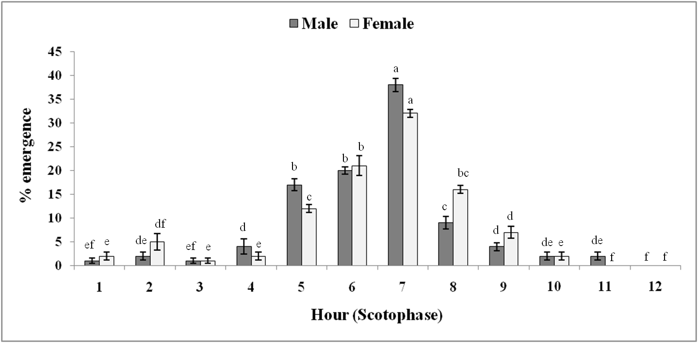
Emergence pattern of A. janata male and female

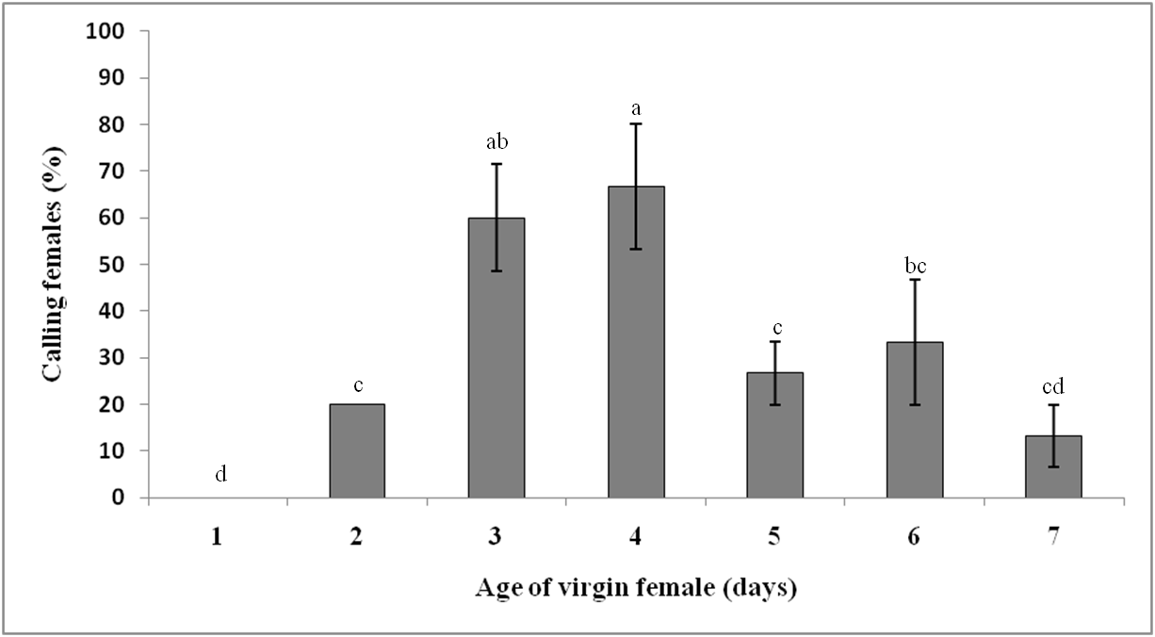
Calling behaviour of A. janata virgin females at different ages

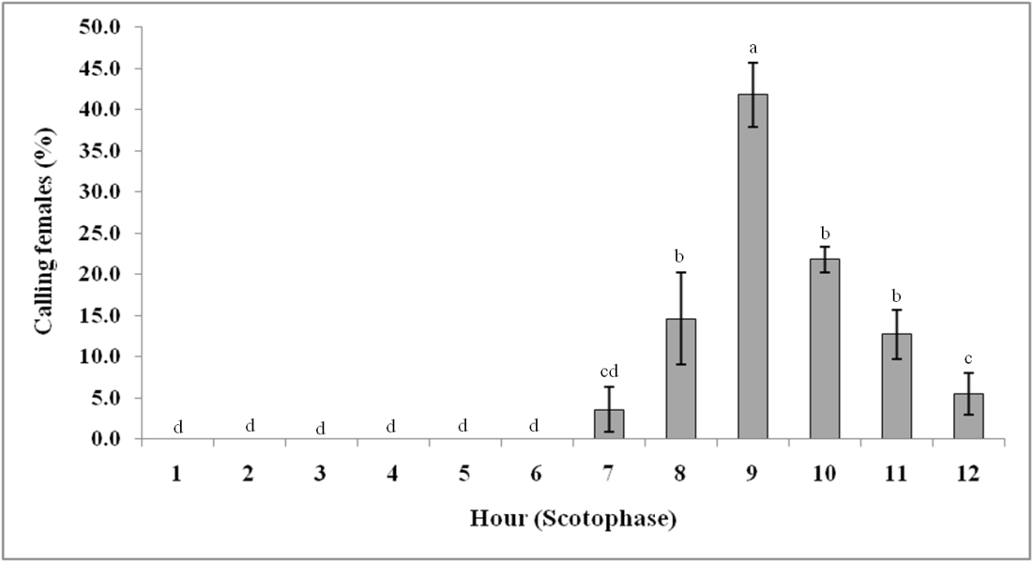
Temporal pattern of calling behaviour exhibited by A. janata females

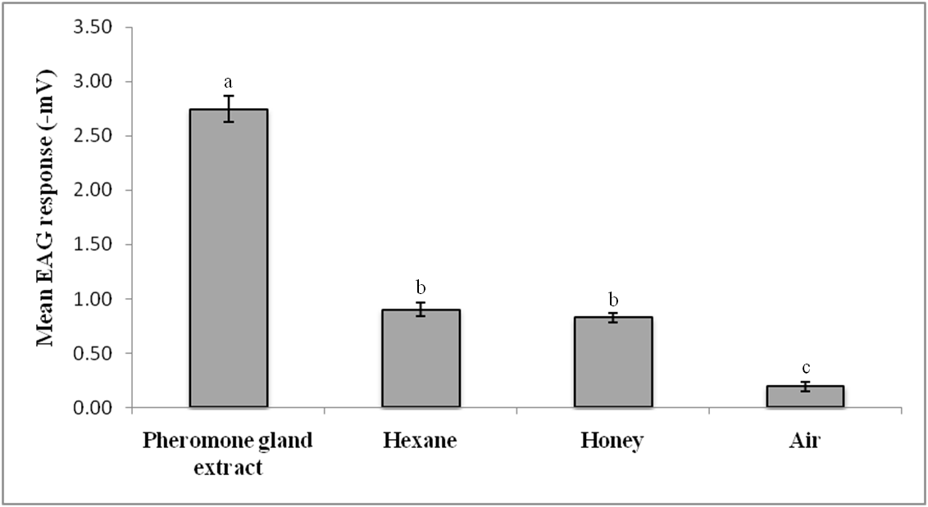
EAG response (in negative potential) of male A. janata to pheromone gland extracts and checks

