**Expression profiling (RT-PCR)**

**2014-15**

Primers for 12 candidate genes in castor were synthesised based on their role in sex expression in other crops and verified the amplification conditions using gradient PCR (Fig 3A). RNA was isolated from field grown plants of 3 varieties and RT-PCR (Fig 1) was carried out to verify the expression of candidate genes.

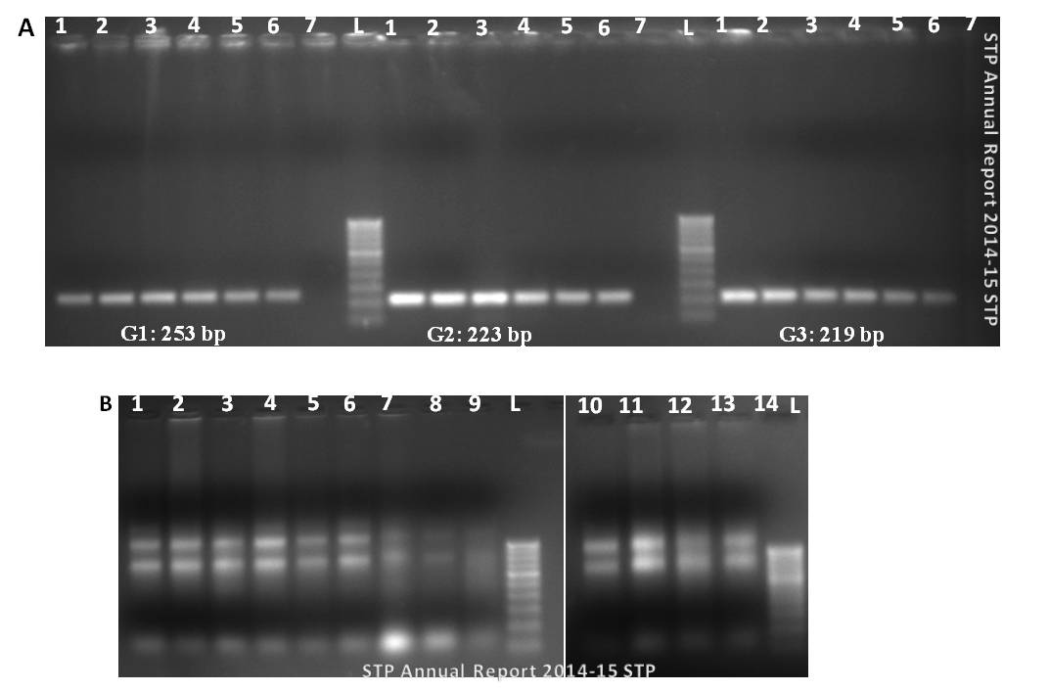

**Fig 1** A. Gradient PCR of 3 candidate genes involved in sex expression/ determination using castor genomic DNA. Lane 1,2,3,4,5 and 6 show amplification products at Tm(annealing temperature) of 45°C, 48°C, 53°C, 58.5°C, 61°C and 64.7 °C respectively. Lane 7 is negative control without genomic DNA. L is 100 bp ladder. B. Agarose gel electrophoresis showing total RNA isolated from different tissues from 3 varieties. Total RNA from monoecious line (Lanes 1-4), Pistillate line (Lanes 5-9) and from male line (Lanes 10-15) are shown. L is 100 bp ladder

**2015-16**

To understand the genes differentially expressed and determining sex expression, samples were collected from the field twice from 2 parental lines (monoecious and pistillate) at different stages for transcriptome sequencing and/gene expression profiling. Alternatively, gene expression profiling was done for 12 candidate genes in castor using primers synthesised based on their role in sex expression in other crops, at the amplification conditions verified using gradient PCR. Differential gene expression was observed for 3 candidate genes possibly involved in male and female flower development, in monoecious line, using RT-PCR with RNA isolated from 3 different tissues/ stages viz Shoot apical meristem before floral initiation, male and female flower buds.Gene expression analysis for 12 candidate genes was carried out in a monoecious line in 4 different tissues/ stages. Differential gene expression was observed for 3 genes. Ethylene synthesis genes were upregulated in male flowers and exhibited low expression level in female flowers indicating the role of ethylene in masculinization in castor. The results need to be reconfirmed.