Epigenetic mechanisms governing sex expression

2012-13
Epigenetic mechanisms play a major role in most of the development processes especially floral development. About 100 seeds of two parental lines were treated with a single concentration of epimutagen 5 aza 2' deoxy cytidine. The seedlings were germinated in pots and raised under controlled conditions in green house along with untreated controls. Observations are carried out regularly for the alteration in phenotype, if any in the epimutagen-treated plants.

2013-14
Seeds of 2 parental lines of castor were treated with 2 concentrations of epimutagen 2-deoxy 5-azacytidine and grown along with control plants. The variation in phenotype especially sex expression was monitored in the treated plants. No significant effect was noticed in the sex expression in both lines at 2 concentrations. Few seed-treated plants were injected with epimutagen. Higher proportion of male flowers was observed in 2 plants when compared to control (Fig. 1)

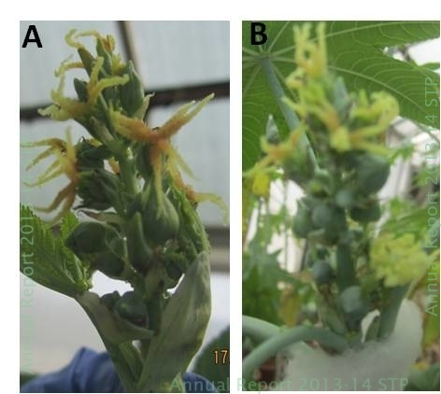

Fig 1. Effect of epimutagen treatment on sex expression in castor. Higher proportion of male buds observed in B. treated plants when compared to A. Untreated/control plants

2014-15
Seeds (120-140) of 3 parental lines of castor ( 2 monoecious lines and a pistillate line) were treated with 4 concentrations of epimutagen 2-deoxy 5-azacytidine along with control plants and grown in pots in controlled conditions. Few seed-treated plants were injected with epimutagen before and after primary inflorescence differentiation, along with control (Fig 2A). Injection had an effect on stage of differentiation. In field–grown plants of 3 parental lines, secondary or higher order spike buds, before and after differentiation were injected with 4 concentrations of epimutagen, in 2 sets. The variation in phenotype especially sex expression was monitored in the treated plants in controlled conditions and in field. A seed-treated and uninjected epimutant in a monoecious line exhibited stunting, rosette growth and completely male spike (Fig 2B). Few plants of a monoecious line with 70-80% male flowers exhibited variation in sex expression such as reduced percentage of male flowers and the male flowers were stunted and small (Fig 2C). However there was no significant effect of epimutagen seed treatment or injection on the monoecious line with 2 whorls (10-20%) of male flowers or the pistillate line grown under controlled conditions.. . This is in contrary to the earlier report of increased proportion of male flowers in 2 plants of this line. Also the lower proportion of male flowers in monoecious line with 70-80% male flowers needs to be reconfirmed. The plant in the middle row in controlled conditions were taller and had prolonged vegetative phase (ie)10X (concentration of epimutagen) taller than 20 X followed by 5 X and 1 X. Growth of inflorescence was stunted in 20 X (the growth inhibition being in the order 20X>10X>1X>/=5X) .Samples were collected from control and treated (injected) plants at regular intervals. The pollen from epimutagen treated plants did not show treatment-induced male sterility

Thus, Seed treatment of epimutagen 2-deoxy 5-azacytidine at 4 concentrations was carried out for 3 parental lines (DCS 107, DPC -9 RG 156). Alteration in the sex expression in few treated plants was observed in a monoecious line out of two monoecious line verified.

Fig 2. Effect of epimutagen on sex expression. A. Two monoecious lines and a pistillate line treated with 4 concentrations of epimutagen raised in pots under controlled environmental conditions. B. An epimutant of monoecious line showing stunting, rosette leaves and small spike with fully male flower buds. C. The monoecious line with 70-80% male flowers (control) shows reduced percentage of male flowers(20-30%) in the lower whorls in the 4 treated concentrations (treated).
2015-16
Sex expression in the progeny of epimutagen treated plants were verified. 5 seeds from each 4-5 parent line treated with a single concentration of epimutagen (either injected or seed treated alone) were sown to raise progeny plants. Progeny from parent lines of all 4 concentrations of 1X, 2X, 10X, 20X) in 2 monoecious and a pistillate variety/ line were raised. Nearly 280 plants were monitored for variation in sex expression but no significant difference in sex expression was observed in progeny but that of pistillate lines were showing monoecious offtypes. Floral differentiation was delayed when compared to the control in a monoecious variety and did not occur in majority of plants.

Table 1. Number of epimutagen-treated parental lines whose progeny was used for verifying alteration in sex phenotypes.
Concentration  Of epimutagen (2-deoxy 5-aza cytidine | Monoecious Line A1 (with 80 % male at bottom of spike) | Monoecious Line A2 | Monoecious Line B (30-50% male) | Pistillate Line
1X | 3 | - | 4 | 2
2X | 4 | - | 4 | 1
10X | 5 | 3 | 5 | 2
20X | 1 | 4 | 6 | 5
Control | 1 | 1 | 2 | 1

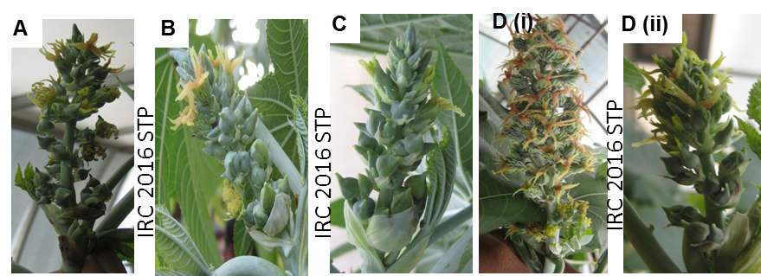

Fig 3. Sex expression in progeny of epimutagen treated plants. Monoecious line with 50% male flowers (DCS 107) showing no significant alteration in sex expression at (A) 1X concentration, (B) 5X and (C) 20X concentrations. (D) Control plants showing early inflorescence initiation and development.

