Probing the bisexuality in castor flowers

2015-16

Bisexuality of flowers was also probed where the pistillate and male lines exhibited gradation in bisexuality such as, fully developed male and female organs or with rudimentary stigma or stamens.Bisexuality precedes unisexuality and unisexuality is attained by selective growth arrest of opposite sex organs in castor flowers.At high temperatures, the pistillate inflorescence completely reverted to male inflorescence in higher orders above quarternary. Castor flowers belong to intermediary between class 1 and class 2 flowers.

Sex reversion occurs at floral and inflorescence level at high temperatures during summer. Reversion is unidirectional towards maleness, from female to bisexual in female flowers and from bisexual to male in spikes with terminal bisexual flowers. Sex alterations and reversions in spikes increases the proportion of male flowers.
Sex reversions, alterations as well as high sexual polymorphisms in castor are due to alterations in male/ female floral developmental pathways.

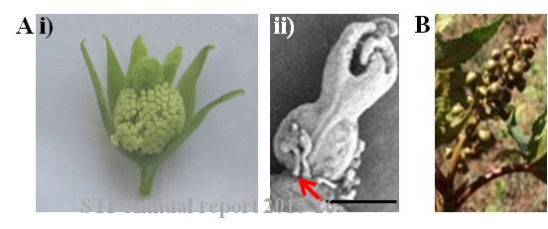
Fig 1. Bisexual flowers in castor parental lines A.(i) Bisexual flower showing fully developed ovary and stamens in crossed progeny of stable pistillate line. (ii) Bisexual flower showing rudimentary stamens. B. Reversion of pistillate inflorescence (with 1-2 bisexual flowers) to completely male inflorescence at high day temperatures of 39-42 °C.

