Protocols for mass rearing of fall armyworm Spodoptera frugiperda (J. E. Smith)
P. Lakshmi Soujanya¹, J. C. Sekhar¹, S. B. Suby², M. Lava Kumar Reddy³, S. Divya¹ and Sujay Rakshit⁴
¹ Winter Nursery Centre, ICAR-Indian Institute of Maize Research, Rajendranagar, Hyderabad - 500030, India
² ICAR - Indian Institute of Maize Research, Pusa Campus, New Delhi - 110 012, India
^{3.}Maize Research Centre, PJTSAU, Rajendranagar, Hyderabad - 500030, India
⁴ICAR-Indian Institute of Maize Research, PAU Campus, Ludhiana, Punjab - 141004, India
Introduction
Fall armyworm Spodoptera frugiperda (J. E. Smith) is an invasive lepidopteran pest which feeds on maize causing substantial damage. FAW is polyphagous pest originated from the tropical and subtropical regions of America. FAW has the potential to cause maize yield losses in a range from 8.3 to 20.6 m tonnes per annum, in the absence of any control methods which represents a range of 21%–53% of the annual production of maize (Day et al. 2017). Pest populations are being controlled through pheromones, host plant resistance, mechanical control and also through chemical insecticides. The effectiveness of these methods is determined by evaluating biological parameters of test insects using bioassays. For running successful bioassays availability of healthy insects in substantial numbers is essential to meet the requirements. Vanderzant (1966) reported that mass rearing of insects can either be achieved by growing them on their respective host plants or by providing a suitable and nutritionally adequate medium to support their growth and development. Despite the several artificial diets suitable for FAW, its larval cannibalistic behavior is considered as a challenge for most rearers. Efficient mass rearing is possible with the addition of slightly more space and equipment. Basic requirements include a separate diet preparation area, a larval rearing room, and an adult emergence/oviposition room. The rearing and oviposition rooms require controlled temperature (18-30⁰C), humidity (50-95% R.H.) and photoperiod. FAW can be reared in many types of containers including glass vials or cups, ice cube trays (Bailey and Chada, 1968), and "jelly cups" (Burton and Cox, 1966; Burton, 1967).
Diet Ingredients and Preparation
The mass rearing of fall armyworm can be done both under natural and artificial diets. The detailed protocols are mentioned below.
Natural diet
To raise the initial culture of fall armyworm in the laboratory, minimum number of 100 larvae to be collected from maize fields. Field collected larvae were reared in plastic jars (1 L capacity) containing tender cut baby corn pieces. The baby corn is to be washed with Sodium hypochlorite and rinse with water to prevent contamination before used as feed. The larvae from third instar were transferred to multi-well (50) tissue culture plates (length-26 cm; width-13.5 cm) due to cannibalistic behaviour in mature larvae of fall armyworm. Every day sufficient amount of cut baby corn pieces are to be provided to fall armyworm larvae as a food. All the pupae obtained were collected and kept in separate jars for adult emergence. Newly emerged moths from pupae were carefully removed and released in oviposition cage containing 5-8 day old potted maize plants (BML 6) (Lakshmi Soujanya 2018, Un published data). Honey solution (10% W/V) was provided as food to the moths by soaking 3 cm cotton plug in the solution. The portion of leaves bearing egg masses were carefully removed, transferred to petri-plates with tender portion of baby corn and can be utilized for further studies. However, rearing FAW on their natural host may not be feasible every time for several reasons, such as seasonal availability, excessive costs, and variable quality. Therefore, artificial diets that bear little resemblance to their natural host may provide satisfactory growth and development of insects.

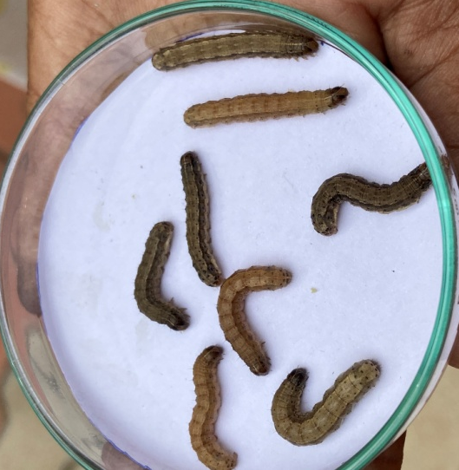
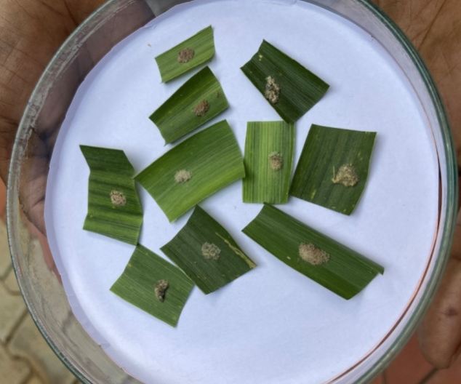

Plate 1a. Egg masses Plate 1b. Mature larvae
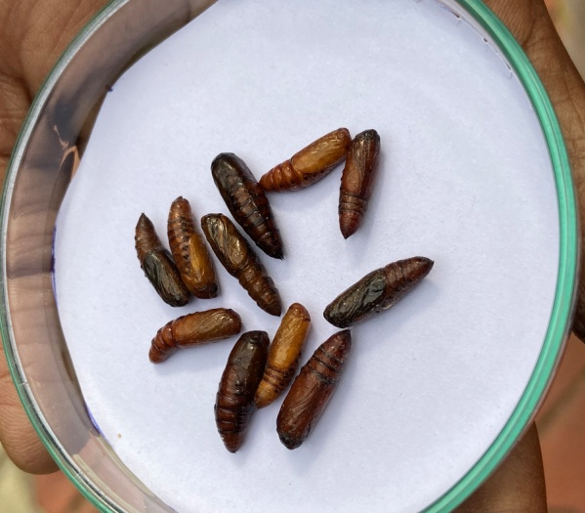

Plate 1c. Pupae Plate 1 d. Adults
Plate 1. Egg masses (1a), larvae (1b), pupae (1c) and adults (1d) obtained in the laboratory when reared under natural diet-Babycorn

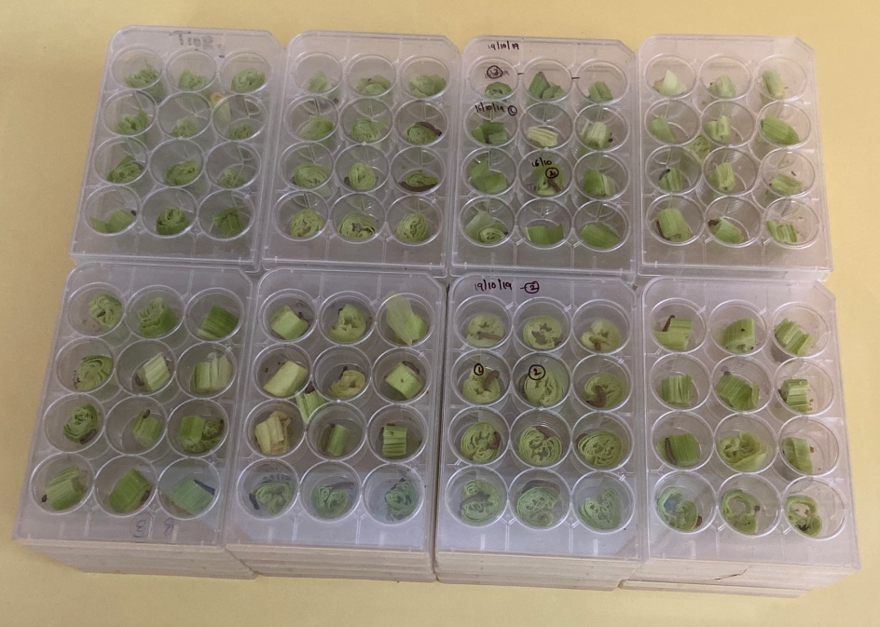
Plate 2: Rearing of FAW larvae in multi-well tissue culture plates

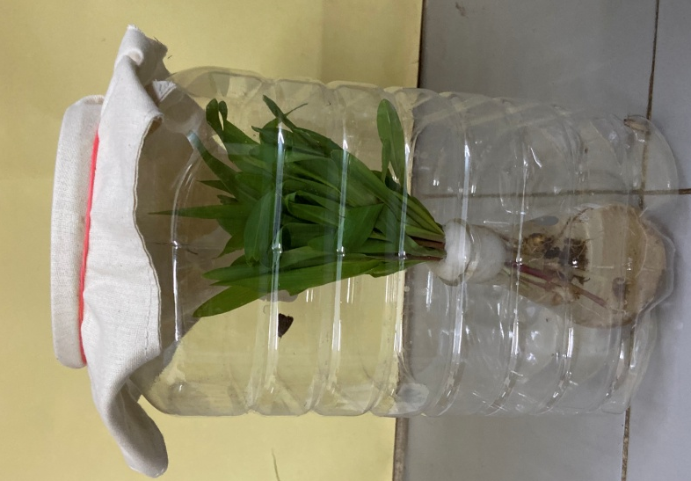

Plate 3: Oviposition cage with 5-8 day old potted maize plants

Artificial/Synthetic diet
The use of artificial diets to rear insects promotes knowledge about the biology, behavior, and nutritional requirements of insects, which is fundamental for the development of efficient integrated pest management programs. Several diets have been successfully used to rear FAW in the laboratory. Because of the FAW's polyphagous nature, it can be reared on many diets that have been developed for other species. One of the first artificial diets used to rear FAW was the wheat germ diet developed for the European corn borer, Ostrinia nubilalis (Hubner), where first instar larvae were started on corn and transferred to artificial diet in the second instar (Revelo and Raun 1964). Burton (1967) was the first to develop mass rearing techniques for the FAW solely on an artificial wheat germ diet. The more economical modified pinto bean diet, developed for rearing the corn earworm, Heliothis zea (Boddie) (Burton 1969), was subsequently used for rearing the FAW. Numerous modifications of the rearing procedures have been made to more efficiently rear the FAW, but the modified pinto bean diet remains the standard diet of choice (Perkins 1979). The FAW has been reared in the laboratory for over 360 generations on the modified pinto bean diet.
Diet Ingredients for fall armyworm (Modified Pinto bean diet -Burton 1969)
S.No | Ingredient | Quantity
1. | Pinto beans | 111 g
2. | Torula Yeast | 33.8 g
3. | Ascorbic acid | 3.4 g
4. | Wheat germ | 52.8 g
5. | Methyl-p-hydroxy benzoate | 2.1 ml
6. | Sorbic acid | 1.1 g
7. | Formaldehyde (10%) | 8.4 ml
8. | Water (For mixing above ingredients) | 490 ml
9. | Agar | 13.5 g
10. | Water (For Agar solution) | 338.0 ml

To prepare the diet, beans can be ground to the fineness of 35 mesh with a commercial grinder. Beans can also be soaked overnight in water plus a small amount of formaldehyde.
FAW can also be successfully mass-produced on maize stem borer diet, as practiced by CIMMYT in Africa. Several synthetic diets have been optimized by various institutions, including International Centre for Wheat and Maize Improvement Centre (CIMMYT), International Institute of Tropical Agriculture (IITA), International Centre of Insect Physiology and Ecology (ICIPE), and the Agricultural Research Council (ARC)-South Africa, based on local availability of ingredients. The synthetic insect diet is a combination of nutritive substances including carbohydrates, proteins, fat, minerals, and vitamins. Each fulfills a specific function in the development of the insect and influences the safe shelf life of the constituted diet.
a) CIMMYT Diet
Fraction A: Mix all the powdered ingredients except methyl-p-hydroxybenzoate from Fraction A using a plastic spoon, in a clean container under a fume hood. Boil the distilled water, cool it to 60°C, and then mix with the pre-mixed ingredients using a blender for 1 minute. Add methyl-p-hydroxybenzoate (dissolved in 20ml of absolute ethanol) to the mixture in the blender, and then blend for a further 2 minutes.
Fraction B: Weigh agar powder in a separate container and then add to cold distilled water in a separate saucepan. Boil while stirring periodically, and then cool to 60°C. Add the ingredients of Fraction B to Fraction A and blend for 3 minutes.
Fraction C: Finally, add 40% formaldehyde to the ingredients of Fractions A and B in the blender and then mix for 3 minutes at room temperature.
b) ICIPE diet
Prepare Fractions A-C as described for the CIMMYT diet, using the ingredients and quantities listed for the ICIPE diet (Table 1).
c) ARC-RSA diet
Fraction A: Mix all dry ingredients in Fraction A well with 1,500ml distilled water in a container.
Fraction B: Boil 1,000ml distilled water, add 7.5g sorbic acid, and stir periodically until the sorbic acid is dissolved. In a separate container, add agar to 1000ml water and mix well. Add agar mix to sorbic acid mix. Boil for 10 minutes. Let Fraction B cool down to 70°C, then add it to Fraction A and mix well with a blender.
Fraction C: Add formaldehyde (40%) to the mix of Fraction A and B. Dissolve Nipagen (3g) in 75ml ether. Add to the mix of Fraction A and B. Dispense an appropriate volume of the diet into plastic trays, jars, or vials.
Table 1. Three potential diet ingredient options used presently for rearing FAW
S.No | Ingredients | CIMMYT  Quantity g or ml per 3 L diet | ICIPE  Quantity g or ml per 3 L diet | ARC-RSA  Quantity g or ml per 3 L diet
Fraction A
1. | Maize leaf powder | 75.6 g | 75.0 g | -
2. | Common bean powder | 265.2 g | 187.5 g | -
3. | Chickpea | - | - | 250 g
4. | Wheat germ | - | 150.0 g | 225 g
5. | Brewer’s yeast | 68.1 g | - | 45 g
6. | Torula yeast | - | 32 g | -
7. | Milk powder | - | 57 g | 45 g
8. | Ascorbic acid | 7.5 g | 9 g | -
9. | Sorbic acid | 3.9 g | 4.5 g | -
10. | Methyl-p hydroxybenzoate | 6.0 g | 7.5 g | -
11. | Vitamin E capsules | 6.3 g | - | -
12. | Multivitamin drops | - | 3.0 ml | -
13. | Sucrose | 105.9 g | - | -
14. | Distilled water | 1,209.3 ml | 1350 ml | 1500 ml
Fraction B
1. | Agar (Tech No.3) | 37.8 g | 34.5 g | 50 g
2. | Distilled water | 1,209.3 ml | 1200 ml | 1000 ml
3. | Sorbic acid | - | - | 7.5 g
Fraction C
1. | Formaldehyde 40% | 6.0 ml | 6.0 ml | 1.0 ml
2. | Suprapen p  (Tetracycline) | - | 7.5 g | -
3. | Nipagen | - | - | 3 g
4. | Ether | - | - | 75 ml
Sources: CIMMYT diet – adapted from Tefera et al. (2011); ICIPE diet – Sevgan Subramanian (ICIPE, Kenya), personal communication; ARC-RSA diet – Erasmus Annemie (ARC-Grain Crops, RSA), personal communication.
Surface-disinfested black-head eggs or neonate larvae are to be released into the prepared diet. Several FAW neonates can be introduced into the same container. However, at the third instar, the larvae need to be transferred to multiwell tissue culture plates because of their cannibalistic nature. Keep the multiwell tissue culture plates containing the larvae on shelves in the larvae-rearing room under controlled environmental conditions (27±1°C; 65±5% RH; 12:12 light:dark photoperiod).
The larval and pupal development has to be monitored daily to identify problems such as contamination with fungi or insects, and discard any affected diet containers immediately. Begin close monitoring for pupal harvesting 14-20 days after diet infestation, and daily thereafter to avoid moth emergence within rearing jars. Harvest pupae at once when at least 50% of the larvae have pupated. Clean the pupae with a gentle spray of distilled water, and place on tissue paper to drain excess moisture. Transfer the pupae to clean vials lined with moist tissue paper. Keep the vials at room temperature (25±1°C); 12:12 light:dark photoperiod; and a relative humidity of 75±5%. Newly emerged moths from pupae were carefully removed and released in oviposition cage (Plate 2) containing 5-8 day old potted maize plants (BML 6). On a daily basis, check each oviposition cage and collect eggs that have been oviposited on plant leaves. Surface-disinfect the eggs by dipping them in 10% formaldehyde for 15 minutes, rinsing them thoroughly using distilled water, and then drying them on filter paper. Transfer the surface-disinfested egg batches on waxed paper into clean plastic containers.
Several other larval diets were evaluated and modified by various researchers. Silva and Parra (2013) reared FAW larvae since the second instar to pupation in rectangular plastic containers containing 40 individuals and observed 90% larval survivorship with below mentioned diet.
Diet Ingredients for fall armyworm (Greene et al. 1976; Silva and Parra 2013 )
S.No | Ingredient | Quantity
1. | Water | 3400 ml
2. | Gelcarin | 46 g
3. | Pinto beans | 250 g
4. | Wheat germ | 200 g
5. | Soybean Protein | 100 g
6. | Casein | 75 g
7. | Torula Yeast | 125 g
8. | Ascorbic acid | 12 g
9. | Vitamin mixture (Vanderzants NBC) | 20 g
10. | Tetracycline | 250 g
11. | Formaline (40%) | 12 g
12. | Methyl-p-hydroxy benzoate | 10 g
13. | Sorbic acid | 6 g

Combine ingredients 1 and 2 at room temperature in a 4-liter pyrex beaker and mix thoroughly. Sequentially add ingredients 3-7 while heating the solution to 75°C.Continue mixing while the temperature cools to 68°C. Add ingredients 8-13, blend at high speed for one minute and pour into rearing containers.
Pinto et al. (2019) evaluated three types of artificial corn based diet for rearing FAW including standard diet based on beans (D₁), a diet with corn flour as substitute for wheat germ (D₂), and a diet replacing beans with green corn (D₃). Results showed that the most adequate diets for rearing FAW in the laboratory are D₁ and D₃.
Diet Ingredients for fall armyworm (Pinto et al. 2019)
S.No | Ingredient | Quantity
 |  | D1 | D2 | D3
1. | Bean | 240 g | 240 g | -
2. | Green Corn | - | - | 60 g
3. | Wheat germ | 120 g |  | 120 g
4. | Corn Flour |  | 240 g
5. | Brewer’s Yeast | 72 g | 72 g | 72 g
6. | Ascorbic acid | 7.3 g | 7.3 g | 7.3 g
7. | Sorbic acid | 2.4 g | 2.4 g | 2.4 g
8. | Methylparahydroxy benzoate (Nipagin) | 4.4 g | 4.4 g | 4.4 g
9. | Vitamin solution | 10.0 ml | 10.0 ml | 10.0 ml
10. | Formaldehyde (40%) | 6.0 ml | 6.0 ml | 6.0 ml
11. | Agar | 20.0 g | 20.0 g | 20.0 g
12. | Distilled water | 1.0 ml | 1.0 ml | 1.0 ml

Composition of the vitamin solution used for artificial diets
S.No | Component | Amount
1 | Niacinamide | 4 mg
2 | Calcium pantothenate | 4 mg
3 | Thiamine HCl | 1 mg
4 | Riboflavin | 2 mg
5 | Pyridoxine Hcl | 1 mg
6 | Folic acid | 1 mg
7 | Biotin | 0.08 mg
8 | Vitamin B12 | 0.008 mg
9 | Distilled Water | 400 ml

Precautions
Insect artificial diets are also suitable for growth of some microorganisms, including bacteria, fungi and viruses. Most of these microorganisms are pathogenic to insects and may cause an outbreak in laboratory, and other contaminating organisms may cause spoilage of the artificial diet. Sources of microbial contamination can include field-collected insects; improper handling of the insects; an insufficiently clean insectary environment; or inadequate sterilization of the containers and diets during preparation, storage, and use. Immediate removal and disposal of contaminated diets and infected insects; proper sterilization of diets, working areas, and utilities; good personnel hygiene; and following recommended occupational safety guidelines will minimize microbial contamination in an insectary. Moth scales and toxic fumes during sterilization can cause respiratory problems and allergies. Therefore, all insectary personnel must wear a laboratory coat, hand gloves, and face-mask in the laboratory.
References
Bailey DL and HL Chada. 1968. Effects of natural (sorghum) and artificial (wheat germ) diets on development of the Corn Earworm, Fall Armyworm, and Southwestern Corn Borer. Journal of Economic Entomology 61(1): 257-260.
Burton RL and HC Cox. 1966. An automated packing machine for lepidopterous larvae. Journal of Economic Entomology 59(4) : 907 -9.
Burton RL.1967. Mass rearing the Fall Armyworm in the laboratory. USDA-ARS 33-117.12 pp.
Burton RL.1969. Mass rearing the CEW in the laboratory. USDA-ARS 33-134. pp.
Day R, Abrahams P, Bateman M, Beale T, Clottey V, Cock M, Colmenarez Y, Corniani N, Early R, Godwin J and Gomez J. 2017. Fall armyworm: impacts and implications for Africa. Outlooks on Pest Management 28(5):196-201.
Greene GL, Leppla NC and Dickerson WA. 1976. Velvet bean caterpillar: A rearing procedure and artificial medium. Journal of Economic Entomology 69: 487–488.
Perkins, W. D. 1979. Laboratory rearing of the fall armyworm. Florida Entomologist 62: 87·91.

Pinto JRL, Torres AF, Truzi CC, Vieira NF, Vacari AM and De Bortoli SA. 2019. Artificial Corn-Based Diet for Rearing Spodoptera frugiperda (Lepidoptera: Noctuidae). Journal of Insect Science 19(4):2 doi: 10.1093/jisesa/iez052.
Revelo MA and E S Raun. 1964. Rearing the fall armyworm under greenhouse conditions. Journal of Economic Entomology 57: 1000.
Silva CSBD and Parra JRP. 2013. New method for rearing Spodoptera frugiperda in laboratory shows that larval cannibalism is not obligatory. Revista Brasileira de Entomologia 57(3) http://dx.doi.org/10.1590/S0085-56262013005000029.
Tefera T, Mugo S, Tende R and Likhayo P. 2011. Mass rearing of stem borers, maize weevil and larger grain borer insect pests of maize. CIMMYT: Nairobi, Kenya.
Vanderzant ES. 1966. Defined diets for phytophagous insects. Insect Colonization and Mass Production (ed. by CN Smith), pp. 273– 303. Academic Press, New York, NY, USA.

