**ICAR-CIPHET, Ludhiana developed Low Cost Portable Ozone based Fruits and Vegetable Washer-Cum-****Purifier (Ozo-C)**

During the Covid-19 pandemic as people bring home fruits, vegetable, mutton and fish. The fear of contracting corona virus from the same also looms large. To ensure food safety, when we buy such commodities from the vendors and bring home is cause of concern, a suitable gadget with standard protocol is urgently required to ensure complete safety of commodities at home.

Keeping in view the present grim situation of Covid-19, The ICAR-CIPHET, Ludhiana has addressed the issue and developed a Portable Fruits and Vegetable Washer-Cum-Purifier named Ozo-C based on Ozone technology. Dr R.K.Singh, Director, ICAR-CIPHET informed that the portable system is an excellent ozonator which removes pesticides, bacteria, viruses and harmful chemical from the surface of fruits and vegetable, sea foods and meat making them hygiene.

The system works on principle of silent “corona discharge method”. It uses electric discharge to produce ozone by splitting the normal oxygen molecules in the air into single atoms. These atoms recombine with air (i.e O2) to form ozone (O3). The device was made with a unit cost of Rs.3500 and it is successfully demonstrated at ICAR-CIPHET, Ludhiana for use.

**Features and usage of Ozo-C**

1. This Ozone based device comprises of PVC box, air blower, ozone generator, ozone air distribution system, timer and on-off switch.The operation of developed device is very simple and user friendly.
2. Take a container and put the fruits and vegetables in it.
3. Fill the container till water level is above fruits and vegetable to be cleaned. Dip the silicon tube with air stone into the container.
4. Set the time of operation (15 -30 min based on commodity) and switch on the power supply.
5. The device will automatically stop after expiry of set time. Remove the stone and throw the treated water.
6. Finally clean and rinse the fruits and vegetables with fresh running water.
7. The cleaned fruits/vegetables are now ready to use for consumption. We can also store the item for later use.
8. The device is compact in design, requiring a small space of 28 cm length, 24 cm width and 10 cm height and weigh only 1.8 Kg.
9. Its ozone output is 100-200 mg/h and its output air pressure is 0.2 kg/cm2.
10. The device operates on a 220 V-240 AC single phase power supply.

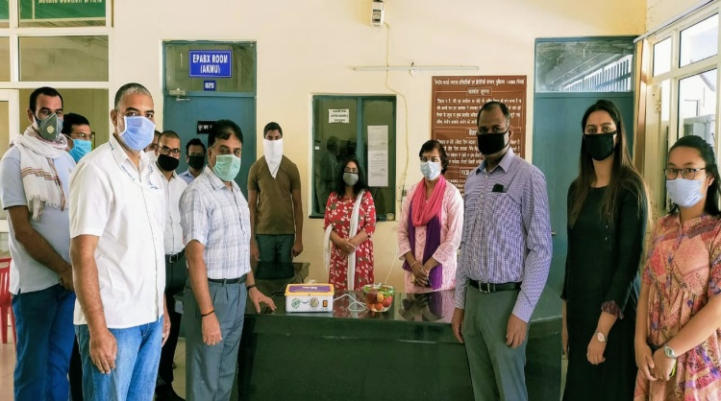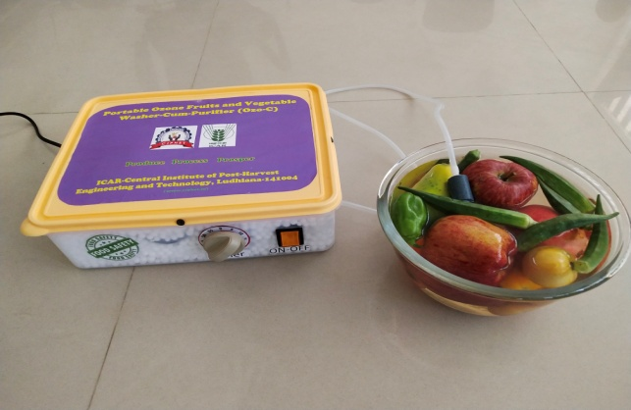

**Portable Ozone Fruits and Vegetable Washer-Cum-Purifier (Ozo-C)**

The Ozone technology based Portable Fruits and Vegetable Washer-Cum-Purifier (Ozo-C) is the need of the hour as fruits and vegetable safety and quality have become more important now in the wake of the COVID-19 pandemic.This compact device may find a place in every kitchen, hotels, small scale fruit vegetable processors and vendors where it can play a vital role in reducing the risk of infection especially during this pandemic period. This portable system has been designed and developed by Dr. Ranjeet Singh, Dr. K. Narsaiah, and Ms. Surya Tushir under the guidance and support of Dr. R.K. Singh, Director, ICAR-CIPHET, Ludhiana.