Modern Technologies in Indian Agriculture
April 4, 2019
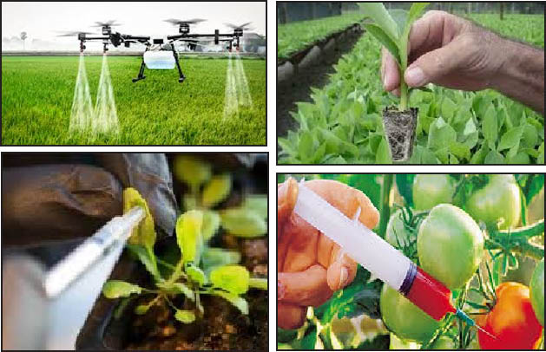
Dr. Hannah Krujia
ACTO Agronomy, KVK Phek
Modern agricultural farming methods increase the production in almost every agriculture and allied sector. Using modern agriculture and farming is a must because modern farming methods can increase production and can feed the world. Major parts of the population are directly or indirectly involved with agriculture and farming business. Income source of people are limited, so raising of poultry birds, dairy, fish, sheep, goat etc. can be a great source of earning some extra income. As well as it will ensure availability of food for the next generation and ever increasing population. Modern Agricultural Technology is all about to reduce human efforts. By applying these practices the farmers can gain more profit and at the same time, increase their productivity of yield.
Information Technology in Agriculture (IT):
- It helps the farmers to receive appropriate ideas and make decisions to increase the productivity of their yield.
- This is also useful to know information on weather forecasting and climatic conditions.
- Information Technology is helpful in spontaneous and better agricultural practices.
- Helps in exploring the marketing system, price and reduction in agricultural risks and enhances income.
- It is useful to implement online trading of the agricultural produce.
- Information Technology optimizes the use of various inputs like Fertilizers, Water, Pests and Seeds.
Global Positioning System Technology (GPS):
- GPS technology is widely used by large farmers.
- By applying the GPS devices to the tractors it can set your machine in an auto driving mode, in this process it ploughs the field easily without using human labour.
- Programmes and instructions are set to do the land preparation, sowing, seeding, watering and we can set it to apply fertilizers in the field.
- GPS technology helps the farmers to save time and money in variable aspects.
Plant Breeding:
- Plant breeding can increase the yield and productivity of the crops.
- It is useful in developing new varieties of crop from a single crop.
- Breeding can introduce Sexual reproductive plants through use of a seed.
Tissue Culture:
- This is used to produce a number of varieties of crops from a single genome of the plant.
- Tissue Culture produces a number of crops at lesser space.
- Tissue Cultured plants produces varieties of crops which can give more yield and at the same time that are highly resistant to diseases.
- They can grow easily without the application of fertilizers and pesticides.
Genetically Modified Organism (GMOs):
- GMOs are helpful in resisting the crops from harmful chemicals and fertilizers.
- Some parts of the plants are not used for the cropping system. Hence with the help of the GMOs in that portion, we can implement the waste parts of those crops and can be used in the productivity.
- The GMO crops produced in the laboratories are by applying the practices of Breeding and Tissue culture.
- GMOs crops are resistant to drought, high temperature and can survive without application of water.
Nanotechnology:
- Nanotechnology is extensively helpful in agriculture
- It is useful to protect the crops in the field and can monitor the growth of plants and detect any diseases in crop plants
- One of the techniques like Electroscoping is helpful to absorb the fertilizers and pesticides in the crop field.
- This technology is useful in studying the plant hormones and regulations.
- Nanobarcodes and Nanoprocessing are useful in monitoring the quality of agriculture products.
- Carbon Nanotubes are useful in detecting and killing the pathogens and viruses in the crops.
- They can induce the growth of roots and seed germination with the help of auxins.
These are some of the different Modern Technology in Agriculture in India that can be used in the farms to increase the productivity of crops. The frequent climatic changes taking place has caused damage and a great loss to the farmers. Owing to the growing population there is more need and demand for food and due to urbanization there is more demand for land so producing more in less available and cultivable land is a great challenge. Since there are many advantages of modern technology in agriculture, farmers should select wisely this technologies for enhancing the production and productivity.

