Exp-II b. Rapid screening of sunflower genotypes for P acquisition in soil with differential P levels-Poly bag technique (2013-2016)
Based on the protocol for rapid screening of sunflower in solution culture, the critical P level for sunflower to express deficiency symptoms and poor dry matter was between 2-4ppm. A method was devised to screen genotypes simulating soil condition. Poly bag technique was adopted to screen genotypes to study the root morphology and microbial association responsible for high P acquisition against differential P levels in soils. Based on two years study, it was found that 4 genotypes out of 77 were efficient in P acquisition under stress situation. These four were further evaluated for its P acquisition and root parameters under stress situation in the final year of the project in 2015-16.

Technical details
- No of identified genotypes: 4 (HOHAL-17, CSFI-5075, HOHAL-22 & CSFH-8712)
- 2 P levels: 1. Low P soil (9.3kg/ha) and 2. High P soil (58 kg/ha)
- Uniform N and K was applied as per RDF
- No of Replication: 5
- DOS: 17-08-2015
- DOH: 20-09-2015
- Checks: CMS-335A & DRSH-1
- CMS-335A was excluded due to poor germination

Objective 1: To evaluate identified sunflower genotypes for P acquisition at stressed (NMNF=8.4 kg P/ha) and sufficient levels (150% RDF=58 kg P/ha) of LTFE soil
Results Highlights
 | P Content (%) |  |  | Dry matter (g/pl) |  |  | P Uptake (mg/g)
Genotype | P1(+P) | P2(- P) | Mean | P1(+P) | P2(- P) | mean | P1(+P) | P2(- P) | Mean
HOHAL-17 | 0.23 | 0.40 | 0.32 | 1.37 | 3.06 | 2.21 | 3.28 | 12.42 | 7.85
CSFI-5075 | 0.41 | 0.32 | 0.36 | 2.18 | 1.76 | 2.22 | 8.93 | 5.69 | 7.33
HOHAL-22 | 0.39 | 0.31 | 0.35 | 2.08 | 2.23 | 2.15 | 8.31 | 6.98 | 7.65
CSFH-8712 | 0.29 | 0.22 | 0.25 | 1.50 | 0.69 | 1.09 | 4.49 | 1.55 | 3.02
DRSH-1 | 0.41 | 0.18 | 3.00 | 1.57 | 0.46 | 1.02 | 6.48 | 0.86 | 3.67
Mean | 0.35 | 0.29 |  | 1.84 | 1.64 |  | 6.73 | 5.50
CV(%) | 9.24 |  |  | 9.67 |  |  | 12.89
CD (0.05) Genotype | 0.028 |  |  | 0.15 |  |  | 0.75
P levels | 0.017 |  |  | 0.10 |  |  | 0.45

Objective 2: To evaluate identified sunflower genotypes for root variation grown under P stressed and sufficient conditions

 | Root length (cm/pl) |  |  | Root volume (cc/pl)
Genotype | P1(+P) | P2(- P) | mean | P1(+P) | P2(- P) | Mean
HOHAL-17 | 22.4 | 27.0 | 24.7 | 5.32 | 15.17 | 10.25
CSFI-5075 | 22.1 | 33.7 | 27.9 | 7.12 | 8.32 | 7.72
HOHAL-22 | 15.8 | 15.8 | 15.8 | 5.17 | 5.17 | 5.17
CSFH-8712 | 17.5 | 17.0 | 17.2 | 1.82 | 1.82 | 1.82
DRSH-1 | 21.6 | 13.9 | 17.8 | 7.32 | 1.37 | 4.35
Mean | 19.9 | 20.7 |  | 5.35 | 6.37
CV(%) | 9.01 |  |  | 4.06
CD (0.05) Genotype | 0.50 |  |  | 0.78
P levels | 0.31 |  |  | 0.48

Results and Discussions
Based on the previous screening trials, four P efficient sunflower genotypes viz., HOHAL-17, CSFI-5075, HOHAL-22, CSFH-8712 and a check (DRSH-1) were further evaluated during kharif 2015 in order to validate P acquisition trait of genotypes in soils collected from the LTFE experiment treatments (No manure no fertilizer treatment plot for Low P and the soil from 150% RDF treatment for high P situations, respectively). The results showed that the highest P acquisition was noticed in genotype HOHAL-17 (7.2mgP /g dry matter) under P stress situation and was followed by CSFI-5075 (5mgP/g DM). Further, the results pertaining to root parameters under low P situation, genotype HOHAL-17 showed the highest root volume (16cc/pl) followed by CSFI-5075 (9 cc/pl). Similarly, highest root length was observed in CSFI-5075 (33cm/pl) and followed by HOHAL-17 (27cm/pl). Genotypes with such root traits could be responsible for high P acquisition in marginal P soils and further has to be evaluated in different soil types. Hence, a pot experiment during rabi 2015-16 has been planned to evaluate the above genotypes in black soils for acquisition of native P. Growth of genotype HOAL-17 under differential P situation is shown in fig1 (LHS and RHS) below.

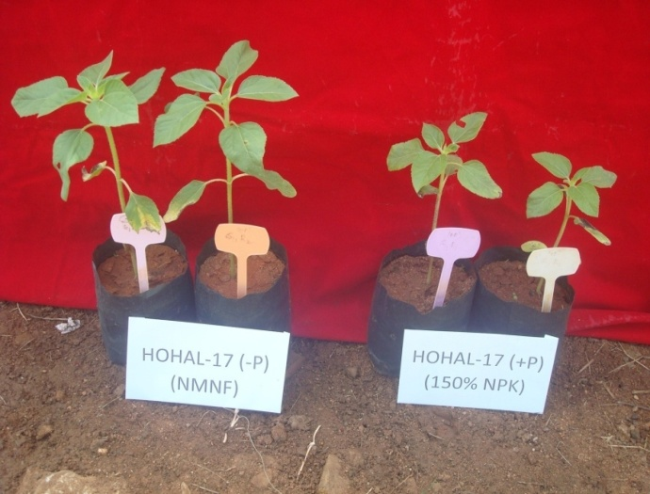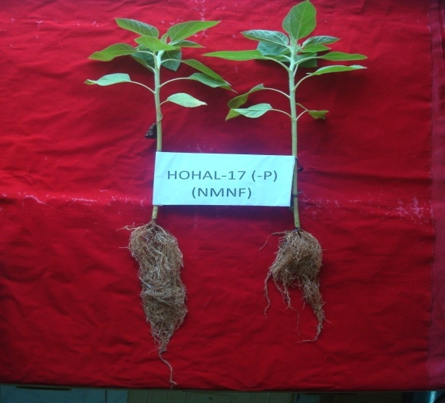
Fig1. Left image: Genotype HoHAL-17 in low P soil (8.4 kg/ha; LHS) and P sufficient situation high P soil (58 kg/ha; RHS). Right image: Root growth of HOHAL-17 in P starved soil at 30 days during 2015-16.

