Activity 3.4. Disease management of Powdery mildew disease of sunflower
Powdery mildew generally occurs late enough in the season and has become an epidemic warranting management.
Cultural practices
- Powdery mildew infection on sunflower occurs when the crop is at flowering or grain formation stages when fungicides are seldom used. Hence, reducing the likelihood of the disease outbreak is more effective than trying to control the disease once it is established.
- Sunflower cultivation should be taken up in areas that receives full sun most of the day and should be avoided in situations of high humidity.
- Irrigating the crop in the morning limits the build-up of humidity in the crop during the night.
- High plant densities, low air circulation and overcrowding should be avoided as it leads to heavy infection.
- Crop rotation should be followed for control and spread of the disease.
- Late season application of nitrogen fertilizer should be avoided to limit the production of succulent tissue making the plant vulnerable to infection.
- As the fungus overwinters as chasmothecia, the plant debris at the end of the season should be removed and destroyed to reduce the inoculums available to start new infections
- Late sown sunflower by late April has less disease than the early (mid March) sown crop.

Chemical control
A field experiment was conducted to evaluate the relative efficacy of fungicides against powdery mildew of sunflower with six systemic and one non systemic fungicides viz., triadimefon (0.1%), triademorph (0.05%), difenoconazole (0.05%), propiconazole (0.1%), carbendazim (0.1%), benlate (0.1%) and wettable sulphur (0.3%). Per cent disease severity and yield in q/ha were recorded and cost benefit ratio were computed the data were presented in Tables 32-34. The results obtained revealed that all the treatments reduced the disease significantly compared to the unsprayed control. Difenoconazole recorded significantly lowest per cent disease severity of 18.33. Treatements with propiconazole and triademorph were on par with difenoconazole. Wettable sulphur was least effective and disease severity in control was highest (46.67%). Highest seed yield was recorded in difenoconazole which was significantly superior over other treatments. Benlate and wettable sulphur treatments also recorded higher yield as compared to rest of chemical treatments. Untreated control recorded lowest yield.
The economic analysis and cost benefit ratio has been worked out for different fungicides. The highest income obtained was with difenoconazole (` 19040/ha) followed by benlate (Rs. 14040/ha). However, when incremental cost benefit ratio was calculated triademorph (1: 20.42), difenoconazole (1: 11.50) and Benlate (1: 10.17) were found to be superior. Although, carbendazim (1: 8.7) and wettable sulphur (1: 24) had better cost benefit ratio, their disease control efficiency was low compared to other fungicides.
- When symptoms just appear, application of sulphur dust at 25-30 kg/ha (0.2-0.3%) or calixin 1ml/l or karathane 0.2% or Benlate 0.2% three times at 15 days interval effectively control the disease.
- Under high incidence of powdery mildew, sprays of difenoconazole (0.05%), or propiconazole (0.1%) is effective. at 45, 60 DAS is effective if needed at 75 DAS also
- 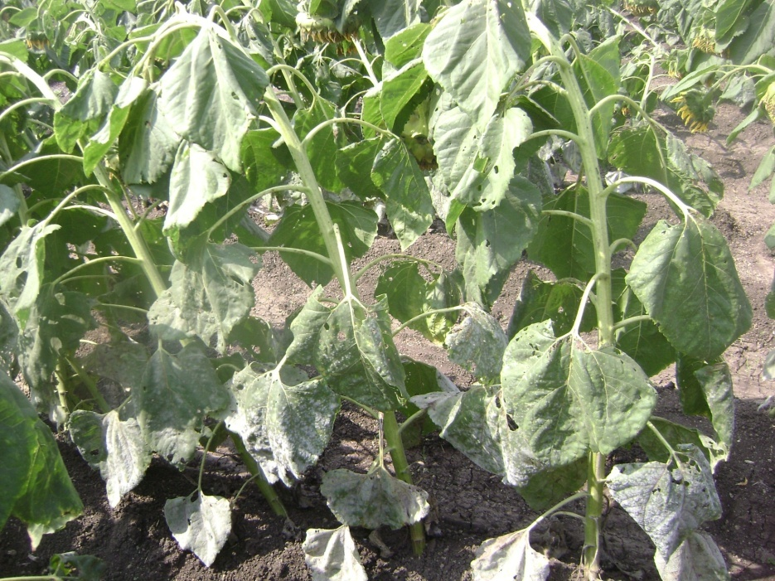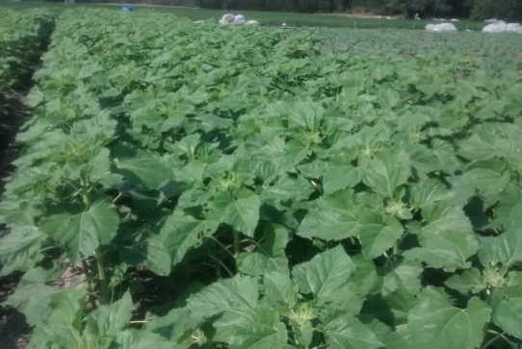
- Control Protected with fungicidal Spray

