Epidemiology and biochemical basis for resistance of cultivars against Alternaria
In induced systemic disease resistance, in Morden (Susc.) the activity of peroxidases, poly phenols increased with application of inducers while in DRSH-1, TX 16 R (Moderately resistant) there was slight increase in enzyme activity. More release of polyphenols observed with Alpha amino butyric acid (AABA) however release of peroxidases high with Gama amino butyric acid (GABA). Release of total sugars was more with GABA. In morden (susceptible) trichome number was less, simple and unsegmented with simple stomatal appearance (Fig.6). In DRSH-1 trichome number was more, segmented and curved stomata.

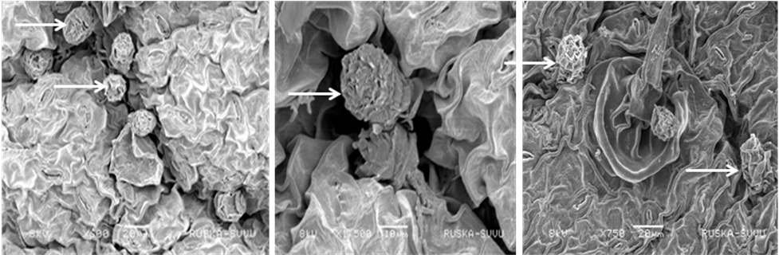

Fig.: Conidia on leaf surface after spraying of inoculum. A and B- DRSH-1. C- Morden.Arrow shows conidia in SEM
Activity 2.2. Biochemical basis of differences in M. resistant and susceptible genotypes for A. helianthi
Secondary metabolite profiling of Alternariaster helianthi of sunflower: Nine isolates of A. helianthi, causal agent of sunflower leaf blight collected from different sunflower growing states were selected based on pathogenic variability studies as three groups ie highly virulent, moderately virulent, less virulent and these were used for secondary metabolite analysis. The secondary metabolite profiling has shown difference with in the isolates, three less virulent isolates ie Ah 92, Ah 160, Ah 158 has different metabolite pattern. However the isolates under highly virulent (Ah 18-patancheru, TS; Ah 38 - Mudhol, KA; Ah 125-Jalna, MH) and moderately virulent (Ah 157 - Muzaffarpur, BR; Ah 142-Sirapur, KA; Ah 12-Narkhoda, TS) had identical banding. These results reveal that secondary metabolites of A. helianthi have a definite role in A. helianthi virulence and disease severity in leaf blight of sunflower.
The above nine isolates were used for mycelium proteins analysis by electrophoresis (native and dissociated protein). The molecular weight of the native protein bands varied between 23.3 to 66 KDa. SDS PAGE was performed for dissociated protein analysis and the molecular weight of the bands varied from 6.6 to 43 KDa. Even though the difference was observed in the mycelium protein banding there was no significant variation between the isolates of highly, moderately and less virulent isolates.

