Activity 1.2 .Epidemiology of Alternaria
To identify the weather factors responsible for the leaf blight development, two sunflower cultivars ie Morden and KBSH 44 were sown at fortnightly intervals (4 sowings). In each sowing, Propiconazole (0.1% - 3 sprays) sprayed plots and unsprayed plots were maintained. Leaf blight severity was recorded weekly in each plot and spore load of Alternariaster helianthi was recorded by spore traps weekly. The weather parameters were recorded during the crop period at different centers.
Leaf blight severity was more in 30th July and 16th August sown crops. In 30th July sown crop, the disease severity was 94.1% and 88.1% in Morden and KBSH-44 respectively with spore load of 41.6 (Table 3.6.c). Sporeload, relative humidity and dew point are contributing factors for 16th July, 30th July and 31st August sown crops while minimum temperature, wind speed are contributing factors for 16th August sown crop. In stepwise regression analysis, spore load and dew point were significant contributors for increasing the disease severity having equation of PDI = + 1.90034 Spl + 0.39736* dew period. These results indicated that spore load, dew point, relative humidity, minimum temperature were the most influencing weather parameters for the disease severity. Disease severity was more in 16th July and 31st July sown crop than other dates of sowing. Disease progression was rapid in 16th July sown crop however it was moderate in 31st August sown crop. In 16th July sown crop, the disease severity was 94% in Morden and 64 % in KBSH-44 with spore load of 29/week. In 31st July sown crop, the disease severity was 92.7% and 77.7% in Morden and KBSH-44 respectively with spore load of 41. Significant correlations were observed with spore load, minimum temperature, RH2 and dew point for both cultivars
Variability in isolates of Alternaria helianthi - Leaf blight of sunflower : Thirty isolates of A. alternata of sunflower were clustered into 3 groups based on morphological and cultural characters. Pathogenic variability of 220 A. helianthi isolates on different sunflower cultivars by artificially inoculation method revealed seven groups based on disease severity. None of the isolate was resistant to all seven sunflower cultivars tested (Fig.4). Among cultivars, most of A. helianthi isolates showed moderately resistant reaction on KBSH-1 followed by SCG-99. Morden was susceptible to most of the isolates whereas DRSF-108 was susceptible to all A. helianthi isolates. Thirty isolates of A. alternata grouped into 3 major groups based on disease severity on sunflower cultivars (Fig.5).

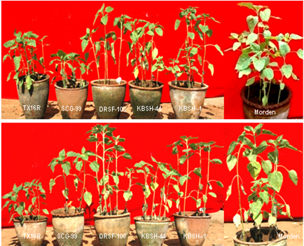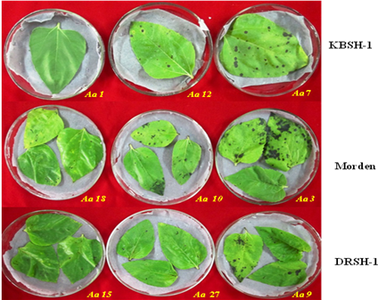
Ah 200
Ah 188
Fig 4: Disease reaction of isolates of Fig 5: Leaf spots on different cultivars with
A. helianthi on different cultivars. isolates of A. alternata.

Molecular variability of 30 isolates of A. alternata exhibited four major groups. A total of 185 bands were obtained with 142 bands (76%) polymorphic from PCR amplification with 12 primers using genomic DNA of A. alternata isolates.

