**Validation of SNPs associated with wilt resistance**

An attempt was made to validate the SNPs showing statistically significant association with wilt resistance in association analysis. The co-segregation of SNP genotypes with wilt resistance was assessed in the F2 population of RG1289 (susceptible) × RG1149 (resistant). A total of 76 F2 individuals was screened for reaction to wilt in pot with artificial inoculation. Of 76 F2 plants, 32 showed resistant and 44 showed susceptible reaction. A subset of 20 SNPs markers from the list of SNPs putatively associated with wilt resistance were used to genotype the parents of the validating population. The polymorphic markers (12) were then used to genotype the F2 plants. Out of 12 polymorphic markers, three markers namely Rc_29648-63299, Rc_29648-57163 and Rc_29648-75201 showed co-segregation with the observed phenotype. For instance, at the marker locus, Rc_29648-63299, 17 individuals were homozygotes for the allele ‘C’, 16 were homozygotes for the allele ‘T’ and 43 were heterozygotes (Fig 1).

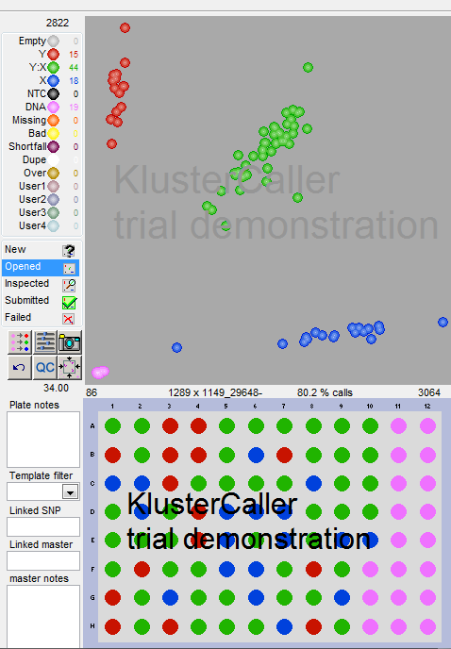

CC

CT

TT

Fig 1. Genotype clusters of F2 individuals (RG1289 × RG1149) for the SNP locus Rc_29648-63299

As the wilt resistance is controlled by recessive genes with complementary interaction in this cross, it is expected that all the F2 individuals carrying the resistant allele in homozygous condition (CC) would be resistant. The F2 individuals carrying the susceptible allele in homozygous condition (TT) and the heterozygote individuals (CT) could be ether susceptible (3 parts) or resistant (1 part) depending on the allelic composition of the second locus (Table 2). When the genotypic data was compared with the phenotype of the corresponding F2 individuals, 13 out of 17 plants carrying the allele ‘C’ in homozygous condition were resistant. A total of 16 plants carried the susceptible allele ‘C’ in homozygous condition out of which four were resistant and 13 were susceptible (1:3). Similarly, out of 43 heterozygotes, 15 were resistant and 28 were susceptible (1:3). The proportion of resistant and susceptible individuals in the F2 generation was as per the theoretical expectation when the trait is controlled by two recessive genes in complementary interaction. The other markers Rc_29648-57163 and Rc_29648-75201 also showed the similar genotype-phenotype pattern. All these markers are physically placed in close proximity (within 18,000 bases) in the genome. These markers can be used in selecting resistant individuals in segregating populations generated using RG1149 as source for resistance.

Table 2. Expected and observed genotype and phenotype of F2 population of RG1289 × RG1149

|  |  |  |  |
| --- | --- | --- | --- |
| **Expected** | | **Observed** | |
| Genotype | Phenotype | Genotype | Phenotype |
| *r1r1R2R2*(1 part)  *r1r1R2r2* (2 parts)  *r1r1r2r2* (1 part) | Resistant - 19 | CC - 17 | Resistant - 13 |
| Susceptible - 4 |
| *R1R1r2r2*(1 part) | Resistant – 4.8 | TT - 16 | Resistant - 3 |
| *R1R1R2R2* (1 part)  *R1R1R2r2*(2 parts) | Susceptible – 14.2 | Susceptible - 13 |
| *R1r1r2r2* (2 parts) | Resistant – 9.5 | CT - 43 | Resistant - 15 |
| *R1r1R2R2*(2 parts)  *R1r1R2r2*(4 parts) | Susceptible – 28.5 | Susceptible - 28 |
| Total | Resistant – 33.3  Susceptible – 42.7 |  | Resistant – 31  Susceptible – 45 |