**Putative QTL associated with gray mold resistance in castor**

To identify the genomic regions associated with gray mold resistance, a set of 107 RILs of JC12 × 48-1 was evaluated for resistance to gray mold. The population along with parents and susceptible check (DCH-519) were raised in the experimental farm of Regional Agricultural Research Station, Chinthapalli under ANGRAU during *Kharif* 2016. Under epiphytotic condition (Fig 2), the RILs were scored for gray mold resistance on a 1-4 scale (low to high disease severity).

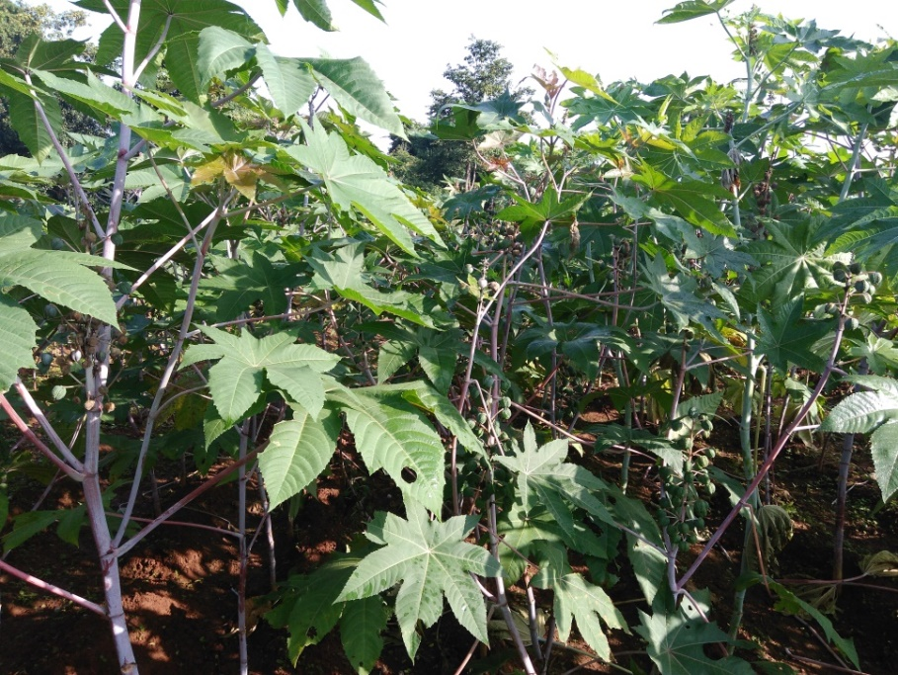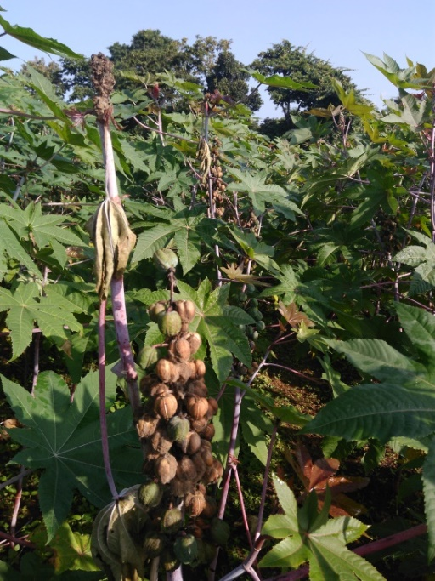

Fig 2. Reaction of RILs of JC12 × 48-1 for gray mold at Regional Agricultural Research Station, Chinthapalli

The disease severity scores were used to identify QTL linked to gray mold resistance using QTL Cartographer V2.5. A total of four QTLs (Table 3), two on linkage group (LG) 3 and one each on LG-5 and LG-9 was identified at LOD score more than 2.5.

Table 3. QTLs associated with gray mold resistance in castor

|  |  |  |  |  |  |
| --- | --- | --- | --- | --- | --- |
| No. | Linkage group | Marker | Position | LOD score | R2 |
| 1 | 3 | Rc_29929-1526434 | 34.8 | 4.02 | 0.17 |
| 2 | 3 | Rc_28093-12497 | 83.1 | 3.83 | 0.13 |
| 3 | 5 | Rc_29736-670976 | 92.9 | 2.65 | 0.08 |
| 4 | 9 | Rc_29358-25528 | 48.1 | 7.77 | 0.25 |