Title : Soybean variety Dsb-21 for protein enhancement

Background: Bailhongal taluk is known for the production of soybean. Majority of the farmers are cultivating JS-335 variety of soybean which is prone to pod shattering and susceptible to rust. Realizing the gravity of the problem of the farmers, KVK has demonstrated new variety Dsb-21.

Interventions: Demonstrations were taken at Chikkabagewadi, Mattikopp, Sampagaon and Deshanur villages of Bailhongal taluk involving 31 farmers

Process: KVK imparted training to the farmers on seed treatment with bio-fertilizers, use of macro and micro nutrients & environment friendly plant protection measures

Technology: Integrated crop management in Soybean (agronomic practices like weed and water management, nutrient management through foliar application, environment friendly and cost effective plant protection measures)

Impact
Horizontal Spread: Dsb-21 resistant to rust and tolerant to pod shattering was conducted in 160 farmers fields covering of 67.40 ha along with participatory seed production. This has resulted in an area expansion of 650 ha with a production of 13,000 q and increase in productivity from 15-20 q/ha.

Economic gains: The total additional returns gained is Rs. 1.20 crores due to varietal
replacement

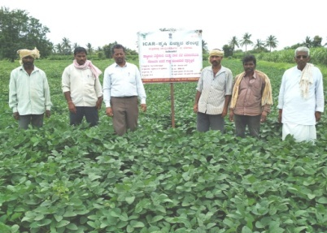 | 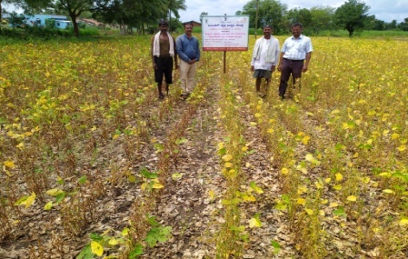
A view of field performance of soybean variety Dsb-21

Year-wise area expansion of soybean variety Dsb-21 in Belagavi

