PROFORMA FOR ANNUAL REPORT 2010-11

(FOR THE PERIOD APRIL 2010 TO MARCH 2011)

KRISHI VIGYAN KENDRA (UTTARA KANNADA)

PART I - GENERAL INFORMATION ABOUT THE KVK

1.1. Name and address of KVK with phone, fax and e-mail
KVK Address | Telephone |  | E mail | Web Address
 | Office | Fax
Krishi Vigyan Kendra  Banavasi Road,  Sirsi-581 401  District : Uttara Kannada  State : Karnataka | Office  (08384)  228411 | FAX  (08384)  228411 | kvkuks@gmail.com | www.kvkuttarkannada.org

1.2 .Name and address of host organization with phone, fax and e-mail
Address | Telephone |  | E mail | Web Address
Address | Office | Fax
University of Agricultural Sciences,  Krishi Nagar  Dharwad -580 005 | (0836)  2448512,  2447494 | (0836)  2748199 | deuasd@rediffmail.com | www.uasd.edu

1.3. Name of the Programme Coordinator with phone & mobile No
Name | Telephone / Contact
 | Residence | Mobile | Email
Dr. Hemant G. Hegde | 08384247958 | 9448495345 | hemihg@gmail.com
1.4. Year of sanction: 11-07-2000
1.5. Staff Position (as 31st March 2011)
Sl.  No. | Sanctioned post | Name of the incumbent | Designation | M/F | Discipline | Highest Qualification  (for PC, SMS and Prog. Asstt.) | Pay  Scale | Basic pay | Date of joining KVK | Permanent  /Temporary | Category (SC/ST/  OBC/  Others)
1 | Programme  Coordinator | Dr. Hemant  G. Hegde | Programme Coordinator | M | Horticulture | Ph.D (Horticulture) | 37400-61100+10000(AGP) | 60450 | 22.08.2006 | P | GM
2 | SMS | Mr. Ganapathi. T. | SMS (Hort.) | M | Horticulture | M.Sc. (Horticulture) | 37400-61100+9000(AGP) | 49240 | 15.06.2005 | P | OBC
3 | SMS | Dr (Mrs) Roopa S. Patil | SMS (Agril. Entomology) | F | Agricultural Entomology | Ph.D (Agril. Entomology) | 15600-39100+6000(AGP) | 24330 | 3.12.2008 | P | GM
4 | SMS | Smt. Vinutha U. Muktamath | SMS (Home Science) | F | Home Science | M.Sc (Home Science) | 15600-39100+6000(AGP) | 22250 | 15.07.2009 | P | GM
5 | SMS | Dr. Rajakumar G. R. | SMS (Soil Science) | M | Soil Science | Ph.D (Soil Science) | 15600-39100+6000(AGP) | 23620 | 21.07.2009 | P | GM
6 | SMS | Vacant | - | - | Agronomy | - | - | - | - | - | -
7 | SMS | Vacant | - | - | Vet. Science | - | - | - | - | - | -
8 | Programme Assistant( Lab Tech.)/T-4 | Vacant | - | - | Agro forestry | - | - | - | - | - | -
9 | Programme Assistant (Computer)/ T-4 | Mrs. Annapurna F. Neeralgi | Programme Asst. (Computer) | F | Computer Science | BCA | 9300-37800 + 4200 AGP | 10230 | 29.03.2010 | P | SC
10 | Programme Assistant/ Farm Manager | Dr. Praveen T. Goroji | Farm Manager | M | Soil science | Ph. D (Soil Science) | 9300-37800 + 4200 AGP | 10230 | 13.11.2008 | P | GM
11 | Assistant | Mr. N. K. Nayak | Accountant /Superintendent | M | Accounts | MA | 11400-21600 | 18600 | 02.01.2006 | P | GM
12 | Jr. Stenographer | Miss Purnima K. Hirehal | Typist | F | Typist | MA | 8000-14800 | 8000 | 12.11.2009 | P | ST
13 | Driver | Mr.Balappa Taragar | Driver | M | Driver (LV) | SSLC | 5800-10500 | 5900 | 06.10.2009 | P | GM
14 | Driver | Vacant | Tractor Driver | - | - | - | 5800-10500 | - | - |  | -
15 | Supporting staff | Mr. H.A. Nadaf | Cook cum caretaker | M | Cook cum Caretaker | 10th | 5200-8200 | 5500 | 02.08.07 | P | cat-1
16 | Supporting staff | Contract | Messenger | - | - | - | - | - | - | -- | -

1.6. Total land with KVK (in ha) : 2.5 ha

S. No. | Item | Area (ha)
1 | Under Buildings | 0.5
2. | Under Demonstration Units | -
3. | Under Crops | 1.0
4. | Orchard/Agro-forestry | 1.0
5. | Others | -

1.7. Infrastructural Development:

A) Buildings
S.  No. | Name of building | Source of  funding | Stage
S.  No. | Name of building | Source of  funding | Complete |  |  | Incomplete
S.  No. | Name of building | Source of  funding | Completion  Date | Plinth area (Sq.m) | Expenditure (Rs.) | Starting Date | Plinth area  (Sq.m) | Status of construction
1. | Administrative  Building
2. | Farmers Hostel | NATP | 2003 | 395.81 | - | - | - | -
3. | Staff Quarters
 | 1
 | 2
 | 3
 | 4
 | 5
 | 6
4. | Demonstration Units
 | 1
 | 2
 | 3
 | 4
5 | Fencing
6 | Rain Water harvesting system
7 | Threshing floor
8 | Farm godown
9
10

B) Vehicles

Type of vehicle | Year of purchase | Cost (Rs.) | Total kms. Run | Present status
Motor bike  KA 31 J 3307 | Yamaha Crux  2002 | 42,850.00 | 25040 | Good
Motor bike  KA 25 EC 7562  KA 25 EC 7564 | Hero Honda - Passion  2009  2009 | 42,450.00  42,450.00 | 6770  5310 | Good  Good
Toyota Qualis Jeep  KA 31M 2652 | 2004 | 5,00,000.00 | 109038 | Good
C) Equipments & AV aids

Name of the equipment | Year of purchase | Cost (Rs.) | Present status
Godrej copier | 30-03-2001 | 80,234/- | Good condition
Stabilizer | 30-03-2001 | 6,000/- | ’’
Portable OHP | 31-03-2001 | 23,920/- | ’’
Honda make EBK 2000 generator | 31-03-2001 | 32,800/- | ’’
EB 833 Altimeter | 25-02-2002 | 10,990/- | ’’
Thomson TV 29’’ monitor | 30-03-2002 | 28,700/- | ’’
Thomson CD player | 30-03-2002 | 6,500/- | ’’
Sharp VCR | 30-03-2002 | 12,300/- | ’’
Computer and accessories | 30-03-2003 | 72,513/- | ’’
Public address system | 26-02-2003 | 10,500/- | ’’
Nikon Camera | 29-09-2003 | 28,350/- | ”
Air Conditioner for computer hall | 27-09-2003 | 10,500/- | ’’
Photo display frame | 27-09-2003 | 17,000/- | ’’
Exhibition showcase | 27-09-2003 | 14,000/- | ’’
Scanner | 27-09-2003 | 3,500/- | ’’
Sony Digital Camera | 2006 | 13,000/- | Under repair
Computer HP- with accessories | 31.3.2007 | 36,000/- | ’’
Motorized screen | 2008 | 24,000/- | ’’
Lexmark Printer | March 2008 | 15,043/- | ’’
Printer (4 in one) | 31.3.2009 | 13,950/- | ’’
Sony DV cam – Portable camera | Jan-2010 | 1,84,000/- | ’’
Computer and accessories-HP DC-7000 series (2 Nos) | April-2010 | 77690/- | ’’
Lenovo s10-3s Idea pad |  | 21600/- | ’’

1.8. Details SAC meeting conducted in 2010-11

Sl.No | Date | Number of Participants | No. of absentees | Recommendations
1 | 25.3.11 | 38 | 10 | It was suggested to take up seed production programme in association with the farmers giving importance to local varieties.
2 | 25.3.11 | 38 | 10 | Messages to farmers should be sent through mobile SMS regularly. At least 5000 farmers should be enrolled to extend this facility.
3 | 25.3.11 | 38 | 10 | Success stories like in ginger crop should be documented and other programmes like FFS should be given wide publicity by broadcasting in AIR & TV
4 | 25.3.11 | 38 | 10 | Proposal should be sent to ICAR for developing and implementing demonstrations on rain water harvesting and sprinkler/drip irrigation
5 | 25.3.11 | 38 | 10 | While presenting FLDs thrust should be given to farmer’s opinion. Also importance should be given to increase the Revolving Fund
6 | 25.3.11 | 38 | 10 | To disseminate the technology to the farmers planning should be done in coordination with line departments. Also while presenting FLD & OFT results impact analysis should be based on financial assessment
7 | 25.3.11 | 38 | 10 | KVK Website should be updated regularly and KVK Database is to be created
8 | 25.3.11 | 38 | 10 | Suggested to arrange soil campaigns and collect and analyze soil samples and to prepare taluka wise soil fertility maps
9 | 25.3.11 | 38 | 10 | Details of the successful farmers in different areas , trained farmers and critical inputs available with them should be documented and wide publicity should be given through AIR
10 |  |  |  | Fodder bank in 1 or two acres of land should be established in KVK
11 |  |  |  | While presenting the progress reports impact and results should be supported with good action photographs and video clippings
12 |  |  |  | More programmes regarding mechanized paddy transplanting should be organized and farmer commodity groups should be established for employment generation
13 |  |  |  | Along with watershed area development a survey should be conducted to know the demand of bio fuel planting materials and details should be handed over to Dean, Forestry
14 |  |  |  | Facility to document & to provide information on non agriculture enterprises should be made available
15 |  |  |  | Emphasis should be given to the programmes related to the needs of the farmers instead of taking research activities in KVKs
16 |  |  |  | In association with agriculture and other line departments and through ATMA programmes burning issued of farmers should be address and suitable technology should be disseminated to the farmers
PART II - DETAILS OF DISTRICT

2.1 Major farming systems/enterprises (based on the analysis made by the KVK)
S. No | Farming system/enterprise
1 | Rainfed area : Paddy- Pulses, Arecanut based intercropping system  Small Irrigation through wells and springs  Non Timber Forest Produce, Fisheries and Dairy

2.2 Description of Agro-climatic Zone & major agro ecological situations (based on soil and topography)
S. No | Agro-climatic Zone | Characteristics
1 | Zone – 9 | It consists of eastern transition belt and west coast with a geographical area 25,670.60 sq.km. It has hill zones and valleys with red sandy loam, clay loam and laterite soils. In some parts medium black soils are also found. Major crops grown are paddy, cotton, arecanut based mixed crops of spices.
2 | Zone – 10 | The zone consists of coastal and hill tracts with rainfall 3500 mm. The major crops grown are paddy, groundnut, pulses and arecanut based cropping system. Sandy soils, costal alluvial, red sandy loam, laterite soils are found in these regions.

S. No | Agro ecological situation | Characteristics
1 | Coastal ecosystem | High to very high rainfall of about 3500 mm, hot and humidity climate with highly leached sandy alkaline soils.
2 | Hill zone ecosystem | Rainfall ranges from 2500 to 3500 mm, with valleys and low hills. Major area covered is forest and dominated by laterite soils.
3 | Transitional ecosystem | Rainfall ranges from 800-1200 mm. dominated by plains and rolling hills. Soils vary from red loam to medium black soils.

2.3 Soil type/s
S. No | Soil type | Characteristics | Area in ha
1 | Lateritic soils | Deep, well drained to excessively drained, yellowish red to dark reddish brown, sandy loam to sandy clay and clay surface soils and clay subsoil’s, moderate to severely eroded with surface crusting. | 36332
2 | Coastal laterite soil | Deep, well drained to excessively drained, dark brown to yellowish red and dark reddish brown, sandy clay loam to clay loam surface soils and sandy clay to clay subsurface soils, moderately to severely eroded with surface crusting. | 36332
3 | Coastal alluvial soils | Deep, well drained and poorly drained, pale brown to dark yellowish brown, sand, sandy loam to loam surface soils and sand to loam subsurface soils. | 36332
4 | Red gravely clay soils | Deep and shallow, well drained to excessively drained, yellowish brown dark red to reddish brown, gravely sandy loam to sandy clay loam and loamy sand surface soils and no calcareous cracking clay to silty clay soils, moderately to severely eroded. | 144589
5 | Red clay soils | Deep to moderately deep and hallow, well drained, brown to yellowish red to reddish brown, sandy loam and sandy clay to clay subsurface soils, moderately to severely eroded. | 552877
6 | Forest soils (Brown forest soil) | Deep to moderately, Deep, well drained to excessively drained, dark brown to dark yellowish brown and black sandy clay to sandy clay loam, humus rich surface soils and clay to sandy clay, gravely sandy clay to clay sub surface soils, moderately to severely eroded. | 291679
7 | Medium black soils | Shallow, well drained grey to dark grey and brown clay loam and silty clay loam. | 291679

2.4. Area, Production and Productivity of major crops cultivated in the district
S. No | Crop | Area (ha) | Production (Metric tons) | Productivity (kg /ha)
1 | Paddy | 72300 | 21690 | 3000
2 | Cotton | 3700 | 2590 | 7000
3 | Groundnut | 2500 | 4500 | 1800
4 | Green gram | 650 | 715 | 1100
5 | Black gram | 700 | 8400 | 1200
6 | Maize | 4750 | 14250 | 3000
7 | Sugarcane | 2770 | 221600 | 80 tones
8 | Arecanut | 16634 | 41091 | 2470
9 | Coconut | 7690 | 1309 | 170
10 | Black pepper | 408 | 17.29 | 420
12 | Ginger | 204 | 5066 | 24830
13 | Cardamom | 536 | 133.67 | 250
14 | Cashew | 2996 | 6361 | 2120
15 | Banana | 2346 | 69110 | 29460
16 | Mango | 1894 | 34257 | 18090
17 | Pine apple | 450 | 33217 | 73820

2.5. Weather data
Month | Rainfall (mm) | Temperature ⁰ C |  | Relative Humidity (%)
 |  | Maximum | Minimum
Janaury | 3.4 | 29.6 | 14.7 | 87.8
February | 0 | 32.8 | 15.4 | 89.3
March | 7.1 | 34.9 | 17.7 | 87
April | 35.3 | 35.6 | 19.8 | 80
May | 44.3 | 33.6 | 28.2 | 83.4
June | 396 | 29.58 | 20.2 | 87.2
July | 723 | 26.2 | 19.6 | 90
August | 366 | 26.7 | 19.7 | 91.8
September | 376 | 27.5 | 19.5 | 90.6
October | 77.6 | 29.3 | 19.0 | 88
November | 140.6 | 29.2 | 18.1 | 89
December | 0.4 | 28.6 | 14 | 82.6
* ARS Paddy , Sirsi

  - Production and productivity of livestock, Poultry, Fisheries etc. in the district

Category |  | Population | Production | Productivity
Cattle
Crossbred | 35410 |  | 141640000 | 4000ltr
Indigenous | 331762 |  | 232233400 | 700ltr
Buffalo | 118767 |  | 249410700 | 2100ltr
Sheep
Crossbred | 0 |  | 0 | 0
Indigenous | 2702 |  | 81060 | 30Kg
Goats | 12087 |  | 362610 | 30Kg
Pigs
Crossbred | 673 |  | 100950 | 150Kg
Indigenous | 15510 |  | 853050 | 55Kg
Rabbits | 278 |  | 1112 | 4Kg
Poultry
Hens
Desi |  | 125633 | 0 | 1.25Kg
Improved |  | 239940 | 157041.25 | 2Kg
Ducks |  | 11234 | 479880 | 4.5Kg
Turkey and others |  | 125 | 50553 | 6Kg
Fish
Marine(Prawns,Shrimp,Scampi) |  |  | 62779.56 mt
Inland |  |  | 7015.6 mt

  - District profile has been prepared and submitted Yes / No:Yes

2.8 Details of Operational area / Villages

Sl.No. | Taluk | Name of the block | Name of the village | How long the village is covered under operational area of the KVK (specify the years) | Major crops & enterprises | Major problem identified | Identified Thrust Areas
1 | Sirsi | Banavasi  Hegadekatta  Vaddinakoppa  Kenchagadde  Manjuguni | Andagi  Bidralli  Hegadekatta  Vaddinakoppa  Kenchagadde  Manjuguni | One year | Ginger  Mango  Arecanut  paddy | Rhizome rot ginger  Powdery mildew and hoppers  Soil acidity and Nut drop  Rootgrub menace, severe problem of leaf folder in paddy | Management of pests and diseases  Soil test based nutrient management, ecofriendly management of rootgrub in arecanut and leaf folder in paddy
2 | Siddapur | Bilagi | Keregadde , Bilagi and Akkunji | One year | Pepper ,Paddy | Improper processing , Soil acidity and Low yield | Value addition ,INM
3 | Mundagod | Mundagod  Kalakoppa | Indur | One year | Paddy | Soil acidity and Si deficiency  Insect pests and diseases | Nutrient management, IPM
4 | Honnavar | Habbu chitte | Habbu chitte | One year | Coconut | Rhinoceros beetle damage in coconut | IPM

2.9 Priority thrust areas

S. No | Thrust area
1  2  3  4  5  6  7  8  9  10  11 | Crop improvement – Introduction of improved varieties in Paddy, Pulses  Production technology of agriculture, horticulture and Agro forestry  Insect pests and disease management in agriculture and horticulture crops  Soil health and water conservation  Organic Farming  Post harvest technology and value addition.  Income generating activities – Mushroom, Bamboo Crafts, Plants Nursery  Integrated Farming Systems  Vocational Training to rural youth  Establishment of commodity groups  Fodder production

PART III - TECHNICAL ACHIEVEMENTS

3.A. Details of target and achievements of mandatory activities
OFT |  |  |  | FLD
1 |  |  |  | 2
Number of OFTs |  | Number of farmers |  | Number of FLDs |  | Number of farmers
Targets | Achievement | Targets | Achievement | Targets | Achievement | Targets | Achievement
10 | 10 | 57 | 54 | 13 | 12 | 99 | 100

Training |  |  |  | Extension Programmes
3 |  |  |  | 4
Number of Courses |  | Number of Participants |  | Number of Programmes |  | Number of participants
Targets | Achievement | Targets | Achievement | Targets | Achievement | Targets | Achievement
78 | 102 |  | 3147 | 600 | 741 | - | 14834

Seed Production (Qtl.) |  | Planting materials (Nos.)
5 |  | 6
Target | Achievement | Target | Achievement
5 | 6.78 | 500 | 3000

Livestock, poultry strains and fingerlings (No.) |  | Bio-products (Kg)
7 |  | 8
Target | Achievement | Target | Achievement
 |  | 50 | 93

3.B1. Abstract of interventions undertaken based on thrust areas identified for the district as given in Sl.No.2.7
S. No | Thrust area | Crop/  Enterprise | Identified Problem | Interventions
 |  |  |  | Title of OFT if any | Title of FLD if any | Number of Training (farmers) | Number of Training (Youths) | Number of Training (extension personnel) | Extension activities  (No.) | Supply of seeds (Qtl.) | Supply of planting materials (No.) | Supply of livestock (No.) | Supply of bio products
1. | Insect ,pest and disease management | Arecanut | Low yield, stem tapering and finally death of palms | Organic based products for the management of arecanut root grub | - | 03 | - | - | Field visit5 | - | - | - | 2 | 20 L neem oil + 20kg soapnut seeds
2 |  | Paddy | Low yield due to Leaf folder, a major pest in hilly tracts | Ecofriendly approaches in the management of leaf folder in paddy | - | 04 | - | Timely management practices were suggested during bimonthly meetings | Field visit 4 | - | - | - | 1 | 2.5 Kgs of N. rileyi
3 |  |  | Low yield due to insect pests (leaf folder, stem borer, WBPHand gundy bug) and diseases (blast0 | - | IPM in paddy | 07 | - | Timely management practices were suggested during bimonthly meetings | Field visit 6 | - | - | - | 2 | 32 nos Pheeromone traps + 8 l of neem pesticides
4 |  | Coconut | Hindrance in growth of palms and secondary infection by diseases at damage site | - | Management of rhinoceros beetle in coconut | 1 | - | - | Field visit 3 | - | - | - | 2 | 5 nos bucket traps + 1.0 kgs M. anisopliae
5 |  | Black pepper | Death of vines due to foot rot of blackpepper | - | Integrated management of foot rot of black pepper | 3 | 01 | 01 | 6 | - | - | - | - | -
6 |  | Mango | Powdery mildew and hoppers | Use of plant extracts  from bio- digester for the management of leaf hoppers and powdery mildew in mango | - | 05 | 02 | 02 | Field visits-04 | Bio-digester-03  Jaggery -06kg | - | - | - | Neem cake -6kg  Ground nut  cake - -6 kg
7 | Value addition | Pepper | Poor quality produce | - | Production of quality black pepper | 03 | 01 | 02 | Field visits-03 | UV resistant plastic sheet -272 kg | - | - | . | -
8 | Production technology | Ginger | Ginger rhizome rot | - | Yield maximization in ginger through management of rhizome rot | 03 | 02 | 04 | State level seminar -01  Field day -01 | Sreptocycline  Ridomyl-MZ | - | - | - | Neem cake  4q/acre  Trichoderma
9 | Fodder production | Bajra cow pea mixture | Scarcity of fodder in summer | Production of fodder bajra and legume mixture as source of nutrient rich green fodder in summer | - | 03 | - | - | Field visits – 04 | 16 kg | - | - | - | -
10 | IFS | Silvi-Horti | Low incme | - | Popularization of silvi-horti-pastoral system for sustainable land use | 2 | 1 | - | Field visits -04 | - | Pickling mango varieties  Garcinia -Kokam | - | - | -
11 | Nutrient management | Paddy | Soil acidity and Si deficiency | Evaluation of foliar silicon in paddy groen in acid laterite soils | - | 2 | - | - | - | - | - | - | - | -
12 | INM | Paddy | Soil acidity and low yield | - | Integrated nutrient management in paddy | 2 | - | 1 | 2 | - | - | - | 2 | 2
13 | Soil Fertility Management | Arecanut | Soil acidity and Nut drop | - | Soil test based nutrient management | 2 | - | - | 2 | - | - | - | - | -
14 | Income generating activity | Mushroom | High cost of production | Assessment of media for production of oyster mushroom | - | 6 | 01 | - | Field visits- 8 | 18kg mushroom spawn | - | - | - | -
15 |  | Long pepper | Lack of awareness | - | Production of long pepper as subsidiary income generating crop | 2 | - | - | 4 | - | 2000 | - | - | -
16 | Post harvest technology | Jackfruit value addition | Dehydration and value addition | Efficacy of poly tunnel drier for production of hygienic jackfruit leather/figs/pappad | - | 2 | 01 | - | 3 | - | - | - | - | -
17 |  | Garcinia | Cumbersome procedure of oil extraction | - | Extraction and utilization of oils & fats from garcinia species | 01 | - | - | 03 | - | - | - | - | -
18 | Drudgery reduction | Agri/horti production | Dehydration and value addition | Small scale solar driers for quality farm produce and drudgery reduction | - | 2 | - | - | 4 | - | - | - | - | -
19 |  | Paddy | Scarcity of labour | - | Popularization and use of mechanized paddy transplanter as IGA through commodity groups | 6 | 01 | 02 | 16 | - | - | - | - | -
20 |  | Groundnut | Scarcity of labour | - | Popularization of groundnut decorticator | 03 | - | - | 6 | - | - | - | - | -

3.B2. Details of technology used during reporting period
S.No | Title of Technology | Source of technology | Crop/enterprise | No.of programmes conducted
 |  |  |  | OFT | FLD | Training | Others (Specify)
1 | 2 | 3 | 4 | 5 | 6 | 7 | 8
1 | Organic based products for the management of arecanut root grub | UASDharwad & ITK | Arecanut | 5 | - | 03 | 5 field visits, 2 method demos, 7 consultancy
2 | Eco friendly approaches in the management of leaf folder in paddy | UASDharwad & ITK | Paddy | 10 | - | 04 | 2 field visits, 1 method demo
3 | IPM in paddy | UASDharwad and DRR, Hyderabad | Paddy | - | 12 | 07 | 7 field visits, 2 method demos, 6 consultancy
4 | Management of rhinoceros beetle in coconut | UASDharwad | Coconut | - | 2 | 01 | 3 field visits, 1 method demo
5 | Production of quality black pepper | KVK UK | Black pepper | - | 15 | 06 | Field visits -03
6 | Yield maximization in ginger through management of rhizome rot | Indian spice research Institute Kochi  UAS,Dharwad | Ginger | - | 04 | 09 | Seminar -01  Field visit -08  Field day -01
7 | Use of plant extracts  from bio- digester for the management of leaf hoppers and powdery mildew in mango | KVK UK | Mango | 03 | - | 09 | Field visits -04
8 | Popularization of silvi-horti-pastoral system for sustainable land use | UASDharwad | Silvi- horti | - | 10 | 03 | Field visits-04
9 | Evaluation of foliar Si in paddy grown in acid laterites | UAS Bangalore | Paddy | 6 | - | 2 | Field visits -04
10 | Integrated nutrient management in Paddy | UAS Dharwad | Paddy | - | 10 | 2 | Field visit -08  Field day -01
11 | Soil test based nutrient management in Arecanut | UAS Dharwad | Arecanut | - | 13 | 2 | Field visit -08  Field day -01
12 | Fodder production | ITK | Bajra+ cowpea | 8 | - | 03 | Field visits-04
13 | IG Activity | UASDharwad | Mushroom | 5 | - | 07 | Field visits – 8
14 | IG Activity | ITK | Jackfruit | 03 | - | 03 | Field visits 03
15 | Post harvest technology | ITK | Fish | 04 | - | 01 | Field visits – 1
16 | Drudgery Reduction | ITK | Small scale solar drier | 03 | - | 02 | Field visits 04,demonstrations-02
17 |  | UASDharwad | Mechanized Paddy transplanter | - | 10 | 09 | Field visits 16
18 | IDM | ITK | Foot rot of black pepper | - | 08 | 05 | Field visits 10, Demonstrations-12,consultancy-25
19 | IG Activity | UASDharwad | Long pepper | - | 10 | 02 | Field visits -04
20 | Drudgery Reduction | UASDharwad | Groundnut | - | 03 | 03 | Field visits-05, demonstrations-04
21 | Post harvest technology | UASBangalore | Garcinia | - | 03 | 01 | Demonstrations-03
22 | Cultivation of black green gram in paddy fallows | ITK | Blackgreen gram | 05 | - | 02 | Field visits-04

3.B2 contd..
No. of farmers covered
OFT |  |  |  | FLD |  |  |  | Training |  |  |  | Others (Specify)
General |  | SC/ST |  | General |  | SC/ST |  | General |  | SC/ST |  | General |  | SC/ST
M | F | M | F | M | F | M | F | M | F | M | F | M | F | M | F
9 | 10 | 11 | 12 | 13 | 14 | 15 | 16 | 17 | 18 | 19 | 20 | 21 | 22 | 23 | 24
5 | - | - | - | - | - | - | - | 20 | - | - | - | 32 | 05 | 03 | -
8 | 2 | - | - | - | - | - | - | 47 | 08 | 02 | 01 | 32 | 12 | - | -
- | - | - | - | 7 | 2 | 3 | - | 82 | 15 | 10 | - | 46 | 21 | 17 | 12
- | - | - | - | 2 | - | - | - | 12 | 3 | - | - | 5 | - | - | -
- | - | - | - | 13 | - | 02 | - | 110 | - | 10 | - | - | - | - | -
- | - | - | - | 03 | - | 01 | - | 130 | 25 | 40 | 06 | 100 | 25 | 40 | 15
02 | - | 01 | - | - | - | - | - | 115 | 15 | 25 | 06 | - | - | - | -
- | - | - | - | 03 | 02 | 04 | 01 | 12 | 02 | 05 | 01 | - | - | - | -
6 | - | - | - | - | - | - | - | 566 | 115 | 136 | 15 | - | - | - | -
 |  |  |  | 06 | 01 | 03
 |  |  |  | 09 | - | 04
- | 03 | - | - | - | - | - | - | 8 | 32 | 06 | 01 | - | - | - | -
- | 04 | - | - | - | - | - | - | - | 15 | 02 | - | - | - | - | -
- | 04 | - | - | - | - | - | - | 0 | 10 | - | - | - | - | - | -
- | 04 | - | - | - | - | - | - | 8 | 20 | 3 | - | - | - | - | -
- | - | - | - | 06 | 04 | - | - | 40 | 22 | 15 | 04 | - | - | - | -
- | - | - | - | 08 | - | - | - | 42 | - | 06 | - | - | - | - | -
- | - | - | - | - | - | 0 | 10 | 10 | 8 | - | 20 | 0 | - | - | -
- | - | - | - | - | 03 | - | - | 18 | 16 | - | - | --- | - | - | -
- | - | - | - | 03 | - | - | 03 | 04 | - | 02 | 08 | - | - | - | -
05 | - | - | - | - | - | - | - | 10 | 2 | 02 | - | - | - | - | -

PART IV - On Farm Trial
4.A1. Abstract on the number of technologies assessed in respect of crops
Thematic areas | Cereals | Oilseeds | Pulses | Commercial Crops | Vegetables | Fruits | Flower | Plantation crops | Tuber Crops | TOTAL
Integrated Nutrient Management | 1 |  |  |  |  |  |  |  |  | 01
Varietal Evaluation
Integrated Pest Management | 01 |  |  |  |  | 01 |  | 01 |  | 03
Integrated Crop Management |  |  | 1 |  |  |  |  |  |  | 01
Integrated Disease Management
Small Scale Income Generation Enterprises
Weed Management
Resource Conservation Technology
Farm Machineries
Integrated Farming System
Seed / Plant production
Value addition
Drudgery Reduction
Storage Technique |  |  |  |  |  | 01 |  |  |  | 01
Mushroom cultivation |  |  |  |  |  |  |  |  |  | 01
Crop production | 1 |  |  |  |  |  |  |  |  | 01
Total |  |  |  |  |  |  |  |  |  | 08

4.A2. Abstract on the number of technologies refined in respect of crops

Thematic areas | Cereals | Oilseeds | Pulses | Commercial Crops | Vegetables | Fruits | Flower | Plantation crops | Tuber Crops | TOTAL
Integrated Nutrient Management
Varietal Evaluation
Integrated Pest Management
Integrated Crop Management
Integrated Disease Management
Small Scale Income Generation Enterprises
Weed Management
Resource Conservation Technology
Farm Machineries
Integrated Farming System
Seed / Plant production
Value addition |  |  |  |  |  | 01 |  |  |  | 01
Drudgery Reduction
Storage Technique
Mushroom cultivation
Total |  |  |  |  |  |  |  |  |  | 01
4.A3. Abstract on the number of technologies assessed in respect of livestock enterprises

Thematic areas | Cattle | Poultry | Piggery | Rabbitry | Fisheries | TOTAL
Evaluation of Breeds
Nutrition Management
Disease of Management
Value Addition |  |  |  |  | 1 | 01
Production and Management
Feed and Fodder
Small Scale income generating enterprises
TOTAL |  |  |  |  |  | 01

4.B. Achievements on technologies Assessed and Refined
4.B.1. Technologies Assessed under various Crops
Thematic areas | Crop | Name of the technology assessed | No. of trials | Number of farmers | Area in ha
Integrated Nutrient Management | Paddy | Evaluation of foliar Si in paddy | 06 | 06 | 1.2
Integrated Pest Management | Areanut | Organic based products for the management of arecanut root grub | 05 | 05 | 75 palms each
Integrated Pest Management | Paddy | Ecofriendly approaches in the management of leaf folder in paddy | 10 | 10 | 4
Integrated Pest Management | Mango | Use of plant extracts from bio- digester for the management of leaf hoppers and powdery mildew in  mango | 03 | 03 | -
Crop Production
Crop Production | Long Pepper | Production of long pepper as subsidiary income generating crop | 10 | 10 | -
Seed / Plant production | Jackfruit | Efficacy of poly tunnel drier for production of hygienic jackfruit leather /figs/papad | 03 | 03 | -
Value addition | Fish | Efficacy of solar tunnel drier for dehydration of fish | 04 | 04 | -
Mushroom cultivation | Oyster Mushroom | Assessment of media for production of oyster mushroom | 05 | 05 | -
Total |  |  | 46 | 46

4.B.2. Technologies Refined under various Crops

Thematic areas | Crop | Name of the technology assessed | No. of trials | Number of farmers | Area in ha
Value addition | Agri /horti products | Small scale solar driers for quality farm produce and drudgery reduction | 03 | 03 | -
Total |  |  | 03 | 03

4.B.3. Technologies assessed under Livestock and other enterprises
Thematic areas | Name of the livestock enterprise | Name of the technology assessed | No. of trials | No. of farmers
Feed and fodder | Cattle | Green fodder production | 08 | 08
Total |  |  | 08 | 08

4.C1. Results of Technologies Assessed

1. Results of On Farm Trial
Crop/ enterprise | Farming situation | Problem definition | Title of OFT | No. of  trials | Technology Assessed | Parameters of assessment | Data on the parameter | Results of assessment | Feedback from the farmer | Any refinement done / needed | Justification for refinement
1 | 2 | 3 | 4 | 5 | 6 | 7 | 8 | 9 | 10 | 11 | 12
Paddy | Rainfed | Soil acidity and Si deficiency | Evaluation of Foliar Silicon in Paddy grown under laterite soils | 6 | Foliar Silicon | Yield | q/ha | AP: 53.75 | Crop is healthy with more tillers | - | -

Contd..
Technology Assessed | Source of Technology | Production | unit (kg/ha, t/ha, lit/animal, nuts/palm, nuts/palm/year) | Net Return (Profit) in Rs. / unit | BC Ratio
13 | 14 | 15 | 16 | 17 | 18
Technology option 1 (Farmer’s practice):  87:46:60 | - | 33.75 | kg/ha | 19875/ha | 1:1.99
Technology option 2:  RDF75:75:90  +Ash @ 1.5 tons/ha | UAS Dharwad | 49.25 | kg/ha | 32325/ha | 1:2.69
Technology option 3:  RDF+Foliar Si 4 ml/L | UAS Bangalore  (Dept.of Soil science) | 53.75 | kg/ha | 35975 /ha | 1:2.90

2. Results of On Farm Trial
Crop/ enterprise | Farming situation | Problem definition | Title of OFT | No. of  trials | Technology Assessed | Parameters of assessment | Data on the parameter | Results of assessment | Feedback from the farmer | Any refinement needed | Justification for refinement
1 | 2 | 3 | 4 | 5 | 6 | 7 | 8 | 9 | 10 | 11 | 12
Paddy | Rainfed | Incidence of leaf folder | Eco friendly approaches in the management of leaf folder in paddy | 10 | a. Gnidea glauca 5% aqueous leaf extract as foliar spray  b. N. rileyi 1 g/l of water as foliar spray | No. of freshly damaged leaves per hill and yield q/ha | a. 0.6 and 31.25q/ha  b. 1.05 and 30.85 q/ha | Gnidea glauca 5% aqueous leaf extract found very effective in managing pest population. But, N. rileyi entomopathogenic fungi load needs to be still higher to cause the infection. Both are best alternative to chemicals and ecofreindly | Gnidea glauca is locally available and effective in managing leaf folder organically. Noticed diseased larvae due fungus infection | - | -

Contd..
Technology Assessed | Source of Technology | Production | unit (kg/ha, t/ha, lit/animal, nuts/palm, nuts/palm/year) | Net Return (Profit) in Rs. / unit | BC Ratio
13 | 14 | 15 | 16 | 17 | 18
Technology option 1 (Farmer’s practice)  Passing thorny branch over the crop | - | 30.15 | q/ha | 8143 | 1.40
Technology option 2  Foliar spray of Chlorpyrifos 20 EC @ 2ml/l | UAS, Dharwad | 31.50 | q/ha | 8675 | 1.51
Technology option 3a  Gnidea glauca 5% aqueous leaf extract as foliar spray | ITK and successful preliminary trials conducted at ARS, Sirsi | 31.25 | q/ha | 9750 | 1.50
Technology option 3b  N. rileyi, 1X10¹¹conidia /ml @ 1 g/l of water as foliar spray | ITK and successful preliminary trials conducted at ARS, Sirsi | 30.85 | q/ha | 8210 | 1.38

3. Results of On Farm Trial
Crop/ enterprise | Farming situation | Problem definition | Title of OFT | No. of  trials | Technology Assessed | Parameters of assessment | Data on the parameter | Results of assessment | Feedback from the farmer | Any refinement done / needed | Justification for refinement
1 | 2 | 3 | 4 | 5 | 6 | 7 | 8 | 9 | 10 | 11 | 12
Arecanut | Rainfed | Root grub infestation | Organic based products for the management of arecanut root grub | 5 | Drenching of soil with mixture of neem oil and soap nut acqueous extract 5 % | % reduction in rootgrub population | 72.86 % | Appearance of new healthy green frond, improvement in growth of the palms | Neem oil & soap nut extract found eco friendly, residue free and effective alternative to chemicals | - | -

Contd..
Technology Assessed | Source of Technology | Production | unit (kg/ha, t/ha, lit/animal, nuts/palm, nuts/palm/year) | Net Return (Profit) in Rs. / unit | BC Ratio
13 | 14 | 15 | 16 | 17 | 18
Technology option 1 (Farmer’s practice)  Soil application @ 2ml chlorpyriphos 20EC /2 l/palm (not in time ) | - | 39.71 | % reduction in rootgrub population | - | -
Technology option 2  Drenching of soil with chlorpyriphos 20EC @ 3 ml/l of water (5 l of solution/palm) | UAS, Dharwad | 84.41 | % reduction in rootgrub population | - | -
Technology option 3  Drenching of soil with mixture of neem oil and soapnut acqueous extract 5 % | ITK and successful preliminary trials conducted at ARS, Sirsi | 72.86 | % reduction in rootgrub population | - | -

4. Results of On Farm Trial
Crop/ enterprise | Farming situation | Problem definition | Title of OFT | No. of  trials | Technology Assessed | Parameters of assessment | Data on the parameter | Results of assessment | Feedback from the farmer | Any refinement done / needed | Justification for refinement
1 | 2 | 3 | 4 | 5 | 6 | 7 | 8 | 9 | 10 | 11 | 12
Mango | Rainfed | Mango hoppers and powdery mildew | Use of plant extracts  from bio- digester for the management of leaf hoppers and powdery mildew in mango | 03 | Use of plant extracts  from bio- digester for the management of leaf hoppers and powdery mildew in mango | % Hopper s incidence  % powdery mildew incidence  No. of fruits per sq, meter | 08  12  06 | Observed less incidence of powdery mildew and hoppers and more yield | Plant extracts were found to effective | - | -

Contd..
Technology Assessed | Source of Technology | Production | unit (kg/ha, t/ha, lit/animal, nuts/palm, nuts/palm/year) | Net Return (Profit) in Rs. / unit | BC Ratio
13 | 14 | 15 | 16 | 17 | 18
Technology option 1 (Farmer’s practice)  No Proper Spray is given | - | 1200 | kg/ha | 24,000-2000=22000//ha | 11
Technology option 2  Monocrotophos @ 1.25 ml/l + Hexaconozole @ 1.0 ml/l | UAS Dharwad | 1680 | kg/ha | 33,600-2000=31,600/ha | 15.8
Technology option 3  Glyricidia, parthenium, euphatorium,blackgram, cowpea,sunhemp( leaves @ 3 kg each ), Gobar gas slurry(n10 litre), Jaggery (2 kg), Butter milk (10 litre), Pulses powder (2 kg), Cow urine (10 litre)and Neem cake ( 2.0 kg) digested and sprayed @ 1:10 ratio | KVK,UK | 2400 | kg/ha | 48,000-2,500=45,500/ha | 22.7

5. Results of On Farm Trial
Crop/ enterprise | Farming situation | Problem definition | Title of OFT | No. of  trials | Technology Assessed | Parameters of assessment | Data on the parameter | Results of assessment | Feedback from the farmer | Any refinement done / needed | Justification for refinement
1 | 2 | 3 | 4 | 5 | 6 | 7 | 8 | 9 | 10 | 11 | 12
Fodder bajra | Rainfed | Scarcity of fodder during summer | Assessment of fodder bajra – legume mixture in paddy fallows | 8 | Green fodder legume mixture in paddy fallows | Fodder yield tones/ha | 26 t/ha | More palatable compared to other fodders . | Increased milk yield + health of animals | - | -

Contd..
Technology Assessed | Source of Technology | Production | unit (kg/ha, t/ha, lit/animal, nuts/palm, nuts/palm/year) | Net Return (Profit) in Rs. / unit | BC Ratio
13 | 14 | 15 | 16 | 17 | 18
Fallow | - | - | - | -
Fodder Maize | POP UASD | 22 | t/ha | 14000 | 2.75
Fodder bajra legume mixture | ITK | 26 | t/ha | 18000 | 3.25

6. Results of On Farm Trial
Crop/ enterprise | Farming situation | Problem definition | Title of OFT | No. of  trials | Technology Assessed | Parameters of assessment | Data on the parameter | Results of assessment | Feedback from the farmer | Any refinement done / needed | Justification for refinement
1 | 2 | 3 | 4 | 5 | 6 | 7 | 8 | 9 | 10 | 11 | 12
Blackgreen gram | Residual soil moisture | Paddy fallow | Cultivation of black green gram under residual soil moisture in paddy fallows | 5 | black green gram cultivation under residual soil moisture | Yield | q/ha | Suitable for paddy fallows | Yield is on par with green gram but fetches low price | - | -

Contd..
Technology Assessed | Source of Technology | Production | unit (kg/ha, t/ha, lit/animal, nuts/palm, nuts/palm/year) | Net Return (Profit) in Rs. / unit | BC Ratio
13 | 14 | 15 | 16 | 17 | 18
T1: Fallow | -
T2: Green gram – Pusa baisaki | UASD | 3.20 | Qtl/ha | 11000 | 3.2
T3: Black green gram (UAS, Dharwad) | UASD | 2.90 | qtl/ha | 9500 | 2.9

7. Results of On Farm Trial
Crop/ enterprise | Farming situation | Problem definition | Title of OFT | No. of  trials | Technology Assessed | Parameters of assessment | Data on the parameter | Results of assessment | Feedback from the farmer | Any refinement done / needed | Justification for refinement
1 | 2 | 3 | 4 | 5 | 6 | 7 | 8 | 9 | 10 | 11 | 12
Mushroom | - | High cost of production | Assessment of media for production of oyster mushroom | 05 | Pady Husk  Arecaut husk  Coconut coir | Cost of cultivation, yield | Yield in kgs | Paddy starw is good media | Paddy straw give more yield. High chance of infection in areacanut husk | - | -

Contd..
Technology Assessed | Source of Technology | Production  (Mushroom) | unit (kg/ha, t/ha, lit/animal, nuts/palm, nuts/palm/year) | Net Return (Profit) in Rs. / unit | BC Ratio
13 | 14 | 15 | 16 | 17 | 18
T1: Paddy straw | UASD | 6 | Kg/kg spawn | 320 | 4.2
T2:Arecnut Husk | ITK, Trials conducted by COF Sirsi | 3.25 | Kg/kg spawn | 152.50 | 3
T3:Cocont Coir | ITK, Trials conducted by COF Sirsi | 3.8 | Kg/kg spawn | 191 | 2.66

8. Results of On Farm Trial
Crop/ enterprise | Farming situation | Problem definition | Title of OFT | No. of  trials | Technology Assessed | Parameters of assessment | Data on the parameter | Results of assessment | Feedback from the farmer | Any refinement done / needed | Justification for refinement
1 | 2 | 3 | 4 | 5 | 6 | 7 | 8 | 9 | 10 | 11 | 12
Jackfruit/ processing & valueaddition | NA | Dehydration of jackfruit for preservation and value addition | Efficacy of poly tunnel drier for production of hygienic jackfruit leather/fig /pappad | 4 | Dehydration of jackfruit pappad | Time taken for drying, shelf life, colour  Contamination | 6.30 hrs, good even after 3 months  Pale cream, dust free | Drying in drier is on par with sun drying . Free from dust and other contamination,  Drier suitable for drying copra, black pepper, nutmeg, cinnamon, chilies and other food products also | Very good & necessity for every farm house. No hassles of rain or due. Free from animal and bird theft. Nick named it as “My Solar Drier” | Needs improvement on the quality of the material used in fabrication of drier | Improving the hygiene and food contamination

Contd..
Technology Assessed | Source of Technology | Production | Please give the unit (kg/ha, t/ha, lit/animal, nuts/palm, nuts/palm/year) | Net Return (Profit) in Rs. / unit | BC Ratio
13 | 14 | 15 | 16 | 17 | 18
T1: Farmers Practice- Sun Drying | - | 2000 | Numbers | 1600 | 3.2
T2:Drying in solar drier | Dept of Science and Technology, Govt of India &Gujarat energy development agency | 2000 | Numbers | 1600 | 3.2
9. Results of On Farm Trial
Crop/ enterprise | Farming situation | Problem definition | Title of OFT | No. of  trials | Technology Assessed | Parameters of assessment | Data on the parameter | Results of assessment | Feedback from the farmer | Any refinement done / needed | Justification for refinement
1 | 2 | 3 | 4 | 5 | 6 | 7 | 8 | 9 | 10 | 11 | 12
Fishery | NA | Dehydration of fish for preservation and value addition | Efficacy of solar tunnel drier for hygienic dehydration of fish | 4 | Dehydration of fish | Time taken for drying, shelf life, colour  Contamination |  | Drying in drier is on par with sun drying . Free from dust and other contamination, | Very good & necessity for every farm house. No hassles of rain or due. Free from animal and bird theft. | - | -
* The trial was conducted for prawns

Technology Assessed | Source of Technology | Production | Please give the unit (kg/ha, t/ha, lit/animal, nuts/palm, nuts/palm/year) | Net Return (Profit) in Rs. / unit | BC Ratio
13 | 14 | 15 | 16 | 17 | 18
T1: Farmers Practice- Sun Drying | - | 100 | Kg | 8500 | 1.32
T2:Drying in solar drier | - | 100 | Kg | 9500 | 1.57
4.C2. Details of each On Farm Trial for assessment to be furnished in the following format separately as per the following
details
OFT : 1
1 Title of Technology Assessed : Evaluation of Foliar Silicon in Paddy grown under laterite soils
2 Problem Definition : Soil acidity and Si deficiency
3 Details of technologies selected for assessment : Foliar Silicon in Paddy
4 Source of technology : UAS Bangalore (Dept.of Soil science)
5 Production system and thematic area: Integrated Nutrient Management
6 Performance of the Technology with performance indicators: No.of Tillers and Yield q/ha
7. Feedback, matrix scoring of various technology parameters done through farmer’s participation / other scoring
techniques : Crop health is good, with more number of tillers/hill
8 Final recommendation for micro level situation : Yet to be assessed for one more year
9 Constraints identified and feedback for research: nil
10 Process of farmers participation and their reaction : Found the crop to be more vigorous and resistant to pest
OFT : 2
1 Title of Technology Assessed : Organic based products for management of arecanut root grub
2 Problem Definition : Root grub infestation
3 Details of technologies selected for assessment: Drenching of soil with mixture of neem oil and soapnut aqueous 5% extarct
4 Source of technology: ITK and successful preliminary trials conducted at ARS, Sirsi
5 Production system and thematic area: Rainfed and Plant protection
6 Performance of the Technology with performance indicators : % reduction in root grub population at 60 DAT
7. Feedback, matrix scoring of various technology parameters done through farmer’s participation / other scoring
techniques : Neem oil and soap nut extract was found eco friendly and effective alternative to chemicals
8 Final recommendation for micro level situation: Neem oil and soap nut 5% aqueous extract can be effective alternative to chemical insecticides best suited in
organic farming
9 Constraints identified and feedback for research: Preparation of standard plant extracts
10 Process of farmers participation and their reaction: Neem oil and soap nut extract was found eco friendly in managing root grubs, appearance of new healthy green frond, improvement in growth of the palms.

OFT : 3
1 Title of Technology Assessed : Eco friendly approaches in the management of leaf folder in paddy
2 Problem Definition : Incidence of leaf folder
3 Details of technologies selected for assessment: a. Gnidea glauca 5% aqueous leaf extract as foliar spray
b. N. rileyi 1 g/l of water as foliar spray
4 Source of technology: ITK and successful preliminary trials conducted at ARS, Sirsi
5 Production system and thematic area: Rainfed and Plant protection
6 Performance of the Technology with performance indicators : No. of freshly damaged leaves per hill and yield q/ha
7. Feedback, matrix scoring of various technology parameters done through farmer’s participation / other scoring
techniques : Gnidea glauca is locally available botanical insecticide and effective in managing leaf folder organically.
8 Final recommendation for micro level situation: G. glauca leaf extract and N. rileyi can be effective alternative to chemical insecticides best suited in
organic farming
9 Constraints identified and feedback for research: Preparation of plant extracts, congenial microclimate for entomopathogenic fungus to cause the infection and nil
10 Process of farmers participation and their reaction: : Gnidea glauca is locally available and effective in managing leaf folder organically. Noticed diseased larvae due to fungus infection
OFT : 4
1 Title of Technology Assessed : Use of plant extracts from bio- digester for the management of leaf hoppers and powdery mildew in mango
2 Problem Definition : Powdery mildew and mango hoppers
3 Details of technologies selected for assessment : Bio digester extract of glyricidia, parthenium, euphatorium,blackgram, cowpea,sunhemp( leaves @ 3 kg each ), gobar gas slurry (n10 litre), Jaggery (2 kg), Butter milk (10 litre), Pulses powder (2 kg), Cow urine (10 litre)and Neem cake ( 2.0 kg)
4 Source of technology : Krishi Vigyan Kendra, Sirsi
5 Production system and thematic area: Rain fed
6 Performance of the Technology with performance indicators : Yet to be documented
7. Feedback, matrix scoring of various technology parameters done through farmer’s participation / other scoring
techniques : Less incidence of hoppers and powdery mildew and good quality chemical residue free fruits
8 Final recommendation for micro level situation : Needs to be re-assessed in the coming years
9 Constraints identified and feedback for research : Standardization of ingredients and their quantity
10 Process of farmers participation and their reaction :residue free fruits

OFT : 5
1 Title of Technology Assessed : Assessment of fodder bajra – legume mixture in paddy fallows
2 Problem Definition : Scarcity of green fodder during summer
3 Details of technologies selected for assessment : fodder bajra + cow pea mixture
4 Source of technology : ITK
5 Production system and thematic area : Crop production
6 Performance of the Technology with performance indicators: High yield, more palatable, low cost of cultivation
7. Feedback, matrix scoring of various technology parameters done through farmer’s participation / other scoring
techniques : Increased milk yield , improved animal health, 10 out of 10 farmers say most useful
8 Final recommendation for micro level situation: Can be adapted as a good source green fodder in summer
9 Constraints identified and feedback for research:Suitable varieties which will give higher yield
10 Process of farmers participation and their reaction: Actively participated and preserved seeds for next kharif and summer, opine that the crop is boon to the farmers

OFT : 6
1 Title of Technology Assessed : Cultivation of black green gram under residual soil moisture in paddy fallows
2 Problem Definition : Paddy fallows with very low moisture status
3 Details of technologies selected for assessment: Black green gram
4 Source of technology : UASD
5 Production system and thematic area : Crop production
6 Performance of the Technology with performance indicators : Thrives where normal green gram fail
7. Feedback, matrix scoring of various technology parameters done through farmer’s participation / other scoring
techniques: Grains are acceptable
8 Final recommendation for micro level situation:
9 Constraints identified and feedback for research: Improved varieties with good seed fodder yield
10 Process of farmers participation and their reaction: Gives normal yield

OFT : 7
1 Title of Technology Assessed : Assessment of media for production of oyster mushroom
2 Problem Definition : High cost of production
3 Details of technologies selected for assessment: Pady Husk,Arecaut husk , Coconut coir
4 Source of technology : ITK, Trials conducted by COF Sirsi
5 Production system and thematic area: Mushroom Cultivation
6 Performance of the Technology with performance indicators: Paddy straw is suitable
7. Feedback, matrix scoring of various technology parameters done through farmer’s participation / other scoring techniques: Paddy straw is better compared to coconut
coir and arecanut husk
8 Final recommendation for micro level situation: Paddy straw is recommended
9 Constraints identified and feedback for research: Arecanut husk is more prone to infection and techniques for sterilizing necessary.
10 Process of farmers participation and their reaction: Farmers find paddy straw as a good media and coconut coir can also be used
OFT : 8
1 Title of Technology Assessed: Efficacy of poly tunnel drier for production of hygienic jackfruit leather/pappad/figs
2 Problem Definition : Dehydration/value addition
3 Details of technologies selected for assessment: Small poly tunnel drier with platform
4 Source of technology: Dept of Science and Technology, Govt of India &Gujarat energy development agency
5 Production system and thematic area: Post harvest processing and value addition
6 Performance of the Technology with performance indicators: Farmers have shown keen interest and borrowed the design for getting it fabricated locally.
7. Feedback, matrix scoring of various technology parameters done through farmer’s participation / other scoring techniques: 30 out of 30 farmers feel it is appropriate technology
8 Final recommendation for micro level situation: Needs fine tuning
9 Constraints identified and feedback for research: Equipment suitable for small farmer’s requirement of larger models for big farmers
10 Process of farmer’s participation and their reaction: Farmers have shown interest and have requested for transfer of technology.
OFT : 9
1 Title of Technology Assessed : Efficacy of solar tunnel drier for dehydration of fish
2 Problem Definition : Dehydration/value addition
3 Details of technologies selected for assessment: Solar drier
4 Source of technology : Dept of Science and Technology , GOI
5 Production system and thematic area: Value addition
6 Performance of the Technology with performance indicators: Product is hygienic and free from animal and bird theft
7. Feedback, matrix scoring of various technology parameters done through farmer’s participation / other scoring
techniques : Best suited for house hold and small entrepreneur
8 Final recommendation for micro level situation : Can be modified for large scale commercial drying
9 Constraints identified and feedback for research : commercial purpose larger size drier is required
10 Process of farmers participation and their reaction : drying is faster and hygienic
4.D1. Results of Technologies Refined
Results of On Farm Trial
Crop/ enterprise | Farming situation | Problem definition | Title of OFT | No. of  trials | Technology refined | Parameters of refinement | Data on the parameter | Results of refinement | Feedback from the farmer | Details of refinement done
1 | 2 | 3 | 4 | 5 | 6 | 7 | 8 | 9 | 10 | 11
Copra/Solar drying | NA | Refinement of home scale solar drier for increased efficience | Home scale solar drier for quality farm produce and drudgery reduction | 04 | Heat exchange | Placement of Heat exchange & improvement in draft | Time taken for drying and quality parameters like colour texture , flavour, taste labour required and market price | Quick drying, free from contamination, retaining colour and flavour | Very useful for drying copra for small house holds. Can be used for other products also (fruits, vegetables and spices) | Modification in heat exchange chamber and placement of drying chamber
Contd..
Technology Refined | Source of Technology for Technology Option1 /  Justification for modification of assessed  Technology Option 1 | Production | Please give the unit (kg/ha, t/ha, lit/animal, nuts/palm, nuts/palm/year) | Net Return (Profit) in Rs. / unit | BC Ratio
13 |  | 14 | 15 | 16 | 17
Technology Option 1 (best performing Technology Option in assessment) | Farmer Practice | 6 | Kg/batch | - | -
Technology Option 2 (Modification over Technology Option 1) | - | 6 | Kg/batch | - | -
Technology Option 3 (Another Modification over Technology Option 1) | FAO & USAID | 6 | Kg/batch | - | -
* Tehchnology 3 gives good colour, taste and flavor to the dried products.

4.D.2. Details of each On Farm Trial for refinement to be furnished in the following format separately as per the proforma
below

1. Title of Technology refined : Home scale solar drier for quality farm produce and drudgery reduction
2 Problem Definition : Refinement of home scale solar drier for increased efficience
3 Details of technologies selected for refinement : Modification in heat exchange chamber and placement of drying chamber
4 Source of technology : FAO & USAID
5 Production system and thematic area :Preservation and Value addition
6 Performance of the Technology with performance indicators : Final recommendation needs to be assessed by appropriate scientists
7. Feedback, matrix scoring of various technology parameters done through farmer’s participation / other scoring
techniques
8 Final recommendation for micro level situation :
9 Constraints identified and feedback for research : Need for improvement of fabricating materials
10 Process of farmers participation and their reaction : Farmers feel that such equipment is very essential for dehydration of home products in day to day life alternative
equipment not available in the market easily.

PART V - FRONTLINE DEMONSTRATIONS

5.A. Summary of FLDs implemented during 2010-11
Sl.  No. | Category | Farming  Situation | Season  and  Year | Crop | Variety/ breed | Hybrid | Thematic area | Technology Demonstrated | Area (ha) |  | No. of farmers/  demonstration |  |  | Reasons for shortfall in achievement
 |  |  |  |  |  |  |  |  | Proposed | Actual | SC/ST | Others | Total
 | Oilseeds | Residual moisture | Summer 2010-11 | Groundnut | GPBD-4 | - | Drudgery reduction | Groundnut decorticator for deshelling | - | - | - | 3 | 3 | -
 | Pulses
 | Cereals | Rainfed | Kharif 2010-11 | Paddy | Intan | - | Plant protection | IPM | 4 | 4 | 3 | 9 | 12 | nil
 |  | Rainfed | Kharif 2010 | Paddy | 1001 | - | INM | INM in Paddy | 4 | 4 | 4 | 6 | 10 | -
 |  | Rainfed | Kharif 2010-11 | Paddy | Abhilash | - | Drudgery reduction | Mechanized transplanting | 5 | 5 | - | 10 | 10 | -
 | Fruit | Rainfed | Kharif 2010 | Mango and Koam | Picling varieties | - | IFS | Silvi--horti-pastrol system | 1.0 | 1.0 | 05 | 05 | 10 | -
 |  | Rainfed | Summer 2010-11 | Garcinia | Garcinia indica and Garcinia gummigatta | - | Value addition | Extraction of fats and oils | - | - | 03 | - | 03 | -
 | Spices and condiments | Rainfed | Summer ,2011 | Black pepper | Paniyur-1 | - | Value addition | Solarization of black pepper in between UV resistant polythene sheets | - | - | 02 | 13 | 15 | -
 |  | Rainfed | Kharif ,2010 | Ginger | Himachal | - | Production technology | Yield maximization through disease management | 1.0 | 1.0 | 03 | 01 | 04 | -
 |  | Rainfed | Khariff 2010 | Blackpepper |  | Paniyur-1 | IDM | Integrated Management of foot rot of blackpepper | 0.06 | 0.06 | - | 08 | 08
 | Medicinal and aromatic | Rainfed | Kharif + rab/summer  2010 | Long pepper | Vishwam | - | Income generation | Long pepepr as an intercrop | - | - | 10 | - | 10 | -
 | Plantation | Rainfed | Rabi/summer 2010-11 | Coconut | local | - | Managemnt of rhinoceros beetle | Monitoring through traps, Treatment of FYM pit with metarrhizium and filling up of bored holes with malathion and sand | 1 | 1 | - | 2 | 2 | nil
 |  | Rainfed | Kharif/ Rabi 2010-11 | Arecanut | Local | - | Soil Test based nutrient management | Soil Test based nutrient management | 4 | 4 | 04 | 09 | 13 | -

5.A. 1. Soil fertility status of FLDs plots during 2010-11
Sl.  No. | Category | Farming  Situation | Season  and  Year | Crop | Variety/ breed | Hybrid | Thematic area | Technology Demonstrated | Season and year | Status of soil |  |  | Previous crop grown
 |  |  |  |  |  |  |  |  |  | N | P | K
 | Cereals | Rainfed | Kharif 2010 | Paddy | 1001 |  | INM | INM in Paddy | Kharif 2010 | L-M | L | L
 |  | Rainfed | Kharif 2010 | Paddy | IR 64 |  | Machine Transplanting | Machine Transplanting in Paddy | Kharif 2010 | L-M | L | L
 | Spices and condiments | Rainfed | Kharif 2010 | Black pepper |  |  |  | Integrated management of foot rot |  | L-M | L | L
 | Commercial | Rainfed | Kharif 2010 | Ginger |  |  |  | Ginger rhizome rot management |  | L-M | L | L
 | Medicinal and aromatic | Rainfed | Kharif 2010 | Long pepper |  |  |  | Production of Long pepper |  | L-M | L | L
 | Fodder | Rainfed | Kharif 2010 |  |  |  |  | Popularization of silvi-culture system |  | M | L | L
 | Plantation | Rainfed | Kharif 2010 | Arecanut | Local | - | Soil test based nutrient management | Soil test based nutrient management in Arecanut | Kharif/Rabi 2010-11 | L-M | L | L

5.B. Results of Frontline Demonstrations

5.B.1. Crops
Crop | Name of the technology demonstrated | Variety | Hybrid | Farming situation | No. of Demo. | Area  (ha) | Yield (q/ha) |  |  |  | % Increase | *Economics of demonstration (Rs./ha) |  |  |  | *Economics of check  (Rs./ha)
 |  |  |  |  |  |  | Demo |  |  | Check | % Increase | Gross  Cost | Gross  Return | Net Return | **  BCR | Gross  Cost | Gross  Return | Net Return | **  BCR
 |  |  |  |  |  |  | H | L | A
Cereals | IPM | Intan | - | Rainfed | 12 | 4 | 39.5 | 49.25 | 44.75 | 40.20 | 11.32 | 22365 | 43631 | 21266 | 1.95 | 28350 | 39195 | 10845 | 1.38
 | INM | 1001 | - | Rainfed | 10 | 4 | 61.88 | 39.38 | 48.56 | 34.63 | 41.18 | 12500 | 43704 | 33204 | 1:3.50 | 10500 | 31167 | 20667 | 1:2.97
Fruit | Silvi--horti-pastrol system | Pickling varieties | - | Rainfed | 10 | 1.0 | - | - | - | - | - | - | - | - | - | - | - | - | -
Spices and condiments | Solarization of black pepper in between UV resistant polythene sheets | Paniyur -1 | - | Raifed | 15 | - | 32 | 28 | 30 | 28 | 7.14 | 114750 | 559000 | 478955 | 1:4.89 | 1,11,000 | 540000 | 429000 | 1:4.86
 | Yield maximization through disease management | Himachal | - | Rainfed | 04 | 1.0 | 330 | 270 | 300 | 155 | 93.54 | 1,26,750 | 9,00,000 | 7,73,250 | 1:7.10 | 1,15,000 | 4,65,000 | 3,50,000 | 1:4.04
 | Integrated management of foot rot f blackpepper | - | Paniyur-1 | Rainfed | 06 | 0.06 | 9.5 | 5.5 | 6.8 | 1.8 | 73 | 115000 | 402543 | 287543 | 3.99 | 87500 | 232646 | 145146 | 2.66
Commercial
Medicinal and aromatic | Production of long pepper as subsidiary income generating crop | Vishwam | - | Rainfed | 10 | - | - | - | - | - | - | - | - | - | - | - | - | - | -
 | Initial crop yields have begun however not sufficient quantity for marketing. Farmers advised to extend the area with the planting material available
Plantation | Management of rhinoceros beetle in coconut |  |  | Rainfed | 2 | 1
 | Soil test based nutrient management in Arecanut | Local | - | Rainfed | 13 | 4 | 36.25 | 31.00 | 33.06 | 27.83 | 50.27 | 44000 | 387500 | 343500 | 1:8.81 | 38000 | 325000 | 287000 | 1:8.55
Others | Extraction and utilization of oils and fats from Garcinia Species |  |  |  | 03 | - | Hand operated mini oil expeller is not suitable for the Garcinia species. .But works with coconut and groundnut

FLD : IPM in paddy
Data on additional parameters other than yield (viz., reduction of percentage in weed/pest/ diseases etc.)
Data on other parameters in relation to technology demonstrated
Parameter with unit | Demo | Check
No of moths trapped | 0.4/trap | -
Blast (%) | <3.65 | >10.5
Leaf folder (%) | <1.5 | <2.75
Ear head bug (%) | <7.5 | >15.00

FLD : Yield maximization through disease management
Data on additional parameters other than yield (viz., reduction of percentage in weed/pest/ diseases etc.)
Data on other parameters in relation to technology demonstrated
Parameter with unit | Demo | Check
Ginger : % rhizome rot incidence | 7 | 27

FLD : Integrated management of foot rot f black pepper

Data on additional parameters other than yield (viz., reduction of percentage in weed/pest/ diseases etc.)
Data on other parameters in relation to technology demonstrated
Parameter with unit | Demo | Check
Incidence of foot rot/collar rot | 3.3 | 65.5
Incidence of | 10 | 35
Mortality of vines | 2.7 | 52.54
Farmers reaction | Excellent & can be adopted as plastic is reusable | -

FLD : INM in paddy

Data on additional parameters other than yield (viz., reduction of percentage in weed/pest/ diseases etc.)
Data on other parameters in relation to technology demonstrated
Parameter with unit | Demo | Check
Tillers/hill | 22 | 18
Panicle length, cm | 22.20 | 19.00

FLD : Soil test based nutrient management in arecanut
Data on additional parameters other than yield (viz., reduction of percentage in weed/pest/ diseases etc.)
Data on other parameters in relation to technology demonstrated
Parameter with unit | Demo | Check
Nut drop | Avg. 10 nuts / palm | Avg. 50 nuts / palm
Nut splitting / disease | Not observed | Observed with specks on nuts

5.B.5. Farm implements and machinery
Name of the implement | Cost of the implement in Rs. | Name of the technology demonstrated | No. of Demo | Area covered under demo  in ha | Labour requirement in Mandays |  | % save | Savings in labour (Rs./ha) | *Economics of demonstration (Rs./ha) |  |  |  | *Economics of check  (Rs./ha)
 |  |  |  |  | Demo | Check | % save | Savings in labour (Rs./ha) | Gross cost | Gross  Return | Net Return | **  BCR | Gross  Cost | Gross  Return | Net Return | **  BCR
Groundnut decorticator | 2500 | Popularization of groundnut decorticator | 03 | 6 | 2/100 kg deshelling | 12/100 kg deshelling | 83% | 800 | - | - | - | - | - | - | - | -
Paddy transplanter | 2500/ha (Hiring charges) | Popularization and use of mechanizaed paddy transplanter as IGA through commodity groups | 10 | 05 | 3/ha | 50/ha | 52% | 3250 | 16750 | 56250 | 39500 | 3.35 | 20000 | 40500 | 20500 | 2.0

Data on additional parameters other than labour saved (viz., reduction in drudgery, time etc.)
Data on other parameters in relation to technology demonstrated
Parameter with unit | Demo | Local
% wastage | 1% | 4%

5.B.6.6Technical Feedback on the demonstrated technologies on all crops / enterprise

S. No | Crop / Enterprise | Name of the technology demonstrated | Feed Back
1 | Ginger | Yield maximization in ginger through management of rhizome rot | Cultivar Himachal found to be disease tolerant
2 | Black pepper | Solarization of black pepper in between UV resistant polythene sheet | Higher percent of oleoresin(8.1) and piperine(3.8) noticed as compare to check(7.3 and 2.8 respectively)
3 | Paddy | INM in Paddy | Availability of biofertilizers in market needs to be ensured
4 | Arecanut | STCR in Arecanut | Long term, at least for 4 years it needs to be studied

5.B.6.7 Farmers’ reactions on specific technologies

S. No | Crop / Enterprise | Name of the technology demonstrated | Feed Back
1 | Ginger | Yield maximization in ginger through management of rhizome rot | Rhizome treatment with effective chemical, neem cake application and time of sowing can reduce the disease to a greater extent
2 | Black pepper | Solarization of black pepper in between UV resistant polythene sheet | The produce fetches Rs.5/- per kg more in the market as compared to check
3 | Paddy | INM in Paddy | Seed treatment with biofertilizers seems to be essential
4 | Arecanut | STCR in Arecanut | Nut splitting and nut drop is reduced on application of nutrients based on soil test

5.B.6.8 Extension and Training activities under FLD

Sl.No. | Activity | No. of activities organised | Number of participants | Remarks
1 | Field days | 03 | 395 | -
2 | Farmers Training | 19 | 402 | -
3 | Media coverage | 04 | - | -
4 | Training for extension functionaries | 10 | 193 | -

PART VII. TRAINING

7.A.. Farmers’ Training including sponsored training programmes (On campus)
Area of training | No. of  Courses | No. of Participants
Area of training | No. of  Courses | General |  |  | SC/ST |  |  | Grand Total
Area of training | No. of  Courses | Male | Female | Total | Male | Female | Total | Male | Female | Total
Integrated Farming | 3 | 0 | 0 | 0 | 54 | 9 | 63 | 54 | 09 | 63
Production of low value and high volume crop | 3 | 130 | 15 | 145 | 25 | 05 | 25 | 155 | 20 | 175
Cultivation of Fruit | 02 | 46 | - | 46 | 5 | - | 5 | 51 | - | 51
Export potential of ornamental plants | 1 | 52 | 0 | 52 | 0 | 0 | 0 | 52 | 0 | 52
Production and Management technology | 05 | 99 | 5 | 80 | 30 | 09 | 39 | 129 | 14 | 143
Processing and value addition | 01 | 15 | - | 15 | 07 | - | 07 | 22 | - | 22
Others (pl.specify) | 3 | 45 | 7 | 52 | 15 | 5 | 20 | 50 | 12 | 62
Production and Management technology | 2 | 95 | 25 | 120 | 25 | 15 | 40 | 120 | 40 | 160
Production and Management technology | 02 | 35 | 3 | 38 | 5 | 2 | 7 | 40 | 05 | 45
Processing and value addition | 02 | 35 | 05 | 40 | 10 | - | 10 | 45 | 05 | 50
Production and management technology | 2 | 40 | 15 | 55 | 10 | 05 | 15 | 50 | 20 | 70
Designing and development for high nutrient efficiency diet | 1 | 0 | 20 | 20 | 0 | 5 | 05 | 0 | 25 | 25
Value addition | 2 | 08 | 34 | 42 | 0 | 11 | 11 | 08 | 45 | 53
Women empowerment | 1 | 0 | 18 | 18 | 0 | 10 | 10 | 0 | 28 | 28
Location specific drudgery production | 3 | 37 | 15 | 52 | 05 | 10 | 15 | 42 | 30 | 72
Integrated Disease Management | 1 | 14 | 0 | 14 | 0 | 0 | 0 | 14 | 0 | 14
Mushroom production | 1 | 10 | 12 | 22 | 02 | 00 | 02 | 12 | 12 | 24
Entrepreneurial development of farmers/youths | 1 | 12 | 02 | 14 | 0 | 0 | 0 | 12 | 02 | 14
TOTAL | 36 | 673 | 176 | 825 | 193 | 86 | 274 | 856 | 267 | 1123

7.B.. Farmers’ Training including sponsored training programmes (Off campus)
Area of training | No. of  Courses | No. of Participants
Area of training | No. of  Courses | General |  |  | SC/ST |  |  | Grand Total
Area of training | No. of  Courses | Male | Female | Total | Male | Female | Total | Male | Female | Total
Crop Production
Weed Management | 1 | 10 | 02 | 22 | 01 | 03 | 01 | 11 | 15 | 26
Production of low value and high volume crop | 2 | 65 | 15 | 80 | 25 | 05 | 30 | 90 | 20 | 110
Plant propagation techniques | 3 | 55 | 10 | 65 | 35 | 18 | 53 | 90 | 28 | 118
Nursery Management | 2 | - | - | - | 63 | 20 | 83 | 63 | 20 | 83
Production and Management technology | 1 | 20 | 0 | 20 | 0 | 0 | 0 | 20 | 0 | 20
Processing and value addition | 2 | 65 | 20 | 85 | 15 | 10 | 25 | 80 | 30 | 110
Others (pl.specify) | 1 | 16 | - | 16 | - | - | - | 16 | - | 16
Production and Management technology | 3 | 35 | 15 | 50 | 15 | 10 | 25 | 50 | 25 | 75
Production and management technology | 2 | 23 | - | 23 | - | 14 | 14 | 23 | 14 | 37
Soil fertility management | 02 | 19 | - | 19 | 10 | - | 10 | 29 | - | 29
Soil and water testing | 03 | 45 | - | 45 | 11 | - | 11 | 56 | - | 56
Household food security by kitchen gardening and nutrition gardening | 2 | 32 | 30 | 62 | 0 | 10 | 10 | 30 | 42 | 72
Design and development of low/minimum cost diet
Designing and development for high nutrient efficiency diet | 1 | 0 | 16 | 16 | 0 | 02 | 02 | 0 | 18 | 18
Gender mainstreaming through SHGs | 1 | 0 | 13 | 13 | 00 | 0 | 0 | 0 | 13 | 13
Value addition | 3 | 25 | 45 | 70 | 12 | 20 | 32 | 37 | 65 | 102
Women empowerment | 2 | 0 | 35 | 35 | 0 | 7 | 7 | 0 | 42 | 42
Location specific drudgery production | 5 | 50 | 35 | 85 | 15 | 19 | 34 | 65 | 54 | 119
Integrated Pest Management | 6 | 76 | 40 | 116 | 45 | 14 | 59 | 121 | 54 | 175
Mushroom production | 1 | 15 | 30 | 45 | 08 | 15 | 23 | 23 | 45 | 68
TOTAL | 43 | 551 | 306 | 867 | 265 | 167 | 419 | 804 | 485 | 1289

7.C. Training for Rural Youths including sponsored training programmes (on campus)
Area of training | No. of  Courses | No. of Participants
Area of training | No. of  Courses | General |  |  |  | SC/ST |  |  | Grand Total
Area of training | No. of  Courses | Male | Female |  | Total | Male | Female | Total | Male | Female | Total
Nursery Management of Horticulture crops | 1 | 15 |  | - | 15 | 6 | - | 6 | 21 | - | 21
Planting material production | 1 | 15 |  | 7 | 22 | 8 | 5 | 13 | 23 | 12 | 35
Value addition | 1 | 12 |  | 6 | 18 | 5 | 1 | 6 | 17 | 7 | 24
Any other (pl.specify)  Management of micronutrients in Plantation crops | 01 | 135 |  | - | 135 | - | - | - | 135 | - | 135
Testing of organic matter and soil pH by Om kit | 01 | 30 |  | - | 30 | - | - | - | 30 | - | 30
TOTAL | 05 | 207 |  | 13 | 220 | 19 | 06 | 25 | 226 | 19 | 245

7.D. Training for Rural Youths including sponsored training programmes (off campus)
Area of training | No. of  Courses | No. of Participants
Area of training | No. of  Courses | General |  |  |  | SC/ST |  |  | Grand Total
Area of training | No. of  Courses | Male | Female |  | Total | Male | Female | Total | Male | Female | Total
Nursery Management of Horticulture crops | 1 | 12 |  | 8 | 18 | 6 | 1 | 7 | 18 | 8 | 26
Value addition | 2 | 16 |  | 8 | 24 | 6 | 2 | 8 | 22 | 10 | 32
Post Harvest Technology | 1 | 12 |  | 4 | 16 | 5 | - | 5 | 17 | 4 | 21
TOTAL | 04 | 40 |  | 20 | 58 | 17 | 03 | 20 | 57 | 22 | 79
7.E. Training programmes for Extension Personnel including sponsored training programmes (on campus)
Area of training | No. of  Courses | No. of Participants
Area of training | No. of  Courses | General |  |  |  |  | SC/ST |  |  | Grand Total
Area of training | No. of  Courses | Male | Female |  | Total |  | Male | Female | Total | Male | Female | Total
Integrated Nutrient management | 04 | 65 |  | 25 |  | 90 | 22 | 08 | 30 | 87 | 33 | 120
Production technology of pulsese | 01 | 45 |  | 05 |  | 50 | 8 | 02 | 10 | 53 | 07 | 60
Value addition | 1 | 6 |  | 1 |  | 7 | - | - | - | 6 | 1 | 7
Bio digester extract preparation | 1 | 5 |  |  |  | 5 |  |  |  | 5 |  | 5
Scientific ginger cultivation practices | 2 | 12 |  |  |  | 12 |  |  |  | 12 |  | 12
IFS | 1 | 27 |  | 0 |  | 27 | 0 | 0 | 0 | 27 | 0 | 27
Women & Child care | 1 | 0 |  | 14 |  | 14 | 0 | 0 | 0 | 0 | 14 | 14
Total | 11 | 160 |  | 45 |  | 205 | 30 | 10 | 40 | 190 | 55 | 245
7.F. Training programmes for Extension Personnel including sponsored training programmes (off campus)
Area of training | No. of  Courses | No. of Participants
Area of training | No. of  Courses | General |  |  |  |  | SC/ST |  |  | Grand Total
Area of training | No. of  Courses | Male | Female |  | Total |  | Male | Female | Total | Male | Female | Total
Integrated Nutrient management | 01 | 42 |  | 0 |  | 42 | 08 | 0 | 08 | 50 | 0 | 50
Women and Child care | 1 | 0 |  | 14 |  | 14 | 0 | 0 | 0 | 0 | 14 | 14
Total | 02 | 42 |  | 14 |  | 56 | 08 | 0 | 08 | 50 | 14 | 64

7.G. Sponsored training programmes
S.No. | Area of training | No. of  Courses | No. of Participants
S.No. | Area of training | No. of  Courses | General |  |  | SC/ST |  |  | Grand Total
S.No. | Area of training | No. of  Courses | Male | Female | Total | Male | Female | Total | Male | Female | Total
1 | Soil health and fertility management
 | Management of micronutrients in Plantation crops | 01 | 135 | - | 135 | - | - | - | 135 | - | 135
 | Testing of organic matter and soil pH by Om kit | 01 | 30 | - | 30 | - | - | - | 30 | - | 30
 | Total | 02 | 165 | - | 165 | - | - | - | 165 | - | 165

Details of sponsoring agencies involved
1.KSDA

7.H. Details of vocational training programmes carried out by KVKs for rural youth
S.No. | Area of training | No. of  Courses | No. of Participants
S.No. | Area of training | No. of  Courses | General |  |  | SC/ST |  |  | Grand Total
S.No. | Area of training | No. of  Courses | Male | Female | Total | Male | Female | Total | Male | Female | Total
1 | Post harvest technology and value addition
1.a. | Value addition | 1 | - | 24 | 24 | - | 6 | 6 | - | 30 | 30
2. | Tailoring, stitching, embroidery, dying etc. | 1 | - | 20 | 20 | - | 11 | 11 | - | 31 | 31
 | Grand Total | 2 | - | 44 | 44 | - | 11 | 11 | - | 61 | 61
PART VIII – EXTENSION ACTIVITIES

Extension Programmes (including activities of FLD programmes)

Nature of Extension Programme | No. of Programmes | No. of Participants (General) |  |  | No. of Participants  SC / ST |  |  | No.of extension personnel
Nature of Extension Programme | No. of Programmes | Male | Female | Total | Male | Female | Total | Male | Female | Total
Field Day | 07 | 175 | 35 | 210 |  |  |  | 45 | 15 | 60
Kisan Mela | 12 | 8000 | 2000 | 10000
Kisan Ghosthi
Exhibition | 5 | 1000 | 500 | 1500 |  |  |  | 30 | 10 | 40
Film Show | 10 | 450 | 50 | 500
Method Demonstrations | 15 | 180 | 250 | 430
Farmers Seminar | 12 | 300 | 35 | 335
Workshop | 05 | 200 | 125 | 325
Group meetings | 15 | 350 | 50 | 400
Lectures delivered as resource persons | 35 | 900 | 250 | 1150
Newspaper coverage | 27
Radio talks | 09
TV talks | 01
Popular articles | 15
Extension Literature | 05
Advisory Services | 600
Scientific visit to farmers field | 20
Farmers visit to KVK | 2000
Diagnostic visits | 18
Exposure visits | 08
Ex-trainees Sammelan
Soil health Camp
Animal Health Camp
Agri mobile clinic
Soil test campaigns | 6
Farm Science Club Conveners meet
Self Help Group Conveners meetings | 6 | - | 62 | 62 | - | 15 | 15 | - | 77
Mahila Mandals Conveners meetings
Celebration of important days  (specify)  World Environment day & International women’s day | 2 | - | 115 | 115 | - | 32 | 32 | - | 147
Any Other (Specify)
Total | 2833

PART IX – PRODUCTION OF SEED, PLANT AND LIVESTOCK MATERIALS

9.A. Production of seeds by the KVKs
Crop category | Name of the crop | Variety | Hybrid | Quantity of seed  (qtl) | Value  (Rs) | Number of farmers to whom provided
Pulses | Velvet bean | - | - | 10kg | 350 | 08
Vegetables | Vegetable seed kit | Major vegetables |  | 123 kits | 61500 | 123
Total

9.B. Production of planting materials by the KVKs
Crop category | Name of the crop | Variety | Hybrid | Number | Value (Rs.) | Number of farmers to whom provided
Vegetable seedlings | Drumstick | Dhanraj | - | 500 | 2500 | 83
Fruits | Papaya | Taiwan | - | 500 | 2500 | 83
Spices | Pepper rooted cuttings | Paniyur -1 | - | 1000 | 10000 | 41
Total |  |  |  | 2000 | 15000 | 207

9.C. Production of Bio-Products

Bio Products | Name of the bio-product | Quantity  Kg | Value (Rs.) | Number of  farmers to  whom provided
Misc food products | Turmeric powder | 10kg | 1200 | 12
Total |  | 10 kg | 1200 | 12

PART X – PUBLICATION, SUCCESS STORY, SWTL, TECHNOLOGY WEEK AND
DROUGHT MITIGATION

10. A. Literature Developed/Published (with full title, author & reference)
(A) KVK News Letter ((Date of start, Periodicity, number of copies distributed etc.) : 4 quarterly issues , 100 copies each
(B) Literature developed/published :
Item | Title | Authors name | Number
Research papers | Infestation status of teak plantation against stem borer, Alcterogystia cadambae Moore (Lepidoptera : Cossidae) : a case study from Dandeli province of Karnataka | Gunaga, R. P., Hanumantha, M., Roopa S. Patil, Doddabasava and Biradar S. S.
 | A report on infestation status of Loranthus among teak plantation s of Dandeli province of Karnatka, India. | Hanumantha, M., Gunaga, R. P., Doddabasava , and Biradar, S. S. and Roopa S. Patil,
Technical reports
News letters | Newsletter – 4 issues (April- June 2010, July-Sept 2010, Oct-Dec 2010, Jan-mar-2011) | Publisher : Hegde, H.G.PC,KVK,UKS | 500
Technical bulletins
Popular articles | Kalpavrikshakke Sambhavaneeya Hosa kuttu | S. T. Prabhu and Roopa S. Patil | -
 | Shatamanada Sadagara Kanda Mahila Dinacharane | Vinutha U. Muktamath, Roopa S. Patil and Rajeswari N.
 | Malenad adikege muluvagiruv beru hulu | S. T. Prabhu and Roopa S. Patil
 | Ginger production technologies | Ganapathi T
 | Scientific arecanut production technologies | Ganapathi T
Extension literature | Om Soil testing Kit | Rajakumar GR and Hemant G.Hegde | 1000
Folder | Biodigestor | Ganapathi T, Vinutha U. Muktamath,G.R. Rajakumar, Roopa S. Patil and BGN | 1000
 | Bhattada pramukha keetagalu hagoo rogagalu | Roopa S. Patil, S. T. Prabhu and M. R. Ravikuar
 | Ginger production and value addition | Ravi kumar, M.R. Ganapathi,T  Vinutha Muktamath | 1000
booklet | Om Soil testing Kit (Kannada and English) | Rajakumar GR and Hemant G.Hegde | 100
TOTAL

10.B. Details of Electronic Media Produced
S. No. | Type of media (CD / VCD / DVD/ Audio-Cassette) | Title of the programme | Number
1 | CD | Mechanized Paddy Transplanter | 1

10.C. Success Stories / Case studies, if any (two or three pages write-up on each case with suitable action photographs. The Success Stories / Case Studies need not be restricted to the reporting period).
Success Story

Ravindra Bhat –A young farmer with Initiative
Shri . Ravindra Bhat is a young farmer ,who hails from Vanalli village of Sirsi taluk in Uttara Kannada district. He is a rare, well educated youth farmer with lot of initiative and zeal towards agriculture in the time when youths are shunning away from agriculture.

Shri Ravindra Bhat with lot of enthusiasm to achieve something in agriculture contacted Krishi Vigyan Kendra , Sirsi in the year 2006. Since then he has adopted many innovative techniques like scientific methods of pepper cultivation, multicropping pattern in areca nut plantation , etc. He is a regular contact farmer of KVK , Sirsi who attends different trainings, workshops organized by KVK, sirsi and has adopted many innovative and scientific methods of cultivation in his farm. In the year 2009 , he attended one of the awareness campaigns of KVK , Sirsi regarding food security. He is one innovative farmer who started cultivating paddy by adopting mechanized methods of paddy transplanting through KVK interventions.

Later KVK scientists gave him a complete training on the use of paddy transplanting machine , dapog methods of seed bed preparation , CMS technology and mulching in pepper , soil sampling , Integrated farming system, etc. Now he is a youth farmer facilitator of KVK in spreading these technologies to different farmers by making Raita Shakti Kutas with the help of KVK. KVK scientists also have encouraged him in growing black green gram in paddy fallows through FLD programmes. This has boosted his morale and he is making optimum use of his land round the year and is getting regular and stable income. He has become a champion for sustainable agriculture in the area.
In the year 2010 KVK suggested to buy a paddy transplanter and guided him to take subsidy from line department and gave him information about availability , model , etc. With this encouragement he along with five other youths has purchased a paddy transplanter and has formed a commodity group. In the first year that is kharif 2010 he has covered about 5 nearby panchayats and has covered about 50 acres of paddy transplanting through mechanization. Thus by KVK intervention he has brought the paddy land which were left fallow for more than 3 years due to labour scarcity . The youths have kept a target of covering more than 100 acres in the next kharif. Thus he is helping KVK in horizontal spreading of the technology there by increasing cereal and pulse area which is a great contribution to food security which is top priority programme of Govt. of India.
Thus , Shri Ravindra Bhat of Vanalli is a model for all youths with self respect for taking up agriculture as an enterprise.

10.D. Give details of innovative methodology or innovative technology of Transfer of Technology developed and used during the year:
The depletion of soil organic matter is taking place at an alarming rate, Farmers are adopting different methodologies due to higher cost of farm inputs and shortage of labour which is aggravating the faster depletion of organic matter. Campaigns and training lectures did not cause an impact. Hence KVK scientist developed the tool called the Om Soil Kit where in a farmer can rapidly test his soil and get an inference regarding the important productivity parameters such as soil organic matter status ,pH of the soil and the And the kits were distributed to 25 SHGs in the district. The farmers reaction was overwhelming and thank the KVK scientist for developing the kit which has educated them in soil and crop productivity enhancement and sustainable agriculture. Similar opinion was revealed by extension functionaries and NGOs working in the district.

Similarly Jalodhar mapak a low cost tool for gauging the depth to the water table in different seasons has helped the farmer to understand the gravity of the problem and the importance of soil drainage and soil erosion in crop productivity.

10.E. Give details of indigenous technology practiced by the farmers in the KVK operational area which can be considered for technology development (in detail with suitable photographs)
S. No. | Crop / Enterprise | ITK Practiced | Purpose of ITK
1 | Arecanut | Multi storeyed cropping system with Arecanut, Black pepper, Nutmeg | Sustainable land utilization, Maximum benefit of space, light ,soil and moisture regime

10.F. Indicate the specific training need analysis tools/methodology followed for

- Identification of courses for farmers/farm women :
- PRA of the villages
- Bench mark Survey
- Field Visits
- Rural Youth :
- Income generating activity
- Entrepreneurship development in agriculture based on PRA
- Inservice personnel : Need based training,

10.G. Field activities

i. Number of villages adopted : Tigani,Kuntavani,Baragadde
ii. No. of farm families selected : 96
iii. No. of survey/PRA conducted : 3

10.H. Activities of Soil and Water Testing Laboratory
Status of establishment of Lab :
1. Year of establishment : September 2005
2. List of equipments purchased with amount :

Sl. No | Name of the Equipment | Qty. | Cost
1 | pH meter | 1 | 8,000
2 | EC meter | 1 | 8,000
3 | Kjeldhal N distillation Unit | 1 | 1,00,000
4 | Plant Sample digestion Unit (Kjeldhal) | 1 | 1,00,000
5a | Distillation Unit (Glass double)-5L / hr | 1 | 10,000
5b | Distillation Unit (Glass double)-1 L/hr | 2 | 10,000
6 | Spectrophotometer | 1 | 40,000
7 | Flame photometer | 1 | 40,000
8 | Hot Air Ovn | 1 | 20,000
9 | Willey mill (Plant sample Grinder) | 1 | 25,000
10 | Hot plate | 1 | 10,000
11 | Horizantal Shaker | 1 | 15,000
12. a | Weighing Balance (Cap 500 g, Acc 0.1 g) | 1 | 5,000
12. b | Weighing Balance (Cap 100 g, Acc 0.001 g) | 1 | 25,000
Total |  | 15 | 4,16,000

Details of samples analyzed so far since establishment of SWTL:
Details | No. of Samples analyzed | No. of Farmers benefited | No. of Villages | Amount realized (Rs.)
Soil Samples | 741 | 552 | 142 | 123208
Water Samples | 160 | 160 | 105 | 123208
Plant samples | - | - | - | 123208
Manure samples | - | - | - | 123208
Others (specify) | 23 | 23 | 23 | 123208
Total | 924 | 735 | 270

Details of samples analyzed during the 2010-11 :

Details | No. of Samples analyzed | No. of Farmers benefited | No. of Villages | Amount realized (Rs.)
Soil Samples | 330 | 210 | 50 | 25,200*
Water Samples | 24 | 24 | 24
Plant samples | - | - | -
Manure samples | - | - | -
Others (specify) | 12 | 12 | 12
Total | 362 | 246 | 86 | 25,200
*amount yet to be received from various sources

10.I. Technology Week celebration
Period of observing Technology Week: From 20-7-2010 to 26-7-2010
Total number of farmers visited : 810
Total number of agencies involved : 04
Number of demonstrations visited by the farmers within KVK campus : 05

Other Details
Types of Activities | No. of  Activities | Number of  Farmers | Related crop/livestock technology
Gosthies | 01 | 34 | Organic farming
Lectures organized | 08 | 452 | Paddy, pulses , horticulture crops, organic farming , etc.
Exhibition | 01 | 615 | Paddy, pulses , horticulture crops, organic farming , etc.
Film show | 02 | 540 | Paddy transplanting , vermi composting , organic farming , floriculture
Fair | - | - | `-
Farm Visit | 05 | 240 | Paddy , arecanut , pepper
Diagnostic Practicals | 10 | 150
Supply of Literature (No.) | 10 | 600
Supply of Seed (q) | - | -
Supply of Planting materials (No.) | - | -
Bio Product supply (Kg) | - | -
Bio Fertilizers (q) | - | -
Supply of fingerlings | - | -
Supply of Livestock specimen (No.) | - | -
Total number of farmers visited during the technology week |  | 810

PART XI. IMPACT

11.A. Impact of KVK activities (Not to be restricted for reporting period).

Name of specific technology/skill transferred | No. of participants | % of adoption | Change in income (Rs.)
Name of specific technology/skill transferred | No. of participants | % of adoption | Before (Rs./Unit) | After (Rs./Unit)
Processing of black pepper | 500 | 80% | 230/kg | 240/kg
IDM in black pepper | 25 | 60% | 362/vine | 718/vine
Rhizome rot management in ginger | 600 | 80% | 80000/acre | 200000/acre
Mechanized paddy transplanting | 60 | 10% | 60000/ha | 75000/ha
NB: Should be based on actual study, questionnaire/group discussion etc. with ex-participants.

11.B. Cases of large scale adoption
Black pepper processing: 500 farmers adopted processing method of solarization in between polythene sheets a technology developed by UASD. Now the technology has spread to the neighboring districts and state.

Rhizome rot management in ginger: The incidence due to bacterial rot was from 30-90% . A low cost IDM technology by UASD was dessiminated through training, demonstrations and seminars. The disease incidence was brought down to 10%. Now the area under ginger is around 7000 ha and the technology has spread not only in the district but also neighboring districts Hassan, chikkamagalur, shimoga and bidar.

11.C. Details of impact analysis of KVK activities carried out during the reporting period

- Area under pepper has increased due to dissemination of knowledge on management of diseases in pepper, processing and low cost plant propagation technology.
- Progressive farmers and youth groups have purchased 5 paddy transplanters
- Yield maximization in ginger by 40%
- IN M practices and foliar spray methods have been adopted by the farmers.
PART XII - LINKAGES

12.A. Functional linkage with different organizations
Sl.No | Name of organization | Nature of linkage
1 | Sri Kshetra Dhrmastala Grameenabhivrudhi Yojane (SKDRDP) | Training, Field visits, Method demonstration, Seminars.
2 | JSS, Mysore | Training, Field Visits, Method Demonstrations
3 | State Dept. of Agriculture | Trainings, demonstrations, seminars and field days.
4 | State Dept. of Horticulture | Training programmes, demonstrations, seminars and field days, NHM Activities.
5 | Thotagar’s Service Soceity, Sirsi | Trainings, input procurement, seminars.
6 | State Dept. of Animal husbandry & Veterinary Sciences | Animal Health Camps, trainings.
7 | Grameen Banks | Guidance to beneficiaries about schemes in Trainings
8 | Rotary / Lions club / Junior chamber | Trainings
9 | BAIF, Institute for rural development | Trainings, demonstrations.
10 | Water shed department | Trainings.
11 | All India Radio, E-TV and Door Darshan | Publicity and transfer of technology
12 | Kadamba charitable trust, Sirsi | Trainings, method demonstration, meetings , Seminars.
13 | Snehakunja Charitable Trust, Honnavar | Training & method demonstration.
14 | Farmers clubs | Trainings, demonstrations, seminars and field days.
15 | D- RUDSETI, Haliyal and Mundgod | Trainings, demonstrations and field days.
12.B. List special programmes undertaken by the KVK and operational now, which have been financed by State Govt./Other Agencies
Name of the scheme | Date/ Month of initiation | Funding agency | Amount (Rs.)
AICRP soil science trials on rice | June2010 | D.R.R.Hyderabad | 15000
National anola campaign | July 2010 | IIHR, Bangalore | 873750
Empowerment of SC farm house holds in agriculture zones of northern Karnataka | April 2010 | Dept of Agriculture, Govt of Karnataka | 3048000
Empowerment of ST farm house holds in agriculture zones of northern karnataka | April 2010 | Dept of Agriculture, Govt of Karnataka | 1686000

12.C. Details of linkage with ATMA

a) Is ATMA implemented in your district Yes

If yes, role of KVK in preparation of SREP of the district? Survey of three AEZ at K.K.Halli at Haliyal Taluk, Onikere at Sirsi Taluka and Holigade at Kumta Taluk of the district.

Coordination activities between KVK and ATMA during 2010-11
S. No. | Programme | Particulars | No. of programmes attended by KVK staff | No. of programmes Organized by KVK | Other remarks (if any)
01 | Meetings | Development Departments | 4 | - | -
02 | Research projects | - | - | -
 |  | - | - | -
03 | Training programmes | - | - | -
 |  | - | - | -
04 | Demonstrations | - | - | -
 |  | - | - | -
05 | Extension Programmes | - | - | -
 | Kisan Mela | - | - | -
 | Technology Week | - | - | -
 | Exposure visit | - | - | -
 | Exhibition | - | - | -
 | Soil health camps | - | - | -
 | Animal Health Campaigns | - | - | -
 | Others (Pl. specify) | - | - | -
06 | Publications | - | - | -
 | Video Films | - | - | -
 | Books | - | - | -
 | Extension Literature | - | - | -
 | Pamphlets | - | - | -
 | Others (Pl. specify) | - | - | -
07 | Other Activities (Pl. specify) | - | - | -
 | Watershed approach | - | - | -
 | Integrated Farm Development | - | - | -
 | Agri-preneurs development | - | - | -
 |  | - | - | -

12.D. Give details of programmes implemented under National Horticultural Mission

S. No. | Programme | Nature of linkage | Funds received if any Rs. | Expenditure during the reporting period in Rs. | Constraints if any
1. | Training |  | Nil |  | No
 | On integrated management of diseases of plantation and horticultural crops | Farmers
 |  | Extension Functionaries
 |  | Rural youths
2. | Demonstrations |  | Nil |  | No
 | Plastic kotte wrapping to areca growers | Farmer/Extension functionary/rural youth
 | Scientific method of Bordeaux mixture preparation | Farmer/Extension functionary/rural youth
 | Seed treatment to Onion seeds | Farmer/Extension functionary/rural youth
3. | Survey for collection of diseases samples for forecasting | Farmers/department officials/mass media | 38715.00 | 24357.00 | No
4. | Dissemination of Technologies | Farmers/department officials/mass media | 20472.00 | 15511.00

12. G Kisan Mobile Advisory Services

Month | No. of SMS sent | No. of farmers to which SMS was sent | No. of feedback / query on SMS sent
April 2010 | 5 | 350 | -
May | 4 | 350 | -
June | 7 | 350 | -
July | 8 | 350 | -
August | 6 | 350 | -
September | 5 | 350 | -
October | 9 | 350 | -
November | 4 | 350 | -
December | 5 | 350 | -
January 2011 | 6 | 350 | -
February | 4 | 350 | -
March | 5 | 350 | -

PART XIII- PERFORMANCE OF INFRASTRUCTURE IN KVK

13.B. Performance of instructional farm (Crops) including seed production

Name  of the crop | Date of sowing | Date of harvest | Area (ha) | Details of production |  |  | Amount (Rs.) |  | Remarks
 |  |  |  | Variety | Type of Produce | Qty. (kgs) | Cost of inputs | Gross income | Remarks
Cereals | 30.06.2010 | 17.12.2010 to 20.12.2010 | 0.8 | KMP-105 | TL seeds | 678 | 3150 | 13560
 |  |  |  | KMP-105 | bulk | 603 | 3150 | 5608
 |  |  |  | Intan | bulk | 1603 | 3150 | 14908
 |  |  |  | Mixture (Abhilash and other exptls var) | bulk | 232 | 3150 | 2158

13.C. Performance of production Units (bio-agents / bio pesticides/ bio fertilizers etc.,)
Sl.  No. | Name of the Product | Qty | Amount (Rs.) |  | Remarks
Sl.  No. | Name of the Product | Qty | Cost of inputs | Gross income | Remarks
 | Om Soil testing Kit | 25 Main kits | 17000 | 20000 | Only trial kits are being produced
 |  | 25 Refill kits kits | 5000 | 7500 | Only trial kits are being produced

13.E. Utilization of hostel facilities
Accommodation available (No. of beds): 20
Months | No. of trainees stayed | Trainee days (days stayed) | Reason for short fall (if any)
April-2010 | 14 | 01 | -
May-2010 | - | - | -
June-2010 | - | - | -
July-2010 | - | - | -
August-2010 | 06 | 17 | -
September-2010 | 06 | 01 | -
October-2010 | 02 | 01 | -
November-2010 | 05 | 04 | -
December-2010 | 30  27 | 03  06 | -
Jan-2011 | 29 | 02 | -
February-2011 | 02 | 13 | -
March-2011 | 15  72 | 04  01

PART XIV - FINANCIAL PERFORMANCE

14.A. Details of KVK Bank accounts

Bank account | Name of the bank | Location | Branch code | Account Name | Account Number | MICR Number | IFSC Number
With Host Institute | SBI | Dharwad | 03151 | Comptroller,UASD | 1002545154
With KVK | SBI | Sirsi | 0197 | PC, KVK,UK,Sirsi | 301578095325 | 581002401 | 0000917
14.C. Utilization of KVK funds during the year 2010-11 (Rs. in lakh)

S.  No. | Particulars | Sanctioned | Released | Expenditure
A. Recurring Contingencies
1 | Pay & Allowances | 3500000 | - | 3911991
2 | Traveling allowances | 100000 | - | 113302
3 | Contingencies
A | Stationery, telephone, postage and other expenditure on office running, publication of Newsletter and library maintenance (Purchase of News Paper & Magazines) | 180000 | 180000 | 178514
B | POL, repair of vehicles, tractor and equipments | 140000 | 140000 | 139277
C | Meals/refreshment for trainees (ceiling upto Rs.40/day/trainee be maintained) | 75000 | 75000 | 74788
D | Training material (posters, charts, demonstration material including chemicals etc. required for conducting the training) | 30000 | 30000 | 34169
E | Frontline demonstration except oilseeds and pulses (minimum of 30 demonstration in a year) | 175000 | 175000 | 168927
F | On farm testing (on need based, location specific and newly generated information in the major production systems of the area) | 80000 | 80000 | 81942
G | Training of extension functionaries | 25000 | 25000 | 19622
H | Maintenance of buildings | 30000 | 30000 | 30000
I | Establishment of Soil, Plant & Water Testing Laboratory | - | - | -
J | Library | 5000 | 5000 | 3442
K | Extension activities | 30000 | 30000 | 28272
L | Farmers field school | 25000 | 25000 | 16450
TOTAL (A) |  | 4395000 | 4395000 | 4800696
B. Non-Recurring Contingencies
1 | Works | - | - | -
2 | Equipments including SWTL & Furniture | 750000 | 750000 | 733707
3 | Vehicle (Four wheeler/Two wheeler, please specify) | - | - | -
4 | Library (Purchase of assets like books & journals) | 10000 | 10000 | 10324
TOTAL (B)
C. REVOLVING FUND
GRAND TOTAL (A+B+C) |  | 5155000 | 5155000 | 5544727

14.D. Status of revolving fund (Rs. in lakh) for the three years
Year | Opening balance as on 1st April | Income during the year | Expenditure during the year | Net balance in hand as on 1st April of each year
April 2008 to March 2009 | 214358.52 | 23266 | 25 | 237599.52
April 2009 to March 2010 | 237599.52 | 69697 | 59699 | 247597.52
April 2010 to March 2011 | 247597.52 | 213882 | 162688 | 298791.52

15. Details of HRD activities attended by KVK staff during 2010-11

Name of the staff | Designation | Title of the training programme | Institute where attended | Dates
Dr. Roopa S. Patil | SMS (Agril. Entomology) | Technology demonstration for harnessing oilseed and pulse productivity | UAS, Dharwad | 26.07.10 to 30.07.10  (5 days)
 |  | Use of biotechnology and awareness on GM crops and post release monitoring | UAS, Dharwad | 06.09.10 to 07.09.10  ( 2 days)
 |  | Mass production of parasitoids against papaya mealy bug | NBAII, Bangalore | 28.10.10 to 30.10.10  ( 3 days)
 |  | Harnessing the potential of biopesticides against pests and diseases : its implications in sustainable crop protection | TNAU, Coimbatore | 09.11.10 to 29.11.10  (21 days)
 |  | development and promotional strategies of GM crops for transfer of technology centers | UAS, Dharwad | 19.02.11
Dr.Rajakumar GR | SMS Soils Science | Remote Sensing and GIS applications in Agriculture developments | MANAGE, Hyderabad | 19-23 July  2010

SUMMARY FOR 2010-11

I. TECHNOLOGY ASSESSMENT
Summary of technologies assessed under various crops
Thematic areas | Crop | Name of the technology assessed | No. of trials
Integrated Nutrient Management | Paddy | Evaluation of foliar Si in paddy | 06
Integrated Pest Management | Arecanut | Organic based products for the management of arecanut rootgrub | 05
Integrated Pest Management | Paddy | Ecofriendly approaches in the management of leaf folder in paddy | 10
Integrated Pest Management | Mango | Use of plant extracts from bio digester for the management of leaf hoppers  and powdery mildew in mango | 03
Integrated Crop Management | Long pepper | Production of long pepper as subsidiary income generating crop | 10
Value addition | Jackfruit | Efficacy of poly tunnel drier for production of hygienic jackfruit/leather/figs | 04
Value addition | Fish | Efficacy of solar tunnel drier for dehydration of fish | 04
Mushroom Cultivation | Oyster Mushroom | Assessment of media for production of oyster mushroom | 05
Total |  |  | 47

Summary of technologies assessed under livestock
Thematic areas | Name of the livestock enterprise | Name of the technology assessed | No. of trials
Feed and Fodder management | Cattle | Production of green fodder (Bajra+Cowpea) | 08
Total

Summary of technologies assessed under home science
Thematic areas | Enterprise | Name of the technology assessed | No. of trials
Mushroom Cultivation | Mushroom | Assessment of media for production of oyster mushroom | 05

II. TECHNOLOGY REFINEMENT

Summary of technologies refined under various crops
Thematic areas | Crop | Name of the technology refined | No. of trials
Value addition | Farm Produce | Small scale solar driers for quality farm produce and drudgery reduction | 04
Total |  |  | 04

III. FRONTLINE DEMONSTRATION

Other crops
Crop | Thematic area | Name of the technology demonstrated | No. of KVKs | No. of Farmer | Area  (ha) | Yield (q/ha) |  | % change in yield | Other parameters |  | *Economics of demonstration (Rs./ha) |  |  |  | *Economics of check  (Rs./ha)
 |  |  |  |  |  | Demons  ration | Check |  | Demonstration | Check | Gross  Cost | Gross  Return | Net Return | **  BCR | Gross  Cost | Gross  Return | Net Return | **  BCR
Cereals | Plant protection | IPM |  | 12 | 04 | 44.75 | 44.20 | 11.32 | 1. No. of moths trap : 0.4/track  2. Blast % : <3.65  Leaf folder %: <1.5  Ear head bug:<7.5% | -  >10.5  >2.75  >15 | 22365 | 43631 | 21266 | 1.95 | 28350 | 39195 | 10845 | 1.38
 | Nutrient Management | INM |  | 10 | 04 | 48.56 | 34.63 | 41.18 | Tillers /hill:22  Panicle length:22.2 | 18  19 | 12500 | 43704 | 32204 | 3.5 | 10500 | 31167 | 20667 | 2.97
Millets
Oilseeds
Pulses
Vegetables
Flowers
Ornamental
Fruit | IFS | Silvi horti pastrol system |  | 10 | 1 | - | - | - | - | - | - | - | - | - | - | - | - | -
Spices and condiments | Processing | Solarization of black pepper in between UV resistant polythene sheets |  | 15 | - | 30 | 28 | 7.14 |  |  | 114750 | 559000 | 478955 | 4.89 | 111000 | 540000 | 42000 | 4.86
 | IDM | Integrated management of foot rot of blackpepepr |  | 08 | 0.06 | 6.8 | 1.8 | 73 |  |  | 115000 | 40253 | 287543 | 3.99 | 87500 | 232646 | 145146 | 2.66
 | Disease Management | Yield maximization through disease management | - | 04 | 1 | 300 | 155 | 93.54 |  |  | 126750 | 900000 | 773250 | 7.1 | 115000 | 465000 | 350000 | 4.04
Commercial
Medicinal and aromatic | Income Generation | Production of long pepper as subsidiary income generating crop | - | 10 | - | - | - | - | - | - | - | - | - | - | - | - | - | -
Fodder
Plantation | Insect Management | Management of rhinoceros beetle in coconut | - | 02 | 1.0 | - | - | - | - | - | - | - | - | - | - | - | - | -
 | Nutrient Management | Soil test based nutrient management in arecanut | - | 13 | 4 | 33.06 | 27.83  50.27 |  |  | 44000 | 3875000 | 343500 | 8.81 | 38000 | 325000 | 287000 | 8.55
Fibre
Others (pl.specify) |  | Extraction and utilization of oils and fats from Garcinia Species | - | 03 | - | The model was not suitable for garcinia species.
 | Total

Farm implements and machinery

Name of the implement | Crop | Name of the technology demonstrated | No. of KVKs | No. of Farmer | Area (ha) | Filed observation (output/man hour) |  | % change in major parameter | Labor reduction (man days) |  |  |  | Cost reduction (Rs./ha or Rs./Unit ect.)
 |  |  |  |  |  | Demons  ration | Check
Groundnut decorticator | Groundnut | Popularization of groundnut decorticator | - | 03 | 06 | 2/100 kg deshelling | 12/100 kg deshelling | 83% | 10 |  |  |  | 800
Paddy Transplanter | Paddy | Popularization and use of mechanized paddy transplanter as IGA through commodity groups | - | 10 | 05 | 3/ha | 50/ha | 52% |  |  |  |  | 3250

IV. Training Programme

Farmers’ Training including sponsored training programmes (On campus)
Area of training | No. of  Courses | No. of Participants
Area of training | No. of  Courses | General |  |  | SC/ST |  |  | Grand Total
Area of training | No. of  Courses | Male | Female | Total | Male | Female | Total | Male | Female | Total
Integrated Farming | 3 | 0 | 0 | 0 | 54 | 9 | 63 | 54 | 09 | 63
Production of low value and high volume crop | 3 | 130 | 15 | 145 | 25 | 05 | 25 | 155 | 20 | 175
Cultivation of Fruit | 02 | 46 | - | 46 | 5 | - | 5 | 51 | - | 51
Export potential of ornamental plants | 1 | 52 | 0 | 52 | 0 | 0 | 0 | 52 | 0 | 52
Production and Management technology | 05 | 99 | 5 | 80 | 30 | 09 | 39 | 129 | 14 | 143
Processing and value addition | 01 | 15 | - | 15 | 07 | - | 07 | 22 | - | 22
Others (pl.specify) | 3 | 45 | 7 | 52 | 15 | 5 | 20 | 50 | 12 | 62
e) Tuber crops
Production and Management technology | 2 | 95 | 25 | 120 | 25 | 15 | 40 | 120 | 40 | 160
Production and Management technology | 02 | 35 | 3 | 38 | 5 | 2 | 7 | 40 | 05 | 45
Processing and value addition | 02 | 35 | 05 | 40 | 10 | - | 10 | 45 | 05 | 50
Production and management technology | 2 | 40 | 15 | 55 | 10 | 05 | 15 | 50 | 20 | 70
Designing and development for high nutrient efficiency diet | 1 | 0 | 20 | 20 | 0 | 5 | 05 | 0 | 25 | 25
Value addition | 2 | 08 | 34 | 42 | 0 | 11 | 11 | 08 | 45 | 53
Women empowerment | 1 | 0 | 18 | 18 | 0 | 10 | 10 | 0 | 28 | 28
Location specific drudgery production | 3 | 37 | 15 | 52 | 05 | 10 | 15 | 42 | 30 | 72
Integrated Disease Management | 1 | 14 | 0 | 14 | 0 | 0 | 0 | 14 | 0 | 14
Mushroom production | 1 | 10 | 12 | 22 | 02 | 00 | 02 | 12 | 12 | 24
Entrepreneurial development of farmers/youths | 1 | 12 | 02 | 14 | 0 | 0 | 0 | 12 | 02 | 14
TOTAL | 36 | 673 | 176 | 825 | 193 | 86 | 274 | 856 | 267 | 1123

Farmers’ Training including sponsored training programmes (Off campus)
Area of training | No. of  Courses | No. of Participants
Area of training | No. of  Courses | General |  |  | SC/ST |  |  | Grand Total
Area of training | No. of  Courses | Male | Female | Total | Male | Female | Total | Male | Female | Total
Weed Management | 1 | 10 | 02 | 22 | 01 | 03 | 01 | 11 | 15 | 26
Production of low value and high volume crop | 2 | 65 | 15 | 80 | 25 | 05 | 30 | 90 | 20 | 110
Plant propagation techniques | 3 | 55 | 10 | 65 | 35 | 18 | 53 | 90 | 28 | 118
Nursery Management | 2 | - | - | - | 63 | 20 | 83 | 63 | 20 | 83
Production and Management technology | 1 | 20 | 0 | 20 | 0 | 0 | 0 | 20 | 0 | 20
Processing and value addition | 2 | 65 | 20 | 85 | 15 | 10 | 25 | 80 | 30 | 110
Others (pl.specify) | 1 | 16 | - | 16 | - | - | - | 16 | - | 16
Production and Management technology | 3 | 35 | 15 | 50 | 15 | 10 | 25 | 50 | 25 | 75
Production and management technology | 2 | 23 | - | 23 | - | 14 | 14 | 23 | 14 | 37
Soil fertility management | 02 | 19 | - | 19 | 10 | - | 10 | 29 | - | 29
Soil and water testing | 03 | 45 | - | 45 | 11 | - | 11 | 56 | - | 56
Household food security by kitchen gardening and nutrition gardening | 2 | 32 | 30 | 62 | 0 | 10 | 10 | 30 | 42 | 72
Designing and development for high nutrient efficiency diet | 1 | 0 | 16 | 16 | 0 | 02 | 02 | 0 | 18 | 18
Gender mainstreaming through SHGs | 1 | 0 | 13 | 13 | 00 | 0 | 0 | 0 | 13 | 13
Value addition | 3 | 25 | 45 | 70 | 12 | 20 | 32 | 37 | 65 | 102
Women empowerment | 2 | 0 | 35 | 35 | 0 | 7 | 7 | 0 | 42 | 42
Location specific drudgery production | 5 | 50 | 35 | 85 | 15 | 19 | 34 | 65 | 54 | 119
Integrated Pest Management | 6 | 76 | 40 | 116 | 45 | 14 | 59 | 121 | 54 | 175
Mushroom production | 1 | 15 | 30 | 45 | 08 | 15 | 23 | 23 | 45 | 68
TOTAL | 43 | 551 | 306 | 867 | 265 | 167 | 419 | 804 | 485 | 1289

Training for Rural Youths including sponsored training programmes (on campus)
Area of training | No. of  Courses | No. of Participants
Area of training | No. of  Courses | General |  |  |  |  |  | SC/ST |  |  |  |  |  | Grand Total
Area of training | No. of  Courses | Male | Female |  | Total |  |  | Male |  | Female |  | Total |  | Male |  | Female |  | Total
Nursery Management of Horticulture crops | 1 | 15 |  | - |  | 15 |  | 6 |  | - |  | 6 |  | 21 |  | - |  | 21
Planting material production | 1 | 15 |  | 7 |  | 22 |  | 8 |  | 5 |  | 13 |  | 23 |  | 12 |  | 35
Value addition | 1 | 12 |  | 6 |  | 18 |  | 5 |  | 1 |  | 6 |  | 17 |  | 7 |  | 24
Any other (pl.specify)  Management of micronutrients in Plantation crops | 01 | 135 |  | - |  | 135 |  | - |  | - |  | - |  | 135 |  | - |  | 135
Testing of organic matter and soil pH by Om kit | 01 | 30 |  | - |  | 30 | - |  | - |  | - |  | 30 |  | - |  | 30
Total | 05 | 207 |  | 13 |  | 220 | 19 |  | 06 |  | 25 |  | 226 |  | 19 |  | 245

Training for Rural Youths including sponsored training programmes (off campus)
Area of training | No. of  Courses | No. of Participants
Area of training | No. of  Courses | General |  |  |  |  |  | SC/ST |  |  |  |  |  | Grand Total
Area of training | No. of  Courses | Male | Female |  | Total |  |  | Male |  | Female |  | Total |  | Male |  | Female |  | Total
Nursery Management of Horticulture crops | 1 | 12 |  | 8 |  | 18 |  | 6 |  | 1 |  | 7 |  | 18 |  | 8 |  | 26
Value addition | 2 | 16 |  | 8 |  | 24 |  | 6 |  | 2 |  | 8 |  | 22 |  | 10 |  | 32
Small scale processing
Post Harvest Technology | 1 | 12 |  | 4 |  | 16 | 5 |  | - |  | 5 |  | 17 |  | 4 |  | 21
TOTAL | 04 | 40 |  | 20 |  | 58 | 17 |  | 03 |  | 20 |  | 57 |  | 22 |  | 79

Training programmes for Extension Personnel including sponsored training programmes (on campus)
Area of training | No. of  Courses | No. of Participants
Area of training | No. of  Courses | General |  |  |  |  | SC/ST |  |  | Grand Total
Area of training | No. of  Courses | Male | Female |  | Total |  | Male | Female | Total | Male | Female | Total
Integrated Nutrient management | 04 | 65 |  | 25 |  | 90 | 22 | 08 | 30 | 87 | 33 | 120
Women and Child care | 1 | 0 |  | 14 |  | 14 | 0 | 0 | 0 | 0 | 14 | 14
Production technology of pulsese | 01 | 45 |  | 05 |  | 50 | 8 | 02 | 10 | 53 | 07 | 60
Value addition | 1 | 6 |  | 1 |  | 7 | - | - | - | 6 | 1 | 7
Bio digester extract preparation | 1 | 5 |  |  |  | 5 |  |  |  | 5 |  | 5
Scientific ginger cultivation practices | 2 | 12 |  |  |  | 12 |  |  |  | 12 |  | 12
IFS | 1 | 27 |  | 0 |  | 27 | 0 | 0 | 0 | 27 | 0 | 27
Total | 11 | 160 |  | 45 |  | 205 | 30 | 10 | 40 | 190 | 55 | 245

Sponsored training programmes
S.No. | Area of training | No. of  Courses | No. of Participants
S.No. | Area of training | No. of  Courses | General |  |  | SC/ST |  |  | Grand Total
S.No. | Area of training | No. of  Courses | Male | Female | Total | Male | Female | Total | Male | Female | Total
1 | Soil health and fertility management
a | Management of micronutrients in Plantation crops | 01 | 135 | - | 135 | - | - | - | 135 | - | 135
B | Testing of organic matter and soil pH by Om kit | 01 | 30 | - | 30 | - | - | - | 30 | - | 30
 | Total | 02 | 165 | - | 165 | - | - | - | 165 | - | 165

Details of vocational training programmes carried out for rural youth
S.No. | Area of training | No. of  Courses | No. of Participants
S.No. | Area of training | No. of  Courses | General |  |  | SC/ST |  |  | Grand Total
S.No. | Area of training | No. of  Courses | Male | Female | Total | Male | Female | Total | Male | Female | Total
1 | Value addition | 1 | - | 24 | 24 | - | 6 | 6 | - | 30 | 30
2 | Others (pl.specify)
 | Tailoring, stitching, embroidery, dying etc. | 1 | - | 20 | 20 | - | 11 | 11 | - | 31 | 31
 | Agril. para-workers, para-vet training
 | Grand Total | 2 | - | 44 | 44 | - | 11 | 11 | - | 61 | 61

V. Extension Programmes
Activities | No. of progammes | No. of farmers | No. of Extension Personnel | TOTAL
Advisory Services | 600 | 600 | - | 600
Diagnostic visits | 18
Field Day | 07 | 210 | 60 | 270
Group discussions | 15 | 430 |  | 430
Kisan Ghosthi
Film Show | 10 | 500 | - | 500
Self -help groups | 06 | 62 | 15 | 77
Kisan Mela | 12 | 10000 |  | 10000
Exhibition | 05 | 1500 | 40 | 1540
Scientists' visit to farmers field | 20
Plant/animal health camps
Farm Science Club
Ex-trainees Sammelan
Farmers' seminar/workshop | 17 | 680 | - | 680
Method Demonstrations | 15 | 430 | - | 430
Celebration of important days | 02 | 115 | 32 | 147
Special day celebration
Exposure visits | 08 | 160 | 0 | 160
Soil Health Campaigns | 6
Total | 741 | 14057 | 147 | 14834
Details of other extension programmes
Particulars | Number
Electronic Media : CD | 1
Extension Literature : Om Soil Kit | 1000
News Letter : 04 issues | 500
News paper coverage:
Technical Articles :
Technical Bulletins :
Technical Reports :
Radio Talks : | 09
TV Talks | 01
Animal health amps (Number of animals treated) | -
Others (pl.specify)
Total

- PRODUCTION OF SEED/PLANTING MATERIAL

Production of seeds by the KVKs
Crop category | Name of the crop | Name of the variety  (if hybrid pl. specify) | Quantity of seed  (q) | Value  (Rs) | Number of farmers
Cereals | Paddy | KMP-105 Tl seeds | 6.78 | 13560.00 | 25
Vegetables | Vegetable seed kit | - | - | 123 kits | 123
Green Manure | Velvet bean | - |  | 10 | 08
Total

Production of planting materials by the KVKs
Crop category | Name of the crop | Name of the variety  (if hybrid pl. specify) | Number | Value (Rs.) | Number of farmers
Vegetable seedlings | Drumstick | Dhanraj | 500 | 2500 | 83
Fruits | Papaya | Taiwan | 500 | 2500 | 83
Spices | Pepper | Paniyur-1 | 1000 | 10000 | 41
Total |  |  | 2000 | 2500 | 207

Production of Bio-Products

Bio Products | Name of the bio-product | Quantity | Value (Rs.) | No. of Farmers
Bio Products | Name of the bio-product | Kg | Value (Rs.) | No. of Farmers
Misc food products | Turmeric powder | 10 kg | 1200 | 12
Supplementary feed | Azolla | 83kg | 8300 | 83
Total |  | 93 kg | 9500 | 95

VII. DETAILS OF SOIL, WATER AND PLANT ANALYSIS 2010-11

Samples | No. of Samples | No. of Farmers | No. of Villages | Amount realized (Rs.)
Soil | 330 | 210 | 50 | 25200
Water | 24 | 24 | 24
Plant |  |  | -
Manure |  |  | -
Others (pl.specify) | 12 | 12 | 12
Total | 362 | 246 | 86 | 25200

VIII. SCIENTIFIC ADVISORY COMMITTEE

Number of SACs conducted : 01

IX. NEWSLETTER
Number of issues of newsletter published : 04

X. RESEARCH PAPER PUBLISHED
Number of research paper published : 03

XI. DETAILS ON RAIN WATER HARVESTING STRUCTURE AND MICRO-IRRIGATION SYSTEM

Activities conducted
No. of Training programmes | No. of Demonstration s | No. of plant materials produced | Visit by farmers  (No.) | Visit by officials  (No.)

PHOTO GALLERY

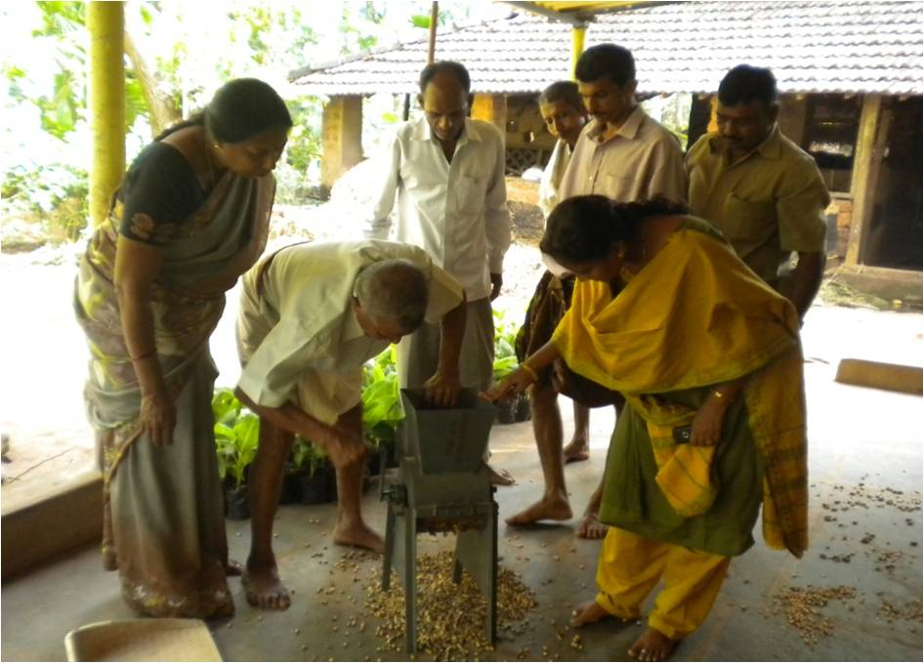 | 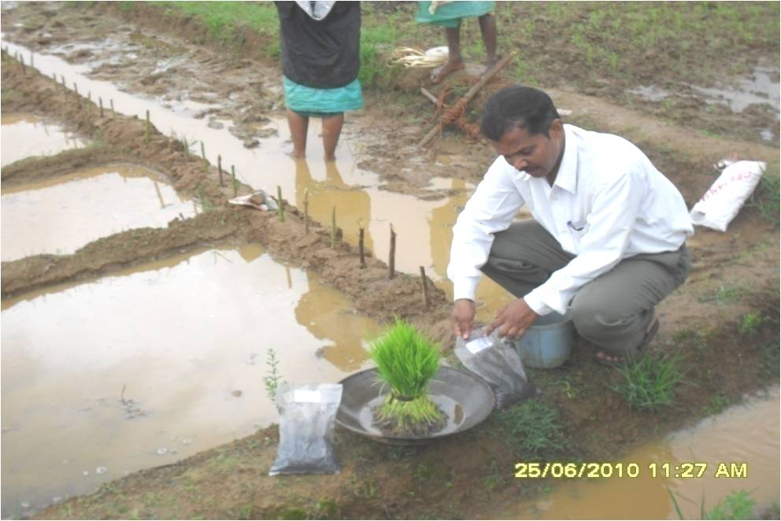 | 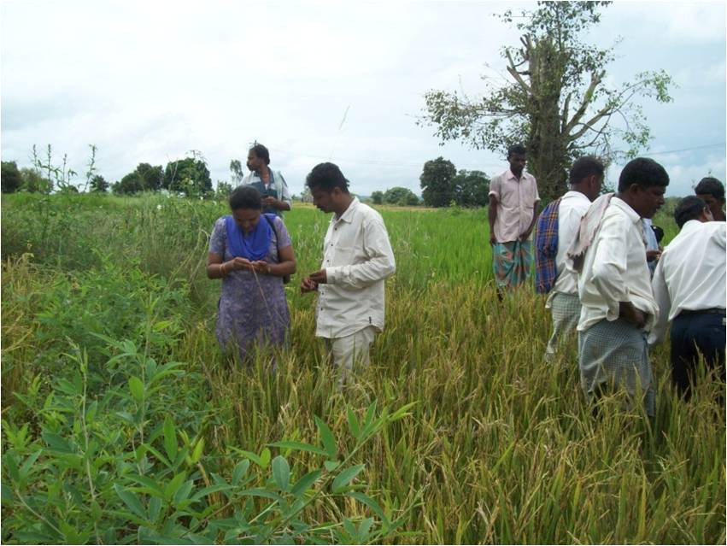
Demonstration of Groundnut decorticator | Demonstration of use of bio fertilizers in paddy | Diagnostic visit to ear head bug affect paddy field
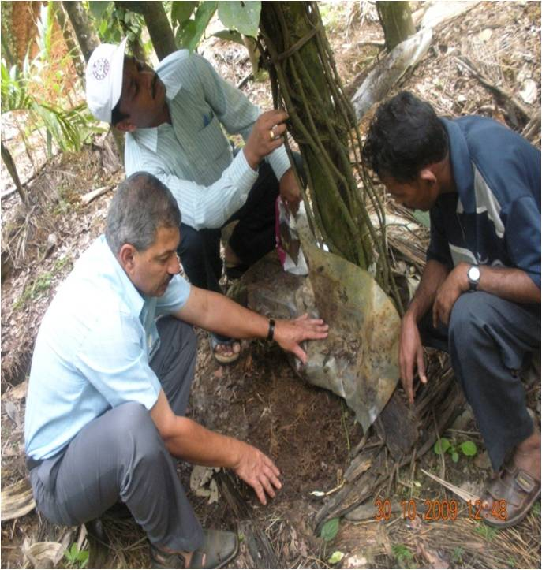 | 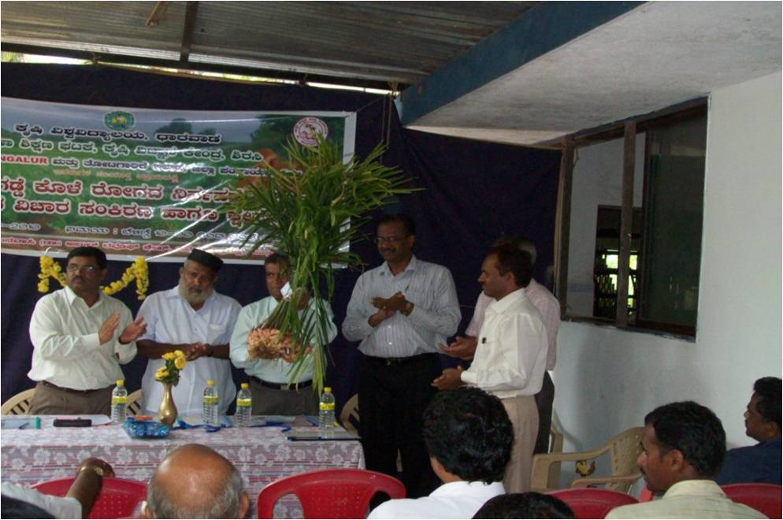 | 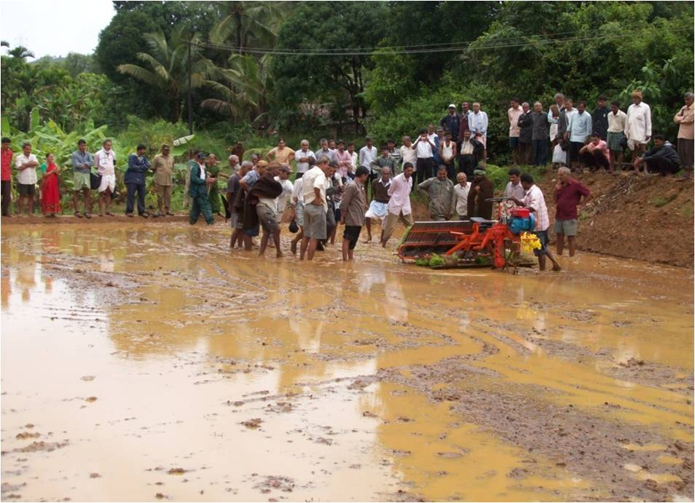
Footrot management in black pepper | Statelevel Ginger Seminar | Training cum demo on mechanized paddy transplanting

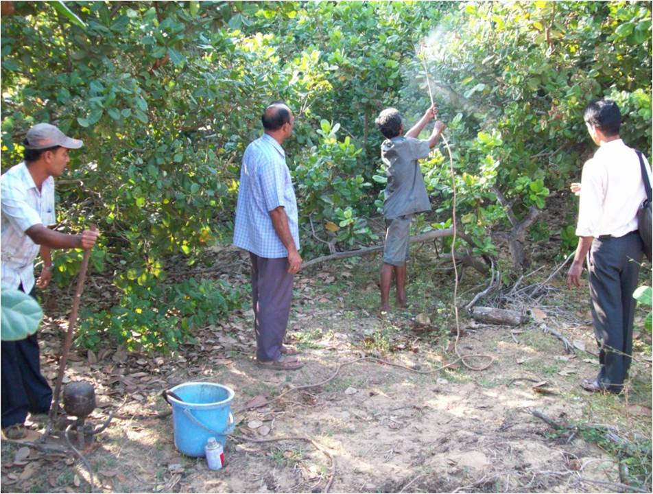 | 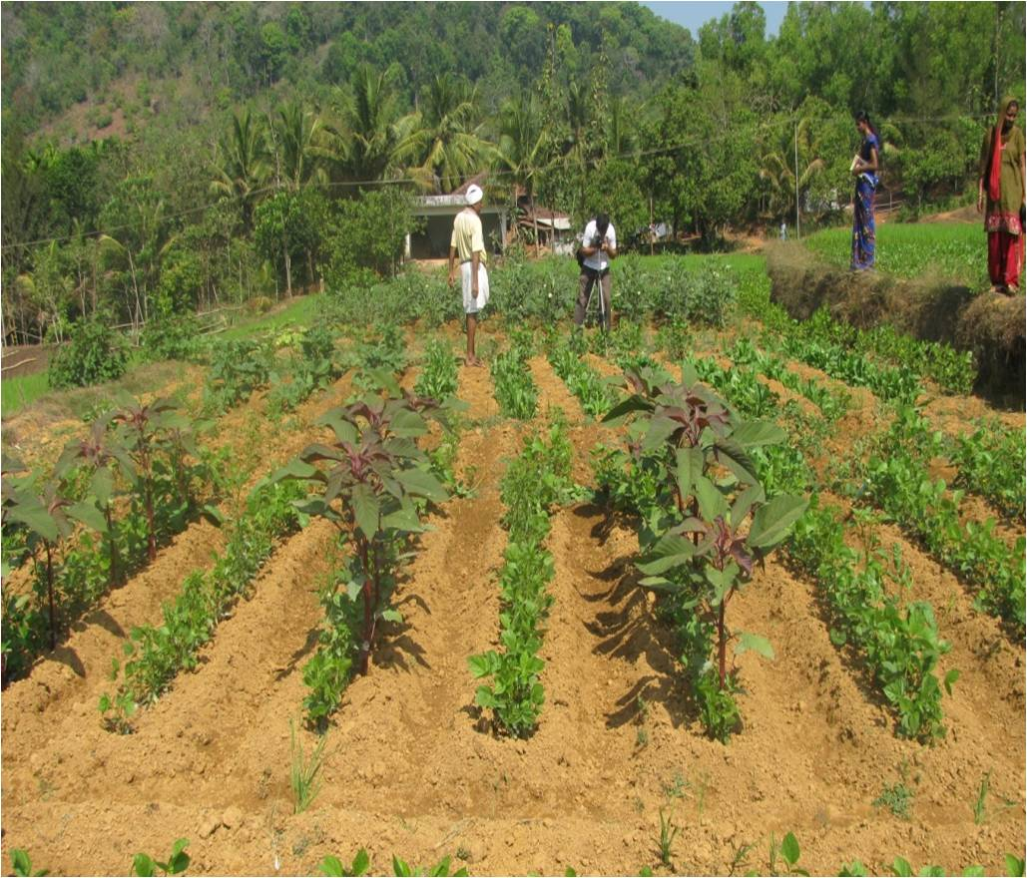 | 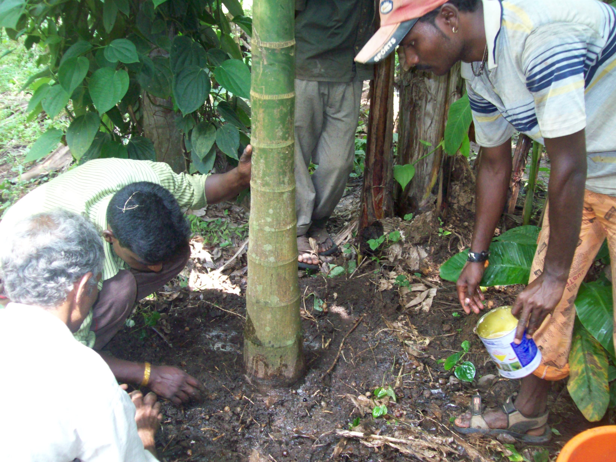
Management of tea mosquito in cashew | Nutrition Vegetable garden for small farmers | IPM practices for rootgrub management
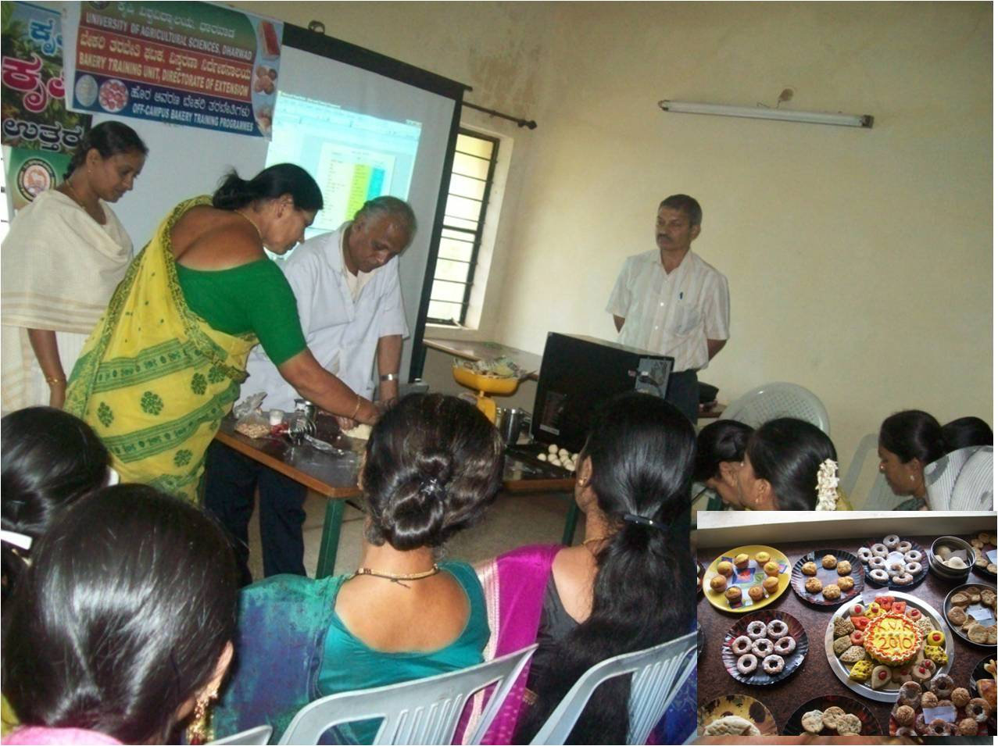 | 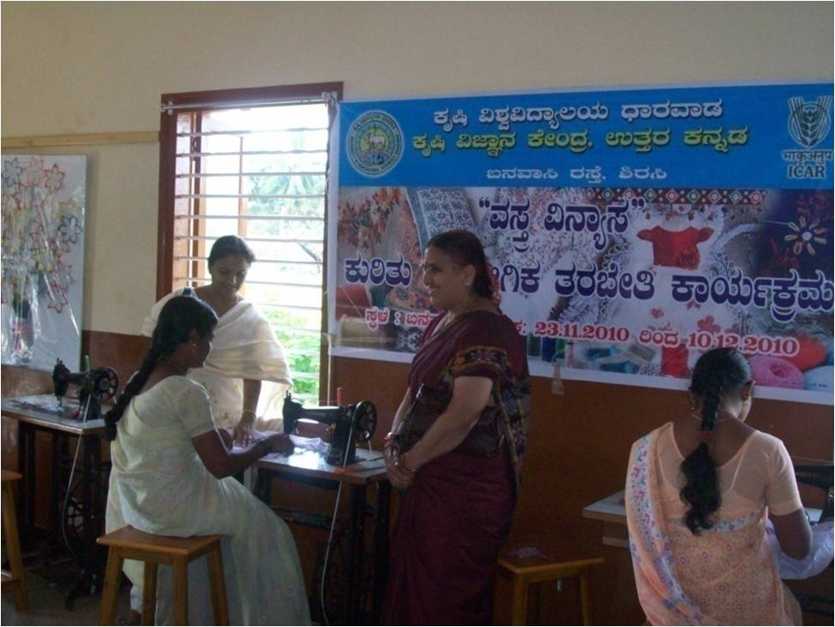 | 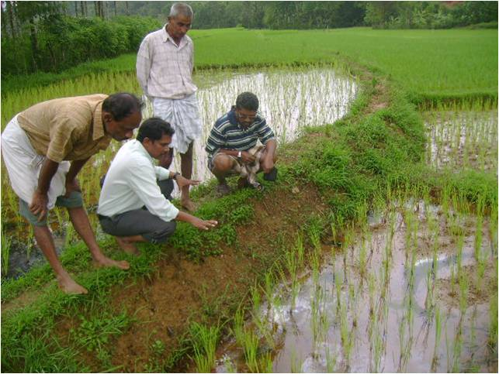
Vocational training on bakery product preperation | Vocation training on tailoring | Imparting knowledge on soil acidity management

