Improved Agenda for Exchange of Sugarcane True Seed (Fluff/Fuzz)

N.Rajendra Prasad¹,Bakshiram¹,G.Hemaprabha¹ and
Ravindra Naik²
1 ICAR-Sugarcane Breeding Institute, Coimbatore 2 ICAR-CIAE regional Centre, Coimbatore

True seed harvested from sugarcane flowers commonly known as fluff or fuzz’ is the basic material for selection and development of new improved varieties The natural climatic conditions around Coimbatore (11⁰N Latitude and 77⁰ Longitude) were found to be most ideal for profuse flowering and seed setting without any cost on artificial equipment.This strongpoint offers a great opportunity for commercialisation of sugarcane seed fluff.
Ever since its inception in 1912, sustained breeding programmes helped for evolving better commercial clones for the entire countrythrough Coimbatore canes which extended throughout the globe for commercial or breeding use.
A revival of demand for proven Coimbatore canes as well as botanical seed i.e. fluff/fuzz has arisen from various sugarcane growing countries.The exchange of true seed offers means to obtain genes of choice. Sharing the true seed (fluff/ fuzz) from crosses done between parents of choice at ICAR-Sugarcane Breeding Institute, Coimbatore with countries in dire need of sugarcane fluff opens new avenues in sugarcane research abroad as well as revenue generation.
As envisaged by global bodies like FAO/IPGRI(1993) and sugarcane breeding stations in various countries either fluff or defuzzed seed can become a marketable input.The movement of seed might provide a safer, more extensive and rapid alternative to vegetative material.Our well-organized breeding programmes would open new vistas for marketing of true seed.
Seed Technology Laboratory,ICAR-Sugarcane Breeding Institute, Coimbatore has got the proven techniques and technologies for handling sugarcane true seed viz.seedprocessing, testing for germination, seedstorage, packing and transport. Rajendra Prasad (1991) standardised procedure for seed germination test for fluff as well as defuzzed seed. Seed storage facility at minus20⁰C at Seed Technology Laboratory could maintain good initial germinability fluff/defuzzed seed for more than five years.(Rajendra Prasad,1998, Rajendra Prasad and Balasundarm,2002,2004)
Defuzzing is practiced to improve the handling of fluff in sowing. Disinfection becomes easier. Through reduction of weight and principally volume the storage and transport becomes easier.1000- seed weight ranges from 0.5 to 2.5 g (Rajendra Prasad and Tripathi,1999).
At Sugarcane Breeding Institute,N.Balasundaram and N.Rajendra Prasad fabricated mechanical defuzzing machine run by 0.5 HP motor.Defuzzed seed gave better germination(Rajendra Prasad,1993,1994,Rajendra Prasad et al.,1998,Rajendra Prasad and Balasundaram,2004).A prototype model of a brush operated sugarcane defuzzing machine was fabricated by Rajendra Prasad (ICAR-SBI) and Ravindra Naik(ICAR-CIAE) in 2020.Rotating ,circular nylon brushes were deployed for defuzzing and oscillating sieves for seed cleaning. Power transmission effected through 1 HP electric motor. The seed fluff fed between the rotating brushes will get defuzzed and cleaned. The seed recovery from open-pollinated general fluff collections ranged from 50-70%.No reduction in seed germination observed.

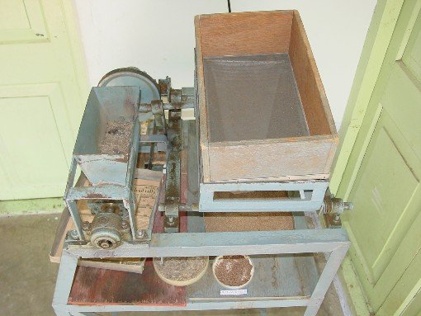
ICAR-SBI MECHANICAL DEFUZZING MACHINE(1991)

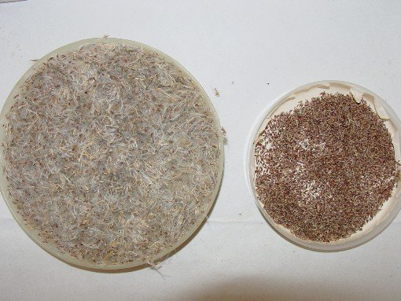
SEED FLUFF AND DEFUZZED SEED

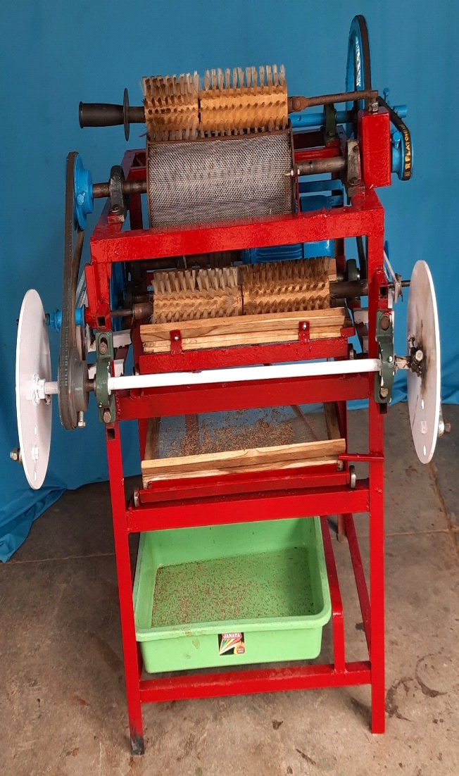

ICAR-SBI and CIAE BRUSH-TYPE DEFUZZING MACHINE
(2020)

As we have a well-knit breeding programmes, supplyingthe seed fluff of requirement and choice may not be a problem. The seed collected after hybridization, processing and packing can be despatched to any country instantly. The price tag must be worked out carefully resulting in optimum revenues considering the cost of seed production,processing,packing and transport.The beneficiaries include the Sugarcane research stations of the countries which are in dire need to have good sugarcane true seed for initiating their varietal evolution programmes specific to their country.

References

Balasundaram,N(1991,1992,1993) Annual Report, Sugarcane Breeding institute, Coimbatore
Rajendra prasad,N.(1991 to 2000) Annual Reports ,Sugarcane breeding institute, Coimbatore
Rajendra Praasd,N ,D .Neelamathi,T V Sreenivasan and BK Tripathi (1998) Storage studies in sugarcane defuzzedseed.Indian Sug.XX,Nov.577-579
Rajendra Prasad N and BK Tripathi (1999) Germination test for Sugarcane true seed Seed Res.27(2)185-187.
Rajendra Prasad,N and N.Balasundaram (2004) Conservation of Saccharum spontaneum as defuzzed true seed.Proc.Internl.Symp.onSustainable Sugarcane &Sugar production technology.Nanning,P.R.China pp.253-256.(Eds. yang-rui Li and S.Solomon,China Agriculture Press,Beijing,China.
Rajendra Prasad N(2020) Annual Report,ICAR-Sugarcane Breeding Institute, Coimbatore.

