KRISHI VIGYAN KENDRA………………… (MALAPPURAM)

ANNUAL REPORT- 2021

(FOR THE PERIOD FROM 01 January, 2021 TO 31 December, 2021 along with good action oriented photographs in jpeg format for all activities of KVK with size of more than 2 MB need to be sent separately with caption in the file name)

KrishiVigyan Kendra Malappuram , KCAET campus, Tavanur P.O, Tavanur – 679 573

Kerala Agricultural University, Vellanikkara, K.A.U P.O, Thrissur

GENERAL INSTRUCTIONS

Please read the following instructions very carefully before starting preparation of the report.

- Annual report is the most important document for the KVK and it directly reflects the overall achievements pertaining to the reported period. Hence due care needs to be given by each KVK while preparing the report.

- Period of Report is from 01 January, 2021 to 31 December, 2021.

- Action photographs with relevant captions covering all OFTS/FLDS/TRAINING/EXTENSION activities of the KVK in High resolution should be submitted separately in a CD/DVD along with this report. A part from this, soft copy of the activity wise photos may be submitted in JPEG format.

- Prepare Summary tables carefully tallying with the relevant portions of the main report on all aspects.

- Retain the blank column and rows as such and do not merge the cells. Please specify NIL, wherever not applicable or details are not available.

- Check the names of varieties and hybrids and specify in the report.

- Check the units and totals of each data table.

- Extension activity under celebrations for each important day, please insert separate rows and give appropriate data separately. Clubbing of data should be avoided.

- Success stories/case studies should be supported with data tables and graphs. Without photos success stories will not be considered for inclusion in Annual Report of ATARI.

PART I – GENERALINFORMATION ABOUT THE KVK

1.1. Name and address of KVK with phone, fax and e-mail
KVK Address | Telephone |  | E mail | Web Address
 | Office | Fax
KrishiVigyan Kendra MalappuramTavanur – 679 573 | 0494 2686329 | 0494 2687640 | kvkmalappuram@kau.in | kvkmalappuram.kau.in

1.2.Name and address of host organization with phone, fax and e-mail
Address | Telephone |  | E mail | Web Address
 | Office | Fax
Kerala Agricultural University  Vellanikkara, KAU P.O, Thrissur | 0487-2370150 | 0487-2370150 | de@kau.in | www.kau.in

1.3. Name of the Programme Coordinator with phone & mobile No.
Name | Telephone / Contact
 | Residence | Mobile | Email
Dr. Ibraheem Kutty .C |  | 9562497320 | ibraheemkutty.c@kau.in

1.4. Year of sanction:

1.5. Staff position as on 31 December 2021
Sl.  No. | Sanctioned post | Name of the incumbent | Designation | M/F | Discipline | Highest Qualification  (for PC, SMS and Prog. Asstt.) | Pay  Scale | Basic pay | Date of joining KVK | Permanent  /Temporary | Category (SC/ST/  OBC/  Others)
1 | Head/Senior Scientist | Dr. Ibraheem Kutty .C | Programme Coordinator | M | Animal Reproduction | MVSc, MPH; PhD | 57700-162000 | 75300 | 20-05-20 | Permanent | OBC
2 | Scientist/SMS | Abdul Jabbar P.K | Asst. Professor | M | Agrl. Extension | MSc, | 57700-162000 | 73000 | 18-09-19 | Permanent | OBC
3 | Scientist/SMS | Priya G. Nair | Asst. Professor | F | Agrl. Engineering | M.Tech, | 57700-162000 |  |  | Permanent | Others
4 | Scientist/SMS | Dr. Prasanth K | Asst. Professor | M | Horticulture | MSc, PhD | 57700-162000 | 59400 | 08-03-19 | Permanent | Others
5 | Scientist/SMS | Dr. Najitha Ummer | Asst. Professor | F | Agrl. Entomology | MSc, PhD | 57700-162000 | 59400 | 18-03-19 | Permanent | OBC
6 | Scientist/SMS | Dr. Lilia baby | Asst. Professor | F | Home Science | MSc, PhD | 57700-162000 | 59400 | 14-03-19 | Permanent | Others
7 | Scientist/SMS | Ms. Prasanthi .K | Asst. Professor | F | Agronomy | MSc. | 57700-162000 | 59400 | 16-03-19 | Permanent | Others
8 | Scientist/SMS  DAMU | Ms. Sushna | SMS | F | Agro Meteorology | MSc (Agro meteorology) |  | 54000 |  | Temporary | Others
9 | Programme Assistant ( Lab Tech.) | Sri. Ambujan C.V. | Technical Officer | M | Agrl. Engg | B.Tech (Agri.Engg) | 55350-101400 | 89000 | 01-11-04 | Permanent | Others
10 | Programme Assistant (Computer) | Rosh kurian | Computer Programmer | M |  |  |  | 21000 |  | Temporary | Others
11 | Programme Assistant/ Farm Manager | Smt. Sandhya .M | Farm Officer | F |  | BSc(Agri.) | 9300- 34800 | 40500 | 18-03-13 | Permanent | Others
12 | Assistant | Ms. Arachana Lal AM | Asst. Section officer | F |  |  | 9300- 34800 | 27800 | 03-10-07 | Permanent | Others
13 | Jr. Stenographer | Smt. Silna .A | Computer Asst. | F |  |  | 5200- 20200 | 30700 | 14-12-16 | Permanent | Others
14 | Agromet observer  DAMU | Mr. Ashique | Agromet observer | M |  | BSc(Agri) |  | 18000 |  | Temporary | OBC
15 | Driver - 1 | Lakshmanan .A | LDV driver | M |  |  | 5200- 20200 | 28500 | 10-08-19 | Permanent | SC
16 | Driver - 2 | Ashraf | LDV driver | M |  |  |  | 18000 | - | Temporary | OBC
17 | SS-1 | Sri. Sreenivasan | Class IV | M |  |  | 5200- 20200 | 23400 | 26-08-16 | Permanent | SC
18 | SS-2 | Sri. Abdul Azeez | Class IV | M |  |  | 5200- 20200 | 16500 |  | Permanent | OBC

1.6. Total land with KVK (in ha): 20 ha

S. No. | Item | Area (ha)
1 | Under Buildings | 4.00
2. | Under Demonstration Units | 0.24
3. | Under Crops | 14.26
4. | Orchard/Agro-forestry | 1.00
5. | Others | 0.50

1.7. Infrastructural Development:

A) Buildings
S.  No. | Name of building | Source of  funding | Stage
 |  |  | Complete |  |  | Incomplete
 |  |  | Completion  Date | Plinth area (Sq.m) | Expenditure (Rs.) | Starting Date | Plinth area  (Sq.m) | Status of construction
1. | Administrative  Building | ICAR | July 2006 | 546 | 43,92,000 |  |  | Completed
2. | Farmers Hostel | ICAR | July 2009 | 300 | 24,00,000 |  |  | Completed
3. | Staff Quarters | ICAR | March 2010 | 394.95 | 30,50,000 |  |  | Completed
 | 1
 | 2
 | 3
 | 4
 | 5
 | 6
4. | Demonstration Units |  | September 2007 | 160 | 5,60,000 |  |  | Completed
 | 1 Green house | ICAR
 | 2 Vermi compost unit | ICAR
 | 3 Poly House | Dept. of Agri
 | 4 Rain shelter | Dept. of Agri
5 | Fencing
6 | Rain Water harvesting system | ICAR | 2011 |  | 10,00,000 |  |  | completed
7 | Threshing floor
8 | Farm godown
9 | Machinery yard | State Planning Board | May 2015 | 80.0 | 33,00,000 |  |  | Completed
10 | Solar power unit | ICAR award money utilization | June 2017 |  | 3,00,000 |  |  | Completed
11 | Seed drying and processing unit | State Plan project | Jan 2022 |  | 5,00,000 |  |  | Completed
12 | Farmer innovation museum cum exhibition unit | State Plan project |  |  | 6,00,000 |  |  | Ongoing
13 | Automatic weather station | IMD | Aug 2021 |  |  |  |  | Completed

B) Vehicles

Type of vehicle | Year of purchase | Cost (Rs.) | Total kms. Run | Present status
Jeep Bolero LX 2WD | 2017 | 8,00,000 | 91200 | Good
Two wheeler-Bike | 2006 | 38,616 | 50030 | Good (15 years over)
Two wheeler - scooter | 2009 | 43,955 | 41064 | Good

C) Lab equipment & AV aids

Name of the equipment | Year of purchase | Quantity (No.) | Cost (Rs.) | Present status
Computer | 2015 | 3 | 75,000 | Good
Digital camera | 2011 | 1 | 19,500 | Damaged and needs replacement
EPABX | 2010 | 1 | 49,900 | Good
LCD projector | 2017 | 2 |  | Good
Laptop and printer(DAMU) | 2019 | 1 | 60000 | Good
Laptop | 2020 | 1 | 37700 | Good
Computer | 2021 | 3 | 78500 | Good
Digital Camera | 2021 | 1 | 36500 | Good

D) Farm equipment and implements

Name of the equipment/implement | Year of purchase | Quantity (No.) | Cost (Rs.) | Present status
Tractor (New Holland Ford 3230 42 HP) | 2005 | 1 | 3,43,235 | Good
Kubota mini tractor | 2017 | 1 | 6,00,000 | Good
Duck foot cultivator | 2017 | 1
9 T Heavy spring cultivator (SC120) | 2017 | 1
1.8. Details of SAC meeting organized

Date | Number of Participants | Salient Recommendations | Action taken | Remarks, if any
28-10-2021 | 25 | Dr. Jayasree Krishnankutty, Director of Extension:  She gave suggestions for the ensuing programmes of various disciplines. She suggested to initiate steps to upgrade the existing processing unit of KVK Malappuram as a common facilitation centre seeking financial assistance from NABARD, if possible, which can create more impact among stakeholders. | Actions based on recommendations will be implemented in year 2022
 |  | Smt. Sreekala P, PAO Malappuram: She suggested to start more awareness programmes on climate change, flood and its implications in agriculture. The banana and tapioca farmers had faced serious problems due to glut in the market and stressed the need to concentrate more capacity development programmes under the KVK in banana and tapioca value addition. She also emphasised to start capacity development programmes on marketing technologies for strengthening weekly market and eco shops in Malappuram district.
 |  | Mr. Chandran K, Project Director ATMA: suggested to initiate alternative ways to continue MTA and such kind of research extension interfaces utilizing KVK funds, if possible. He asked to include more number of front line demonstrations in rice and popularisation of DAMU activities in Malappuram district. He also emphasised the need for more interventions to address the man animal conflict in agriculture utilizing effective technologies through the involvement of KVK.
 |  | Sri. Ananda Bose, District Soil Conservation Officer: Since Malappuram district is facing several climate vagaries recently, he sought technical support to prepare the landslide map of Malappuram district. He also expressed the need to get the rainfall intensity data for the analysis of various drainage related projects and sought KVK support.
 |  | Dr. Deepa Chirayath, represented for District Animal Husbandry office: She suggested to include training on silage preparation to Kudumbashree self-help groups, among the KVK programmes. She also suggested KVK to start mineral mixture production unit for cattle, to support the dairy farmers in the district. She also mentioned the major concern of cattle farmers due to the increasing incidence of blood parasite infestations and asked to address the same in KVK activities.
Smt. Sheeba Khamer, Deputy Director, Dairy Development Department
She suggested initiate capacity development programmes to milk societies on value addition of milk. She revealed the concern on many reports of milk being contaminated by harmful substances such as aflatoxin, antibiotics and so on and suggested to include training programmes on clean milk production and fodder cultivation.

 |  | Sri. Mohammed Fawas, IEO, District industries centre: He sought the possibilities of collaborative training with District Industries Centre in ODOP training programme
 |  | Dr. Suma Nair, Programme Coordinator,KVK Thrissur: She assured the availability of the mushroom spawn to KVK in needy situation. She sought the possibility of Edayur Red chilli powder production to empower the FPO activities.
 |  | Dr. Sumiya K.V, Programme Coordinator, KVK Palakkad: Also, suggested the popularization of paired row planting in paddy, since this technology is effective in yield increase.
 |  | Smt. Soumya K.V, Block Coordinator Kudumbasree Mission: Suggested different areas where KVK can render training programms to Kudumbasree mission such as value addition in milk, fodder cultivation and ornamental fish production.
 |  | Sri Latheef, Farmer: He requested to conduct field schools for technology dissemination and emphasised the importance of Integrated farming system approaches to enhance the farmer income. Promotion of hybrid seeds to enhance the productivity especially in vegetable and the need to give more off campus training than on campus training were also emphasised. Also, recommended for providing production management protocol for important crops and suggested more training programmes to be conducted for upgrading knowledge of agricultural officials. He also pointed out the essentiality of facilitation centre at KVK to support the farmers.
 |  | Smt. Chandrika, Farmer representative: She suggested steps to ensure timely supply of planting materials of tuber crops, cool season vegetables, and organic manure.
 |  | Sri. Mohanakrishnan, farmer representative: He sought the technical support of KVK to strengthen the newly established FPO of Edayur chilli.
 |  | Dr. M. J. Chandra Gowda Nodal Officer, ATARI Bengaluru: He advised to focus on activities to enhance farmers’ income. Also, advised to emphasise ARYA & Nutri-garden programmes.

PART II - DETAILS OF DISTRICT

2.1 Major farming systems/enterprises (based on the analysis made by the KVK)
S. No | Farming system/enterprise
 | Coconut based homesteads
 | Rice based cropping systems
 | Banana based farming system
 | Summer vegetables
 | Goat rearing
 | Dairy Enterprise

2.2 Description of Agro-climatic Zone & major agro ecological situations (based on soil and topography)
S. No | Agro-climatic Zone | Characteristics
1 | Sub humid laterite | Regions where moisture in normally less than under humid conditions but still sufficient for the production of many agricultural crops without irrigation or dryland farming. Annual rainfall varies from 150 -180 cm. Soil is laterite
2 | Sub humid alluvium | Soil type is alluvium with above climate
3 | Sub humid forest loam | Soil type is forest loam with above climate
4 | Humid forest loam | Average annual rainfall is heavy (over 200cm) but varies in amount and in seasonal and areal distribution. Soil is forest loam
5 | Per humid laterite | This climate has humidity index values of +100 and above and compares closely to the wet climate. Rainfall is greater than 200 cm.

S. No | Agro ecological situation | Characteristics
1 | Zone VI - Malappuram type | Soil type is laterite. Places such as Tirur ,Kuttippuram, Tanur, Tirurangadi, Vengara, Malappuram, Manjery, Kondotty are coming under this zone.
2 | Zone II – Coastal Sandy | Soil type is sandy loam. Ponnani area is coming under this zone.
3 | Zone VII – Malayoram | Soil type is laterite without B horizon. Area such as Perinthalmanna, Mankada, Vandur are coming under this zone.

2.3 Soil type/s
S. No | Soil type | Characteristics | Area in ha
1 | Loamy sand | Well drained soil with cultivation of coconut, paddy, banana and vegetables | 20469
2 | Gravelly clay loam | Well drained soil with cultivation of coconut, arecanut, banana and fruit trees | 163702
3 | Gravelly loam | Excessively drained soil with cultivation of cashew | 8796
4 | Silty clay loam | Imperfectly drained soil with cultivation of paddy, vegetables, banana and pulses | 21672
5 | Gravelly clay | Well drained soil with cultivation of coconut, cashew and tapioca | 63251
6 | Gravelly sandy clay loam | Well drained soil with cultivation of coconut, cashew and rubber | 10725
7 | Gravelly silty loam | Well drained soil with cultivation of rubber and pepper | 4245
8 | Silty clay loam | Excessively drained soil with forest | 28497
9 | Clay loam | Excessively drained soil with forest and rubber cultivation | 37687

2.4. Area, Production and Productivity of major crops cultivated in the district
S. No | Crop | Area (ha) | Production (Metric tons) | Productivity (kg /ha)
 | Coconut | 105090 | 855 million nuts | 8136 nuts/ha
 | Rubber | 42775 | 40040 | 936
 | Areca nut | 17929 | 15997 | 892
 | Paddy | 7864 | 23571 | 3026
 | Pepper | 2718 | 523 | 192
 | Cashew | 1939 | 322 | 166
 | Tapioca | 5459 | 202502 | 37091
 | Betel leaves | 130 | 3655 | 28079
 | Sesamum | 59.89 | 11.845 | 198
 | Vegetables | 4929
 | Jack | 8511 | 22 million fruits | 2585
 | Mango | 8120 | 33393 | 4113
 | Banana | 7572 | 60912 | 8044
 | Plantain | 4431 | 25882 | 5841
* Please provide latest data from authorized sources. Please quote the source

2.5. Weather data
Month | Rainfall (mm) | Temperature ⁰ C |  | Relative Humidity (%)
 |  | Maximum | Minimum
January 2021 | 73.8 | 32.22 | 22.19 | 71.58
February | 6.2 | 34.94 | 23.71 | 68.07
March | 0 | 36.91 | 24.29 | 63.9
April | 36.2 | 34.88 | 24.00 | 74.6
May | 293.8 | 32.4 | 22.74 | 79.19
June | 315.8 | 30.98 | 22.71 | 80.33
July | 499.8 | 30.25 | 22.46 | 79.45
August | 278.1 | 29.75 | 22.8 | 79.12
September | 208.6 | 31.83 | 22.98 | 79.66
October | 505.1 | 30.32 | 22.85 | 79.7
November | 214.6 | 30.5 | 22.63 | 84.9
December | 8.0 | 32.5 | 21.67 | 74.9
* Agricultural Research Station, Anakkayam

  - Production and productivity of livestock, Poultry, Fisheries etc. in the district

Category | Population | Production | Productivity
Cattle
Crossbred | 84131 | 98460 mt/yr | 2390 Kg/lactation
Indigenous
Buffalo | 19893 | 4448 mt/yr | 1758 Kg/lactation
Sheep
Crossbred
Indigenous
Goats | 145187 |  | 14
Pigs | 945 |  | 45
Crossbred
Indigenous
Rabbits | 20014
Poultry
Hens | 1249813 | 21.92 lakh eggs/year | 205 eggs/bird/year
Desi
Improved
Ducks | 91376 | 4.14 lakh eggs/year | 130 eggs/bird/year
Turkey and others | 97926 | - | -

Category | Area | Production | Productivity
Fish
Marine
Inland
Prawn
Scampi
Shrimp
* Please provide latest data from authorized sources. Please quote the source

  - District profile maintained in the KVK has been Updated for 2021: Yes

2.8 Details of Operational area / Villages

Sl.No. | Taluk | Name of the block | Name of the village | How long the village is covered under operational area of the KVK (specify the years) | Major crops & enterprises | Major problem identified | Identified Thrust Areas
1 | Ponani  Tirur  Ernad  Thirurangadi | Ponnani  Tirur  Tirur  Kuttippuram  Tirur  Malappuram  Tirurangadi  Tirur  Tirur  Vandur | Kuttippuram  Marakkara  Edayur  Irimbiliyam  Nannambra  Moonniyur  Vallikkunnu  Thennala  Vettom  AR Nagar  Tavanur  Edapal  Changaramkam  Athavanad  Parappanangadi | 11  5  6  4  5  5  4  5  14  5  13  6  4  11  4 | Coconut | Low productivity and income | Enhancing the productivity of homesteads
 |  |  |  |  |  | Scarcity and high cost of organic manure | Promoting on-farm organic source of nutrients
 |  |  |  |  |  | Labour scarcity | Small scale farm mechanization
 |  |  |  |  |  | Pest and Disease Incidence | IPDM
 |  |  |  |  |  | Scarcity of water for irrigation | Soil and moisture conservation
 |  |  |  |  |  | Yield decline of intercropped turmeric | Enhancing the productivity of homesteads
2 | Nilambur  Perinthalmanna  Ernad  Kuttippuram | Ponnani  Tirur  Tirur  Kuttippuram  Tirur  Malappuram  Tirurangadi  Tirur  Tirur  Vandur | Oorangattiri  Keezhuparamba  Edayur  Athavanadu  Morayur  Vattamkulam  Parappanangadi  Edapal  Ullanam  Angadippuram  Kuttippuram  Thenjippalam | 7  3  6  11  4  10  4  10  8  6  11  4 | Vegetables | Pest & Disease incidence | IPDM
 |  |  |  |  |  | Low productivity in rainy season | Enhancing fruit and vegetable productivity
 |  |  |  |  |  | Labour scarcity | Small scale mechanization
 |  |  |  |  |  | Water scarcity and high cost on drip irrigation | Soil and water conservation
 |  |  |  |  |  | Unavailability of land in urban areas | Enhancing fruit and vegetable productivity
 |  |  |  |  |  | Low
3 | Ponani  Tirur  Nilambur | Ponnani  Tirur  Kuttippuram  Malappuram  Tirurangadi  Tirur  Vandur | Perumpadappa  Maranchery  Nannammukku  Alamkode  Vattamkulam  Thavanur  Kalady  Purathur  Triprangode  Thirunavaya  Mangalam  Chungathara  Vazhikkadavu  Angadaippuram  AR Nagar  Koloopalam | 9  7  5  5  10  12  5  4  5  10  4  8  5  6  5  3 | Paddy | Decrease in fertility of rice soils and high cost of organic manure | Promoting on-farm organic source of nutrients
 |  |  |  |  |  | Labour scarcity | Small scale mechanization
 |  |  |  |  |  | Pests diseases and weeds | IPDM
 |  |  |  |  |  | High acidity in kole areas | Enhancing kole rice productivity
 |  |  |  |  |  | Fallowing of rice fields | Utilisation of rice fallows
 |  |  |  |  |  | Attack of grains by baya weaver bird | IPDM
 |  |  |  |  |  | Yield decline due to drought | Drought mitigation
4 | Ponani  Tirur | Ponnani  Kuttippuram  Tavanur  Tanur | Edappal  Vattamkulam  Kalady  Edapal  Kololamba  Parappanangadi | 5  5  10  12  5  4 | Dairying | High cost of feed and lack of fodder grass | Enhancing the productivity of homesteads
 |  |  |  |  |  | Low performance of hybrid napier in shade | Enhancing the productivity of homesteads
 |  |  |  |  |  | Ecto-parasite infestation | Scientific management of cattle and goat
5 | Tirur | Tirur | Tirur  Thirunavaya  Thanalur  Niramaruthur  Chembra  Vylathur | 8  11  8  8  5  5 | Betelvine | High cost of organic manure | Promoting organic sources
 |  |  |  |  |  | Pest & disease incidence | IPDM
 |  |  |  |  |  | Scarcity of water for irrigation | Soil & water conservation
6 | Tirur  Ernad | Tirur  Perinthalmanna  Vandur  Tavanur  Kuttippuram  Manjeri | Irimbiliyam  Edayur  Morayur  Kondotty  Vazhakkad  Nediyirippu  Edapal  Vattamkulam  Athavanad  Kuttippuram  Tirunavaya | 8  6  5  5  10  12  5  4  5  11  11 | Banana | Scarcity of water for irrigation | Soil and moisture conservation
 |  |  |  |  |  | Pest and disease incidence | IPDM
 |  |  |  |  |  | Labour scarcity | Small scale mechanization
 |  |  |  |  |  | Fluctuating price | Fruit and vegetable productivity
 |  |  |  |  |  | Yield decline due to micronutrient deficiency | Soil health management
7 | Tirur  Nilambur | Vandur  Tirur  Tavanur | Kondotti  Tirur  Vazhikkadav  Tavanur | 5  8  5  12 | Pepper | Low yield due to drought  Yield decline due to micronutrient deficiency | Drought mitigation  Enhancing the productivity of homesteads
8 | Ponani | Tavanur | Tavanur  Ponani  Edapal | 12  6  10 | Perennial fruit crops | Drudgery in processing of fruit pulp | Value addition
9 | Perinthalmanna | Malappuram | Moonniyoor | 5 | Tapioca | Fluctuating price | Small scale mechanization
10 | Ponnani  Tirur  Nilambur  Perinthalmanna | Tavanur  Tirur | Tavanur,  Kalady  Edappal  Ezhuvathuruthy  Vettom  Mangalam  Purathur  Thirunavaya  Nilambur  Vazhikkadavu  Amarambalam  Oorgattiri  Muthuvalloor  Kondotti  changaramkulam | 12  5  10  5  12  5  4  10  8  8  3  4  4  5  6 | Homestead farming | Lack of integration and low income | Enhancing the productivity of homesteads
 |  |  |  |  |  | Pest incidence in mushrooms | IPDM
 |  |  |  |  |  | Destruction of crops by wild boars | IPDM
 |  |  |  |  |  | Yield decline in oyster mushrooms | Enhancing the productivity of homesteads
11 | Ponani  Tirur  Ernad |  | Tavanur  Kalady  Edappal  Thirunavaya  Morayur  Kondotty  Mangalam  Purathur | 12  5  10  10  5  5  4  4 | Arecanut | Pest and disease management | IPM practices
 |  |  |  |  |  | Nutrient deficiency | INM practices

2.9 Priority thrust areas

S. No | Thrust area
1 | Enhancing the productivity of homesteads
2 | Integrated pest and disease Management (IPDM)
3. | Soil health management
4 | Enhancing fruit and vegetable productivity
5 | Production of quality seeds and planting materials
6 | Small scale farm mechanization
7 | Enhancing Kole rice productivity
8 | Utilization of rice fallows
9 | Promotion of organic inputs in crop production
10 | Soil moisture conservation and drought mitigation
11 | Scientific management of cattle and goat
12 | Household waste management
13 | Value addition

PART III - TECHNICAL ACHIEVEMENTS

3.A. Target and Achievements of mandatory activities
OFT |  |  |  | FLD
1 |  |  |  | 2
OFTs (No.) |  | Farmers (No.) |  | FLDs (No.) |  | Farmers (No.)
Target | Achievement | Target | Achievement | Target | Achievement | Target | Achievement
5 | 1 ( 4 ongoing) | 25 | 25 | 16 | 4 ( 12 ongoing) | 135 | 135

Training (Farmers/farm women) |  |  |  | Training (Rural youth)
3 |  |  |  | 4
Courses (No.) |  | Participants (No.) |  | Programmes (No.) |  | Participants (No.)
Target | Achievement | Target | Achievement | Target | Achievement | Target | Achievement
75 | 75 | 3500 |  | 10 | 15 | 500

Training (Extension personnel) |  |  |  | Training (sponsored)
5 |  |  |  | 6
Courses (No.) |  | Participants (No.) |  | Programmes (No.) |  | Participants (No.)
Target | Achievement | Target | Achievement | Target | Achievement | Target | Achievement
5 | 7 | 100 |  | 50 |  | 3000

Training (Vocational) |  |  |  | Extension Programmes
7 |  |  |  | 8
Courses (No.) |  | Participants (No.) |  | Programmes (No.) |  | Participants (No.)
Target | Achievement | Target | Achievement | Target | Achievement | Target | Achievement
2 | 2 | 50 | 45

Seed Production (Q) |  | Planting material (Nos.)
9 |  | 10
Target | Achievement | Target | Achievement
10 | 16.9 | 100000 | 94115

Livestock, poultry strains and fingerlings (No.) |  |  |  | Bio-products (Kg)
11 |  |  |  | 12
Target |  | Achievement |  | Target |  | Achievement
Soil, water, plant and manure analysis  (including mobile kits) |  |  |  | Mobile agro advisories provided
13 |  |  |  | 14
Samples (No.) |  | Farmers (No.) |  | Messages including text, voice (No.) |  | Farmers (No.)
Target | Achievement | Target | Achievement | Target | Achievement | Target | Achievement
3.B1. Abstract of interventions undertaken
S. No | Thrust area | Crop/  Enterprise | Identified Problem | Interventions
 |  |  |  | Title of OFT if any | Title of FLD if any | Number of Training (farmers) | Number of Training (Youths) | Number of Training (extension personnel) | Extension activities  (No.) | Supply of seeds (Qtl.) | Supply of planting materials (No.) | Supply of livestock (No.) | Supply of bio products
 |  |  |  |  |  | 1 |  |  |  |  |  |  | No. | Kg

3.B2. Details of technology used during reporting period
S.No | Title of Technology | Source of technology | Crop/enterprise | No. of programmes conducted
 |  |  |  | OFT | FLD | Training | Others (Specify)
1 | 2 | 3 | 4 | 5 | 6 | 7 | 8

3.B2 contd..
No. of farmers covered
OFT |  |  |  | FLD |  |  |  | Training |  |  |  | Others (Specify)
General |  | SC/ST |  | General |  | SC/ST |  | General |  | SC/ST |  | General |  | SC/ST
M | F | M | F | M | F | M | F | M | F | M | F | M | F | M | F
9 | 10 | 11 | 12 | 13 | 14 | 15 | 16 | 17 | 18 | 19 | 20 | 21 | 22 | 23 | 24

PART IV - On Farm Trial
4.A1. Abstract on the number of technologies assessed in respect of crops
Thematic areas | Cereals | Oilseeds | Pulses | Commercial Crops | Vegetables | Fruits | Flower | Plantation crops | Tuber Crops | TOTAL
Integrated Nutrient Management | 1 |  |  |  |  |  |  |  |  | 1
Varietal Evaluation |  |  |  | 1 |  | 1 |  |  |  | 2
Integrated Pest Management
Integrated Crop Management
Integrated Disease Management |  |  |  | 1 |  |  |  |  |  | 1
Small Scale Income Generation Enterprises
Weed Management
Resource Conservation Technology
Farm Machineries
Integrated Farming System
Seed / Plant production
Value addition |  |  |  |  |  |  |  |  | 1 | 1
Drudgery Reduction
Storage Technique
Cropping Systems
Farm Mechanization
Mushroom cultivation
others
Total | 1 |  |  | 2 |  | 1 |  |  | 1 | 5

4.A2. Abstract on the number of technologies refined in respect of crops

Thematic areas | Cereals | Oilseeds | Pulses | Commercial Crops | Vegetables | Fruits | Flower | Plantation crops | Tuber Crops | TOTAL
Integrated Nutrient Management
Varietal Evaluation
Integrated Pest Management
Integrated Crop Management
Integrated Disease Management
Small Scale Income Generation Enterprises
Weed Management
Resource Conservation Technology
Farm Machineries
Integrated Farming System
Seed / Plant production
Value addition
Drudgery Reduction
Storage Technique
Cropping Systems
Farm Mechanization
Mushroom cultivation
Others
Total

4.A3. Abstract on the number of technologies assessed in respect of livestock

Thematic areas | Cattle | Poultry | Piggery | Rabbit | Fisheries | TOTAL
Evaluation of Breeds
Nutrition Management
Disease of Management
Value Addition
Production and Management
Feed and Fodder
Small Scale income generating enterprises
Dairy
Others (Pl. specify)
TOTAL

4.A4. Abstract on the number of technologies refined in respect of livestock

Thematic areas | Cattle | Poultry | Piggery | Rabbit | Fisheries | TOTAL
Evaluation of Breeds
Nutrition Management
Disease of Management
Value Addition
Production and Management
Feed and Fodder
Small Scale income generating enterprises
Dairy
Others (Pl. specify)
TOTAL

4.B. Achievements on technologies Assessed and Refined

4.B.1. Technologies Assessed under various Crops

Thematic areas | Crop | Name of the technologies | No. of trials | Number of farmers / locations | Area in ha (Per trial covering all Technological Options in a farm)
Integrated Nutrient Management | Rice | Assessment of performance of medium duration high yielding rice varieties under Rice - amorphophallus cropping system | 5 | 5 | 0.40
Varietal Evaluation | Water melon | Assessment of high yielding water melon varieties for Malappuram district | 5 | 5 | 0.06
 | Vetiver | Assessment of Vetiver varieties for coastal areas | 5 | 5 | 0.03
Integrated Pest Management
Integrated Crop Management
Integrated Disease Management | Betel vine | Assessment of Trichoderma capsules of KAU and IISR against Phytophthora rot in Tirur betel vine | 5 | 5 | 0.04
Small Scale Income Generation Enterprises
Weed Management
Resource Conservation Technology
Farm Machineries
Integrated Farming System
Seed / Plant production
Value addition | Cassava | Assessment of cassava varieties suitable for product development | 5 | 5
Drudgery Reduction
Storage Technique
Mushroom cultivation
Total

4.B.2. Technologies Refined under various Crops

Thematic areas | Crop | Name of the technologies | No. of trials | Number of farmers/locations | Area in ha (Per trial covering all Technological Options in a farm)
Integrated Nutrient Management
Varietal Evaluation
Integrated Pest Management
Integrated Crop Management
Integrated Disease Management
Small Scale Income Generation Enterprises
Weed Management
Resource Conservation Technology
Farm Machineries
Integrated Farming System
Seed / Plant production
Post Harvest Technology/Value addition
Drudgery Reduction
Storage Technique
Mushroom cultivation
Cropping Systems
Farm Mechanization
Others, Pl specify
Total

4.B.3. Technologies assessed under Livestock
Thematic areas | Name of the livestock | Name of the technologies | No. of trials | No. of farmers/locations
Evaluation of breeds
Nutrition management
Disease management
Processing and Value addition
Production and management
Feed and fodder management
Small scale income generating enterprises
Others, pl. specify
Total

4.B.4. Technologies Refined under Livestock and other enterprises
Thematic areas | Name of the livestock | Name of the technologies | No. of trials | No. of farmers/locations
Evaluation of breeds
Nutrition management
Disease management
Processing and Value addition
Production and management
Feed and fodder management
Small scale income generating enterprises
Others, pl. specify
Total

4.B.5. Technologies assessed under various enterprises by KVKs

Sl. | Thematic areas | Name of the enterprise | Name of technology(s) | No. of trials | No. of locations
1 | Drudgery reduction
2 | Entrepreneurship Development
3 | Health and nutrition
4 | Processing and value addition | Processed food | Assessment of cassava varieties suitable for product development | 2 SHGs | 2
5 | Energy conservation
6 | Small-scale income generation
7 | Storage techniques
8 | Household food security
9 | Organic farming
10 | Agro forestry management
11 | Mechanization
12 | Resource conservation technology
13 | Value Addition
14 | Others, pl. specify

4.B.6.Technologies assessed under various enterprises for women empowerment

 | Thematic areas | Name of enterprise | Name of technology(s) | No. of trials | No. of locations
1 | Drudgery Reduction
2 | Entrepreneurship Development
3 | Health and Nutrition
4 | Value Addition | Processed food | Assessment of cassava varieties suitable for product development | 2 SHGs | 2
5 | Women Empowerment
6 | Others, pl. specify

4.C1.Results of Technologies Assessed

Crop/ enterprise | Farming situation | Problem definition | Title of OFT | No. of  trials | Technology Assessed | Source of technology | Yield | Unit of yield | Observations other than yield | Gross Return Rs. / unit | Net Return Rs. / unit | BC Ratio (Gross income/ Gross Cost)
1 | 2 | 3 | 4 | 5 | 6 | 7 | 8 | 9 | 10 | 11 | 12 | 13
 |  |  | Assessment of high yielding water melon varieties for Malappuram district |  | T.O.1 (Farmers practice)
 |  |  |  |  | T.O.2
 |  |  |  |  | T.O.3
 |  |  | Assessment of Trichoderma capsules of KAU and IISR against Phytophthora rot in Tirur betel vine | 5 | TO1(FP) |  | 534 | bundles | 9.02 % leaf infection | 13395 | 28275 | 1.27
 |  |  |  |  | TO 2 | IIHR | 864.2 |  | 2.56 % | 21605 | 79313 | 1.58
 |  |  |  |  | TO 3 | KAU | 704.2 |  | 4 % | 16995 | 49326 | 1.38
 |  |  |  |  | TO 4 | IISR | 679.8 |  | 3.7 % | 17605 | 43226 | 1.34
 |  |  | Assessment of performance of medium duration high yielding rice varieties under Rice - amorphophallus cropping system |  | Ongoing
 |  |  | Assessment of Vetiver varieties for coastal areas |  | ongoing
 |  |  | Assessment of cassava varieties suitable for product development |  | ongoing

Assessment of high yielding water melon varieties for Malappuram district
Assessment of Trichoderma capsules of KAU and IISR against Phytophthora rot in Tirur betel vine
Assessment of performance of medium duration high yielding rice varieties under Rice - amorphophallus cropping system
Assessment of Vetiver varieties for coastal areas
Assessment of cassava varieties suitable for product development

4. C2. Feedback on technologies assessed

Name of technology assessed | Useful characters as well as constraints of technology | Socio-economic as well as administrative constraints for its adoption

4.C3. Details of Successfully completed / concluded technology assessment (support with necessary summary of data and photographs)

1. Title of Technology Assessed
2. Performance of the Technology on specific indicators
3.Specific Feedback from farmers
4.Specific Feedback from Extension personnel and other stakeholders
5. Feedback to Research System based on results and feedback received
6. Feedback on usefulness and constraints of technology

4.D1. Results of Technologies Refined

Crop/ enterprise | Farming situation | Problem definition | Title of OFT | No. of  trials | Technology Refined | Source of technology | Yield | Unit of yield | Observations other than yield | Gross Return Rs. / unit | Net Return Rs. / unit | BC Ratio (Gross income/ Gross Cost)
1 | 2 | 3 | 4 | 5 | 6 | 7 | 8 | 9 | 10 | 11 | 12 | 13
 |  |  |  |  | T.O.1 (Farmers practice)
 |  |  |  |  | T.O.2
 |  |  |  |  | T.O.3

4. D2. Feedback on technologies refined

Name of technology refined | Useful characters as well as constraints of technology | Socio-economic as well as administrative constraints for its adoption

4.D.2. Details of Technologies refined:

1. Title of Technology Refined
2. Performance of the Technology on specific indicators
3. Specific Feedback from farmers
4. Specific Feedback from Extension personnel and other stakeholders
5. Feedback to Research System based on results/feedback received
6. Feedback on usefulness and constraints of technology

PART V - FRONTLINE DEMONSTRATIONS

5.A. Summary of FLDs implemented
Sl.  No. | Category | Farming  Situation | Season | Crop | Variety/ breed | Hybrid | Thematic area | Technology Demonstrated | Area (ha) |  | Farmers (No.) |  | Farmers (No.)
 |  |  |  |  |  |  |  |  | Proposed | Actual | SC/ST | Others | Small/ Marginal | Others
 | Oilseeds
 | Pulses | Irrigated |  | Black gram | VBN 8 |  | Varietal evaluation | Demonstrations of high yielding short duration Black gram variety VBN-8 in summer fallows
 | Cereals | Rainfed |  |  |  |  |  | Assessment of paired row planting system in paddy
 | Millets
 | Vegetables | Irrigator |  | Ridge gourd |  | KRH-1 | Varietal evaluation | Demonstration of ridge gourd hybrid ‘KRH-1’ with ICM
 |  | Irrigator |  | Bhindi | Angita |  | Varietal evaluation | Demonstration of Bhindi variety ‘Anjita’ with ICM
 | Flowers
 | Ornamental
 | Fruit | Irrigated |  | Musk melon |  |  |  | Demonstration of high yielding musk melon variety ‘Arka Siri’ with ICM
 |  | Irrigator |  | banana | Nendran |  | IPDM | Prophylactic management of Pseudostem weevil in Banana using entomopathogenic nematode
 | Spices and condiments
 | Commercial
 | Medicinal and aromatic
 | Fodder |  |  |  |  |  |  | Demonstration of shade tolerant Guinea grass ‘CO (GG) 3’ in coconut planted homesteads
 | Plantation |  |  |  |  |  |  | In-situ moisture conservation measures in coconut garden
 |  |  |  |  |  |  |  | Management of Rhinoceros beetle in juvenile Coconut palms using botanical cake and paste
 | Fibre
 | Dairy
 | Poultry
 | Rabbitry
 | Piggery
 | Sheep and goat
 | Duckery
 | Common carps
 | Mussels
 | Ornamental fishes
 | Oyster mushroom
 | Button mushroom
 | Vermicompost
 | Sericulture
 | Apiculture
 | Implements |  |  |  |  |  |  | Demonstration of Tractor drawn root harvester for Ginger, Coleus and Turmeric
 |  |  |  |  |  |  |  | Assessment of different crop geometry in vegetables for cost reduction in drip irrigation
 | Others -Tubers |  |  |  |  |  |  | Prophylactic management of collar rot in Amorphophallus
 |  |  |  |  |  |  |  | Demonstration of bio fortified sweet potato variety Bhookrishna with ICM in Malappuram District
 |  |  |  |  |  |  |  | Demonstration of high yielding CMD resistant short duration tapioca variety Sree Suvarana with ICM

5.A. 1. Soil fertility status of FLDs plots, if analysed
Sl.  No. | Category | Farming  Situation | Season  and  Year | Crop | Variety/ breed | Hybrid | Thematic area | Technology Demonstrated | Season and year | Status of soil |  |  | Previous crop grown
 |  |  |  |  |  |  |  |  |  | N | P | K
 | Oilseeds
 | Pulses
 | Cereals
 | Millets
 | Vegetables
 | Flowers
 | Ornamental
 | Fruit
 | Spices and condiments
 | Commercial
 | Medicinal and aromatic
 | Fodder
 | Plantation
 | Fibre

5.B. Results of FLDs

5.B.1. Crops

Crop | Name of the technology demonstrated | Variety | Hybrid | Farming situation | No. of Demo. | Area  (ha) | Yield (q/ha) |  |  |  | % Increase | Economics of demonstration (Rs./ha) |  |  | Economics of demonstration (Rs./ha)
 |  |  |  |  |  |  | Demo |  |  | Check |  | Gross  Return | Net Return | BCR | Gross  Return | Net Return | BCR
 |  |  |  |  |  |  | H | L | A
Oilseeds
Pulses | Demonstrations of high yielding short duration Black gram variety VBN-8 in summer fallows |  |  |  |  |  |  | Ongoing
Cereals | Assessment of paired row planting system in paddy |  |  |  |  |  |  | Ongoing
Millets
Vegetables | Demonstration of ridge gourd hybrid ‘KRH-1’ with ICM |  |  |  |  |  |  | Ongoing
 | Demonstration of Bhindi variety ‘Anjita’ with ICM |  |  |  |  |  |  | Ongoing
Flowers
Ornamental
Fruit | Demonstration of high yielding musk melon variety ‘Arka Siri’ with ICM |  |  |  |  |  |  | Ongoing
 | Prophylactic management of Pseudostem weevil in Banana using entomopathogenic nematode |  |  |  |  |  |  | Ongoing
Spices and condiments | Demonstration of Tractor drawn root harvester for Ginger, Coleus and Turmeric
Commercial
Fibre crops like cotton
Medicinal and aromatic
Fodder | Demonstration of shade tolerant Guinea grass ‘CO (GG) 3’ in coconut planted homesteads | CO(GG)3 |  | Irrigated | 10 |  | 6215 | 1584 | 2753 | 0 | 126 | 13765000 | 8500 | 1
Plantation | Management of Rhinoceros beetle in juvenile Coconut palms using botanical cake and paste
 | In-situ moisture conservation measures in coconut garden | WCT |  | irrigated | 5 | 2.02 | 19373 nuts/ha/year | 14774 nuts/ha/year |  |  | 31.13 | 232476 | 134851 | 1.38 | 177288 | 94663 | 1.14
Fibre
Others (pl.specify) | Prophylactic management of collar rot in Amorphophallus |  |  |  |  |  | Ongoing
 | Demonstration of bio fortified sweet potato variety Bhookrishna with ICM in Malappuram District |  |  |  |  |  | Ongoing
 | Assessment of different crop geometry in vegetables for cost reduction in drip irrigation |  |  |  | 5 | 0.1 | On going
 | Demonstration of high yielding CMD resistant short duration tapioca variety Sree Suvarana with ICM |  |  |  |  |  | Ongoing
* Economics to be worked out based total cost of production per unit area and not on critical inputs alone.
** BCR= GROSS RETURN/GROSS COST
H – Highest Yield, L – Lowest Yield A – Average Yield

Assessment of paired row planting system in paddy
Demonstration of high yielding musk melon variety ‘Arka Siri’ with ICM
Demonstration of ridge gourd hybrid ‘KRH-1’ with ICM
Prophylactic management of Pseudostem weevil in Banana using entomopathogenic nematode
Management of Rhinoceros beetle in juvenile Coconut palms using botanical cake and paste
Prophylactic management of collar rot in Amorphophallus
Demonstration of Bhindi variety ‘Anjita’ with ICM
Demonstration of bio fortified sweet potato variety Bhookrishna with ICM in Malappuram District
Demonstration of high yielding CMD resistant short duration tapioca variety Sree Suvarana with ICM
Demonstrations of high yielding short duration Black gram variety VBN-8 in summer fallows
Demonstration of Bypass fat in feed to counteract negative energy balance of transition period
Incorporation of Betaine in dairy cattle ration to reduce the impact of thermal stress on productivity
Demonstration of shade tolerant Guinea grass ‘CO (GG) 3’ in coconut planted homesteads
In-situ moisture conservation measures in coconut garden
Demonstration of Tractor drawn root harvester for Ginger, Coleus and Turmeric
Assessment of different crop geometry in vegetables for cost reduction in drip irrigation
Enhancement of income from coconut through value addition and product diversification

Data on additional parameters other than yield (viz., reduction of percentage in weed/pest/diseases etc.)
Data on other parameters in relation to technology demonstrated
Parameter with unit | Demo | Check

5. B2. Feedback on technologies demonstrated

Name of technology demonstrated | Useful characters as well as constraints of technology | Socio-economic as well as administrative constraints for its adoption

5.B.3. Livestock and related enterprises
Type of livestock | Name of the technology demonstrated | Breed | No. of Demo | No.  of Units | Name of the parameter with unit | Yield (kg/animal) |  |  |  | % Increase | *Economics of demonstration Rs./unit) |  |  | *Economics of check  (Rs./unit)
 |  |  |  |  |  | Demo |  |  | Check if any |  | Gross  Return | Net Return | **  BCR | Gross  Return | Net Return | **  BCR
 |  |  |  |  |  | H | L | A
Dairy | Demonstration of Bypass fat in feed to counteract negative energy balance of transition period | HF | 10 | 1 | Milk yield | 4 | 0.5 | 2.25 | 0.35 |  | 4500 | 2000 | 1.8
 |  |  |  |  | BCS | 1.5 | 0 | 1 | -0.5
 |  |  |  |  | Milk fat | 2.0 | 0.5 | 1.0 | 0
 |  |  |  |  | PP heat | -40 | -8 | -16 | 0
 | Incorporation of Betaine in dairy cattle ration to reduce the impact of thermal stress on productivity |  |  |  | On going
Poultry
Rabbitry
Pigerry
Sheep and goat
Duckery
Others (pl.specify)
* Economics to be worked out based total cost of production per unit area and not on critical inputs alone.
** BCR= Gross Return/Gross Cost

Data on additional parameters other than yield (viz., reduction of percentage diseases, increase in conceiving rate, inter-calving period etc.)
Data on other parameters in relation to technology demonstrated
Parameter with unit | Demo | Check if any

5. B4. Feedback on livestock technologies demonstrated

Name of livestock technology demonstrated | Useful characters as well as constraints of technology | Socio-economic as well as administrative constraints for its adoption

5.B.5. Fisheries
Type of Breed | Name of the technology demonstrated | Breed | No. of Demo | Units/ Area (m²) | Name of the parameter with unit | Yield (q/ha) |  |  |  | % Increase | *Economics of demonstration (Rs./unit) |  |  | *Economics of check  (Rs./unit)
 |  |  |  |  |  | Demo |  |  | Check if any |  | Gross  Return | Net Return | **  BCR | Gross  Return | Net Return | **  BCR
 |  |  |  |  |  | H | L | A
Common carps
Mussels
Ornamental fishes
Others (pl.specify)
* Economics to be worked out based total cost of production per unit area and not on critical inputs alone.
** BCR= GROSS RETURN/GROSS COST
H-High L-Low, A-Average

Data on additional parameters other than yield (viz., reduction of percentage diseases, effective use of land etc.)
Data on other parameters in relation to technology demonstrated
Parameter with unit | Demo | Check if any

5. B6. Feedback on fisheries technologies demonstrated

Name of fisheries technology demonstrated | Useful characters as well as constraints of technology | Socio-economic as well as administrative constraints for its adoption

5.B.7. Other enterprises
Enterprise | Name of the technology demonstrated | Variety/ species | No. of Demo | Units/ Area {m²} | Name of the parameter with unit | Yield |  |  |  | % Increase | *Economics of demonstration (Rs./unit) or (Rs./m2) |  |  | *Economics of check  (Rs./unit) or (Rs./m2)
 |  |  |  |  |  | Demo |  |  | Check if any |  | Gross  Return | Net Return | **  BCR | Gross  Return | Net Return | **  BCR
 |  |  |  |  |  | H | L | A
Oyster mushroom
Button mushroom
Vermicompost
Sericulture
Apiculture
Others (value addition) | Enhancement of income from coconut through value addition and product diversification |  |  |  | Ongoing
* Economics to be worked out based total cost of production per unit area and not on critical inputs alone.
** BCR= Gross Return/Gross Cost
H-High L-Low, A-Average

Data on additional parameters other than yield (viz., additional income realized, employment generation, quantum of farm resources recycled etc.)
Data on other parameters in relation to technology demonstrated
Parameter with unit | Demo | Local

5. B8. Feedback on enterprises demonstrated

Name of enterprise demonstrated | Useful characters as well as constraints of technology | Socio-economic as well as administrative constraints for its adoption

5.B.9. Farm implements and machinery
Name of the implement | Cost of the implement in Rs. | Name of the technology demonstrated | No. of Demo | Area covered under demo  in ha | Name of the operation with unit | Labour requirement in Mandays |  | % save | Savings in labour (Rs./ha) | *Economics of demonstration (Rs./ha) |  |  | *Economics of check  (Rs./ha)
 |  |  |  |  |  | Demo | Check |  |  | Gross  Return | Net Return | **  BCR | Gross  Return | Net Return | **  BCR
* Economics to be worked out based total cost of production per unit area and not on critical inputs alone.
** BCR= Gross Return/Gross Cost

Data on additional parameters other than labour saved (viz., reduction in drudgery, time etc.)
Data on other parameters in relation to technology demonstrated
Parameter with unit | Demo | Local

5. B10. Feedback on farm implements demonstrated

Name of farm implement demonstrated | Useful characters as well as constraints of technology | Socio-economic as well as administrative constraints for its adoption

5.B.6.Extension and Training activities under FLD

Sl.No. | Activity | No. of activities organised | Number of participants | Remarks
1 | Field days | 12 | 122
2 | Farmers Training | 21 | 245
3 | Media coverage | 6
4 | Training for extension functionaries
5 | Others (Please specify)

PART VI – DEMONSTRATIONS ON CROP HYBRIDS

Demonstration details on crop hybrids
Type of Breed | Name of the technology demonstrated | Name of the hybrid | No. of Demo | Area (ha) | Yield (q/ha) |  |  |  | % Increase | *Economics of demonstration (Rs./ha) |  |  | *Economics of check  (Rs./ha)
 |  |  |  |  | Demo |  |  | Check |  | Gross  Return | Net Return | **  BCR | Gross  Return | Net Return | **  BCR
 |  |  |  |  | H | L | A
Cereals
Bajra
Maize
Paddy
Sorghum
Wheat
Others (pl.specify)

Total
Oilseeds
Castor
Mustard
Safflower
Sesame
Sunflower
Groundnut
Soybean
Others (pl.specify)
Total
Pulses
Greengram
Blackgram
Bengalgram
Redgram
Others (pl.specify)

Total
Vegetable crops
Bottle gourd
Capsicum
Others (pl.specify)
Total
Cucumber
Tomato
Brinjal
Okra
Onion
Potato
Field bean
Others (pl.specify)

Total
Commercial crops
Sugarcane
Coconut
Others (pl.specify)

Total
Fodder crops
Maize (Fodder)
Sorghum (Fodder)
Others (pl.specify)

Total

H-High L-Low, A-Average

*Please ensure that the name of the hybrid is correct pertaining to the crop specified

Feedback on crop hybrids demonstrated

Name of crop hybrid demonstrated | Useful characters as well as constraints of technology | Socio-economic as well as administrative constraints for its adoption

PART VII. TRAINING

7.A.. Training of Farmers and Farm Women including sponsored training programmes (On campus)
Area of training | No. of  Courses | No. of Participants
 |  | General |  |  | SC/ST |  |  | Grand Total
 |  | Male | Female | Total | Male | Female | Total | Male | Female | Total
Crop Production
Weed Management
Resource Conservation Technologies
Cropping Systems
Crop Diversification
Integrated Farming
Micro Irrigation/Irrigation
Seed production
Nursery management
Integrated Crop Management
Soil and Water Conservation
Integrated Nutrient Management | 5 | 121 | 78 | 199 | 27 | 18 | 45 | 148 | 96 | 244
Production of organic inputs
Others (pl.specify)
Horticulture
a) Vegetable Crops
Production of low value and high volume crop | 8 | 87 | 37 | 124 | 12 | 19 | 31 | 99 | 56 | 155
Off-season vegetables
Nursery raising
Exotic vegetables
Export potential vegetables
Grading and standardization
Protective cultivation
Others (pl.specify)
b) Fruits
Training and Pruning
Layout and Management of Orchards
Cultivation of Fruit
Management of young plants/orchards
Rejuvenation of old orchards
Export potential fruits
Micro irrigation systems of orchards
Plant propagation techniques | 4 | 74 | 47 | 121 | 17 | 11 | 28 | 91 | 58 | 149
Others (pl.specify)
c) Ornamental Plants
Nursery Management
Management of potted plants
Export potential of ornamental plants
Propagation techniques of Ornamental Plants
Others (pl.specify)
d) Plantation crops
Production and Management technology
Processing and value addition
Others (pl.specify)
e) Tuber crops
Production and Management technology
Processing and value addition
Others (pl.specify)
f) Spices
Production and Management technology
Processing and value addition
Others (pl.specify)
g) Medicinal and Aromatic Plants
Nursery management
Production and management technology
Post harvest technology and value addition
Others (pl.specify)
Soil Health and Fertility Management
Soil fertility management | 3 | 117 | 88 | 205 | 37 | 24 | 61 | 154 | 112 | 266
Integrated water management
Integrated nutrient management
Production and use of organic inputs
Management of Problematic soils
Micro nutrient deficiency in crops
Nutrient use efficiency
Balanced use of fertilizers
Soil and water testing
Others (pl.specify)
Livestock Production and Management
Dairy Management | 2 | 24 | 21 | 45 |  |  | 24 | 21 | 45 | 45
Poultry Management | 1 | 31 | 18 | 49 | 2 | 4 | 6 | 33 | 22 | 55
Piggery Management
Rabbit Management
Animal Nutrition Management
Animal Disease Management
Feed and Fodder technology
Production of quality animal products
Others (pl.specify) | 2 | 21 | 32 | 53 | 5 | 11 | 16 | 26 | 43 | 69
Home Science/Women empowerment
Household food security by kitchen gardening and nutrition gardening
Design and development of low/minimum cost diet
Designing and development for high nutrient efficiency diet
Minimization of nutrient loss in processing
Processing and cooking
Gender mainstreaming through SHGs
Storage loss minimization techniques
Value addition | 3 | 11 | 58 | 69 | 7 | 12 | 19 | 18 | 70 | 88
Women empowerment
Location specific drudgery production
Rural Crafts
Women and child care
Others (pl.specify) | 3 | 24 | 66 | 90 | 11 | 18 | 29 | 35 | 84 | 119
Agril. Engineering
Farm machinery and its maintenance
Installation and maintenance of micro irrigation systems | 3 | 78 | 37 | 115 | 24 | 14 | 38 | 102 | 51 | 153
Use of Plastics in farming practices
Production of small tools and implements
Repair and maintenance of farm machinery and implements
Small scale processing and value addition
Post Harvest Technology
Others (pl.specify) | 4 | 128 | 34 | 162 | 21 | 20 | 41 | 149 | 54 | 203
Plant Protection
Integrated Pest Management | 4 | 67 | 41 | 108 | 21 | 17 | 38 | 88 | 58 | 146
Integrated Disease Management | 3 | 55 | 38 | 93 | 14 | 12 | 26 | 69 | 50 | 119
Bio-control of pests and diseases
Production of bio control agents and bio pesticides
Others (pl.specify)
Fisheries
Integrated fish farming
Carp breeding and hatchery management
Carp fry and fingerling rearing
Composite fish culture
Hatchery management and culture of freshwater prawn
Breeding and culture of ornamental fishes
Portable plastic carp hatchery
Pen culture of fish and prawn
Shrimp farming
Edible oyster farming
Pearl culture
Fish processing and value addition
Others (pl.specify)
Production of Inputs at site
Seed Production
Planting material production
Bio-agents production
Bio-pesticides production
Bio-fertilizer production
Vermi-compost production
Organic manures production
Production of fry and fingerlings
Production of Bee-colonies and wax sheets
Small tools and implements
Production of livestock feed and fodder
Production of Fish feed
Mushroom production | 4 | 37 | 38 | 75 | 17 | 21 | 38 | 54 | 59 | 113
Apiculture
Others (pl.specify)
CapacityBuilding and Group Dynamics
Leadership development | 2 | 42 | 23 | 65 | 12 | 6 | 18 | 48 | 29 | 83
Group dynamics
Formation and Management of SHGs
Mobilization of social capital
Entrepreneurial development of farmers/youths | 2 | 57 | 35 | 92 | 24 | 13 | 37 | 81 | 48 | 129
Others (pl.specify)
Agro-forestry
Production technologies
Nursery management
Integrated Farming Systems
Others (Pl. specify)
TOTAL | 23 | 974 | 691 | 1665 | 251 | 220 | 471 | 1225 | 911 | 2136

7.B Training of Farmers and Farm Women including sponsored training programmes (Off campus)
Area of training | No. of  Courses | No. of Participants
 |  | General |  |  | SC/ST |  |  | Grand Total
 |  | Male | Female | Total | Male | Female | Total | Male | Female | Total
Crop Production
Weed Management
Resource Conservation Technologies | 1 | 38 | 27 | 65 |  |  |  | 38 | 27 | 65
Cropping Systems
Crop Diversification
Integrated Farming
Micro Irrigation/Irrigation
Seed production
Nursery management
Integrated Crop Management
Soil and Water Conservation
Integrated Nutrient Management | 4 | 215 | 156 | 371 |  |  |  | 215 | 156 | 371
Production of organic inputs
Others (pl.specify)
Horticulture
a) Vegetable Crops
Production of low value and high volume crop | 5 | 312 | 214 | 526 |  |  |  | 312 | 214 | 526
Off-season vegetables
Nursery raising
Exotic vegetables
Export potential vegetables
Grading and standardization
Protective cultivation | 3 | 184 | 94 | 278 |  |  |  | 184 | 94 | 278
Others (pl.specify)
b) Fruits
Training and Pruning
Layout and Management of Orchards
Cultivation of Fruit
Management of young plants/orchards
Rejuvenation of old orchards
Export potential fruits
Micro irrigation systems of orchards
Plant propagation techniques | 2 | 65 | 31 | 96 |  |  |  | 65 | 31 | 96
Others (pl.specify)
c) Ornamental Plants
Nursery Management
Management of potted plants
Export potential of ornamental plants
Propagation techniques of Ornamental Plants
Others (pl.specify)
d) Plantation crops
Production and Management technology
Processing and value addition
Others (pl.specify)
e) Tuber crops
Production and Management technology
Processing and value addition
Others (pl.specify)
f) Spices
Production and Management technology
Processing and value addition
Others (pl.specify)
g) Medicinal and Aromatic Plants
Nursery management
Production and management technology
Post harvest technology and value addition
Others (pl.specify)
Soil Health and Fertility Management
Soil fertility management | 1 | 157 | 62 | 219 |  |  |  | 157 | 62 | 219
Integrated water management
Integrated nutrient management | 4 | 124 | 81 | 205 |  |  |  | 124 | 81 | 205
Production and use of organic inputs
Management of Problematic soils
Micro nutrient deficiency in crops
Nutrient use efficiency
Balanced use of fertilizers
Soil and water testing
Others (pl.specify)
Livestock Production and Management
Dairy Management | 4 | 156 | 74 | 230 |  |  |  | 156 | 74 | 230
Poultry Management
Piggery Management
Rabbit Management
Animal Nutrition Management
Animal Disease Management
Feed and Fodder technology
Production of quality animal products
Others (pl.specify) | 2 | 64 | 43 | 107 |  |  |  | 64 | 43 | 107
Home Science/Women empowerment
Household food security by kitchen gardening and nutrition gardening | 3 | 4 | 47 | 51 | 0 | 18 | 18 | 4 | 65 | 69
Design and development of low/minimum cost diet
Designing and development for high nutrient efficiency diet
Minimization of nutrient loss in processing
Processing and cooking
Gender mainstreaming through SHGs
Storage loss minimization techniques
Value addition | 5 | 147 | 215 | 362 |  |  |  | 147 | 215 | 362
Women empowerment
Location specific drudgery production
Rural Crafts
Women and child care
Others (pl.specify)
Agril. Engineering
Farm machinery and its maintenance
Installation and maintenance of micro irrigation systems | 4 | 148 | 73 | 221 |  |  |  | 148 | 73 | 221
Use of Plastics in farming practices
Production of small tools and implements
Repair and maintenance of farm machinery and implements
Small scale processing and value addition
Post Harvest Technology
Others (pl.specify) | 5 | 172 | 65 | 237 |  |  |  | 172 | 65 | 237
Plant Protection
Integrated Pest Management | 10 | 247 | 238 | 485 |  |  |  | 247 | 238 | 485
Integrated Disease Management
Bio-control of pests and diseases
Production of bio control agents and bio pesticides
Others (pl.specify)
Fisheries
Integrated fish farming
Carp breeding and hatchery management
Carp fry and fingerling rearing
Composite fish culture
Hatchery management and culture of freshwater prawn
Breeding and culture of ornamental fishes
Portable plastic carp hatchery
Pen culture of fish and prawn
Shrimp farming
Edible oyster farming
Pearl culture
Fish processing and value addition
Others (pl.specify)

Production of Inputs at site
Seed Production
Planting material production
Bio-agents production
Bio-pesticides production
Bio-fertilizer production
Vermi-compost production
Organic manures production
Production of fry and fingerlings
Production of Bee-colonies and wax sheets
Small tools and implements
Production of livestock feed and fodder
Production of Fish feed
Mushroom production
Apiculture
Others (pl.specify)
CapacityBuilding and Group Dynamics
Leadership development
Group dynamics | 2 | 47 | 28 | 75 |  |  |  | 47 | 28 | 75
Formation and Management of SHGs
Mobilization of social capital
Entrepreneurial development of farmers/youths | 6 | 214 | 165 | 379 |  |  |  | 214 | 165 | 379
Others (pl.specify)
Agro-forestry
Production technologies
Nursery management
Integrated Farming Systems
Others (Pl. specify)
TOTAL | 55 | 2294 | 1613 | 3907 | 0 | 18 | 18 | 2294 | 1631 | 3925

7.C.Training for Rural Youths including sponsored training programmes (on campus)
Area of training | No. of  Courses | No. of Participants
 |  | General |  |  |  |  |  | SC/ST |  |  |  |  |  | Grand Total
 |  | Male | Female |  | Total |  |  | Male |  | Female |  | Total |  | Male |  | Female |  | Total
Nursery Management of Horticulture crops
Training and pruning of orchards
Protected cultivation of vegetable crops
Commercial fruit production
Integrated farming
Seed production
Production of organic inputs
Planting material production
Vermi-culture
Mushroom Production | 6 | 37 |  | 76 |  | 113 |  | 34 |  | 48 |  | 82 |  | 71 |  | 124 |  | 195
Bee-keeping | 1 | 18 |  | 11 |  | 29 |  | 14 |  | 8 |  | 22 |  | 32 |  | 19 |  | 51
Sericulture
Repair and maintenance of farm machinery and implements
Value addition | 1 | 7 |  | 12 |  | 19 |  | 4 |  | 3 |  | 7 |  | 11 |  | 15 |  | 26
Small scale processing
Post Harvest Technology
Tailoring and Stitching
Rural Crafts
Production of quality animal products
Dairying
Sheep and goat rearing
Quail farming
Piggery
Rabbit farming
Poultry production
Ornamental fisheries
Composite fish culture
Freshwater prawn culture
Shrimp farming
Pearl culture
Cold water fisheries
Fish harvest and processing technology
Fry and fingerling rearing
Any other (pl.specify)
TOTAL

7.D. Training for Rural Youths including sponsored training programmes (off campus)
Area of training | No. of  Courses | No. of Participants
 |  | General |  |  |  |  |  | SC/ST |  |  |  |  |  | Grand Total
 |  | Male | Female |  | Total |  |  | Male |  | Female |  | Total |  | Male |  | Female |  | Total
Nursery Management of Horticulture crops
Training and pruning of orchards
Protected cultivation of vegetable crops
Commercial fruit production
Integrated farming
Seed production
Production of organic inputs
Planting material production
Vermi-culture
Mushroom Production | 2 | 23 |  | 12 |  | 35 |  | 7 |  | 6 |  | 13 |  | 30 |  | 18 |  | 48
Bee-keeping
Sericulture
Repair and maintenance of farm machinery and implements
Value addition
Small scale processing
Post Harvest Technology
Tailoring and Stitching
Rural Crafts
Production of quality animal products
Dairying
Sheep and goat rearing
Quail farming
Piggery
Rabbit farming
Poultry production
Ornamental fisheries
Composite fish culture
Freshwater prawn culture
Shrimp farming
Pearl culture
Cold water fisheries
Fish harvest and processing technology
Fry and fingerling rearing
Any other (pl.specify)
TOTAL

7.E.Trainingprogrammes for Extension Personnel including sponsored training programmes (on campus)
Area of training | No. of  Courses | No. of Participants
 |  | General |  |  |  |  | SC/ST |  |  | Grand Total
 |  | Male | Female |  | Total |  | Male | Female | Total | Male | Female | Total
Productivity enhancement in field crops
Integrated Pest Management
Integrated Nutrient management | 7 | 86 |  | 32 |  | 118 | 56 | 30 | 86 | 142 | 62 | 204
Rejuvenation of old orchards
Protected cultivation technology
Production and use of organic inputs
Care and maintenance of farm machinery and implements
Gender mainstreaming through SHGs
Formation and Management of SHGs
Women and Child care
Low cost and nutrient efficient diet designing
Group Dynamics and farmers organization
Information networking among farmers
Capacity building for ICT application
Management in farm animals
Livestock feed and fodder production
Household food security
Any other (pl.specify)
Total | 7 | 86 |  | 32 |  | 118 | 56 | 30 | 86 | 142 | 62 | 204

7.F. Training programmes for Extension Personnel including sponsored training programmes (off campus)
Area of training | No. of  Courses | No. of Participants
 |  | General |  |  |  |  | SC/ST |  |  | Grand Total
 |  | Male | Female |  | Total |  | Male | Female | Total | Male | Female | Total
Productivity enhancement in field crops
Integrated Pest Management
Integrated Nutrient management
Rejuvenation of old orchards
Protected cultivation technology
Production and use of organic inputs
Care and maintenance of farm machinery and implements
Gender mainstreaming through SHGs
Formation and Management of SHGs
Women and Child care
Low cost and nutrient efficient diet designing
Group Dynamics and farmers organization
Information networking among farmers
Capacity building for ICT application
Management in farm animals
Livestock feed and fodder production
Household food security
Any other (pl.specify)
Total

7.G. Sponsored training programmes conducted
S.No. | Area of training | No. of  Courses | No. of Participants
 |  |  | General |  |  | SC/ST |  |  | Grand Total
 |  |  | Male | Female | Total | Male | Female | Total | Male | Female | Total
1 | Crop production and management
1.a. | Increasing production and productivity of crops | 2 | 42 | 27 | 69 | 12 | 7 | 19 | 54 | 34 | 88
1.b. | Commercial production of vegetables
2 | Production and value addition
2.a. | Fruit Plants
2.b. | Ornamental plants
2.c. | Spices crops
3. | Soil health and fertility management | 4 | 127 | 71 | 198 | 15 | 7 | 22 | 142 | 78 | 220
4 | Production of Inputs at site
5 | Methods of protective cultivation | 4 | 141 | 43 | 184 | 21 | 17 | 38 | 162 | 60 | 222
6 | Others (pl.specify)
7 | Post harvest technology and value addition
7.a. | Processing and value addition | 3 | 94 | 52 | 146 | 17 | 7 | 24 | 111 | 59 | 170
7.b. | Others (pl.specify) | 1 | 31 | 14 | 45 | 4 | 6 | 10 | 35 | 20 | 55
8 | Farm machinery
8.a. | Farm machinery, tools and implements
8.b. | Others (pl.specify) | 4 | 112 | 32 | 144 | 7 | 11 | 18 | 119 | 43 | 162
9. | Livestock and fisheries
10 | Livestock production and management
10.a. | Animal Nutrition Management | 2 | 25 | 18 | 43 | 4 | 7 | 11 | 18 | 32 | 29
10.b. | Animal Disease Management
10.c | Fisheries Nutrition
10.d | Fisheries Management
10.e. | Others (pl.specify)
11. | Home Science
11.a. | Household nutritional security
11.b. | Economic empowerment of women | 2 | 0 | 44 | 44 | 0 | 22 | 22 | 0 | 66 | 66
11.c. | Drudgery reduction of women
11.d. | Others (pl.specify)
12 | Agricultural Extension
12.a. | CapacityBuilding and Group Dynamics | 3 | 33 | 27 | 60 | 18 | 12 | 30 | 51 | 39 | 90
12.b. | Others (pl.specify)
 | Total

Details of sponsoring agencies involved
1.
2.
3.

7.H. Details of Vocational Training Programmes carried out by KVKs for rural youth
S.No. | Area of training | No. of  Courses | No. of Participants
 |  |  | General |  |  | SC/ST |  |  | Grand Total
 |  |  | Male | Female | Total | Male | Female | Total | Male | Female | Total
1 | Crop production and management
1.a. | Commercial floriculture
1.b. | Commercial fruit production
1.c. | Commercial vegetable production
1.d. | Integrated crop management
1.e. | Organic farming
1.f. | Others (pl.specify)
2 | Post harvest technology and value addition
2.a. | Value addition
2.b. | Others (pl.specify) | 1 | 5 | 8 | 13 | 4 | 10 | 14 | 9 | 18 | 27
3. | Livestock and fisheries
3.a. | Dairy farming
3.b. | Composite fish culture
3.c. | Sheep and goat rearing
3.d. | Piggery
3.e. | Poultry farming
3.f. | Others (pl.specify)
4. | Income generation activities
4.a. | Vermi-composting
4.b. | Production of bio-agents, bio-pesticides,  bio-fertilizers etc.
4.c. | Repair and maintenance of farm machinery  and implements | 1 | 0 | 8 | 8 | 0 | 10 | 10 | 0 | 18 | 18
4.d. | Rural Crafts
4.e. | Seed production
4.f. | Sericulture
4.g. | Mushroom cultivation
4.h. | Nursery, grafting etc.
4.i. | Tailoring, stitching, embroidery, dying etc.
4.j. | Agril. para-workers, para-vet training
4.k. | Others (pl.specify)
5 | Agricultural Extension
5.a. | Capacity building and group dynamics
5.b. | Others (pl.specify)
 | Grand Total | 2 | 5 | 16 | 21 | 4 | 20 | 24 | 9 | 36 | 45

7.F. Details of Skill Training Programmes carried out by KVKs under ASCI
S.  No. | Name of Job Role | Date  of Start | Date of Close | Total  Participants | No. of Participants |  |  |  |  |  |  |  |  | Date  of  Assessment | No of Participants passed  assessment
 |  |  |  |  | General |  |  | SC/ST |  |  | Grand Total
 |  |  |  |  | Male | Female | Total | Male | Female | Total | Male | Female | Total
1
2.
PART VIII – EXTENSION ACTIVITIES

8.1. Extension Programmes (including extension activities undertaken in FLD programmes)

Nature of Extension Programme | No. of Programmes | No. of Participants (General) |  |  | No. of Participants  SC / ST |  |  | No.of extension personnel
 |  | Male | Female | Total | Male | Female | Total | Male | Female | Total
Advisory services | 427 | 356 | 167 | 523 | 172 | 88 | 260 | 14 | 22 | 36
Farmers visit to KVKs | 132 | 543 | 312 | 855 | 154 | 78 | 232 | 0 | 0 | 0
Lectures delivered as resource persons
Diagnostic Visits | 25 | 172 | 105 | 277 | 89 | 31 | 120 | 5 | 5 | 10
Field Days | 3 | 45 | 38 | 73 | 35 | 22 | 57 | 3 | 4 | 7
Group discussions/ meetings
Kisan Gosthies
Film Shows
Self help group meetings | 5 | 0 | 30 | 30 | 0 | 0 | 0 | 0 | 0 | 0
Mahilamandals meetings
Kisan Melas | 2 | 155 | 76 | 131 | 47 | 25 | 72 | 5 | 3 | 8
Exhibitions | 2 | 400 | 350 | 750 | 125 | 85 | 210 | 5 | 5 | 10
Scientist visit to farmers fields | 89 | 223 | 112 | 335 | 95 | 30 | 125 | 12 | 9 | 21
Soil health camps
Animal health camps | 1 | 86 | 17 | 103 | 13 | 9 | 24 | 0 | 0 | 0
Plant health camps
Farm Science Club meetings
Ex-trainees Sammelans
Farmers seminars
Workshops
Method Demonstrations | 5 | 32 | 21 | 53 | 17 | 34 | 51 | 7 | 5 | 12
Celebration of important days | 6 | 326 | 355 | 771
Special day celebrations
Exposure visits | 28 | 237 | 187 | 424 | 127 | 83 | 210 | 9 | 7 | 16
Others, Please specify
Total | 725 | 2575 | 1770 | 4325 | 874 | 485 | 1361 | 60 | 60 | 120

8.2 Other extension activities like print and electronic media etc.

Sl. No. | Type of media/activity | Number of activities/Number
1 | Popular articles | 8
2 | Newspaper coverage | 22
3 | Extension Literature | 5
4 | Radio Talks | 4
5 | TV Talks | 2
6 | CD/DVD/Video clips
7 | Animal health camps (no. of animal treated) | 25
8 | Others, please specify
 | Total | 66

PART IX – PRODUCTION OF SEED, PLANT AND LIVESTOCK MATERIAL

9.A. Production of seeds by the KVKs
Crop category | Name of the crop | Name of the  Variety | Quantity of seed  (kg) | Value  (Rs) | Number of farmers to whom provided
Cereals (crop wise)
Oilseeds
Pulses
Commercial crops
Vegetables | Chilli | Ujvala | 6.23
 | Cowpea | Anaswara | 64.19
 | Cowpea | Kanakamany | 74.62
 | bhindi | Varsha Upahar | 40.144
 | Bottle gourd | Arka bahar | 22.336
 | Pumpkin | Ambili | 24.644
 | cucumber | Soubhagya | 19.497
 | Bitter gourd | Preethi | 19.231
 | Snakegourd | Manusree | 15.438
 | Ashgourd | KAU Local | 15.972
 | Amaranthus | Co-1 | 45.54
 | Amaranthus | Arun | 16.964
 | Cowpea | Jyothika | 27.035
 | Brinjal | Haritha | 9.732
 | Tomato | Anagha | 0.977
 | Assorted | Assorted | 103.73
Flower crops |  |  | 506.28
Spices
Fodder crop seeds
Fiber crops
Forest Species
Others (specify) | Mushroom spawn |  | 1183.8
Total |  |  | 1690.08

9.B. Production of hybrid seeds by the KVKs
Crop category | Name of crop | Name of the  hybrid | Quantity of seed  (q) | Value  (Rs) | Number of farmers to whom provided
Total

9.C. Production of planting material by the KVKs
Crop category | Name of the crop | Variety | Number | Value (Rs.) | Number of farmers to whom provided
Commercial
Vegetable seedlings | Tomato | Anagha | 8670
 | Brinjal | Haritha | 12883
 | Chilli | Ujvala | 11471
 | Cabbage |  | 8998
 | Cauliflower |  | 9805
 | pumpkin | Ambili | 17400
 | Bhindi | Varsha upahar | 3400
 | Bottle gourd | Arka bahar | 2895
 |  | Total
Fruits |  |  | 457
Ornamental plants |  |  | 647
Medicinal and Aromatic |  |  | 214
Plantation
Spices | Curry leaf |  | 154
Tuber | Sweet potato |  | 4552
 | Tapioca |  | 2520
Fodder crop saplings | Hybrid napier |  | 11367
Forest Species
Others(specify)
Total
 |  |  | 94115

9.D. Production of hybrid planting materials by the KVKs
Crop category | Name of crop | Name of the  hybrid | Quantity of seed  (q) | Value  (Rs) | Number of farmers to whom provided
Total

9.C. Production of Bio-Products

Bio Products | Name of the bio-product | Quantity  (q) | Value (Rs.) | Number of  farmers to  whom provided
Bio Fertilizers | Azolla | 98
 | Enriched Coir pith compost | 10972
Bio-pesticide | Verticilium | 209
 | Beuveria | 270
Bio-fungicide | Pseudomonas | 3588
 | Trichoderma | 3051
Bio Agents | Fish amino acid (Ltr) | 74
Others (specify) | Neem soap | 112
 | Sampoorna mix | 892
 | AYAR mix | 12785
 | Traps | 1115

9.D. Production of livestock

Particulars of Livestock | Name of the breed | Number | Value (Rs.) | Number of farmers to whom provided
Dairy animals
Cows
Buffaloes
Calves
Others (Pl. specify)
Poultry
Broilers
Layers
Duals (broiler and layer)
Japanese Quail
Turkey
Emu
Ducks
Others (Pl. specify)
Piggery
Piglet
Others (Pl.specify)
Fisheries
Fingerlings
Others (Pl. specify)
Total

PART X – PUBLICATIONS, SUCCESS STORY, INNOVATIVE METHODOLOGY, ITK, TECHNOLOGY WEEK

10. A. Literature Developed/Published (with full title, author & reference)

(i) KVK Newsletter:
Date of start: 2006 Periodicity: yearly Copies printed in each issue: 500 nos

(ii) Summary of Literature developed/published

Item | Number
Research papers- International
Research papers- National | 4
Technical reports
Technical bulletins
Popular articles - English | 4
Popular articles – Local language | 7
Extension literature | 6
Others if any

(iii) Details of Literature developed/published
Please provide the details of above publication in the following format:
1. Research articles in journals: Complete citation indicating authors, year of publication, title of publication, journal name, volume and page number in sequence.
Example:
Dagar J C, Tomar O S, Minhas P S and Kumar M, (2013) Lemon grass productivity as affected by salinity of irrigation water, planting methods and fertilizer doses on a calcareous soil in a semi-arid region of northwest India.Indian Journal of Agricultural Sciences, 83(7): 734-738.
2. Technical Reports/ bulletins: Authors name, Title of the technical report, name of publishing KVK, number of pages.
Example:
Abrol I P, Dargan K S and Bhumbla D R, (1973) Reclaiming Alkali Soils, Bulletin No. 2, Central Soil Salinity Research Institute, Karnal, 58p.
- Popular articles: Authors name, Title of the article, date of publication, Name of the newspaper/magazine, page no.
Example:
Santhosh H M and Ashok P, (2021) Drip irrigation system and its management, Krishi Kamadenu,14(2):35-39.
- Extension literature; Authors name, month and year of publication, Title of extension literature like folders, pamphlets etc., name of publishing KVK, number of pages.
Example:
Ravi Kand Shankar R, (2021) Sodic soil reclamation, No. 20, KVK Koppel, 4p.
Yasmeen, Arimbra house, Thennala , Malappuram (Dt.)
Phone: 9544283084

- Category: Agriculture/Horticulture/Animal husbandry/ Fisheries/ value addition/marketing/ women empowerment/ social sciences etc

Women empowerment – Livelihood and social farming through women agricultural produce company

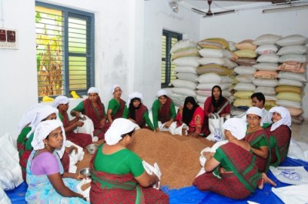

- Background information regarding land & other resources owned, new technologies/ innovations/ skills developed, implemented and disseminated among the community with area and extent of outreach. (5-6 lines)
From an ordinary member of a self-help group in 2006, Ms. Yasmeen became the Managing Director of a women agricultural producer company in 2015 comprising of 374 women farmers cultivating rice in an area of 236 acres of leased land. From the lessons she learnt from the bitter experiences of women entrepreneurs, she organised women cultivating rice in leased lands in to 126 groups and formed the Thennala Agro Producers company.
- Training and motivational support to the farmers/members of the community (4-5 lines)
While the men in the locality discouraged, the Kudumbasree poverty eradication mission, KVK and NABARD motivated them to withstand and handholded them with effective group management skills. In 2011 she was elected as the Chairperson of the Community Development Society CDS of ThennalaGramaPanchayath.
.
- Impact in the area in terms of income/employment generation/ women’s empowerment/ health & nutritional security/education of women in the community with the support from the woman farmer/entrepreneurs (8-10 lines)

She manages The Thennala Agricultural Producer Company as its Managing Director, with 374 women farmers as the shareholders. The rice was marketed under the brand “Thennala Rice”. She runs a special school for the differently abled children and is perusing a graduate degree. Yasmeen has inspired poor women to engage in agro based micro enterprises changing their lives. Her commitment to support differently abled children has lessened the hardships of those mothers confined to their home. It helped them to go out for livelihood earning avenues. Though she remains single, she considers the mother of these 36 differently abled children of the Blooms special school.
- Awards & recognitions received (4-6 lines)
2017- Kudumbasree( Govt of Kerala) award for the best CDS chairperson
2017- Kairali TV Jwalaaward for the best women entrepreneur of Kerala
2018- Recognition from His Excellency Governer of Kerala
2020- Asianet News award Sthreesakthi

- Contributing/enabling Factors including people/ Institutions responsible for the motivation and other similar detail/ underlying message (if any) (6-7 lines)
The producer company and the leased in land cultivation by farm women is a result of focused efforts of the Kudumbasree, NABARD , Department of Agriculture and the KVK .The producer company is in the process of initiating their own milling facility with the help of KVK and NABARD, since external dependence on milling limits their collective performance heavily .Yasmeen , who has become the member of the District Panchahaythrecently by the support of other women has won the support of the District Panchahayath and has been in search of land for the mill. The KVK has promised introducing cage fish culture in their paddy field where rice is grown only during the third crop season. Since majority of women lack irrigation facilities for rice, KVK has collaborated in popularising human powered treadle pumps as their irrigation system wherever possible as requested by them. Also they are provided with PPFM as drought mitigation strategies in rice fields.
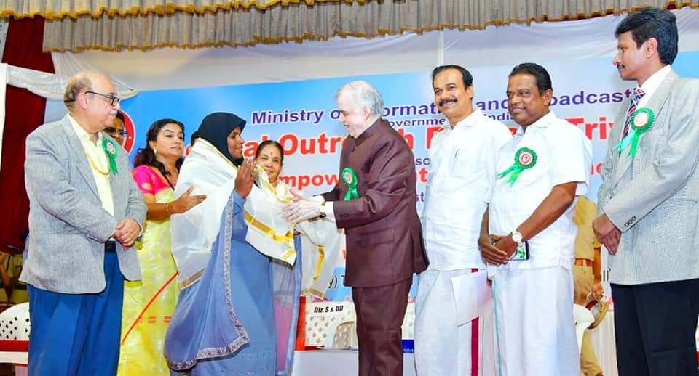
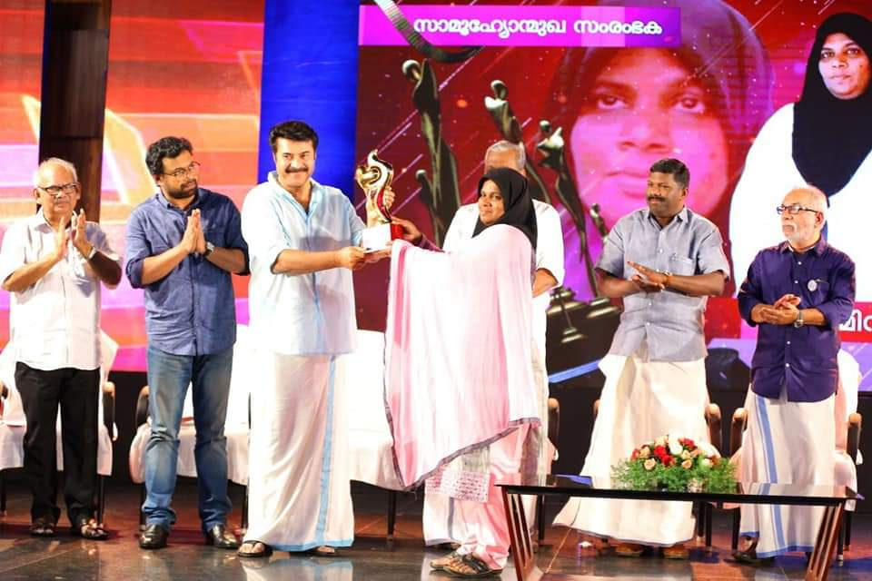

Receiving the recognition from the Governor Receiving the Kairali TV award
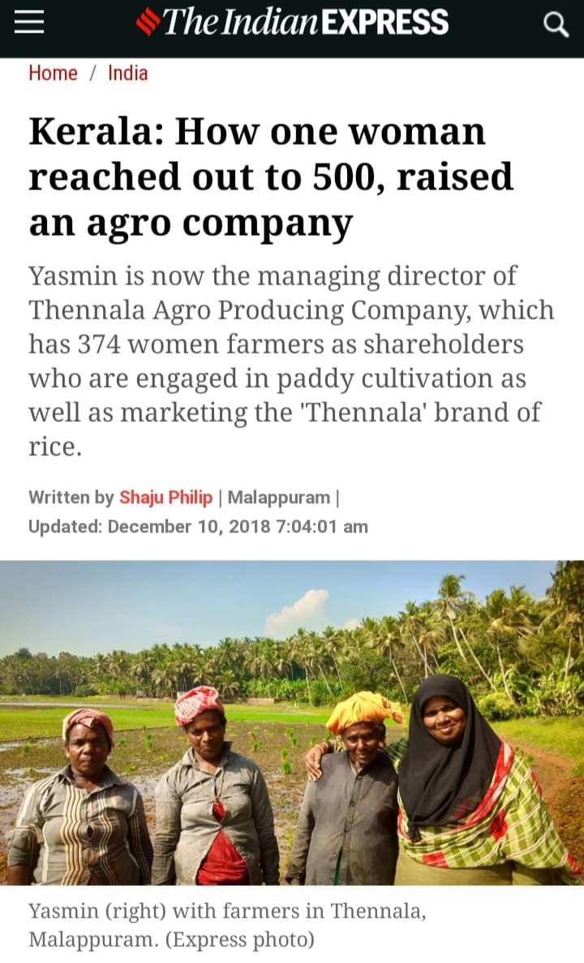
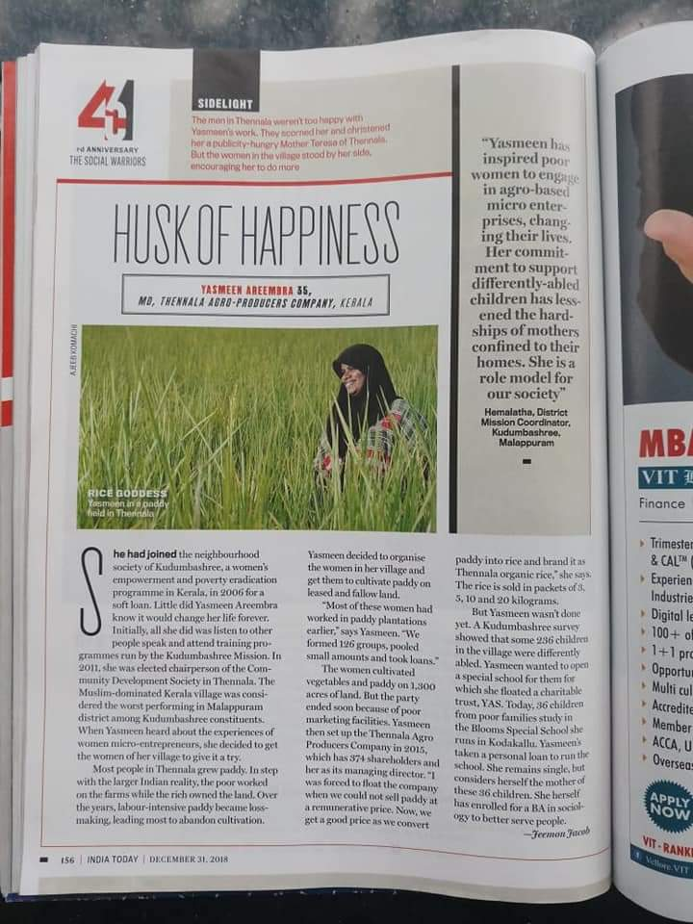
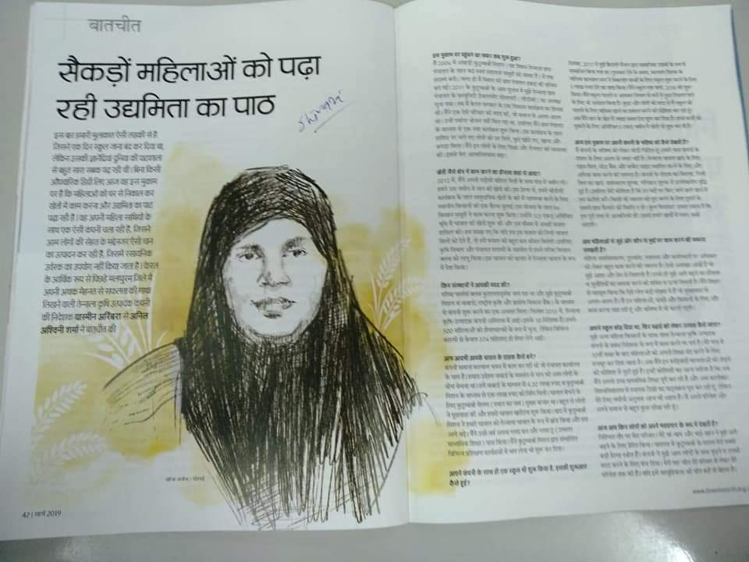
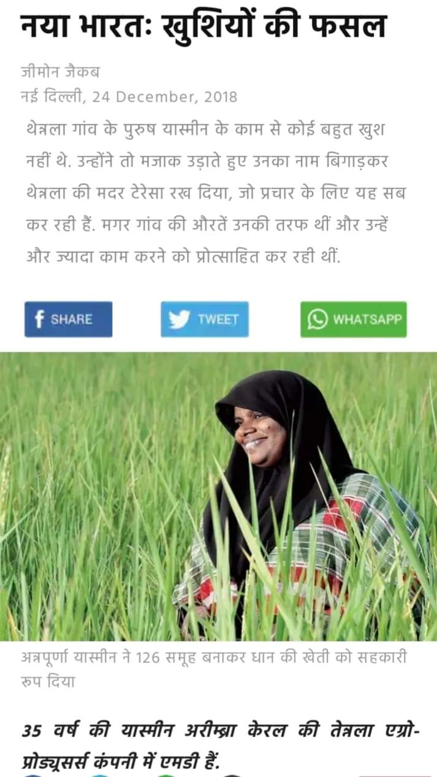

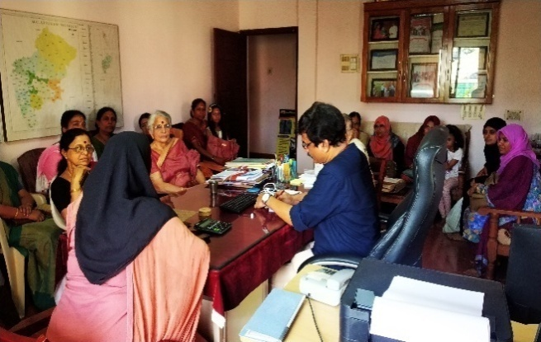
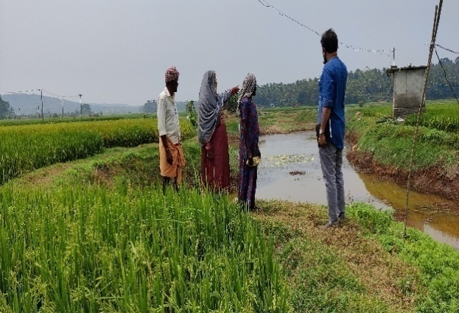

Field visit of KVK Yasmeen in brain storming held at KVK
10.B. Details of Electronic Media Produced
S. No. | Type of media | Title | Details
1 | CD / DVD
2 | Mobile Apps
3 | Social media groups with KVK as Admin
4 | Facebook account name
5 | Instagram account name
6 | Others if any

10.C. Success Stories / Case studies, if any (two/three-pages write-up on each case with suitable action photographs. The Success Stories / Case Studies need not be restricted to the reporting period).

This will be considered only with suitable photos for further reporting/reference.

The Broad outline for the case study may be

Title

Background

Interventions
Process
Technology

Output and outcome

Impact
Horizontal Spread
Economic gains
Employment Generation

Photos

Photo | Photo
Title | Title
Photo | Photo
Title | Title

10.D. Give details of Innovative Methodology or Innovative Approach of Transfer of Technology developed and used during the year

10.E. Give details of Indigenous Technical Knowledge practiced by the farmers in the KVK operational area which can be considered for technology development (in detail with suitable photographs)
S. No. | Crop / Enterprise | ITK Practiced | Purpose of ITK | Scientific Rationale

10 F. Technology Week celebration: nil

Period of observing Technology Week: From to
Total number of farmers visited :
Total number of agencies involved :
Number of demonstrations visited by the farmers within KVK campus :

Other Details
Types of Activities | No. of  Activities | Number of  Farmers | Related crop/livestock technology
Gosthies
Lectures organized
Exhibition
Film show
Fair
Farm Visit
Diagnostic Practicals
Supply of Literature (No.)
Supply of Seed (q)
Supply of Planting materials (No.)
Bio Product supply (Kg)
Bio Fertilizers (q)
Supply of fingerlings
Supply of Livestock specimen (No.)
Total number of farmers visited the technology week

10 E. Recognition and Awards: Please give details about National and State level recognition and awards

PART XI – SOIL AND WATER TEST

11.1 Soil and Water Testing Laboratory

A. Status of establishment of Lab : 2011
1. Year of establishment :
2. List of equipments purchased with amount :

Sl. No | Name of the Equipment | Qty. | Cost | Status
1 | Spectrophotometer | 1 | 333000 | Good
2 | Microprocessor based Distillation system – Classic DX | 1 | 198349 | Good
3 | Flame photometer | 1 | 41184 | Good
4 | Water quality analyser | 1 | 40267 | Good
5 | Electrical conductivity analyser | 1 | 16840 | Good
6 | Digital pH meter | 1 | 5104 | Good
7 | Rotary shaker | 1 | 12797 | Good
8 | Double distillation unit | 1 | 54841 | Good
9 | Electronic balance | 1 | 49181 | Good
10 | Plant sample grinder | 1 | 20900 | Good
11 | Microprocessor based macro block digestion system –  KES 081 | 1 | 84578 | Good
12 | Pusa STFR kit | 1 | 72000 | Good
Total

B. Details of samples analyzed since establishment of SWTL:

Details | No. of Samples analyzed | No. of Farmers benefited | No. of Villages | Amount realized (Rs.)
Soil Samples | 820 | 548 | 97
Water Samples
Plant samples
Manure samples
Others (specify)
Total

C. Details of samples analyzed during 2021:

Details | No. of Samples analyzed | No. of Farmers benefited | No. of Villages | Amount realized (Rs.)
Soil Samples | 57 | 45 | 22 | 5700
Water Samples
Plant samples
Manure samples
Others (specify)
Total

11.2 Mobile Soil Testing Kit
A. Date of purchase and current status
Mobile Kits | Date of purchase | Current status
1.
2.

B. Details of soil samples analyzed during 2021 and since establishment with Mobile Soil Testing Kit:

 | During 2020 | During 2021 | Cumulative progress (Total)
Samples analyzed (No.)
Farmers benefited (No.)
Villages covered (No.)

11.3 Details of soil health cards issued based on SWTL & Mobile Soil Testing Kit:

Particulars | Date (s) | Villages (No.) | Farmers (No.) | Samples analyzed (No.) | Soil health cards issued (No.)
SWTL
Mobile Soil Testing Kit

11.4 World Soil Health Day celebration
Sl. No. | Farmers participated (No.) | Soil health cards issued (No.) | VIPs (MP/ Minister/MLA attended (No.) | Other Public Representatives participated | Officials participated (No.) | Media coverage (No.)
 | 45 | 45 |  |  | 4 | yes

PART XII. IMPACT

12.A. Impact of KVK activities (Not restricted for reporting period).

Name of specific technology/skill transferred | No. of participants | % of adoption | Change in income (Rs.)
 |  |  | Before (Rs./Unit) | After (Rs./Unit)
Food processing | 40
Seedling production | 30
NB: Should be based on actual study, questionnaire/group discussion etc. with ex-participants.

12.B. Cases of large scale adoption (Please furnish detailed information for each case with suitable photographs)

12.C. Details of impact analysis of KVK activities carried out during the reporting period

PART XIII - LINKAGES

13A. Functional linkage with different organizations

Name of organization | Nature of linkage
NB The nature of linkage should be indicated in terms of joint diagnostic survey, joint implementation, participation in meeting, contribution received for infrastructural development, conducting training programmes and demonstration or any other

13B. List of special programmes undertaken by the KVK and operational now, which have been financed by State Govt./Other Agencies

Name of the scheme | Date/ Month of initiation | Funding agency | Amount (Rs.)

13C. Details of linkage with ATMA

Coordination activities between KVK and ATMA
S. No. | Programme | Particulars | No. of programmes attended by KVK staff | No. of programmes Organized by KVK | Other remarks (if any)
01 | Meetings | Meetings | Governing Board, Managing Committee, MTA | 8
02 | Research projects | Research projects
 |  |  | Training to farmer groups mobilized using the provision of within the district trainings and outside the district trainings | 3
03 | Training programmes | Training programmes | ATMA demonstration plots, FLDs of KVK | 14
04 | Demonstrations | Demonstrations
 |  |  | Organised at KVK collaborating with ATMA | 12
05 | Extension Programmes | Extension Programmes |  | 10
 | Kisan Mela | KisanMela
 | Technology Week
 | Exposure visit
 | Exhibition
 | Soil health camps
 | Animal Health Campaigns
 | Others (Pl. specify)
06 | Publications
 | Video Films
 | Books
 | Extension Literature
 | Pamphlets
 | Others (Pl. specify)
07 | Other Activities (Pl.specify)
 | Watershed approach
 | Integrated Farm Development
 | Agri-preneurs development

13D. Give details of programmes implemented under National Horticultural Mission

S. No. | Programme | Nature of linkage | Funds received if any Rs. | Expenditure during the reporting period in Rs. | Constraints if any

13E. Nature of linkage with National Fisheries Development Board
S. No. | Programme | Nature of linkage | Funds received if any Rs. | Expenditure during the reporting period in Rs. | Remarks

13F. Details of linkage with RKVY
S. No. | Programme | Nature of linkage | Funds received if any Rs. | Expenditure during the reporting period in Rs. | Remarks

13G. Kisan Mobile Advisory Services

Month | No of Advisories | Message type (Text/Voice) | SMS/voice calls sent (No.) |  |  |  |  |  | Total SMS/Voice calls sent (No.) | Farmers benefitted (No.)
 |  |  | Crop | Livestock | Weather | Marketing | Awareness | Other enterprises
January
February
March
April
May
June
July
August
September
October
November
December
Total

PART XIV- PERFORMANCE OF INFRASTRUCTURE IN KVK

14A. Performance of demonstration units (other than instructional farm)

Sl. No. | Demo Unit | Year of  establishment | Area  (ha) | Details of production |  |  | Amount (Rs.) |  | Remarks
 |  |  |  | Variety | Produce | Qty. | Cost of inputs | Gross income

14B. Performance of instructional farm (Crops) including seed production

Name  of the crop | Date of sowing | Date of harvest | Area (ha) | Details of production |  |  | Amount (Rs.) |  | Remarks
 |  |  |  | Variety | Type of Produce | Qty. | Cost of inputs | Gross income
Cereals
Paddy | July 2021 | October 2021 | 2.0 ha | Uma  Jyothi | Seed | 5250 | 185000 | 270000 | Managed with the technical support of KVK by KCAET using KAU funds
Pulses
Oilseeds
Fibers
Spices & Plantation crops
Coconut |  |  | 5.0 ha | WCT,CDO  CDG | Nuts | 52,000 | 286500 | 665500
Floriculture
Fruits
Vegetables | 3 seasons |  | 7.0 ha | 22 varieties | seed | 150
Others (specify)

14C. Performance of production Units (bio-agents / bio pesticides/ bio fertilizers etc.,)

Sl.  No. | Name of the Product | Qty | Amount (Rs.) |  | Remarks
 |  |  | Cost of inputs | Gross income
1 | Verticillium | 7.29 | 22000 | 35875
2 | Beuveria | 5.13 | 15000 | 25034
3 | Pseudomonas | 48.97 | 115000 | 258000
4 | Trichoderma | 36.24 | 150000 | 272625

14D. Performance of instructional farm (livestock and fisheries production)

Sl.  No | Name  of the animal / bird / aquatics | Details of production |  |  | Amount (Rs.) |  | Remarks
 |  | Breed | Type of Produce | Qty. | Cost of inputs | Gross income

14E. Utilization of hostel facilities

Accommodation available (No. of beds)
Months | No. of trainees stayed | Trainee days (days stayed) | Reason for short fall (if any)
January | 12 | 25 | Online trainings
February | 23 | 52 | Online trainings
March | 21 | 40 | Online trainings
April |  |  | Used as CFLTC staff quarters
May |  |  | Used as CFLTC staff quarters
June |  |  | Used as CFLTC staff quarters
July |  |  | Used as CFLTC staff quarters
August |  |  | Used as CFLTC staff quarters
September | 10 | 15 | Online trainings
October | 15 | 30 | Online trainings
November | 14 | 20 | Online trainings
December | 18 | 35 | Online trainings

14F. Database management
S.No | Database target | Database created
1 | Farm leaders | 159
2 | DFI success stories | 110

14G. Details on Rain Water Harvesting Structure and micro-irrigation system

- Rain Water Harvesting Structure

Amount sanction (Rs.) | Expenditure (Rs.) | Details of infrastructure created / micro irrigation system etc. | Activities conducted |  |  |  |  | Quantity of water harvested in ‘000 litres | Area irrigated / utilization pattern
 |  |  | No. of Training programmes | No. of Demonstration s | No. of plant materials produced | Visit by farmers  (No.) | Visit by officials  (No.)

- Micro-irrigation systems

Amount sanction (Rs.) | Expenditure (Rs.) | Details of infrastructure created / micro irrigation system etc. | Activities conducted |  |  |  |  | Quantity of water harvested in ‘000 litres | Area irrigated / utilization pattern
 |  |  | No. of Training programmes | No. of Demonstration s | No. of plant materials produced | Visit by farmers  (No.) | Visit by officials  (No.)
PART XV – SPECIAL PROGRAMMES

15.1 Paramparagath Krishi Vikas Yojana (PKVY)
Sl No. | Name of cluster village | Initial soil fertility status (Average of cluster village) |  |  |  | Facilities created for organic source of manure | Name of Crops cultivated | Variety | Organic inputs applied including bio-agents and botanicals treatment | Yield (q/ha) | Economics
 |  | Aval. N | Aval. P | Aval. K | OC % |  |  |  |  |  | Cost of cultivation (Rs/ha) | Net returns (Rs/ha)
1 | 1.
 | 2.
2 | 1.
 | 2.

15.2 District Agriculture Meteorological Unit (DAMU)

 | Agro advisories |  |  | Farmers awareness programmes
Sl No. | No of Agro advisories generated | No of farmers registered for agro advisories | No of farmers benefitted | No of programmes | No of farmers benefitted
1
2

15.3 Fertilizer awareness programme organised
State | Name of KVK | Details of Activities/programmeOrganised | Number of Chief Guests | No. of Farmers attended program | Total participants

15.4 Seed Hub

Crops | Variety | Year of release | Production |  |  |  | No of farmers benefited/Sold to no. of farmers | Quantity seed sold (q)
 |  |  | Target (q) | Area (ha.) | Actual Production  (q) | Category  (FS/CS)

15.5 CFLD on Oilseeds:

Sl.No. | Crop | Varieties demonstrated and check | Allocated |  | Implemented
 |  |  | Area (ha) | Demos (No.) | Area (ha) | Demos (No.)
 | Total

15.6 CFLDs on Pulses:

Sl.No. | Crop | Varieties demonstrated and check | Allocated |  | Implemented
 |  |  | Area (ha) | Demos (No.) | Area (ha) | Demos (No.)
 | Total

15.7 Krishi Kalyan Abhiyan (Aspirational districts)

Type of Activity | Date(s) conducted | No. of farmers (General) |  |  | No. of farmers  SC / ST |  |  | No.of extension personnel
 |  | Male | Female | Total | Male | Female | Total | Male | Female | Total

15.8 Micro-Irrigation

Type of Activity | Date(s) conducted | No. of farmers (General) |  |  | No. of farmers  SC / ST |  |  | No. of extension personnel
 |  | Male | Female | Total | Male | Female | Total | Male | Female | Total

15.9 Tribal Sub-Plan (TSP)
Farmer Training |  | Women Farmer Training |  | Rural Youths |  | Extension Personnel |  | OFT (No of Technologiess) | Number of farmers involved |  |  | Participants in extension activities (No.) | Production of seed (q) | Production of Planting material (Number in lakh) | Production of Livestock strains (Number in lakh) | Production of fingerlings (Number in lakh) | Testing of Soil, water, plant, manures samples (Number)
No. of Trainings/Demos | No. of Farmers | No. of Trainings/Demos | No. of Women Farmers | No. of Trainings/Demos | No. of Youths | No. of Trainings/Demos | No. of Ext. Person |  | On- farm trials | Frontline demos | Mobile agro- advisory to farmers

15.10 SCSP

Farmer Training |  | Women Farmer Training |  | Rural Youths |  | Extension Personnel |  | OFT (No of Technologiess) | Number of farmers involved |  |  | Participants in extension activities (No.) | Production of seed (q) | Production of Planting material (Number in lakh) | Production of Livestock strains (Number in lakh) | Production of fingerlings (Number in lakh) | Testing of Soil, water, plant, manures samples (Number)
No. of Trainings/Demos | No. of Farmers | No. of Trainings/Demos | No. of Women Farmers | No. of Trainings/Demos | No. of Youths | No. of Trainings/Demos | No. of Ext. Person |  | On- farm trials | Frontline demos | Mobile agro- advisory to farmers

15.11 NARI

Activity | Achievement
 | Number of activity | No. of farmers/ beneficiaries
OFTs – Nutritional Garden (activity in no. of Unit)
OFTs – Bio-fortified Crops (activity in no. of Unit)
OFTs – Value addition(activity in no. of Unit/Enterprise)
OFTs - Other Enterprises (activity in no. of Unit/Enterprise) (activity in no. of Unit/Enterprise)
FLDs – Nutritional Garden (activity in no. of Unit)
FLDs – Bio-fortified Crops (activity in no. of Unit)
FLDs – Value addition(activity in no. of Unit/Enterprise)
FLD- Other Enterprises (activity in no. of Unit/Enterprise) (activity in no. of Unit/Enterprise)
Trainings
Extension Activities

15.12 KVK Portal

No. of Events added by KVKs | No. of Facilities added by KVKs | Filled Report on Package of Practices (Y/N) |  |  |  | Filled Profile Report (Y/N)
 |  | Crop | Livestock | Fisheries | Horticulture | Employees | Posts | Finance | Soil Health Cards | Appliances | Crops | Resources | Fish
264 | 9 | y | y |  | y | y | y | y | y | y | y

15.13 KSHAMTA

Number of Adopted Villages | No. of Activities |  | No. of farmers benefited
 | Demo | Training | Demo | Training

15.14 DFI

Sl | District | Taluks | Villages | Farmers (No.) | Average Benchmark Income (Rs/year) | Crops/ enterprises | KVK Interventions | Additional Net Income generated due to KVK interventions (Rs/year) | Total income of farmer (Rs/year)

PART XVI - FARMERS FEEDBACK ON ASSESSED/DEMONSTRATED TECHNOLOGIES OF CROPS / LIVESTOCK

16.1 Farmers feedback on performance of crop varieties/hybrids

Sl. No. | Crop varieties/hybrids assessed/ demonstrated | Farmer’s feedback

16.2 Farmers feedback on performance of agronomic practices

Sl. No. | Agronomic practices | Farmer’s feedback

16.3 Farmers feedback on performance of pest and disease management in crops

Sl. No. | Pest and disease management in crops | Farmer’s feedback

16.4 Farmers feedback onperformance of farm machinery technologies
Sl. No. | Farm machinery technologies | Farmer’s feedback

16.5 Farmers feedback onperformance of livestock and fisheries technologies
Sl. No. | Livestock/fisheries technologies | Farmer’s feedback

PART XVII - FINANCIAL PERFORMANCE

17A. Details of KVK Bank accounts

Bank account | Name of the bank | Location | Branch code | Account Name | Account Number | MICR Number | IFSC Number
With Host Institute | State bank of india | Kuttippuram | 70195 | SB | 67201968181 |  | SBTR0000195
With KVK | Federal bank | Tavanur | 1171 | SB | 11710100084319 |  | FDRL0001171

17B. Utilization of KVK funds during the year 2020-21(Rs. in lakh)

S.  No. | Particulars | Sanctioned | Released | Expenditure
A. Recurring Contingencies
1 | Pay & Allowances |  |  | 16445872
2 | Traveling allowances |  |  | 150000
3 | Contingencies
A | Stationery, telephone, postage and other expenditure on office running, publication of Newsletter and library maintenance (Purchase of News Paper & Magazines) |  |  | 184503
B | POL, repair of vehicles, tractor and equipments |  |  | 172984
C | Meals/refreshment for trainees (ceiling upto Rs.40/day/trainee be maintained) |  |  | 44244
D | Training material (posters, charts, demonstration material including chemicals etc. required for conducting the training) |  |  | 59564
E | Frontline demonstration except oilseeds and pulses (minimum of 30 demonstration in a year) |  |  | 110000
F | On farm testing (on need based, location specific and newly generated information in the major production systems of the area) |  |  | 106432
G | Training of extension functionaries |  |  | 25000
H | Maintenance of buildings |  |  | 99976
I | Establishment of Soil, Plant & Water Testing Laboratory
J | Library |  |  | 10000
k | Extension activities |  |  | 25000
L | EDP |  |  | 25000
M | Soil health card |  |  | 24995
N | Nutrigarden |  |  | 25000
TOTAL (A)
B. Non-Recurring Contingencies |  |  |  | 17538570
1 | Works
2 | Equipment including SWTL & Furniture |  |  | 242513
3 | Vehicle (Four wheeler/Two wheeler, please specify)
4 | Library (Purchase of assets like books & journals)
TOTAL (B)
C. REVOLVING FUND
GRAND TOTAL (A+B+C) |  |  |  | 17791083

17C. Status of revolving fund (Rs. in lakh) for the last three years
Year | Opening balance as on 1st January | Income during the year | Expenditure during the year | Net balance in hand as on 31st December of each year
January to December 2019 | 11377971 | 8372916 | 7827938 | 12385746
January to December 2020 | 12385746 | 8143805 | 7990373 | 12572896
January to December 2021 | 12572896

18. Details of HRD activities attended by KVK staff

Name of the staff | Designation | Title of the training programme | Institute where attended | Dates

19. Please include any other important and relevant information which has not been reflected above (write in detail).

