A specific polyhouse was constructed at ICAR-CIPHET Ahohar under AICRP on PET for increasing the cultivation season of mushrooms in hot and arid region. Performance of the structure was evaluated by growing the *Pleurotus* spp. (button mushroom) and *A. bisporus* (*dhingri* mushroom).

**Study and analysis of existing mushroom structures**

Prior to develop an intended structure, button and *Dhingri* mushrooms were cultivated during their respective seasons at ICAR-CIPHET Abohar to understand the microclimate required for these crops. Observations indicated that the microclimate required for efficient cultivation of button mushroom is as follows.

* + 1. Compost preparation: temperature ≥40°C is beneficial
    2. Spawn run: air temperature 23 ± 1°C, bed temperature 24-25°C, CO2 15000 ppm, RH about 90-95%
    3. Case run: air temperature 23 ± 1°C, bed temperature 24-25°C, CO2 15000 ppm, RH about 90-95%
    4. Cropping: air temperature 15-17°C, CO2 800-1000 ppm, RH about 80-90%

Following observations were drawn based on the observations noted during preliminary cropping trials.

* Cultivation season of button mushroom in Abohar region is reduced due to high temperature (25 to 30°C) in October and March.
* This season is from October to March-mid April (about 5-6 months) in temperate region during which 2-3 crops are grown but due to high temperature in Abohar region, only one crop is possible.
* It was also observed that during cultivation of *Dhingri* mushroom (May-July), maximum ambient temperature reached up to 50°C and RH dropped up to 25-30% which did not allow mushroom cultivation.
* Thus, results underscored the importance of suitable structure for mushroom cultivation which will increase the cultivation season.

Along with preliminary cropping trials, a survey was conducted to study and understand the mushroom cultivation practices followed by farmers in Abohar region as well as farmers of Haryana (Sonepat region). During survey, different mushroom structures (Fig.1a, b and c) used by farmers of Punjab and Haryana were visited and analysed. Following observations were drawn from the study.

* Visit to mushroom structure near Abohar revealed that button mushroom can be grown in the region with suitable structures but the cultivation season is reduced due to high temperature in October and March (25 to 30°C).
* It was also observed that farmers use mushroom structures which are temporary, made of locally available materials and low cost. These structures are susceptible to insect and pests attack and lack in appropriate HVAC.
* Thus, above observations revealed the need of scientifically designed structure which would fulfill the functional requirements of mushroom crops grown in hot and arid region.

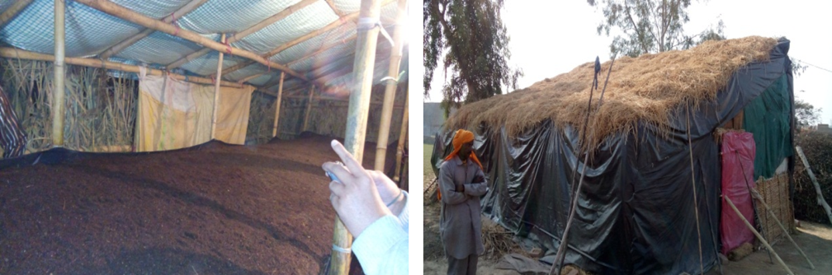

**Fig.1a Mushroom polyhouse developed by a farmer in Abohar region**

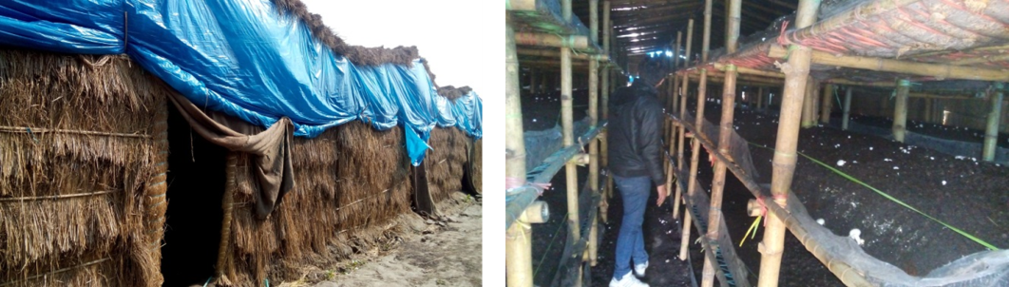

**Fig.1b Mushroom polyhouse developed by a farmer in (Sonepat) Haryana**

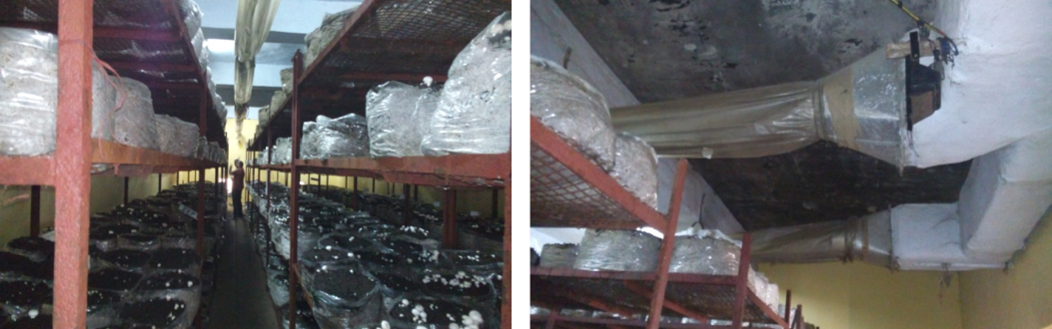

**Fig1c Commercial structure for Mushroom cultivation (HAIC, Haryana)**

**Development of mushroom polyhouse at ICAR-CIPHET Abohar**

Based on the observations noted during preliminary cropping trials and survey of existing structures, mushroom polyhouse structure was designed and developed. This structure was insulated from external environment using jute, EPF thermocol and UV-stabilized polythene. It was also provided with two evaporative cooling arrangements namely, foggers and Fan-pad system to control inside temperature and relative humidity. A pasteurization unit, in the form of polytunnel, was also provided with the structure to prepare compost at elevated temperatures (≥40°C). The details of the mushroom polyhouse developed in the study are given below.

**Specifications of the structure are as follows (Fig. 2, 3 and 4).**

* + - * Orientation: East-West
      * Dimensions: length - 15 m, width - 4 m, ridge height - 4.27 m
      * Foundation walls: height - 1.22 m, width – 0.2 m
      * Roof: ridge height from the floor - 4.27 m, eve height from the floor - 2.13 m.

It is a multi-layered roof composed of iron net (half inch mesh), polythene sheet (25 micron), jute sheet (2-3 mm thick), EPF thermocol sheet (8 mm thick) and UV stabilized polythene sheet (400 micron). Thermal conductivities of all these materials are listed in Table 1.

* + - * Walls: Front wall - centre height is 4.27 m, front wall is furnished with two 18 inch exhaust fans. Rear wall - centre is height 4.27 m.

Evaporative cooling pad is provided in the rear wall (Fig.4).

Pad: material *khus*, length - 4 m, height - 1. 37 m, thickness - 4 cm

* + - * Floor: floor material: single layer vertical brick

Floor of the structure is at 1 m deepbelow ground level (Fig.2). The aim of lowering the floor was to provide extra height to the structure with minimized risk of overturningdue to strong winds and to achieve more cooling effect through evaporative cooling system (overhead foggers).

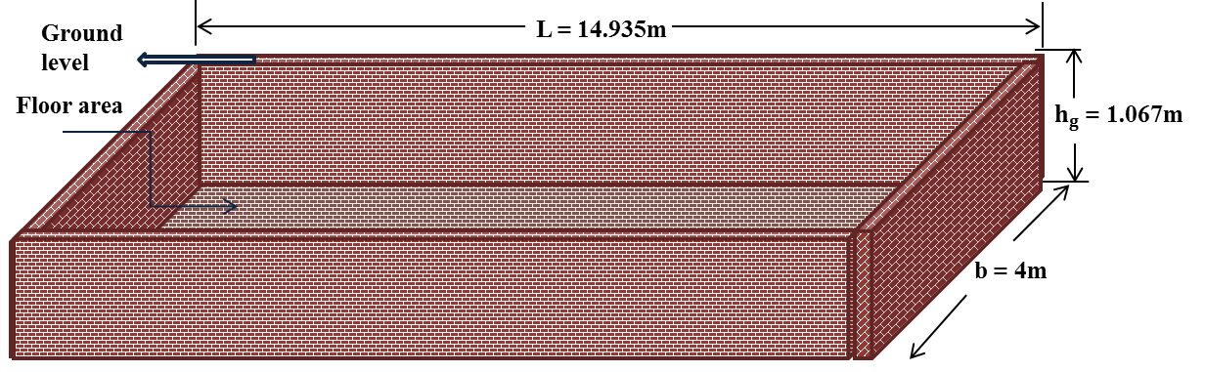

**Fig.2 Floor arrangement of mushroom polyhouse**

* Door: double door frame was used to prevent the entry of insects and pests while entering in to the structure.

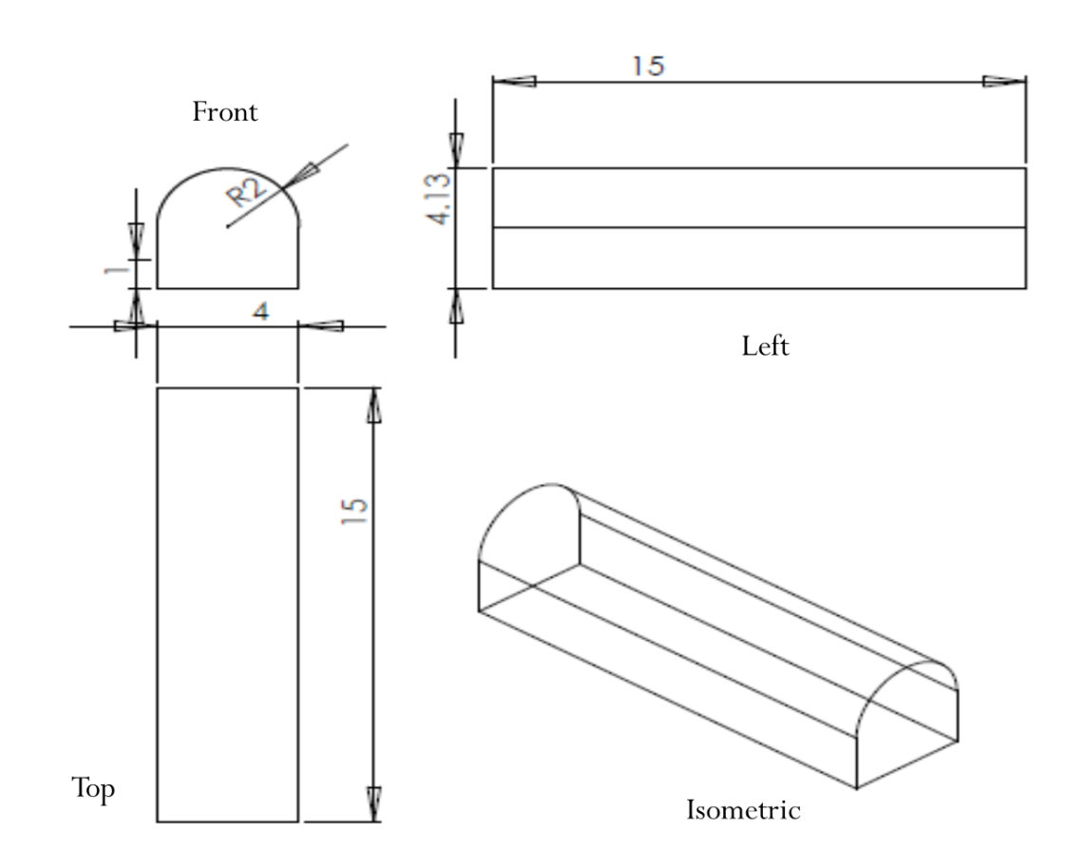

**Fig.3 Conceptual diagram of mushroom polyhouse (Dimensions in ‘m’)**

**Table 1 Thermal conductivities of different materials used in roof**

|  |  |  |  |
| --- | --- | --- | --- |
| **Roof material** | **Thickness (mm)** | **Thermal conductivity** | **Reference** |
| EPF (expanded polyurethane foam) thermocol | 8 mm | 0.0245 w/m.K | Table A–6 adapted from ASHRAE, Handbook of Fundamentals |
| Jute sheet | 3 mm | 0.25 w/m.K | Kawabata and Rangaswamy (2001) |
| UV stabilized black polythene sheet (300 gsm) | 0.4 mm | 0.45 w/m.K | 23C. 55-120. Polyethylene - Low Density. LDPE. 100-200. 50. |
| LDPE Polythene sheet | 0.025 mm | 0.33 w/m.K | 23C. 55-120. Polyethylene - Low Density. LDPE. 100-200. 50. |

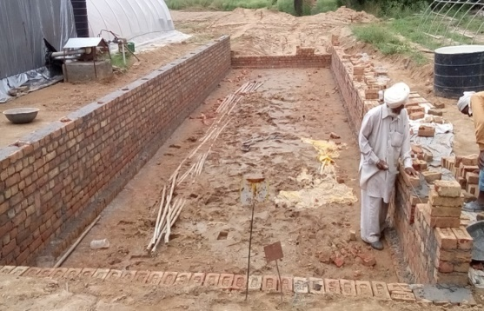 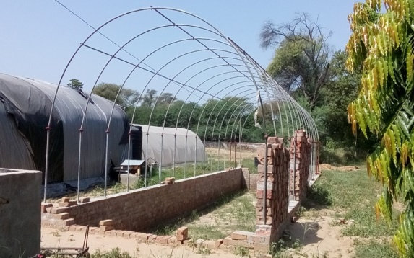

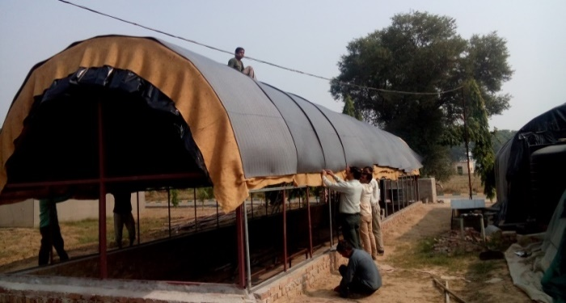 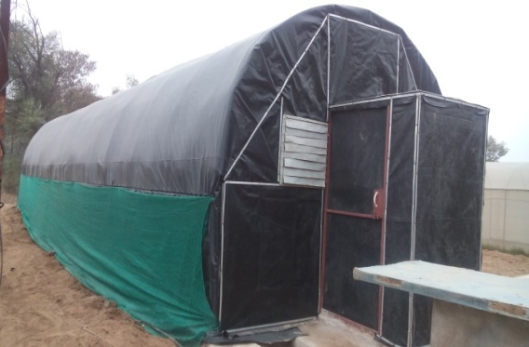

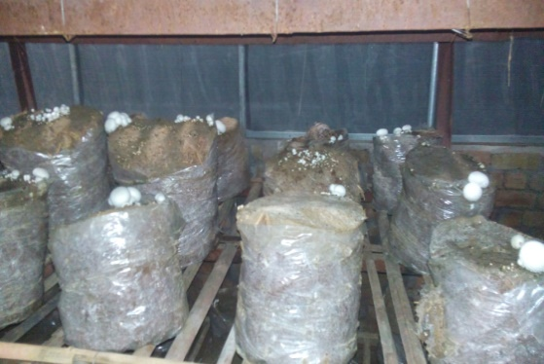 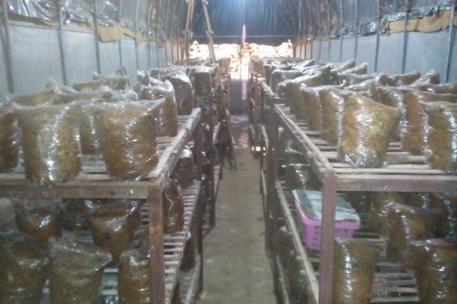

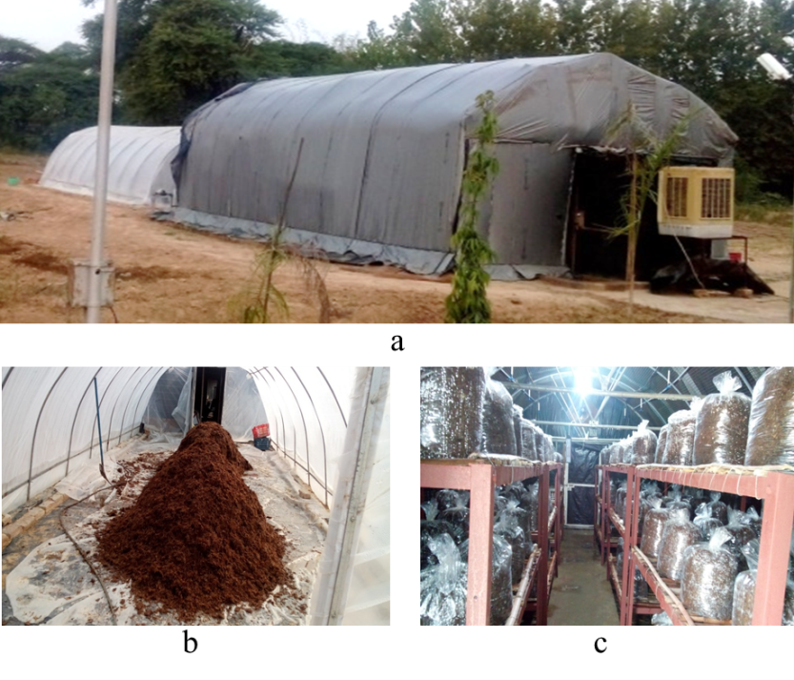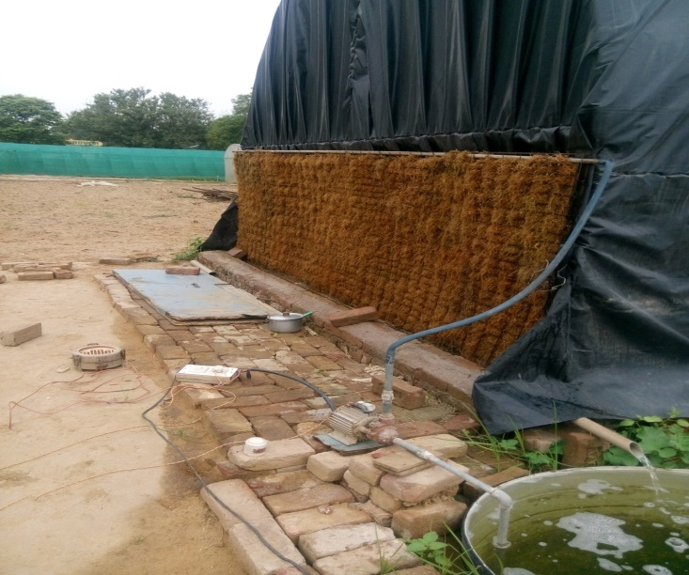

**Fig.4 Mushroom polyhouse at ICAR-CIPHET, Abohar**

**Temperature profile inside mushroom polyhouse**

After its construction, temperature profile inside mushroom polyhouse was determined. Temperatures at 9 different locations inside mushroom polyhouse were recorded under no crop load condition (Fig.5). No any cooling arrangement was provided to the structure during this period. It was found that different locations in the structure attained different temperatures. Lower tier (T3, T6 and T9) showed considerably lower temperatures (by about 10°C) compared to other six locations (Fig.6). It might be due to the height of the structure and depth of the floor. T9 showed the least value of temperature.

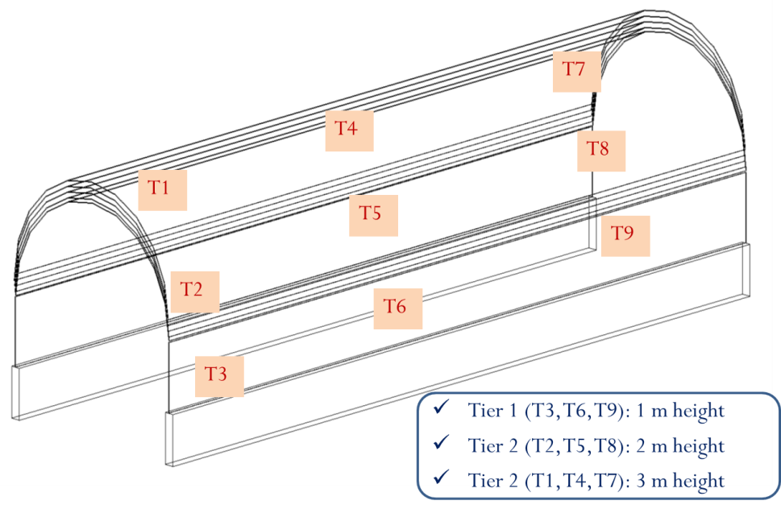

**Fig.5 Temperature profile inside mushroom polyhouse**

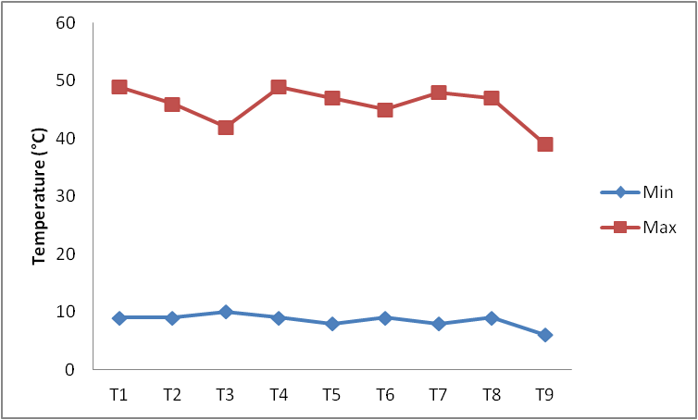

**Fig.6 Maximum and minimum temperatures recorded during day hours**

Outside temperature and temperature inside structure at nine different locations were continuously recorded for 24 h in October month. Average inside temperature was plotted against time and presented in Fig.7. Cooling requirement can easily be understood from this plot. Fig.7 indicates that both inside and outside temperatures were almost constant till 9:00 am in the morning. After that, they increased till 2:00 pm in the afternoon and again decreased. Results indicated that the structure needed external cooling from 11:00 am in the morning to 6:00 pm in the evening.

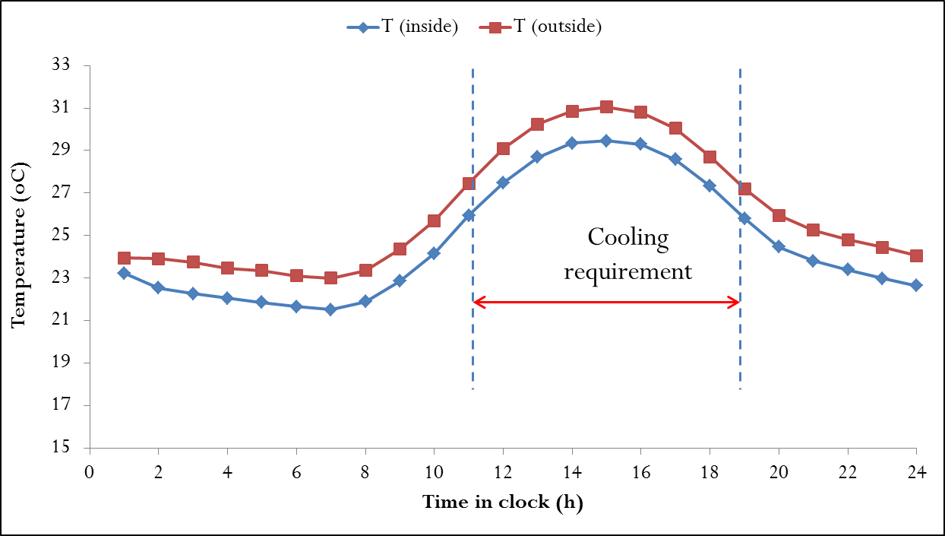

**Fig.7 Temperature behavior inside and outside the structure in October month**

**Heat gain by Mushroom polyhouse**

Heat load is generally the total heat which accounted for the increasing or decreasing temperature inside polyhouse. Heat gained by mushroom polyhouse was determined in the study. Heat load was the total heat accounted for increasing or decreasing the temperature inside mushroom polyhouse. Total heat gain (QT) inside polyhouse was due to,

* heat inflow from surroundings (QS)
* heat generated by compost (QC)
* heat generated by workers (QW)
* heat generated by data logger, battery etc. (QD)

QT = QS + QC + QW + QD

However, QC , QW and QD were negligible in comparison to QS  (QC >> QC , QW and QD ). Hence QS  was given more consideration during study.

QS had two components: heat gain through roof (QR) and heat gain through walls (QW) as shown in Fig.8.

Description of the dimensions mentioned in Fig.11 is as follows.

L = 15 m B = 4 m H = 4.27 m h = 2.36 m H – h = 1.91 m h – h1 = 1.3 m

Surface area exposed to the surrounding was determined as follow.

1. Roof area (AR) = 89.38 m2
2. Wall area (AW) = 66.23 m2

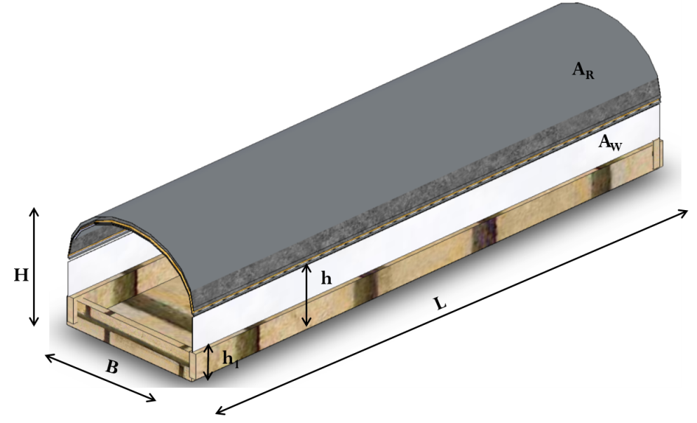

**Fig.8 Surface area exposed to the surrounding**

Heat gain through roof (QR) was determined using Eq.1.

$$Q_{R}=U_{R}A_{R}ΔT …(1)$$

UR was determined using Eq.2

$$\frac{1}{U_{R}}=\frac{1}{h_{i}}+\frac{x_{P}}{K_{P}}+\frac{x_{J}}{K_{J}}+\frac{x_{F}}{K_{F}}+\frac{x_{U}}{K_{U}}+ \frac{1}{h_{o}} …(2)$$

Where, QR = heat infiltrated through roof (W)

UR = overall heat transfer coefficient of roof (W/m2K) = 2.29

AR = roof area (m2)

∆T = temperature difference of inside and outside of roof (°C)

h= convective heat transfer coefficient of air at low speed (W/m2.K)

X = layer thickness (XP= polythene, XJ= jute, XF= foam, XU= UV stabilized polythene)

K = thermal conductivity of layers (KP= polythene, KJ= jute, KPF= foam, KU= UV-stabilized polythene)

Heat gain through wall (QW) was determined using Eq.3.

$$Q_{W}=U_{W}A_{W}ΔT …(3)$$

UW was determined using Eq.4

$$\frac{1}{U_{W}}=\frac{1}{h_{i}}+\frac{x_{U}}{K}+ \frac{1}{h_{o}} …(4)$$

Where, UW = overall heat transfer coefficient of wall (W/m2.K) = 9.12

AW = surface area of wall (m2)

∆T = temperature difference of inside and outside of wall (°C)

Total heat gained during October and November months was determined and presented in Table 2. It was observed that heat gained by the structure was dependent on outside temperature and varied with the months of year. Consequently, cooling requirements varied with the month.

**Table 2 Heat gained by structure during different months**

|  |  |  |  |  |  |  |  |  |
| --- | --- | --- | --- | --- | --- | --- | --- | --- |
| Month | Average Outside temp (oC) | Roof | | | Wall | | | Total heat gain (QT in W) |
| Area (m2) | Ur (W/m2K) | QR (W) | Area (m2) | UW (W/m2K) | QW (W) |
| October | 31 | 89.38 | 2.29 | 371.79 | 66.23 | 9.12 | 2479.3 | 2545.51 |
| November | 26 | 89.38 | 2.29 | 638.04 | 66.23 | 9.12 | 1010.3 | 1648.3 |
| December | 16 | 89.38 | 2.29 | 321.2 | 66.23 | 9.12 | 612.3 | 933.5 |
| January | 15 | 89.38 | 2.29 | 293.5 | 66.23 | 9.12 | 692.1 | 985.4 |
| February | 20 | 89.38 | 2.29 | 381.6 | 66.23 | 9.12 | 863.2 | 1244.8 |
| March | 23 | 89.38 | 2.29 | 492.5 | 66.23 | 9.12 | 2132.1 | 2624.8 |

**Cooling of mushroom polyhouse**

**Two evaporative cooling arrangements were provided:**

1. Foggers

During *spawn run*, structure needs to be closed without air exchangeto achieve desirable CO2 concentration. During this period, cooling is possible with foggers only. Fan-pad system would reduce CO2 concentration and hence may not be advisable.

1. Fan-pad system

This system is useful during case run and cropping period as air exchange is desirable during *fruiting stage*.

To meet the demand of cooling, evaporating (fan-pad) cooling system that was able to down the inside temperature by 10.62°C within 40 minute of operation was installed. The cooling pad was made of *khus* with dimensions as length 3.96 m, height 1.37 m and thickness 3-4 cm. The reason behind selecting *khus* as padding materials over other materials was that air flow through *khus* pad is higher as comparing to wood wool and coconut coir pad (Shekhar *et al*., 2016). *Khus* was tied with GI wire mesh to prepare a pad. Two electric exhaust fans with 20 inches sweep were used for achieving air exchange in the polyhouse. Fans have 4 straight blades. 6 overheads foggers (total discharge as 24 L/h) were installed inside the polyhouse for maintain the desired temperature as well as relative humidity.

In the present investigation, 10 locations were selected for measuring the lengthwise variation in temperature and RH. Similarly, height wise variation in temperature and RH was measured at 8 different points as shown in Fig.9. The measurement of temperature and relative humidity were done by infrared temperature meter and zeal wet & dry bulb hygrometer respectively. Following are the observed data.

Temperature measurement along the length

* + - Lengths (m): 1.5, 3.0, 4.5, 6.0, 7.5, 9.0, 10.5, 12.0, 13.5 15.0 (10 locations)
    - Operation times (min): 5, 10, 20, 30, 40, 50, 60

Temperature measurement along the height

* + - Height (m): 0.61, 1.07, 1.52, 1.98, 2.44, 2.90, 3.35, 3.81 (8 locations)
    - Operation times (min): 5, 10, 20, 30, 40, 50, 60

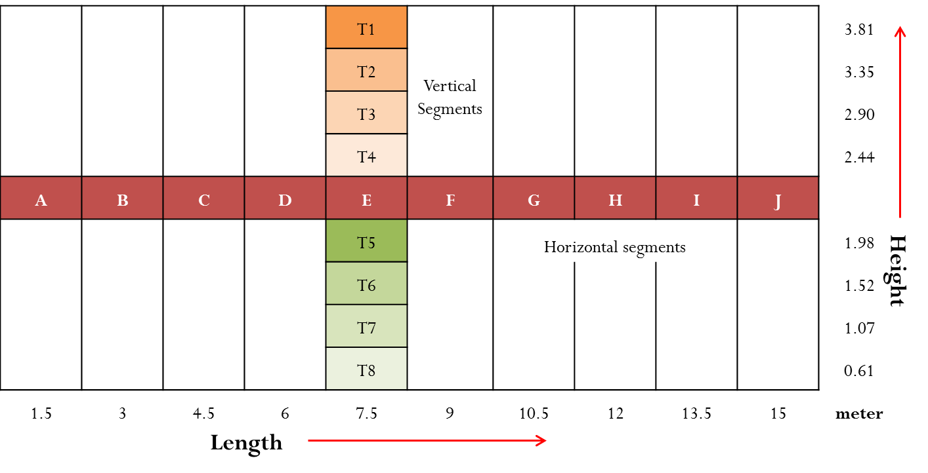

**Fig.9 Locations of temperature and RH measurement points in the structure**

**Water requirement for cooling the structure using evaporative cooling system**

Amount of water required to cool the structure using evaporative cooling system was calculated using following equation (Eq. 5).

$$V × ρ ×C × ΔT=\frac{d_{m}}{d_{t}}×λ …(5)$$

Where, V = volume of polyhouse (m3)

ρ = density of air (kg/ m3)

C = specific heat of air (kJ/kg)

ΔT = temperature difference (°C)

m = mass of water required (kg)

λ = latent heat of water (2257 kJ/kg)

Water required to reduce the inside temperature using evaporative cooling system was determined as 0.13 litre/°C. Therefore, water required to reduce inside temperature by approximately 10°C was about 1.3 litre. However, structure was receiving heat continuously from the sun. Hence, in actual sense, more water required to be sprayed/misted to achieve desired temperature.

**Performance evaluation of evaporative cooling systems**

Fan-pad system and foggers were operated individually and temperatures and relative humidity inside structure were determined at different locations.

**1. Effect of fan-pad system on inside temperature and RH**

Fan-pad system was operated for 10-60 min and variation in inside temperature along the length was determined (Fig.10). It was observed that after 60 min of operation, temperatures inside mushroom polyhouse at all the 10 locations were almost same. Before cooling, inside temperatures at 10 different locations were about 37-39°C, however after cooling (operating the fan-pad for 60 min), inside temperatures were reduced to 27-28°C i.e. almost 10°C reduction (Fig.10).

About 10oC reduction

**Fig.10 Variation in inside temperature along the length due to fan-pad cooling operation**

During October month, fan-pad system was operated for six different times ranging from 10 min to 60 min. Variation in inside temperature (average of 15 locations inside the structure) and RH with operating time was determined and presented in Fig.9. It is evident from Fig.9 that initially, inside temperature was 28°C and it decreased with time till 30 min of operation. However, after 30 min it became almost constant (about 24°C) with no further decrease in temperature. Similarly, inside RH was found to be about 76% after 30 min of operation. These conditions were found conducive for spawn run of button mushroom.

Fan-pad system draws out the inside air and brings fresh air in. Consequently, it reduces the CO2 concentration inside the structure. In Fig.10 red horizontal arrows indicate that fan-pad system was ON for this period. Fig.10 showed that temperature and CO2 concentration inside structure decreased whereas RH increased when cooling was ON. Fan-pad system maintained the inside temperature about 24°C, RH about 70% and CO2 level about 400 ppm.

**Fig.9 Effect of Fan-pad system on inside temperature and RH**

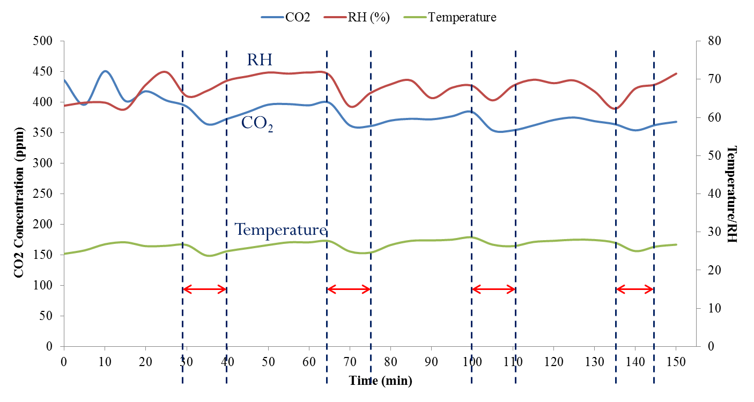

**Fig.10 Variation in Temperature, RH and CO2 concentration due to fan-pad cooling operation**

**2. Effect of fogger system on inside temperature and RH**

Like Fan-pad system, fogger system was operated for six different times ranging from 10 min to 60 min and variation in inside temperature (average of 15 locations inside the structure) and RH with operating time was determined and presented in Fig.11. It is evident from Fig.11 that initially, inside temperature was 29°C and it decreased with time till 20 min of operation. However, after 20 min of operation, it became almost constant (about 23°C) with no further decrease in temperature. Similarly, inside RH was found to be about 78% after 20 min of operation. These conditions were found conducive for spawn run of button mushroom.

**Fig.11 Effect of foggers on inside temperature and RH**

**Crop production**

Different types of mushroom houses such as thatch type houses, structural insulated panel (SIP), steel frame structure, bamboo woven mattings, bamboo pole rafter and leaf-woven roof, thatch house with shade cloth, thatch house with insect screening, brick house with thatch roof and a vent house and greenhouses clad with insulation and roof vents etc. have been reported in the literature (Kwon *et al.,* (2004). Most of these structures had some drawbacks and advantages in different seasons. However, mushroom polyhouse developed in the study was found more suitable for increasing the cultivation season of button mushroom in hot and arid region. Results indicated that spawning of button mushroom was possible in October month which allowed starting the cultivation one month earlier. Similarly, mushroom polyhouse provided the favourable environment in March also thereby further extending the cultivation season by month.

Oyster mushroom was cultivated during April to June as this period was favourable for evaporative cooling and thereby reduction in temperature. Evaporative cooling arrangements were used to achieve desirable temperatures and RH inside structure. Button and oyster mushroom crops were cultivated in the structure as per standard practices.

During summer months, spawns of oyster mushroom were procured from DMR, Solan (HP) and its mycelial and fruit body growth were tested under polyhouse conditions at ICAR-CIPHET Abohar. Similarly, button mushroomwas cultivated in winter months (Nov-March) using wheat straw as compost. Crop was cultivated in bags (5 kg compost capacity) as well as in plastic crates (5-6 kg compost). Comparatively, more vigorous growth of mycelial was recorded in crates. Therefore, it can be suggested that button mushroom needs to grown in crates during winter season. Probable crop production and return (in Rs.) per annum from CIPHET mushroom polyhouse is given in Table 3.

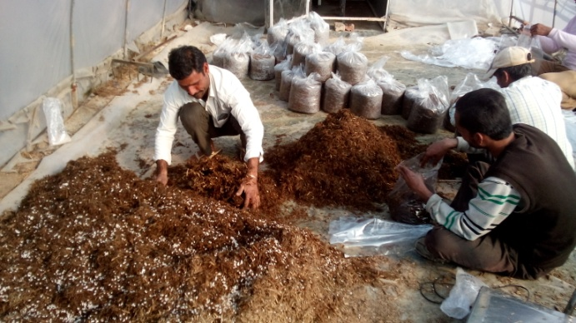 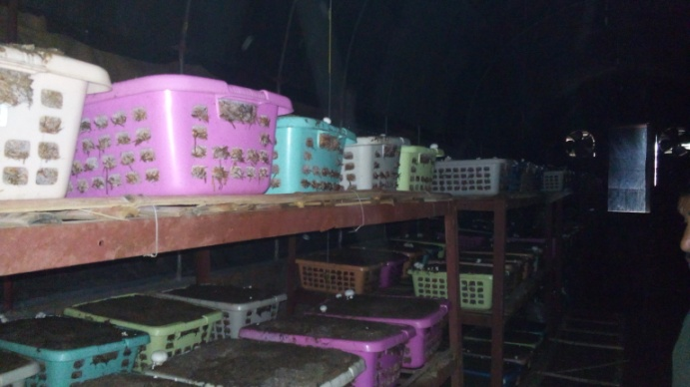

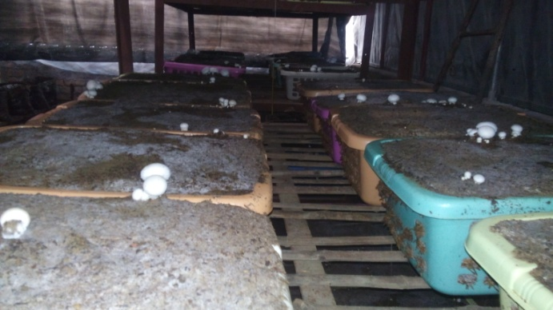 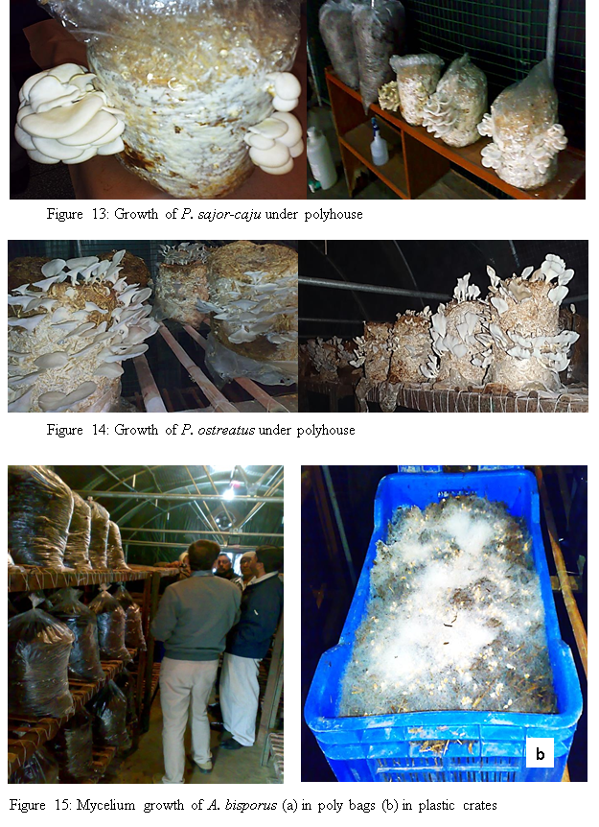

**Fig.12 Cultivation of Button and oyster mushroom**

**Table 3 Crop production and return (in Rs.) per annum from CIPHET mushroom polyhouse**

|  |  |  |  |  |  |
| --- | --- | --- | --- | --- | --- |
| **Crop** | **Number of crops** | **Average production** | **Total production (kg)** | **Market price (Rs.)** | **Return (Rs.)** |
| Button | 2 | 16 kg/qt of compost | 1280 | 100 | 128000 |
| Oyster | 1 | 14 kg/qt of compost | 560 | 80 | 44800 |
| **Total** | | | | | **172800** |

**Quality of freshly harvested button mushroom**

Observation on growth and quality parameters of button mushroom cultivated in CIPHET mushroom polyhouse during winter was noted. It was found that mushroom contained 88 % moisture, 0.2 % acidity, 11.13 mg/100 g ascorbic acid with pH of 6.6. Fresh mushroom is highly perishable and deteriorates immediately after harvest. It develops brown color on the surface of the cap due to the lyses of cell and enzymatic action of polyphenol oxidase that results in shorter shelf life. Further, to inhibit post-harvest browning of fresh mushroom a trial using GRAS agents viz. Ascorbic acid (100 to 500 ppm), citric acid (0.1 to 1.5 %), caffic acid, glutamic acid alone, and in combination with *aloe vera* jel were tested. Five minutes dip of mushroom in 60 % aloe vera gel along with 1 % citric acid and its drying at 60 ºC for seven hour resulted in retaining of desirable color of mushroom L*(89.1), a*(46.9) and b*(36.18) respectively.

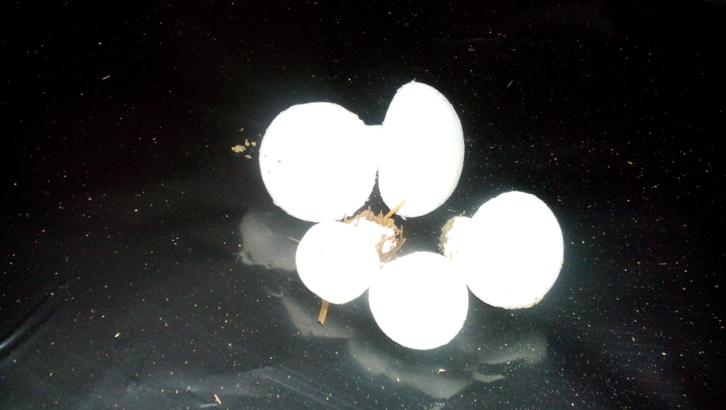

**Fig.13 Freshly harvested button mushroom**

**Economic evaluation of CIPHET mushroom polyhouse**

Input costs, net return and benefit-cost ratio (B/C ratio) are presented in Table 4.

**Table 4 Economic evaluation of CIPHET mushroom polyhouse**

|  |  |  |  |  |
| --- | --- | --- | --- | --- |
| **Cost** | | | | |
| 1. | **Non-recurring cost (fixed cost)** | | | |
|  | Particular | Amount (Rs) | Particular | Amount (Rs) |
|  | UV stabilized polythene | 20000 | Cement | 4000 |
|  | EPF thermocol | 12000 | Bricks | 20000 |
|  | Jute | 5600 | GI and MS pipes | 72000 |
|  | Plastic | 900 | Labor | 16000 |
|  | Iron net | 10000 | Misc. | 12500 |
|  | Insect net | 6000 |  |  |
|  | **Total** | | | **180000** |
| 2. | **Interest (on fixed cost)** | | | |
|  | @ 15% per annum and depreciation @ 10% per annum on initial investment | | | Rs. **45000** |
| 3. | **Recurring cost** | | | |
|  | Cost of straw, spawn, chemical treatments, electricity, labour, water, polythene, packaging etc.  (2 crops of button mushroom and 1 crop of oyster produces about 1840 kg mushroom) | | | Rs. 35/kg of mushroom |
|  | Total recurring cost for three crops | | | Rs. **55200** |
|  | **Total cost per annum (2 + 3)** | | | Rs. **100200** |
| **Benefit** | | | | |
| 1. | **Total mushroom production** | | | |
|  | Button mushroom (2 crops) | | 1280 kg (@16kg/qt of compost | |
|  | Oyster mushroom (1 crop) | | 560 kg (@ 14 kg/qt of compost | |
| 2. | **Total income** | | | |
|  | Button mushroom (2 crops) | | Rs.128000 (@ Rs.100/kg | |
|  | Oyster mushroom (1 crop) | | Rs. 44800 (@ Rs.80/kg | |
|  | **Total income** | | | Rs. **172800** |
| 3. | **Net benefit per annum** | | | **Rs.** 72600 |
| 4. | **Benefit : cost ratio** | | | **1.38** |