Thompson seedless grapes were procured from local market of Abohar as well as from Dindori, Nasik and were stored in cold store (4-10°C)prior to their use. Subsequently, the initial characteristics of fresh samples were determined.

1. Experiments for determination of optimum dipping time and temperatureofethyl oleate and potassium carbonate.

* *First stage (dipping time):*
* Grapes were pretreated with ethyl oleate and potassium carbonate at room temperature for 1, 2, 3, 4 and 5 min respectively.No significant improvement in drying rate was observed above 2 minutes of dipping time.
* *Second stage (dipping temperature):*
* 2 minutes of dipping time was fixed for varying temperatures from 30 to 60℃
* Grapes were pre-treated in potassium carbonate and ethyl oleate solutions for fixed time of 2 min at 30, 40, 50, and 60⁰C followed by drying at 60⁰C.
* The effects of solution temperature on drying rate and color attributes were investigated.
* Grapes dipped into the solution at 60⁰C for 2 min had the fastest drying rate.
* Regardless of the dipping time and temperature, all raisins had varying degrees of brown color.
* As the temperature of the dipping solution increased the drying rate also increased.
* Dipping temperature was optimized on the basis of color value. *a\** value was observed as a significant indicator of browning during drying of grapes depending on the pretreatment condition (Table 1).
* Grapes preserved their initial greenish–yellow color up to 30 or 40% weight loss; however, when the weight loss was 50% or higher, browning was visible
* Based on color, 30oC was the best among all other dipping temperatures.

**Table 1 Effect of dipping temperature on color attributes of raisins**

|  |  |  |  |
| --- | --- | --- | --- |
| **Dipping Temperature (⁰C)** | **L\*** | **a\*** | **b\*** |
| Control (ambient) | 34.72 | 3.32 | 8.84 |
| 30 | 31.47 | ***2.42*** | 6.99 |
| 40 | 39.60 | 4.79 | 11.91 |
| 50 | 39.77 | 5.73 | 12.40 |
| 60 | 47.74 | 7.58 | 17.45 |

1. Another pretreatment with olive oil was conducted and various physico-chemical parameters were tested such as; moisture content, TSS, acidity, total phenol content, enzymatic activity (PPO). Drying duration was compared with the standard practice of treatment with ethyl oleate and potassium carbonate. Grapes after treatment were dried using different drying methods such as., shade drying, poly-house drying, solar drying and tray drying.

* Results (Table 2) suggested that pretreatment with EO and PC resulted grape drying in lesser time as compared to treatment with olive oil. Also, olive oil resulted in higher PPO activity (Table 2) as compared to treatment with EO and PC. Treatment with olive oil also resulted in higher moisture content.

**Table 2 Comparison of different pretreatments on the overall quality of raisins**

|  |  |  |  |  |  |  |  |
| --- | --- | --- | --- | --- | --- | --- | --- |
| **Ethyl Oleate and Potassium Carbonate Pre-treatment** | | | | | | | |
| **Type of drying** | **MC (%)** | **TSS (̊Brix)** | **Acidity (%)** | **Reducing sugars (%)** | **TPC (mg/g)** | **PPO (EU ml-1 min-1)** | **Drying duration** |
| Shade drying | 16.17 | 81.19 | 0.49 | 54.65 | 2.87 | 2.18 | **5 days** |
| Polyhouse drying | 15.28 | 81.09 | 0.50 | 48.30 | 2.56 | 1.17 | **2 days** |
| Solar drying | 15.13 | 80.64 | 0.50 | 53.75 | 2.61 | 1.16 | **2 days** |
| Tray drying | 14.87 | 79.40 | 0.51 | 53.24 | 2.54 | 1.14 | **4 days** |
| **Olive Oil Pre-treatment** | | | | | | | |
| Shade drying | 16.31 | 83.05 | 0.50 | 56.88 | 3.21 | 4.56 | **10 days** |
| Polyhouse drying | 15.58 | 82.26 | 0.50 | 54.17 | 2.98 | 3.27 | **3 days** |
| Solar drying | 15.47 | 81.74 | 0.50 | 54.11 | 2.65 | 3.11 | **3 days** |
| Tray drying | 14.91 | 81.45 | 0.49 | 53.39 | 2.78 | 2.69 | **5 days** |

1. In another attempt to identify the optimum pre-treatment, Ethyl oleate, K2CO3, MgSO4, MgCl2, ZnCl2, ZnSO4 and CuSO4 with different concentrations, combinations and dipping times were used for pre-treating the grapes. Different pre-treatments showed significant (p<0.05) effect on moisture content and color attributes of samples in shade drying. Pre-treatments retained the green color as compared to untreated grapes. It was found that maximum green colour was retained when grapes were pre-treated with 4% CuSO4 for 4 minutes followed by air drying at 68°C (Fig.1).

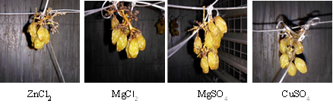

**Fig. 1 Cabinet dried sample with different chemical pre-treatments**

* Grapes with initial moisture content of 78.95% were subjected to shade drying, cabinet drying at three different temperatures (60, 70 and 80°C) and polytunnel drying. Final moisture content of dried grapes was about 20±0.5% (*w.b*.). All the samples were pre-treated with ethyl oleate (1.6%) and potassium carbonate (2.0%) treatment prior to drying. Results showed that raisins produced using cabinet dryer (at 60-80°C) were brownish in color. Polyhouse drying (above 60°C) was not successful in maintaining color of grapes and showed burnt appearance within 48 hours. However, raisins produced under shade drying were greenish (lower *a\** value). Shade drying also resulted in decreased lightness (*L\** value) and yellowness (*b\** value). Thus study showed that shade drying with lower temperatures (35 to 40°C) is a good alternative than any other drying procedures including polyhouse drying, cabinet drying, sun drying etc.

1. **Application of ascorbic acid as antibrowning agent**

**Two ascorbic acid treatments were applied independently:**

1. *Dipping in ascorbic acid solution before drying*

Subsequently afterethyl oleate and potassium carbonate treatment, grapes were dipped in ascorbic acid solutions of different concentrations (100, 200, 300, 400 and 500 ppm) for fixed time of 2 min (based upon the preliminary studies). After dipping treatment,samples were kept for shade drying. Grapes that were not pretreated with dipping solution served as control.

1. *Spraying of ascorbic acid solution during drying*

Samples treated with ethyl oleate and potassium carbonate treatment were kept for shade drying. Ascorbic acid solutions of different strengths (100, 200, 300, 400 and 500 ppm) were sprayed on each sample at an interval of 24 hours. Spray was applied for 30 s to each sample from an angle of 45° at a distance of 1 m so that all the berries get uniformly coated with ascorbic acid solution. Spraying was accomplished using sprayer with a nozzle. Spraying treatment was continued till desired level of moisture content is achieved. Grapes that were not subjected to spraying treatment served as control.

Total ten treatments of ascorbic acid dip and spray were applied independently to the samples. The denominations of different ascorbic treatments used in study are given in Table 1. Grapes samples were shade dried in a closed ventilated room. During drying, day temperature ranged from 25-27°C, night temperature ranged between 20 to 22°C,whereas relative humidity ranged between 25 to 35 per cent. Ceiling fan was put on for 8 hours in a day. The grapes were tied with the help of a string in air for proper circulation of air.The dried samples were collected everyday during drying to evaluate the changes occurring in color attributes, moisture content, total phenolic content and polyphenol oxidase (PPO) activity.

Results (Table 3 and 4) indicated that moisture content, colour intensity and total phenolic content (TPC) weresignificantly (α=0.05) affected by treatment of grapes with ascorbic acid. T4 (300 ppm): colour intensity - 8.31; moisture content - 20.25%

Untreated grapes: colour intensity - 9.82; moisture content - 28.25%,

**Table 3 Effect of dipping grapes in ascorbic acid solution before shade drying**

|  |  |  |  |
| --- | --- | --- | --- |
| **Ascorbic Acid Pre-treatments** | **TPC (mg/ml)** | **Color Intensity** | **M.C (%)** |
| T1(control) | 2.145 | 9.82 | 28.25 |
| T2 (100 ppm) | 2.256 | 9.91 | 23.12 |
| T3 (200 ppm) | 2.302 | 8.35 | 23.01 |
| T4 (300 ppm) | 2.452 | **8.31** | **20.25** |
| T5 (400 ppm) | 2.354 | 8.45 | 21.12 |
| T6 (500 ppm) | 2.274 | 8.41 | 20.65 |

Spray of ascorbic acid on grapes during shade drying

* On the basis of color, ascorbic acid spray during drying was better than the dipping pre-treatment of ascorbic acid
* The ascorbic acid spray could retain green color as it has antioxidant properties
* Ascorbic acid dose resulted in more TPC.
* Spraying the ascorbic acid solution on grapes (pretreated with ethyl oleate + potassium carbonate) during drying.
* In each approach, grapes were first pre-treated with EO+PC (2 min dip) and dried under shade (24-39oC)

**Table 4 Effect of spraying ascorbic acid on grapes during shade drying**

|  |  |  |  |
| --- | --- | --- | --- |
| **Ascorbic Acid** | **TPC (mg/ml)** | **Color Intensity** | **M.C (%)** |
| T1(control) | 2.213 | 7.345 | 28.56 |
| T2 (100 ppm) | 4.573 | 6.951 | 25.23 |
| T3 (200 ppm) | 5.112 | 6.485 | 24.56 |
| T4 (300 ppm) | 4.785 | **6.356** | **21.56** |
| T5 (400 ppm) | 4.516 | 6.562 | 22.26 |
| T6 (500 ppm) | 4.613 | 6.412 | 22.85 |

* Denominations of the treatments used in the study

|  |  |  |  |  |  |  |
| --- | --- | --- | --- | --- | --- | --- |
| **Ascorbic acid treatment** | **Treatment denomination** | | | | | |
| **Concentrations of ascorbic acid solution** | | | | | |
| Nil | 100 ppm | 200 ppm | 300 ppm | 400 ppm | 500 ppm |
| Dipping | D0 | D100 | D200 | D300 | D400 | D500 |
| Spraying | S0 | S100 | S200 | S300 | S400 | S500 |

**Detailed results are given in following tables**

**Table i. Effect of ascorbic acid dipping and spraying treatments on PPO activity of raisins**

**Table ii. Effect of ascorbic acid dipping and spraying treatments on browning index of raisins**



* The results of present study revealed that the application of ascorbic acid is helpful in retaining green color of raisins and improving drying rate of grapes.
* Application of ascorbic acid on grape bunches has been proved significant. The raisin quality was improved in ascorbic acid treated cases as compared to untreated grape berries.
* Different doses of ascorbic acid were recorded with reduced PPO activities during grape drying.
* Spraying of ascorbic acid during drying was found more effective than ascorbic acid dip.

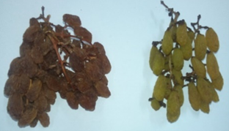

**Fig 3. Raisins produced from S0 and S200 treatments**

**Findings**

1. Process protocol for production of green raisins using **Mettallo-complex**
   * Dipping in EO + PC for 2 min (temp. about 30oC)
   * Dipping in 4% solution of CuSO4 for 6 min, followed by drying (65°C, for 6-7 h)
2. Process protocol for production of green raisins using **ascorbic acid**
   * Dipping in EO + PC for 2 min (temp. about 30oC)
   * Ascorbic acid spray (300 ppm) once in a day till drying completes
   * Drying in a forced ventilated pulytunnel (with shade) dryer for 4 days (ambient temperature varied 28-35°C)

**Ultrasonication and hot water pretreatment of grapes for production of green raisins (as suggested by 28th IRC)**

* **Sample:** Grapes var. *Thompson seedless*
* **Sample size:** 150 g
* **Treatments:** T1- 0, T2- 3, T3- 6, T4- 9, T5- 12, T6- 15, T7- 18, T8- 21 minutes in water and T9 -EO+PC treated sample
* **Power (W)** : 240 w
* **Temperature (**°C) **:** 30 °C
* 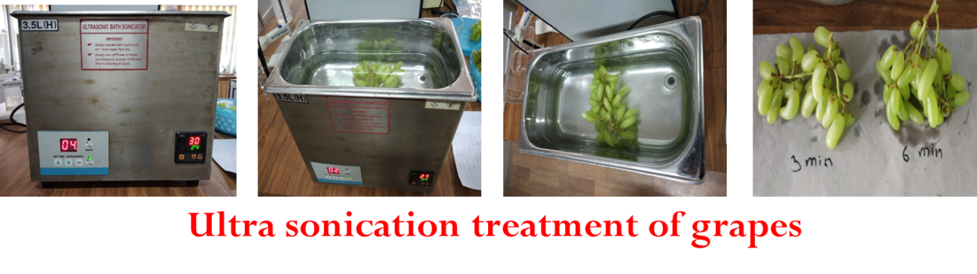**Drying :** Shade drying at ambient conditions (Temperature – 10- 25 °C)

**Findings**

* Grapes turned brown in color as the drying proceeded
* Drying time – 20 to 25 days

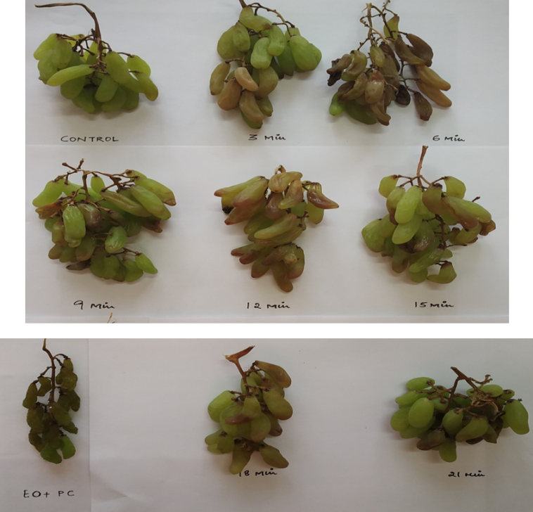

**Hot Water Treatment of Grapes for Production of Green Raisins (28th IRC)**

* **Sample:** Grapes var. *Thompson seedless*
* **Sample size:** 150 g
* **Treatments:** T1- 0, T2- 3, T3- 6, T4- 9, T5- 12, T6- 15, T7- 18, T8- 21 minutes in water and T9 -EO+PC treated sample
* **Temperature (**°C) **:** 65-70 °C
* **Drying :** Shade drying at ambient conditions (Temperature – 10- 25 °C)

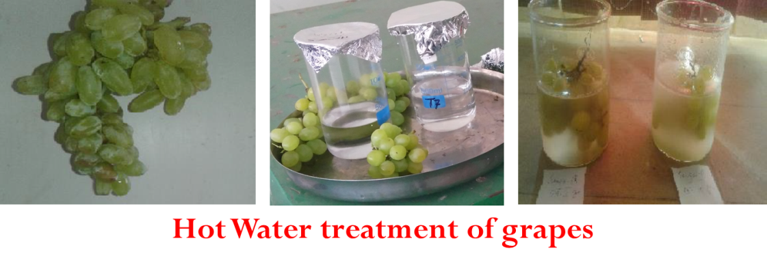

**Findings**

* Grapes turned brown in color as the drying proceeded
* Drying time – 20 to 25 days

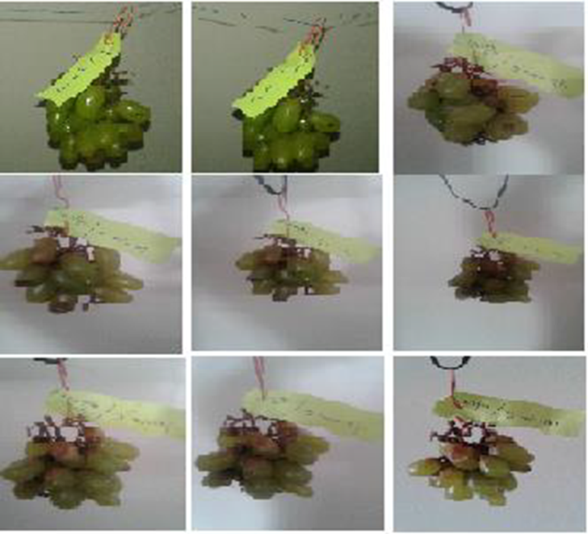

**Low temperature drying**

* In USA, Mediterranean and European countries, green colored raisins are produced by keeping the grapes on the vines (Dry-On-Vine) under cool and dry air conditions
* With that concept, some drying methods were tested for production of green raisins. Care was taken that temperature was not allowed to rise above 35°C in any of the drying method.

1. **Low temperature vacuum assisted drying (25-30oC):**

Low temperature vacuum drying of grapes was carried out at 25-30**o**C. Thompson seedless variety of grapes was used to dry in this system. However, system resulted in incomplete drying of grapes and was dropped.

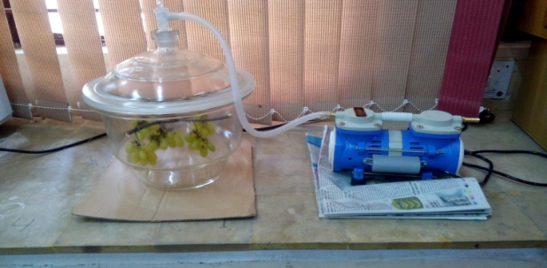

**Fig. 4Low temperature vacuum drying system**

1. **Low temperature air drying (10oC):**

Low temperature air drying of grapes was carried out at around 10**o**C. Thompson seedless variety of grapes was used to dry in this system. However, system resulted in incomplete drying of grapes and was dropped.

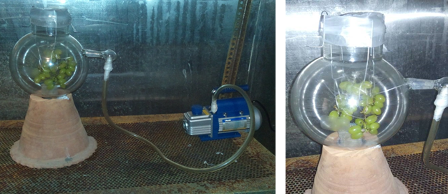

**Fig. 5Low temperature air drying system**

**Expt I: Development of dehumidified polytunnel dryer**

*Polytunnel dryer*

* Dimensions: length = 153 cm; width = 70 cm; height = 50 cm (Fig. 6)
* Covered with UV-stabilized polysheet (Fig. 6)
* Fan was attached at one end for air circulation (Fig. 6)

*Dehumidification system*

* Gaur straw balls were used to prepare air de-humidification system (Fig. 7)
* Gaur straw balls and fan were enclosed in pipes.
* Balls dimension: about 2 cm dia.; length in pipe – about 100 cm (Fig. 7)

**Findings and conclusions**

* Air dehumidification system lowered the inside air humidity from 68 % to 62 % when system was operated for one hour under no load condition.
* Under loading condition (1 kg grapes), dehumidification system did not show significant decrease in the RH. It reduced the RH by 3-4 % only.
* Hence, it was observed that dehumidified polytunnel was not found efficient in increasing the drying rate and preventing the green color loss.

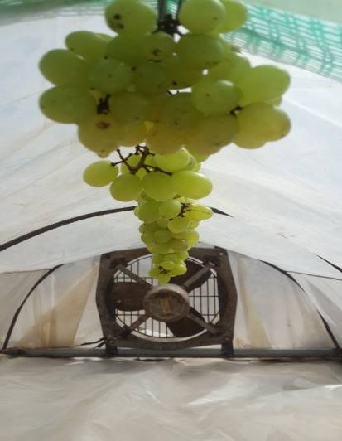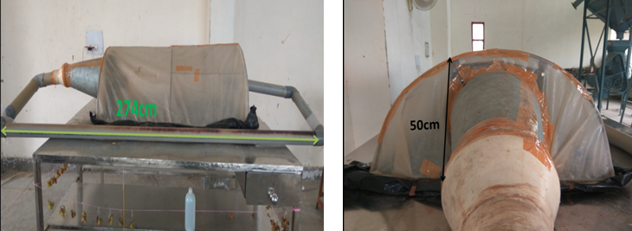

**Fig. 6Polytunnel dryer**

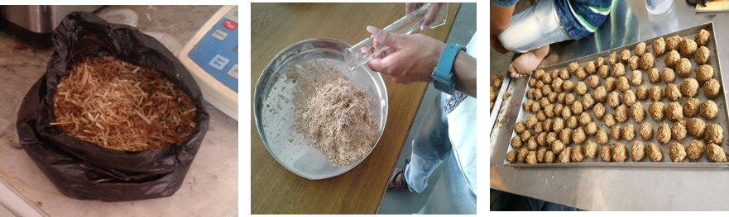

**Fig. 7 Guar straw Balls (For Dehumidification)**

* Temperature in the dryer varied from 28-33°C.
* Dryer was tested during July-August (Humid days), ambient RH varied from 65-75%
* Air dehumidification system lowered the inside air humidity from 68% to 62% when system was operated for one hour under loading condition (1 kg load).
* Drying duration: 9 to 10 days
* Grape color: brown and greenish brown.

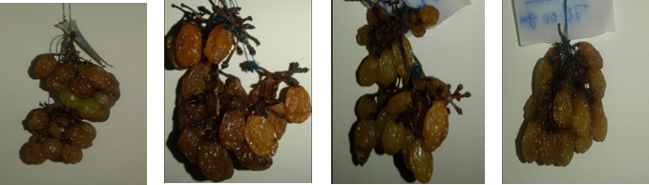

**Fig. 8 Grapes dried in polytunnel drier**

**Expt II: Forced ventilated shade drying system (in dark)**

**Forced ventilated shade drying**

* It was hypothesized that shade drying would not allow air temperature to rise above 35°C (temperature >35°C causes browning)
* Forced ventilation would increase the drying rate at higher humdities also
* **Dark**: Fruits dried in the dark remain more green and lighter in color than shade-dried fruits (L. Peter Christensen, 2000)
* Therefore forced ventilated shade drying system (in dark) was tested for production of green raisins.

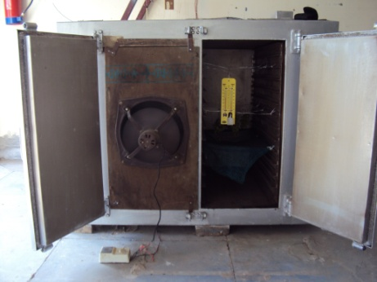

**Fig. 9 Set-up for forced ventilated shade drying of grapes**

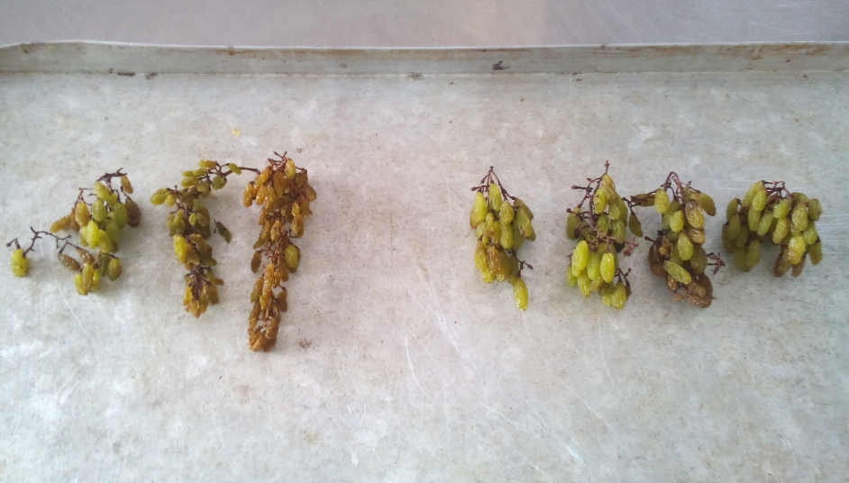

**Fig. 10(1) Shade drying, (2) Force ventilated shade drying**

* Final moisture content of the raisins was about: 22% and the whole drying duration were 6 days.

**Table 1 Temperature variation in shade drying and force ventilated shade drying system**

|  |  |  |  |  |  |  |
| --- | --- | --- | --- | --- | --- | --- |
| **Days** | **Shade drying** | | | **Force ventilated shade drying** | | |
|  | **DBT** | **WBT** | **RH (%)** | **DBT** | **WBT** | **RH (%)** |
| 1 | 29 | 18 | 32.7 | 27 | 17 | 35.2 |
| 2 | 27 | 17 | 35.2 | 26 | 17 | 39.4 |
| 3 | 27 | 17 | 35.2 | 27 | 17 | 35.2 |
| 4 | 26 | 19 | 51.1 | 25 | 18 | 50.0 |
| 5 | 27 | 17 | 35.2 | 26 | 17 | 39.4 |
| 6 | 28 | 17 | 31.4 | 27 | 17 | 35.2 |

* It was observed from table 1 that during shade drying (SD) dry bulb temperature was in the range of 26-29 ° C whereas in force ventilated shade drying (FVSD) system it was lower i.e. 25-27 ° C.
* Wet bulb temperature during SD was in the range of 17-19 ° C whereas in force ventilated shade drying (FVSD) system it was lower i.e. 17-18 ° C.
* The humidity levels varied from 31.4-51.1% and in FVSD system it varied from 35.2 to 50.0%.
* From results, it was observed that forced ventilated shade drying (in dark) system was found efficient in production of green raisins.

**Final findings**

1. Process protocol for production of green raisins using Mettallo-complex
   * Dipping in EO + PC for 2 min (temp. about 30oC)
   * Dipping in 4% solution of CuSO4 for 6 min, followed by drying (65°C, for 6-7 h)
2. Process protocol for production of green raisins using ascorbic acid
   * Dipping in EO + PC for 2 min (temp. about 30oC)
   * Ascorbic acid spray (300 ppm) once in a day till drying completes
   * Drying in a forced ventilated pulytunnel (with shade) dryer for 4 days (ambient temperature varied 28-35°C)
3. Process protocol for production of green raisins using Forced ventilated shade drying system (in dark)
   * Dipping in EO + PC for 2 min (temp. about 30oC)
   * Forced ventilated shade drying in dark (temperature <35°C)
   * Drying period: 4-6 days
4. Recommendations based on existing drying methods

Shade drying in a “cool air” type structures may be used for production of green raisins. Low-cost structure, temperature: 35°C.