|  |  |  |
| --- | --- | --- |
| C:\Users\Dr Palanimuthu\Documents\University Logo Black(1).jpg | ***University of Agricultural Sciences, Bangalore***  **ICAR-Krishi Vigyan Kendra, Bengaluru Rural District**  **Krishi Mantana**  **Vol. 10., Quarterly Newsletter (Jan - March, 2022) No. 1** | http://3.bp.blogspot.com/-Aui_5lNJsoQ/Tm7xKFOUqgI/AAAAAAAAAis/7pvXshp0Ruc/s1600/icar+logo.jpg |

**Training on Scientific Rearing of Sheep and Goat**

* ICAR-KVK, Hadonahalli, Bengaluru Rural District and CBM India Trust, Bengaluru jointly organised the training program for specially challenged persons and their family members on scientific rearing of sheep and goat at ICAR-KVK, Hadonahalli, Doddaballapur, Bengaluru rural district for three days from 02.02.2022 to 04.02.2022. The programme was inaugurated by Dr. G. M Nagaraj, Deputy Director, Department of Animal Husbandary and Veterinary Services, Bengaluru (Rural). Dr. B. Manjunath, Scientist (Plant Protection), KVK, Hadonahalli and Sebastin, C., Composer of CBM India Trust were graced the occasion. 25 participants were benefitted the programme.
* In this programme the trainees gained the knowledge about housing systems for sheep and goat, nutrition and disease management. The trainees were also taken for exposure visit to well established sheep and goat unit at Gangasandra village.

|  |  |
| --- | --- |
| E:\POPS\Reports\MONTHLY REPORT\MONTHLY REPORTS\DE_Report\2021\Monthly reports\February 2022\Inaguration of training programme on  scientific rearing of goat and sheep.jpg | E:\POPS\Reports\MONTHLY REPORT\MONTHLY REPORTS\DE_Report\2021\Monthly reports\February 2022\Exposure visit to sheep and goat rearing unit.jpg |
| **Inaguration of the programme** | **Exposure visit to sheep & goat unit** |

**Skill training on Integrated Pest Management in Vegetable Crops**

ICAR-Krishi Vigyan Kendra, Bengaluru Rural District in association with MANAGE, Hyderabad conducted skill training program for rural youths on Integrated Pest Management in Vegetable Crops at ICAR-KVK, Hadonahalli, Doddaballapur, Bengaluru rural district for 6 days from 7.02.2022 to 12.02.2022. The programme was inaugurated by Dr. A. P. Mallikarjuna Gowda, Senior Scientist and Head, ICAR – KVK, Bengaluru Rural District along with other Scientists.

In the training programme 15 trainees gained the knowledge about Pest and disease resistant varieties of vegetables, Role of nutrients in vegetables in relation to pest & disease management, Pesticide residual analysis in vegetable crops and integrated management of fruit flies in vegetables etc.

|  |  |
| --- | --- |
| **E:\POPS\Reports\MONTHLY REPORT\MONTHLY REPORTS\DE_Report\2021\Monthly reports\February 2022\participants gaining practical knowledge about diseases .JPG** | **E:\POPS\Reports\MONTHLY REPORT\MONTHLY REPORTS\DE_Report\2021\Monthly reports\February 2022\Participants of Skill training programme.JPG** |
| **Gaining practical knowledge** | **Participants of the skill training** |

**Participatory Workshop on “Enhancement of Technical Competencies of KVK Scientists”**

Directorate of Extension, UAS, Bangalore organized two days participatory workshop on “Enhancement of Technical Competencies of KVK Scientists” on 3rd and 4th March, 2022 at ICAR- KVK, Bengaluru Rural. Dr. N. Nagaraj, former Director of Extension has inaugurated the workshop and delivered inaugural speech about technical competencies of KVK Scientists. Dr. M. J. Chandregowda, Principal Scientist, Dr. D. V. Srinivasa Reddy, Principal Scientist and Dr. B. T. Rayudu, Principal Scientist, ATARI, Bengaluru were graced the function as chief guests. Dr. N. Devakumar, Director of Extension presided the function.

Dr. N. Nagaraj, Dr. M. J. Chandregowda, Dr. D. V. Srinivasa Reddy and Dr. B. T. Rayudu served as key resource persons during the workshop. Dr. Pankaja. H. K. Technical officer, Directorate of Extension facilitated the workshop. The Senior Scientists and Scientists from seven KVK’s of UAS, Bangalore were actively participated in the workshop. They were trained about roles and responsibilities, formulation of OFT and FLD, modalities to organize training, impact assessment etc. All participants felt that the workshop was fruitful and require such frequent workshops/brainstorming sessions to update their knowledge and implement the same in KVK activities.

|  |  |
| --- | --- |
| **E:\POPS\Reports\MONTHLY REPORT\MONTHLY REPORTS\DE_Report\2021\Monthly reports\March 2022\IMG_9794 (1).JPG** | **E:\POPS\Reports\MONTHLY REPORT\MONTHLY REPORTS\DE_Report\2021\Monthly reports\March 2022\IMG_9843 (1).JPG** |
| **Inaguration of the programme** | **Participants of the workshop** |

**Field days conducted**

* Conducted Field day of FLD - Eco friendly management of diamond backmoth in cabbage on 17.01.2022 at Krishnarajapura
* Conducted Field day of OFT - Assessment of nutrient management in marigold on 17.01.2022 at Kaggalahalli
* Conducted Field day of FLD - Integrated pest and disease management in tomato on 18.01.2022 at Kaggalahalli
* Conducted Field day of FLD - ICM in Redgram on 18.01.2022 at Vabasandra
* Conducted Field day of CFLD – ICM in Redgram on 25.01.2022 at Lakkondahalli
* Conducted Field day of FLD - Ration balancing in dairy animals on 31.01.2022 at Lakkondahalli
* Conducted Field day of FLD - Pro-biotics for post weaning Sheep on 31.01.2022 at Lakkondahalli
* Conducted Field day of OFT - Assessment on management of mites and thrips in mulberry on 17.01.2022 at Thimmasandra
* Conducted Field day of FLD - Demonstration of multicut fodder CoFS-31 for green forage and silage on 22.02.2022 at Krishnarajapura

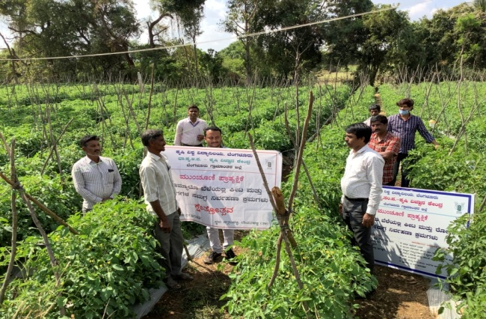 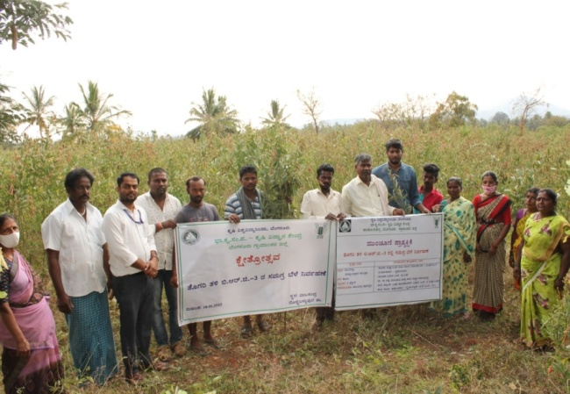

|  |  |
| --- | --- |
|  |  |
| **Field day of FLD on Tomato** | **Field day of FLD on Redgram** |
|  |  |
| E:\POPS\Reports\Annual Report\2021-22\Photos for annual report 2022 (KVK, BRD)\Field day.JPG |  |
| **Field day of FLD on Cabbage** | **Field day of OFT on Mulberry** |
|  |  |
|  |  |
| **Field day of OFT on Marigold** | **Field day of FLD on CoFS-31** |
|  |  |
| E:\POPS\Reports\Annual Report\2021-22\Photos for annual report 2022 (KVK, BRD)\FEILD DAY OF FLD COW.JPG | E:\POPS\Reports\Annual Report\2021-22\Photos for annual report 2022 (KVK, BRD)\FEILD DAY SHEEP.JPG |
| **Field day of FLD on Ration Balancing** | **Field day of FLD on Sheep** |
|  |  |

**Services available at KVK**

* Analysis of soil and water samples and advisory services
* Analysis of infected plant samples and advisory services about IPM practices
* Production and sale of quality planting material and advisory services
* Millets Processing Centre and KVK Marketing Complex
* Production and Sale of Pongamia oil, Pongamia cake and biofuel

**Services and Sale of Technological Inputs**

* Analysed of 50 Soil and 29 Water samples of farmers and provided advisory services
* Sold 162 quality horticultural planting materials

----------------------------------------------------------------------------------------------------

|  |  |
| --- | --- |
| **Chief Editor**  Dr. A. P. Mallikarjuna Gowda  Senior Scientist & Head  **Editor and Associate Editors**  Dr. B. Manjunath, Scientist (Plant Protection)  Dr. J. Venkate Gowda., Scientist (Agronomy)  Dr. P. Veeranagapa., Scientist (Soil Science)  Sri N. Jagadish, Farm Manager  Smt. B. V. Manjula, Programme Assistant (Lab)  Smt. Sukanya, G.V., Programme Assistant (Computer) | **Contact For Further Information:**  Senior Scientist & Head  ICAR- Krishi Vigyan Kendra, Hadonahalli Doddaballapura Taluk, Bengaluru Rural District Karnataka – 561205, P**hone:** 94498 66928  **Email:** [kvkbrd@gmail.com](mailto:kvkbrd@gmail.com), **Website:** [www.kvkbrd.org](http://www.kvkbrd.org)  To  -----------------------------------------------------  -----------------------------------------------------  ----------------------------------------------------- |