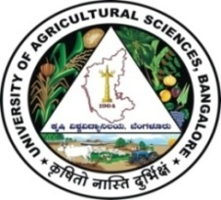 | University of Agricultural Sciences, Bangalore  ICAR-Krishi Vigyan Kendra, Bengaluru Rural District  Krishi Mantana  Vol. 10 Quarterly Newsletter (April - June, 2022) No. 2 | 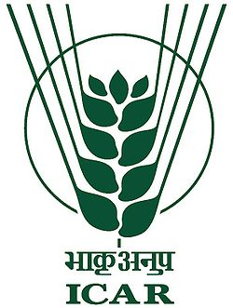
Kissan Bhagidari – Prathmika Hamari Campaign

ICAR-Krishi Vigyan Kendra, Bengaluru Rural District and Karnataka State Department of Agriculture, Bengaluru District jointly organised one day Campaign on Kisan Bhagidari – Prathamika Hamari at ICAR-Krishi Vigyan Kendra, Hadonahalli on 26.04.2022 under the chairmanship of Dr. A.P. Mallikarjuna Gowda, Senior Scientist & Head, ICAR-Krishi Vigyan Kendra, Bengaluru Rural District.
The programme was inaugurated by Smt. Vinutha, M.C., DD, Dept. of Agriculture, Bengaluru District and she briefed about the Bhartiya Prakritik Krishi paddati and schemes of Dept. of Agriculture.
In the technical session, Dr. J. Venkate Gowda, Scientist (Agronomy) highlighted about Natural farming, Importance and cultivation practices of minor millets and oil seeds. Miss Meghana S.V., Scientist (Home Science) briefed about Biofortified varieties and its importance as food, Dr. M. Manjunath, Senior Consultant, Centre of Excellence for FPO, College of Horticulture, UHS campus, GKVK, Bengaluru detailed about the formation of FPO and roles of FPO. Dr. Swapnil from Regional Centre for Organic and Natural farming, Bengaluru was participated as Chief guest and organized demonstration on preparation of Panchagavya. The exhibition was organized on millets by displaying eight millets standies with respect to importance and cultivation aspects of millets.
The inaugural session of the programme was live streamed and 250 members were benefitted from the programme. The people representative of Gram Panchayath and Zilla Panchayath were graced the occasion.
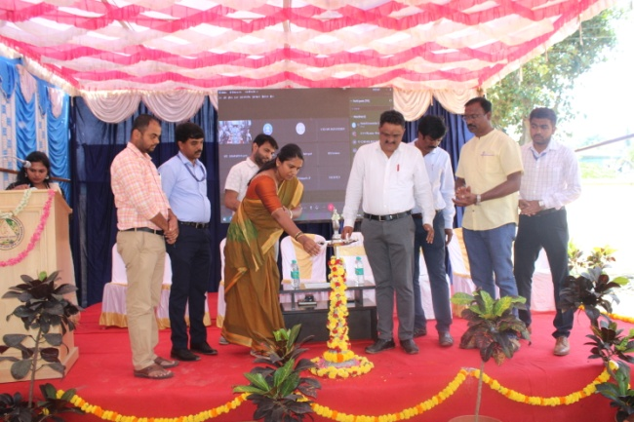 | 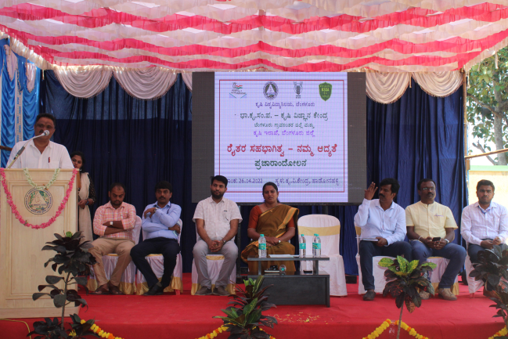
Inaguration of the programme | SS&H briefed during the programme
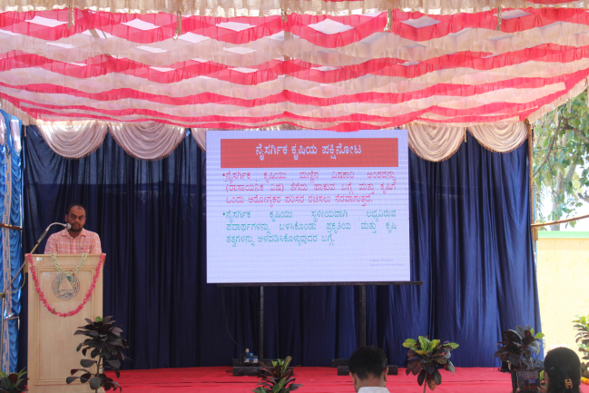 | 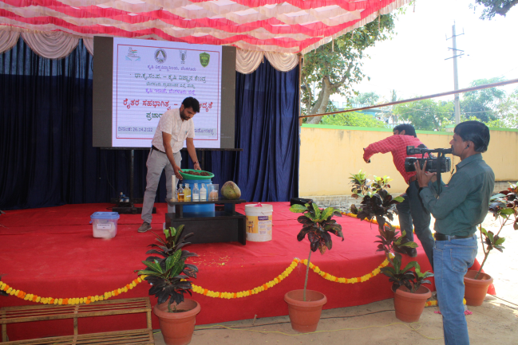
Natural farming by Scientist (Agronomy) | Method demonstration on preparation of Panchagavya

Drone Pilot Training

ICAR- Krishi Vigyan Kendra, Bengaluru Rural District, Karnataka has conducted a pilot training on “Use of Drone Technology in Agriculture” with a sponsorship of IFFCO, Bengaluru and in collaboration with Department of Agriculture, Bengaluru from 21.05.2022 to 03.06.2022. Shri. Venkataramreddy patil, Additional Agriculture Director, Karnataka State Department of Agriculture inaugurated the programme along with other dignitaries on 21.05.2022. He emphasized that, the programme was aimed to sensitizing the farmers to overcome problems viz., shortage of farm laborers’ and high input costs, through farm mechanization and precision agriculture. He also told that, the management of invasive pest and diseases would also become economical and easy with the help of drones.
Senior Scientist & Head was presided the programme and he elaborated that, farming sector is facing several challenges, including labour shortage and falling incomes, the use of Unmanned Aerial Vehicles (UAVs), popularly known as drones, has come to the rescue of farmers to aid them in various activities including spraying of pesticides and nutrients. He also pointed that, this demonstration will stimulate the farming community for achieving maximum production from a limited area and solving the lack of availability of farmer laborers’. 25 farmers from different parts of Karnataka were participated in the programme. The participants were given Hands on Training (HoT) on use of drones with the different payload capacities used for spraying pesticides and nutrients for the crops, using the multi and hyper-spectral sensors installed on the drones and data visualization.
Dr. C. Narayanaswamy, State Marketing Manager, IFFCO, Bengaluru, Smt, Vinutha , Deputy Director of Agriculture, Bengaluru (D), Smt. Sushilama, Assistant director of Agriculture, Dept. of Agriculture, Doddaballapura (Tq.) and Shri. Chethan, IFFCO, Bangalore were present as a chielf guests of the programme.

Inaguration of the training | Practical session

Celebration of International yoga day

ICAR-Krishi Vigyan Kendra, Bengaluru Rural District organized Celebration of International Yoga day, Awareness on Balanced use of fertilizers, Awareness on region specific agro forestry on 21.06.2022. Dr. Krishna murthy, Professor & Head (STCR), UAS, GKVK, Bengaluru explained about the Balanced use of fertilizers and use of nano fertilizers. Dr. J. Venkate Gowda, Scientist (Agronomy), ICAR-KVK, Bengaluru Rural District briefed about silvi pasture models suitable for Bengaluru Rural District viz., Melia dubia + COFS-31 fodder, RET forest species models and field visit was also arranged to KVK demo plots. 57 members were participated in the programme.

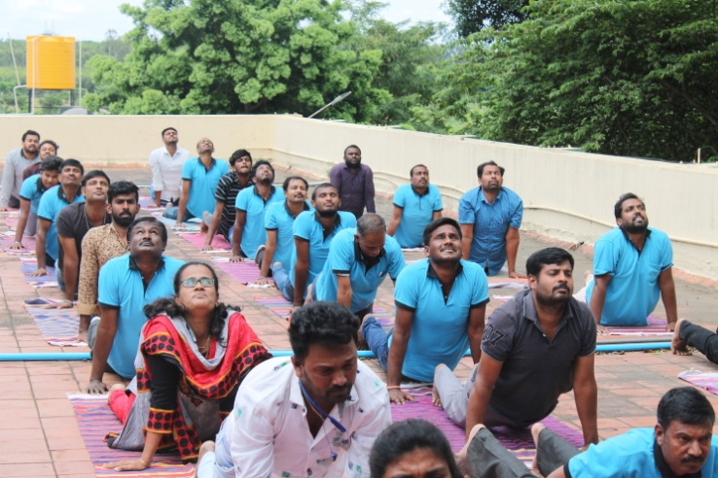 | 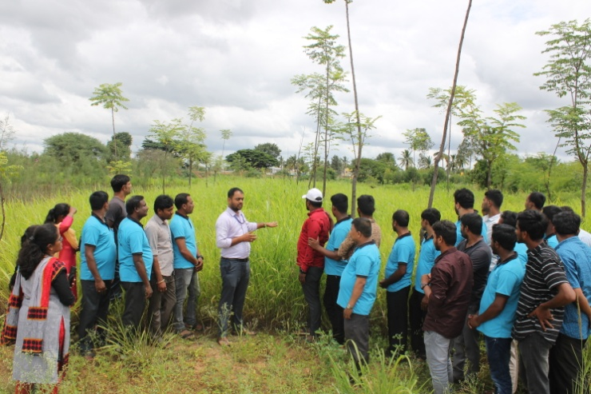
Celebration of International yoga day | Explaining the silvi pasture models

Off-Campus Training Programs Conducted

# | Title | Type * | No of Participants
1 | Method demonstration on seed treatment in Redgram under NFSM on 20.06.2022 at Lakkondahalli | Farmers | 20
2 | Method demonstration on seed treatment in cowpea on 20.06.2022 at Channapura | Farmers | 18
3 | Method demonstration on seed treatment in Redgram on 30.06.2022 at Kammasandra | Farmers | 16
Total |  |  | 54

On-Campus Training Programs Conducted for farmers:
# | Title | Type * | No of Participants
1 | Skill development training on Livestock management from 22.04.2022 to 23.04.2022 at KVK | SC farmers | 30
2 | Kisan Bhagidhari Pratamika Hamari Programme – Kissan mela on 26.04.2022 at KVK | Farmers/farm women | 250
3 | Garib kalyan sammelan and Hon’ble Prime ministers programme live telecast on 31.05.2022 at KVK, Hadonahalli | Farmers/farm women | 60
4 | Soil health and plant nutrition management | Farmers/farm women | 28
Total |  |  | 368

Services available at KVK
- Analysis of soil and water samples and advisory services
- Analysis of infected plant samples and advisory services about IPM practices
- Production and sale of quality planting material and advisory services
- Millets Processing Centre and KVK Marketing Complex
- Production and Sale of Pongamia oil, Pongamia cake and biofuel
Services and Sale of Technological Inputs
- Analysis of 12 Soil and 6 Water samples of farmers and advisory services
- Sale of 111 quality horticultural planting materials
----------------------------------------------------------------------------------------------------
Chief Editor  Dr. A. P. Mallikarjuna Gowda  Senior Scientist & Head  Editor and Associate Editors  Dr. B. Manjunath, Scientist (Plant Protection)  Dr. J. Venkate Gowda., Scientist (Agronomy)  Dr. P. Veeranagapa., Scientist (Soil Science)  Dr. Y. D. Chithra., Scientist (Agril. Extension)  Sri N. Jagadish, Farm Manager  Smt. B. V. Manjula, Programme Assistant (Lab)  Smt. Sukanya, G.V., Programme Assistant (Computer) | Contact For Further Information:  Senior Scientist & Head  ICAR- Krishi Vigyan Kendra, Hadonahalli Doddaballapura Taluk, Bengaluru Rural District Karnataka – 561205, Phone: 94498 66928  Email: kvkbrd@gmail.com  Website: www.kvkbrd.org  To  -----------------------------------------------------  -----------------------------------------------------  -----------------------------------------------------

