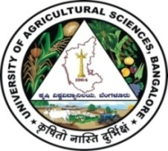 | University of Agricultural Sciences, Bangalore  ICAR-Krishi Vigyan Kendra, Bengaluru Rural District  Krishi Mantana  Vol. 8., Quarterly Newsletter (Jan - March, 2020) No. 1 | 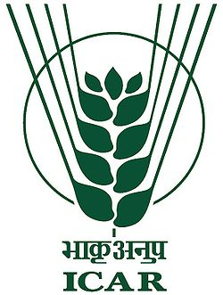

Eleventh Scientific Advisory Committee

- The Eleventh Scientific Advisory Committee (SAC) meeting of ICAR-KVK, Bengaluru Rural District was held on 12.02.2020 under the Chairmanship of Vice-Chancellor, UAS, Bangalore. The Senior Scientist and Head welcomed the chairman and members of the committee. The Vice-Chancellor briefed the mandates of KVK in relation to farmers and the purpose of SAC meeting.
- The Senior Scientist and Head, presented the Action Taken Report on the recommendations of Tenth Scientific Advisory Committee meeting and obtained the approval. The Scientists presented the results of On Farm Testing, Front Line Demonstrations, Training Programmes, Farmers Field School, Other extension activities, Adopted village programmes, Paramparagath Krishi Vikas Yojana, Bio fuel project and ARYA project for the year 2018-19. The Farm Manager presented the Soil and plant health clinic and progress of farm activities during the period for the year 2018-19. Finally, the Senior Scientist and Head briefed the action plan for the year 2019-20.

On the occasion, leaflets on ‘Integrated management practices of Fall Army Worm, Ornamental fish rearing, Azolla – Multipurpose water plant, Impact of village adoption programme at Rameshwara village and CDs on Success of Progressive farmers Smt. Manjula and Sri Jagadeesh Giri’ were released by the dignitaries. Field day on “Potato” was also organized in the KVK farm.
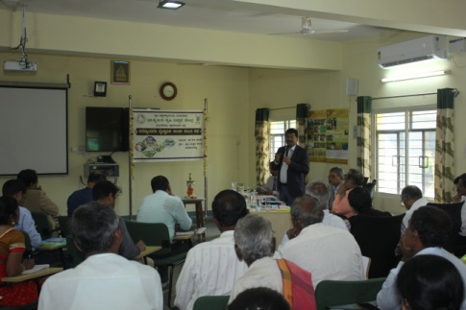 | 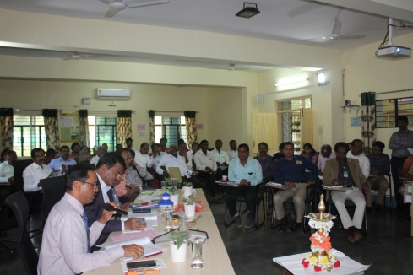 | 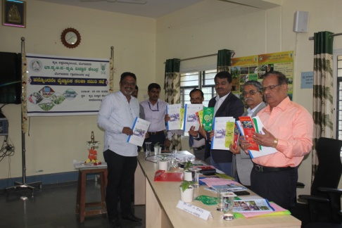
Vice-Chancellor addressing the SAC members | Address by Director, ATARI | Release of folders by dignitaries
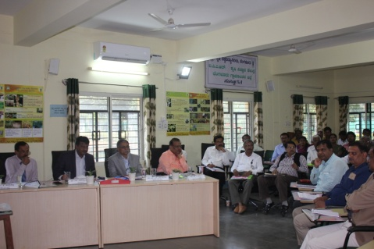 | 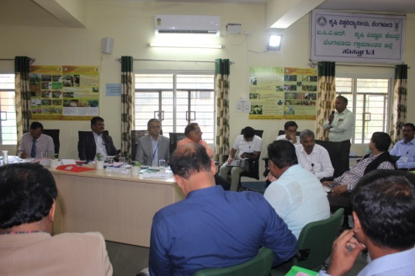 | 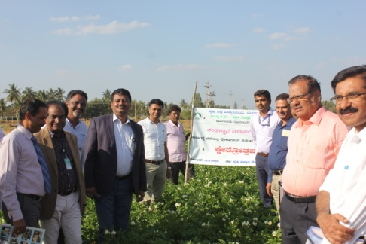
Interaction with SAC members |  | Potato field day

Field day on Improved production technology in castor

Field day on Improved production technology in castor was organized at Vabasandra, Doddaballapur Taluk on 13.01.2020. Dr. Venkate Gowda, J., Scientist (Agronomy) explained about importance of variety, spacing, nipping technology and plant protection aspects to farmers. Dr. Veeranagappa, P., Scientist (Soil Science) explained nutrient management practices in castor. 43 farmers were participated and benefitted from this programme.

Field day on COFS-31 and Silage making
Organised field day on CoFS-31 technology on 9th March, 2020 at Lakkondahalli, Hosakote taluk, where 54 farmers were attended the field day. Dr. Venkate Gowda, J., Scientist (Agronomy) explained about production technology of CoFS-31 and silage making technology by using CoFS-31 fodder.

Field day on Tomato
Conducted Tomato field day on 7th, March 2020 at Lakkondahalli, Hosakote Taluk, where 42 farmers were attended and benefitted from the field day. Dr. P. Veeranagappa, Scientist (Soil Science) explained about advantage of fertigation techniques in Tomato.

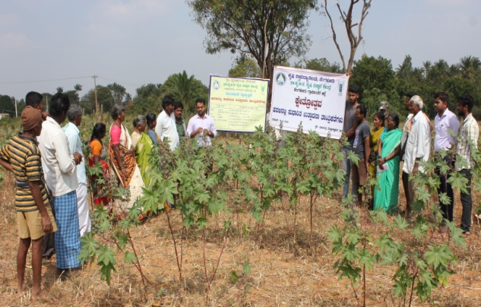 | 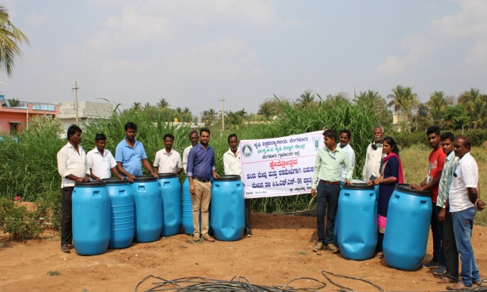 | 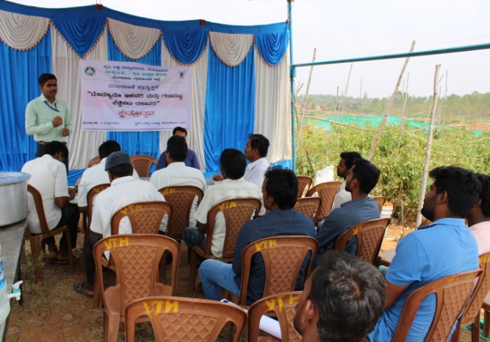
Field day on Improved production technology in castor | Field day on COFS-31 and Silage making | Field day on Tomato

Skill development programme on “Bee keeping "

Six days skill development programme on Bee keeping sponsored by MANAGE, Hyderabad was conducted from 2nd March to 7th March, 2020 at ICAR-Krishi Vigyan Kendra, Bengaluru Rural District. Dr. A. P. Mallikarjuna Gowda, Senior Scientist & Head has inaugurated the programme and briefed about importance and role of honey bees in pollination of crops and enhancement of yield.
Sri Lakshme Gowda, Kuntanahalli village, Entrepreneur in Bee keeping participated as a resource person and shared his experience in bee keeping with trainees.
Dr. B. Manjunath, Scientist (Plant protection) explained about initial bee keeping practices, natural enemies and diseases of bees and their control measures. Hands on training about examining bee box, transformation of colony, harvesting, extraction and it’s storage. 15 rural youths were benefited from this training programme.
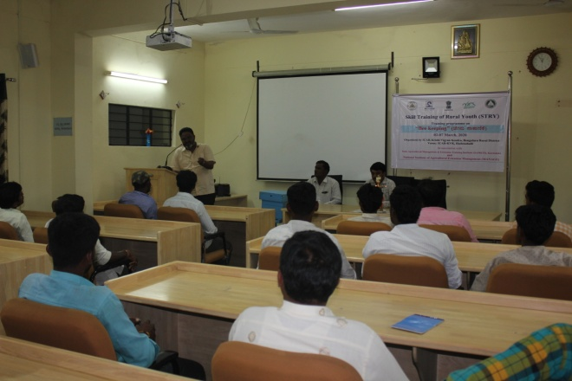 | 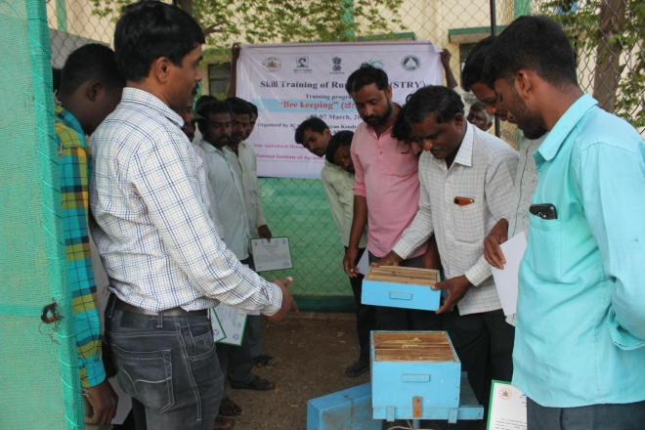 | 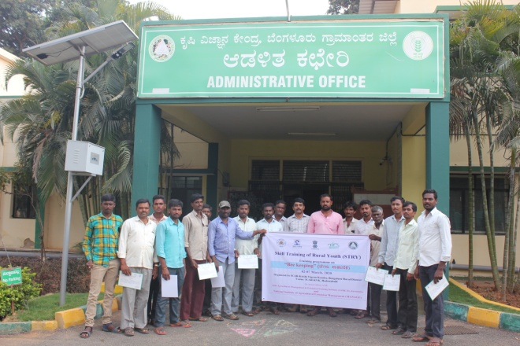
Senior Scientist & Head, KVK, addressing the trainies | Hands on training in Bee keeping | Group photo

Skill development programme on Integrated Nutrient Management

Skill development programme on Integrated Nutrient Management sponsored by MANAGE, Hyderabad was conducted for six days 16th March to 21st March, 2020 at ICAR-Krishi Vigyan Kendra, Bengaluru Rural District. Dr. A. P. Mallikarjuna Gowda, Senior Scientist & Head explained about role of nutrients in plants and different compost methods.
Dr. Venkate Gowda, J., Scientist (Agronomy) explained about precision farming and crop diversification. He also emphasised the role of organic farming practices on soil and crop productivity. Dr. B. Manjunath, Scientist (Plant Protection) delivered lecture on Integrated pest and disease management and safe use of pesticides. Dr. Veeranagappa, P., Scientist (Soil Science) provided information on soil testing, application of nutrients based on soil test results, methods of fertilizer use, deficiency symptoms in plants, water soluble fertilizers and imparted hands on training for identification of deficiency symptoms in field.
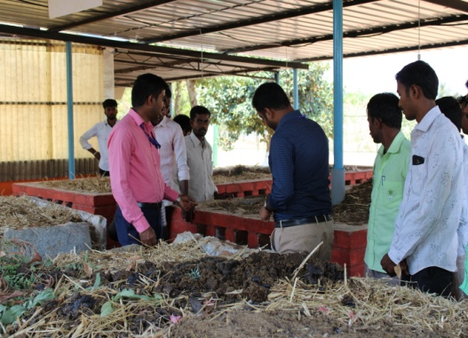 | 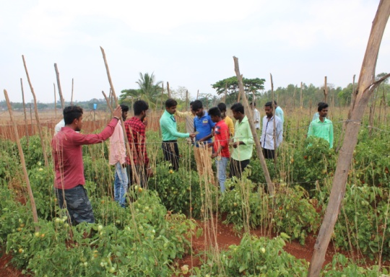 | 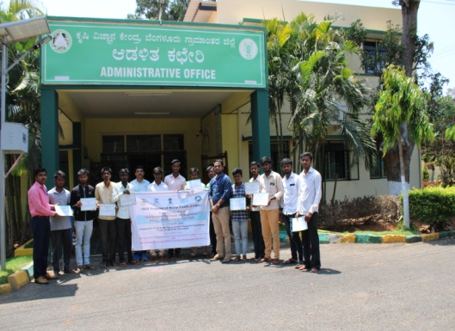
Observation on different compost methods at KVK | Identification of deficiency symptoms | Group photo

Services available at KVK
- Analysis of soil and water samples and advisory services
- Analysis of infected plant samples and advisory services about IPM practices
- Production and sale of quality planting material and advisory services
- Production and sale of Vegetable Special
- Millets Processing Centre and KVK Marketing Complex
- Production and Sale of Pongamia oil, Pongamia cake and biofuel

Services and Sale of Technological Inputs
- Analysis of 202 Soil and 86 Water samples of farmers and advisory services
- Sale of 120 kg Vegetable Special for foliar spray in vegetables
- Sale of quality horticultural planting materials

----------------------------------------------------------------------------------------------------

Chief Editor  Dr. A. P. Mallikarjuna Gowda  Senior Scientist & Head  Editor and Associate Editors  Dr. B. Manjunath, Scientist (Plant Protection)  Dr. J. Venkate Gowda., Scientist (Agronomy)  Dr. P. Veeranagapa., Scientist (Soil Science)  Dr. Y. D. Chithra., Scientist (Agril. Extension)  Sri N. Jagadish, Farm Manager  Smt. B. V. Manjula, Programme Assistant (Lab) | Contact For Further Information:  Senior Scientist & Head  ICAR- Krishi Vigyan Kendra, Hadonahalli Doddaballapura Taluk, Bengaluru Rural District Karnataka – 561205, Phone: 94498 66928  Email: kvkbrd@gmail.com, Website: www.kvkbrd.org  To  -----------------------------------------------------  -----------------------------------------------------  -----------------------------------------------------

