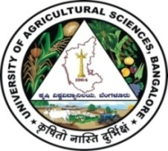 | University of Agricultural Sciences, Bangalore  ICAR-Krishi Vigyan Kendra, Bengaluru Rural District  Krishi Mantana  Vol. 8 Quarterly Newsletter (July - September, 2020) No. 3 | 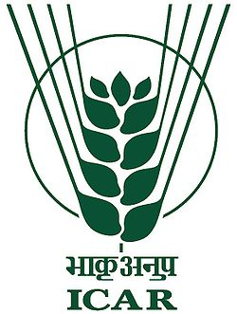
Parthenium Awareness Week
Parthenium is one of the weed which is causing more damage for cultivation of crops and also mankind therefore, Parthenium awareness week was conducted from 17th August to 22nd August 2020, mainly to create awareness on the notorious weed, which causes many diseases like skin allergy, hay fever, breathing problems in human beings and animals besides reducing agricultural productivity, loss of biodiversity. The programme was organized at different villages viz., Thuruvanahalli, Tubagere, S.S.Ghati, Hadonahalli, Laghumenahalli of Bengaluru Rural District and briefed the gathering about significance of celebration and the harmful effects caused by parthenium and various cultural and management techniques for eradication of weed. KVK staff and all participants uprooted parthenium weeds in the vicinity of the programme.

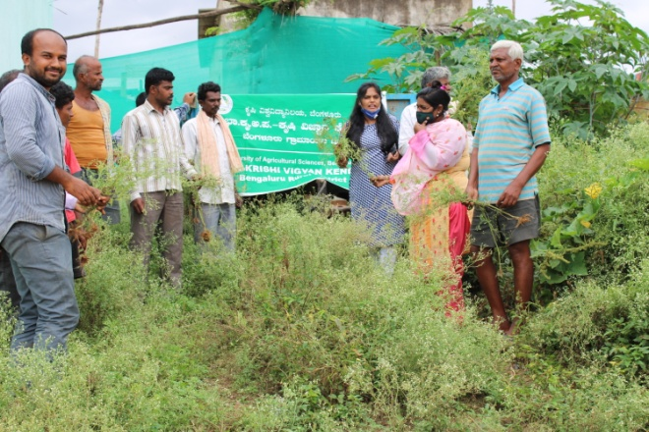 | 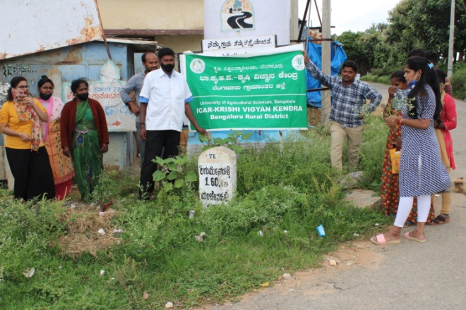
Awareness programme on Parthenium at Thuruvanahalli | Awareness programme on Parthenium at S.S. Ghati

Training programme for Extension functionaries of Dept. of Sericulture on “Integrated pest and disease management in mulberry”

ICAR-Krishi Vigyan Kendra, Bengaluru Rural District has organized on-campus training programme on 31.08.2020 for the Extension personnel of Department of Sericulture and farmers on the topic “Integrated pest and disease management in mulberry”.
The programme was chaired by the Joint Director of Sericulture Mr. S. V. Kumar and Dr. A. P. Mallikarjuna Gowda, Senior Scientist and Head, Krishi Vigyan Kendra, Bengaluru Rural District stressed upon the need for conducting need based capacity building programmes to transfer the technologies to the farmers.
Joint Director of Sericulture explained about the cocoon marketing and minimum support price for cocoon production and Deputy Director Mr. Prabhakar explained about the mulberry production and pest and disease menace in mulberry.
The technical session was conducted by the Resource person Dr. B. Manjunath, Scientist (Plant Protection) on Integrated pest and disease management in mulberry. He explained about the mechanical, chemical and biological methods of controlling thrips and mites in mulberry and their management in mulberry production. About 36 Extension personnel and 14 farmers benefitted from the programme.

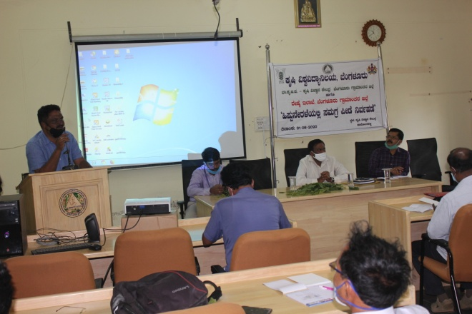 | 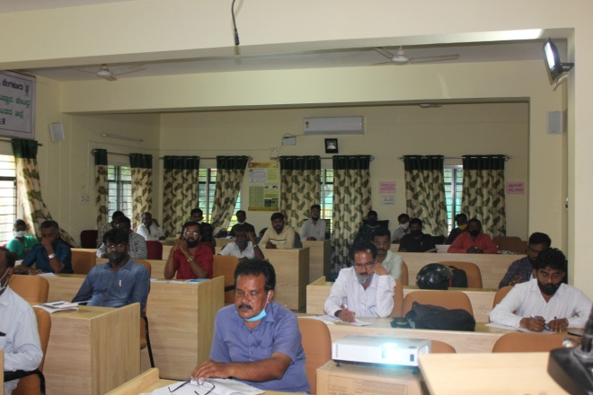

Celebration of Hindi Sapthah

Hindi Diwas was celebrated on 14.09.2020 at ICAR-Krishi Vigyan Kendra, Bengaluru Rural District. Dr. A.P. Mallikarjuna Gowda, Senior Scientist & Head, briefed the importance of celebration of Hindi Diwas.
Sri Manjesh, G.N., Scientist, DMAPR, Boriavi, Anand, Gugarath participated as a chief guest and highlighted the Hindi as important official language in India and the purpose of celebrating Hindi Diwas.
On this occasion Hindi script has been included in letter head and KVK name board to promote Hindi language at KVK. 18 KVK staff were participated in this programme

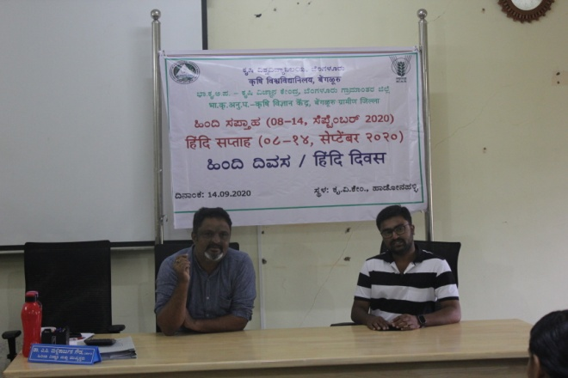 | 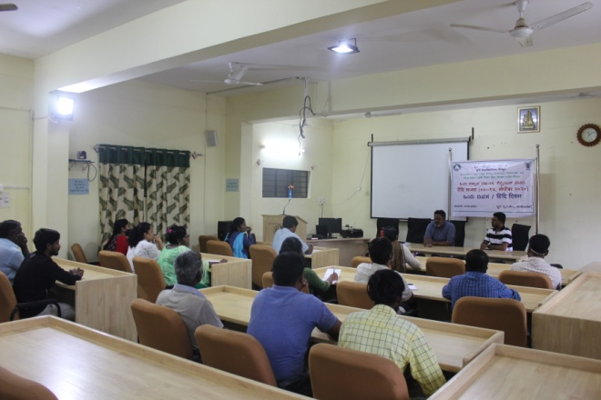

Poustika/Poshan Maah Programme

Nutrition/Poshan Diwas was organised on 16.09.2020 at ICAR-Krishi Vigyan Kendra, Hadonahalli, Bengaluru Rural District in collaboration with IFFCO and Women and Child Welfare Department to create awareness on nutrition security for Anganawadi workers and farm women. Smt. Anitha Lakshmi, CDPO, Doddaballapur Taluk participated as chief guest and highlighted the role of Anganawadi workers to mitigate the malnutrition in children.
Dr. A.P. Mallikarjuna Gowda, Senior Scientist & Head, ICAR-KVK, Bengaluru Rural District, briefed the Importance of National Nutrition month, balanced nutritious food for good health, diseases related to food, nutrition security, major problems from malnutrition and also stressed the theme of the year “Eat Right, Bite by Bite”.
Mr. Sathish, Manager, IFFCO participated in the programme and highlighted the importance of cleanliness and hygiene in the present COVID-19 situation. On this occasion he distributed the masks and vegetable seed kits to the participants.
In the technical session, models of Nutri garden, Balanced diet for nutrition security, Bio-fortified varieties etc. were taught to the participants.
The method demonstration on preparation of Ragi laddu and Ragi mixture was done by involving participants. KVK staff, 53 Anganawadi workers and 20 farm women were participated and benefitted from the programme.
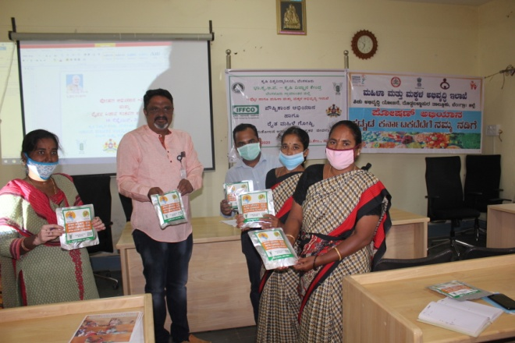 | 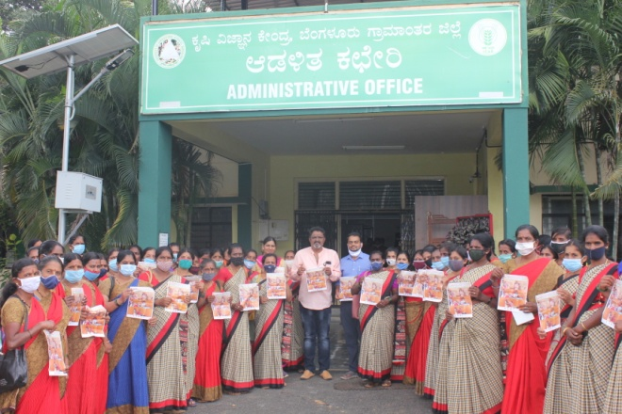

Multi Location Trials and Farm Trials

ICAR-KVK, Bengaluru Rural has undertaken two multi location trials of Niger and Sesamum at KVK farm. In addition, six farm trials viz., varietal trials on Foxtail millet, Little millet, Proso millet, Finger millet & Grain amaranthus and slag based gypsum trial in Groundnut have also been under taken both at KVK farm and farmers field. Dr. Y. G. Shadakshari, Director of Research, UAS-B and the team of Scientists visited ICAR-KVK, Bengaluru Rural on 3rd September, 2020 to review the status of multi-location trials and farm trials taken at KVK farm and farmers field. During the field visit, suggestions to KVK experts were given to note the field observations regarding different parameters in all the crops and particularly phyllody disease in Sesamum. The team also visited the seed production plots of Finger millet, Soybean & Redgram taken at KVK farm and later visited the Dragon fruit & Guava plot cultivated by a progressive farmer under the guidance of KVK.
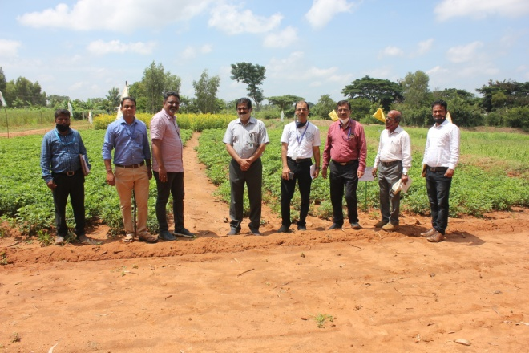 | 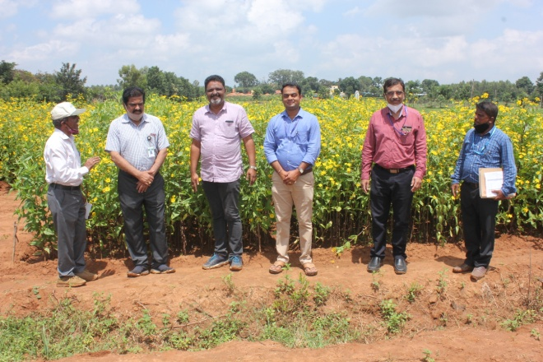

Services available at KVK
- Analysis of soil and water samples and advisory services
- Analysis of infected plant samples and advisory services about IPM practices
- Production and sale of quality planting material and advisory services
- Production and sale of Vegetable Special
- Millets Processing Centre and KVK Marketing Complex
- Production and Sale of Pongamia oil, Pongamia cake and biofuel

Services and Sale of Technological Inputs
- Analysis of 29 Soil and 25 Water samples of farmers and advisory services
- Sale of 204 kg Vegetable Special for foliar spray in vegetables
- Sale of quality horticultural planting materials
----------------------------------------------------------------------------------------------------
Chief Editor  Dr. A. P. Mallikarjuna Gowda  Senior Scientist & Head  Editor and Associate Editors  Dr. B. Manjunath, Scientist (Plant Protection)  Dr. J. Venkate Gowda., Scientist (Agronomy)  Dr. P. Veeranagapa., Scientist (Soil Science)  Dr. Y. D. Chithra., Scientist (Agril. Extension)  Sri N. Jagadish, Farm Manager  Smt. B. V. Manjula, Programme Assistant (Lab)  Smt. Sukanya, G.V., Programme Assistant (Computer) | Contact For Further Information:  Senior Scientist & Head  ICAR- Krishi Vigyan Kendra, Hadonahalli Doddaballapura Taluk, Bengaluru Rural District Karnataka – 561205, Phone: 94498 66928  Email: kvkbrd@gmail.com  Website: www.kvkbrd.org  To  -----------------------------------------------------  -----------------------------------------------------  -----------------------------------------------------

