|  |  |  |
| --- | --- | --- |
| F:\Final FB-11-05-2010\Fertlizer book photos\UAS- Logo.jpg | ***University of Agricultural Sciences, Bangalore***  **KRISHI VIGYAN KENDRA, BANGALORE RURAL DISTRICT (KVK-BRD)**  **Krishi Mantana**  **Vol. 2 Quarterly Newsletter (April – June 2014) No. 2** |  |

**On Farm Testing finalized for 2014-15**

1. 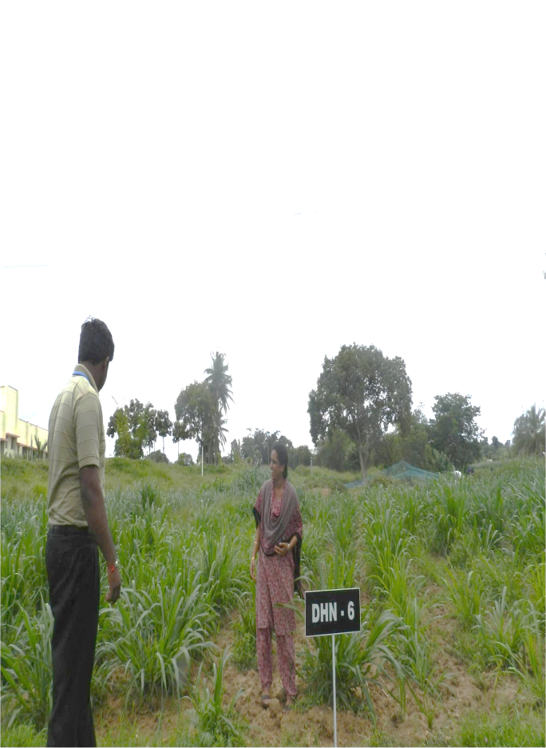Assessment of Bengal gram variety for wilt and drought resistance
2. Assessment of multi cut Fodders for yield and quality
3. Assessment on management of late blight in Potato
4. Effective management practices of Panama wilt in Banana
5. Arecanut intercropping systems for improved soil fertility and better remuneration
6. Efficacy of different education methods to combat Anemia among adolescent girls

**Front Line Demonstrations finalized for 2014-15**

1. 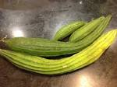Demonstration of Redgram variety BRG-5 for wilt resistance
2. Photo insensitive Field bean variety HA-4 for enhanced returns
3. Addressing drought and blast vulnerability through Finger millet variety ML-365
4. Promotion of fodder cafeteria to mitigate drought by introducing annual & perennial fodder crops
5. Moisture conservation and weed management through plastic mulching in Tomato
6. 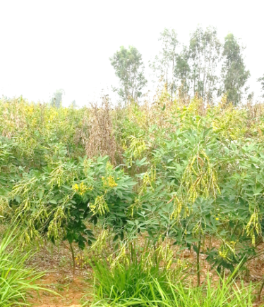Eco-friendly management of diamond back moth and black rot in Cauliflower
7. Effective management of pests & diseases in Mango
8. Management of late blight in Tomato
9. Enhancing Beetroot quality through use of Boron
10. Improvement of berry size and quality through Grape Special
11. Quality enhancement in Ridge gourd through AMC & Vegetable Special
12. Integrated dairy calf management
13. Infertility management in cross bred dairy animals
14. Management of foot-rot/soft hoof in dairy animals
15. Nutritional intervention with urea molasses mineral block (UMMB lick) in Goats
16. Oral Pellet Vaccine against Ranikhet disease in backyard poultry
17. Vegetable roof gardening for nutrition security
18. Promotion of fruits& vegetable preservator in Schools
19. Thresher cum pearler in finger millet for resource poor farmers

**Trainings**

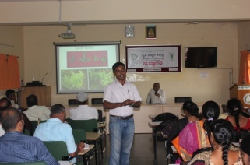**Bimonthly workshops**

Technical staff from Dept. of Agriculture of Bangalore Rural and Bangalore Urban districts participated in the Bimonthly workshops held at KVK on 21st April and 5th June, 2014. The climate, monsoon, agricultural and market situations, Integrated Pest & Disease Management in Cereals, Pulses & Oilseeds were discussed with the participants.

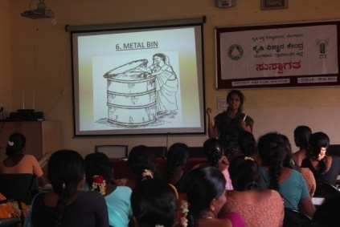**Handling and Safe Storage of Food Grains**

Forty nine farm women were trained about different methods of handling and safe storage of food grains. Different issues such as **qualities of seeds during storage, storage of food grains using local methods, scientific practices in seed storage, management of storage pests and economic losses due to storage pests** were discussed with the participants.

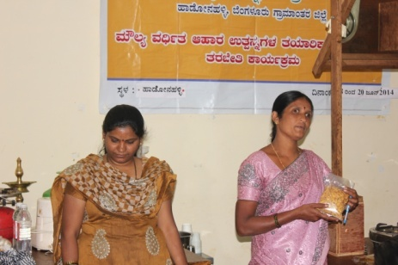**Post Harvest Processing and Value Addition of Fruits and Vegetables**

Vocational training programme on **Post Harvest Processing and Value Addition of Fruits and Vegetables** was organized for 27 farm women for 3 days during 18-20 June, 2014. Various value added products of fruits (Mango, Amla and Jack) and Vegetables (Tomato) such as papad, jam, mixture, halva, juice, chips, etc were demonstrated with hands on training. Importance of packaging, labeling hygienic production and licensing procedure, marketing aspects were discussed with emphasis on case studies & success stories.

**Sustainable Agriculture Practices for Rural Youth**

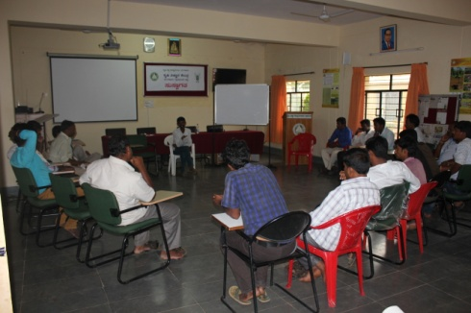Eighteen Rural Youth have been trained on ‘Sustainable Agriculture Practices’ during 27-31 May, 2014. This programme was organized in collaboration with Samvada Trust – Baduku Community College. Different topics such as Goals and aims of Rural youth, Constraints and Challenges in Agriculture, Importance of Rural Youth in Agriculture, Food Security, Green, Blue, Yellow and White Revolutions, Integrated Farming System, Soil Health Management, Soil and Water Conservation Measures, etc. were discussed with the trainees. Participatory Training Methods such as Brain Storming, Case study analysis, games, etc. were used during the training programme.

**‘Scientific Agricultural Management in Rainfed** **Agriculture’** under **Bhoochetana programme**

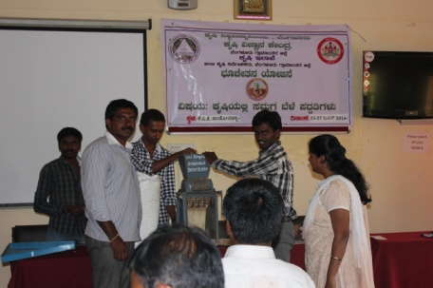Three workshops were organized for facilitators of **Bhoochetana programme** of theDept. of Agriculture of Bangalore Rural on **‘Scientific Agricultural Management in Rainfed** **Agriculture’.** Seventy four Farmer Facilitators participated in the workshops conducted in June, 2014. Detailed information was provided by the Dept. staff about Mission, Objectives, Methodology and targets of Bhoochetana programme, Roles and responsibilities of Bhoochetana facilitators and Developmental programmes of State Agriculture Department.

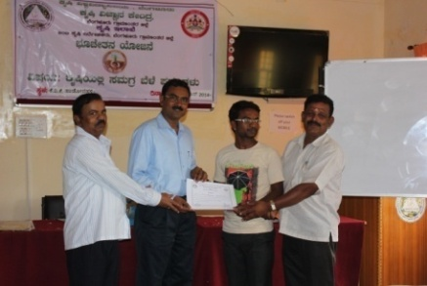KVK Scientists provided information about latest technology in soil sampling and crop-wise nutrient recommendation and management, crops and crop practices suitable for dry land of red soil regions in southern districts, integrated crop management practices to improve productivity in drylands, integrated pest and disease management practices and post harvest technology and value addition. Participatory training methods were used to provide in depth understanding about FFS – Objectives, Philosophy, implementation stages, AESA, Integrated Farming System practices, Farmer Producer Organizations, Whole Family Farming and Market Intelligence. Officers from the Dept. of Statistics educated the facilitators about crop harvesting practices & Crop cutting experiments.

**Field Day**

Field day on **‘Critical Production Techniques in Bitter gourd’** was organized at Byradenahalli village of Devanahalli taluk on 25th June, 2014. Dr.K.N.Srinivasappa, Programme Coordinator, KVK, Bangalore Rural explained importance of mulching techniques in horticultural crops. Smt. B.G.Vasanthi, SMS(Soil Science) briefed the role of micronutrients (Boron and zinc) for Bitter gourd. Dr.B.Manjunath, SMS(Plant Protection) discussed about the major pests & disease of Bitter gourd and various cultural and biological methods of management. Progressive farmer Mr.Jayaram expressed his views of mulching technique and its advantage to five extension functionaries from Agriculture and Horticulture departments and 45 farmers who participated in the programme.

**Soil Health Camps**

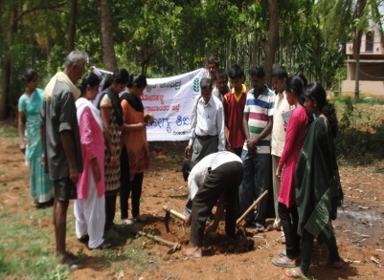Four Soil Health Camps were organized at Arasanahalli, Chikkanahalli, Akkupet and Doddahejaji villages as part of OFT and FLD initiation activities. About 235 farmers were sensitized about the importance and methods of soil sampling. Dr. K.N. Srinivasappa, Programme Coordinator, Smt B.G.Vasanthi, SMS (Soil Science), Dr.N.E. Naveen, SMS (Agronomy) and Dr. B. Manjunath, SMS (Plant Protection), Dr Savita S. Manganavar, SMS (Home Science) Dr. Ananda G Manegar, SMS (Animal Science) participated in the camps. Smt Vasanthi B.G. explained the importance of soil testing, its advantage and also the ways of maintaining soil health and fertility status .Method Demonstration of sampling technique was demonstrated during this programmes. The farmers were also sensitized for the implementation of the FLD & OFT Demonstrations.

**Animal Health Camp**

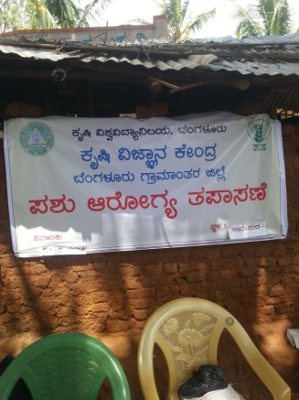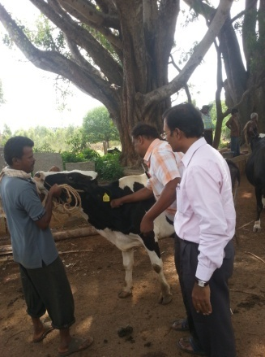One Animal Health Camps were organized at Karepura, Doddaballapur Taluk on 24-06-2014 in collaboration with Mangalore Chemicals & Fertilizers Ltd., Bangalore and Department of Animal Husbandry & Veterinary Sciences, GOK. About 100 cows were treated for infertility and 150 sheeps were dewormed and vaccinated against hemorrhagic septicemia. Seventy three farmers benefited from the camp. Dr.Ananda Manegar, G., SMS(Animal Science) participated in treatment of infertility in dairy animals. Dr B Manjunath, SMS (Plant Protection) and Dr N E Naveen, SMS (Agronomy) participated in the programme.

**Celebration of Important Days**

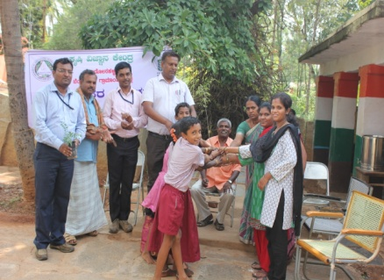KVK in collaboration with I&D Centre on Biofuel celebrated **World Environment Day** on 06-06-2014 at Govt. Higher Primary School, Purushanahalli, Doddaballapur taluk and at Karepura village. Dr. N.E. Naveen SMS (Agronomy) briefed the students about the importance of environment day and means of protecting it. Smt B.G.Vasanthi, SMS (Soil Science) explained about the environmental pollution and also strategies to reduce the pollution. Dr. B. Manjunath SMS (Plant Protection) briefed about the safe use of pesticides to reduce the pesticidal load. Dr Savita S. Manganavar SMS (Home Science) explained the importance of planting in relation to nature and human health. Dr. Ananda G Manegar SMS (Animal Science) also participated in the programme. Mr. Naveen, Research Associate, I&D centre explained about various biofuel plants and its importance. As a mark of identity, biofuel plants such as Pongamia and Neem were planted in the school premises.

**Guest Lectures**

* Branding, Marketing strategies of value added products
* Soil sampling techniques and nutrient analysis
* Scientific diary management
* IPM in field & Horticulture crops
* Agronomic practices for Kharif season
* Climate change and Contingent Planning in Agriculture for Hassan District
* Seed treatment and Integrated Nutrient Management
* Management of Commodity Based Associations
* Participatory Rural Appraisal PRA) techniques and Strategic Research and Extension Plan (SREP)

**Extension Activities**

* International Jack fruit Symposium - GKVK
* Mango and Jack Mela - Lalbagh
* Mango Diversity Mela – IIHR

**Participation in Symposia**

* Dr K N Srinivasappa, Programme Coordinator and Dr Savita S Manganavar, SMS (Home Science) participated in the ‘**International Symposium on Jackfruit and Breadfruit of the Tropics’** held on 15-16 May, 2014 at UAS (B), GKVK, Bangalore.
* Dr K N Srinivasappa presented a paper titled **‘Survey and Documentation of Elite Jackfruit seedlings, progenies in Bangalore Rural district’.**
* Dr Savita S Manganavar presented a paper titled ‘**Jackfruit – Value Addition & Branding – An Entrepreneurship model for Women groups of Bangalore Rural district’.**

**Integrated Farming System Demonstration**

Training programmes were conducted to the members of Corn and Banana Growers Association about the following topics.

* Scientific Sheep Rearing Activities
* Importance of Seed Production Activities and Methods of Utilization of Revolving Fund
* Preparatory Activities for Kharif season for the members of Banana & Corn Growers Association
* Foundation Seed Production in Fodder Maize SA TALL
* 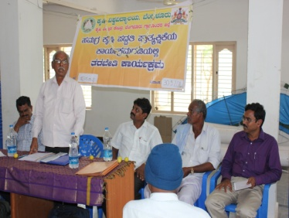Integrated Crop Practices in Fodder Maize SA TALL

Prof E.Yellappa, Programme Facilitator, IFSD project guided the members of CBAs about **Group Dynamics, Revolving Fund Utilization and Future Role of CBAs**. Dr. S.M. Pillegowda, Professor, NSP, GKVK explained to the members about importance of seed production and encouraged the farmers to undertake Fodder Maize SA TALL seed production in Hosahalli gram panchayat. Dr.K.N.Srinivasappa, Programme Coordinator, KVK-BRD explained to the members about IFSD activities for the year 2014-15.

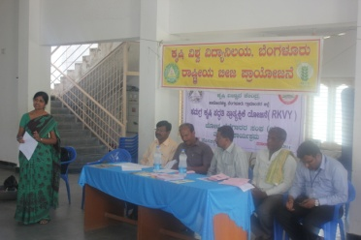National Seed Project (NSP), GKVK organized a training programme about **‘Seed Production and Integrated Crop Practices in Fodder Maize SA TALL’** on 21-6-2014 in Hosahalli gram panchayat under IFSD in collaboration with KVK-BRD. Members of Banana Growers Association and Corn Growers Association participated in the programme. Dr.S.M.Pillegowda, Professor, NSP, GKVK informed to the farmers about various seed production activities of NSP. Dr.T.M.Venkataramanappa, Senior Breeder, NSP briefed to the farmers about seed quality and isolation distance. Dr.Parashivamurthy, Associate Professor, NSP gave information to the farmers about seed germination and seed quality parameters to be maintained. Dr.N.E.Naveen, SMS (Agronomy) updated the farmers about critical production techniques to be followed in Maize production.

**Services and Sale of Technological Inputs**

Over 128 soil and 112 water samples brought by farmers were analyzed and suitable agro-advisories were provided to the farmers during this quarter. Farmers purchased 172 kg Vegetable Special for use in various vegetables. Farmers also purchased 1071 quality horticultural planting materials from the plant propagation unit of KVK.

**Plant Health Clinic**

Sixty plant samples were diagnosed for pests and diseases and advisories were given to the farmers about control measures.

Field visits were carried out and visited fields of 25 farmers in Hosahalli, Karepura, Doddahejjaji, Peddanahalli, Bommavara, Arasanahalli, Amligee, Hasiruvalli, K R Pura and Jakkenahalli villages and remedies were suggested to farmers’’ problems.

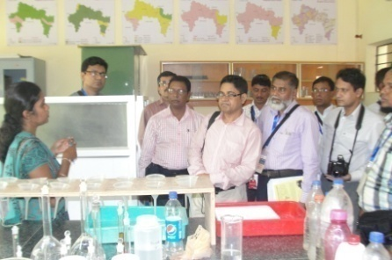**Important Visitors**

* Sri Subodh Yadav, IAS, Commissioner for Agriculture on 02-05-2014
* About 76 Officers from Regional Development Bank, Sri Lanka visited KVK in June, 2014 as part of **Entrepreneurship Development Activities**

|  |  |
| --- | --- |
| **Published by**  **Dr. K.N. Srinivasappa,**  Programme Coordinator, KVK, Hadonahalli, Doddaballapura Taluk, Bangalore Rural District, Karnataka – 561205 | **Edited by**  **Dr M Padmavathi**  SMS, (Agril. Extension), KVK, Hadonahalli, Doddaballapura Taluk, Bangalore Rural District,  Karnataka – 561205 |
| **Contact For Further Information:**  Programme Coordinator, Krishi Vigyan Kendra, Hadonahalli, Doddaballapura Taluk, Bangalore Rural District, Karnataka – 561205 **Phone:** 080-27652082 **Email:** [kvkbrd@gmail.com](mailto:kvkbrd@gmail.com)  **Website:** [www.kvkbrd.org](http://www.kvkbrd.org) | To  ---------------------------------------------------------  -----------------------------------------------------------  ----------------------------------------------------------- |